GAUTENG DEPARTMENT OF EDUCATION

SENIOR CERTIFICATE EXAMINATION

MOTOR MECHANICS SG

TIME: 3 hours

MARKS: 200

REQUIREMENTS:

Calculator and drawing instruments

INSTRUCTIONS:

- This examination paper consists of SECTION A and SECTION B.
- All questions in Section A are COMPULSORY.
- Answer Question 1 (Multiple choice) on the answer sheet on the inside cover of your answer book.
- Answer any FOUR questions from Section B.
- An information sheet containing formulae is included on page 12.

SECTION A

COMPULSORY

QUESTION 1

MULTIPLE CHOICE QUESTIONS

Each of the following questions is supplied with four possible answers of which only ONE possibility is correct in each case. Make use of the answer sheet on the inside cover of your answer book and draw a cross (X) over the letter which, in your opinion, is the correct answer.

1.1 The system using two rear axles with drive on both is called

- double reduction drive.
- tandem drive.
- two speed drive.
- limited slip drive.

1.2 The two opposing forces used in the vacuum speed governor, to govern the engine speed of a compression ignition engine are

- atmospheric pressure and intake manifold vacuum.
- spring tension and atmospheric pressure.
- centrifugal force and spring tension.
- intake manifold vacuum and centrifugal force.

1.3 Which one of the following will tend to move a body from rest, or change the speed of an object?

- Power
- Work
- Torque
- Force

1.4 What is the optimum air/fuel ratio for petrol and air?

- 08:1
- 17:1
- 15:1
- 12:1

  - The international colour code for a 220 volt three-core cable is

- earth green and yellow, live brown, neutral blue.
- earth green and yellow, live blue, neutral brown.
- earth brown, live green and yellow, neutral blue.
- earth blue, live brown, neutral green and yellow.

  - When disconnecting a battery, the first step would be to disconnect the

- live conductor.
- earth conductor.
- positive conductor.
- negative conductor.

  - When a person suffers an electric shock the first thing to do, is

- start artificial respiration immediately.
- inform the teacher.
- carry the person to a safe area in the work centre.
- switch off the current.

  - The stator of a torque converter is responsible for

- transferring power.
- vortex flow of oil.
- increasing torque.

D. increasing power.

Positive castor on the front wheels occurs when the top of the kingpin is

- tilted to the back.
- tilted to the outside.
- tilted to the front.
- tilted to the inside.

  - If the indicated power of an engine is 60 000 W, and the brake is 43.20 kW, the mechanical efficiency of the engine will be

- 0.072%.
- 13.8%.
- 72%.
- 138.8%.

  - The S.I. unit for torque is

- N.m.
- N/m.
- N/mm.
- N/m².

1.12 The two basic elements of petrol are carbon and

- oxygen.
- hydrogen.
- nitrogen.
- carbon dioxide.

1.13 Which one of the following types of electrical motors is used as the motor of a windscreen wiper?

- Alternating current motor
- Parallel motor
- Series motor
- Two-way rotational motor

1.14 In the compression ignition engine injection pump, injection ceases when the helix of the pump plunger

A. covers the inlet and the spill ports.
B. uncovers the spill port.
C. just closes the spill port.
D. just closes the inlet port.

1.15 Which one of the following balances is disturbed by the load variations of the pistons, caused by combustion pressures on the pistons?

- The power balance
- The static balance
- The dynamic balance
- The mechanical balance

1.16 Which stroke is indicated as the negative pressure area on the cylinder pressure diagram of a four stroke engine?

- The power stroke
- The compression stroke
- The inlet stroke
- The exhaust stroke

1.17 The transistor used on electronic ignition systems has a connector lead known as the collector. To which one of the following units is this collector connected?

- Ignition switch
- Accumulator
- Contact points
- Ignition coil

1.18 The angle formed by the cylinders of a V-8 engine to ensure equal firing periods, should be

- 30º.
- 60º.
- 90º.
- 120º.

  - When the road wheel of a vehicle is over-inflated, it will wear

- on the inside of the tyre.
- on the outside of the tyre.
- in the centre of the tyre.
- across the whole surface of the tyre.

- The function of a diode in an alternator is to  - convert alternating current to direct current.  - convert direct current to alternating current.  - generate more power.  - generate less power.  - The firing order for a four-stroke, five-cylinder in-line engine is  - 1 2 4 5 3.  - 1 3 5 2 4.  - 1 5 2 4 3.  - 1 3 5 4 2.  1.22 The connection of an ammeter in an electrical circuit is always in  - parallel.  - series.  - parallel or series.  D. series and parallel.  1.23 If the compression ratio of an engine is 12:1 and the engine operates at sea level, the compression pressure developed in the combustion chamber will be  - 12 kPa.  - 120 kPa.  - 1200 kPa.  - 12 000 kPa.  1.24 The component of the double epicyclical gear train which is held stationary to engage first gear is the  - primary sun gear.  - secondary sun gear.  - annulus.  - planet gear carrier.  1.25 The phase angle for a six-cylinder, four-stroke, compression ignition engine is  - 30º.  - 60º.  - 90º.  - 120º. | 25X2=[50]

QUESTION 2

Match the correct term in Column B with the description from Column A. Write only the question number in Column A and the correct letter from Column B in your answer book. (Example 2.1 – A).

COLUMN A | COLUMN B
2.1 Angle formed between the perpendicular line and the centre line of the wheel as seen from the front.  - Even distribution of all weight around the axis of rotation in a single plane.  - Fills the cylinder with an increased initial pressure, which is higher than atmospheric pressure.  - Uncontrollable explosion of a trapped charge in the combustion chamber.  - Twisting action transmitted by a rotating shaft.  - It acts as a one way valve.  - Theoretical or calculated power.  - Second gear in an automatic gearbox.  - The resistance of a fuel to flow.  2.10 Not a true hydro-carbon fuel. | - Dynamic balance  - Detonation  - Power  - King pin inclination  - Wild-knocking  - Blower  - Transistor  - Alcohol  - Static balance  - Brake power  - Secondary sun gear stationary  - Diode  - Indicated power  - Volatility  - Torque  - Supercharger  - Camber angle  - Kerosene  - Delivery valve  - Viscosity  - Primary sun gear stationary
[10]

QUESTION 3  Complete the following statements. Write down the answer only, next to the appropriate question number in your answer book.  3.1 When the sliding angle of the front wheel is larger than the sliding angle of the rear wheels, this is known as _______.  3.2 When the combustion of petrol takes place in the presence of an inadequate supply of oxygen, incomplete combustion occurs and ________ and water are released.  3.3 A final drive, consisting of two permanent reductions in the final drive system, is known as a_________ final drive.  3.4 The brake power of an engine is determined with the aid of a ________.  3.5 In the alternator, the three stator coils can be connected to each other to form a Y-connected stator or a ________ connected stator. | 5X2=[10]

QUESTION 4

Read the following statements below and indicate whether they are TRUE or FALSE. Write down only TRUE or FALSE in your answer book, next to the appropriate question number.

4.1 With an inverted helix, the commencement of injection remains constant, while the end of injection varies according to the requirements of the engine.

  - A reference fuel with an octane value of 85,consists of 85% heptane and
15% iso-octane.

  - The field coil of the alternator rotates, while the field coils of the generator remain stationary.

  - The power balance of a V-4-engine is good.

  - A gear ratio of 1:2, means that the driving gear will complete two revolutions for every one revolution completed by the driven gear.

  - 1 kPa = 1 kN/m²

4.7 Fractions distilled between 345º C and 425º C are known as diesel.

4.8 An engine with a brake power value of 73,33 kW, develops a torque of
250 N.m at 2 600 revolutions per minute.

4.9 Anything that causes a resistance to the free flow of air in an engine, has a negative effect on volumetric efficiency as engine speed increases.  4.10 The firing period for a two-stroke, two cylinder engine is 360º. | 10X1=[10]

TOTAL FOR SECTION A: [80]

SECTION B  Answer any FOUR questions from Section B.  QUESTION 5  5.1 Draw a typical cylinder pressure diagram for a four-stroke petrol engine having a compression ratio of 8:1.  5.2 To rotate a car engine at 50 revolutions per minute, a force of 135 Newton is applied perpendicularly to the crank arm of a starting handle. The distance from the centre of the crank arm to the point of the applied focus is 168 mm.  Calculate:  - The torque  - The power  5.3 Define the following terms with reference to a motor car engine:  - Compression ratio  - Volumetric efficiency | (12)  (5)  (5)  (4)  (4)  [30]

QUESTION 6

Study the sketch of the carburettor in Figure 6.1 and answer the questions that follow.

5
7
6
4
3
1
2

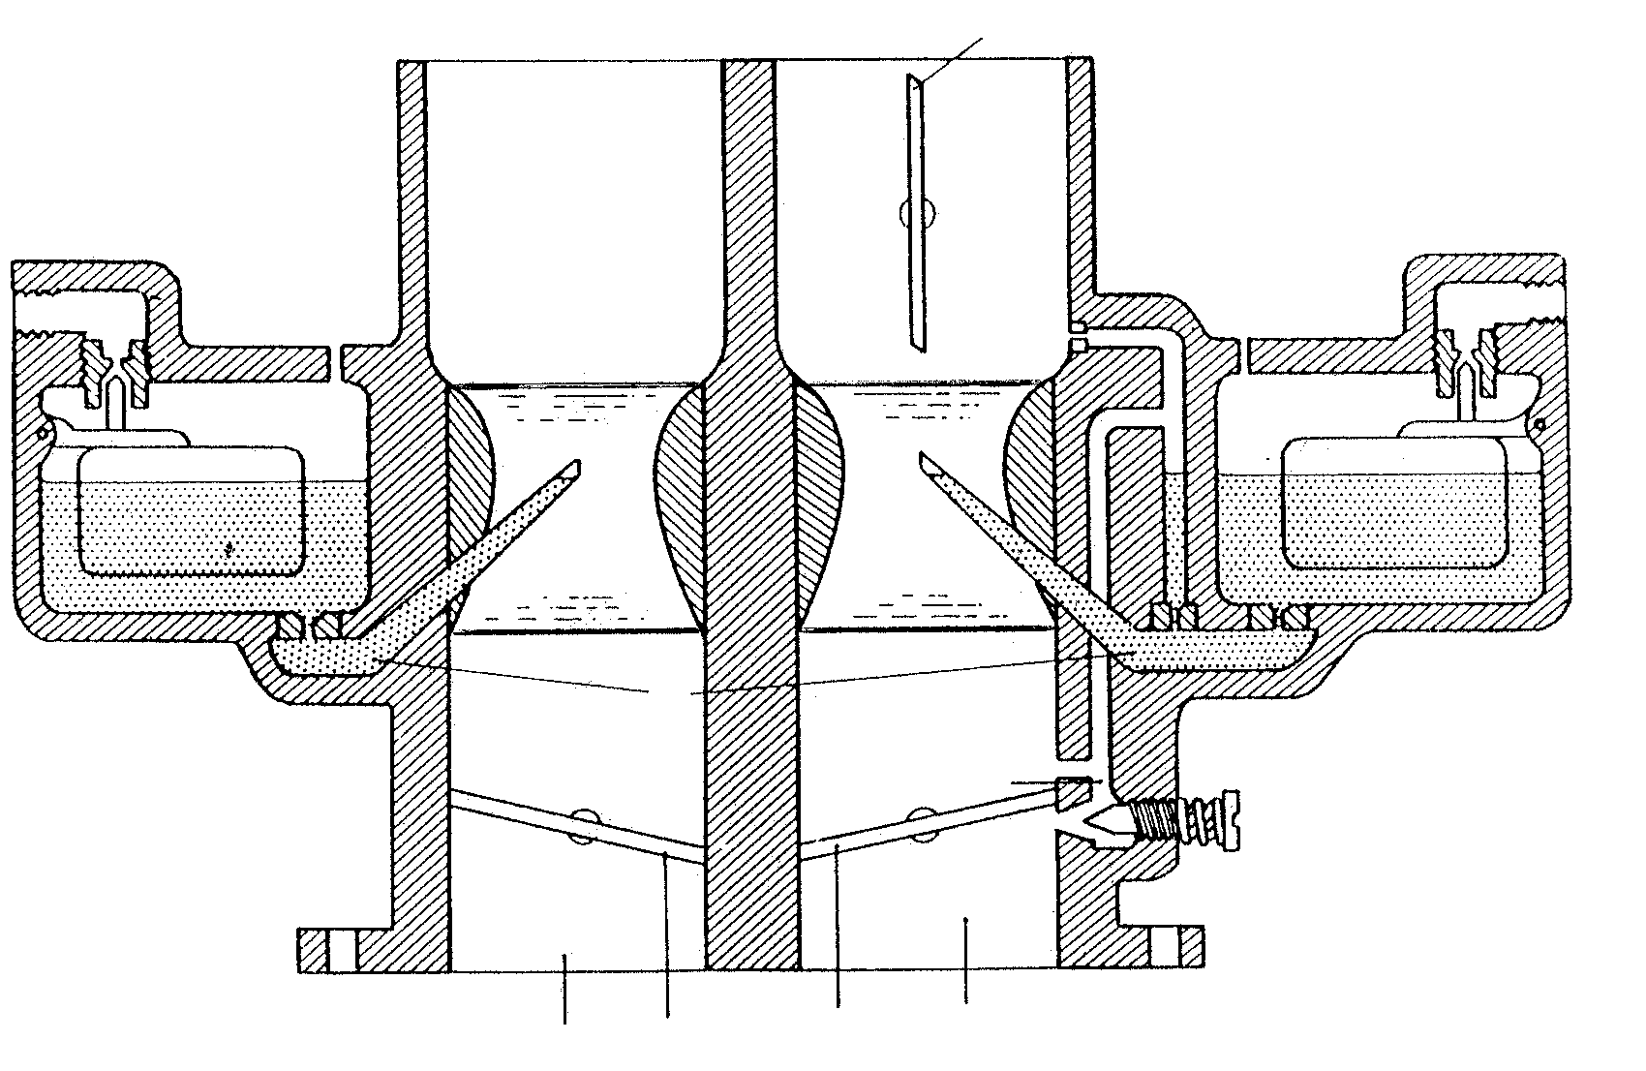

Figuur 6.1

6.1 What type of carburettor is shown in Figure 6.1?  - Name the components 1 to 4.  6.3 Name the circuit responsible for  - maintaining a constant predetermined level of fuel in this carburettor.  providing an air/fuel ratio of 8:1.  6.4 Explain the function of component 6.  6.5 Briefly describe how the piston of a constant-vacuum carburettor is lifted during acceleration. | (2)  (4)  (2)  (2)  (2)  (6)

6.6 Why are no complicated compensating circuits required in a constant vacuum carburettor?  6.7 With the aid of simple labelled sketches, show the difference between  - a conventional helix; and  - an inverted helix. | (4)  (4)  (4)  [30]

QUESTION 7  7.1 Define effective pump stroke, with regard to a plunger type fuel injection pump.  7.2 State TWO reasons why the plunger type fuel injection pump used on a compression ignition engine, is equipped with a delivery valve.  7.3 Draw a simple, labelled, sectional sketch of an injector pump element (plunger and barrel-type) as used in a compression ignition engine’s injector pump.  Show the following:  - The plunger with the helix, at the beginning of maximum fuel delivery  - The plunger with the helix at the end of maximum fuel delivery  7.4 Name TWO functions of a blower used on a two-stroke compression ignition engine.  7.5 Name TWO opposing forces that are used in a mechanical governor to control the engine speed of a compression ignition engine.  7.6 Briefly discuss why fuel filters are necessary in the fuel supply system of the compression ignition engine. | (4)  (4)  (5)  (5)  (4)  (4)  (4)  [30]

QUESTION 8

Figure 8.1 below shows the important components of an automatic gearbox. Study the sketch and answer the questions that follow.

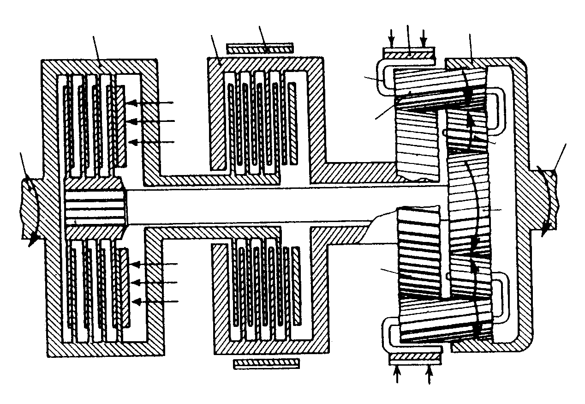

1
2
3
4
12
8
5
6
7
11
10
9

Figure 8.1

8.1 Name the components marked 1 - 12.  8.2 If the first gear is selected, which components in the epicyclical gear-train are locked and which are free to rotate?  8.3 If reverse gear is selected, which components are locked?  8.4 If second gear is selected, which components are locked?  8.5 Draw a neat, labelled sketch of the torque converter. | (12)  (4)  (2)  (2)  (10)  [30]

QUESTION 9  9.1 Draw neat labelled sketches to illustrate the following:  - Toe-in  - Negative castor  - The Ackerman principle  - A rack and pinion steering box  - A steering layout with a single tie-rod  9.2 Name TWO advantages of power steering.  9.3 What is the main function of a steering box? | (4)  (5)  (6)  (4)  (5)  (4)  (2)  [30]

QUESTION 10  10.1 Draw a neat, labelled, diagrammatic layout of a transistor ignition system, equipped with contact points for a single cylinder engine.  10.2 Describe the operation of a rheostat type fuel gauge when the fuel level is high. | (12)  (8)

Figure 10.1 shows the wiring diagram of the alternator-charging system with an electromagnetic voltage regulator. Study this diagram and then answer

Questions 10.3 and 10.4.

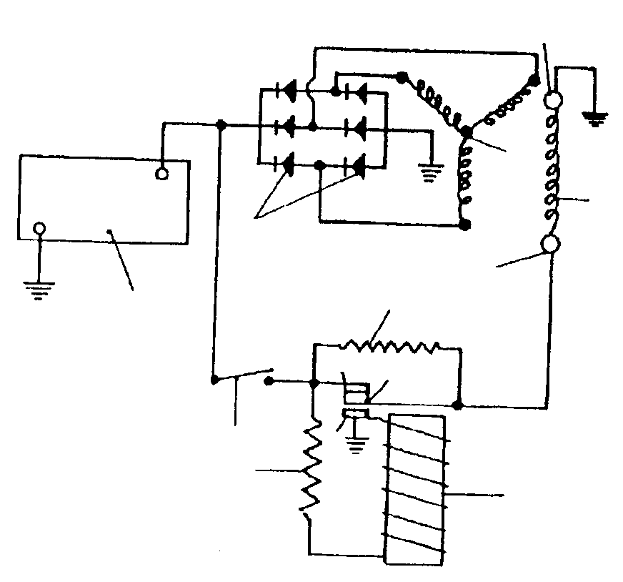
9
8
6
11
12
10
7
3
5
4
2
2
1
3

Figure 10.1

Name the components 2,3,4,7,8 and 10.  - What is the function of component number 2?  - State ONE advantage of an alternator in comparison to a generator. | (6)  (2)  (2)  [30]
TOTAL FOR SECTION B: [120]
TOTAL: 200

FORMULAE

F x distance
time
M.E.P. x π x D² x stroke length x r/s x number of cylinders
4 x 2

B.P. x 100
I.P.

π D²
4
π D² L
4

* F = m x a * Work = F x distance

* Power = * T = F x R

* Power =

* Power = M.E.P. x π x D² x stroke length x r/s x number of cylinders
4

* I.P. = PLANn * Atmospheric pressure = 100 kPa

* Brake power = 2 π N T * Brake power = F x 2 π R x N

* Mechanical efficiency =

* Compression pressure = C.R. x atmospheric pressure

* C.R. = $\frac{\text{SV}+\text{CV}}{\text{CV}}$ * Area =

* Stroke volume =

