GAUTENG DEPARTMENT OF EDUCATION
SENIOR CERTIFICATE EXAMINATION

LATIN HG
(First Paper: Prescribed Reading and Language Study)

TIME: 2½ hours

MARKS: 200

INSTRUCTIONS:

- Answer ALL the sections: Sections A, B, C and D.
- Question 5 in Section B must be answered on the answer sheet on page 16 of the examination paper. Please detach this page and place it at the back of your answer book once you have answered this question. Do not forget to fill in your examination number.
- Answer either Question 7 or Question 8 in Section D.

SECTION A
PREPARED TRANSLATIONS

QUESTION 1

Translate the following passage into English.

Queen Dido has decided to commit suicide.

At trepida et coeptis immanibus effera Dido 1  sanguineam volvens aciem, maculisque trementis  interfusa genas et pallida morte futura,  interiora domus inrumpit limina et altos  conscendit furibunda gradus ensemque recludit 5  Dardanium, non hos quaesitum munus in usus.  Hic, postquam Iliacas vestis notumque cubile  conspexit, paulum lacrimis et mente morata  incubuitque toro dixitque novissima verba:  “Dulces exuviae, dum fata deusque sinebat, 10  accipite hanc animam meque his exsolvite curis.  Vixi et quem dederat cursum fortuna peregi,  et nunc magna mei sub terras ibit imago.” | [25]

QUESTION 2

Translate the following passage into English.

Nero’s passion for chariot racing

equorum studio vel praecipue ab ineunte aetate flagravit 1  plurimisque illi sermo, quamquam veteretur, de circensibus erat;  et quondam tractum prasinum agitatorem inter condiscipulos  querens, obiurgante paedagoge, de Hectore se loqui ementitus  est. sed cum inter initia imperii eburneis quadrigis cotidie in 5  abaco luderet, ad omnes etiam minimos circenses e secessu  commeabat, primo clam, deinde propalam, ut nemini dubium  esset eo die utique affuturum. neque dissimulabat velle se  palmarum numerum ampliari; quare spectaculum multiplicatis  missibus in serum protrahebatur, ne dominis quidem iam 10  factionum dignantibus nisi ad totius diei cursum greges ducere. | [25]

QUESTION 3

Translate the following passage into English.

Love is hard work according to Ovid.

Ingenii est experientis amor. 1  ardet in abducta Briseide magnus Achilles:  dum licet, Argivas frangite, Troes, opes.  Hector ab Andromaches complexibus ibat ad arma,  et galeam capiti quae daret, uxor erat. 5  Mars, quoque deprensus, fabrilias vincula sensit:  notior in caelo fabula nulla fuit.  Ipse ego segnis eram discinctaque in otia natus  mollierant animos lectus et umbra meos  impulit ignavum formosae cura puellae, 10  iussit et in castris aera merere suis,  inde vides agilem nocturnaque bella gerentem.  Qui nolet fieri desidiosus, amet. | [25]

QUESTION 4

Translate the following passage into English.

Pliny’s attitude towards the races

Omne hoc tempus inter pugillares ac labellos iucundissima quiete 1  transmisi. “ quemadmodum” inquis “in urbe potuisti?” circenses erant,  quo genere spectaculi ne levissime quidem teneor. Nihil novum, nihil  varium, nihil quod non semel spectasse sufficiat. Quo magis miror tot  milia virorum tam pueriliter identidem cupere currentes equos 5  insistentes curribus homines videre. Si tamen aut velocitate  equorum aut hominum arte traherentur, esset ratio non nulla;  nunc favent panno, pannum amant, et si in ipso cursu medioque  certamine hoc color illuc, ille huc transferatur, studium favorque  transibit, et repente agitatores illos, equos illos, quos 10  procul noscitant, quorum clamitant nomina relinquent. | [25]

TOTAL FOR SECTION A: | [100]

SECTION B
SCANSION

N.B. Answer this section on the answer sheet on page 16 of this paper.

Remember to place the answer sheet at the back of your answer book before handing it in.

QUESTION 5

Scan the lines on the answer sheet on page 16, carefully marking quantities, feet and main caesurae clearly. | 20÷2 = [10]

TOTAL FOR SECTION B: | [10]

section c
TEXTUAL / CONTEXTUAL QUESTIONS

QUESTION 6

Read through the following extracts carefully and answer ALL the questions set at the end of each one. Do not translate any of the extracts.

6.1 VERGIL

“Et nostras audite preces. Si tangere portus 1
infandum caput ac terris adnare necesse est,
et sic fata Iovis poscunt, hic terminus haeret:
at bello audacis populi vexatus et armis,
finibus extorris, complexu avulsus Iuli 5
auxilium imploret videatque indigna suorum
funera; nec, cum se sub leges pacis iniquae
tradiderit, regno aut optata luce fruatur,
sed cadat ante diem mediaque inhumatus harena.

Haec precor, hanc vocem extremam cum sanguine fundo.” 10

6.1.1 Who is the speaker of these lines? | (1)

6.1.2 What is the terminus to which the speaker is referring in line 3 and what brought it about? | (2)

6.1.3 Why are the words cum sanguine (line 10) prophetic? | (1)

6.1.4 In leaving, Aeneas was putting the interests of others before his own happiness. Name at least TWO persons or things he was considering in the action he took. | (2)

6.1.5 To whom does luli refer (line 5)? Give the other name by which he was also known. | (2)

6.1.6 Why is the speaker behaving irrationally? | (2)

6.1.7 To what do the two parts of the expression regno aut optata luce  (line 8) refer in this context? | (2)

6.1.8 Explain why being mediaque inhumatus harena (line 9) was such a terrible thing to suffer. | (1)  [13]

6.2 PLINY

Recte fecisti quod gladiatorium munus Veronensibus 1
nostris promisisti, a quibus olim amaris, susciperis, ornaris.
Inde etiam uxorem carissimam tibi et probatissimam habuisti,
cuius memoriae aut opus aliquod aut spectaculum atque hoc
potissimum, quod maxime funeri, debebatur. Praeterea tanto 5
consensu rogabaris, ut negare non constans, sed durum
videretur. Illud quoque egregie, quod tam facilis tam liberalis
in edendo fuisti. Nam per haec etiam magnus animus
ostenditur. Vellem Africanae, quas coemeras plurimas, ad
praefinitum diem occurrissent: sed licet cessaverint illae 10
tempestate detentae, tu tamen meruisti ut acceptum tibi
fieret, quod quo minus exhiberes, non per te stetit. Vale.

6.2.1 (a) To whom is Pliny addressing this letter?  (b) Why is he doing this? | (1)  (1)

6.2.2 Why does Pliny use the word nostris (line 2)? | (2)

6.2.3 Explain the significance of the following phrase:  spectaculum ... quod maxime funeri (lines 4 and 5) | (2)

6.2.4 What is the implication of the phrase tu meruisti (line 11)? | (2)

6.2.5 What was Pliny’s opinion of the gladiatorial show? How does this correlate with other views on this issue? | (3)

6.2.6 Compare Pliny’s attitude in this letter to his comments and attitude in his letter to his friend Calvisius with regard to the chariot races. | (2)  [13]

6.3 THE TIBULLUS COLLECTION

Invisus natalis adest, qui rure molesto 1
et sine Cerintho tristis agendus erit
dulcius urbe quid est? an villa sit apta puellae
atque Arretino frigidus amnis agro?
iam, nimium Messalla mei studiose, quiescas; 5
non tempestivae saepe, propinque, viae.
Hic animum sensusque meos abducta relinquo,
arbitrio quam vis non sint esse meo.

6.3.1 Who is the author of this poem? | (1)

6.3.2 Why are the words abducta and quam in the last couplet in the feminine form? | (1)

6.3.3 This short poem is an example of a genethliakon. Explain what this word means. | (1)

6.3.4 The adjective invisus (line 1) is emphasised by its position in the sentence. With which noun does it agree? (give the Latin as well as the English meaning). Explain why the author feels this way. | (3)

6.3.5 Explain the reference to Arretino agro (line 4). | (2)

6.3.6 At which time of the year is this taking place? Quote a Latin word to justify your answer. | (2)

6.3.7 What is the implication of the words abducta and vis in the last couplet? | (1)

6.3.8 What does this poem teach us about the position of women in Roman society? | (1)

6.3.9 Did the author go to the country in the end? How, do you imagine, did she feel about that? | (2)  [14]

6.4 TERTULLIAN

ethnici malum et bonum pro arbitrio et libidine 1
interpretantur. Sic ergo evenit, ut qui in plateis litem
manu agentem aut compescit aut detestatur, idem in stadio
gravioribus pugnis suffragium ferat, et qui ad cadaver hominis
communi lege defuncti exhorret, idem in amphitheatro 5
derosa et dissipata et in suo sanguine squalentia corpora
patientissimis oculis desuper incumbat; immo qui propter
homicidae poenam probandam ad spectaculum veniat, idem
gladiatorem ad homicidium flagellis et virgis compellat
invitum, et qui insigniori cuique homicidae leonem poscit, idem 10
gladiatori atroci petat rudem et pilleum praemium conferat.

6.4.1 What observations does Tertullian make about the behaviour of pagans in lines 1 – 4? | (3)

6.4.2 Explain fully the example he gives in lines 4 to 9. | (2)

6.4.3 What effect do the games have on the audience and the gladiators? | (2)

6.4.4 How does Tertullian’s opinion of the gladiatorial show compare with those of Cicero in the Theatre of Pompey? | (3)  [10]

TOTAL FOR SECTION C: | [50]

section d
LANGUAGE STUDY

Answer either question 7 or Question 8.

QUESTION 7

Translate the following sentences into Latin.

7.1 During the reign of Nero, there was such a great fire in Rome that many citizens died. | (7)

7.2 Tibullus was hoping to live in the country. | (5)

7.3 By watching the games, Seneca realized how many animals were killed daily. | (7)

7.4 Ovid begs Amor, who is attacking him, to seek another. | (7)

7.5 If you were to set out at once, you would arrive here in two days. | (7)

7.6 Mercury had ordered Aeneas to listen to Jupiter and not to stay in Carthage. | (7)  [40]

OR

QUESTION 8

8.1 VERGIL

At trepida et coeptis immanibus effera Dido 1
sanguineam volvens aciem, maculisque trementis
interfusa genas et pallida morte futura,
interiora domus inrumpit limina et altos
conscendit furibunda gradus ensemque recludit 5
Dardanium, non hos quaesitum munus in usus.
Hic, postquam Iliacas vestis notumque cubile
conspexit, paulum lacrimis et mente morata
incubuitque toro dixitque novissima verba:

“Dulces exuviae, dum fata deusque sinebat, 10
accipite hanc animam meque his exsolvite curis.”

8.1.1 State the case and give a reason for the case of the following nouns:

- coeptis (line 1)  - genas (line 3)  - curis (line 11) | (6)

8.1.2 munus and usus (line 6) are both in the accusative but for different reasons. State these reasons. | (2)

8.1.3 Quote from the passage a Latin adjective in the superlative degree of comparison. | (1)

8.1.4 Explain why maculis and trementis (line 2), although they have similar endings, do not agree with each other. | (2)  [11]

8.2 SENECA

equorum studio vel praecipue ab ineunte aetate flagravit 1
plurimisque illi sermo, quamquam veteretur, de circensibus erat;
et quondam tractum prasinum agitatorem inter condiscipulos
querens, obiurgante paedagoge, de Hectore se loqui ementitus
est. sed cum inter initia imperii eburneis quadrigis cotidie in 5
abaco luderet, ad omnes etiam minimos circenses e secessu
commeabat, primo clam, deinde propalam, ut nemini dubium
esset eo die utique affuturum. neque dissimulabat velle se
palmarum numerum ampliari; quare spectaculum multiplicatis
missibus in serum protrahebatur, ne dominis quidem iam 10
factionum dignantibus nisi ad totius diei cursum greges ducere.

8.2.1 Quote an example of the following:

- Present participle  - Prolative infinitive  - Ablative absolute  - Future participle  - Deponent verb | (5)

8.2.2 luderet (line 6) and esset (line 8) are both imperfect subjunctive. Is this statement TRUE or FALSE? Justify your answer with reference to the construction within which each occurs. | (3)

8.2.3 Give the other degrees of comparison of minimos (line 6) in the same case, number and gender. | (2)  [10]

8.3 OVIDIUS

Ingenii est experientis amor. 1
ardet in abducta Briseide magnus Achilles:
dum licet, Argivas frangite, Troes opes.
Hector ab Andromaches complexibus ibat ad arma,
et galeam capiti quae daret, uxor erat. 5
Mars, quoque deprensus fabrilias vincula sensit:
notior in caelo fabula nulla fuit.
Ipse ego segnis eram discinctaque in otia natus
mollierant animos lectus et umbra meos
impulit ignavum formosae cura puellae, 10
iussit et in castris aera merere suis,
inde vides agilem nocturnaque bella gerentem.
Qui nolet fieri desidiosus, amet.

8.3.1 Give an example of each of the following:

- Adjective in the comparative degree of comparison  - Present subjunctive  - Relative pronoun | (3)

8.3.2 ardet (line 2) and daret (line 5) are in the same mood for the same reason. Is this statement TRUE or FALSE? Justify your answer. | (3)

8.3.3 The construction of in caelo (line 7) and that of in otia (line 8) differ. Explain this. | (2)

8.3.4 Rewrite line 11 by using imperavit and not iussit. | (2)  [10]

8.4 PLINY

Omne hoc tempus inter pugillares ac labellos iucundissima quiete 1
transmisi. “ quemadmodum” inquis “in urbe potuisti?” circenses erant,
quo genere spectaculi ne levissime quidem teneor. Nihil novum, nihil
varium, nihil quod non semel spectasse sufficiat. Quo magis miror tot
milia virorum tam pueriliter identidem cupere currentes equos 5
insistentes curribus homines videre. Si tamen aut velocitate
equorum aut hominum arte traherentur, esset ratio non nulla;
nunc favent panno, pannum amant, et si in ipso cursu medioque
certamine hoc color illuc ille huc transferatur, studium favorque
transibit, et repente agitatores illos equos illos, quos 10
procul noscitant, quorum clamitant nomina relinquent.

8.4.1 State and explain the case of spectaculi (line 3) and panno (line 8). | (2)

8.4.2 With which nouns do the following adjectives agree?

- omne (line 1)  - insistentes (line 6)  - medio (line 8) | (3)

8.4.3 Give an alternative form for spectasse (line 4). | (1)

8.4.4 sufficiat (line 4) and relinquent (line 11) are both in the same mood. Is this statement TRUE or FALSE? Justify your answer. | (3)  [9]  [40]

TOTAL FOR SECTION D: | [40]

TOTAL: | 200

ANSWER SHEET / ANTWOORDBLAD

CANDIDATE’S NUMBER / KANDIDAAT SE NOMMER

section b / afdeling b
question 5 / vraag 5

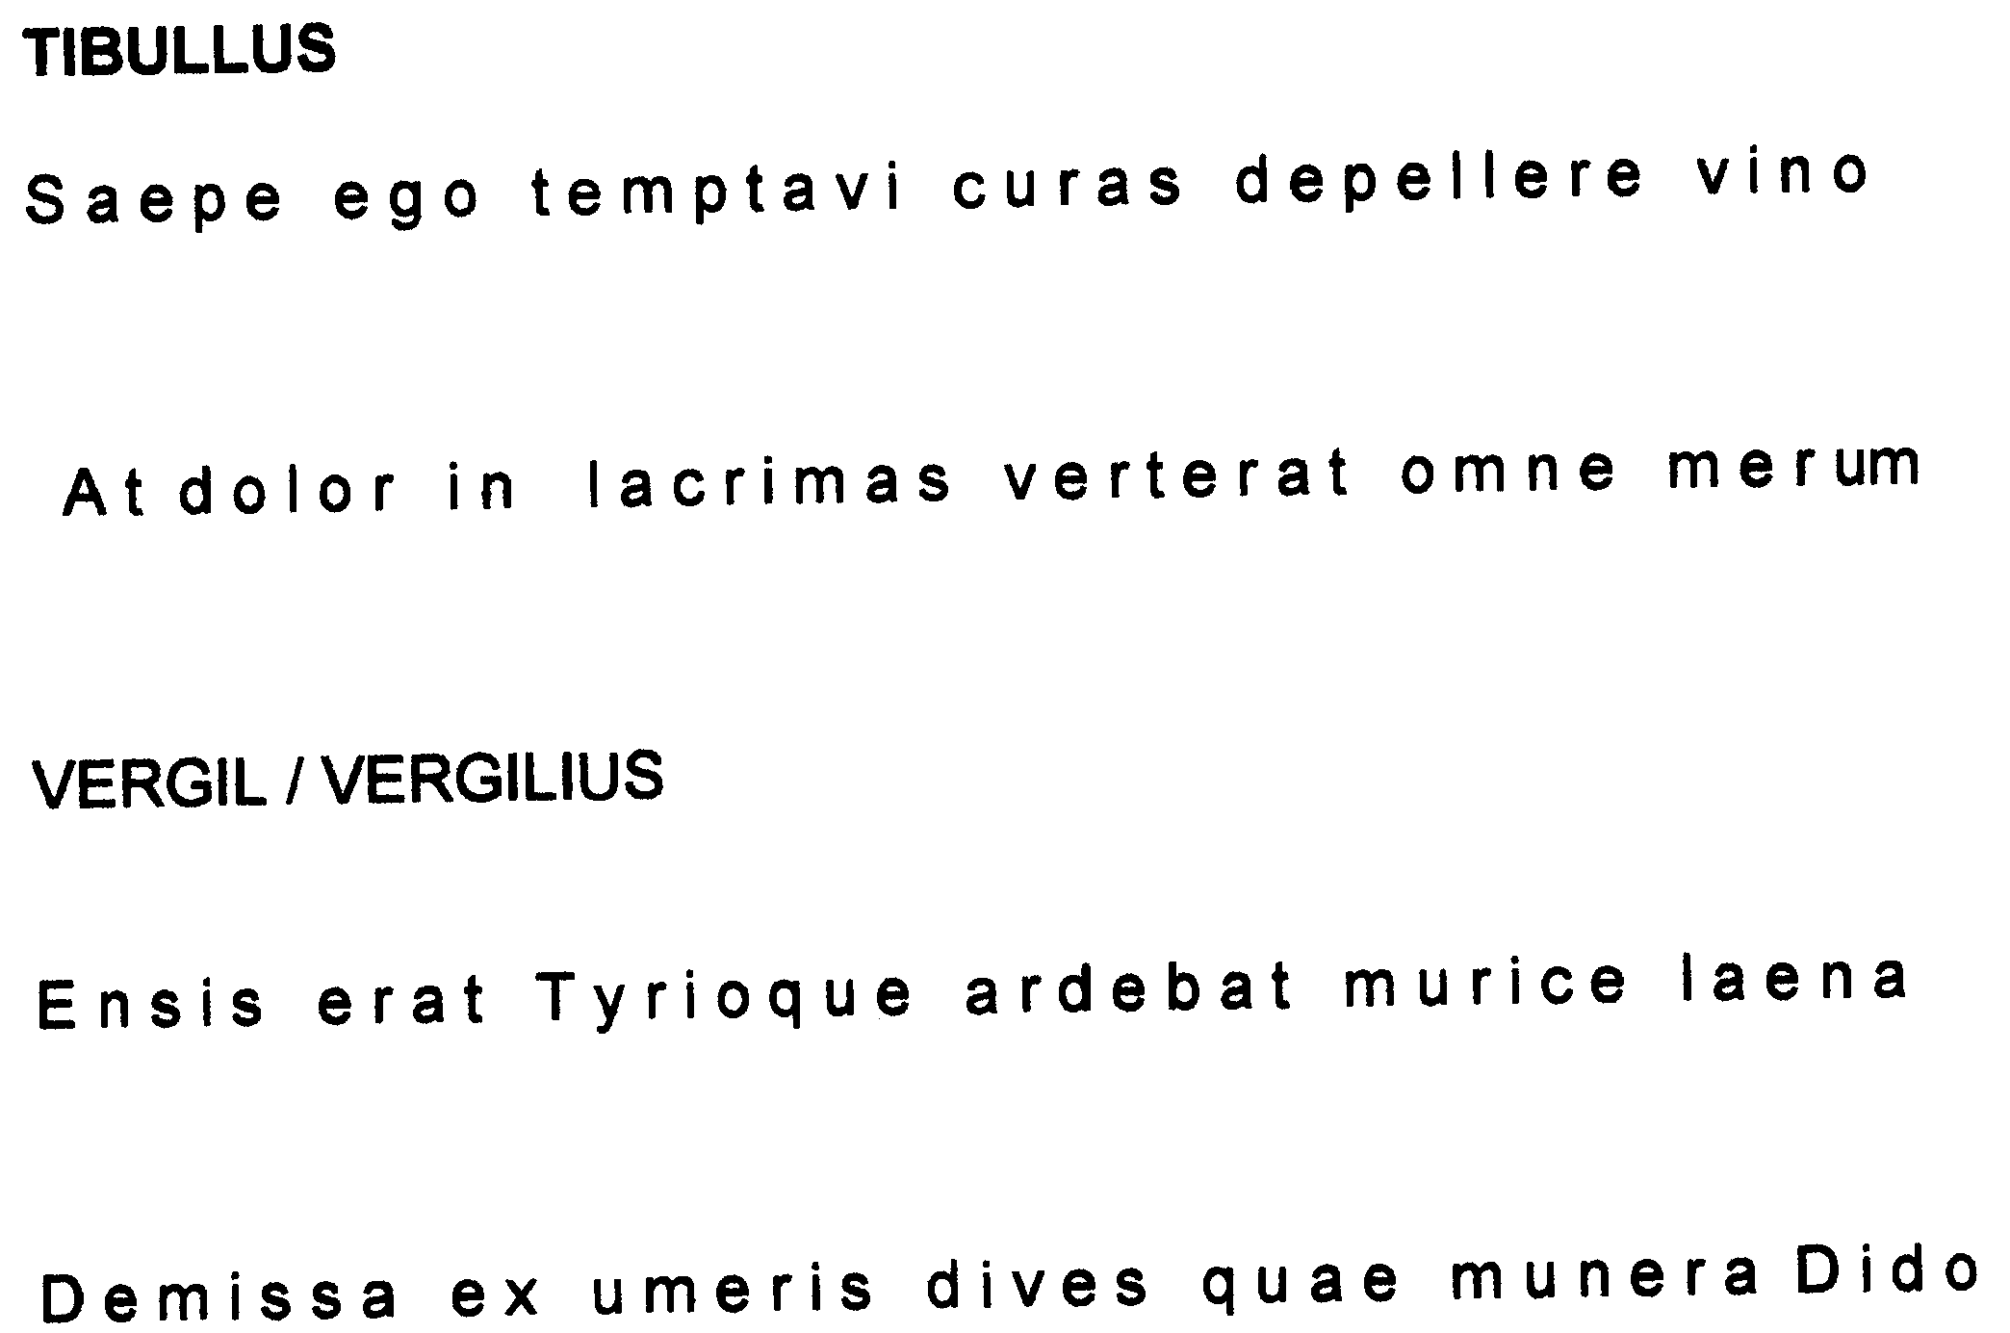
From:
/ Uit: TIBULLUS
From:
Uit: VERGILIUS
(4)

(4)

(4)

(4)
16÷2 = [8]

(2)
[10]

Explain why the metre of the pentameter (at dolor....) seems to run counter to the meaning of the verse.

_____________________________________________________________________________________________

