GAUTENG DEPARTMENT OF EDUCATION

SENIOR CERTIFICATE EXAMINATIONS

ISIZULU ULIMI LOKUQALA
IZINGA ELIPHEZULU
(Iphepha Lesithathu)

ISIKHATHI: 2½ amahora

AMAMAKI: 120

IMIYALO:

- Leli phepha lineziqephu ezintathu.
- Funda umyalo kulowo nalowo mbuzo bese uphendula njengoba uyaliwe.
- Hlela umsebenzi wakho njengoba kuhlelwe imibuzo.
- Phendula ngesiZulu esamukelekile.
- Kusiqephu C phendula umbuzo OWODWA vo.

ISIQEPHU A

UMBUZO 1

Khetha isihloko ESISODWA kwezingezansi ubhale kugcwale amakhasi AMABILI.

  - Buka umfanekiso ongezansi ubhale indaba ngawo.

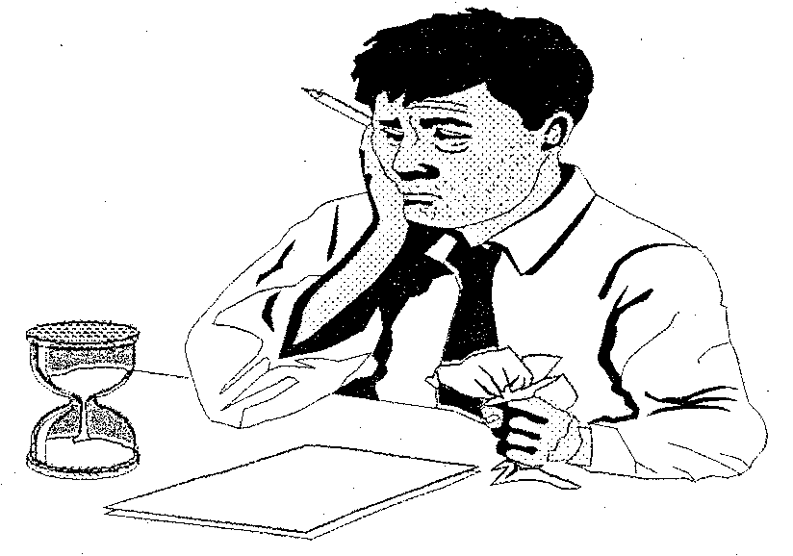

1.2 Xoxa indaba ubhekise kokufanayo nokwehlukile emasikweni omdabu ezinhlanga ezahlukene.

1.3 Inhlawulo kwabephula imithetho kagwayi.

1.4 Buka umfanekiso ongezansi ubhale indaba equbula imizwa ethile kuwena. Nika indaba yakho isihloko esiyifanele.

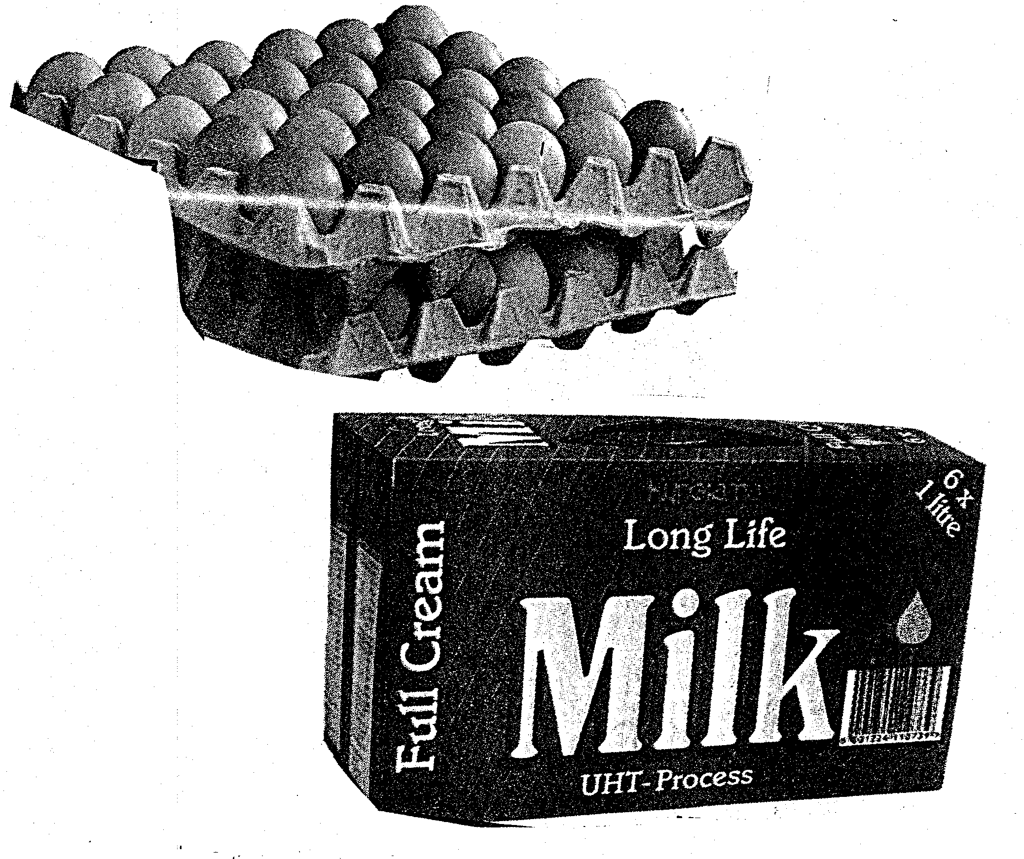

- Ikhadi engalithola ngosuku lwami lokuzalwa lalehlukile kwamanye kanti futhi laletha inguquko empilweni yami, nanamhlanje liseyingxenye yami.  AMAMAKI ESIQEPHU A: | 1x40=(40)  [40]

ISIQEPHU B

UMBUZO 2

Khetha incwadi EYODWA kwezilandelayo. Incwadi yakho igcwale ikhasi ELILODWA vo.

  - Wena unguMphathi wakwaSabelo’s Hair Cabin. Lapha kwaSabelo nidayisela abaninizitolo imithi yokucwala, yokunakelela nokuhlobisa izinwele. Ngeviki eledlule uthole le ncwadi evela kwelinye lamakhasimende enu. Yifunde le ncwadi bese uyiphendula.

11518 Mji Street
Orlando West Extension
1852
14 Novemba 2002

Mphathi
Sabelo’s Hair Cabin
91 Commissioner Street
Johannesburg
2000

Mhlonipheki

MAYELANA NE-ODA ELINGUNOMBOLO ZE1029PX

Lesi yisisekelo sodaba esaxoxisana ngalo nawe ngomhla ka-07 Novemba 2002. Lolu wudaba lwemithi yezinwele eyayikhangisa endalini. Yeqiwe yisikhathi sokusetshenziswa. Le mithi yileyo eyayingamabhokisi angamashumi amabili nanhlanu amakhilogremu ibhokisi ngalinye.

Ngiyabonga ukuthumela kwenu umhloli uMnu. B. Mdletshe oye wazibonela mathupha leli oda. Uye walithatha-ke waphindela nalo emuva njengobufakazi balokho engikushoyo. Wethembisa ukuthi izinyathelo zizothathwa lapho kutholakele le ncwadi yami eyethula udaba ngokugcwele. Ngingathokoza uma ngingaxazululelwa lolu daba ukuze ngikwazi ukuphindela nalo emuva njengobufakazi balokho engikushoyo.
Ngiyabonga.

Ozithobayo

U-T. M. Mashothi
(Ikhasimende)

2.2 Isithandwa sakho osha amashushu ngaso usibone siphuma emzini wenyanga ethile. Udidekile manje, awusazi ukuthi usithanda ngempela noma wenziwa yimithi. Sibhalele uveze uvo lwakho.
1x20=[20]

UMBUZO 3

Khetha OKUKODWA ubhale ugcwalise ikhasi ELILODWA vo.

3.1 Indabambiko

Umninimuzi mumbe udayisa indlu yakhe. Kule ndlu kunayo yonke into kagesi edingwa ngumuntu omusha nothanda ukuphila impilo engcono nephambili. Bhala indabambiko eya kubakhangisi bale ndlu edayiswayo abangoSma & Sma Household ubeke uvo lwakho ngalesi sikhangisi esingezansi

Umuzi use-11518 Mji Street e-Orlando West.
Kunamakamela amane okuyigumbi lokuphekela, lokuphumula namabili okulala. Kunamakamelo amabili angaphandle komuzi nendlu yokugezela negalaji lemoto. Kunogesi namakhaphethi phansi kuwo onke amakamelo.
Ifulelwe ngothayela.
Woza uzibonele. Imbila yeswela umsila ngokulayezela.
Bonana noSma & Sma.
Umakhalekhukhwni: 083 373 3210

  - Amaminithi omhlangano
Indawo ohlala kuyona iseyintsha. Kunezinkinga eziningi umphakathi obhekene nazo njengokuthi imigqomo yezibi ayenele, izincwadi zeposi azifakelwa ezindlini, futhi akukho zikole. Le ndawo iphinde ihlushwe wubugebengu.
Nina njengomphakathi nibe nomhlangano lapho benidingida khona zonke lezi zindaba. Senekele izixazululo eziphakanyiswe kulo mhlangano.
1x20=[20]

UMBUZO 4

Khetha OKUKODWA kokulandelayo ubhale ngakho.

4.1 Funda lesi siqephu esingezansi bese ubhala uhlelo lokuzazisa. Bhala ikhasi ELILODWA vo.

UThemba Mtshali ungumnsinsi wokuzimilela eNingizimu Afrika, ungowokuzalwa kwantuthu. Kumanje bakhe kwandonga ziyaduma eGoli kunombolo 1887 Ntuzuma Road Mapetla. UngumZulu phaqa. Wafunda izifundo zakhe kwaMakhutha Junior Primary School kusukela zamabanga / ebangeni 1-7. Amabanga 8-12 wawafunda eBuhlebuyeza School lapho aphasa izifundo zikamatikuletsheni ezilandelayo: isiZulu HG, isiNgisi HG, Mathematics SG, iBusiness Economics HG, Economics SG ne-Accounting HG. Uqale ukuzisebenza kulo nyaka. Unomakhalekhukhwini onombolo 083 382 0928 nemoto kanokusho. Unengane eyodwa zwi kodwa akashadile. Umazisi wakhe unale nombolo 7611140733 089. Kuyenzeka abambe amatoho kwaPick ’n Pay alungise ugesi ngoba unekhono lawo. Akehlukani nomculo nokudlala ikhompyutha.

4.2 Akha uhlaka lwesihlanzamagama (Fax) uthumele umlayezo ocacile wesifo. Lo mlayezo uzokwaziswa ephephandabeni iMercury. Amagama ozowasebenzisa kulo mlayezo angeqi kwangu-20.  1x10=  AMAMAKI ESIQEPHU B: | [10]  50

ISIQEPHU C  UBUCIKO BOMLOMO  Phendula umbuzo OWODWA.  UMBUZO 5  INKOSI YINKOSI NGABANTU – MSIMANG C.T.  - Xoxa ngezehlakalo ezingakholeki ezitholakala enganekwaneni enesihloko esithi, Inkosikazi esenyangeni ubhekise empilweni yanamuhla.  NOMA  5.2 Funda iziqeshana ezilandelayo bese uphendula imibuzo engezansi: | (30)

Isiqeshana A:

Sibiya ngenkomo,  Abafokazana bebiya ngamahlahla!  Nina bakwaNkom’isengelwa emaweni  Ingasengelw’esibayeni akuyona eyakhona  Gumede kaNdaba!  Mkhananda owafinyelela kubalondolozi,  Wemuka noGodokazi way’eMfolozi.  UHhiya kwabanani,  Okwaphekwa esendlini  Kwaze kwephulwa esendlini  Engazange afe kufudumala.  Mgxebe!  Khathi!  Nina bakaSotobe kaMpangalala! | 3  6  9  12

- Sinikeze izibonelo EZINTATHU zokuxhumana ezitholakala kulezi zithakazelo ezingenhla.  - Bawuhlobo olunjani abantu bakwaSibiya? Kungani usho kanjalo?  - Shono amaphuzu AMABILI ngokubaluleka kwezithakazelo.  - AbakwaSibiya abaganiselani nakwabani? Sekela impendulo yakho.  - Moya muni otholakala kulezi zithakazelo? Sekela impendulo yakho. | (6)  (3)  (2)  (2)  (2)  [15]

Isiqeshana B:

Uma esihlahleni kukhona amavukuthu ayishumi bese wena ujikijela elilodwa ngetshe ulishaye ulibulale, kuzosala amangaki?

- Nikeza impendulo yalesi siphicaphicwano.  - Hlobo luni lwesiphicaphicwano lolu? Sekela impendulo yakho.  - Nikeza izinhlobo EZINTATHU zeziphicaphicwano ozaziyo, sekela ngesibonelo ESISODWA esinempendulo, ohlotsheni ngalunye.  - Ingabe zibalulekile yini iziphicaphicwano? Bonisa amasu AMABILI ongawasebenzisa esikhathini samanje ukusekela impendulo yakho.  - Phawula ngesakhiwo sesiphicaphicwano, sekela ngesibonelo esifanele. | (2)  (2)  (5)  (3)  (3)  [15]  [30]

NOMA

IZINDABA EZIMFUSHANE NAMA-ESEYI

Phendula umbuzo OWODWA.  UMBUZO 6  UMLABALABA – NXUMALO O.E.H.M.  6.1 Ingabe uMdejane, uZanazo noMalusi bayizibonelo zothisha ezifanelekile esikhathini samanje? Phawula ngombuzo ongenhla, uqhathanise ngokushiwo kule ndaba emfushane nokwenzeka esikhathini samanje. | [30]

NOMA

6.2 Funda iziqeshana ezilandelayo bese uphendula imibuzo engezansi:

Isiqeshana A:

Ubungani siyabuthanda, futhi baningi kithi ababazisayo. Kodwa kababaningi abacabangayo ukuthi buke buphele. Bukhona futhi obugugayo. Engani bukhona ubungani obugcina abaninibo sebebizwa ngokuthi yinkukhu nempaka kwakukade kuthiwa ngamathe nolimi. Abaningi bayazibuza ukuthi engabe kusuke sekwenzenjani uma ubungani sebushintsha bubheka lapho baqhamuka ngakhona. Nokwenza bese kusala izibonkolo ezazingekho ngesikhathi bungakabibikho. Isizathu salokho imvamisa phela yikuthi kuthathe kungene abantu abazoxova lobu bungane. Babuxova ngoba banomona.

- Chaza amagama adwetshelwe ukuthi asho ukuthini.  - Ngobunjani ubungani okuthiwa buyaguga?  - Phawula ngobuntu bobungani besikhathi samanje.  - Ingabe bubalulekile yini ubungani? Sekela ngamaphuzu AMABILI.  - Ukwakhiwa kabusha kwentsha kungadinga ubungani buphi? | (4)  (3)  (3)  (3)  (2)  [15]

Isiqeshana B:

Kusuke esinamathambo isidumo. Bonke sebewotha ubomvu.
Sebefuna ukuzifikela mathupha kuXolani osehlahle amehlo.
Laba abaseduze kwakhe sebembambe ngesidlozana, basho ukumudla bamfele. “Kahleni bakwethu! Ningajahi ukumsebenza uXolani. Ngiyazi ukuthi kuyacasula khona ukuthi sithi sizitshela ukuthi sonke size ngobunye kanti kukhona oze ngobunyoka. Kodwa-ke kufuneka ubufakazi kuqala,” Kusho umphathisihlalo ezama kuphebeza abantu asebewotha ubomvu.

- Moya muni otholakala kulesi siqeshana? Sekela ngokwakwenzeka.  - Landa ngamafuphi ngokumsebenza ukuthi bakufeza kanjani.  - Phawula ngobunyoka esibuthola endabeni uphinde ubuqhathanise nesimo sanamuhla.  - Wayengafanele ukuphathwa kabi uXolani. Wawungenzani ukulungisa isimo uma wawunguSokhela?  AMAMAKI ESIQEPHU C:  AMAMAKI ESEWONKE: | (4)  (3)  (4)  (4)  [15]  [30]  30  120

