GAUTENG DEPARTMENT OF EDUCATION

SENIOR CERTIFICATE EXAMINATIONS

ISIZULU ULIMI LOKUQALA
IZINGA ELIPHEZULU
(Iphepha Lesithathu)

ISIKHATHI: 2½ amahora

AMAMAKI: 120

IMIYALO:

- Leli phepha lineziqephu ezintathu.
- Funda umyalo kulowo nalowo mbuzo bese uphendula njengoba uyaliwe.
- Hlela umsebenzi wakho njengoba kuhlelwe imibuzo.
- Phendula ngesiZulu esamukelekile.
- Kusiqephu C phendula umbuzo OWODWA vo.

ISIQEPHU A

UMBUZO 1

Khetha isihloko ESISODWA kwezingezansi ubhale kugcwale amakhasi AMABILI.

  - Senekele isixazululo salesi sitatimende:
Imisebenzi eminingi abantu abayenzisisi ngoba kunesikhalo sokuthi imali yomvuzo incane. Kuye kube sekudaleka amagebe nezikhala ezinkulu ngokungenzisisi.

1.2 Buka umfanekiso ongezansi ubhale indaba ngawo. Nika indaba yakho isihloko esiyifanele.

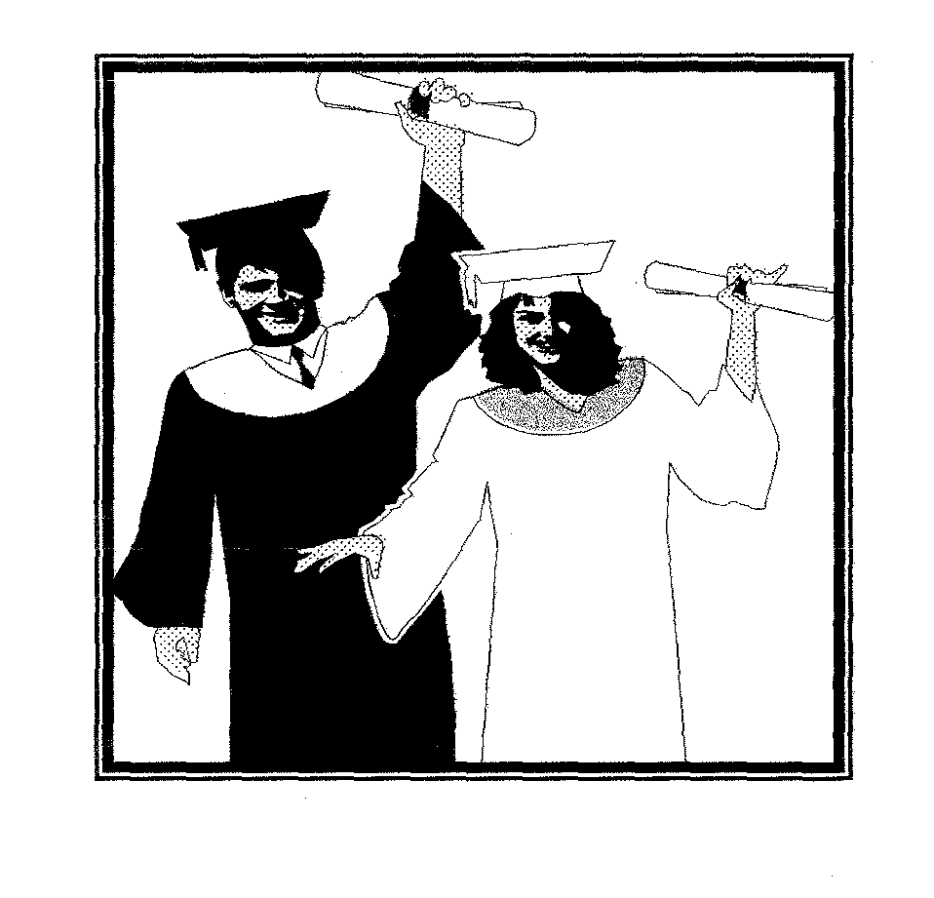

1.3 Ukucwasana ngokwebala, ngokobuzwe, ngokobulili, ngokwemfundo nangokwemisebenzi kudale amagebe kuzakhamuzi zaseNingizimu Afrika. Xoxa ngalawo magebe avelile nokuthi angavalwa kanjani.

1.4 Buka umfanekiso ongezansi ubhale indaba equbula imizwa ethile kuwena. Nika indaba yakho isihloko esiyifanele.

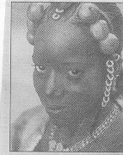

1.5 UHulumeni makabukeze isigwebo sentambo. Bhala uveze umbono wakho ngalolu daba. | 1x40=[40]

ISIQEPHU B

UMBUZO 2

Khetha incwadi EYODWA kwezilandelayo. Incwadi yakho igcwale ikhasi ELILODWA vo.

  - Wena ubuke wafaka isicelo somsebenzi enkampanini eyaziwa ngokuthi
yiDineo CC. Wabizwa wahlolwa bukhoma wase ubhalelwa waziswa ukuthi uqokwe njengayena muntu ofunekayo esikhaleni leso ebesikhangisiwe. Ngosuku othole ngalo lo mbiko, uye wathola incwadi evela enkampanini yakwaSOK bekwazisa ukuthi bakunikeza isikhundla esinomsebenzi ongcono nesizokukhokhela kangcono. Uye wawuthatha lo msebenzi. Ake ubabhalele laba abakwaDineo CC incwadi ngomoya opholile ubachazele ukuthi awusezukusithatha isikhundla leso somsebenzi abebekunike sona.

2.2 Bhalela umngani wakho incwadi umqwashise ukuthi umuntu onezimpawu zengculazi umbona kanjani.
1x20=[20]

UMBUZO 3

Khetha umbuzo OWODWA kwelandelayo. Bhala ugcwalise ikhasi ELILODWA.

3.1 Wena unguMphathi enkampanini yeMTN. Ngenyanga edlule uthole incwadi evela komunye wamakhasimende enu engawuvali umlomo encoma ukuziphatha kwesisebenzi esisebenza ngaphansi kwakho. Nasocingweni usuke wathintwa ngabantu abambalwa nabo bencoma wona umsebenzi walesi sisebenzi. Ake ubhale imemorandamu uyibhekise kuMqondisi wenkampani wethule lolu daba wenze neziphakamiso ezithile mayelana nalsi sisebenzi esizinikele kangaka emsebenzini waso.

  - Omunye wabafundi eninabo esikoleni senu obefunda ibanga-12 udutshulwe washona ngokukhulu ukuzuma. Lo mfundi yilokhu waqala isikole ufunda naye: nakuba engeyena umngane wakho kodwa wazi konke ngaye nakuzuzile. Ushone eneminyaka eyishumi nesishiyagalolonye. Senekele-ke umlando kamufi.

1x20=[20]

UMBUZO 4

Khetha umbuzo OWODWA kwelandelayo:

  - Ijezi lakho osulisebenzise izinyanga eziyisithupha awusalithandi kodwa futhi ufuna ukuzuza utho ngalo. Lifake endalini ekhangisayo uveze incazelo egcwele ngalo. Isikhangisi osakhayo asibe yimigqa engu-15 noma ngaphezulu kwalokho.

4.2 Akha uhlelo lokuzazisa oluzogcwala ikhasi ELILODWA vo uzethule kubaxhasi boMnyango weMfundo yaseGauteng. Umfundi ozimisele emfundweni yakhe uzonikezwa umfundaze.
1x10=[10]

ISIQEPHU C
IZINDABA EZIMFUSHANE NAMA-ESEYI

Phendula umbuzo OWODWA kulesi siqephu

UMLABALABA – O.E.H.M. Nxumalo

UMBUZO 5  - Hluza le ndatshana ethi Unembeza ngaphansi kwalezi zihlokwana:  - Isihloko  - Isingeniso  - Abalingiswa  - Isigameko  - Isiphetho | (3)  (5)  (5)  (10)  (7)  [30]

NOMA

5.2 Funda lezi zigatshana ezilandelayo bese uphendula imibuzo ezolandela:

Isiqeshana: A

Kukhona ubungani babantu ababili. Kukhona ubungani babantu abayidlanzana. Kukhona ngisho nezinhlangano ezibizwa ngokuthi ngezabangani. Mina ngiyathanda ukuba sibuvume futhi ubungani bomuntu oyedwa naye uqobo. Uma umuntu engumngani wakhe uyazithanda, akakwenzi okujivaza ubuyena, akabi yinhlabathi, wenza konke okuthuthukisa obudlelwane obuhle naye wonke. Izidingo zomzimba uzifeza ngemfanelo. Izidingo zomphefumulo uzifeza njengoba kulindelekile. Izidingo zengqondo nazo azifunzisele ngesiko elifanele. Ubudlelwane bobungani lobu bungikhumbuza ubudlelwane obukhulukazi. Lobo yibudlelwano boMdali oziQu ziNtathu. Yizona ezingumsuka wobudlelwane bobungani ngokubona kwami. Isimo esithi uNkulunkulu uBaba, uNkulunkulu
iNdodana noNkulunkulu uMoya Oyingcwele, yibudlelwano bobungani obunzulu nobuyisiqalelo sayo yonke imvelo ehlobene.

Ziningi izizathu ezithandanisa abantu. Abanye abantu bathandana nje ngesizathu bavele bezwa imimoya yabo ixhumana. Kakukho okunye okuyisizathu abangasibeka esingaphezu kwalokho. Laba bantu ungababona behamba bobabili njalo, bexoxa kahle, bekhiphelana izifuba, beduduzana, okuhle bekwetshisa ndawonye. Izibukeli noma abaqhelelene nabo bavamise ukuthikamezeka kancane ngalobu bungani. Noma mhlawumbe kusuke kwenza ukuthi bazibona bengaphandle kwesibaya, benesizungu, noma bazibona bengakwazi bona ukwenza lokhu okwenziwa ngabangani, kasazi. Iqiniso yikuthi kuba khona ababufenyisayo lobu bungani. Basho khona ukuthi mhla baxabana kuyokuba sengathi kabakaze bakhonzane kangaka.

- Nikeza isihloko sale eseyi.  - Nikeza OKUNE okwenziwa ngumuntu ongumngani wakho uqobo.  - Yiziphi ezinye izinhlobo zobungani?  - Shono izizathu EZIMBILI ezithandanisa abantu.  - Shono OKUHLANU okwenziwa ngabantu abathandanayo. | (2)  (4)  (2)  (2)  (5)  [15]

Isiqeshana: B

Into enhle ivela obala ubuhle bayo ngokuba iqhathaniswe nenye. Ehhe, uzibeke phambi kwakho izinto ezinhle, izinto zokubukwa nje. Usungamema-ke ilima lalabo abazopha iso, futhi bengathengi mehlo, behlulele ukuthi ngubani omuhle. Iphutha leli ukusukela umntanomuntu ezihambela yedwa vo emgwaqweni bese uthi muhle, wedlula bonke abantu, kusho ukuba nguhubhu kabhejane wokuqala nowokugcina. Uma kungenjalo, nsinzwandini uyidliwa lokugcina. Ulimi lolu lunomnqantula, awazi ukuthi indima uzoyala kanjani. Ingakho-ke nje ugxumela egameni elithi “umuhle”. Ngokusho kanjena, insizwa lena isuke icabanga ukuthi izozwelwa, isheshe ithole umusa. Phinde! Ungafa, hhayi kanjalo.

Kubi ukuba muhle. Impela kubi, kakhulukazi uma ungumuntu wesifazane. Kusuke kukwejwayeze nabo bonke omadakeyana abazishaya izinkinselana laba. Nokunguvukuvale kuthola ithuba lokukhipha amangwevu akho okuba ngovukuvale. Bakhuzele entombini baze balale ngomhlane, besho nokusho ukuthi sebelala ngesaka. Kuxake nje intombi izomenzani – ke umuntu oselala ngesaka? Uthi zona izinkomo unazo?

- Sithini isihloko sale eseyi?  - Ivela kanjani into enhle?  - Yini ilima?  - Ukwenzani ukupha iso? | (2)  (2)  (2)  (1)

- Umlobi uthi kubi ukuba muhle. Yingani esho njalo?  - Chaza lokhu kulandelayo:  - uhubhu kabhejane  - uvukuvale  - idliwa | (2)  (2)  (2)  (2)  [15]  [30]

UMBUZO 6  UBUCIKO BOMLOMO  Phendula umbuzo OWODWA.  INKOSI YINKOSI NGABANTU – C.T. MSIMANG  - Hluza le nganekwane ethi Uheshane nezinkukhu ngaphansi kwalezi zihlokwana:  - Isakhiwo  - Abalingiswa  - Indikimba  - Isizinda | (10)  (10)  (5)  (5)  [30]

NOMA  - Phendula imibuzo elandelayo:  - Buyini ubuciko bomlomo?  - Bubaluleke ngani ubuciko bomlomo? Nikeza OKUBILI.  - Shono ukuthi nhloboni yobuciko bomlomo obuchazwe ngezansi:  - Inkondlo emfushanyana yokuthunduzela umntwana.  - Inkondlo yokutusa ende noma emfishanyana.  - Isosha sokuzithokozisa nokuqeda isizungu. Sishiwo ngabantwana uma bedlala.  - Igama likakhokho othile ohlotsheni lolo.  - Shono umehluko okhona phakathi kwesisho nesaga. Nikeza OKUBILI.  - Siyini isiphicaphicwano?  - Zibaluleke ngani iziphicaphicwano? Nikeza OKUNE.  - Nikeza izinhlobo EZIMBILI zeziphicaphicwano.  - Yini umsebenzi wezaga? Nikeza emine  AMAMAKI ESIQEPHU C:  AMAMAKI ESEWONKE: | (2)  (4)  (1)  (1)  (1)  (1)  (4)  (4)  (4)  (4)  (4)  [30]  30  120

