UMNYANGO WEZEMFUNDO WASEGAUTENG

UKUHLOLWA KUKAMATIKULETSHENI

ISIZULU ULIMI LOKUQALA IZINGA ELIPHEZULU
(Iphepha Lokuqala)

ISIKHATHI: amahora angu–3

AMAMAKI: 160
IMIYALO:

- Landela umyalo okulowo nalowo mbuzo
- Izimpendulo zinombolwe njengasemibuzweni
- Ingxenye yombuzo ingehlukani neminye
- Phendula yonke imibuzo ngesiZulu esihle.
- Fundisisa umbuzo ngaphambi kokuphendula.

ISIQEPHU A
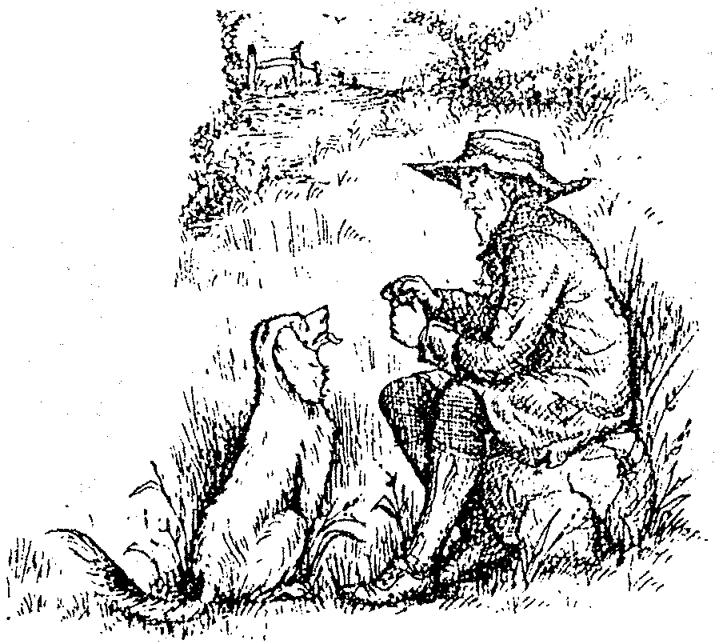

UMBUZO 1
IZINDATSHANA EZIDLULISA UMLAYEZO

Khetha iziqephu EZIMBILI ubhale ngazo. Gcwalisa ikhasi ELILODWA vo ngalokho nalokho okukhethile.

  - Indabambiko (imemorandamu)
Bhala indabambiko ngokuvezwa yilo mfanekiso.

  - Amaminithi

Izingane zesikole ezingamashumi ayisithupha bezithenge izoso komama abadayisa emgwaqweni, ezingamashumi amane ziphuthunyiswe esibhedlela zijuqwa izisu. Odokotela bathe zidle ukudla okunoshevu.
Abameli babafundi babe nomhlangano nomama odayisa izoso kucutshungulwa loludaba. Sibhalele amaminithi alo mhlangano kuvele iziphakamiso ezithathiwe.

- Umbiko  Isalukazi sakwaMdlolo sesiphelelwe imali singcwaba abantwana baso nabazukulu ababhuqwa yingculazi. Kusuka ngoJanuwari kuze kube manje isalukazi sesingcwabe abantwana abayisikhombisa. Bhalela abafundi bephephandaba i-Afrika uveze ucwaningo olwenzile kulo mndeni. | 2x20=[40]

ISIQEPHU B

UMBUZO 2

Funda lesi siqeshana bese uphendula imibuzo elandelayo:

Izinyanga abantu abathanda ukusebenzisa umzala, uyaye ubone bewugcoba noma bewuphuza. Intombazane yokugcina kwethu yakhuluma zagcwala izindlebe ingitshela ngemisebenzi yezinyanga. Kulula ukwenza isilo sengubo komunye. Mina-ke bandla ngadela kweyokosa. Isisusa yimali. Hawu ngiyababaza!

Sebenzisa igama inyanga emshweni uveze omunye umqondo owehlukile kulona ovezwe esiqeshini.  - Ibizo abantu ibizoqoqa imaphi amabizo AMABILI aqoqelwe kuleli gama?  - Sebenzisa igama umzala emshweni kuvele izincazelo EZIMBILI ezivezwa ukwehluka kwephimbo.  - Nika igama ELILODWA esikhundleni saleli binzana: intombazane yokugcina kwethu.  - Chaza umehluko ovezwa yileli gama elidwetshelwe ngezansi:  - intombazane yokugcina kwethu.  - intombazane yokugcina kithi.  - Sebenzisa elinye igama emishweni EMIBILI eliyibizoqoqa elisho ukukhuluma.  - Chaza lezi zisho ezilandelayo  - Zagcwala izindlebe  - Ngadela kweyokosa  - Nika igama elihlonipha imali.  - Isibabazo uHawu! sisebenza kusiphi isimo?  - Sebenzisa igama thanda kuvele imiqondo EMIBILI eyahlukene | (2)  (4)  (4)  (2)  (2)  (2)  (4)  (2)  (2)  (2)  (2)  (4)

Nika umehluko phakathi kwenyanga nesangoma.  - Iselulo esilandela isabizwana umina-ke sisetshenziselweni?  - Nika le ndaba isihloko wesekele. | (4)  (2)  (2)  [40]

ISIQEPHU C

UMBUZO 3

Fingqa lesi siqephu ngamagama akho angu-10

Abantu babezethembisa noko ukuthi okungapheli kuyahlola, besho ukuthi ubusika buzokwedlula kwethwase ihlobo, konke kuqhakaze kube kuhle. Kwasheshe kwaba sobala nokho ukuthi bazethembise bengakazithathi izinduku baye ohlanyeni bayovumisa. Izulu lalilokhu lizibhenguzela izintuli zalo nje zikaMaquba, lingazi nakwazi. Ngisho sekwethwese inyanga kaNcwaba phinde ukuba izwe libe ncwaba. Kwaphinde kwathwasa eka-Mandulo, phinde ukuba abantu bayokwandulelisa ezifeni.
[20]

ISIQEPHU D

UMBUZO 4

Funda lesi siqephu bese uphendula imibuzo esuselwe kuso lesi siqephu.

Bangene abantu esontweni, izinsizwa sezigqokile. Umkhwenyana lo umpeleselwe nangabelungu. Umuntu uyofa edelile, eze umkhwenyana kuyise axhawule, alethe umlonyana kumama wakhe, uMakoti angazi ukuthi enzenjani. Amange yena uyise nonina. Isho phansi kancane i-ogani kusukume wonke umuntu, ishaya lona impela elenza umakoti angene esekhephuka njengeqhwa.

4.1 Guqula umusho Bangene abantu esontweni izinsizwa sezigqokile ube senkathini eyadlula  4.2 Guqula izenzo namabizo kumusho 4.1 ngenhla akhombise ubunye,  4.3 Esenzweni umpeleselwe ngubani umenziwa?  4.4 Umenziwa wenzelwa obani?  4.5 Izakhi ezisitshela ngokwenziwa /-w- / nokwenzelwa / -el-/ zibizwa ngokuthini ngokohlelo lolimi?  4.6 Sebenzisa isiqu sesenzo sho sibe sempambosini yokwenzela. | (2)  (4)  (2)  (2)  (2)  (2)
4.7 Ukulumbana konkamisa uya+ufa kudaleke ngaphansi kwasiphi isimo?  4.8 Ukulwangisa egameni umlonyana kudaleke ngaphansi kwasiphi isimo?  4.9 Igama umpeleselwe lithathelwe kusiphi isenzo? | (2)  (2)  (2)

Khetha igama okuyilona kulana asezikakelweni  Impendulo yakho yibhekise esiqeshini.  4.10.1 Isijobelelo sobuncane esisegameni umlonyana sikhombisa umqondo (wokweyisa / wothando).  4.10.2 Isijobelo esikuleli gama kunkosikazi sisinika umqondo (wobulili besifazane / wobukhulu).  4.10.3 u-njengeqhwa usivezela umqondo (wokufanisa / wokungathekisa)  4.10.4 Isakhi esiphongozwe egameni nangabelungu sisinika muphi umqondo? (isihlanganiso, isiqalo) | (2)  (2)  (2)  (2)

4.11 La magama umuntu, umulomo aneziqalo ezifanayo kepha izigaba zawo zehlukene: nika isizathu salokho.  4.12 nika iziqalo EZIMBILI ezahlukene ukunika omunye umqondo emsukeni webizo umuntu ngaphandle kwalesi esisetshenzisiwe.  4.13 Ebizweni umuntu singakha ubuncane – umntwana noma umntwanyana mahluko muni ovezwa yilezi zijobelelo ngobuncane? | (2)  (4)  (4)

Chaza okwenzeka kule ndaba, sekela impendulo yakho ngokucaphuna odabeni.  - Tomula umusho esiqeshini lapho isabizwana soqobo sisetshenziswe nesivumelwano sikamenziwa, sakhomba ukugcizelela.  - Tomula umusho lapho isabizwana sisebenze sagcizelela ibizo. | (4)  (2)  (2)

Sebenzisa umsuka – shay-emshweni uveze:  - lsenzukuthi  - lbizo  - lsenzo  - lsingazenso esisendleleni encikile  4.18 Isabizwana soqobo uma siqhathanisa siba kuphi nendawo yebizo? siyandulela noma siyalandela? Nika esakho isibonelo. | (2)  (2)  (2)  (2)  (2)

Lesi sakhi esidwetshelwe sezigqokile sisinika muphi umqondo?  4.20 Sebenzisa umsuka walesi senzo sezigqokile emshweni ugcine ngonkamisa ofingqiwe wenkathi esanda kudlula.  AMAMAKI ESEWONKE: | (2)  (2)  [60]  160

