GAUTENG DEPARTMENT OF EDUCATION
SENIOR CERTIFICATE EXAMINATION

ISIZULU ULIMI LWESIBILI
IZINGA ELIPHANSI
(Iphepha Lesithathu)

ISIKHATHI: Amahora Amabili

AMAMAKI: 80

IMIYALO:

- Funda kahle yonke imibuzo.
- Bhala izinombolo zemibuzo njengoba zinjalo ephepheni.
- Bhala ngesandla esifundekayo ukuze ungalahlekelwa ngamamaki, umsebenzi onobunono nokuhlanzeka uyoklonyeliswa.
- Bhala isiZulu esemukelekile.

ISIQEPHU A

UMBUZO 1

Khetha isihloko ESISODWA kwezilandelayo ubhale ngaso indaba. Indaba yakho kumele ibe ngamagama angu 250-300.

  - Ngabe lezi zigidigidi zamarandi asetshenziselwa ukuthenga izikhali zokulwa yicebo elifanele? Bhala imibono yakho ngalokhu.

1.2 Kuthiwa abesifazane bayazibizela ukuba bahlukunyezwe noma badlwengulwe emsebenzini nakwezinye izindawo. Uyavumelana noma uyasiphikisa lesi sitatimende?

1.3 Abantu abaningi isiko lokulobola balibuka ngezindlela ezahlukene. Abanye bathi alinakho elikushoyo kangako ebantwini ngaphandle kokuletha indlala nosizi kulabo asebeshadile. Kukhona abalibona lilihle ngoba lakha ukuzwana nokubumbana okuqinile emindenini eganiselanayo. Wena ulibona kanjani leli siko.

1.4 Bhala indaba egcina ngokuthi … mhlaba kawunoni.

1.5 Bheka lezi zithombe ukhethe ESISODWA bese ubhala indaba ngaso. Ungakhohlwa ukubhala inombolo yesithombe osikhethile kanye nokunika indaba yakho isihloko esifanele.

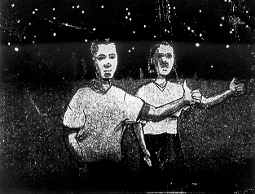
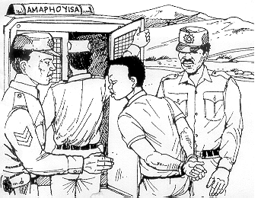

1.5.1
1.5.2

1 x 40 =  AMAMAKI ESIQEPHU A: | [40]  40

ISIQEPHU B

UMBUZO 2

Bhala amagama angu 120 – 150 NGOKUKODWA kwalokhu okulandelayo.

  - Bhala incwadi ubongele umngane wakho ngebhizinisi aseziqalele lona.

2.2 Qedela le ncwadi elandelayo ngokwenza njengoba utsheliwe.

Isibingelelo Ikheli

Ekugcineni sesize sangena endlini yethu entsha, njengoba ubona ngekheli lami elisha.
(Ibinza lesibili: Chaza indlu, ingadi yomuzi kanye nobuhle obutholakala eduze kwaleyo ndawo).
(Ibinza lesithathu: Tshela umngane wakho okuthile mayelana nomakhelwane bakho abasha).
(Ibinza lesine: Tshela umngane wakho ngendawo, ibanga phakathi komuzi nesikole, nezitolo, nenkundla yebhola, nendawo yokubuka ibhayisikobho, njll).
(Ibinza lesihlanu: Mema umngane wakho ukuba akuvakashele ngale mpelasonto ende ezayo).
Sesilulinde ngamnyama usuku oyosivakashela ngalo. Sicela ukuba usize ungasidumazi.
Usize udlulise umkhonzo kubazali bakho, koSibongile nakoNtando.

Isiphetho

2.3 Bhala umbiko ngocwaningo olwenziwe yinhlangano yezomkhathi oyisisebenzi sayo.  2.4 Bhala inkulumo ozoyibeka emcimbini wokuhalalisela umfundi othole umfundaze wokuyofunda phesheya. 1 x 20 = | [20]

AMAMAKI ESIQEPHU B: | 20

ISIQEPHU C

UMBUZO 3

  - Bhala isimemo somhlangano wentsha endaweni ohlala kuyo bese ubhala
i-agenda yalowo mhlangano.

  - Ufuna ukujabulisa abangane bakho ngokuba ubaphekele isitshulu esehla esiphundu.

3.2.1 Bhala izithako ozozithenga ekuphekeni lesi sitshulu.
3.2.2 Bhala indlela yokusipheka lesi sitshulu.

3.3 3.3.1 Ufuna ukuthengisa imoto yakho. Manje bhala isikhangiso esizophuma ephepheni elifundwa endaweni yakini.

NOMA

3.3.2 Funda lesi sikhangiso esingezansi bese uzibhalela esakho sento othanda ukuyithengisa.
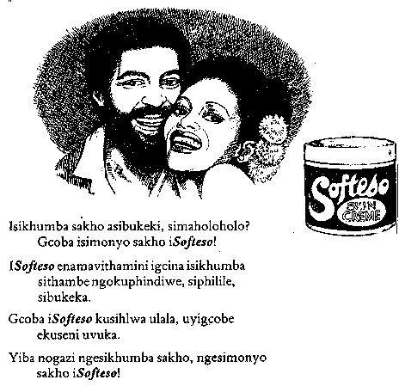

1 x 20 =  AMAMAKI ESIQEPHU C:  AMAMAKI ESEWONKE: | [20]  20  80

