GAUTENG DEPARTMENT OF EDUCATION
SENIOR CERTIFICATE EXAMINATION

ISIZULU ULIMI LWESIBILI
IZINGA ELIPHANSI
(Iphepha Lesithathu)

ISIKHATHI: Amahora Amabili

AMAMAKI: 80

IMIYALO:

- Funda kahle yonke imibuzo.
- Bhala izinombolo zemibuzo njengoba zinjalo ephepheni.
- Bhala ngesandla esifundekayo ukuze ungalahlekelwa ngamamaki, umsebenzi onobunono nokuhlanzeka uyoklonyeliswa.
- Bhala isiZulu esemukelekile.

ISIQEPHU A

UMBUZO 1

Khetha isihloko ISISODWA kwezilandelayo ubhale indaba ngaso. Indaba yakho ibe ngamagama angu 250 – 300.

  - Khetha isithombe ESISODWA kulezi ezilandelayo bese ubhala indaba ngaso. Bhala inombolo yesithombe bese unikeza indaba yakho isihloko esiyifanele.
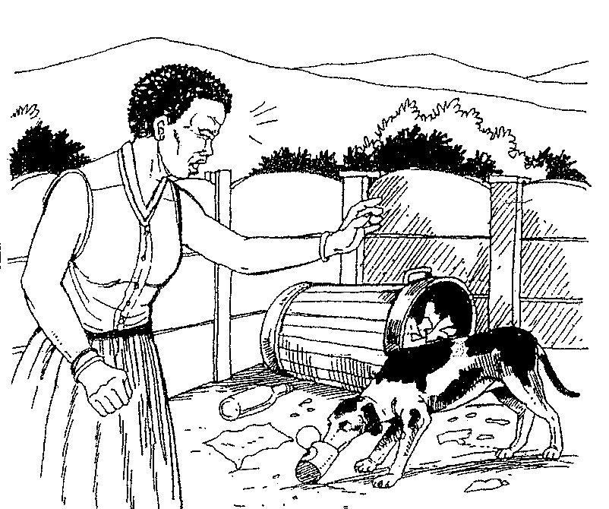
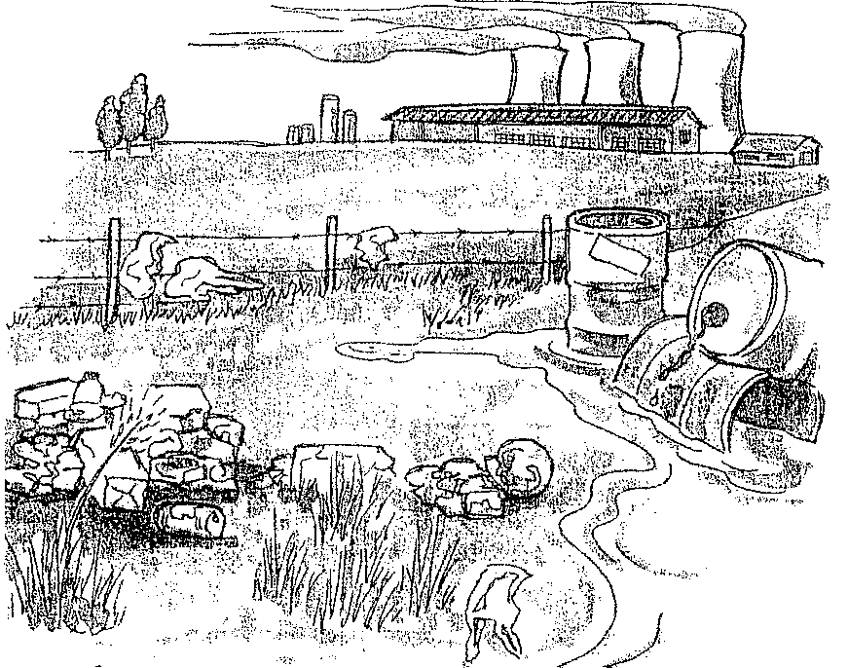

1.1.1
1.1.2

1.2 Isifiso sami esikhulu ukwakhela izingane eziyizintandane ikhaya ngenxa yokuthi abazali babulawa ingculazi.

1.3 Abantu abaningi abangochwepheshe bayathutha baya emazweni aphesheya. Ngabe yini izizathu zalokho?

- Ukusetshenziswa kwezidakamizwa sekuyinkinga enkulu ezikoleni. Izikole ezizimele sezikubona kufanele ukuba abafundi bahlolwe uma besola ukuthi abafundi abathile basebenzisa izidakamizwa. Wena ukubona lokhu kuphambana namalungelo omfundi? Bhala imibono yakho mayelana nalokhu.  1.5 Izinkinga abantu abasha ababhekene nazo namuhla. 1 x 40 = | [40]

AMAMAKI ESIQEPHU A: | [40]

ISIQEPHU B

UMBUZO 2

Bhala amagama angu 120 – 150 NGOKUKODWA kwalokhu okulandelayo

2.1 Khetha isithombe ESISODWA kulezi ezimbili ezilandelayo bese ubhala ingxoxo ngaso.
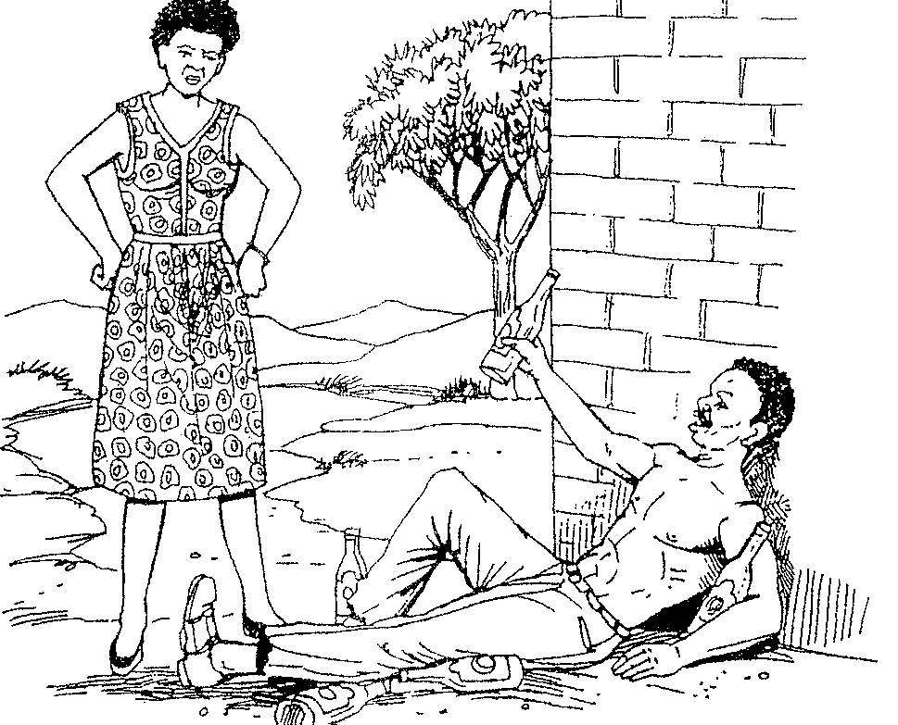
2.1.1

2.1.2
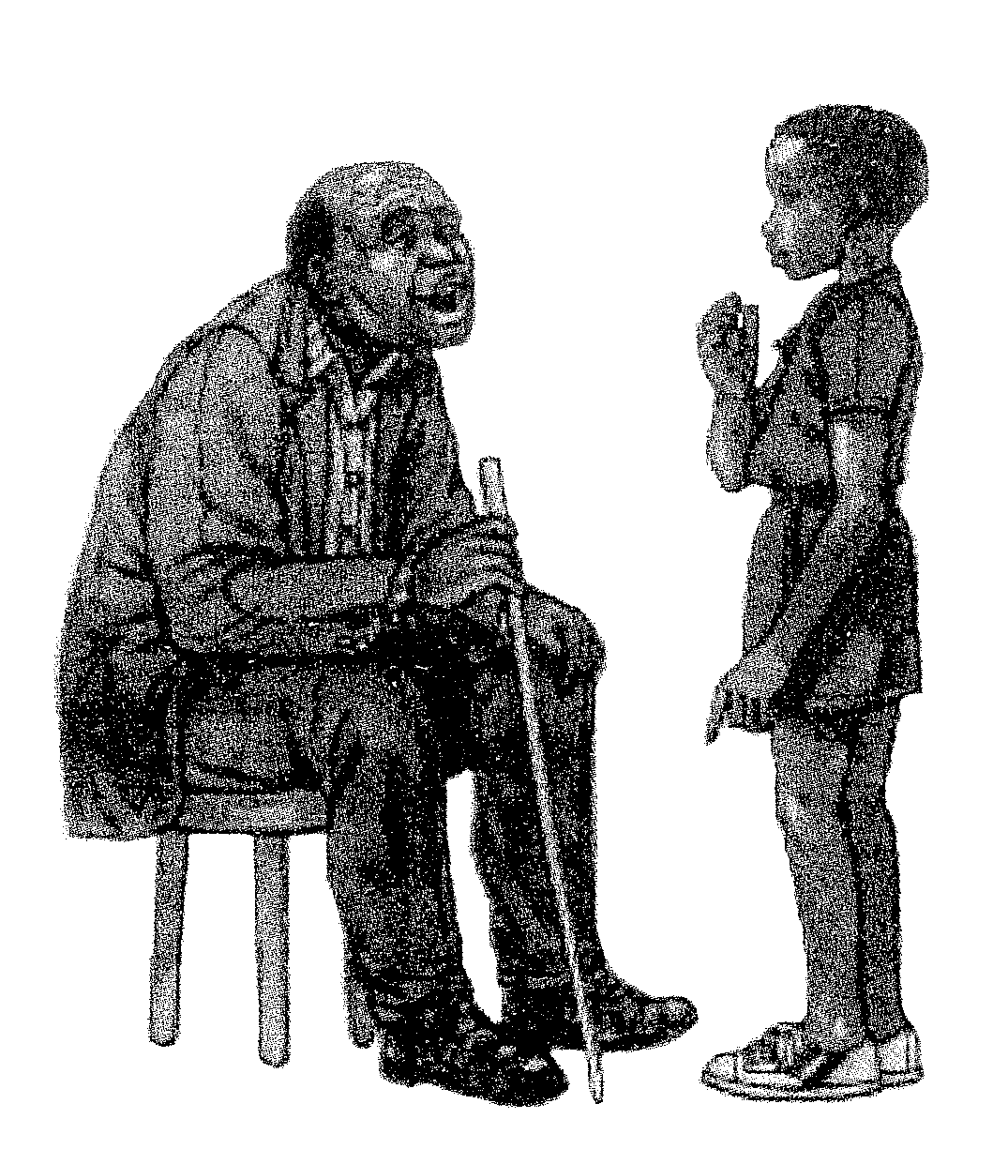

2.2 Funda le ncwadi bese uphendula lo muntu oyibhalile.

Insuze Store
P O Box 443
Nkandla
3855

2 Febhruwari 1998

Malindi

Njengoba wazi ukuthi abazali bami basathe shelele ngaseGoli izinyanga ezintathu, yimina engibheke umuzi kanye nabafowethu ababili abancane. Sengibe nenhlanhla ukuthi ubabekazi, uThoko, uthe uzofika ekhaya akangiphumuze isonto elilodwa. Uphinde wathi uzonginika nemali yokugibela engango R20 ngiye lapho ngithanda ukuvakashela khona.

Ngikhethe ukuba lelo sonto lonke ngilichithe nawe kini. Phela khumbula ukuthi sasethembisene ukuvakashelana kulo nyaka emva kokuhlukana kwethu esikoleni ngonyaka odlule. Ngizofika kuwe mhla ka 15 Mashi ekuseni. Ubongihlangabeza esitobhini sebhasi.

Ngicela ungazise ukuthi isicelo sami siyamukeleka yini. Khonza kuSifiso noZethu.

Yimina umngane wakho
UTobhi

- Bhala umbiko ephephandabeni lakini ngengozi yebhasi eyenzeke izolo.  1 x 20 = | 20

AMAMAKI ESIQEPHU B: | [20]

ISIQEPHU C

UMBUZO 3

Bhala NGOKUKODWA kwalokhu okulandelayo

  - Wena ufuna umuntu ozokusebenzela endlini yakho futhi abheke ingane yakho encane. Bhala isaziso ephepheni uchaze ukuthi ufuna umuntu onjani.

  - Bhala amaminithi engqungquthela yentsha okade uyihambele ngamaholide.

  - Sebenzisa lezi zithombe ukubhala isikhangiso esihlaba umxhwele.
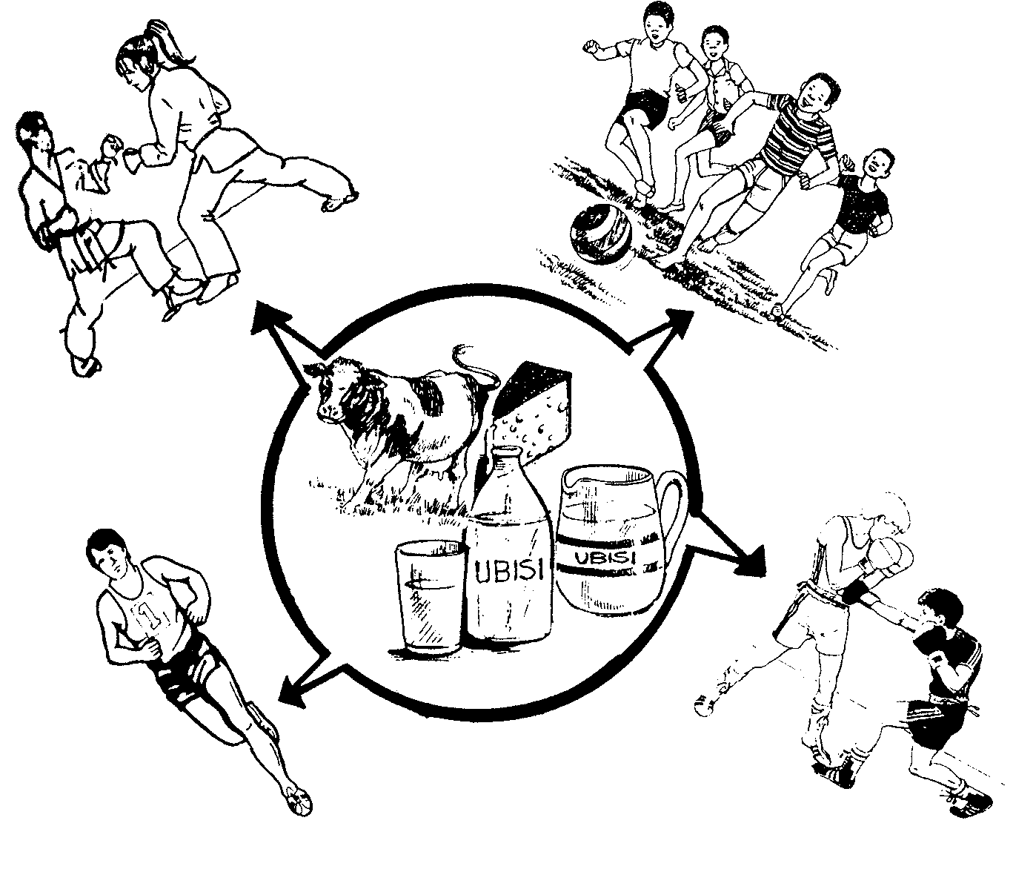

1 x 20 =  AMAMAKI ESIQEPHU C:  AMAMAKI ESEWONKE: | [20]  ]20]  80

