GAUTENG DEPARTMENT OF EDUCATION
SENIORS CERTIFICATE EXAMINATION

ISIZULU ULIMI LWESIBILI
IZINGA ELIPHANSI
(Iphepha Lokuqala)

ISIKHATHI: amahora amabili

AMAMAKI: 80

IMIYALO:

- Leli phepha lineziqephu ezintathu. Phendula ZONKE iziqephu.

- Izinombolo zonke mazinombolwe njengoba kunombolwe imibuzo.

- Bhala ngesiZulu esamukelekile.

ISIQEPHU A

UMBUZO 1

ISIVIVINYO SOKUQONDISISA

Funda le ndatshana bese uphendula imibuzo elandelayo.

Amathuba emisebenzi maningi. Alindele noma ngubani ukuba awaxhakathise ngamawala kodwa ngobuciko nangobunono bekati. Eminye imisebenzi ayidingi khona ukuba umuntu aze ayofika emanyunivesithi. Izindawo zokufunda ezinjengamakolishi, amathekhnikhoni nazo ziyamnikeza umfundi ocela ulwazi namakhono amathuba emisebenzini emihle nengumgogodla wempilo yesizwe sonkana. Okuhle nokubabazeka kakhulu yikho lokho ukuthi ungazifundisa uzithuthukise wena ngokwakho emisebenzini enhlobonhlobo.

UZanele ugcine ebangeni lesishiyagalombili. Ithuba lokufunda esikoleni alimchumanga. Akuthanga-ke ngoba engafundile ukuyaphi, wasesonga izandla, encela izithupha. Wazincinza ukuthi izandla zakhe zimphatheleni. Wathi ethi uthatha inayithi, ethunga echibiyela lokho osekudabukile, kwaphuma izingubo zokumboza imibhede. Waphendula okholo bamayembe asedabukile, wababhekisa emva. Wabona uZanele ukuthi, kuyenzeka. Ikhono likhona.

Waqala wazithengela umshini wakhe omdadlana. Waxhakazisa uZanele. Kwaphela amaphinifo. Wena mapitikoti, amayembe, amabhulukwe, konke lokhu kufuna ukuchibiyelwa, ukululwa, ukunwetshwa, ukunciphiswa, noma yikuphi okunye umnikazi wendwangu afuna kwenziwe kuyo.

Kuhambe kwahamba, wabona uZanele ukuthi ayisengangaye manje. Sekufuneka athuthukise ikhono lakhe lokuthunga okunhlobohlobo. Nempela kwaya ngamagama enkehli. Ukufunda kwakhe kulesi sikole samakhono, kwamenza wazibonela ukuthi yilona hlobo lwemfundo lolu oluhambelana nengqondo nobuhlakani bakhe. Wamane wazihambela nje ezifundweni. Waziphuzela konke ayemele akwazi ukuze abe umthungi onguchwepheshe novelele.

Namuhla uZanele akukho phethini yendwangu angakwazi ukuyithunga. Uma ungena imizi ngemizi kukhonjwa imisebenzi kaZanele ezindongeni nasemafasiteleni. Kusale khona ukuvula amashalofu kukhonjwe amaphinifo, amapitikoti, amayembe emfaniselwane yasesontweni, wena mabhulukwe, alani ukukhonjwa egqokwe abanini bawo.

Funa elakho ekhono nawe. Uthi awuyena nje udokotela, umhlengikazi, umfundisi uthisha umakhenikha, umxhumimapayipi, usogesi, iphoyisa, umantshingelane? Kwazi bani? Qala uzihlole ukuthi yini ophathiswe yona. Bheka izandla zakho. Ufumbetheni? Ungenzi okwenziwa omunye ngoba ufuna udumo, kuzokuhlula. Nawe unokwakho. Uma ungakuboni, buza kowakudalayo. Bakhona abaseduze nawe, buza.

Baningi namuhla okuthi ngenxa yokuzinikela kukaZanele ekuzithuthukiseni, bathole amathuba emisebenzi.

Baningi abancele ulwazi lokuthunga kuyena nabo sebezimele ngokwabo. Impilo-ke inhle ngokuvula uchungechunge lwamathuba emisebenzi. Vuka nawe uthathe ezakho. Ungashiywa!

1.1 Phendula ngo- “Yebo noma” “Cha”

    - Abantu abafunde baze bayofinyelela enyunivesi kuphela abathola imisebenzi emihle.

1.1.2 Isimo nendawo lapho uZanele akhulele khona okwamenza ukuba angaqhubeki nesikole.

1.1.3 Wonke umuntu uzalwa enekhono elithize. Kuba kuwena ukuthi uyalithuthukisa na?

1.1.4 Abantu abangaphiwe ngokwezifundo zengqondo nabo banokuwadala amathuba emisebenzi.

1.1.5 UZanele udume ngokuthunga amakhethini. | 1x5=(5)

1.2 Khetha okuyilona lona kulana owanikiwe

1.2.1 Ukwenza ngobunono bekati kusho:

- Ukuhamba kancane
- Ukwenza kahle
- Ukwenza njengekati

1.2.2 Ukusonga izandla kule ndaba kuchaza:

- Ukugoqa izandla
- Ukusula izandla
- Ukungenzi lutho

1.2.3 Ukuba umthungi onguchwepheshe kumele uyofunda

- Esikoleni samakhono
- Enyunivesithi
- Ekhaya

1.2.4 Usezithengeleni uZanele ngemali ayithole ngokuthunga?

- Umshini wokuthunga
- Imoto
- Indlu

1.2.5 Kule ndaba igama elithi ukuncela lisho:

- Ukumunca  - Ukuphuza  - Ukuthola | 1x5=(5)

1.3 Bhala amagama anomqondofana nalawa angezansi.

- Ikhono  - Indwangu  - Uchwepheshe | 1x3=(3)

1.4 1.4.1 Ufunde kangakanani uZanele? | (1)

1.4.2 UZanele unaliphi ikhono? | (1)

1.4.3 Walibona kanjani leli khono lakhe? | (2)

1.4.4 Yini eyenza ukuba aqhubekele phambili emsebenzini wakhe? | (2)

1.4.5 UZanele waphumelela kalula ezifundweni zesikole samakhono. Kwenziwa yini lokhu? | (2)

1.4.6 Wayeyelani uZanele kulesi sikole samakhono? | (2)

1.4.7 Yini eyenza ukuba uZanele asebenzise umshini omdala? | (2)

1.4.8 Yini ngaphandle komsebenzi wokuthunga engenziwa umuntu ofunde ibanga lesihlanu kuya kwelesikhombisa? | (1)

1.4.9 Yini injongo yokufunda? | (2)

1.4.10 Bhala amagama ezikhungo EZIMBILI ozaziyo lapho kufundelwa khona imisebenzi yezandla noma ezamakhono ehlukene. | (1)

1.4.11 Ungaphatheka kanjani uma uthi uzizamela ngokudayisa kufike umuntu akuntshontshele lokho okudayisayo? Ngani? | (2)

1.4.12 Uthini umbono wakho mayelana nalaba bantu abahlale behamba becela babe bengagugile futhi bengaxhwalile ndawo? | (2)

- Umlobi ukuyala ukuba ungashiywa.  Yini le ezokushiya? Kumele ukuba wenzeni ukuze ungashiywa? | (2)

AMAMAKI ESIQEPHU A: | [35]

ISIQEPHU B

Bhekisisa konke okuku lesi sithombe esingezansi bese ubhala indatshana emnandi nezwakalayo ngalokho okucabangayo ngaso. Bhala indaba yakho ibe ngamaphuzu AYISIKHOMBISA.

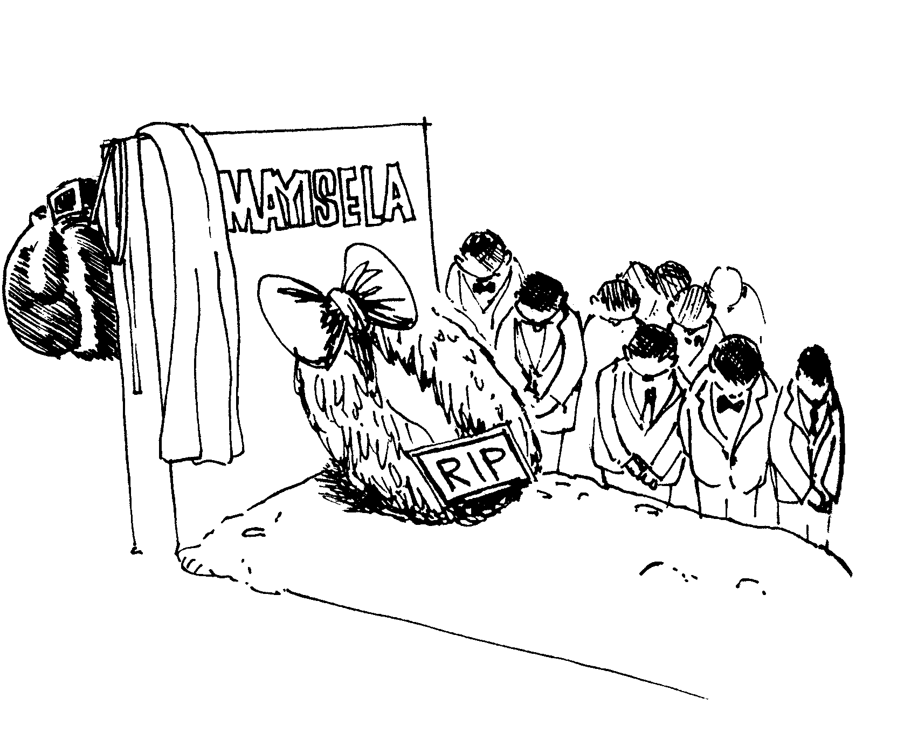

AMAMAKI ESIQEPHU B: | [10]

ISIQEPHU C

UMBUZO 3

UHLELO

3.1 Bhekisisa lesi sithombe esingezansi bese uphendula imibuzo elandelayo ngaso.

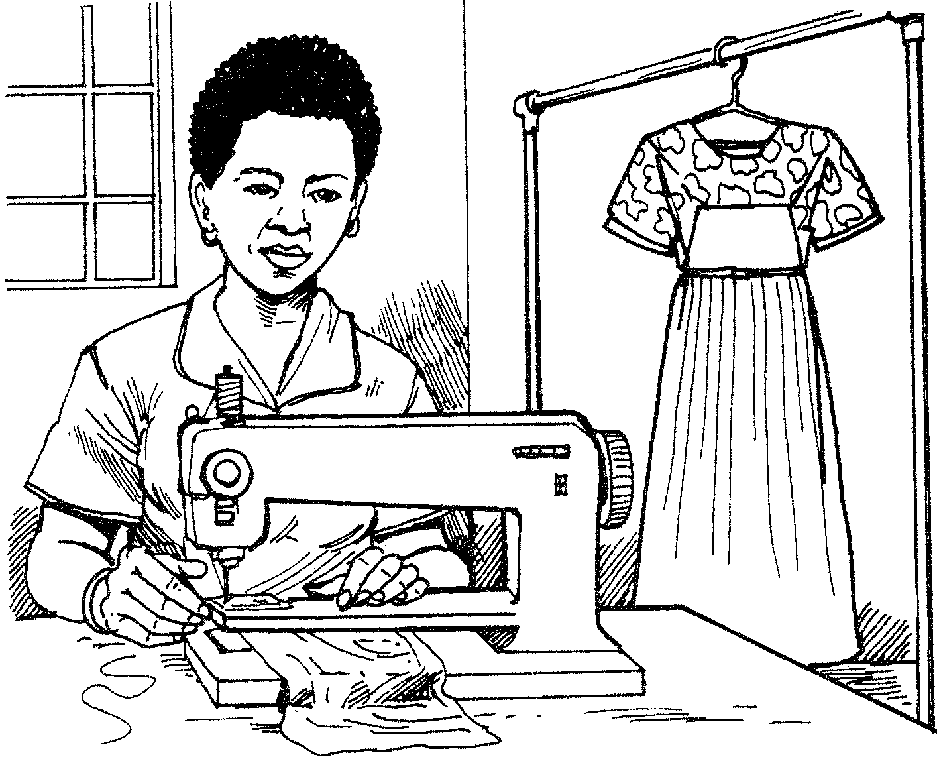

- Wenza msebenzi muni lo muntu osesithombeni?  - Uyawuthanda yini lo msebenzi awenzayo? Sekela impendulo yakho.  - Lo msebenzi owenziwe ngabe ungeminye yemisebenzi yokuzithuthukisa? Shono isizathu ESISODWA.  - Ngabantu abanaliphi ikhono abenza lo msebenzi?  - Siyidingelani imisebenzi efana nalo esikhathini samanje?  - Bhala imisebenzi yezandla EMIBILI oyaziyo ngaphandle kwalo osesithombeni. | (1)  (2)  (2)  (1)  (2)  (2)  [10]

3.2 Lungisa la magama asesibiyelweni.

- Ngenkathi siya kwagogo (sadula) esitolo kwaCele.  - Lesi sitolo sibhekene (nenkuda) yokudlala ibhola.  - Sabahalalisela abafana (ababendlala) ibhola lombhoxo.  - Phakathi kwabo kwakukhona owayemude njenge (dlulamithi).  - Leli qembu labafana lingaphuma phambili (emcintiswaneni) webhola lombhoxo. | 1x5=(5)
3.3 Qala le misho elandelayo ngamagama adwetshwelwe.

Isibonelo: Othisha babiza uKader Asmal.
Impendulo: UKader Asmal ubizwa ngothisha.

- Ubaba ubhema ugwayi.  - Abafana bampompa amabhayisikili.  - Amaphoyisa abamba izigebengu.  - Abafundi bagubha usuku Iwenkululeko.  - Onesi baphuzisa iziguli. | 1x5=(5)

3.4 Bheka lesi sithombe bese ugcwalisa izikhala ngamagama afanele.

Khetha kula magama: bakhathele, ukuhwalala, iklele, khwela, inhlonipho, abakhubazekile.

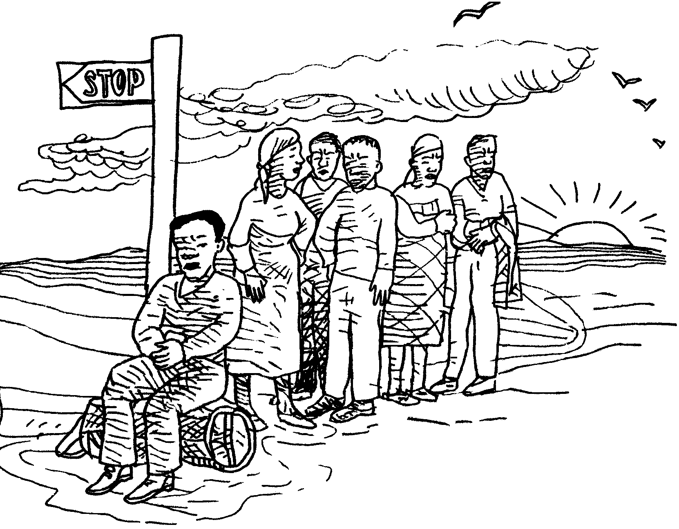

Sekuqala 3.4.1 ________ manje. Abantu sebephumile emsebenzini. Bame 3.4.2 ________ balinde izinto ezizobasiza zibathathe baye emakhaya.  3.4.3 ______ kade besebenza usuku lonke. Uma kufika ithekisi kuzo  3.4.4 _____ abame phambili kuqala. Uma seligcwele abasele bazolindela elilandelayo. Nakuba bekhathele futhi bejahile abadudulani bakhombisa  3.4.5 ________ abanayo. | 1x5=(5)

3.5 Kubatshazwa kuthiweni lapho umuntu:

- ethimula.  - emukela isipho. | 1x2=(2)

3.6 Qedela lesi siqeshana ngesakhi esifanele ukuze sizwakale kahle. Bhala inombolo nesakhi kuphela.

Umama uthole 3.6.1______ nke abantwana belele. Umama ufike 3.6.2____ dwa namuhla ngoba ubaba uyasebenza. Ngesinye isikhathi bahamba 3.6.3_____ bili uma bebuya emsebenzini. | 1x3=(3)

3.7 Lungisa le misho elandelayo ukuze ifundeke kahle. Bhala umusho wonke.

- UNgubane (wakhwela) amadoda emotweni.  - UNgubane (wazikhala) emadodeni.  - La madoda (athola) noNgubane emgwaqweni.  - Izigebengu (zabamba) ngamaphoyisa.  - Izinto zikaNgubane (zalahla) zonke. | 1x5=(5)

AMAMAKI ESIQEPHU C: | [35]

AMAMAKI ASEWONKE: | 80

Ithalente / isiphiwo

Isidwedwe ilapi

ingcweci isihlakaniphi igagu

