GAUTENG DEPARTMENT OF EDUCATION
SENIORS CERTIFICATE EXAMINATION

ISIZULU ULIMI LWESIBILI
IZINGA ELIPHANSI
(Iphepha Lokuqala)

ISIKHATHI: amahora amabili

AMAMAKI: 80

IMIYALO:

- Leli phepha lineziqephu ezintathu. Phendula ZONKE iziqephu.

- Izinombolo zonke mazinombolwe njengoba kunombolwe imibuzo.

- Bhala ngesiZulu esemukelekile.

ISIQEPHU A

UMBUZO 1

ISIFUNDO SOKUQONDISISA

Funda le ndatshana bese uphendula imibuzo ezolandela ngezansi:

“Ungabe usathi nyaka!” kusho le nsizwa ebihleli ngemuva. Yakhipha ivolovolo masinyane yamkhomba ngalo ebunzini. “Hawu sengoneni madoda?” Kubuza uNgubane ethuthumela nezwi selidlengezela. “Usabuza lokhu?” Kubuza lena ehlezi eceleni kwakhe, igqabula ummese imuthi hloko ngawo esingqeni. “Kahleni- bo bafowethu! Sengenzeni?” Kuzikhalela uNgubane. “Thula! Letha lapha ukhiye wemoto!” Kusho lena yevolovolo. Awubhongcule izandla seziqhaqhazela uNgubane ukhiye awunikeze lo muntu angamazi nakumazi nokuthi ungubani wakwabani.

“Buyisa yonke imali esikunike yona”, kusho insizwa yevolovolo. Ayikhiphe uNgubane imali engama-R20 ekhukhwini, ayinike le nsizwa. Imuthi qha ngempama bese ithi, “Khipha yonke imali oyiphethe uyilethe lapha, kanye nezincwadi zasebhange namakhadi akhona, konke ukulethe lapha ngokushesha!” Kusho insizwa yommese. Akukhiphe uNgubane. Ayinike. Ikwemukele. Ikupequlule. Ithole imali engo-R50 abane. Iyithi shwathe ekhukhwini. Ibuke amakhadi. Imamatheke. Iwabuke. Iwabukisise. Bese ithi, “Zithini izinombolo zakho zesifuba zawo wonke la makhadi?” UNgubane ayitshele izinombolo ezifika ekhanda, ahoshe ipeni elisekhukhwini lehembe esifubeni kuNgubane. “Phinda izinombolo zala makhadi!”
Imthethisa le yommese. Aphinde asho izinombolo ezimfikelayo futhi uNgubane. Ibhalabhale kuwona amakhadi lawa lena yommese.

“Khumula lezi zihlangu ozigqokile,” kusho lena yevolovolo ibuka izicathulo zikaNgubane ezintsha ceke. Azikhumule uNgubane. Azihlwithe lona wommese azijwibe phezu kwesihlalo esingemuya. “Khumula leli bhantshi oligqokile ulilethe lapha,” kusho lena yommese. Alinge ukuvula isicabha ukuze aphumele phandle akwazi ukukhumula kahle ibhantshi. “Ulinga ukwenzani? Khumula ukhona lapho, kuthetha le yevolovolo. Athi angakhumula uNgubane, ilemukele ibhantshi lena yommese. Iliphonse esihlalweni esingemuva. Ivule isicabha semoto lena yevolovolo ithi, “Phuma!” Ivule esingakuyona lena yommese, aphume uNgubane.

“Letha leli hembe oligqokile! Kusho lena yommese. Athi esalikhumula nje uNgubane, alihlwithe lona wommese. Aliphonse esihlalweni akade ehleli kuso. Bamqhuba uNgubane laba balisa baya naye ebhuthini yemoto yakhe. Bayivula ibhuthi. Bathi akangene phakathi kuyo. Bamvalela.

1.1 Phendula le mibuzo ngokugcwele:

1.1.1 UNgubane wagibelisa obani emotweni? | (1)

1.1.2 Babekhokhe malini laba bantu? | (1)

1.1.3 Njengoba ezikhalela nje uNgubane, kusho ukuthi babemenzani laba bantu? | (1)

1.1.4 Babehlome ngani laba bantu? | (2)

1.1.5 Bathatha malini kuNgubane? Shono ngesiZulu? | (1)

1.1.6 Bathi bafuna abanikezeni futhi? | (1)

1.1.7 “Izinombolo eziyisifuba”, izinombolo ezinjani? | (2)

1.1.8 Bamvalelaphi uNgubane? | (1)

1.1.9 Ngokubona kwakho, bayini laba bantu? | (1)  [11]

1.2 Phendula ngo-Yebo noma Cha

1.2.1 UNgubane wayehamba ngemoto. | (1)

1.2.2 UNgubane bamkhomba ngesibhamu esiswini. | (2)

1.2.3 Amadoda ayenike uNgubane uR50. | (1)

1.2.4 UNgubane wayenalo ikhadi lasebhange. | (1)

1.2.5 UNgubane naye wakhipha ummese wakhe. | (1)  [5]

1.3 Khetha impendulo efanele:

1.3.1 Ungabe usathi nyaka, kusho ukuthi

- ungahambi
- unganyakazi
- ungakhulumi
- ungabheki

1.3.2 Ukuthi sengoneni kusho ukuthi

- nifunani?
- niyaphi?
- ningobani?
- ngenzeni?

1.3.3 Ukugqabula ummese kusho ukuthi

- ukukhipha ummese
- ukunqamula ummese
- ukuqabula ummese
- ukugqiba ummese

1.3.4 Ukumbongcula ukhiye kusho ukuthi

- ukukhipha ukhiye
- ukubhoboza ukhiye
- ukunikeza ukhiye
- ukubaza ukhiye

1.3.5 Ukuthi qha ngempama kusho ukuthi

- ukuxhawula  - ukushaya  - ukuphosa  - ukuqabula | 1x5=(5)

1.4 Bhala igama elisho okungafani naleli elidwetshelwe

- ukwehla emotweni  - ukugqoka izimpahla  - insizwa ikhiphe ipeni  - ahleke uNgubane  - wagibelisa izintombi ezimbili | 1x5=(5)

1.5 Qala le misho ngokuthi:

I Insizwa yathi kuNgubane … noma Insizwa yabuza kuNgubane…
Isibonelo: ‘Hamba!’
Impendulo: Insizwa yathi kuNgubane makahambe.

- ‘Sinike yonke imali onayo’.  - ‘Thula’.  - ‘Zithini izinombolo zakho?’ | 3x2=(6)

1.6 Bhala amagama asho okufanayo noma amqondofana nalawa alandelayo kule ndaba

- imoyizele  - izinamba  - –vevezela | 1x3=(3)

ISIQEPHU B

UMBUZO 2

UKUFINGQA

Bukisisa lesi sithombe, bheka okukuso bese ubhala indatshana emnandi nezwakalayo ngalokho okucabangayo ngalo mfanekiso. Bhala indaba yakho ibe ngamaphuzu AYISIKHOMBISA.

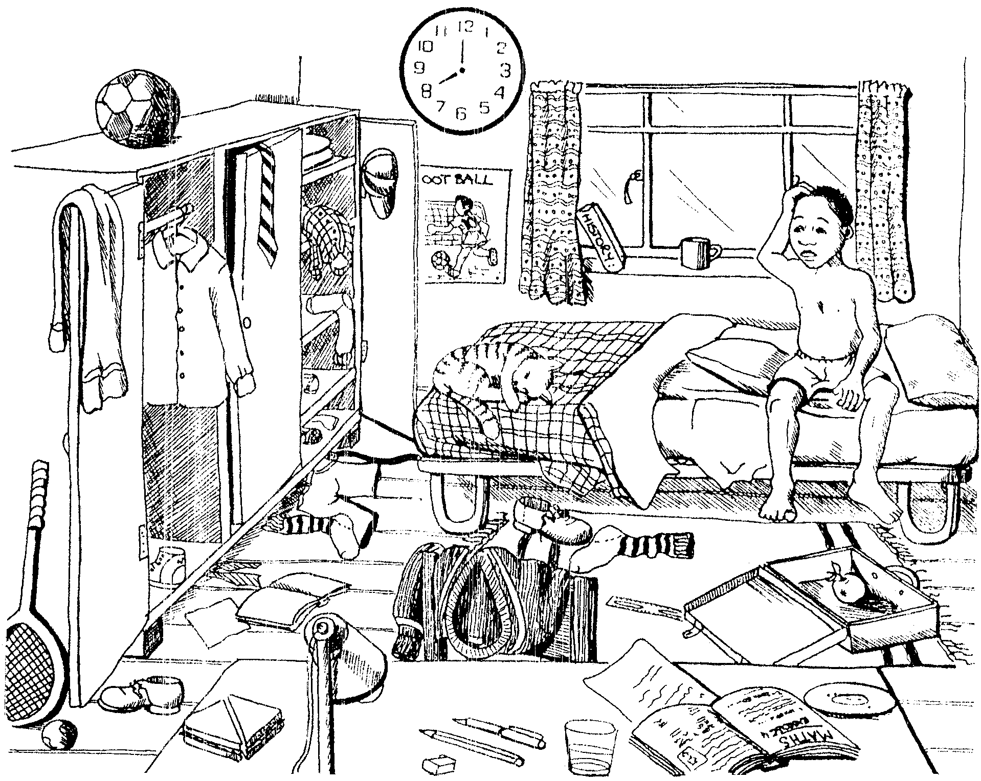

AMAMAKI ESIQEPHU B: | [10]

ISIQEPHU C

UMBUZO 3

UHLELO

3.1 Gcwalisa izikhala ngegama elifanele ukuze lesi siqeshana sendaba yamakhathuni sibe nomqondo ozwakalayo.

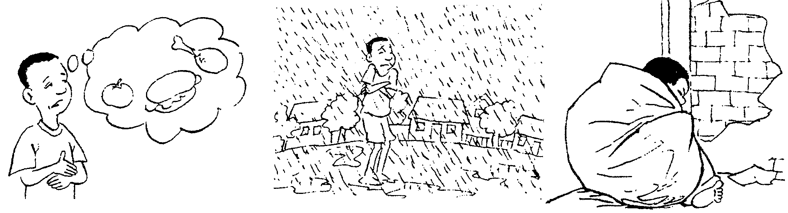

Lo mfana akanabo a 3.1.1___. Uhlala e 3.1.2____ ngokudla ubeke i 3.1.3___ esiswini ngoba akukho lutho esiswini. Namhlanje 3.1.4____ libi kakhulu kuyabanda kanjani futhi ku 3.1.5____. Ngoba akanayo i 3.1.6____ yokulala uzolala khona la e 3.1.7_____. Abantwana abafana nalona bagcina sebe  yi 3.1.8_____. | 1x8=(8)

3.2 Bheka isithombe esilandelayo bese uphendula imibuzo engezansi:

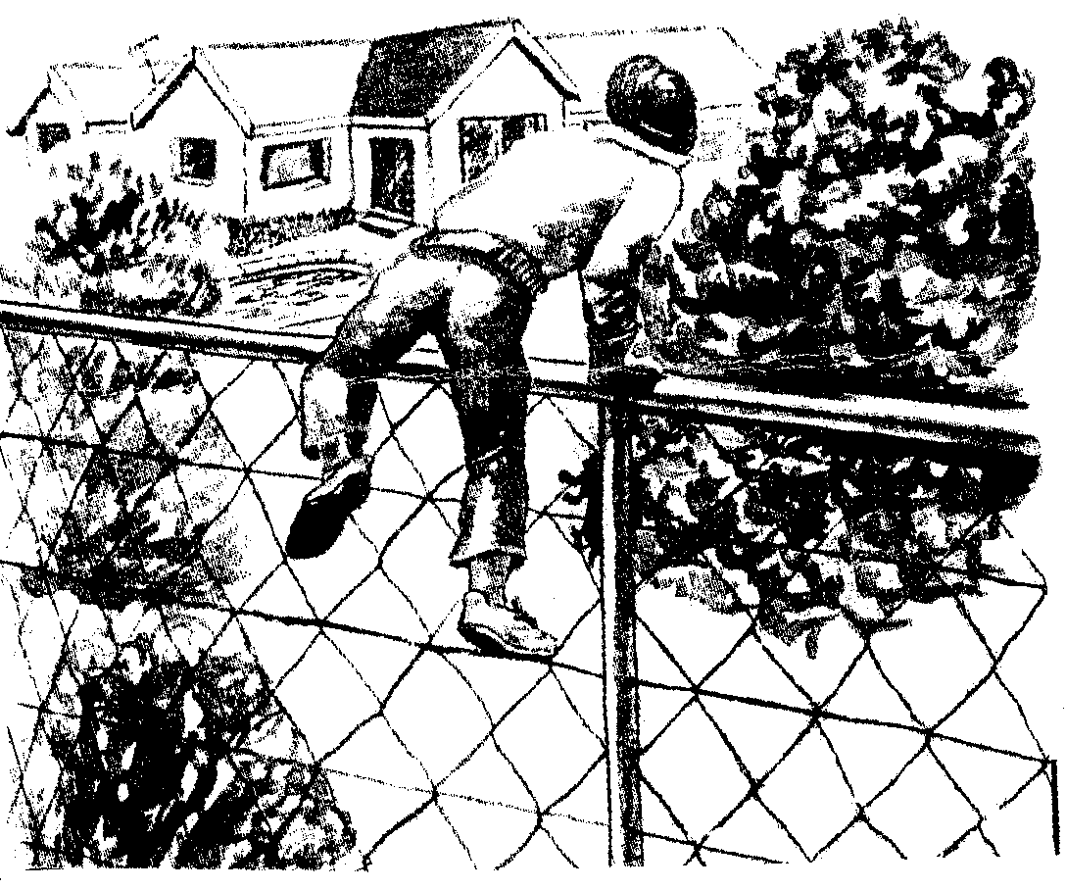

- Kungani le ndoda ingasebenzisi isango?  - Uma ucabanga izokwenzani kulo muzi?  - Ukube bekungumuzi wakho lo, ubungenzani ukuwuvikela? | (1)  (1)  (2)  [4]
3.3 Bheka lesi sithombe esingezansi.

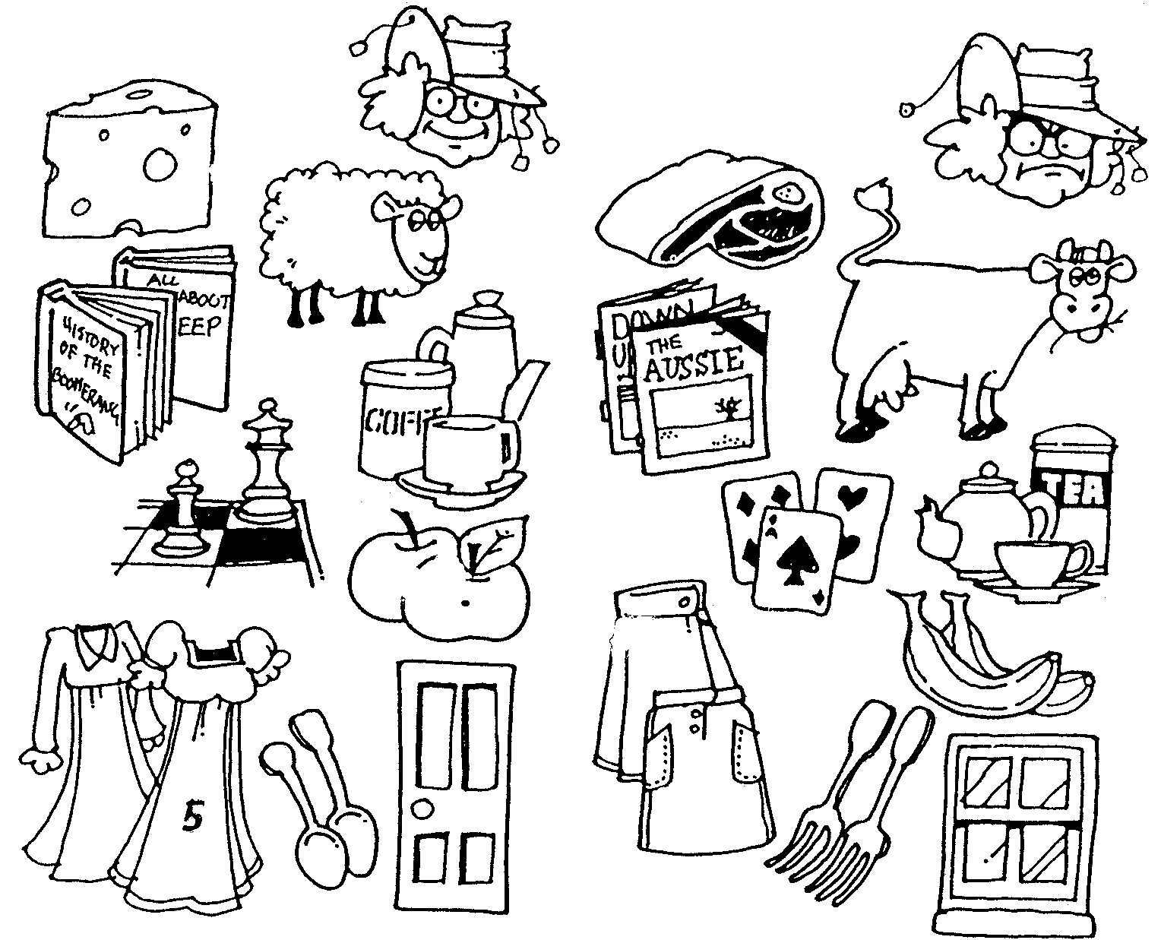
Ngiyazithanda

A
Angizithandi

B
1.
2.
3.
4.
5
1.
2.
3.
4.
5.

UThembi unezinto azithandayo eziku-A kanye nalezo angazithandi eziku- B. Bhala imisho emihlanu egcwele ngalezi zinto azithandayo nangazithandi. Yenza njengasesibonelweni esingezansi.

Isibonelo:

UThembi uyazithanda izingubo kodwa akawuthandi ubhanana. | (10)

3.4 Lungisa izenzo ezikubakaki ukuze zivumelane kahle kule misho.

- Omame (thunga) izingane zabo izingubo zesikole.  - Kuhle (funda) ingane yakho ngoba uzozuza ekugcineni.  - Abantu kuhle (xoxa) uma kunezinkinga.  - Utshani (sika) uMnumzane uGumede izolo. | 1x4=(4)

3.5 Le misho elandelayo yizimpendulo. Bhala umbuzo waleyo naleyo mpendulo.

- Isisu somhambi singangenso yenyoni.  - Izivakashi zafikela emzini kaWinnie Mandela.  - Ngishaywe yileya ndoda.  - Ukhulume kahle uthishanhloko nabazali bezingane. | 1x4=(4)

3.6 Bhala izinciphiso zamagama akubakaki.

- Gcwalisa (isigubhu) sami ngamanzi abandayo.  - Qaqa (intambo) emthwalweni wami.  - Hamba uyongicelela (impuphu) kwaMaNgcobo.  - (Indlu) yegagu iyanetha.  - Ugogo uzoke ahlale (isikhathi) ekhaya. | 1x5=(5)

AMAMAKI ESIQEPHU C: | [35]

AMAMAKI ESEWONKE: | 80

