GAUTENG DEPARTMENT OF EDUCATION

SENIOR CERTIFICATE EXAMINATION

ISIZULU ULIMI LWESIBILI
IZINGA ELIPHAKEME
(Iphepha Lesithathu)

ISIKHATHI: amahora amabili

AMAMAKI: 80

IMIYALO:

- Funda kahle yonke imibuzo.
- Bhala izinombolo zemibuzo njengoba zinjalo ephepheni.
- Bhala ngesandla esifundekayo ukuze ungalahlekelwa ngamamaki, umsebenzi onobunono nokuhlanzeka uyoklonyeliswa.
- Bhala isiZulu esemukelekile.

ISIQEPHU A

UMBUZO 1

Khetha isihloko ESISODWA kulezi ezilandelayo bese ubhala ngaso indaba. Indaba yakho ibe ngamagama angu 250-300.

  - Izilwane azibandlululani, ziyezwana esikhathini esiningi. Kungani thina bantu sibandlululana kangaka?

  - Wena ukubona kuyicebo elihle yini ukuba umsebenzi weposi nezokuxhumana unikwe osomabhizinisi abazimele noma kumele ube sezandleni zikaHulumeni?

  - Kuyenzeka ezikoleni ukuthi abafundi, nothisha nabaphathi bangaboni ngaso linye ngezinto ezithile. Lokhu kungqubuzana sekuvamile ezikhungweni zemfundo. Ake ubeke imibono yakho ngokuthi ngabe ukuduba izifundo ukugwayimba noma ukuduba ukudla kanye nokucekela phansi kwempahla kungaba yisona kuphela isixazululo sezikhalazo zabafundi?

  - Ukubaluleka kwemfundo ezikhathini zanamuhla.

1.5 Bheka lezi zithombe ezingezansi bese ukhetha ESISODWA ubhale ngaso indaba. Ungakhohlwa inombolo yesithombe osikhethile kanye nokunika indaba yakho isihloko esifanele.

1.5.1
1.5.2

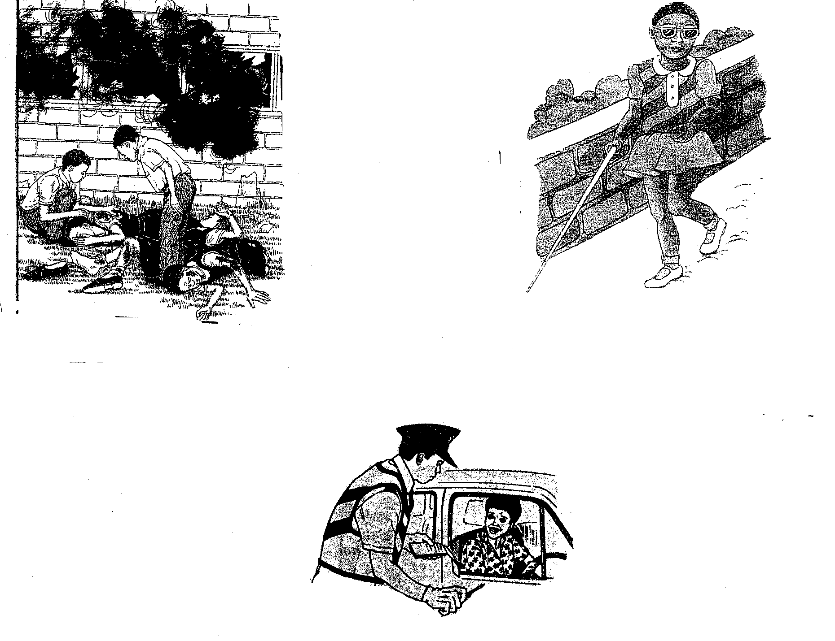
1.5.3

1x40 =  AMAMAKI ESIQEPHU A: | [40]  40

ISIQEPHU B

UMBUZO 2

Bhala amagama ungu 120 – 150 NGOKUKODWA kwalokhu okulandelayo.

  - Bhalela uNgqongqoshe weMfundo, uMnumzane Kadar Asmal, incwadi umcele ukuba anikeze isikole senu imali ukuze abafundi bazokwehliselwa inani lemali okufanele bayikhokhe esikoleni ngonyaka.

  - Bhala umbiko ngokuphathwa kwezilwane esiqiwini obukade usivakashele.

  - Bheka isithombe esingezansi bese ubhala ingxoxo phakathi kwabantu abakulesi sithombe.

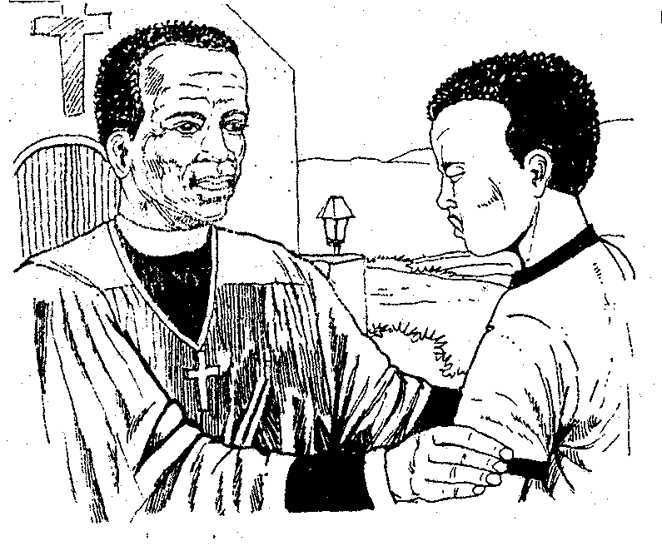

1x20 =  AMAMAKI ESIQEPHU B: | [20]  20

ISIQEPHU C  UMBUZO 3  Bhala NGOKUKODWA kwalokhu:  - Bhala amaminithi omhlangano weLRC ebeninawo esikoleni senu.  - Abazali bakho bazokwenzela indumezulu yedili ngoba uzobe uhlanganisa iminyaka eyishumi nesishiyagalombili. Bhalela abangani bakho isimemo ukuze beze bazojabula kanye nawe ngalolu suku.  - Beninomhlangano we LRC lapho bekudingidwa udaba lokwenyuswa kwenani lemali yesikole. Bhala imemorandamu uyibhekise kuthishanhloko  ngezinqumo enizithathile emhlanganweni weLRC. 1x20  AMAMAKI ESIQEPHU C:  AMAMAKI ESEWONKE: | [20]  20  80

