GAUTENG DEPARTMENT OF EDUCATION
SENIOR CERTIFICATE EXAMINATION

ISIZULU ULIMI LWESIBILI
IZINGA ELIPHAKEME
(Iphepha Lokuqala)

ISIKHATHI: Amahora amabili

AMAMAKI: 80

IMIYALO:

- Leli phepha lineziqephu ezintathu. Phendula ZONKE iziqephu.

- Izimpendulo zonke mazinombolwe njengoba kunombolwe imibuzo.

- Bhala ngesiZulu esamukelekile.

ISIQEPHU A

UMBUZO 1

ISIVIVINYO SOKUQONDISISA

Funda le ndatshana bese uphendula imibuzo elandelayo.

Akusavumi ngihlale phansi sengilokhu ngixaxama njalo kuhle kwesikhukhukazi sishiswa yiqanda. Olwamanqamu phela namhlanje. Yilona kanye usuku engizophenywa ngalo mayelana nolwazi lwami lwalo msebenzi engiwufunile. Lolu phenyo lwami luzokwenziwa ebhilidini elikhulu elisekhoneni lemigwaqo uMarket Street kanye noChurch Street phakathi edolobheni. Ngike ngithuke senginyukunye nefindo likathayi lapha entanyeni ngoba nawo angisawuzwa kahle. Endlini encane ngiya ngiphindelela. Kwenye inkathi sengike ngifike ngijike khona ngingenzi lutho. Kubo lobo budididi kuqhamuke ungqwazi lwensizwa luqonde kimi. Sibingelelane. Lungibuze igama nesibongo. Ngilutshele bese luthi angilulandele ngoba yimina impela olungifunayo. Ngilandele siye singene kwelinye ihhovisi. Mameshane! Kanti ngingenaphi lapha! Kugcwele izimpandla zizungeze elikhulu itafula leli. Anele angingenise lo mfo ebesihamba naye zivele zithi vumbu kanyekanye lezi zimpandla. Azame ukungazisa izibongo zazo zonke lo mfo kodwa asikho nesisodwa engasikhumbula. Abaningi ngaze ngabazi ukuthi bangobani sengisebenza. Kwathi sesazene kwase kuthiwa angihlale phansi. Phambi kwami kwakuhlezi impandla efake izibuko okwakubonakala ukuthi ingusihlalo wala maxoxo ethu. Ngamafuphi-ke la maxoxo ahamba kanje:

Usihlalo: Mnumzane Sokhulu ungake usitshele ukuthi ngabe yini lena ekwenze ukuba ufune lo msebenzi?

Mina: (Ngezwa kuthi ukubuya isibindi kancane). Sengisebenze isikhathi eside ezitolo ezahlukene zezingubo. Lokhu sekuze kwangifaka ugqozi lokuthi ngithuthukise ulwazi lwami lokudayisa. Ngithe uma ngibona lo msebenzi wokuthengisa izimoto, ngabona ukuthi nalo ithuba ebengilokhu ngilifuna. Ulwazi lwami lwezokudayisa luzothuthuka noma yikanjani lapha. (Ngathi ngisathi ngiyaphefumula base bewuhlohlile umbuzo).

Usihlalo: Yini lena ekwenza uthi ulwazi lwakho lokudayisa luzothuthuka uma uthengisa izimoto?

Mina: Umthengisi wezimoto akafani nabanye abathengisi. Akagcini ngokuba umthengisi nje kodwa ubuye abe umxhumanisi. Uba ngumxhumanisi kabili. Ufike abe umxhumanisi womthengi kanye negalaji abuye abe umxhumanisi womthengi kanye nebhange elizoxhasa umthengi ngezimali. Ngale ndlela lo mthengisi uthe ukuthi thuthu kunalowo ovele asebenze ukwehla enyuka esitolo ekhombisa umthengi impahla. (Ngathi uma ngishaya leli phuzu ngabona enye impandla engakwesokunxele sami ithi ukunqekuzisa ikhanda kancane. Ngasho ngenhliziyo ukuthi ayitholile indawo la mazwi ami). Kwaqhamuka isihosho sakwabo sekhehla sangibuza umbuzo ebengingawunakile.

Isihosho: Engxoxweni yakho uthe usuke wasebenza ezitolo eziningi. Besicela ukwazi ukuthi ngabe yini lena eyenza ukuthi ushintshashintshe izindawo zokusebenza.

Mina: (Ngiqale ngithi ukunwaya ikhanda kancane bese ngiyaphendula). Kwenye inkathi kwakusuke kwenza ukuthi umsebenzi usuphelile lapho kade ngisebenza khona lokhu okwakudalwa ukusuka kwesitolo kuleyo ndawo mhlawumbe kube ukuhlakazeka kwenkampani ebisingethe isitolo leso. Ngingakubeka ngingahlonizi-ke nokho ukuthi kwakwenzeka ngishintshe umsebenzi ngenxa yokufuna amadlelo aluhlaza (Bahleke bonke.) Singiphinde futhi isihosho ngomunye umbuzo.

Isihosho: Umdayisi kufanele amphathe kanjani umthengi?

Mina: Okokuqala umthengisi kufanele azi ukuthi impilo yakhe yonke isingethwe umthengi. Ngale ndlela umthengi kufanele umphathe njengomfowenu. Kufanele uwe uvuka naye umchushise kahle kuhlale obala ukuthi le nto ayithengayo iwusizo kanjani nokuthi angenzenjani uma kukhona inkinga ahlangabezane nayo.

Miningi-ke neminye imibuzo eyabuzwa nokho eyayingadle ngakushuba. Ekugcineni ngaze ngadedelwa kule mbiza eshisayo. La maxoxo ethu okufuna umsebenzi ngiwakhunjuzwa ukuthi kuthe ekuseni ngifika lapha emsebenzini ngabona enye insizwa ihlezi cishe ngendlela engangihlezi ngayo nami. Ngiyabona ukuthi ifake isicelo somsebenzi nakhu phela kuphume emaphepheni ukuthi kufuneka umthengisi wezimoto ozozinza kwelaseSayidi.

(Insema 5)

- Bangaki abantu abakule ngxoxo?  1.2 Ubani igama lomuntu oxoxa le ndaba?  1.3 Ngabe wayeyofunani lo muntu kule ndawo ayeye kuyo?  - Yini lena eyamethusa kakhulu uma engena ehhovisi?  - Nhloboni yomsebenzi lena athi oxoxayo useyenze isikhathi eside?  - Bhala izizathu EZIMBILI ezibekwe umfo athe yizona ezamenza ashintshe imisebenzi.  - Umxoxi ngabe wawuthola noma akawutholanga lo msebenzi? Sekela impendulo yakho.  - Abantu abaningi ababizelwa ukuzophenywa ngomsebenzi bayethuka. Kwenziwa yini lokho? | (1)  (1)  (1)  (1)  (2)  (2)  (2)  (2)

- Zikhona yini izinto umuntu angahle azenze ukuze angethuki? Beka imibono yakho.  - Oxoxayo kwakufanele ukuba awuthole lo msebenzi? Sekela impendulo yakho.  - Bhala imishwana EMIBILI ekhombisa ukuthi oxoxayo wayethukile phambi kwama xoxo ophenyo.  - Oxoxayo uhlanganisa umthengi nezinto ezimbili yiziphi lezo zinto?  - Khetha impendulo efanele kulezi ezinikiwe | (2)  (2)  (2)  (2)

1.13.1 Uma kuthiwa olwamanqamu kusuke kushiwo _____.

- udondolo
- uthando
- usuku
- ulwazi

    - Umxhumanisi ngumuntu ongu _____.

- mthungi wezingubo
- mnikazi wesitolo
- mbazi wefenisha
- mhlanganisi wabantu

1.13.3 Amadlelo aluhlaza kule ndaba asho _____.

- isikhotha
- indawo engcono kunenye
- lapho kudla khona imfuyo
- eZulwini

1.13.4 Ukuphenywa kule ndaba kuchaza _____.

- ukubuzwa imibuzo ngomsebenzi
- ukupheqwa kwamakhasi ebhuku
- ukwembulwa kwezingubo
- ukusolwa ngecala

- Khetha impendulo engahambisani negama elithi amatata _____.  - uvalo  - ukwethuka  - ukudangala  - ukungazethembi 1 x 5 = | (5)

1.14 Phendula ngo ‘Yebo’ noma ‘Cha’  - Ukuthi vumbu wukusukuma kanyekanye?  - Usihlalo wamaxoxo wabuza uMnumzane Sokhulu igama nesibongo?  - USokhulu akazange azikhumbule izibongo zezimpandla?  - Yindoda eyayizofuna umzebenzi eyakhumbuza uSokhulu ngolwakhe uphenyo ngenkathi efuna umsebenzi?  - Usihlalo wathi kumela ukuthi umdayisi amphathe kahle umthengi.  1 x 5 = | (5)

1.15 Sebenzisa igama amaxoxo ubhale eyakho imisho EMIBILI ekhombisa imiqondo emibili eyahlukene. 2 x 2 = | (4)

1.16 Kule ndaba izimpandla kushiwo baphi abantu? | (1)

AMAMAKI ESIQEPHU A: | [35]

ISIQEPHU B

UMBUZO 2

UKUFINGQA

Bukisisa lesi sithombe esingezansi bese ubhala indatshana mayelana nemicabango nemizwa equtshulwa yilesi sithombe. Beka indatshana yakho ngamaphuzu AYISIKHOMBISA.
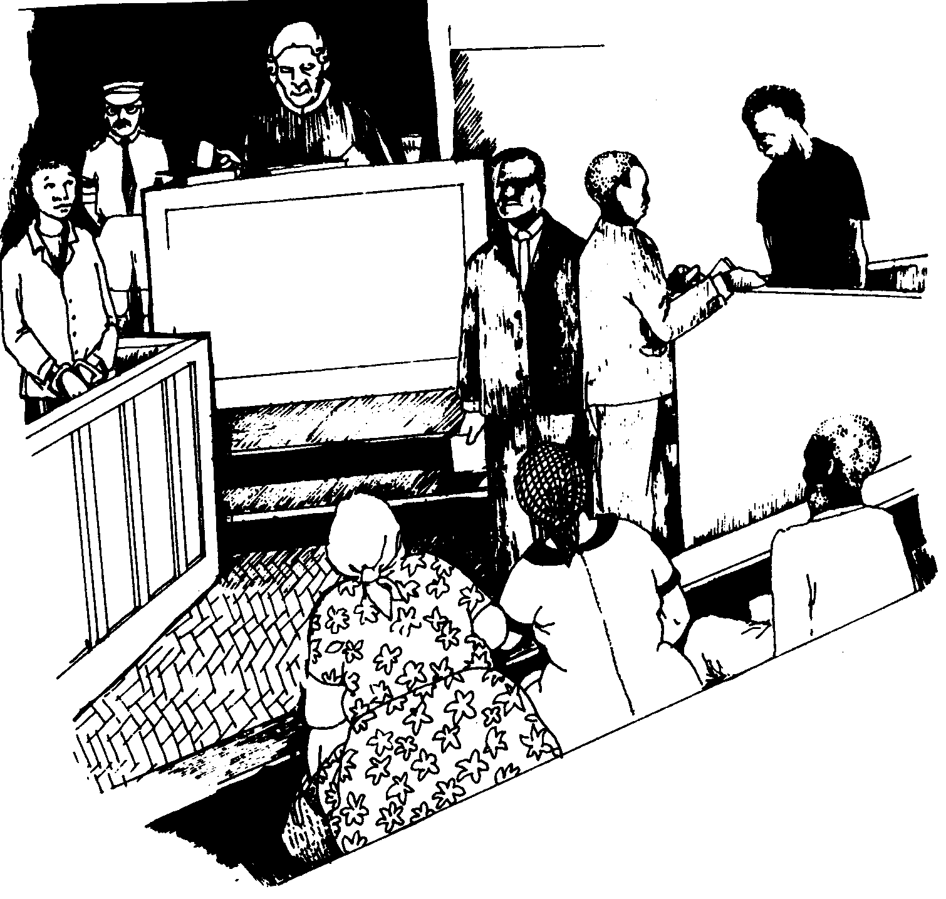

AMAMAKI ESIQEPHU B: | [10]

ISIQEPHU C

UMBUZO 3

UHLELO

Bhekisisa lesi sithombe esingezansi bese uphendula imibuzo elandelayo ngaso.
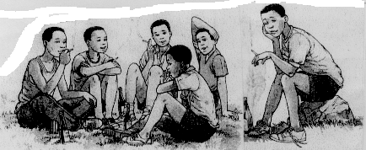

- Benzani laba bafana? Shono OKUBILI?  - Sengathi abekho lapho kufanele babekhona, kufanele babe kuphi, benzani?  - Kungaba yini imbangela yaloku abakwenzayo?  - Uma ucabanga bazogcinaphi uma beqhubeka nalokhu abakwenzayo?  - Seluleko sini ongasinika laba bafana? 2 x 5 = | (10)

3.6 Igama elithi ngena lisetshenziwa ngezindlela ezahlukene. Qondanisa imisho eku- A nezincazelo eziku-B.

A | B
3.6.1 Ngena indlela ngingaze ngikushaye | (a) Ungangeni kabi endabeni
3.6.2 Kubi ukungena izindaba zabantu | (b) Zabavimbezela
3.6.3 Ungaphika ukuthi uyena uma esengene engqephini | (c) Ukungena ingxoxo yabanye
3.6.4 Izigebengu zabangenela ebusuku belele | (d) Egqoke kahle
3.6.5 Lalela kuqala, ungangeni ngesinxele | (e) Hamba

1 x 5 = | (5)

3.7 Bhala le misho ikhombise ukuphika.  - Izinduna zithetha amacala emphakathini.  - Abadiphi babheka impilo yemfuyo.  - Izinkukhu zicosha ummbila.  - Inkosi yotha ibandla layo.  - Amadoda athanda utshwala. 1 x 5 = | (5)

3.8 Bhala ibizo elingaba ngumenziwa kulowo nalowo musho. Bhala impendulo kuphela.  - Obaba bayayihlinza.  - Umfana usidlala kamnandi.  - Uyaligibela umalume uma eya edolobheni. 1 x 3 = | (3)

3.9 Qedela le misho ngokufaka isabizwana sokukhomba esifanele.  - _____ muntu wantshontsha imali ebhange.  - Ngiyalifuna impela _____ bhantshi oliphethe, ngizolithenga.  - _____ bafana bazogijima ibanga elide.  - Hlala phansi izingane zizozigeza _____ zitsha.  - Abafana kumele bakhalime _____ zinkomo ezikude. 1 x 5 = | (5)

3.10 Lungisa igama elikubakaki ukuze kuzwakale ukuthi ngubani owenze lokhu:  - Icala seliphelile, amasela (ajezise) kabuhlungu inkantolo.  - Ikhabishi (alidli) kwelakithi.  - Nanso indoda (efele) umntanayo.  - Abazali bavame (ukufunda) izingane zabo ebusuku. 1 x 4 = | (4)

3.11 Gcwalisa izikhala kule misho ngesivumelwano esifanele:  - Isitha somuntu _____ khulu wuye eqobo.  - Intandane _____ nhle umakhothwa ngunina.  - Ummbila _____ sha uyathandeka uma usuphekiwe. 1 x 3 = | (3)

AMAMAKI ESIQEPHU C:  AMAMAKI ESEWONKE: | [35]  80

