GAUTENG DEPARTMENT OF EDUCATION
SENIOR CERTIFICATE EXAMINATION

ISIZULU ULIMI LWESIBILI
IZINGA ELIPHAKEME
(Iphepha Lokuqala)

ISIKHATHI: Amahora amabili

AMAMAKI: 80

IMIYALO:

- Leli phepha lineziqephu ezintathu. Phendula ZONKE iziqephu.

- Izimpendulo zonke mazinombolwe njengoba kunombolwe imibuzo.

- Bhala ngesiZulu esamukelekile.

ISIQEPHU A

UMBUZO 1

ISIVIVINYO SOKUQONDISISA

Funda le ndatshana bese uphendula imibuzo elandelayo.

Lukhulu esasilubuka lwenzeka kwelakithi ekufikeni kwenkolo. Thina esasingayigqizi qakala le nkolo entsha amagqoka asesibuka enyanye ubone nje ukuthi lukhulu okuthi awalwenze lapha kithi. Kwaseke kufike nakithi ukuthi ngelinye ilanga sovele siwagibele ngomshiza njengoba ehambisa okwamanina nje. Odadewethu base beshiye phansi ukubhinca sebemshungu munye nokungamantombazane okwakuthi kufundela ikilasi. Izinto zaziguquka ngokukhulu ukushesha loku.

Lapha-ke emasontweni bathi kwakukhethwa iziqonga zamadoda zinikezwe izikhundla ezithile. Lezo ziqonga-ke babezibiza ngokuthi amalunga. Ngasohlangothini lwabesifazane nakhona babekhona omame abanikezwe umsebenzi wezikhundla ezithile. Lezo ziqonga-ke babezibiza ngokuthi amalunga. Ngasohlangothini lwabesifazane nakhona babekhona omame abanikezwe umsebenzi ocishe ufane nowabesilisa. Laba banumzane nalabo mame kwabe kuyizithenjwa ezinkulu. Izinto eziningi zesonto zabe zidlula ezandleni zabo. Abanye babo babeke bayibambe inkonzo kuthule umoya uma kwenzekile umfundisi wangababikho. Omunye umsebenzi walezi zipheshethwa zesonto kwabe kungukuhlola ukuthi akukho yini okungamantombazanyana nokungabafanyana osekwenza lezi zikamathandana. Kunomsebenzi owawumkhulu owabe wenza ukuthi amalunga lawo ahlonishwe. Lona kwabe kungumsebenzi wokuma ezimpambanweni zezindlela kusempondo zamthini ukuqapha bonke labo abagangayo ebusuku. Lapha kwelakithi kwabe kunomnumzane

uDlodlo owabe ewenza ngokukhulu ukwethembeka lo msebenzi. Wawusuke uluthezile olunenkume uma uke wazithela kulaba baqaphi.

Uma kwenzekile wazithela kubo umanziswe amazolo, kwakube uzowukhomba impela onamponjwana. Laba baqaphi-ke babegqoka amajazi esisosha baphathe namathoshi kanye nemizaca kumbe izimvubu abaqaphe ngakho ozama ukumba embulule. Okwakungixaka du ukuthi ngangingakaze ngizwe ukuthi kukhona obhaqe ingane yakhe. Lokhu kwabe kudala ukudideka kwelami ikhanda ngoba kwakuzwakala ukuthi ezinye izingane zalaba baqaphi ziyabonakala phandle lapha ebusuku. Zazithi zingakubamba-ke lezi zakwadalawane bese zikuyisa kumfundisi ophethe imishini.

Nina-ke eniyiziboshwa zesonto nanihlaliswa nodwa eceleni phambili kuthiwe ninqunyiwe esontweni. Uma usunqunyiwe esontweni wawungazimbandakanyi nezinto eziNgcwele zesonto njengeSidlo esiNgcwele kanti-ke futhi kubuye kube khona nezindawo ezithile owawungasondeli kuzo. Wawubonakala ngombala impela uma uyisiboshwa sesonto. Iziboshwa zesonto zaziba indidiyela. Kwakuba yilezo ezibanjwe ekuseni endleleni, kube ezenze amacala athile anjengokulwa kanye nalezo ezephule uMyalelo wesithupha eMyalelweni kaMosi.

Okunye okunzima kakhulu okwakwenziwa yisiboshwa sesonto kwakuba umsebenzi onzima. Sasivuka ekuseni noma ngabe kunamakhaza akhipha unyembezi sihambe siyosebenza kwamfundisi. Lapha kwamfundisi sasilima, sihlakula senze neminye imisebenzi enhlobonhlobo. Wawungasifica ekuseni amanzi angabandi enqamula ithambo sisebenza ngawo mhlawumbe sinisela noma siwasha. Sasisebenza impela singene sithi shi emsebenzini. Phela kwakufanele siqale phansi sifunde ikilasi uma sesifuna intethelelo yecala laso. Zaziqondiswa kanjalo-ke izigwegwe kwelakithi ukufika kwenkolo.

(Icashunwe kwiNsema 5)

1.1 Phendula ngo-Yebo noma Cha

- Le ndaba ixoxwa ngesikhathi sasendulo.  - Oxoxa le ndaba ngumuntu ongakholiwe.  - Amantombazana nabafana babevunyelwe ukuthandana.  - Abaqaphi babezibopha ngisho nezabo izingane.  - Ezenkolo zazifundelwa ekilasini lesikole. 1 x 5 = | (5)

1.2 Khetha impendulo okuyiyonayona kulezi ozinikiwe

    - Amagqoka kule ndaba asho:

- abantu abagqoka izingubo zesiLungu.
- abangabahedeni
- abangakholwa
- abeLungu

    - Kule ndaba ngabe elenina likhomba:

- amadoda
- amabhungu
- amakhosikazi
- amalunga

    - Ukugibela ngomshiza kuchaza:

- ukuvika ngomshiza
- ukushaya ngenduku
- ukujikijela ngenduku
- ukusikaza ngoswazi

    - Ukumba umbulule kusho:

- ukumba ushone phansi
- ukuqamba amanga
- ukuhleka njalo
- ukubaleka ngejubane

- Uzowukhomba onamponjwana. Ini?  - umthetho  - umuzi  - umuthi  - umjaho 1 x 5 = | (5)

1.3 Bhala umusho okhuluma ngezeBhayibheli kule ndaba.  1.4 Ukuze iziboshwa zesonto zithethelelwe emacaleni azo kwakumele ukuba ziyosebenza kwaMfundisi. Wena ucabanga ukuthi lokhu kwakulungile? Bhala phansi umbono wakho.  1.5 Bhala igama ELILODWA elisesigabeni sokuqala sale ndaba elikhomba ukuthi amagqoka ayengawathandi amabhinca. | (2)  (3)  (1)

- Amabhinca wona ayewathanda yini amagqoka? Sekela impendulo yakho.  1.7 Umlobi uwabiza ngokuthini amalunga ayesezikhundleni? | (2)  (1)

1.8 UMnumzane Dlodlo wayehluke ngani eningini labaqaphi?  1.9 Abefundisi babengawahloniphi amalungelo abantu ngokoMthethosisekelo kaZwelonke. Uyavuma noma uyaphikisana nalesi sitatimende? Sekela impendulo yakho. | (2)  (3)

- Bhala amagama akule ndaba asho lokhu okulandelayo:  1.10.1 Ekuseni kakhulu  - Ukunganaki noma ukungakhathali  - Ukuba senkingeni noma enkathazweni 2 x 3 = | (6)

1.11 Qondanisa amagama aku-A nalawa avumelana nawo ku-B

A | B
1.11.1 zonda | (a) isilisa
1.11.2 amaphoyisa | (b) dida
1.11.3 xaka | (c) enyanya
1.11.4 bheka | (d) ezakwadalawane
1.11.5 amadoda | (e) qapha | 1 x 5 = (5)

AMAMAKI ESIQEPHU A: | [35]

ISIQEPHU B

UMBUZO 2

UKUFINGQA

Bukisisa lesi sithombe esingenzansi bese ubhala indatshana mayelana nemicabango nemizwa equtshulwa yilesi sithombe. Beka indatshana yakho ngamaphuzu AYISIKHOMBISA.

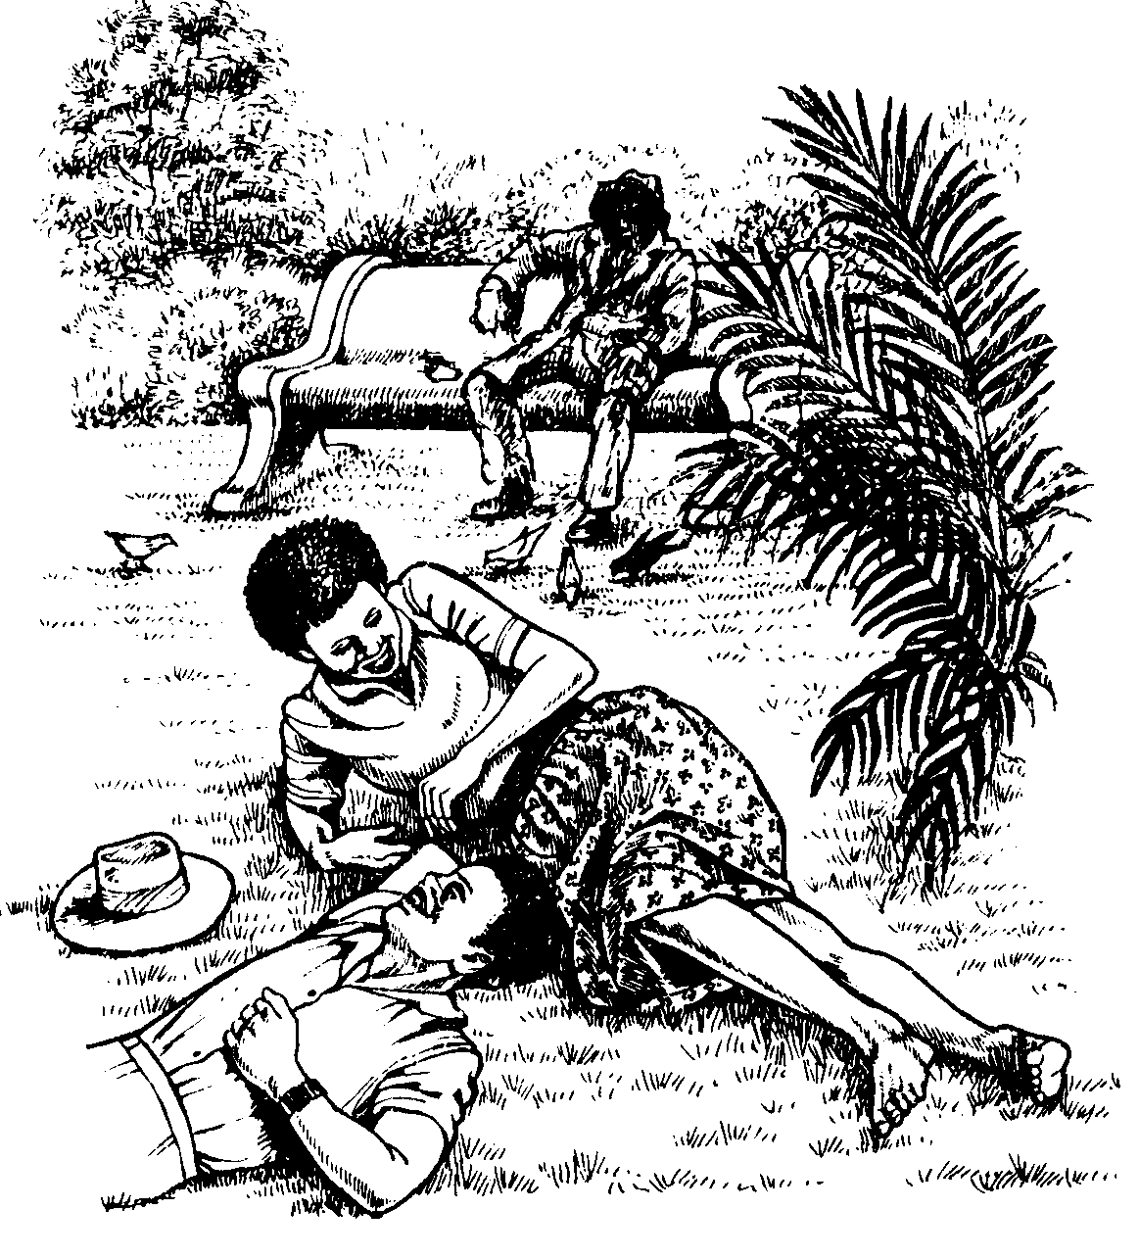

AMAMAKI ESIQEPHU B: | [10]

ISIQEPHU C

UMBUZO 3

UHLELO

- Gcwalisa izikhala kule ndatshane elandelayo ukuze ibe nomqondo. Bhala inombolo yombuzo negama olikhethile kuphela.  Khetha kula magama: izinto, uqobo, ukuthenga, izidakamizwa, izidingo, ikusasa, izimpahla, ngenhloso, ezikoleni, abantu.  Umphakathi yiwo 3.1.1 okumele ukuba unikele 3.1.2 zawo. Izinga lokugqekeza 3.1.3 nasemasontweni liyamangalisa. Ukutshontsha 3.1.4 zesikole yinto ekhubaza 3.1.5 i lezingane zethu ngoba lezi zinto zisiza zona. Kokunye uyothola 3.1.6 bezibandakanya ezenzweni ezingasile nezingafanele 3.1.7 yokuba bathole imali yokuthenga 3.1.8 Izakhamuzi zezwe lethu akufanele nakancane zikukhuthaze lokhu ngokuba ziyeke 3.1.9 izinto emaseleni. Kufanele ukuba sizivikele 3.1.10 ezisiza thina.  1 x 10 = | (10)

3.2 Bheka lesi sithombe esingezansi bese ubhala isimo esifanele segama elikubakaki ukuze lesi siqeshana sizwakale kahle.
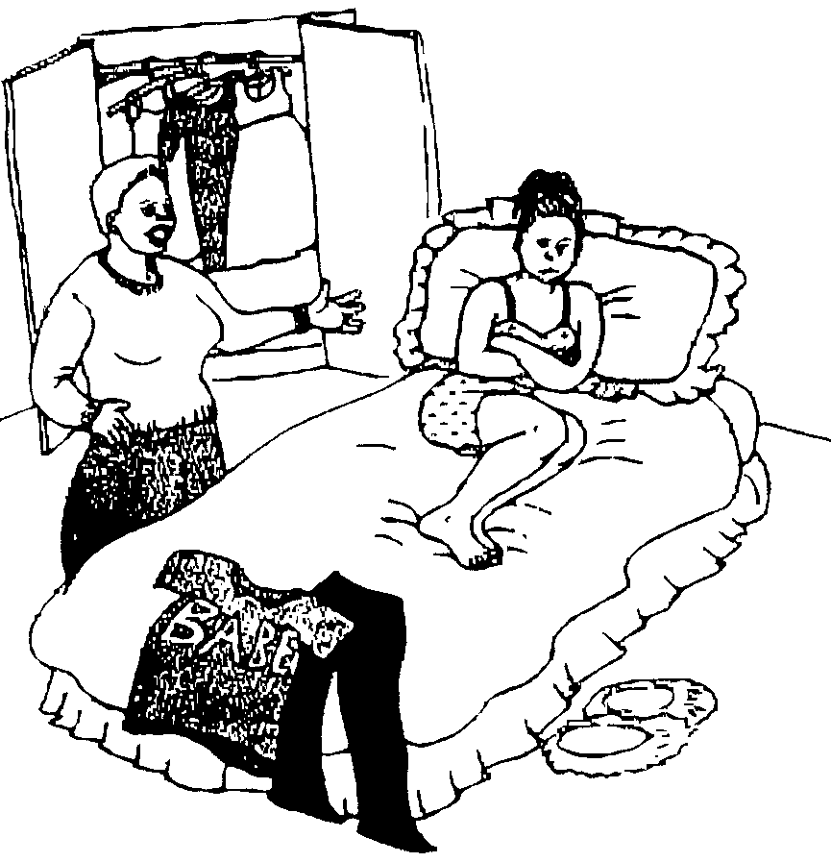

Umama nendodakazi abafuni (ukuvuma) ngenkulumo. Umama (uzothukuthela) indodakzi ngoba ifuna (ukuzikhetha) ingubo ezoyigqoka, kodwa umama wayo uyaqhubeka (ngokufunda) indodakazi ngengubo okumele iyigqoke. Manje indodakazi isithukuthele ngoba ifuna ukugqoka ingubo (ethanda) yiyona.  1 x 5 = | (5)

3.3 Bhekisisa lesi sithombe esingezansi bese ugcwalisa izikhala ngegama elifanele ukuze le ndatshana ibe nomqondo ophelele.

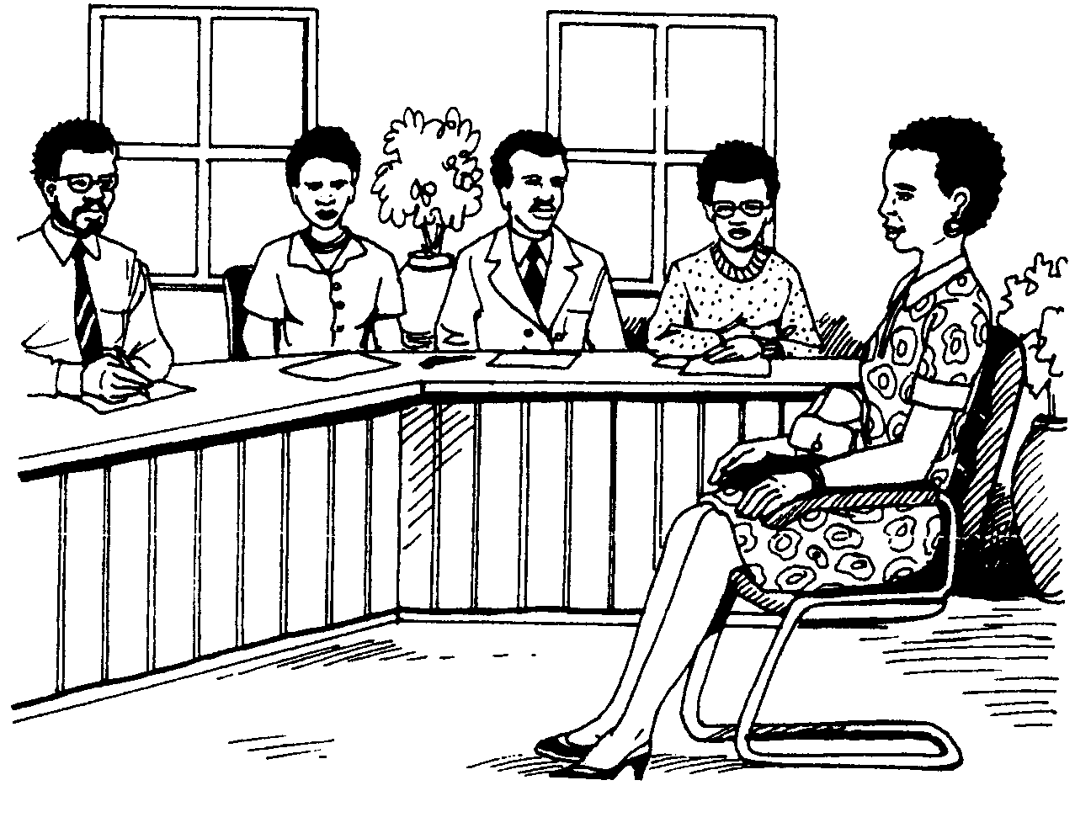

Le ntokazi ehlezi yodwa nguLindiwe. ULindiwe ufake _____ somsebenzi. Namuhla ubizwe ukuba _____ imibuzo. ULindiwe ushaywa _____ ngoba akazi ukuthi uzobuzwa yiphi _____ ngalo msebenzi. Uma ehluleka ukuphendula kahle imibuzo angeke awuthole _____.  1 x 5 = | (5)

3.4 Guqula la magama abhalwe ngokugqamile akhombe ukuthi into incane.

Isibonelo: Ngizothuma umfana esitolo.
Impendulo: Ngizothuma umfanyana esitolo.

- Ikhanda lakhe liyindilinga njengebhola.  - Silahlekile isicathulo sakhe.  - Ngizothengela udadewethu isigubhu sokudlala.  - Umkhulu uthanda ukubhema ipipi lakhe.  - Hamba uyongithengela impuphu esitolo. 1 x 5 = | (5)

3.5 Umuntu onjani obizwa ngokuthi:  - Intandane  - Ipigogo  - Nguphuma langa sikothe  - Impumputhe 1 x 4 = | (4)

3.6 Bhala isimo esifanele sesandiso kule misho elandelayo  - UNtokozo uwe (buhlungu) ngenkathi egxuma ngaphandle.  - Uma izulu liduma kukhishwa abafana (shesha).  - Ilanga (zolo) lingicobe langilalisa ngaze ngaselwa. 1 x 3 = | (3)

3.7 Bhala izenzukuthi ezikhanyisayo kucace lokho okushiwo okhulumayo  - Mina ngingedwa _____ ekhaya.  - Sithe singena bavela bathula bathi _____.  - Lezi zingubo ziwasheke zaba mhlophe _____. 1 x 3 = | (3)

AMAMAKI ESEQEPHU C:  AMAMAKI ESEWONKE: | [35]  80

