GAUTENG DEPARTMENT OF EDUCATION
SENIOR CERTIFICATE EXAMINATION

ISIZULU ULIMI LWESIBILI
IZINGA ELIPHANSI
(Iphepha lokuqala)

ISIKHATHI : amahora angu 2½

IMIKLOMELO : 90

IMIYALO:

- Leli phepha lineziqephu ezimbili, khetha kusiqephu A, uphendule yonke imibuzo kusiqephu B.
- Yonke imibuzo mayiphendulwe ngesiZulu.
- Ohlolwayo uyoklonyeliswa ngokubhala ngendlela efanelekileyo.

ISIQEPHU A

UMBUZO 1

Khetha izihloko EZIMBILI kulezi ezilandelayo ubhale ngazo kugcwale ikhasi ELILODWA ngaleso naleso sihloko.

  - Kuningi okukhulunyiwe ngemiphumela yonyaka odlule. Bhalela umngane wakho incwadi umbekele imibono yakho ngale miphumela.

  - Wena ungunobhala wenhlangano yabasha yangakini. Beninomhlangano lapho benidingida khona udaba lokungavikeleki kwezikole zenu. Bhala amaminithi alowo mhlangano.

  - Bhala incwadi u-ode izincwadi ezine ozithandayo esitolo sezincwadi.

  - Inkinga owaba nayo mhlazane uthuka uvakashelwa umngani wakho ekhaya.
Bhala inkulumo-mpendulwano ubhekise kumfanekiso ongezansi.
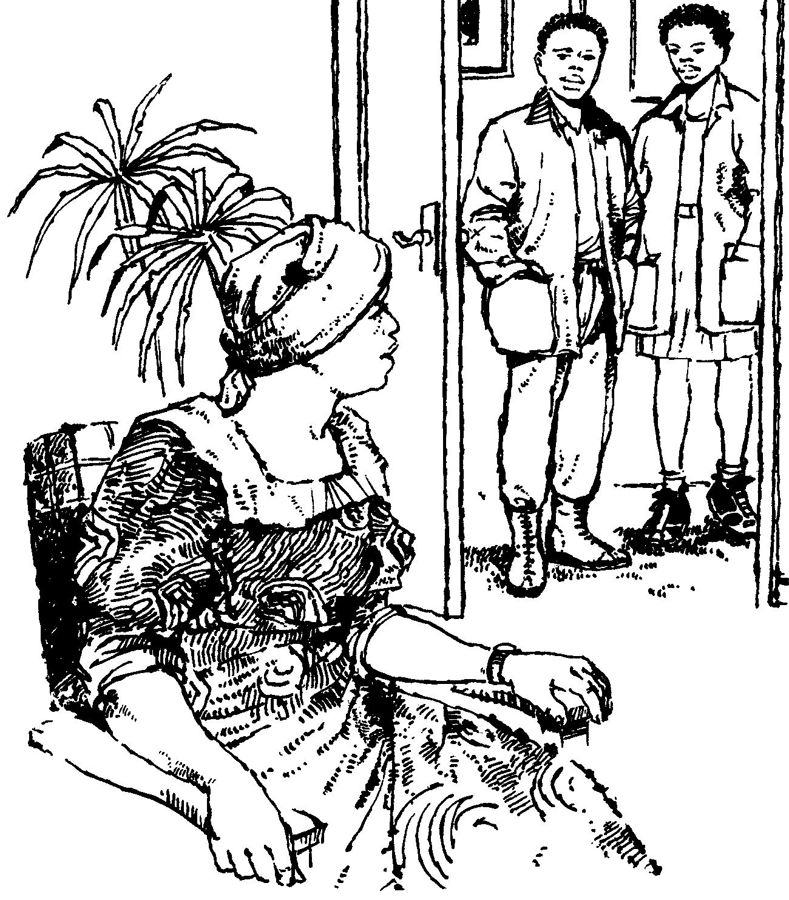

1.5 Bhala incwadi ucele isikhala sokufunda ekolishi olithandayo.

AMAMAKI ESIQEPHU A : 2 x 20 = | [40]

ISIQEPHU B

UMBUZO 2

Fundisisa le ndatshana bese usho ukuthi la mabizo adwetshelwe akuziphi izigaba zamabizo.

Balinganiselwa ku – 50 000 abantu abase South Africa abaphathwa yisifo senhliziyo (minyaka yonke)

Lesi sibalo singaphezulu kwesabafa wumdlavuza. Kuze kube yimanje baningi abantu abangaqondisisi kahle ukuthi lesi sifo bangasivikela kanjani.

Ngokwesibalo esikhishwe yi- Medical Research Council of South Africa abangu – 108 abantu base - South Africa babulawa yisifo senhliziyo nsuku zonke.

Lokhu kwenza lesi sifo sibe umbulali wokuqala nowokugcina. ESouth Africa bangu – 4 Billion abantu abaphethwe yilesi sifo.

Kanti iningi labo lisuke lingazi nokwazi. Abanye babona ngokuthi inhliziyo ime, bafe, ukuthi baphethwe yilesi sifo.  Ezinye izibalo zikhomba ukuthi owesilisa oyedwa kwabathathu nowesifazane oyedwa kwabane baphathwa yilesi sifo bengakayihlanganisi iminyaka engu – 60. Into edingekayo ukuze kunqandwe ukufa kwabantu ngalolu hlobo ukuguqula indlela abaphila ngayo.  Lesi sifo sakheka ngenxa yokugcwala kwamafutha emithanjeni yegazi. Lesi isifo sihlasela uma inhliziyo ingasalithol igazi. | (5)

UMBUZO 3

Ake sithathe ukuthi lesi sifo asisekho. Lesi sigatshana esilandelayo besiyoba senkathini edlule. Bhala -ke lesi sigaba sibe senkathini edlule.

“Lesi sifo sakheka ngenxa yokugcwala kwamafutha emithanjeni yegazi.  Lesi sifo sihlasela uma inhliziyo ingasalitholi kahle igazi” | (5)

UMBUZO 4

Kule misho engezansi bhala isabizwana soqobo esikhundleni samabizo adwetshelwe.

Izibalo zikhomba ukuthi owesilisa oyedwa kwabathathu  nowesifazane uphathwa yilesi sifo engakayihlanganisi iminyaka engu – 60.Into  edingekayo ukuze kunqandwe ukufa kwabantu ukuguqula indlela abaphila  ngayo. | (10)

UMBUZO 5

Kula mabizo alandelayo khipha isiqalo nesiqu  - Izibalo  - Iminyaka  - Indlela  - Ukufa  - Into | (5)

UMBUZO 6

Nciphisa la magama adwetshelwe

Abantu baphathwa yisifo senhliziyo minyaka yonke baningi kunalabo abafa ezingozini zemigwaqo nababulawa umdlavuza. | (5)

UMBUZO 7

Bhala igama elibhalwe ngokugqamile endabeni oyifundile, kumbuzo 2 bese ukhetha kula angenzansi uqondanise nalelo elisho okufanayo.  - Bahlaselwa  - Babalelwa  - Unyaka nonyaka  - Abangakazisisi  - Bangaziphephisa | (10)

UMBUZO 8

8.1 Guqula le misho isho ukuphika

Isibonelo: Abantu baphathwa yisifo
Impendulo: Abantu abaphathwa yisifo

- Babulawa yisifo senhliziyo  - Iningi labo abazi  - Abaningi abakasiqondisisi  - Lesi sifo sakheka ngokugcwala kwamafutha.  - Inhliziyo ibe ingasalitholi igazi kahle. | (5)

8.2 Tomula igama eliyisichasiso uqale ngalo umusho.

Isibonelo: Abantu abagulayo bayahawula
Impendulo: Abagulayo abantu bayahawula

- Abantu abangu – 108 babulawa yinhliziyo.  - Inani elingu – 4 Billion liyagula.  - Owesilisa oyedwa usefa nsukuzonke.  - Lesi sifo siletha ifu elimnyama.  - Imithambo emikhulu yegazi igcwala amafutha. | (5)  (50)

AMAMAKI ESIQEPHU B:  AMAMAKI ESEWONKE: | [50]  90

