GAUTENG DEPARTMENT OF EDUCATION

SENIOR CERTIFICATE EXAMINATION

ISIXHOSA ULWIMI LOKUQALA UHLELO OLUPHAKAMILEYO
(Iphepha Lesithathu)

IXESHA: 2½ iiyure

AMANQAKU: 120
IMIYALELO:

- Eli phepha linamacandelo amathathu.
- Fundisisa umbuzo phambi kokuphendula
- Qala icandelo ngalinye ephepheni elitsha.
- Umvavanywa uya kohlwaywa ngokuthi athathelwe amanqaku ngenxa yomsebenzi omdaka nokupela gwenxa amagama.

ICANDELO A

UMBUZO 1
IZINCOKO

Khetha isincoko sibe SINYE kuphela. Bhala ngaso uzalise amaphepha AMABINI.

1.1 Umbono owandichukumisa umphefumlo endandiwubukele kumabona-kude.

1.2 Ingaba kuyinkcitha xesha ukufundisa umntwana oyintombazana kule mihla?

Jongisisa le mifanekiso ingezantsi ukuze ukhethe ube MNYE ubhale okanye uthulule iingcinga zakho ezithi zivuselelwe ngumfanekiso lowo. Sinike isihloko esifanelekileyo isincoko sakho.
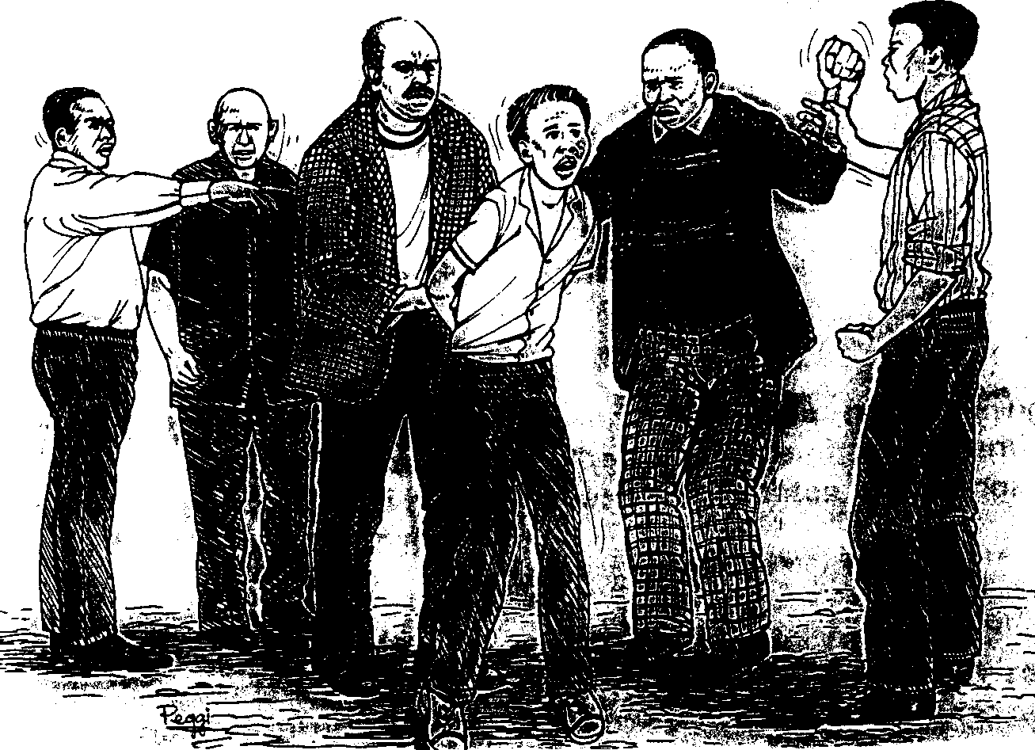

1.3.1

1.3.2
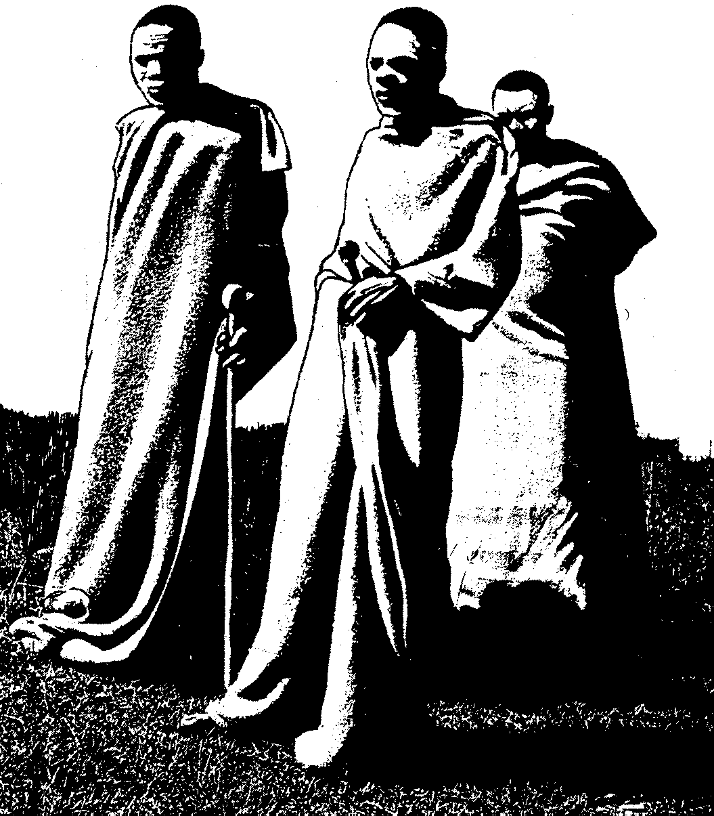

1.4 Xa ndinokuba nguceba wendawo endihlala kuyo.

AMANQAKU ECANDELO A: | [40]

ICANDELO B

UMBUZO 2
IINCWADI

Khetha umbuzo ube MNYE kuphela uze ubhale iphepha libe LINYE kwaphela.

  - Bhalela umphathi-sikhululo samapolisa incwadi umchazela ngokungalali kwenu yingxolo eyenziwa ngabamelwane benu qho ngempela-veki.

  - Bhalela umzi wempahla incwadi u-odole iimpahla ozibone kwincwadi ebebekuthumelele yona.

2.3 Bhalela umhlobo wakho olele esibhedlele ngandletyananye ogula sisifo sika Gawulayo (Aids)
1x20=[20]

UMBUZO 3

IMIHLATHI

Khetha umbuzo ube MNYE uze ubhale iphepha libe LINYE kwaphela.

Bhala isimemo sentlanganiso esine-ajenda njengonobhala ubize abafundi ubabizele entlanganisweni edla nina njengabafundi.  - Bhala ingxelo yobomi ngongasekhoyo utata wakho othe wanishiya. | 1x20=[20]

UMBUZO 4  Khetha intlobo ibe NYE kuphela kule kwezi uzinikiweyo:  - Ubone umsebenzi ephepheni kufunwa utitshala oza kufundisa ezeNzululwazi neziBalo kwibanga le10 – 12. Thumela iCV yakho.  - Thumela ucingo kuBhishophu Lokhwe umxelele ukuba iqumrhu elilawula imicimbi yecawa licela ukuba umfundisi Dyomfa atshintshwe. | 1x10=[10]

AMANQAKU ECANDELO B: | [50]

ICANDELO C

Phendula umbuzo ube MNYE kweli candela.

UMBUZO 5
IINTSOMI

SASINONCWADI KWATANCI – SATYO SC

5.1 5.1.1 Nika imisebenzi EMIBINI yokwenziwa kwamaqhina.  - Amaqhina enziwa ngoobani?  - Ngawaphi amazwi ayimvula-mlomo nasetyenziswa ngumbuzi-maqhina?  - Balisa intsomi yentombazana nesigebenga phantsi kwezingongoma zilandelayo:-  - Umyalelo  - Ukutyeshelwa komyalelo  - Ungcungcutheko  - Usindiso | (4)  (4)  (2)  (4)  (5)  (7)  (4)  [30]

OKANYE

5.2 5.2.1 Kutheni uncwadi lwemveli luphumpeka nje lwakubhalwa phantsi?  - Ingaba uyalungqina uluvo lokuba isekho imfuneko yokwenziwa kweentsomi kule mihla okanye hayi, nika izizathu.  - Vumbulula umxholo wale ntsomi ithi Imvelaphi yezimba?  - Nika iimpendulo zala maqhina alandelayo:-  - Ndinamthi wam awunakusitshulwa nasesingakanani na isikhukula.  - Ndinamlambo wam ongatshiyo, abomvu, onqabileyo amanzi ndiphila ngawo.  - Ndinamntu wam unxibe mnyama, umlomo ubomvu.  - Ndinamntu wam uzakhela indlu kodwa angalali kuyo.  - Ndinamntu wam uthi “Ndimhle ngapha ndimbi ngapha. Ndoniwe yile ndawo”  - Ndinamntu wam uthi xa eza kungeniswa emnyango akhululwe ahanjiswe ze. | (4)  (3)  (10)  (6)

 | Gqibezela la maqhalo alandelayo:-  - Iinyosi zibenza ________  - Isagwityi esivuka mva _________  - Umnxeba wokubhabhisa _________  - Iliso liwela __________  - Imiphanda ibulawa _________  - Enethunga ayisengelwa _________  - Indoda engenankomo _________ |  | (7)
 |  | [30]

OKANYE

UMBUZO 6
AMABALI AMAFUTSHANE

APHA NAPHAYA – JONGILANGA DM

6.1 Dandalazisa le ntetho ingezantsi kula mabali alandelayo:

UJongilanga ngumntu oneliso elibukhali kwizinto ezenziwa ngabantu nentlalo yabo ngokubanzi. Akajongi nje adlule kwizinto azibona kwinto esingathi ayindlela yamkelekileyo yokuphila nokuhlala.

Isiko lisiko  - Alitshoni lingenandaba  - Isiporho saseVayineki | (10)  (10)  (10)  [30]

OKANYE

6.2 Funda isicatshulwa esilandelayo ze uphendule imibuzo engezantsi.

Wethu, ngowawundixelele mhla wanditshata okokuba ndinomkandoda. Ngendeza apha ndizilungiselele, Andizange ndazi ukuba ngokutshata wena ndandizibophelela kwesibomvu isithembu

Uyabona ke ngoku ungxamele ukugabadela, ngumama lo uthetha ngaye ngolo hlobo. Ukuba akufuni sixabane yeka le nto undombelela ngayo. Luchuku nje lwabafazi olu undixelela lona. Banje kanti abafazi aba ukungakwazi ukuhlalisana? Nifuna ndizicande phakathi ndithathe icala?

Kudala ndinyamezele, khawuthethe nomama lo wakho ayeke ukundicekisa. Andazi nokuba ndendele kuwe na okanye kuye.

Siphuma kweliphi ibalana esi sicatshulwa?  - Ngoobani aba bathetha apha?  - Aba bathethayo babini bazalana njani? Chaza.  - Lo ungunobangela wale ngxabano uyintoni yena? Cacisa. | (2)  (4)  (2)  (3)
- Yintoni isithembu.  Yintoni ebangela ukuba kube nzima kwesi esinye isithethi okokuba sithathe icala? | (2)  (4)
Njengoko sele kucacile okokuba ikho le idla umzi, abantu bakhathazekile, khawusityebisele ke wena okokuba umhlola uphi na?  - Ingaba isisombululo sayo le ngxaki side safumaneka kusinina? Ewe okanye hayi.  - Sibekele okuthe kwenzeka ekugqibeleni. | (9)  (2)  (2)

AMANQAKU ECANDELO C | [30]

AMANQAKU ESEWONKE: | 120

