GAUTENG DEPARTMENT OF EDUCATION
SENIORS CERTIFICATE EXAMINATION

ISIXHOSA ULWIMI LOKUQALA
UHLELO OLUPHAKAMILEYO
(Iphepha Lokuqala)

IXESHA: 2½ Iiyure

AMANQAKU: 100

IMIYALELO:

- Yonke imibuzo mayiphendulwe ngesiXhosa.
- Qala icandelo ngalinye kwiphepha elitsha
- Umvavanywa uya kulahlekelwa ngamanqaku ngenxa yomsebenzi omdaka nokupela gwenxa amagama.

ICANDELO A

UMBUZO 1

Funda ezi zicatshulwa zingezantsi uze uphendule imibuzo elandelayo:

Isicatshulwa A:

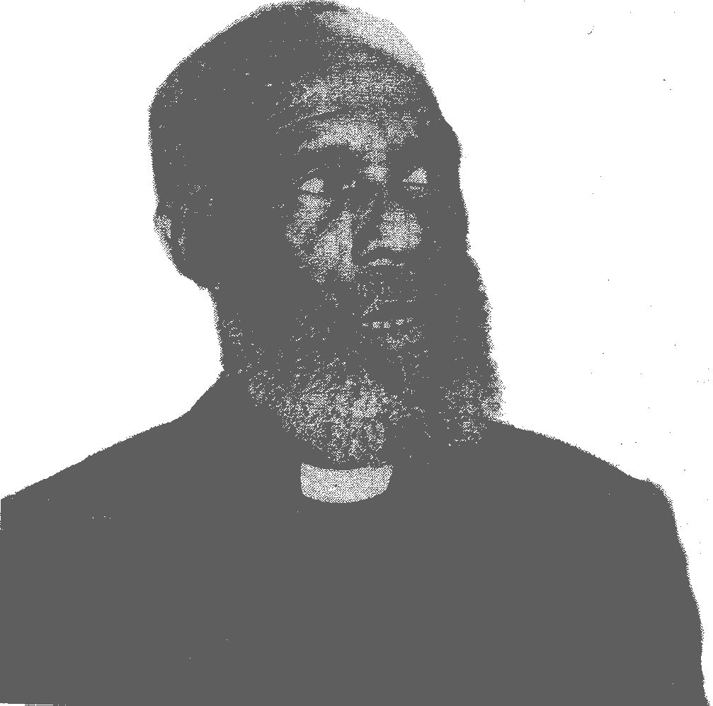

Endlwini kamfundisi uNdleleni simbona ngezo ntsuku kanye ehleli yedwa ethokombisile kucacile ukuba ukwezinzulu iingcinga. Umana ethetha yedwa, aphakame, ahamba-hambe apha endlwini, abuye ahlale phantsi. Uvakele ethandaza esithi, “Ndiyaphinda, Thixo, ndithi ndanelisekile ukuba wawungaphazamanga ukundibizela emsebenzini wakho ndilibhetyebhetyana eloyiswa butywala…”
Uthe xum kuloo ndawo ngathi kusuke kwaphela amazwi okuthetha. Into ebangela ukuba abe nje ukukhathazeka kukuba emva kwesiya siganeko samhlamnene wafunga ukuba akasayi kuze abuye abufake kowakhe umlomo utywala kodwa naku ngoku eqabuka selebuyele ngamandla kubo. Angathini ukubuyela kwinto eyamhlazisa elubala izihlandlo ngezihlandlo sele engasenagama nje phakathi kwabanye abefundisi? Uzibuze watsho ematshekile.
Uzivalele ngendlu kuba phandle phaya lenza izinto zamehlo. Kugqutha umoya obhudla ngesantya esimasikizi. Kuqala ngokuphaphatheka kwamaphepha nokuvuthuluka kwamagqabi emithi eyomileyo.

Emva kokutshawuza kwemibane ngasentla phaya, lixubayele ngesiquphe kulo lonke, yathi iphela iyure kwabe kusina imvulakazi ephelekwe ngumoya owoyikekayo ekwakucacile ukuba uza kusiphula imithi.

(P.T. Mtuze: Indlel’ecand’intlango – Shuter & Shooter)

1.1 Kwakutheni uMfundisi amane ethetha yedwa? | (2)

1.2 Wawuyintoni unobangela wokuba uMfundisi athathe isigqibo sokuba akasokuze abuye abufake utywala emlonyeni wakhe? | (2)

1.3 Lo mntu wayesamkelekile na koogxa bakhe Xhasa impendulo yakho ngoku- caphula kwisicatshulwa. | (3)

1.4 Inkathazo kaMfundisi yayiyintoni? | (2)

1.5 Lwaluyintoni ubizo lwakhe lo mntu kuthethwa ngaye. | (2)  [11]

Isicatshulwa B:

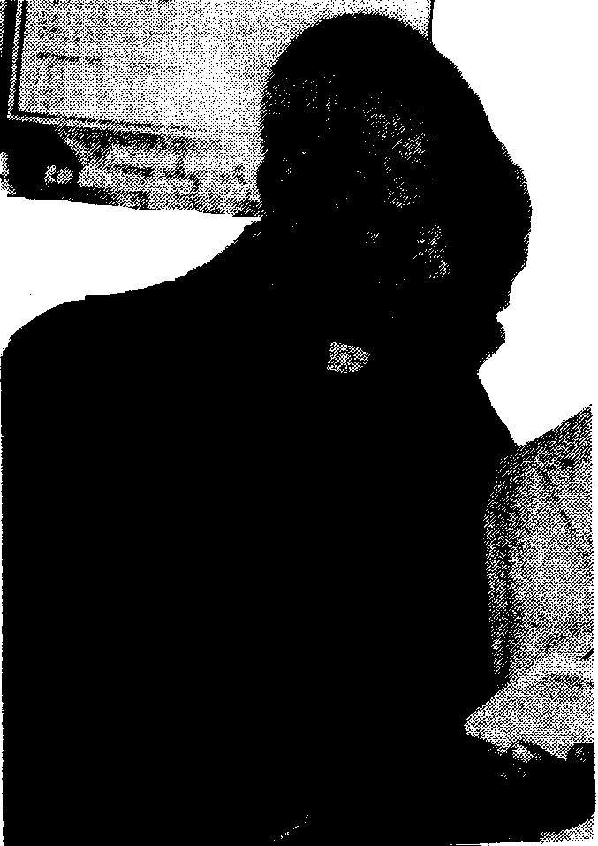

Iintshaba zikaMfundisi zafumana ithuba lokuphembelela umoya ombi phakathi kwakhe nerhamente, zisebenzisa ezo mpazamo zakhe, Yaya incipha imirhumo nenkxaso kaMfundisi. Ezona zinto zazibekwe phambili yayikukusela kukaMfundisi nokugeza kukaNkosikazi.
Kusenzeka yonke le nto nje uMfundisi usophulwa ebukhweni, kufunwa ikhazi. Wayengasalali buhlayo umfundisi kuba wayeqonda ukuba akuntsuku zatywala athelekwe umfazi kowabo. Wancama wayibhokoxela ekhazini yonke imali awayeyiqokelele, basala besitya imithwane.
Nako ngenye imini esekwezo meko abone isipaji silele phantsi kwesitulo ecaweni. Uye engasaboni kuso, wasivula ngezandla ezingcangcazelayo. Uvakele ethetha yedwa esithi “Ndibonwa yini na, makhobongwana,” akuyibona imali ekweso sipaji. Ukhe waba bumangaliswa ziipilisana ezikwakweso sipaji kodwa kube yinto elula ukusuka azipikice, azele ziphaphatheke nomoya lo gama aqhusheke eso sipaji kweyona ngxowa inqabileyo.

Akubanga thuba lide ebuyele ecaweni kwangena ixhegokazi lishixiza lithiwe minxi ngumbefu. Liye lafunisa phantsi kwezitulo, isazela sikamfundisi sekukudala simxelela ukuba yenzekile ke into.
“Ufuna ntoni na mama?” Uzibuzise watsho. “Kowu, Mfundisi, ndingofileyo namhlanje.” Ndilahlekelwe sisipaji esineepilisi zam zesifuba; utshilo lo mama unxunguphalo lubonakala ebusweni bakhe.
Ushixize waya kuphuma ngomnyango emshiya umfundisi esathe manga engazi nokuba makathini na.

Esacinga njalo umfundisi kungene indoda emaphikana yabika ukuba nalo ixhegwazana lithe gangalala phambi kwesango lecawe. Uqubule incwadi yakhe yomthandazo uMfundisi waya. Ufike wabeka isandla phezu kwalo, wathandaza, wazithandazela, wathandazela bonke abefundisi abakwizilingo apha ebomini.

(Mtuze, P.T.., Indlel’Ecand’Intlango, Shuter & Shooter)

1.6 Saba yintoni isiphumo somoya ombi phakathi kwerhamente noMfundisi? | (2)

1.7 Unobangela wokukhalaza kwerhamente wawuyintoni? | (2)

1.8 Iintshaba zakhe zawuphembelela njani umoya omdaka erhamenteni? | (2)

1.9 Yintoni eyayibangela uMfundisi angalali buhlayo? | (2)

1.10 Wayilungisa njani uMfundisi le meko? | (2)

1.11 Wasifumana njani isipaji awasicholayo? | (2)

1.12 Kukuthini ukuthi “gangalala” ngokwalapha kwisicatshulwa? | (2)

1.13 Njengomvavanywa uyibona njengento/isimo esinjani into yokusela kukaMfundisi nokugeza kukaNkosikazi. | (5)

AMANQAKU ECANDELO A: | [30]

ICANDELO B

UMBUZO 2

Shwankathela esi sicatshulwa ngezivakalisi ezi 5 izizathu ezenza ukuba abantu basele, neziphumo zokusela ngokugqithileyo.

 | Abanye abantu bacinga ukuba utywala buyabandwebisa. Asikuko nokuba bayaphosisa! Into obuyenzayo yile: Xa buselwe kancinane, ewe buvakala ngathi bukuvuselele – mhlawumbi ngokukunika isibindi wenze izinto obungephuphi nokuphupha ukuzenza xa ubungaselanga.  Kodwa xa ubusela ngokugqithisileyo, buba nomvuzo nomvuka.  Uqhuba amatakane, uhambe ukhubeka, xa uqhuba imoto, uzibambe kade kakhulu iziqhobosho kunoko ubuya kwenza xa ubungaselanga …  isiphumo – ziingozi.  Umntu uhamba, ahambe axhomekeke etywaleni. Kodwa noko kunjalo bakho abanye abangabusela iminyaka ngeminyaka kodwa bangaze baxhomekeke kubo. Aba ngaba bantu sinokuthi ngabasela ngezici ezithile – xa bephume nabahlobo, besemathekweni, basele nje kancinci. Abasoloko bebunyolukele, kodwa xa ithuba livuma – nokuba kukanye ngonyaka okanye rhoqo – basela ngoko kuphela. Ababuseli lonk’ixesha – kuba akubakhathazi nokuba bayabufumana nokuba ababufumani.  Kodwa malunga nesi-6 kwikhulu ngalinye labaselayo abanathamsanqa kangako. Baxhomekeke etywaleni – abanakuhlala ngaphandle kwabo.  Bambi babufuna ngengqondo – babuselela ukucima iintsizi ngenxa yeengxaki ezithile okanye into efana naleyo. Okanye ke bathatha ithamo okanye amabini ukuqinisa izibindi ukuba bajongane neengxaki ezithile. Nokuba siyintoni na isizathu abasiselelayo, utywala kubo ngelo xesha yinto yokwenyani ebancedayo okanye abacinga ukuba ludondolo lokubanceda bagqibe loo mini. Bubanceda bazive bewenza bhetele umsebenzi ngexa enyanisweni bubenza baphelelwe ziintloni bangakhathali nokuba bawenza kakubi kangakanani na.

AMANQAKU ECANDELO B: | 2x5=[10]

ICANDELO C

UMBUZO 3

Funda esi sicatshulwa wandule ukuphendula imibuzo.

Yimini eyayimbi leyo noxa namhlanje isuka isibulale ngentsini into yokuba nomfanekiso womhlohli wonke wakwaNokholeji elungulunguza phantsi kwetafile.
Le nto yenzeka kulo nyaka uphelileyo, ngokusuka zingakhwelwa ngokwentetho yabafundi, yonke loo mini yangoLwesine. Yehla yona inkathazo nje ukuba libethe icala emva kwentsimbi yesine. Zangena zijuleka izithuthi zabafundi babucala, beleqa ukungaphoswa yintsimbi yesihlanu eziqala ngayo izifundo zasemva kwemini. Bambi babengakhange bagqithwe ngumgosi lowo wokungakhwelwa kwazo emini. Ewe, babekho nabo babekhe bawuthi rhithi umlevo lowo koko bazimisela ukuba abasayi kulawulwa ngabantwana njengoko babebabiza besakubabiza njalo abafundi abahlala kwizakhiwo zokuhlala abafundi apha kwaNokholeji.
Nangona kwakulila ibhungane emini, lalizele limi ngeembambo igumbi lokufundela, yaye ungeze wazi nokuba nezo nkewana zazizinike ikhefu emini zazingekho na eqeleni. Waqhuba umhlohli njengesiqhelo kumnandi ehlekisa. Akazanga aligqibe awayelithetha suka zee pam zona izikhanyiso ngephanyazo. Yaba seso sijwili, ubazi ke nawe abasetyhini ngokuthanda imikhwazo, bebiza umhlohli, endingazi ukuba wayenokuba nancedo luni na kweso sithokothoko sobumnyama. Olo sizana lomhlohli lwaziqhusheka phantsi kwetafile luzama ukusindisa isiqu salo, lungabananze nganto nabo babejweda okweentsana.
Yayisele iphele tu yona imizuzu elishumi elinesihlanu ukuthi qharha kwezikhanyiso zingalindelwe bani. Kwakutsitywa phezu kwezitulo neetafile ke apho inguwashiywa ukusinga emnyango. Ayizange imangalise nakubani ngaloo yure yobindeko nento yokuvumbuluka kwendedeba leyo phantsi kwetafile, igqotsile ukubheka emnyango.
Nanamhl’oku ungamva umhlobokazi wam olirharha kunene esithi akumbona umhlohli lowo, “Ngumbon’ ombi ke lo,” suka siyome intsini kuba leyo yindlela esikhumbuzana ngayo loo mhla waphantsi kwetafile.

(P.P.N. Dudumashe, 1985, Umfundi eUnitra)

3.1 Sebenzisa ezi zifanekisozwi zingezantsi kwizivakalisi, uphuhlise intsingiselo yazo. Izivakalisi zakho zahluke kwezi zikwisicatshulwa.

- pam  - rhithi  - qhasha | 2x3=(6)

3.2 Khetha amagama emboleko kwesi sicatshulwa singentla, wandule ukuxela igama nolwimi ekubolekwe kulo.

Cwangcisa ngoluhlobo:

Igama | Ekubolekwe kulo | Ulwimi

3x3=(9)
[15]

UMBUZO 4

4.1 Funda la mabinza alandelayo aphuma kwisicatshulwa wandule ukuwa- sebenzisa kwezakho izivakalisi, uze unike nentsingiselo

4.1.1 Kwakulila ibhungane  4.1.2 Lalizele limi ngeembambo. | 1x4=(4)

4.2 Kumhlathi wesibini sifumana isenzi “beleqa”. Sebenzisa isiqu sesi senzi kwisivakalisi ngeendlela ezintathu.
Ukubonisa ukuba intsingiselo inakho ukuguquguquka ngenxa yezimamva ezisentyenziswe nazo.
Cwangcisa ngolu hlobo

 | Isenzi | Isivakalisi
 |  |  | 2x3=(6)
 |  |  |  | [10]

UMBUZO 5

Khetha izibanjalo zibe ZIHLANU apha kwisicatshulwa wandule ukujonga indlela ezisetyenziswe ngayo. Usakugqiba uzisebenzise kwizivakalisi zakho ungabhali ezi zikwisicatshulwa.

Cwangcisa ngoluhlobo

Isibanjalo | Isivakalisi

2x5=(10)
[10]

UMBUZO 6

Kumhlathi wesibini wesicatshulwa chonga ezi zigaba zentetho zilandelayo, usakugqiba uzisebenzise kwizivakalisi ngendlela yakho, hayi ekwisicatshulwa.

- Izibizo zibe ZIBINI  - Izimelabizo zokwalatha zibe ZIBINI  - Isimelabizo soqobo sibe SINYE | 1x5=[5]

UMBUZO 7

Lungisa iziphene othi uzifumane kulo mhlathana uwunikiweyo.

zahamba iintsuku umhlange egula sekuphantse kwancameke ugcina kwakubonakala ukuba lomvandedwa umana ukumbhonya bhonya kodwa angade awuxele mntwini. Ugqirha nosibonda nomfundisi bakhe balumana iindlebe malunga nemo yomguli lo besithi kambe emva kokuba ilifa lakhe kwakho ukuzola nakuba kungadange kugqibe kusoloko kubonakala ukuba kukho into emdlayo yaye le nto ngathi ugcina uyayazi kuba nenku esoloko esezinyembezini | [20]

AMANQAKU ECANDELO C: | [60]

AMANQAKU EWONKE: | 100

