GAUTENG DEPARTMENT OF EDUCATION
SENIOR CERTIFICATE EXAMINATION

ISIXHOSA ULWIMI LOKUQALA
UHLELO OLUPHAKAMILEYO
(Iphepha Lokuqala)

IXESHA : 3 Iiyure

AMANQAKU : 160

IMIYALELO

- Yonke imibuzo mayiphendulwe ngesiXhosa.
- Umvavanywa uya kulahlekelwa ngamanqaku ngenxa yomsebenzi omdaka nokupela gwenxa amagama.
- Qala icandelo ngalinye kwiphepha elitsha.

ICANDELO A

UMBUZO 1
IMIHLATHI

Khetha iintlobo zibe MBINI zemihlathi kuphela. Uhlobo ngalunye malungadluli kwiphepha ELINYE, kwaye qala uhlobo ngalunye kwiphepha elitsha.

1.1 IMIZUZU  Ibe shushu ingxoxo phakathi kwegqiza lootitshala nelimele abafundi malunga nomba wokugxothwa komnye wabafundi yinqununu kuba ezithwele. Ungunobhala wale ntlanganiso, kha utsho sive. | (20)

1.2 IMEMORANDAM  Nanko umfanekiso weqela obe ukulo livele kwiphephandaba. Sinomdla wethu, kha usityekezele ngokuqulethwe yimemorandum ebe niyihambisile, ibibhalwe nguwe kaloku utyunjwe ngokuthenjwa liqela lakho. | (20)

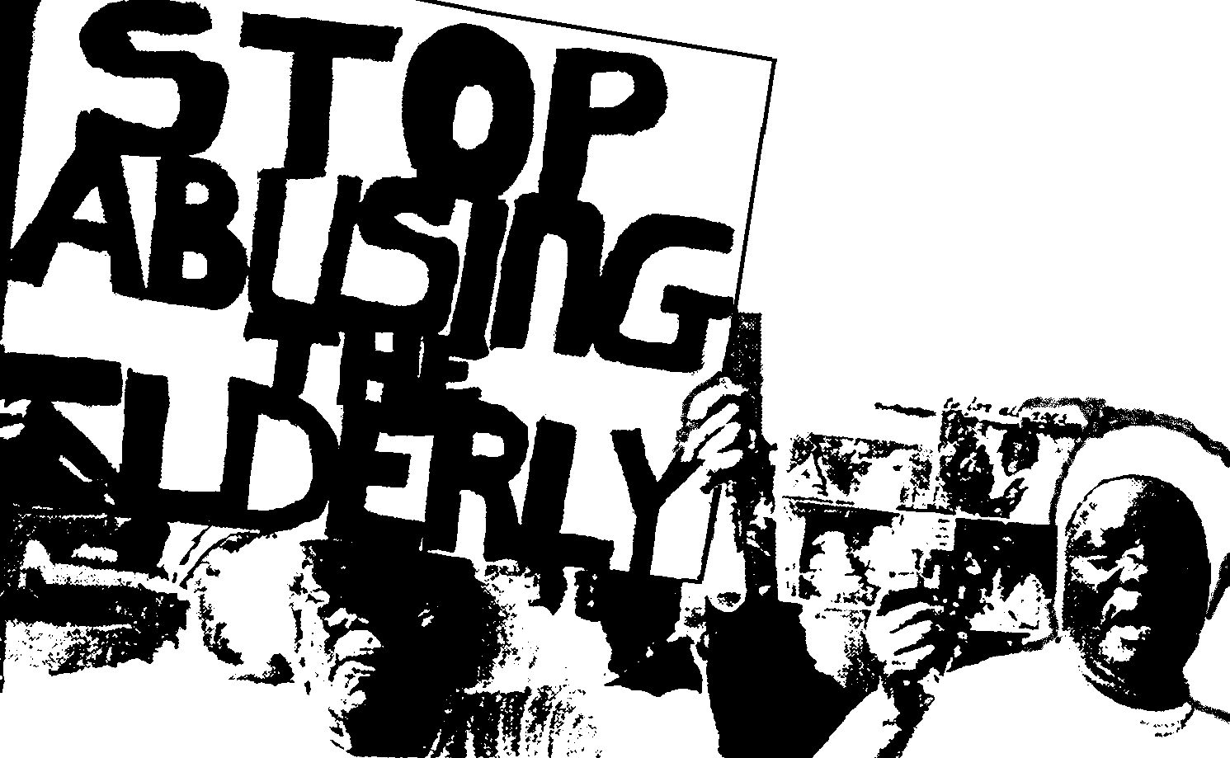 | (20)

1.3 IRIPOTI

Njengomcholacholi ndaba osoloko engasemoyeni, kha usityebisele ngozaziyo ngalo mba ungezantsi:

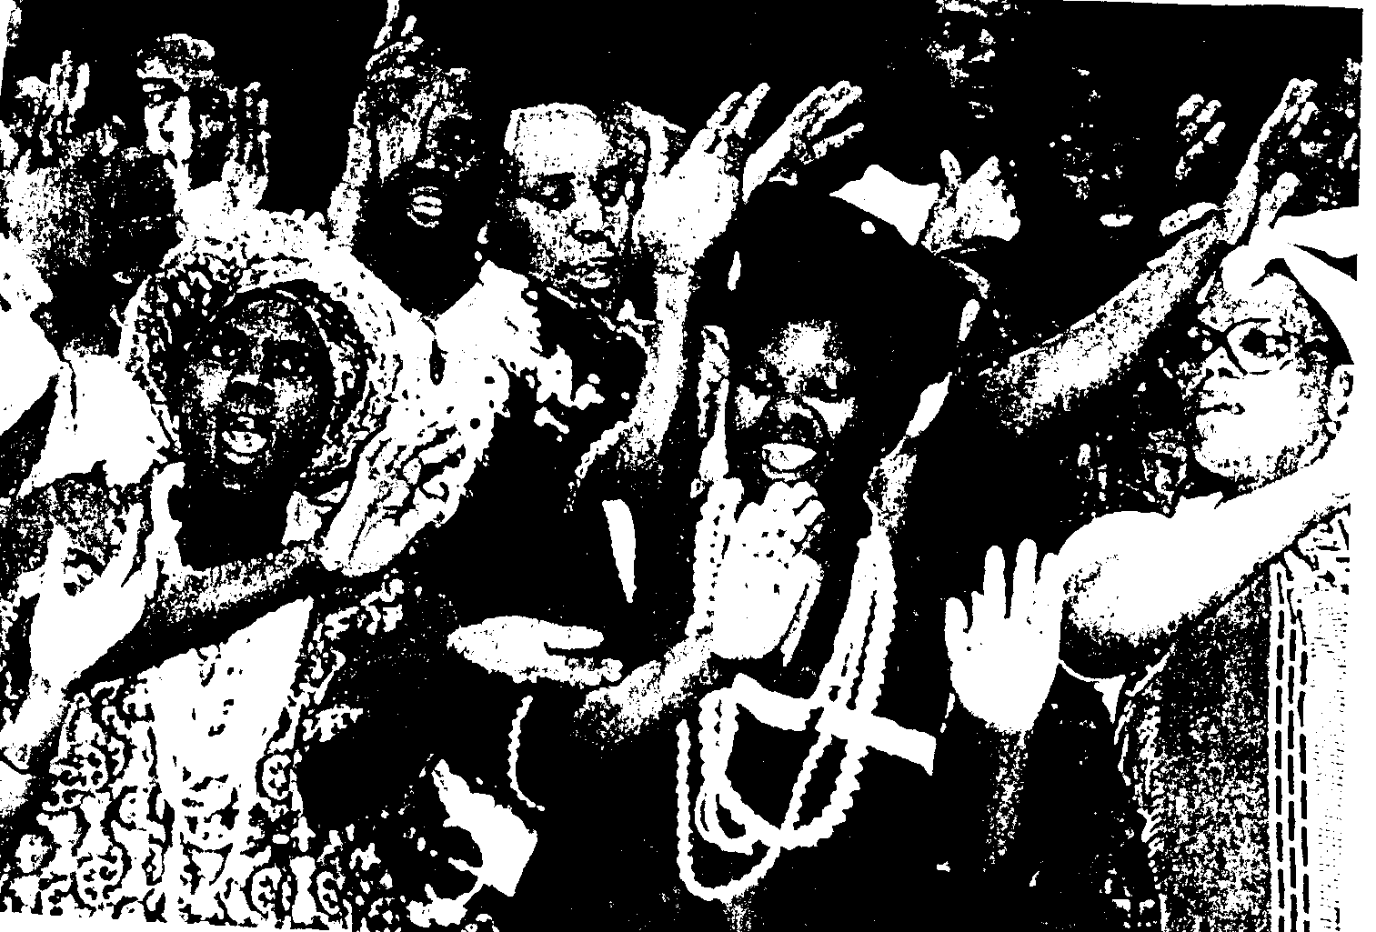 | (20)

20 X 2 = | [40]

ICANDELO B

UMBUZO 2

Shwankathela esi sicatshulwa ngamazwi anamagama 25. Libhale inani lamagama owasebenzisileyo.

Wathi cwaka ixesha elide uNomthandazo efundekelwe yile ngcinga yamtsho wadideka, waza ekugqibeleni wenjenje ukumphendula umfo kaMsweli, “Mna ndingumntu oxhomekeke ekukholiseni abazali bam, ndithi nokuba into bendiyithanda ndizicenge ndiyiyeke ukuba abayithandi. Kukwangokunjalo ke naxa beyithanda, ndiyayizama ndiyithande ngokomqweno wabo. Xa nditshoyo ke ndithetha ukuthi, ezam izigqibo ndedwa azincedi lutho, kuba zixhomekeke kwezabo, ngoko ke akukunceda lutho ukufumane ndikunike ilizwi elingcangcazelayo, ndicinga ukuba mandikhe ndifakane umlomo nabo phambi kokuba ndikunike ilizwi elithe ponono.”  Kufundwa Ngamava M Dana | [20]

UMBUZO 3

Funda esi sicatshulwa singezantsi uze uphendule imibuzo elandelayo:

UThemba uye ngqo kwibhayisekile yakhe engachithanga namnye umzuzu, wafika wakhwela, wanyawuza. Kuthe ukuya kuphuma esangweni wabe unina nomafungwashe sebefihl’ amehlo kuba ibikwisantya esingathethekiyo. Nguntondo onguSonwabile kuphela kwelo khaya obonakele enehlombe nemihlali koku kudyarha kungaka kukaThemba. Uvakele ethetha ekhwaza ekwezo mpembelelo zemincili esithi, “Khanibone umfo kabawo! Khanijonge indlela ayibalekisa ngayo ibhayisekile! Yinjinga utshatshele!’
UThemba esakufika kwindlela ehlayo yemoto ube ngathi ududulwa ngesinyalumani, yaqengqeleka ngakumbi ibhayisekile yakhe, isik’ umoya, kwatsho kwajuba uhili. Iintombi ebezihlakula kwintsimi kaTat’ uQwabe zithe zisakubona eso santya siphezulu zathi nqumama kumsebenzi wazo, zee xhonkxosholo, zatyebis’amehlo. Kusenjalo uThemba uziyekile iimpondo zebhayisekile, akabambelela, izandla zozibini wazifaka kwiingxowana zebhulukhwe, wabeth’umlozi ecula.
“Heyi! Yincutshe yokukwel’ ibhayisekile uThemba, namhlanje ndimncamile,’ uvakele encoma esitsho uNomhle, omnye welo gqiza labahlakuli.
Kuthe xa uThemba athi bhije edolweni elitsolo yahola ibhayisekile ngesiquphe, yambhukuqa, yangxogxa phezu kwakhe.
“Nceda-a-a-ani! Nceda-a-a=ani! Wa-af’ umtwan’abantu! Okhu bethu!” likhuze likhwaza lisitsho ixhegwazana ebelibetha ngezikaTshiwo linyusa loo ndlela. UThemba uvuke sekumzuzu, emthuqwasi luthuli, wazivuthulula ekhwina, encwina, egcuma.
“Akwenzakalanga kakhulu kodwa, mzukulwana?” libuze latsho lisakufika kuye ikhehlekazi.
“Hayi noko, makhulu,” utshilo uThemba etshon’ eqokobheni. Nanko engcambaza, ejingxela ukubuyela endleleni, idolo lakhe lenyele, eyishiya kuloo ndawo yentlavubela yentlekele ibhayisekile yakhe ibubutyobo.

- Kwesi sicatshulwa singentla khetha amazwi adiza ukuba unina kaThemba nomafungwashe bebexhalabile besakubona indlela ayibalekisa ngayo ibhayisekile.  - Uchukumiseke njani wona okaSonwabile umxhelo esakubona indlela ayibalekisa ngayo ibhayisekile uThemba.  - Wenze ntoni uThemba esakubona ukuba iintombi zimbukele ngomdla?  - Cacisa le ntsingiselo ethi. Bhije edolweni elitsolo.  - Esi sikhuzo okhu bethu! sisetyenziswa xa kutheni?  - Ngumntu otheni ekuthiwa ngumafungwashe?  - Untondo ngumntwana wesingaphi?  - Kwesi sicatshulwa singentla khetha isaci esithetha ukuhamba ngeenyawo.  - Nika izaci zibe ZIBINI ezichaseneyo ngentsingiselo kwesi sicatshulwa.  - Kwakwesi sicatshulwa khawukhethe igama elithetha intshatsheli.  - Xela intsingiselo yezi zaci esizithaphulula kwisicatshulwa;  3.11.1 Ukutshon’ eqokobheni  - Ukusik’ umoya  3.12 Xela isigaba sentetho segama ngalinye kula abhalwe ngqindilili kwisicatshulwa. | (2)  (4)  (4)  (2)  (2)  (2)  (2)  (2)  (4)  (2)  (2)  (2)  (10)  [40]

ICANDELO C  UMBUZO 4  Yakha izivakalisi zibe ZIHLANU ngegama Intloko ukubonisa ukuba iintsingiselo azifani zahlukile. | [10]

UMBUZO 5  Sebenzisa la magama kwizivakalisi ngohlobo oluya kucacisa ukuba uyayazi into ethethwa ligama ngalinye.  - Inxeba, umnxeba  - Umxhaxha, isixhaxha  - Ugxa, ulugxa  - Umphako, isiphako  - Iphango, isiphango | [10]

UMBUZO 6  - Bonisa ukuba uyayazi into ethethwa ngala mabinzana kwizivakalisi.  6.1.1 Ukuba yimfene  - Ukuba lilitye  - Ukuba yihagu  - Ukuba liphela  - Ukuba yinyoka | (10)

6.2 Sebenzisa la magama kwizivakalisi ukubonisa ukuba uyawazi into ayithethayo.  - Saa  - Gaga  - Ngcu  - Tywa  - Bhaxa | (10)  [20]

UMBUZO 7  Sebenzisa kwisivakalisi isenzi ngasinye kwezi zilandelayo, ngendlela EZIMBINI. Okukuqala sisebenzise njengesenzi esigqibeleleyo. Okwesibini njengesenzi esilabalabayo.  - Ukuhlala  - Ukushiya  - Ukubuya  - Ukufanela  - Ukukha | [20]

AMANQAKU EWONKE: | 160

