GAUTENG DEPARTMENT OF EDUCATION
SENIOR CERTIFICATE EXAMINATION

ISIXHOSA ULWIMI LOKUQALA
UHLELO OLUPHAKAMILEYO
(Iphepha Lokuqala)

IXESHA : 3 Iiyure

Amanqaku : 160

IMIYALELO:

- Yonke imibuzo mayiphendulwe ngesiXhosa.
- Umvavanywa uya kulahlekelwa ngamanqaku ngenxa yomsebenzi omdaka nokupela gwenxa amagama.
- Qala icandelo ngalinye kwiphepha elitsha.

ICANDELO A

UMBUZO 1

IMIHLATHI

Kweli candelo unikwe iintlobo ezintathu zemihlathi. Khetha iintlobo zibe MBINI kuphela. Uhlobo ngalunye malungadluli kwiphepha ELINYE.

1.1 IRIPOTI / INGXELO

Njengomchola-choli ndaba osoloko engasemoyeni, kha usityebisele ngozaziyo ngalo mba ungasezantsi kwiindaba zangokuhlwa nje.
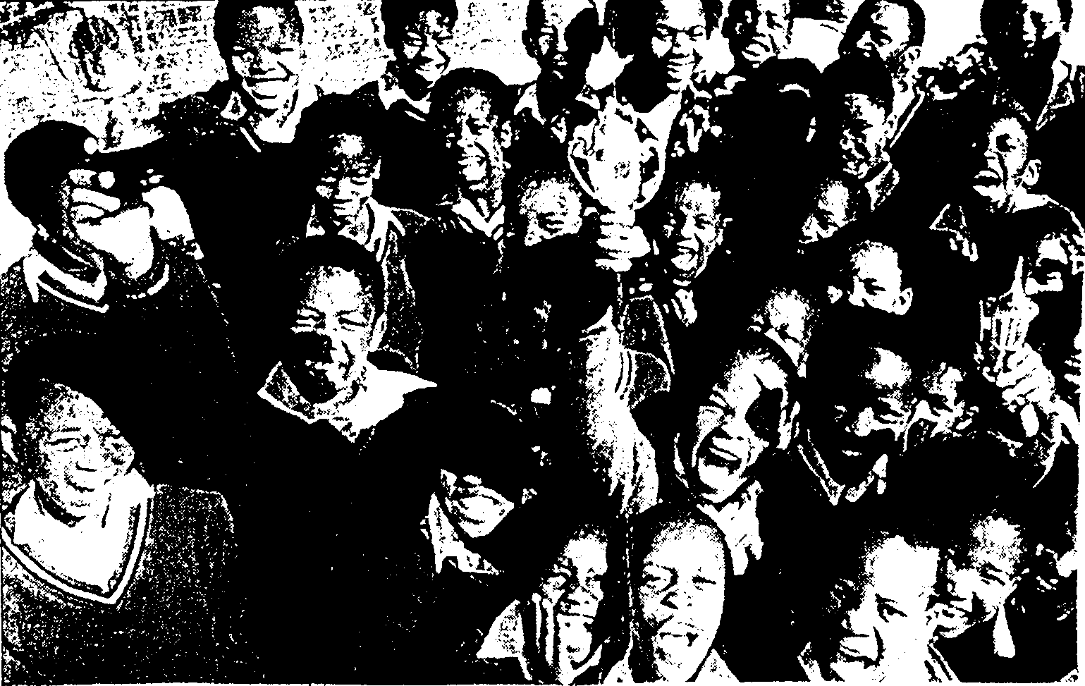

(20)

1.2 ISIMEMO SENTLANGANISO  Imasizenzele ifundisa ngokuzenzela  Umnu G Zonke wombutho Imasizenzele uthi umbutho wakhe ubone kufanelekile ukuba kubekho uqeqesho olunikwa abantu ngokubhekiselele kwingxaki malunga nentlalo abantu abayiphilayo.  Ungunobhala walo mbutho, mema uluntu ulumemela kwintlanganiso eniza kuthi niphalaze iingcinga eninazo ngalo mbutho. | (20)

1.3 IMIZUZU

Ubushushu bentlanganiso phakathi kwekontraka kaNcendanani negqiza labantu malunga nomba oqulathwe ngumfanekiso lo. Ungunobhala wale Ntlanganiso, kha utsho sive.

IXABISO R85 000,00 | (20)  [40]

ICANDELO B

UMBUZO 2

Shwankathela esi sicatshulwa silandelayo ngamazwi aya kuba malunga nama-35
Libhale inani lamagama owasebenzisileyo

Kuhle kwabonakala kuGwali noNtinde, ingekadibani imikhosi, okokuba icebo labo lonakele. Yaba nye idlela yabo, besazinje ukuba ukuxolelwa akukho, yeyokuba kusatywe. Ngelo xesha umzi wasemaXhoseni ubusemi phakathi koMzimvubu noMbhashe. AmaGwali namaNtinde, ngenxa yevuso lawo, awuwela uMbhashe, atsalela phambili, ayiwela iNciba, aliwela iQonce neXesi, akayekelela, wangathi umphindezeleli uhleli ekhosi. Bathe ukuze baqale ukuthi khefu, baqala bawelela ngaphesheya kweNxuba, kwesakwaNojoli, malunga nale ndawo kwakhiwe kuyo namhla isixekwana saseSomerset East. Makhe sibayeke khona, sibuyele kuPhalo, obemi ngoku phakathi koMbashe neNciba.  (Imibengo, W BENNIE) | [20]

UMBUZO 3

Funda esi sicatshulwa singezantsi uze uphendule imibuzo elandelayo.

Lingaphozisanga maseko iqela laseNqabarha lingene ebaleni lingenamkhinkqi, litsholoza ngodlwabevu lwegwija elithi: “kudala sicel’ umngeni, bayasoyika abaphenduli.” Belikhokhelwe nguSizwe “Batshisembawula” Somdaka omatshamba ngathi udl’ amas’ egusha, inguye ngenkqu intlabeli, sel’ eyiloo nto ke ukugqezula urheme kuba kambe ngumntu wenjezu. Besekukho kweso siqhu nezinto eziman’ ukuqobisa, ziphatha kuphutshuluka umsila wembulu, zisuk’ amadlu ngehlombe nemihlali, zitshayelela, zisithi: “Ninganyebelezeli kuza kudlalwa!”
Kungekudala lilandele neqela laseFort Malan, langena ngegwija elithi: “Kudala sisiya ezizweni sibuye nodumo,” laza lalandelisa ngengoma enesingqi segwatyu, ethi: “Naqhel’ amagwala, soze nisenze nto,” kuhlabelela uMvume “Excellent” Jikwana.
Baye bema ngeendawozabo ke abadlali, waza usompempe wavuthela into yakhe, waqala umdlalo. Hayi ke, mfo kabawo, ithe ibhola ikweli cala yabe ikweliya, ingenasizinzo konke. Kwazisuka nje kucace okwekati emhlophe ihambehlungwini ukuba kudibene izangxa, kwaye kakade la maqela omabini ngomahlal’ ezondana. Kuthe ngomkhono weyure kudlalwa, uThembile “Go-man-go” Dumalisile waseNqabarha wakhawulela ibhola wayithi nyenge ngesithende kuSoweto “Jo-‘burg-style” Mqikela othe yena akalibazisa, wadubula isithonga kwangoko. Unozinti uthe eyitsibela ezam’ ukuyiganga yabe seyidlule ngephanyazo yatsho phakathi, wabhakuzela umnatha.
“Huntshu! Ingeni-i-ile!” Idanduluke isitsho ngentswahla yemincili inginginya yababukeli becala likaSoweto behalalisa, bekhuthaza. Isigaba sokuqala siphele inqaku liselinye kwimband’ esikhova.
Ithe idlula imizuzu engama-30 kuphindelwe enkomeni yabe iFort Malan sel’iyiyo ngoku enkqenkqeza phambili okwentloko kaloliwe, ngamanqaku amabini afakwe nguMandla “Jomo” Ndima. Umdlalo ude waphela amanqaku esemi ngolo hlobo, yabe ke iF.M izuza indebe ejikelezayo. Idlule loo mini eso sibhadlalala somdlalo singudaba-mlonyeni komdala nomncinci.

- Loluphi uhlobo lomdlalo webhola olu sibaliselwa ngalo apha ngumbhali? Xhasa impendulo yakho.  - Belisithini igwijo elingene ngalo ebaleni iNqabarha?  - Chaza izinto azibalule ngazo uSizwe xa bekungenwa ebaleni liqela lakhe.  - Gqibezela. Kulo mdlalo bekudibene izinto ebezikade _________.  - Xa kuthiwa kudibene izangxa sukuba kuthethwa ukuba kudibene ntoni?  - Inqaku lokuqala kulo mdlalo lifakwe ngubani?  - Yintoni eyona nxaxheba ibalulekileyo ethathwe nguMandla kulo mdlalo?  - Leliphi iqela elizuze indebe ejikelezayo?  - Sisigaba sini sentetho esi Huntshu! Khawuxele futhi ukuba eli gama lisetyenziswa xa kutheni na?  - Eli gama lithi nyenge lisesiphi isigaba sentetho?  3.11 Yakha isenzi esikuhlobo lokukhankanya ngeli gama ubuzwe ngalo apha ngentla ku 3.10. | (3)  (2)  (3)  (2)  (2)  (2)  (2)  (2)  (4)  (2)  (2)

3.12 Eli gama lithi F.M. lithini ngokupheleleyo ngokuphathelele apha kwesi sicatshulwa?  - Eli qela lizuze indebe ejikelezayo liphumelele ngamanqaku amagaphi?  - Eli gama amatshe lisisibizo esakhiwe kwisifanekisozwi esingubani kwesi sicatshulwa?  - Umkhono weyure yimizuzu emingaphi?  - USizwe, uSoweto, uMvume, uThembile noMandla ngoobani amagama abo asebholeni?  - Nika intsingeselo yesi saci “imband’ esikhova.” | (2)  (2)  (2)  (2)  (5)  (1)  (40)

ICANDELO C

UMBUZO 4

Sebenzisa le mifanekiso oyinikiweyo ukwakha izaci.
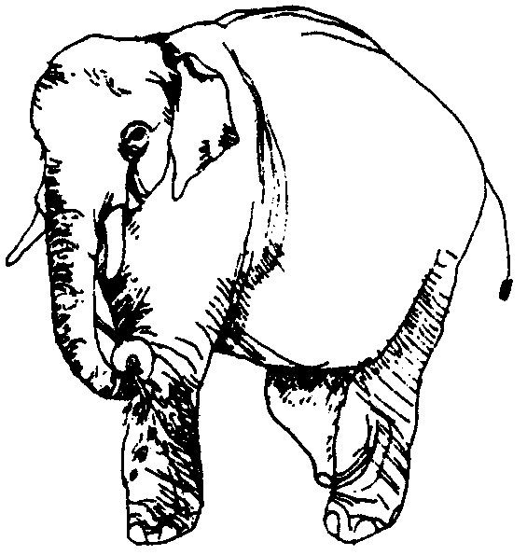
4.2
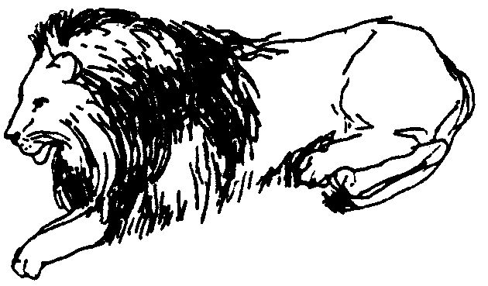  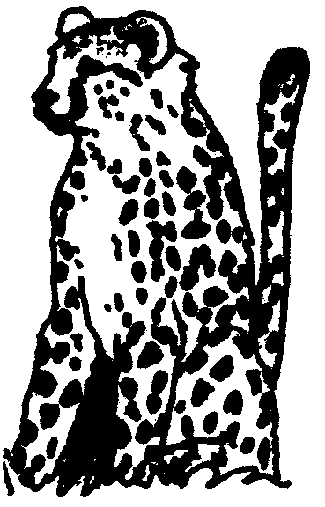  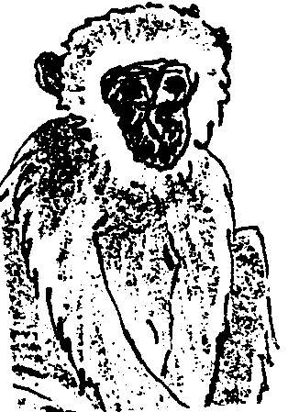  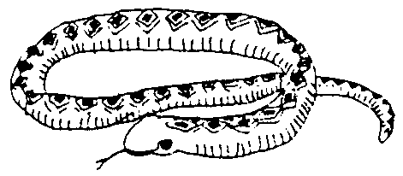  4.1  4.3  4.4  4.5 | [10]

UMBUZO 5  Sebenzisa isenzi ngasinye kwezi zilandelayo ngeendlela EZIMBINI ezahlukileyo kwizivakalisi ukubonisa ukuba iintsingiselo azifani:  - Ukuzala  - Ukucanda  - Ukuthiya  - Ukusinda  - Ukuphanga | [10]

UMBUZO 6  - Sebenzisa ezi zihlanganisi zilandelayo ngohlobo olubonisa ukuba uyayazi indlela esisetyenziswa ngayo isihlanganisi ngasinye.  6.1.1 kodwa  - nokuba  - kuba  - kanti  - xa | (10)

6.2 Sebenzisa ezi zihlomelo zilandelayo kwizivakalisi ngohlobo olubonisa ukuba uyayazi intsingiselo yazo.  - kakuhle  - emlonyeni  - ebusuku  - kamnandi  - kancinci | (10)  [20]

UMBUZO 7

  - Sebenzisa ezi zilabalabi zilandelayo kwizivakalisi wandule uxele uhlobo lwesifezekisi esilandela isilabalabi eso:
7.1.1 –fika
    - –fanele
    - –soloko
    - –hlala
    - –kholisa

Cwangisa impendulo yakho ngolu hlobo:

ISIVAKALISI | UHLOBO LWESIFEZEKISI
7.1.1 ____________________  7.1.2 ____________________  7.1.3 ____________________  7.1.4 ____________________  7.1.5. ____________________ | 7.1.1 ____________________  7.1.2 ____________________  7.1.3 ____________________  7.1.4 ____________________  7.1.5 ____________________ | (10)

7.2 Sebenzisa amagama eentaka okanye izilwanyana okanye izinambuzane ukuchaza isimo somntu ngamnye kwaba balandelayo.  Umzekelo: Umntu othanda ukuzibonakalisa ubuhlobo kanti unobutshaba  Impendulo: yinyoka:  7.2.1 Umntu othanda ukuzibuka esipilini  7.2.2 Umntu olixumbululu lexelegu.  7.2.3 Umntu onamaqhinga.  7.2.4 Umntu olulamileyo.  7.2.5 Umntu ongahlambiyo, omzimba unukayo. | (10)  [20]

AMANQAKU EWONKE: | 160

