GAUTENG DEPARTMENT OF EDUCATION
SENIOR CERTIFICATE EXAMINATION

ISINDEBELE ILIMI LESIBILI
IZINGA ELIPHAKATHI
(Iphepha Lokuthoma)

ISIKHATHI: 2½ ama-iri

AMAMAKSI: 90

YELELA:

- Leliphepha lineengaba ezimbili, isigaba A kanye nesigaba B.
- Ngaphasi kwesigaba A umfundi uyakhetha, bese kuthi ngaphasi kwesigaba B yoke imibuzo iphendulwe.
- Ngaphasi kwesigaba A, umfundi kufuze aphendule imibuzo EMIBILI.
- Ukutlola ngesineke nangobunono kuyokwenza umfundi atlonyeliswe ngcono.

ISIGABA A

UMBUZO 1

Khetha iinhloko EZIMBILI kilezi ezilandelako utlole ngazo kungeqi ikhasi ELILODWA.

1.1 Funda isikhangiso (advertisement) esilandelako esiphuma ku-iKhwezi langomhlaka 13 ku-Matjhi 2001 bese utlola incwadi yokubawa isikhundla somsebenzi esimemezelwako. Veza woke amakghono onawo ngalomsebenzi.

Isikhala somsebenzi/Vacancy

Kufuneka umuntu omutjha onebanga le-Grade 12 nanyana ozoliphothula nonyaka oneminyaka ematjhumi amabili ubudala nanyana ngaphasi ngeminyaka emibili. Umsebenzi azawenza kufundisa iinhlangano zabantu abatjha ukuziphatha navane kukhona ukuziphatha kumbi emiphakathini kanye neenkolweni. UmNyango WezeTja uzimisele ukuqeda into yokobana itja inghale iimfundo zayo nangabe ihlangabezana nobudisi eenkolweni nanyana emNyangweni wezeFundo kanye nokubona itja izigwebela amahlongandlebe emiphakathini. Ozokunikelwa lesisikhundla kufuze abe nelwazi lelimi lesiNdbelele, isiNgisi kanye nelinye lamalimi asemthethweni. Uzakubamba imihlangano neenhlangano zabatjha abuye akhulumisane nabohlokokulu beenkolo. Umuntu onetjisakalo ngalesisikhundla isibawo sakhe angasithumela kuMnqophisi WezeTja, Private Bag X 001, Pretoria, 0002. Ilanga lokuvalwa ngumhlaka 30 Apreli 2001.

Ikhwezi 13 Matjhi 2001

1.2 Umnganakho uthole umfundasimahla kwaVolkswagen bona ayokuraga iimfundo zakhe eyunivesithi ngonyaka ozako. Mtlolele incwadi umthokozise bewumbawe bona akwazise bona wenze njani ukuze aphumelele eemfundweni zakhe kanye nekutholeni umfundasimahla. Mvezele bona nawe uzimisele ukukhamba eenyaweni zakhe. | (20)

1.3 Qala isithombe esingenzasi bese utlola simemo umeme amalunga wehlangano yenu yi i-Ubuntu Youth Club, bona yize emhlanganweni enizobe niwubambe ngeveke ezako le. Kileso simemo veza ne-ajenda nanyana irherho lomhlangano.

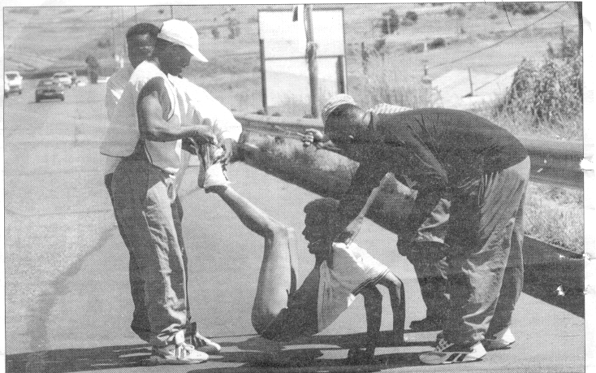 | (20)

1.4 Beninomhlangano ngepelaveke la benibonisana ngokulahlekelwa bubuntu emphakathini ohlala kiwo njengombana ubona esithombeni esingehla Tlola amaminidi walowo mhlangano uveze neenqunto enizithetheko njengomphakathi ofuna ukuthula. | (20)  2x20=[40]

ISIGABA B

UMBUZO 2

2.1 Amagama alandelako araranisiwe. Arhemise kuhle ukuze akuphe nanyana akunikele umutjho ozwakalako. Sebenzisa amagama onikelwe wona kwaphela.

2.1.1 ikhasi, ngayo, ezimbili, eyodwa, khetha, utlole, elilodwa, kilezi kuzale, incwadi. | (10)

  - Lungisa amaledere/iinhlavu zegama eziraranisweko ukuze zinikele igama elizwakalako.

Isibonelo: ociikso = isicoko.

2.2.1 bo, sa, ni, ni be, na | (6)  [16]

UMBUZO 3

3. Tlola igama lokutjengisa ubuhlobo ngalababantu abalandelako.

3.1 ubantwana bakadadwabo kamma  3.2 abantwana bakamalume | [4]

UMBUZO 4

- Funda lemitjho elandelako, utjho bona mhlobo bani wecezu lekulumo igama elithalelwe ngaphasi.  4.1 Ukulala ngeengubo ezimanzi kubangelana umgomani.  4.2 Isudu enzima iyafanelana nawuyimbethe nerhembe ebovu.  4.3 Babantu abanemali abakhamba ngeenkoloyi zomhlobo wePajero. | [6]

UMBUZO 5

5.1 Tlola phasi indlela yesenzo esithalelweko kilemitjho elandelako.  5.1.1 Ukhamba aqale phezulu loyo.  5.1.2 Simfumene adlala amadayisi nabangani bakhe.  5.1.3 Bafike sesikhambile izolo.  5.1.4 Ungambiza eze la ngizomtjela. | (8)

- Tlola izenzo ezithalelwe ngaphasi zibe nepambosi etjhiwo ngeembayaneni bese ulungisa nomutjho wakhona uzwakale kuhle.  5.2.1 Umsana lo akathandi umntazana wakwaPetha. (yokwenzana)  5.2.2 Ngiyayifunda iBhayibheli nangisekhaya (yokwenzisisa) | (4)

- Buyelela utlole imitjho elandelako ngokobana ulungise izenzo ezithalelwe ngaphasi.  5.3.1 Indoda le ibutha umkayo iinzibi zayizolo ngendlini.  - Lendlu ibonakala butjani obuyifuleleko bona yakhe yatjha.  5.3.3 Umsuqwa lo uhluma imbuya esimini kagogo. | (6)  [18]

UMBUZO 6

6.1 Khupha isabizwana esitholakala emutjhweni ngamunye usitlole phasi, bese uyatjho bona sisabizwana siphi kilemitjho elandelako?

6.1.1 Iinkoloyi zakhe zilodlhelwa nanyana kusemini akhona.

6.1.2 Boke abantu abanabomazisi banelungelo lokuvota.

6.1.3 Akusiso engisithandako leso isikhwama mntamama. | [6]  [50]  [90]

