GAUTENG DEPARTMENT OF EDUCATION
SENIOR CERTIFICATE EXAMINATION

HOTELKEEPING AND CATERING SG

TIME: 3 hours

MARKS: 200

INSTRUCTIONS:

- The examination paper consists of THREE sections.

- All sections are COMPULSORY.

- Read the instructions to each question carefully.

- Detach the answer sheet at the end of this examination paper and use it to answer Section A.

SECTION A
SHORT QUESTIONS

- All the short questions in Section A must be answered on the answer sheet at the end of this examination paper.
- Place the answer sheet inside the front cover of your answer book when you have completed Section A.
- Write your examination number on the answer sheet in the spaces provided.

QUESTION 1

  - MULTIPLE- CHOICE QUESTIONS

Several possible answers are given for each question. Select the answer which you consider to be correct and make a distinct cross (X) over the corresponding letter on the answer sheet.

EXAMPLE:

QUESTION: Russian tea may be described as

- Chinese tea without milk.

B. tea with a measure of vodka added.

- strong, hot tea, served with lemon.

- tea made from leaves from Eastern Europe.

ANSWER: | A | B | C | D

NO MARKS will be awarded if more than one cross appears in an answer.

1.1.1 Barding is the process of

- covering meat, such as fillet or chicken breast, with strips of bacon.
- inserting strips of bacon or vegetables into meat.
- pouring fat and pan juices over meat while oven-roasting.
- flattening meat with a mallet.

    - Marbling can often be clearly seen in the

- hump.
- shin.
- aitchbone.
- rump.

    - ______ is the meat-cut used for preparing Beef Wellington.

- Rump
- Sirloin
- Thick flank
- Fillet

    - The term brut refers to sparkling wine which is

- extra dry.
- dry.
- sweet.
- semi-sweet.

    - The _____ sells cigars and cigarettes to guests in upper class restaurants.

- table waiter
- sommelier
- cashier
- maitre d’ hotel

    - Hops are specially cultivated for

- making yeast that is used in industrial baking.
- yeast used for baking bread rolls.
- making a good quality brandy.
- brewing beer.

    - The raising agent in ginger bread is

- dry yeast.
- compressed yeast.
- bicarbonate of soda.
- stiffly beaten egg whites.

    - _____ is used to thicken sweet glazes and sauces because it becomes completely transparent when cooked.

- Liaison
- A white Roux
- Egg white
- Arrowroot

    - A béchamel to which grated cheese and egg yolk is added, is called

- sauce Cumberland.
- chaud-froid sauce.
- sauce Mornay.
- sauce aux oeufs.

    - Demi-glace is made by

- boiling bones slowly in 5 litres of water.
- reducing equal quantities of sauce espagnole and brown stock.
- adding stock to a brown Roux.
- mixing equal quantities of white wine and brown stock into a brown Roux.

    - Sauce Chasseur always contains

- chopped onions, tomatoes and mushrooms.
- chopped onions, white wine, vinegar and mustard.
- reduced white wine, sautéed onions and julienne gherkins.
- chopped mushrooms, sautéed onions and cream.

    - A ______ is a catering business which operates under a well-known name.

- fast food outlet
- steak house
- family restaurant
- franchise

    - The person in charge of all the uniform staff, is the

- receptionist.
- reception porter.
- executive housekeeper.
- foyer porter (concierge).

    - Cleaning material for the rooms division should be ordered by the

- financial manager.
- room divisional manager.
- housekeeper.
- floor porter.

    - The staff member responsible for supplying and controlling the linen service in the hotel is the

- floor housekeeper.
- linen keeper.
- executive housekeeper.
- valet.

    - The member of staff responsible for helping move heavy furniture is the

- head of security.
- cleaner.
- house porter.
- room attendant.

    - A Bavarois is

- a glass container.
- a meringue ring filled with fresh fruit.
- a gelatine dessert made of egg custard as a basis.
- pureed fruit pressed through a sieve and served with a gelatine dessert.
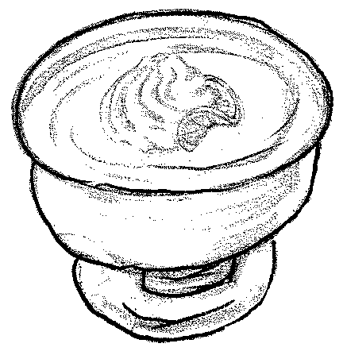
    - This serving bowl is called a

- coupe.
- vacherin.
- souffle dish.
- charlotte.

    - The ideal setting temperature for gelatine is:

- -14°
- 10° – 15°
- 25° – 32°
- -4° – 0°

1.1.20 Which glass should be used when serving Drambuie?

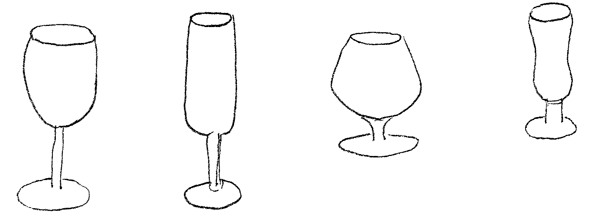  A. B. C. D. | (20)

1.2 Complete the following by writing the missing words in the given spaces on the answer sheet. Write only the correct answer in the space next to the corresponding number.  - A warm butter sauce often served with fresh green asparagus is called a _____ sauce.  - _____ service is used when guests prefer not to have a specific meal in the restaurant, but rather in their hotel rooms.  - A salad consisting of cubes of tomato, pineapple, orange and apple, served with sour cream on a bed of lettuce, is called _____ salad.  - A _____ consists of three parts olive oil and one part vinegar.  - A set menu is also called a _____ menu. | (5)

1.3 Match the dish in Column B with the description in Column A. Write only the letters (A – G) next to the correct number on your answer sheet.

COLUMN A |  | COLUMN B
DESCRIPTION |  | DISH
1.3.1 | A Malay dish made of finely chopped vegetables or fruit, well seasoned | A. | Wiener Schnitzel
1.3.2 | A braised dish made of cubed beef and onions, flavoured with paprika and tomato puree | B. | Sambal
1.3.3 | Five hundred grams of mashed potatoes mixed with choux pastry | C. | Stroganoff
1.3.4 | Thin slices of veal, coated with flour, egg and bread crumbs, fried in oil | D. | Pommes dauphines
1.3.5 | Layers of sliced eggplant, cubed mutton and onions, covered with béchamel sauce | E. | Moussaka
 |  | F. | Goulash
 |  | G. | Pommes duchesse | (5)

1.4 From the list below, choose FIVE correct facts about potatoes. Write down the FIVE letters which you choose opposite Question 1.4 on your answer sheet.  - Start to boil potatoes in cold water.  - Keep potatoes fresh by placing them on an open vegetable shelf.  - Up to Date is a versatile type of potato.  - Potatoes are classified as bulbs.  - Store potatoes in a thick paper bag.  - Potato chips are blanched in deep oil.  - One can serve green potatoes only as mashed potatoes.  - When boiling potatoes in the jacket, one should use enough water to cover the potatoes. | (5)

- Decide whether the following statements are TRUE or FALSE. Write down only True (T) or False (F) next to the corresponding number on your answer sheet.  1.5.1 Employers are responsible for the provision of training and information for their workers.  - An employee should apply the health and safety policy as prescribed by the employer.  - It is the sole responsibility of the employer to ensure the safety and health of people at work.  - The pastry chef is responsible for the preparation of desserts.  - In the smaller hotel the night porter will also do reception work. | (5)

1.6 Choose FIVE facts about Hors d’ oeuvres from the list below. Write down only the letters you choose opposite Question 1.6 on your answer sheet.  - It is best to serve hors d’ oeuvres cold.  - Bite-sized pieces of garnished toast or pastry can be used as basis for canapés.  - Small sandwiches with different fillings can be included on a tray of  hors d’ oeuvres.  - Hors d’ oeuvres are served after the soup.  - When arranging a variety of hors d’ oeuvres on a serving platter, one should have a focal point on the platter.  - Canapés can be brushed with a thin layer of aspic to prevent them from drying out.  - Fruit cocktails can be served as hors d’ oeuvres.  - Hors d’ oeuvres should be served by waiters carrying trays and should never be displayed on trolleys or display tables. | (5)

1.7 Write down the type of service used in the following instances. Write only the name of the service style on your answer sheet next to the corresponding number.  - A spoon and a fork are used to serve the food.  - Portioning of food can be controlled.  - A service style used on aeroplanes and in hospitals.  - Hot and cold dishes are displayed on a table laid with a white tablecloth, which hangs to the ground.  - A formal dinner for a large number of guests. The menu usually has four or more courses. | (5)

TOTAL FOR SECTION A: | [50]

SECTION B
CULINARY STUDIES

- This section must be answered in your answer book.

- Leave a line open after each answer.

- Rule off after you have completed a full question.

QUESTION 2

2.1 Read the following recipe for white bread and answer the questions that follow.

White Bread

1kg white bread flour
10ml salt
20g instant dry yeast
30ml sugar
± 750ml lukewarm water
50ml vegetable oil

- Give THREE reasons why salt is included in this recipe.  - Name TWO properties of instant dry yeast.  - Explain the function of sugar in baked yeast products. | (3)  (2)  (4)

2.2 During a practical class you prepared puff pastry.  - Name TWO products you can make with this pastry. 2 x ½ =  - Write down FOUR rules to take into account when handling the prepared pastry.  - At what temperature should the pastry be baked? | (1)  (4)  (1)

2.3 Explain how wine is produced through the process of fermentation.  2.4 Complete the following statements. Write down only the question number in your answer book and next to it the missing word. | (5)

Sherry is classified as a 2.4.1 _____ wine.  A wine steward should use a 2.4.2 _____ wine glass to serve Sauvignon blanc.  Rum is distilled from 2.4.3 _____ while 2.4.4 _____ is distilled natural wine.  2.4.5 _____ is a type of spirits originally produced in South Africa. It is a crystal clear liquid. | (5)  [25]

QUESTION 3

- The following desserts are served from a guéridon:  Eclairs, milk tart, baklava, steamed pudding and apfelstrudel.  - Name the country of origin of each of these desserts.  - Explain briefly what a guéridon is.  - What serving utensils should be used to serve the desserts when gueridon service is correctly executed?  - Name the kind of dough that is used to prepare the following desserts:  - Milk tart  - Baklava  - Apfelstrudel | (5)  (1)  (1)  (3)

3.1.5 Advise the table head waiter on how to handle and where to place the guéridon trolley. | (3)

3.2 Gelatine  - Give ONE word for each of the following:  - Gelatine is soaked in cold water in order to allow it to absorb water  - Gelatine is added to ice cream to help stop the growth of crystals  - The incomplete protein which is present in the connective tissue of meat on bone  - A light dish that can be sweet or savoury in which stiffly beaten egg whites are added  - A frozen dessert set in a round, dome-shaped mould which is traditionally filled with two different mixtures | (5)

- Give ONE reason for each of the following effects which can occur in gelatine dishes.  - A paw-paw mousse that will not set.  - A gelatine pudding which sticks to the mould.  - An egg custard which curdles when the gelatine is added.  - A gelatine dish which forms a soft jelly.  - A pre-plated unmoulded salmon mousse which melts.  - Explain briefly what a Charlotte Russe is. | (5)  (2)  [25]

QUESTION 4

Mr Meyer is the host of a small dinner party at a restaurant where you are the waiter.  - Mr Meyer orders a bottle of Grand Cru with the first course.  4.1.1 In what kind of glass should Grand Cru be served?  - Why should you present the wine to the host before the seal is broken?  4.1.3 Explain the correct way of pouring this wine. | (1)  (1)  (5)

4.2 Two of the guests order asparagus with Béarnaise Sauce and the other two, crumbed mushrooms with Sauce Tartare.  - Classify the asparagus and the mushrooms according to the edible parts of the plants.  - Briefly explain the following sauces:  - Béarnaise Sauce  - Sauce Tartare 2 x 2 = | (2)  (4)

4.3 Mr Meyer orders a bottle of Chenin Blanc to enjoy with the second course. Explain the procedures you should follow to serve this wine.  4.4 The following meat dishes are ordered:  - Beef Stroganoff  - T-bone steak  - Pork schnitzel  - Lamb noisettes | (4)

- Name the meat cut that is used to prepare each of the above-mentioned dishes.  - The noisettes are served with a sauce consisting of mutton stock, mushrooms and thickened with a brown roux. What basic sauce is used?  - Just before the stroganoff is served, the chef decides to thicken the sauce. Name TWO thickeners which can be used.  - The guests can choose one of the following sauces with the T-bone steak:  - Sauce Robert  - A red-wine sauce (Sauce Bordelaise)  Name the basic sauce which is used in each case.  - Name FOUR criteria for a good quality sauce. | (4)  (1)  (2)  (2)  (4)  [30]

QUESTION 5

Meat  - Name FOUR precautions which can be taken to prevent the loss of meat juices.  - The chef tells a commis chef to larder a leg of springbok with bacon and then to marinade it. Explain how one should go about this instruction.  - Choose the meat cut listed in Column B that will best suit the statement in Column A. Write only the letter (A – E) next to the corresponding number in your answer book. | (4)  (4)

COLUMN A |  | COLUMN B
STATEMENT |  | MEAT CUTS
5.3.1 | The best meat cuts to use for soups and stocks | A. | Boned cuts suitable for dry cooking methods
5.3.2 | The best meat cuts to be vacuum packed | B. | Cuts from the front quarter that contains marble fat
5.3.3 | Whole meat cuts, suitable for corned beef or pot roast | C. | Very good quality meat cuts from the hind quarter of the carcass
5.3.4 | Meat used for deep frying dishes such as fondues | D. | Tough but tasty cuts of meat that contain a large percentage of bone
 |  | E. | Meat cuts from the belly of a sheep | (4)

- Name THREE criteria which should be considered when buying meat.  5.5 Which accompaniment in Column B is most suitable for the meat dish in Column A? Write only the letter (A – F) next to the corresponding number in your answer book. | (3)

COLUMN A |  | COLUMN B
MEAT DISH |  | ACCOMPANIMENT
5.5.1 | Roast leg of pork | A. | Cayenne pepper
5.5.2 | Curried beef potjie | B. | Rosemary
5.5.3 | Boned leg of lamb | C. | Apple sauce
5.5.4 | Steak tartare | D. | Yorkshire pudding
5.5.5 | Roasted beef loin | E. | Red-currant jelly
 |  | F. | Mango chutney | (5)

TOTAL FOR SECTION B: | [20]  [100]

SECTION C
HOTEL ORGANISATION

- This section must be answered in your answer book.

QUESTION 6

- Front office  6.1.1 Name the various methods of payment by identifying the following illustrations. | (3)

BIG BANK 19-22-41-41
Date: ____________
Small Town, Gauteng
Betaal
Pay: __________________________________________

Bedrag
Amoun:: ______________________________________

10 Fat Street T.E. LANK
Small Town
1579

11.DD44 1:98841: 1988 315 9879: 01
B
BIG BANK

VISA

4901 123 459 759
T.E. LANK


(a)

(b)

(c)

6.1.2 Name TWO aspects which a cashier should be aware of when receiving these methods of payment, mentioned in 6.1.1. 2 x 3 = | (6)

6.1.3 The receptionist accidentally rang up R4 100 instead of R410 on a client’s account. How should she/he correct the situation? | (3)

6.2 Laws  - Name THREE instances when an employer has the right to dismiss an employee without notice.  - State whether it is legal to sell alcohol to a customer in the following instances. Write the question number and only the word LEGAL or ILLEGAL next to the corresponding number in your answer book.  - An intoxicated man wants just one more brandy “for the road”.  - A sixteen-year-old boy wants to drink a beer with his dad while they are waiting for the mother to join them.  - A hotel guest orders wine with a meal on a Sunday.  D. Celebrating guests order champagne at 3:00 in the morning. | (3)  (4)

6.3 Safety and security  A chef accidentally cut his/her thumb so deep that the bone is exposed.  - Explain how this wound should be treated.  - Another chef witnesses his colleague’s accident and faints. How should he/she be treated? | (3)  (3)  [25]

QUESTION 7

7.1 Hotel organisation

Choose the member of staff listed in Column B who should fulfil the duties in Column A. Write only the letter (A – F) next to the corresponding number in your answer book.

COLUMN A |  | COLUMN B
DUTIES |  | MEMBER OF STAFF
7.1.1 | The person responsible for the payment of the hotel personnel’s salaries | A. | Financial manager
7.1.2 | Promotes special events at a large hotel | B. | Front office manager
7.1.3 | Controls all accounts (between 21:00 and 7:00) before guests leave the hotel | C. | Night auditor
7.1.4 | The person who ensures that accurate records are kept of room occupation | D. | Receptionist
7.1.5 | Takes full responsibility for all the departments of the hotel | E. | Marketing manager
 |  | F. | General manager | (5)

7.2 Maintenance  7.2.1 Name THREE methods that can be used to open a blocked drain without calling the plumber.  7.2.2 Redraw the illustration of a three- point electrical plug in your answer book and indicate the colour of the different wires that are attached to the different electrical points. | (3)  (3)

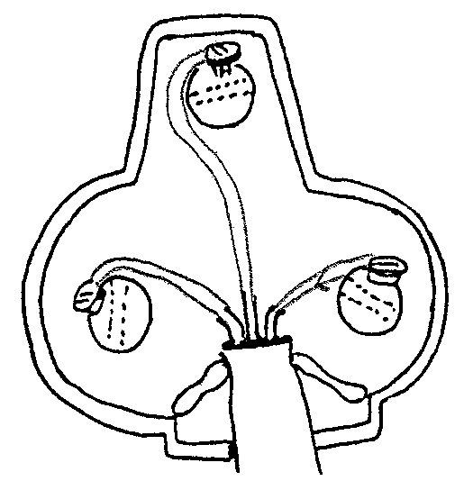
E
N
L

- Housekeeping  7.3.1 Explain what information  - front office should communicate to housekeeping.  - housekeeping should communicate to front office. 2 x 3 = | (6)

7.3.2 Name the FOUR duties of a room servant. | (4)

- Hospitality studies  Name the kind of catering businesses which provide food in the following instances:  7.4.1 They provide light meals to club members and cater for special events on request.  - Meals that are provided for a function not held at the premises of the caterer.  - The chef and kitchen staff are appointed by the company.  - A restaurant owner who pays a certain amount every month to use the name of either a well-known restaurant or a food establishment. | (4)  [25]

TOTAL FOR SECTION C:  TOTAL: | [50]  200

ANSWER SHEET / ANTWOORDBLAD

- Please detach this page and place it inside the front cover of your answer book on completion.
- Maak asseblief hierdie bladsy los en plaas dit voor in jou antwoordboek wanneer jy dit voltooi het.

EXAMINATION NUMBER:
EKSAMENNOMMER:

1.1 | 1.1.1 | A | B | C | D |  | 1.2 | 1.2.1
 | 1.1.2 | A | B | C | D |  |  | 1.2.2
 | 1.1.3 | A | B | C | D |  |  | 1.2.3
 | 1.1.4 | A | B | C | D |  |  | 1.2.4
 | 1.1.5 | A | B | C | D |  |  | 1.2.5 |  |  |  |  |  | (5)
 | 1.1.6 | A | B | C | D
 | 1.1.7 | A | B | C | D |  | 1.3 |  |  |  |  | 1.4
 | 1.1.8 | A | B | C | D |  |  | 1.3.1
 | 1.1.9 | A | B | C | D |  |  | 1.3.2
 | 1.1.10 | A | B | C | D |  |  | 1.3.3
 | 1.1.11 | A | B | C | D |  |  | 1.3.4
 | 1.1.12 | A | B | C | D |  |  | 1.3.5 |  | (5) |  |  |  | (5)
 | 1.1.13 | A | B | C | D
 | 1.1.14 | A | B | C | D |  | 1.5 |  |  |  |  | 1.6
 | 1.1.15 | A | B | C | D |  |  | 1.5.1
 | 1.1.16 | A | B | C | D |  |  | 1.5.2
 | 1.1.17 | A | B | C | D |  |  | 1.5.3
 | 1.1.18 | A | B | C | D |  |  | 1.5.4
 | 1.1.19 | A | B | C | D |  |  | 1.5.5 |  | (5) |  |  |  | (5)
 | 1.1.20 | A | B | C | D | (20)
 |  |  |  |  |  |  | 1.7
 |  |  |  |  |  |  |  | 1.7.1
 |  |  |  |  |  |  |  | 1.7.2
 |  |  |  |  |  |  |  | 1.7.3
 |  |  |  |  |  |  |  | 1.7.4
 |  |  |  |  |  |  |  | 1.7.5 |  |  |  |  |  | (5)
TOTAL / TOTAAL: |  |  |  |  |  |  |  |  |  |  |  |  |  | [50]

