GAUTENG DEPARTMENT OF EDUCATION
SENIOR CERTIFICATE EXAMINATION

HOTELKEEPING AND CATERING SG

TIME: 3 hours

MARKS: 200

INSTRUCTIONS:

- The question paper consists of THREE sections:

- ALL SECTIONS ARE COMPULSORY.

* Section A – Short questions 50 marks
* Section B – Culinary Studies:
Three questions (30 marks each) 90 marks
* Section C – Hotel Organisation:
Two questions (30 marks each) 60 marks

- Carefully read through the instructions to each question.

- Answer Section A (Question 1) on the answer sheet on page 20 of this examination paper. Detach the answer sheet and place it at the back of your answer book when you have finished. Write your examination number on the answer sheet.

- Answer ALL other questions in your answer book.

- Ensure that your answers are clearly and correctly numbered.

- Rule a line across the page at the end of each question.

- Leave a line open between subsections of a question (e.g. between 2.1 and 2.2).

SECTION A

SHORT QUESTIONS

All the short questions in Question 1 of Section A must be answered on the answer sheet provided on page 20. Please detach the answer sheet (page 20) before you begin to answer Section A.

Place the answer sheet at the back of your answer book when you have finished.

QUESTION 1

  - MULTIPLE-CHOICE QUESTIONS

Several possible answers are given for each question. Select the answer which you consider to be correct and make a distinct cross (X) over the corresponding letter on the answer sheet on page 20 of your examination paper.

EXAMPLE:

QUESTION: Russian tea may be described as

- Chinese tea without milk.
- tea with a measure of vodka added.
- strong, hot tea, served with lemon.
- tea made from tea leaves from Eastern Europe.

A | B | C | D

NO MARKS will be awarded if more than one cross appears in an answer.

1.1.1 Schnitzel is traditionally cut from

- a leg of lamb.
- the shoulder of a sheep.
- a leg of pork.
- the silverside.

    - The process of inserting strips of bacon or vegetables into meat is called

- barding.
- larding.
- pickling.
- ripening.

    - Club steaks are cut from the

- loin.
- wing rib.
- thick flank.
- topside.

    - Marbling can often be seen clearly in the

- hump.
- shin.
- aitchbone.
- rump.

    - Which one of the following drinks represents liqueur served on crushed ice?

- Claro
- Chambre
- Frappe
- Must

1.1.6 The degree of sweetness in sparkling wines depends on the amount of grape sugar that is in the wine. Which term describes an extra dry sparkling wine?

- Demi-sec
- Doux
- Brut
- Sec

1.1.7 Aperitif means

- wine or liqueur served on ice.
- wine which is being served with the main course.
- a type of port, liqueur or brandy served with coffee.
- a variety of drinks served before a meal.

    - Bloody Mary and Screwdriver cocktails both contain

- gin.
- vodka.
- lemon juice.
- worcester sauce.

    - Draft beer is served

- at a temperature of 1ºC.
- at a table from a bottle.
- only in pubs or beer gardens in Germany.
- in a large glass directly from a vat/tap.

    - __________ is used to thicken sweet glazes and sauces because it becomes completely transparent when cooked.

- Maizena
- A white Roux
- Egg white
- Arrowroot

    - Mayonnaise is made by

- beating egg yolks and flavourings and adding the oil drop by drop.
- beating the egg yolks, vinegar and flavouring over boiling water until it thickens and then adding melted butter.
- melting butter and then adding vinegar with tarragon slowly.
- heating vinegar and oil over boiling water and then adding the egg yolks little by little.

    - A thickened meat sauce is called

- jus lié.
- jus rôti.
- demi-glace.
- fond brun.

    - A bechamel sauce to which grated cheese and egg yolk is added, is called

- sauce Cumberland.
- chaud-froid sauce.
- sauce Mornay.
- sauce aux oeufs.

1.1.14 The person in charge of all the uniformed staff is the

A. receptionist.
B. reception porter.
C. executive housekeeper.
D. foyer porter (concierge).

1.1.15 Cleaning materials should be ordered by the  - A. financial manager.  B. room divisional manager.  - C. housekeeper.  - D. floor housekeeper. | (15)

    - The _____________ is responsible for supplying and controlling the linen service in the hotel.

- floor housekeeper
- linen keeper
- executive housekeeper
- valet

1.1.17 The room servants report directly to the

- assistant housekeeper.
- front office manager.
- maître d’hôtel.
- reception staff.

1.1.18 One of the responsibilities of a house porter is to

- move heavy furniture.
- take guests to their rooms.
- park cars and care for the keys.
- deliver the morning newspaper.

    - Reception should inform the housekeeper if

- keys are lost.
- hotel rates have been increased.
- guests have special requests.
- guests have not paid their bills.

- It is the duty of the head housekeeper to ensure that  - the “still room” is tidy.  - guests’ clothes have been ironed and pressed.  - all brass accessories are thoroughly cleaned.  - work schedules and service rosters have been drawn up. | (20)

1.2 Match the correct sauce in Column B with the dish in Column A. Write down the correct letter from Column B next to the question number on the answer sheet on page 20.

COLUMN A  DISH | COLUMN B  SAUCE
- Roast leg of lamb  - Oven roasted chicken | - Horseradish sauce  - Hollandaise sauce
1.2.3 Crumbed mushrooms | C. Mint sauce
1.2.4 Smoked trout  1.2.5 Steamed asparagus | D. Bread sauce  E. Sauce Tartare
 | F. Cumberland sauce

(5)
1.3 Match the correct glass in Column B with the drink in Column A.

Write only the letter of your choice alongside the question number on your answer
sheet. (5)

 | COLUMN A  DRINK | COLUMN B  GLASS
1.3.1  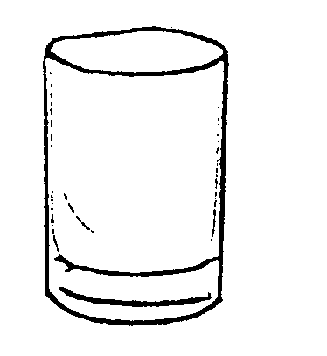   | Tia Maria | - B.  - D.  E. F.
1.3.2 | Cognac | - B.  - D.  E. F.
1.3.3  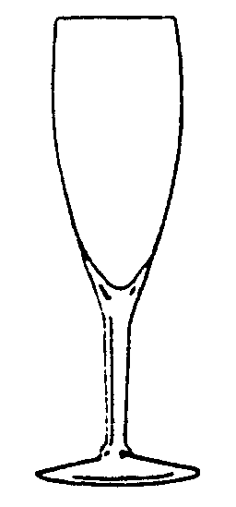  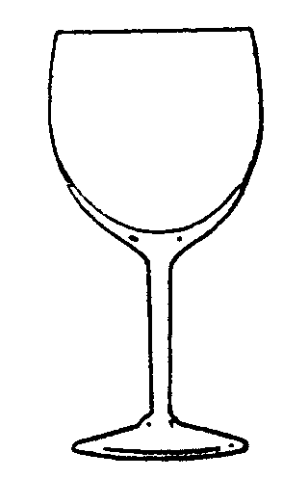 | Cabernet Sauvignon | - B.  - D.  E. F.
1.3.4  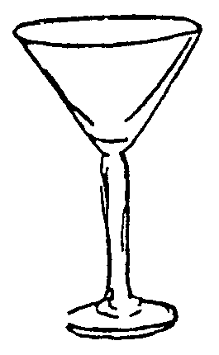  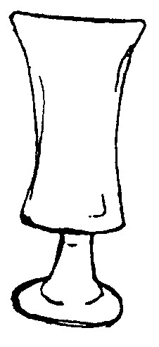 | Rosé | - B.  - D.  E. F.
1.3.5 | Rob Roy | - B.  - D.  E. F.

1.4 Give ONE word for each of the following descriptions. Write down the correct word only on the answer sheet on page 20.  - A salad dressing made of grape vinegar and oil in a ratio of 1:3.  - The transparent, tasteless protein produced from the bones, white connective tissue, cartilage and skin of animals, is called.  - The process by which potato chips are half cooked in oil, cooled and then browned just before serving.  - The process in which sugar is converted into alcohol and carbon dioxide.  - The chemical raising agent used in banana bread.  - The kind of pastry used to make samoosas.  - The kind of pastry used to make barquettes.  - A frozen dessert set in a round dome-shaped mould. Traditionally the mould is filled with two different mixtures. | (8)

1.5 Choose ONE of the ingredients from Column B and match it with the spirits that are made from it in Column B. Write only the letter of your choice alongside the appropriate question number on your answer sheet.

COLUMN A  SPIRITS | COLUMN B  INGREDIENTS
- Vodka | A. peaches
1.5.2 Gin | B. juniper berries
1.5.3 Whisky | C. sugar cane
1.5.4 Rum | D. barley
1.5.5 Tequila | E. agave plant
 | F. potatoes
(5)

1.6 Decide whether the following statements are TRUE or FALSE. Write only TRUE or FALSE alongside the question numbers on your answer sheet.

- Meat containing bone is tastier than meat without bones.  - Yorkshire pudding is a sweet dessert served in England at Christmas time.  - A marinade can be used to soften meat.  - The blue roller markings on meat are an indication that the meat is tender.  - Boiling as a cooking method should only be used for meat cuts with very little fat.  - Beef Stroganoff is a dish made of strips of tender meat such as beef filet. Cream is added just before serving.  - A crown roast is made of two racks of lamb rib joined together to form a circle. | (7)

TOTAL FOR SECTION A: | [50]

SECTION B

CULINARY STUDIES

RESTAURANT ORGANISATION AND BEVERAGES

QUESTION 2

2.1 Study the menu below carefully and answer the questions which follow:

MENU

FAREWELL DINNER

Salad Nicoise/Fruit Cocktail/Advocado Ritz

Tomato Consommé/Bean soup

Roast Pork/Chicken Kebabs/Parmesan Lamb Noisettes
Flavoured Rice/Pommes Fondantes
Ratatouille/Tomato Salad/Macedoine de legumes

Baklava/Fresh fruit platter/Coupe Jacques

Coffee

14 November 1999

- Name the garnish that is traditionally used for Nicoise salad.  - What kind of dressing should be served with a Nicoise salad?  - Fruit cocktail is often served in a coupe. Explain what a coupe is. (You may use a drawing).  - Identify FOUR traditional dishes in the above-mentioned menu and give the country of origin. Tabulate your answer as follows: | (2)  (1)  (1)

FOUR TRADITIONAL DISHES | COUNTRY OF ORIGIN

8x½(4)

- Explain what guests can expect to receive on their plates if they order the following dishes:  - Ratatouille  - Avocado Ritz  - Pommes Fondantes  - A guest orders a Chenin Blanc to be served with the meal. Explain how the waiter should go about serving the wine. Refer to the following:  - The correct glass to be used  - The temperature the wine should be served at  - Pouring the wine  - Name ONE accompaniment that is traditionally served with roast pork.  - Name the meat cut that is used for the lamb noisettes.  - A chasseur sauce is served with the noisettes. Explain to a guest what a chasseur sauce is. | (2)  (2)  (2)  (1)  (1)  (4)  (1)  (1)  (4)

- What cutlery should be laid for:  - the consommé  - the chicken-kebab.  - The hostess would like to serve cheese during the meal. When should the cheese be served? Motivate your answer. | (1)  (1)  (2)  [30]

QUESTION 3

3.1 Guests place the following order from an a la carte menu. Study the menus and answer the questions that follow: | (1)

GUEST A  Hors d’oeuvres  a la Greque  Club steak  Parsley potatoes  Mixed vegetables  Chocolate mousse | GUEST B  Florida cocktail  Eisbein  Potato croquettes  Mixed vegetables  Honey cream sponge | GUESTS C  Waldorf salad  Flambé Chateaubriand  Noisette potatoes  Mixed vegetables  Orange bavaroise

3.1.1 Explain to each guest which ingredients one can expect in the starter he/she ordered. Tabulate your answer as follows:

STARTER | INGREDIENTS
a la Greque
Florida cocktail
Waldorf salad

3X2=(6)

3.1.2 Name the specific meat cuts for the above-mentioned meat dishes and name one accompaniment that is traditionally served with each meat dish. Tabulate your answer as follows:

MEAT DISH | MEAT CUT | ONE ACCOMPANIMENT
Club steak | (1) | (1)
Eisbein | (1) | (1)
Chateaubriand | (1) | (1)

(6)

- Explain how a chef will go about boiling the potatoes for the parsley potatoes.  - The mixed vegetables consist of:  Turnips, asparagus, brussel sprouts and baby marrows.  Classify each vegetable according to the edible part of the plant. Tabulate your answer as follows: | (3)

TYPE OF VEGETABLE | CLASSIFICATION
Turnips
Asparagus
Brussel sprouts
Baby marrows

(4)

3.1.5 The waiter receives the following desserts from the kitchen:

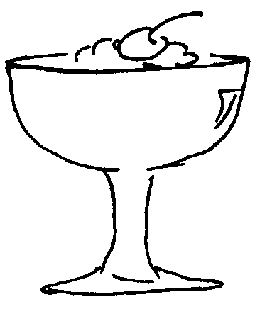
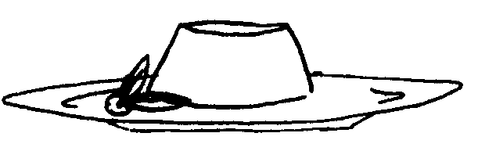
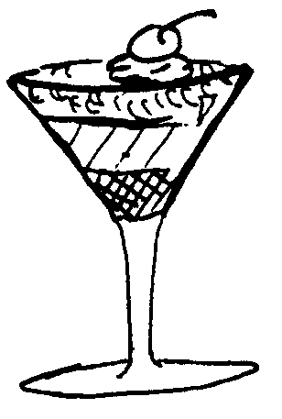
(i) (ii) (iii)

Which dessert should be served to guest A, B and C? Tabulate your answer as follows:

NUMBER OF DESSERT
GUEST A
GUEST B
GUEST C
(3)

3.1.6 Briefly explain how a honey cream sponge is made. | (2)

- The Chateaubriand is served from a Guéridon trolley. Explain the following:  - What is a Guéridon trolley?  - Who should perform the Guéridon trolley service?  - Name FOUR aspects to keep in mind when one prepares and serves this dish. | (1)  (1)  (4)  [30]

QUESTION 4

- BAKED PRODUCTS  4.1.1 Name FOUR rules that should be followed when making pastries.  - A chef is making puff pastry:  - At what temperature should the pastry be baked?  - The end product made from this pastry is very greasy with fat running from it during baking. Give THREE reasons why this happens.  - What is the term used for baking tartlets or tart shells beforehand without fillings? | (4)  (1)  (3)  (1)

4.1.3 Name THREE characteristics of a fully baked bread. | (3)

4.2 DESSERTS

- A crate of pineapples was donated to a hostel. The dessert chef is told to use these pineapples to make a gelatine pudding.  - Why can’t he use the raw pineapple to make the pudding?  - Explain what the influence of too much sugar will be on the formation of the jelly.  - The chef wanted to set the cooked pineapple pieces in the jelly, but discovered that all the pieces sank to the bottom of the mould. Explain why this happened. | (1)  (2)  (2)

4.3 MEAT

4.3.1 There are two pieces of meat in the fridge. Explain briefly how the chef will distinguish between beef and mutton according to the colour of the meat. | (2)

- Most customers in the Western culture, prefer tender meat to flavourful meat.  - From what part of the beef carcass will more tender cuts be taken?  - Explain the term ripening of meat.  - How long does it take for beef to ripen? | (1)  (2)  (1)

4.3.3 A chef is given a topside as part of a mystery basket in a chef’s competition. Advise him/her on TWO uses (apart from minced meat) of this meat cut. | (2)

4.4 SAUCES  Explain the following terms briefly:  - Aspic jelly  4.4.2 Velouté  4.4.3 Espagnole  4.4.4 Beurre manié  4.4.5 Roux | (5)  [30]

TOTAL FOR SECTION B: | [90]

SECTION C

HOTEL ORGANISATION

QUESTION 5

Study the annexure of a brochure of a hotel provided on page 19. Please detach this page for easy reference, then answer the questions that follow:

5.1 The company uses in-house catering. Explain this concept shortly. | (4)

- Explain the differences between the following methods of serving:  5.2.1 the buffet  5.2.2 banquets | (2)  (2)

5.3 Name the different departments of the hotel for which the Food and Beverage Manager is responsible. | (4)

5.4 A potential guest phones to enquire about the rates. Explain briefly the meaning of the different rates offered at this hotel. | 3x2=(6)

- Most of the reservations at the hotel are made by telephone. Name FIVE qualities that the booking staff should have. | (5)

- A travel agent wants to make a booking for 50 overseas guests for a three day conference at the hotel.  5.6.1 Name FOUR items to be included in the package.  5.6.2 Name TWO kinds of services rendered by a hotel that are never included in the room rates.  5.6.3 After two days of conferencing, the guests will have an informal get-together alfresco. Explain the term alfresco. | (4)  (2)  (1)  [30]

QUESTION 6

6.1 SECURITY AND SAFETY

I am a friend of Mr Moloko who is staying at this hotel. May I please have his room number and keys? I’ll wait for him in his room.


6.1.1 Explain what the correct response of the receptionist should be to the gentleman’s request. | (4)

- There is a bomb-scare in a hotel and all the guests and staff members must be evacuated to a nearby school.  - What should be done about the vehicles in the parking area?  - Who should be the first to be transported to the school?  - How should the crowd of people be divided into groups?  - What should be done at the temporary accommodation to ensure that all the guests are accounted for and safe?  - One of the guests got such a fright that he/she fainted. Explain briefly how he/she should be treated. | (1)  (1)  (2)  (2)  (4)

- MAINTENANCE  Preventative maintenance can save a company a lot of money. Name TWO things for each of the following that should be checked regularly:  - Water pipes  - Equipment  - Decorations  - Furniture | 8x½=(4)

- LEGISLATION  6.3.1 Name FIVE responsibilities of the employer.  - According to the law, an employee can be dismissed without notice in only a few cases. Name THREE of these cases.  6.3.3 Complete the following diagram: | (5)  (3)

LIQUOR LAW  (a) How should one pay for liquor? (1)  - What is a corking fee? (3) | (4)  [30]

TOTAL FOR SECTION C: | [60]

TOTAL: | 200

ANNEXURE: BROCHURE OF A HOTEL
In the centre of the city’s shopping district you’ll find a comfortable hotel which offers accommodation with en-suite bathrooms,
air-conditioning, cable television, direct dial telephones and coffee making facilities in each room.

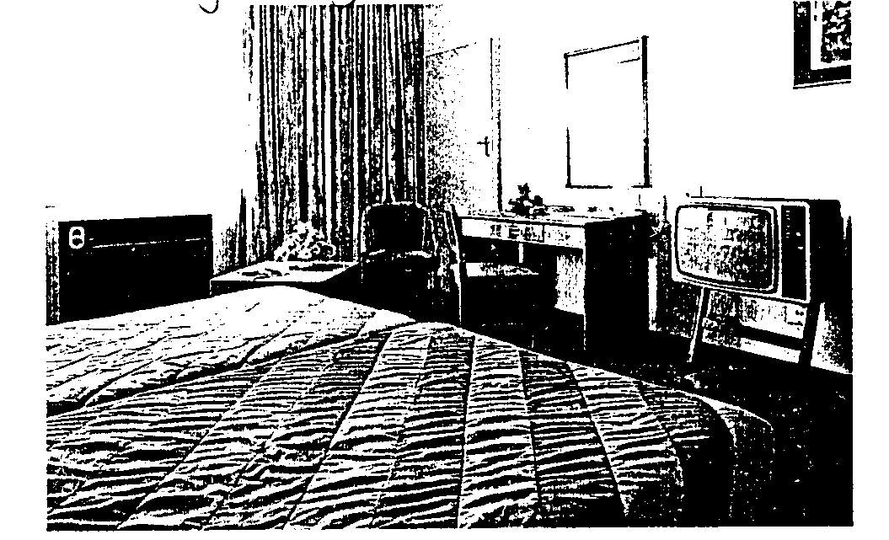
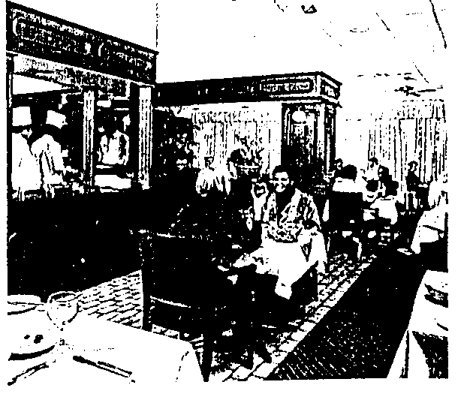
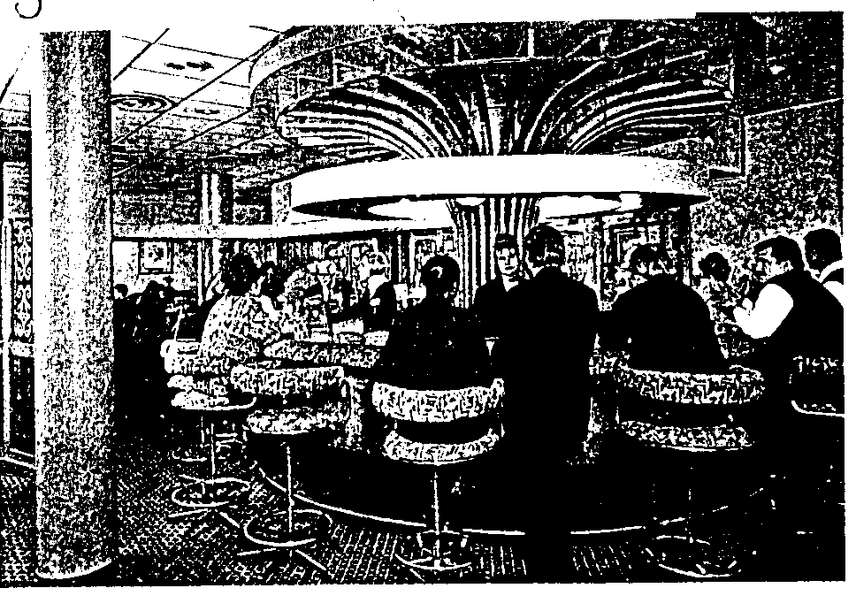
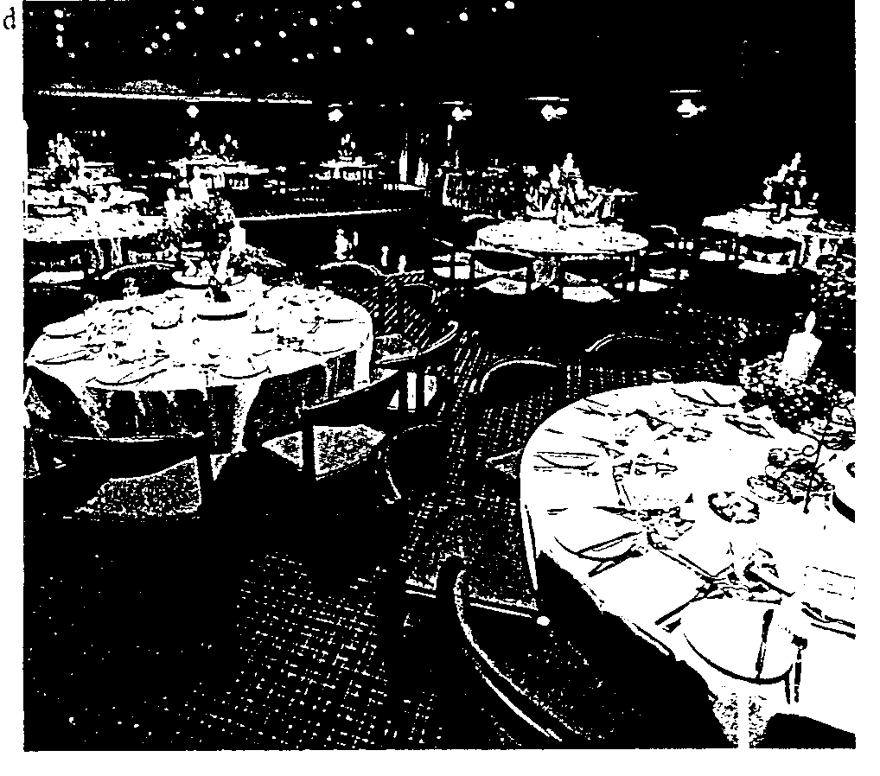
Round off your day of conferencing, and stimulate networking opportunities, by having an informal get-together alfresco.
Tasty à la carte meals, delicious buffet breakfasts and our ever-popular Sunday carvery are served in our cosy imbuia dining room.
For informal business meetings, relax in the elegant Fish Eagle Bar.
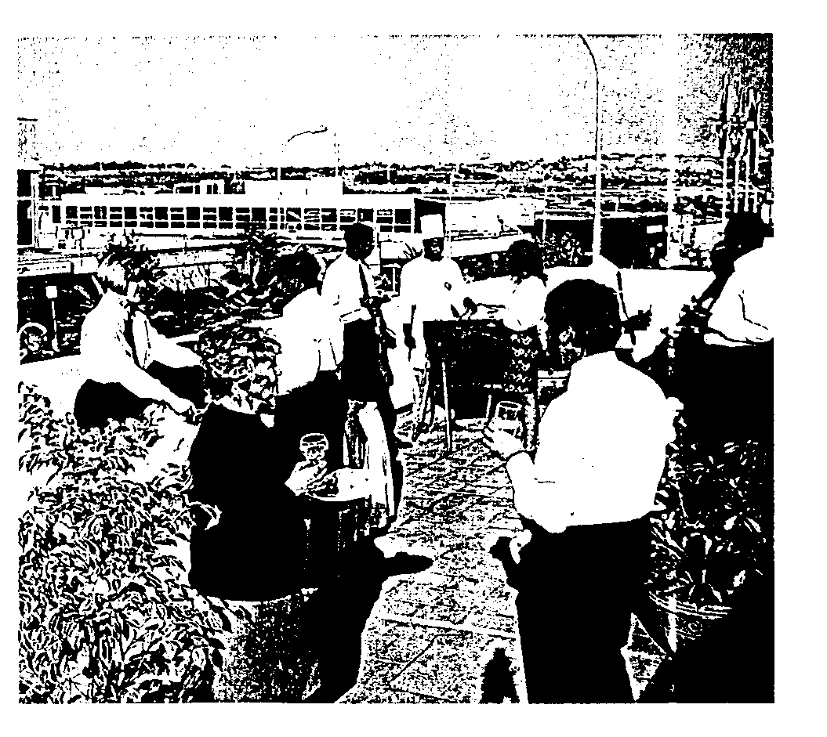

ANSWER SHEET / ANTWOORDBLAD
CANDIDATE’S NUMBER / KANDIDAAT SE NOMMER
800

QUESTION 1.1 / VRAAG 1
1.1.1 | A | B | C | D
1.1.2 | A | B | C | D |  |  |  |  |  |  | QUESTION 1.2 / VRAAG 1.2
1.1.3 | A | B | C | D
1.1.4 | A | B | C | D |  |  |  |  |  |  | 1.2.1
1.1.5 | A | B | C | D |  |  |  |  |  |  | 1.2.2
1.1.6 | A | B | C | D |  |  |  |  |  |  | 1.2.3
1.1.7 | A | B | C | D |  |  |  |  |  |  | 1.2.4
1.1.8 | A | B | C | D |  |  |  |  |  |  | 1.2.5 |  |  |  | (5)
1.1.9 | A | B | C | D
1.1.10 | A | B | C | D
1.1.11 | A | B | C | D
1.1.12 | A | B | C | D
1.1.13 | A | B | C | D
1.1.14 | A | B | C | D
1.1.15 | A | B | C | D
1.1.16 | A | B | C | D
1.1.17 | A | B | C | D
1.1.18 | A | B | C | D
1.1.19 | A | B | C | D
1.1.20 | A | B | C | D | (20)
QUESTION 1.3/ VRAAG 1.3 |  |  |  |  |  |  | QUESTION 1.4/ VRAAG 1.4
1.3.1 |  |  |  |  |  |  | 1.4.1
1.3.2 |  |  |  |  |  |  | 1.4.2
1.3.3 |  |  |  |  |  |  | 1.4.3
1.3.4 |  |  |  |  |  |  | 1.4.4
1.3.5 |  |  | (5) |  |  |  | 1.4.5
 |  |  |  |  |  |  | 1.4.6
 |  |  |  |  |  |  | 1.4.7
 |  |  |  |  |  |  | 1.4.8 |  |  |  |  | (8)
QUESTION 1.5/ VRAAG 1.5 |  |  |  |  |  |  | QUESTION 1.6/ VRAAG 1.6
1.5.1 |  |  |  |  |  |  | TRUE/WAAR |  |  |  |  |  | FALSE/ONWAAR
1.5.2 |  |  |  |  |  |  | 1.6.1
1.5.3 |  |  |  |  |  |  | 1.6.2
1.5.4 |  |  |  |  |  |  | 1.6.3
1.5.5 |  |  | (5) |  |  |  | 1.6.4
 |  |  |  |  |  |  | 1.6.5
 |  |  |  |  |  |  | 1.6.6
 |  |  |  |  |  |  | 1.6.7 |  |  |  |  |  |  |  |  | (7)
[50]

