GAUTENG DEPARTMENT OF EDUCATION
SENIOR CERTIFICATE EXAMINATION

HOTELKEEPING AND CATERING SG

TIME: 2½ hours

MARKS: 200

INSTRUCTIONS:

- The question paper consists of THREE sections.

* Section A – Short questions 50 marks

* Section B – Culinary Studies
Three questions(30 marks each) 90 marks

* Section C – Hotel organisation
Two questions (30 marks each) 60 marks

- All questions are COMPULSORY.

- Carefully read through the instructions to each question.

- Answer Section A (Question 1) on the answer sheet on page 16 of this examination paper. Detach the answer sheet and place it at the back of your answer book when you have finished. Write your examination number on the answer sheet.

- Answer ALL other questions in your answer book.

- Ensure that your answers are clearly and correctly numbered.

- Rule a line across the page at the end of each question.

- Leave a line open between subsections of a question (e.g. between 2.1 and 2.2).

SECTION A

SHORT QUESTIONS

All the short questions in Section A must be answered on the answer sheet provided on page 16. Please detach the answer sheet (page 16) before you begin to answer
Section A.

Place the answer sheet at the back of your answer book when you have finished.

QUESTION 1

  - MULTIPLE-CHOICE-QUESTIONS

Several possible answers are given for each question. Select the answer which you consider to be correct and make a distinct cross (X) over the corresponding letter on the answer sheet on page 16.

EXAMPLE:

QUESTION: Russian tea may be described as:

- Chinese tea without milk
- Tea with a measure of vodka added
- Strong hot tea served with lemon
- Tea made from tea leaves from Eastern Europe

A | B | C | D

Where more than one cross appears in an answer, NO MARKS will be awarded.

1.1.1 _______ are leaf vegetables.

- Celery and rhubarb
- Cabbage and parsley
- Asparagus and watercress
- Spinach and cauliflower

    - _________ are fruit vegetables.

- Carrots and garlic
- Parsnips and onions
- Cucumbers and broccoli
- Tomatoes and baby marrows

    - The enzyme in raw pineapple that hydrolises the proteins in gelatine is

- pepsin.
- bromelin.
- ficin.
- lipase.

    - Fermentation of wines stops once

- all the available sugar in the alcohol has been converted by the yeast.
- the temperature is too high.
- the fermenting juice is cooled rapidly.

- Only (i) and (ii) are correct.
- Only (ii) and (iii)
- Only (i) and (iii)
- (i), (ii) and (iii) are correct.

    - Fortified wines are made by
- adding alcohol which halts the fermentation process.
- adding cane sugar and flavourings.
- letting the wine ferment for a second time.
- the process of distillation.

1.1.6 Who is responsible for the health and safety of people at work?

- The government
- The health and safety department
- Everyone at work, including the employer, employees, contractors and apprentices
- It is the sole responsibility of the employer

1.1.7 Liquor is:

- Any spirit or drink which contains more than 2% alcohol
- Only wine and beer
- Any drink sold in a bar
- Only drinks bottled by S.A. Breweries

    - Trade unions have the right to

- demand salary increases.
- hold elections to elect their management.
- arrange national strikes.
- place their members in managing positions.

    - An employer has the right to dismiss an employee without prior notice in the case of

- theft.
- swearing at the employer.
- absence from work without prior notice.
- negligence with regard to his/her work.

    - Alcoholic drinks may not be sold to

- any resident at the hotel later than 2:00 am.
- any person on closed days, e.g. Christmas Day.
- a person who is already intoxicated.
- a person who is not a resident at a hotel.

    - The raising agent used in puff pastry is

- air.
- steam.
- oxygen.
- yeast.

    - In the making of bread the dough is kneaded in order to

- mix the flour and the water.
- develop the elastic properties of gluten.
- distribute the cellulose evenly.
- stop the growing of the yeast plant.

    - A pudding with an outer layer of lady fingers, filled with a mixture of gelatin, cream and fruit is a

- meringue.
- charlotte.
- bavarois.
- compôte.

1.1.14 When making a chocolate mousse

- the cold liquid is added to the gelatin dispersion.
- more sugar is added to encourage setting.
- cornflour is added to prevent crystal formation.
- the gelatin dispersion is added to the hot milk.

1.1.15 A pavlova consists of  - iced fruit juice which is more granular than ice-cream.  - a vanilla bavarois set in a special mould.  - an iced dessert made of fresh cream.  - a meringue base filled with fruit and whipped cream. | (15)

1.2 Which causes, mentioned in Column B, are responsible for the results listed in Column A? Write the letters of your choice alongside the corresponding question numbers on your answer sheet on page 16.

COLUMN A  RESULTS IN BAKED PRODUCTS | COLUMN B  CAUSES OF FLOPS
1.2.1 Crust shrinks and pulls away from the side | - The fat was too soft  - Too much fat was used
1.2.2 The crust is burned | C. Too much sugar was added
- Oily dough  - Fat runs out during the | D. Dish was placed too close to the  top element
baking process  1.2.5 A hard, tough crust | E. Too much water was added  F. Tart crust was not covered
 | G. The dough was not left to rest

(5)

1.3 Choose a traditional dish from the list given below to complete the statements that follow. Write your answers alongside the corresponding question numbers on the answer sheet on page 16.

LIST OF TRADITIONAL DISHES
Tortilla | Wiener Schnitzel | Christmas turkey
Sukiyaki | Ghoulash | Bokkoms
Sambal | Choux-paste | Sauerkraut
Anchovies | Eisbein | Risotto

A 1.3.1 ____ is made of finely chopped vegetables or fruit mixed with salt, vinegar, chillies, onions and other tasty ingredients. The 1.3.2 ____ is of English origin. Small, salted dried fish are known as 1.3.3 ____. Slices of veal coated with flour, egg and bread crumbs and fried in oil are known as 1.3.4 ____. 1.3.5 ____ is a traditional French tart pastry. 1.3.6 ____ is pickled pork shanks which are later cooked and is traditionally served with 1.3.7____. In Mexico a 1.3.8 ____ is a thin pancake made of maize meal. | (8)

- Choose the correct word from those given between brackets. Write only the words of your choice on the answer sheet on page 16.  1.4.1 (Beurre manié/Beurre Maitre’D) is used to thicken sauces that have already been prepared.  - (Foyot/Beurre blanc/Espagnole) is a basic brown sauce.  - A variation of a typical mayonnaise sauce is (Cumberland sauce/Tartar sauce/Vinaigrette).  - Sauce Bordelaise always contains reduced (grape vinegar/white wine/red wine).  - A Hollandaise sauce is usually served with (cold green salads/asparagus/game).  - (Apple sauce/clarified butter/Chaud-froid sauce) is sometimes used to cover canapés in order to prevent them from drying out.  - (Mint-/Cumberland/Cranberry sauce) is traditionally served with oven-roasted lamb. | (7)

1.5 Choose the meat cut listed in Column B, that is usually used to make the dish listed in Column A. Write only the applicable letter (A – G) next to the question number on the answer sheet on page 16.

COLUMN A  DISHES | COLUMN B  MEAT CUT
- Crown roast | A. Beef fillet
1.5.2 Wiener Schnitzel | B. Lamb loin
1.5.3 Steak Dianne | C. Leg of pork
1.5.4 T-bone | D. Beef loin
1.5.5 Stocks | E. Beef rump
 | F. Leg of lamb
 | G. Beef shin
(5)

1.6 Complete the following organogram of a large hotel’s division of labour. Write only the position of the relevant member of staff next to the corresponding question number on your answer sheet on page 16.

ORGANOGRAM

(10)

TOTAL FOR SECTION A: [50]

Answer Section B and Section C in your answer book.

SECTION B

CULINARY STUDIES

QUESTION 2

Study the following items listed on an a la carte menu:

COLD STARTERS

- Salmon mousse served with melba toast
- Nicoise salad served with vinaigrette
- French salad served with a choice of Thousand Island dressing or yoghurt with fresh herbs

HOT STARTERS

- King prawns served on wild rice with Bearnaise sauce
- Vol-au-vents served with mushroom and cheese filling

FROM THE GRILL

- Lamb kebabs
- Well marinated rib eye steak
- Rump steak grilled to perfection according to your taste

All the above dishes are served with baked potatoes, broccoli and glazed carrots.

- Explain briefly what the following are:  2.1.1 Nicoise salad  2.1.2 Melba toast | (2)  (2)

- The Bearnaise sauce curdled during the preparation.  2.2.1 Give ONE reason why it happened.  2.2.2 Advise the chef how to correct the sauce. | (1)  (2)

2.3 With what does one traditionally garnish a French salad? | (1)

2.4 A Vinaigrette base is used to make a Thousand Island dressing.  - Explain fully what a vinaigrette is.  - What ingredients are added to a vinaigrette in order to make the Thousand Island dressing? Name TWO ingredients. | (3)  (2)

2.5 Name the country from which kebabs originated. | (1)

2.6 Explain the term marinated. | (3)

2.7 Explain fully how a chef should go about grilling the rump steak. | (4)

2.8 A customer orders his steak to be medium done. Describe how the steak should look if it was cooked correctly. | (3)

- Explain how the vegetable chef should go about the following:  - Boiling the broccoli  - Glazing the carrots | (4)  (2)  [30]

QUESTION 3

The following desserts are displayed on a dessert trolley:

Coupes with ice cream
Baklava
Savarin
Apple pie served with egg custard(al’anglaise)
Chocolate eclairs filled with pastry cream(crème pâtissiere)
Cream horns
Strawberry bavarois
Chocolate and peppermint Bombe

- Guéridon service is used to serve these desserts.  3.1.1 What tools should the waiter use for serving the desserts?  3.1.2 Where should the trolley be placed while serving the desserts? | (1)  (1)

  - Various pastries are used in the desserts on the trolley. Name the different kinds of pastry used for each of the following desserts:
Tabulate your answer.

DESSERT | KIND OF PASTRY
Baklava
Savarin
Chocolate eclairs
Cream horns
(4)

3.3 The crust for the apple pie was baked blind.  - What kind of pastry was used?  - Describe how one should go about baking the pastry case blind. | (1)  (5)

3.4 Explain what a coupe is. (You may make use of a drawing). | (2)

3.5 A Bavarois has an egg custard as a base. Discuss the following:  - Why should one use a double boiler to make the egg custard?  - How should one go about adding the gelatine to the custard?  - How must one unmould the individual bavarois?  - How does the custard influence the formation of jelly? | (1)  (4)  (4)  (1)

3.6 Name FOUR uses of gelatine in the catering industry. | (4)

3.7 Give a short explanation of bombe. | (2)  [30]

QUESTION 4

- BEVERAGES  4.1.1 A guest orders a bottle of Merlot 1998.  (a) What glass should the wine steward use to serve this wine?  (b) At what temperature should the wine be served?  (c) Explain the following information which appears on the label of the bottle:  - 1998  - Wine of origin: Olifants river | (1)  (1)  (1)  (1)

4.1.2 Explain how a wine steward should go about serving Brandy and Coke. | (4)

4.1.3 Name FOUR factors to keep in mind when storing wine for a long period. | (4)

4.1.4 Choose the flavour from Column B to match the liqueur in Column A. Write only the name of the flavour next to the question numbers (A to D) in your answer book.

COLUMN A  LIQUEUR | COLUMN B  FLAVOUR
A. Kirsch | chocolate
B. Van der Hum | coffee
C. Cointreau | tangerines
D. Kahlua | cherry kernels
 | liquorice
 | orange
(4)

- State whether the following statements are TRUE or FALSE. Write only the word TRUE or FALSE next to the question number in your answer book.  - Draught beer must be consumed as soon as possible after production.  - The roasted barley is responsible for the dark colour of stout.  - Lager should be poured into a glass at the bar counter.  - One should hold the glass at a slight angle when pouring beer.  - Ales are brewed from yeast which ferments at the top. | (5)

4.2 MEAT

    - The following meat cuts are available to be used for the daily menu:

- thin strips of fillet
- topside cut into cubes
- lamb rib cut into pieces

- Name ONE dish that can be made with each of the above-mentioned meat cuts.
- Name the cooking method that will be best for each dish.

Tabulate your answer as follows:

MEAT CUT | DISH | COOKING METHOD
Fillet strips | (3) | (3)
Topside cubes
Rib pieces
(6)

4.2.2 You must buy a leg of lamb from the butchery. Name THREE criteria one should use in selecting the best meat. | (3)  [30]

TOTAL FOR SECTION B: | [90]

SECTION C

HOTEL ORGANISATION AND HOSPITALITY STUDIES

QUESTION 5

Mr and Mrs Holiday with their baby, arrive unexpectedly at a country lodge.

5.1 Name FIVE important points of information that they need to fill in on the lodge’s register. | (5)

5.2 Mr Holiday prefers to pay with a credit card and would like to do so in advance. Name THREE aspects that the cashier should check on the credit card. | (3)

5.3 The cashier rings up R 3 300 instead of R 330. Explain how he/she should rectify this mistake. | (4)

5.4 Mrs Holiday requests that her diamond necklace be kept in the lodge’s safe. Explain the procedures the receptionist should follow to comply with this request. | (3)

- There is no baby cot in the room and one needs to be brought in for the baby.  5.5.1 Which department should be informed of this request?  5.5.2 Which member of staff is responsible for moving the cot to the bedroom? | (1)  (1)

- An advertisement indicates that the lodge offers  5.6.1 week-end tariffs and  - seasonal tariffs.  Explain the meaning of each of these tariffs. | (2)  (2)

5.7 Mr Holiday compliments the reception staff on good service. Name FIVE personal qualities of the reception staff that could have impressed him. | (5)

5.8 Explain what in-house catering means. | (4)  [30]

QUESTION 6

6.1 SAFETY AND SECURITY

6.1.1 The night porter spots an unattended briefcase in the foyer. Explain what he/she should do. | (5)

6.1.2 The room attendant discovers a gold watch in a bathroom after the guest has left the lodge. Explain what he/she should do now. | (4)

- HOUSEKEEPING  6.2.1 The housekeepers should have good communication with reception. Name FIVE important aspects that should be communicated on a daily basis between these two departments.  6.2.2 How many rooms is a fair number that can be expected of a room attendant to clean every day? | (5)  (1)

- RESTAURANT ORGANISATION  6.3.1 Explain the following:  - plated service  - tray service  - banquet | (4)  (2)  (3)

6.4 HOTEL MAINTENANCE

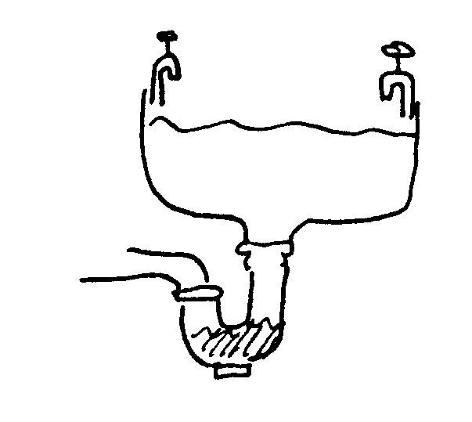

6.4.1 Name THREE methods which can be used to unblock this pipe. | (3)

6.4.2 Draw the plug in your answer book and indicate the colours of the different wires. | (3)

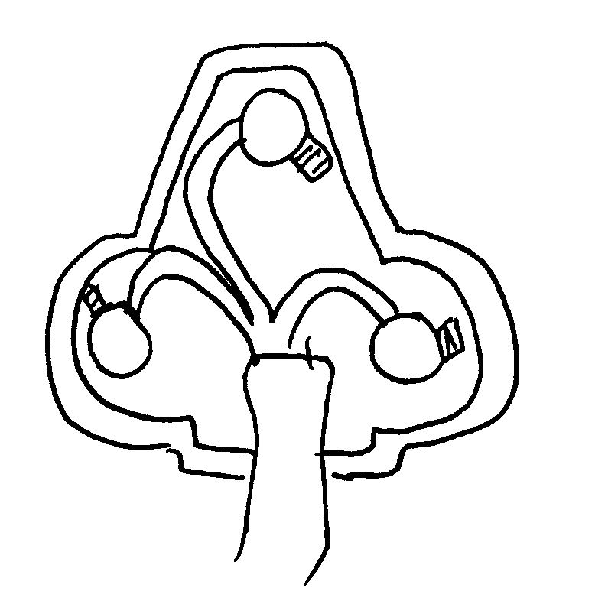 | [30]

TOTAL FOR SECTION C: | [60]

TOTAL: | 200

ANSWER SHEET / ANTWOORDBLAD
EXAMINATION NUMBER / EKSAMENNOMMER

QUESTION 1.1 / VRAAG 1
1.1.1 | A | B | C | D
1.1.2 | A | B | C | D
1.1.3 | A | B | C | D
1.1.4 | A | B | C | D |  | 1.2
1.1.5 | A | B | C | D |  | 1.2.1
1.1.6 | A | B | C | D |  | 1.2.2
1.1.7 | A | B | C | D |  | 1.2.3
1.1.8 | A | B | C | D |  | 1.2.4
1.1.9 | A | B | C | D |  | 1.2.5
1.1.10 | A | B | C | D |  |  | (5)
1.1.11 | A | B | C | D
1.1.12 | A | B | C | D
1.1.13 | A | B | C | D
1.1.14 | A | B | C | D
1.1.15 | A | B | C | D
 |  |  |  | (15)
1.3 |  |  |  |  |  |  | 1.4
1.3.1 |  |  |  |  |  |  | 1.4.1
1.3.2 |  |  |  |  |  |  | 1.4.2
1.3.3 |  |  |  |  |  |  | 1.4.3
1.3.4 |  |  |  |  |  |  | 1.4.4
1.3.5 |  |  |  |  |  |  | 1.4.5
1.3.6 |  |  |  |  |  |  | 1.4.6
1.3.7 |  |  |  |  |  |  | 1.4.7
1.3.8 |  |  |  |  |  |  |  |  |  |  |  |  | (7)
 |  |  |  |  | (8)
1.5 |  |  | 1.6
1.5.1 |  |  | 1.6.1 |  |  |  |  |  | 1.6.6
1.5.2 |  |  | 1.6.2 |  |  |  |  |  | 1.6.7
1.5.3 |  |  | 1.6.3 |  |  |  |  |  | 1.6.8
1.5.4 |  |  | 1.6.4 |  |  |  |  |  | 1.6.9
1.5.5 |  |  | 1.6.5 |  |  |  |  |  | 1.6.10
 | (5)

