GAUTENG DEPARTMENT OF EDUCATION
SENIOR CERTIFICATE EXAMINATION

HOME ECONOMICS SG

TIME: 3 hours

MARKS: 200

INSTRUCTIONS:

- ALL the questions are COMPULSORY.

- Please write neatly and clearly.

- Number your answers exactly as the questions are numbered.

- Answer Question 1A (1.1 to 1.12) (multiple-choice) of Section A on the answer sheet on the inside cover of your answer book.

- Answer Question 1B (1.13 to 1.18) of Section A as well as Section B and Section C in your answer book.

- Use the suggested time guide below.

- Use FIVE minutes at the beginning of the examination to skim read the paper.

- Use FIVE minutes at the end of the examination to check your work.

 | SUGGESTED TIME GUIDE
 | QUESTION NUMBER |  | MARKS | TIME
 | Section A | Question 1 | 50 | 45 minutes
 | Section B | Question 2 | 30 | 25 minutes
 |  | Question 3 | 30 | 25 minutes
 |  | Question 4 | 30 | 25 minutes
 | Section C | Question 5 | 30 | 25 minutes
 |  | Question 6 | 30 | 25 minutes
 |  | TOTAL | 200 | 170 minutes

SECTION A

QUESTION 1A

Indicate the correct answer clearly by making a cross (X) over the corresponding letter on the answer sheet on the inside cover of your answer book.

EXAMPLE: Croûtons are

A. pieces of fried meat.
B. liver patties.
C. fried bread cubes.
D. fish cakes.

ANSWER: | A | B | C | D

NB: Where more than one cross appears in any answer, NO MARKS will be awarded for that question.

1.1 Which one of the dishes listed below is NOT suitable for a person on a low- protein diet?  A. Fruit salad and ice-cream  B. Egg and cheese sandwich  C. Potato and green pepper salad  D. Cauliflower with white sauce | (2)

1.2 The bran and the germ of ______ are removed before being finely ground.  A. sorghum and semolina  B. samp and maize meal  C. flour and cornflour  D. wheat and barley | (2)

1.3 Fresh milk has a slightly salty-sweet taste because of the presence of  A. lactose and chloride salts.  B. glucose and calcium salts.  C. galactose and iron salts.  D. fructose and magnesium salts. | (2)

1.4 Which two items listed below are low energy dairy products suitable for weight reducing diets?  1 Whipping cream  2 Cream cheese  3 Buttermilk  4 Gouda cheese (sweet milk)  5 Fresh homogenised milk  6 Skim milk  A. 1, 4  B. 2, 3  C. 3, 6  D. 4, 5 | (2)

1.5 Choose two reasons from the following list, which best illustrate the need for the use of meat analogues in Mexico and Africa.

1 Animal proteins are expensive.  2 There is a shortage of meat.  3 Plant proteins are more nutritious.  4 Plant proteins digest easier than meat.  A. 1, 2  B. 2, 4  C. 3, 4  D. 1, 3 | (2)

1.6 Rigor mortis, the process of after-death stiffening of the carcass, is caused by  A. an electric current passing through the carcass.  B. cool-shrinkage caused by the rapid cooling of the carcass.  C. biochemical reactions under controlled conditions.  D. the formation of permanent bonds between the actin and the myosin. | (2)

1.7 The natural environment makes provision for  A. opportunities for social interaction.  B. the development of attitudes and beliefs.  C. basic needs such as food and clothing.  D. technological development such as roads and buildings. | (2)

1.8 Which of the following describes the characteristics of a homemaker who is a good manager?  1 Plans ahead, taking available time into consideration  2 Is an artistic interior designer  3 Accepts responsibility for decisions relating to goals and resources  4 Owns the newest timesaving equipment  A. 1, 3  B. 2, 3  C. 1, 4  D. 2, 4 | (2)

1.9 Mrs Zuma is a very busy Home Economics teacher and she decides to buy an automatic washing machine and tumble dryer. Which type of decision did she make?  A. Economical  B. Central  C. Technical  D. Social | (2)

1.10 A compulsive cleaner  A. will ensure that the house is always perfectly clean.  B. will ensure that everything looks good when visitors arrive.  C. cleans when she gets the urge.  D. ensures that the kitchen is clean and germ-free. | (2)

1.11 An ornamental mirror is used to great effect  A. in a small room which has been painted white.  B. to darken a large, bright room.  C. to enlarge a dark corner in a room.  D. to lower the ceiling of a room. | (2)

1.12 An example of a family in the launching stage:  A. Rob and Kate’s eldest child is in Grade 12.  B. Pieter and Anet’s eldest child is in Grade 1.  C. Jacob and Zinzile’s youngest child got married recently.  D. Feroz and Fatima’s eldest child starts university training this year. | (2)  [24]

QUESTION 1B

1.13 Match the egg function in Column B with the food in Column A. Write only the numbers (1.13.1 to 1.13.8) below each other in your answer book and then the letters (A – J) of your choice next to the correct number.

 | COLUMN A |  | COLUMN B
 | Food |  | Egg Function
 | 1.13.1 | Baked egg custard | A. | Foam formation
 | 1.13.2 | Meatballs | B. | Garnishing
 | 1.13.3 | Mayonnaise | C. | Emulsification
 | 1.13.4 | Fried fish | D. | Glazing
 | 1.13.5 | Meringues | E. | Filling
 | 1.13.6 | Meat pies | F. | Coating
 | 1.13.7 | Salad | G. | Binding
 | 1.13.8 | Egg sandwiches | H. | Clarifying
 |  |  | I. | Thickening
 |  |  | J. | Gelatinising | (8)

1.14 Match the cooking method in Column B with the food item in Column A. Write only the numbers (1.14.1 to 1.14.5) below each other in your answer book and then the letters (A – G) of your choice next to the correct numbers.

 | COLUMN A |  | COLUMN B
 | Food Item |  | Cooking Method
 | 1.14.1  1.14.2  1.14.3  1.14.4  1.14.5 | Beef sausage  Cabbage, carrots and mushrooms  Bread rolls  Lightly seasoned hake (fish)  Beef roll | A.  B.  C.  D.  E.  F.  G. | Pot-roasting  Steaming  Stir-frying  Deep-fat frying  Baking  Grilling  Toasting | (5)

1.15 Select from the list FOUR conditions that will promote bacterial growth in food. In your answer book, write the question number 1.15 and the FOUR letters (A – H) of your choice below each other next to the question number.

 | CONDITIONS PROMOTING BACTERIAL GROWTH IN FOOD
 | A. | Reheating soup at a high temperature
 | B. | Defrosting chicken on the kitchen table
 | C. | Storing food at a temperature of 12ºC
 | D. | Keeping a mutton casserole warm at 40ºC
 | E. | Leaving leftover haddock-pie overnight on the stove
 | F. | Freezing leftover food after cooling
 | G. | Defrosting chicken overnight in the bottom of the fridge
 | H. | Reheating leftover chicken to 75ºC | (4)

1.16 Choose THREE places in the home where bright lights must be placed. In your answer book, write the question number 1.16 and the THREE letters (A – E) of your choice below each other next to the question number.

 | PLACES WHERE BRIGHT LIGHTS MUST BE PLACED
 | A. | The stairs
 | B. | The dining room
 | C. | The bathroom
 | D. | The garden path
 | E. | The foyer
 | F. | The bedroom | (3)

1.17 Redraw the following table in your answer book:

 | Cognitive | Affective | Psychomotoric | Non-human

Classify the following resources, which will be used during practical cooking, under the correct headings. Write only the correct number under the correct heading of the table.

1.17.1 A microwave oven

1.17.2 A positive attitude towards given tasks

1.17.3 Knowledge of the different techniques to be applied | (3)

1.18 Match the design principle in Column B with the examples in Column A. Write only the numbers (1.18.1 to 1.18.3) below each other in your answer book and then the letter (A – F) of your choice next to the correct number.

 | COLUMN A |  | COLUMN B |  |  | (3)
 | Example |  | Design principle |  |  | (3)
 | 1.18.1 | Identical cushions are used on the couch and chairs in the lounge. | A.  B.  C.  D.  E.  F. | Formal balance  Informal balance  Harmony of texture  Harmony of colour  Emphasis  Rhythm |  | (3)
 | 1.18.2 | The placement of a painting above the fireplace draws attention to the bedroom fireplace. | A.  B.  C.  D.  E.  F. |  |  | (3)
 | 1.18.3 | The same size decorative plates hang on either side of the wall clock. | A.  B.  C.  D.  E.  F. |  |  | (3)
TOTAL FOR SECTION A: |  |  |  |  | [26]  [50]

SECTION B

QUESTION 2

2.1 Refer to the given recipe when answering Questions 2.1.1 to 2.1.6.

 | LEMON MERINGUE PIE
 | INGREDIENTS
 | Crust | Filling | Meringue
 | 200 ml cake flour  1 ml salt  5 ml sugar  60 g butter | 45 ml cornflour  125 ml sugar  175 ml boiling water  1 egg yolk, beaten  pinch of salt  20 ml cold water  7 ml butter  7 ml grated lemon rind  45 ml lemon juice | 2 egg whites  60 ml sugar  1 ml lemon juice  pinch of salt
METHOD
Crust
1. Sift cake flour and salt together.
2. Cut in butter until mixture resembles coarse breadcrumbs.
3. Press mixture together and knead to form a dough.
4. Line a pie plate (200 mm diameter) with dough, prick and refrigerate for 15 minutes.
5. Bake blind at 180ºC for 10 minutes. Allow to cool.
 | Filling
1. Mix cornflour and sugar, then add 20 ml of cold water and stir.
2. Stir in the boiling water.
3. Cook over direct heat until very thick and translucent, stirring constantly.
4. Put over boiling water and simmer for a further 10 – 15 minutes more, stirring slowly.
5. Add some of the paste to the egg. Stir this mixture into the hot filling.
6. Bring to boil over direct heat for 15 minutes.
7. Simmer over water. Stir occasionally.
8. Remove from heat. Add rest of ingredients.
 | Meringue-topping
1. Whisk the egg whites till foamy.
2. Add lemon juice and whisk to soft-peak stage.
3. Add the sugar and salt. Whisk till sugar is well-blended and soft peaks form.
4. Pour filling into crust and decorate with topping.
5. Bake at 240ºC until golden brown.

Questions applicable to the ingredients of the filling:

2.1.1 What is the function of

(a) the cornflour and

(b) the grated lemon rind in the filling? | (3)

Questions applicable to the method of the filling

2.1.2 Name FIVE changes that take place during the gelatinisation process (as described in step 3 of filling). | (5)

2.1.3 Refer to step 5. Why is the beaten egg yolk not added directly to the hot starch mixture? | (2)

2.1.4 (a) Explain why the cornflour and sugar are mixed together in step 1. | (2)

(b) Why is the cornflour and sugar mixture then mixed with cold water? | (1)

2.1.5 Name THREE ingredients typical of the meringue-topping. | (3)

2.1.6 Determine where the following terms occur in the preparation and storage of the Lemon Meringue Pie.

 | Coagulation, Syneresis | 2x2 = | (4)

2.2 What is turgor pressure (tissue tension)? Explain how it contributes to the texture of vegetables. | (4)

2.3 Identify the methods of cooking used during the cooking of the following foods:

 | A. | Potjiekos (meat and vegetables, cooked in a three-legged cast-iron pot over an open fire) | (6)  [30]
 | B. | Egg (to be used for stuffed egg) | (6)  [30]
 | C. | French fries (chips) | (6)  [30]
 | D. | Pancakes (not using Spray and Cook) | (6)  [30]
 | E. | White bread | (6)  [30]
 | F. | Lamb chops (over glowing coals) | (6)  [30]

QUESTION 3

3.1 3.1.1 Name TWO changes that take place when fruit ripens and explain how the changes happen. | (4)

3.1.2 Name the colour pigment in unripe peaches. | (1)

3.2 Redraw the table below in your answer book and answer the questions on page 11:

 |  |  | 3.2.1 Salad ingredients | 3.2.2 Description of how food spoilage takes place
 | A. | Mould | 1.  2.
 | B. | Withering | 1.  2.

Study the recipe below and answer the questions that follow, using the table you prepared.

Spinach Salad
Young spinach leaves, bread cubes, apple cubes, feta cheese, walnuts, bacon bits, French salad dressing

3.2.1 Which ingredients in the spinach salad may be spoiled through:  A mould? (Name TWO ingredients)  B withering? (Name TWO ingredients) | (4)

3.2.2 Describe how spoilage occurs in each salad ingredient. | (4)

3.3 Redraw the table below in your answer book and answer the questions that follow:

 | Meat and Meat Alternatives | A. | Cereals and Cereal Products | B. | Fruit and Vegetables

3.3.1 Fill in the missing Food Groups under A and B in the table.  3.3.2 Select a food item from the list below that belongs to the five food groups. | (2)

 | Soya-bean burgers, bacon rashers, fruit salad, mealiemeal porridge (pap), cheese soufflé. | (5)

3.4 Explain the given statements with regard to gelatine desserts.

3.4.1 Gelatine mixtures should not be added to boiling milk mixtures. | (2)

3.4.2 The use of metal moulds is preferable to those made of plastic. | (2)

3.4.3 Raw pineapple should not be added to gelatine dishes. | (2)

3.5 When making choux puffs it is important to adhere to the rules. Choose the suitable explanation in Column B by matching the rules in Column A. Write the numbers 3.5.1 – 3.5.4 below each other in your answer book and then the letter (A – D) of your choice next to the correct question number.

 | COLUMN A |  | COLUMN B
 | Rules |  | Explanation
 | 3.5.1 | Measure ingredients accurately | A. | High temperature changes the liquid to steam. (raising agent)
 | 3.5.2 | Use correct mixing method | B. | Too much margarine will result in a very oily puff
 | 3.5.3 | Make sure batter has the right consistency | C. | If batter is too soft, no cavity will be formed
[30] | 3.5.4 | Bake at 200º C for 35 minutes | D. | If batter and water are boiled for too long, there will be too little liquid to change to steam | (4)

QUESTION 4

4.1 From the list, select the main nutrient present in each of the following vegetables. Write only the letter of the nutrient in your answer book and next to it the suitable vegetable.

Sweet potatoes, carrots, corn (mielies), soya beans, spinach

A. Carbohydrates  B. Proteins  C. Iron  D. Vitamin A | (4)

4.2 | FRIED MEATBALLS  INGREDIENTS:  250 g beef mince  25 ml oats  1 beaten egg  2 ml salt  1 ml pepper  Method:  Mix ingredients lightly with a fork.  Shape mixture into meatballs and cook.

4.2.1 List FOUR pre-mortal factors that will influence the eating quality of meat. | (4)

4.2.2 Name TWO suitable cuts used for mince. | (2)

4.2.3 Explain what a person may use to extend the mince to feed more people. (Keeping the nutritional value high in protein is essential.) | (4)

4.2.4 Why were egg and oats added to the mince? | (4)

4.2.5 Suggest a suitable cooking method for the meatballs. | (1)

4.3 Explain the following statements relating to fish:

4.3.1 Steamed hake is used for invalid diets. | (2)

4.3.2 Fish to be fried is usually covered in a batter. | (2)

4.4 Explain why yeast makes bread rise. | (3)

4.5 Study and evaluate the menu according to

A. texture and | (2)
B. colour. | (2)

MENU

DINNER

Tomato Soup

Grilled Fish Tartar Sauce

Tomato Stew Mashed Potatoes

Cinnamon Dumplings

Coffee
10 January 2003

[30]

TOTAL FOR SECTION B: | [90]

SECTION C

QUESTION 5

  - Read the following case study and answer the questions that follow.

Mrs Zondo sets the following financial goals for herself:

1. My money matters are important, but they will not rule my life.
2. I want to be financially independent in a few years.
3. My wants will be satisfied after my needs.
4. Except for long-term home and car loans, I will try not to get into debt.
5. I will spend less than I earn and will use alternative methods available to invest for my future.
6. I will use my money and talents, to make life more pleasant for myself and others, by getting involved in community service.

5.1.1 Identify the type of goal that Mrs Zondo’s financial goals represent. Motivate your answer. | (2)

5.1.2 Determine which goal (1 to 6) in the case study will ensure that Mrs Zondo will be financially sound by the time she retires. Motivate your answer. (Write only the number of the goal, e.g. 2.) | (2)

5.1.3 Name TWO examples of alternative methods to which Mrs Zondo refers. | (2)

5.1.4 Identify the need according to Maslow’s Hierarchy of Human Needs to which reference is being made in Goal 6. Motivate your answer. | (2)

5.2 Mr Zondo and his 10-year-old daughter, Susan, have the following conversation. Study the picture and answer the questions that follow.

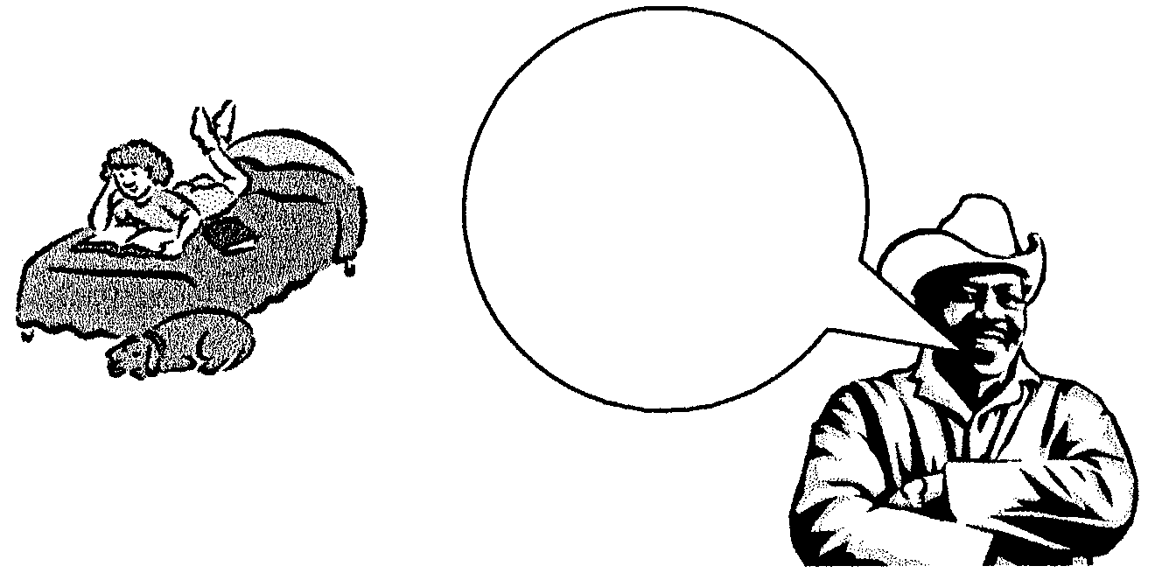

You are already 10 years old and since your brother
is at the Technikon and
your mother starts a new job tomorrow, you will
have to accept more
responsibility at
home.

5.2.1 Since Susan now has more responsibility, she will be more stressed. Identify TWO emotional demands that she will experience. | (2)

5.2.2 Give a reason and explain why it will be necessary for standards relating to tasks in the Zondo home to change. | (2)

5.2.3 Do you think Susan will procrastinate (put off or delay) when she has to cook for the whole family? Motivate your answer. | (3)

5.2.4 Shared responsibility in the home helps to strengthen family ties and cultivates better family relationships. Suggest THREE advantages of shared responsibilities in the family. | (3)

<
5.3 Study the bathroom of the Zondo family and answer the questions that follow.

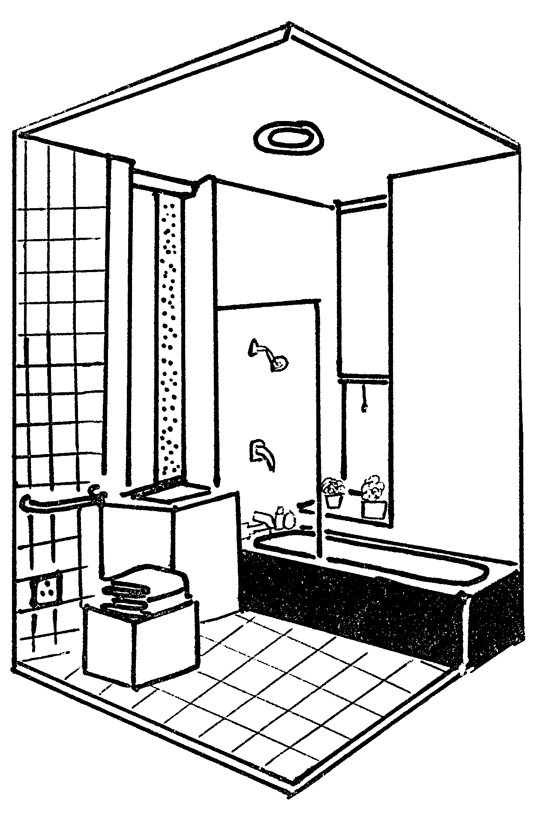

Evaluate the safety aspects in the bathroom under the following headings:

5.3.1 Bath

5.3.2 Floor in front of bath

5.3.3 Power point | (3)

5.4 Study the south-facing bedroom of Mr and Mrs Zondo and answer the questions that follow.

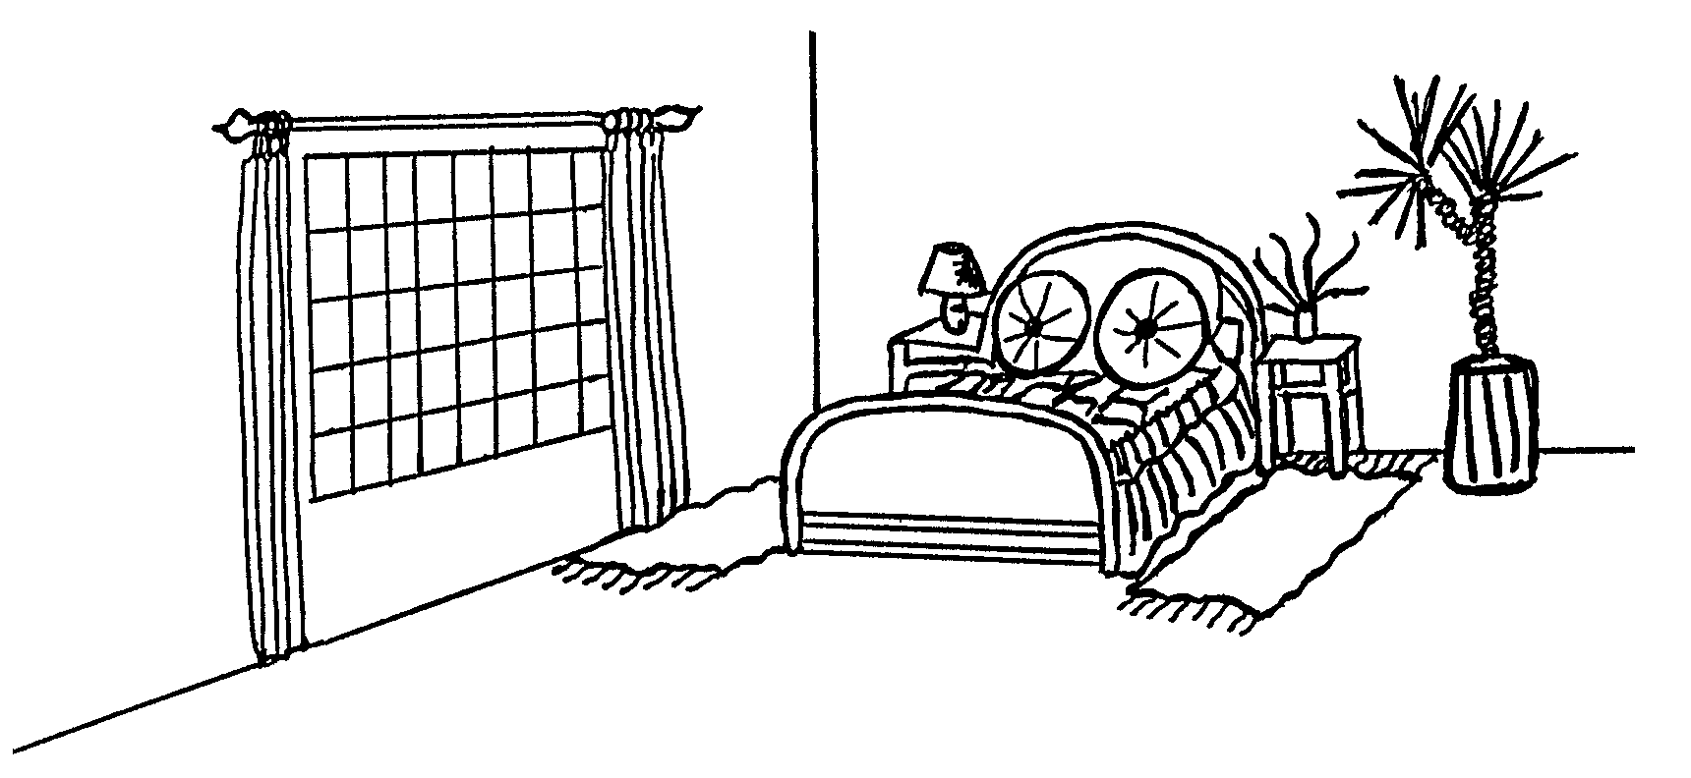

The bedroom faces south and it is a very big room.

5.4.1 Identify the types of balance evident in the bedroom. | (6)

5.4.2 Would you suggest using a warm or cool colour scheme in this room? | (1)

5.4.3 The room is very big. How can the room be insulated to prevent the loss of heat? | (2)  [30]

QUESTION 6

6.1 Meet the Malan family and answer the questions that follow.

 | Family member | Name of family member | Personal Information of family member
 | Grandpa | Simon | 70 years old, pensioner
 | Grandma | Marie | 68 years old, pensioner
 | Mother | Karen | 44 years old, breadwinner, works all day
 | Father | Carel | Deceased
 | Daughter | Stella | 17 years old, Grade 12, very modern
 | Son | Jason | 10 years old, Grade 4, very active

6.1.1 Stella plans to study Fashion Design at the Vaal Triangle Technikon after matriculating. Which stage of the family life cycle will the family enter when Stella leaves home? Motivate your answer. | (2)

6.1.2 Redraw the following table in your answer book and answer the questions. Only write down the appropriate letter in the table.

 | Factors that influence the division of tasks | Explanation

Explain why the following factors will influence the division of tasks in the Malan household.

A. Jason is too young to do too many tasks.
B. Karen is away from home hours at a time.
C. Domestic worker helps to clean the house.
D. Marie is available all day. | (4)

6.1.3 If you look at the family situation, you will understand that conflict can very easily take place within a family. Using the information in the case study, explain the possible reasons for conflict between:

(a) Stella and Jason | (2)
(b) Stella and Karen | (2)

6.2 Study Stella’s bachelor flat for next year and answer the questions that follow.

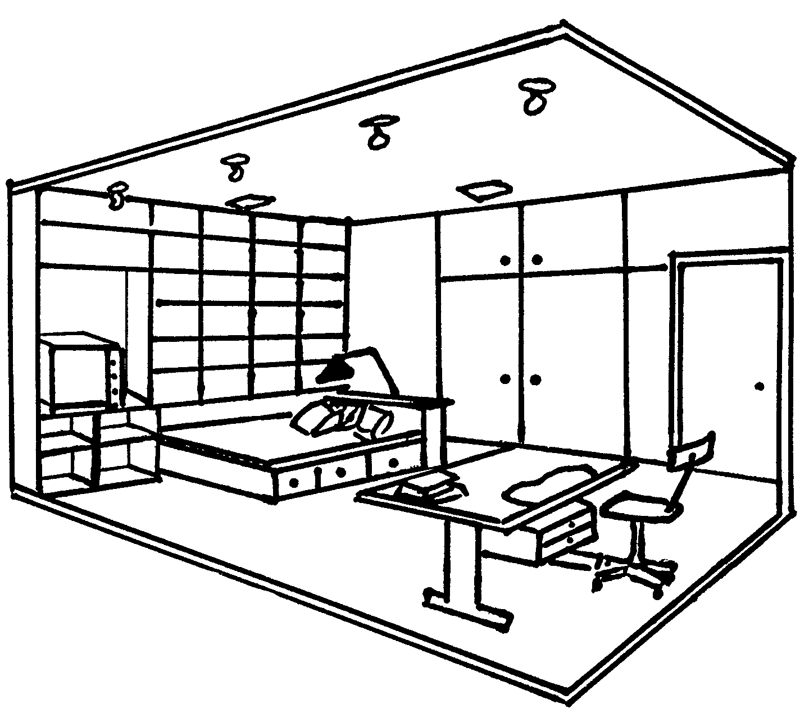

6.2.1 Suggest possible ways of how Stella can entertain her friends in her bachelor flat. | (2)

6.2.2 Identify THREE places where rhythm occurs in this room. | (3)

6.2.3 Name TWO examples of how storage space has been used effectively in this flat. | (2)

- Stella studies Fashion Design and must cut out patterns and fabric. As there is not a big enough table, she will have to cut on the floor. She complains about constant backache.  Identify the type of muscle tension that is caused by this discomfort. | (1)

6.4 Indicate how Stella applied the illusion of space in her room. | (6)

6.5 Study a sketch of the front door of the Malan family’s home and answer the questions that follow.

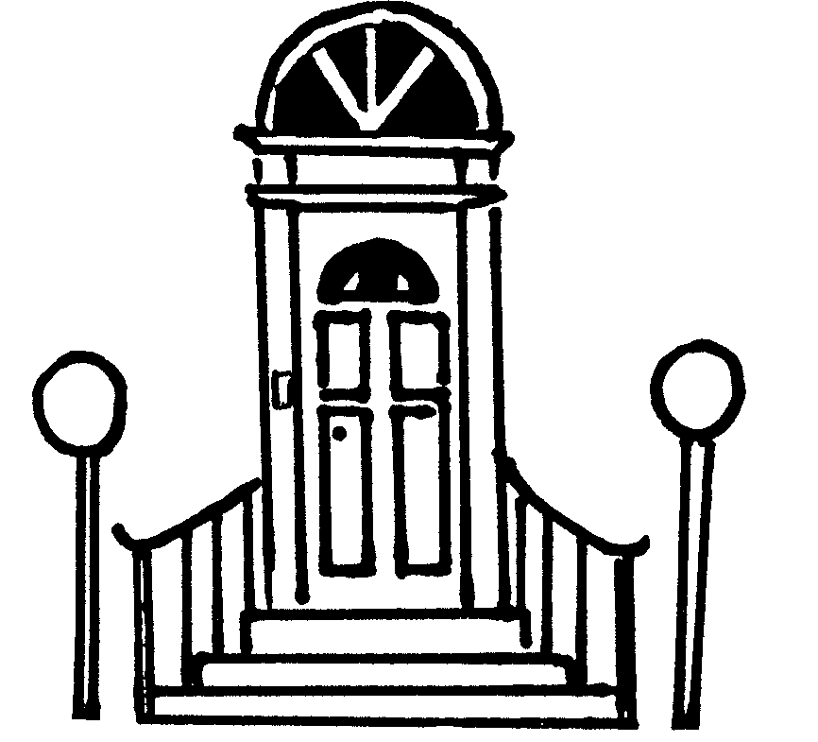

Redraw the table below in your answer book and answer the questions that follow:

 | Functional Design | Decorative Design

6.5.1 Using the table, choose, from the following list, the functional and decorative design present at the front door.

 | Hand railing, door bell, curved lines, lights. | (4)

6.5.2 Identify the most dominant design element on the front door. | (1)

6.5.3 Explain the effect of the design element on the front door. | (1)  [30]

TOTAL FOR SECTION C: | [60]

TOTAL: | 200

