GAUTENG DEPARTMENT OF EDUCATION
SENIOR CERTIFICATE EXAMINATION

HOME ECONOMICS SG

TIME: 3 hours

MARKS: 200

INSTRUCTIONS:

- ALL the questions are COMPULSORY.

- Please write neatly and clearly.

- Number your answers exactly as the questions are numbered.

- Answer Question 1A (1.1 - 1.12) (multiple-choice) of Section A on the answer sheet on the inside cover of your answer book.

- Answer Question 1B (1.13 - 1.19) of Section A, as well as Section B and
Section C in your answer book.

- Use the suggested time guide below.

- Use FIVE minutes at the beginning of the examination to skim read the paper.

- Use FIVE minutes at the end of the examination to check your work.

 | SUGGESTED TIME GUIDE
 | QUESTION NUMBER |  | MARKS | TIME
 | Section A | Question 1 | 50 | 45 minutes
 | Section B | Question 2 | 30 | 25 minutes
 |  | Question 3 | 30 | 25 minutes
 |  | Question 4 | 30 | 25 minutes
 | Section C | Question 5 | 30 | 25 minutes
 |  | Question 6 | 30 | 25 minutes
 |  | TOTAL | 200 | 170 minutes

SECTION A

QUESTION 1A

Indicate the correct answer clearly by making a cross (X) over the corresponding letter on the answer sheet on the inside cover of your answer book.

EXAMPLE: Croutons are

A. pieces of fried meat.
B. liver patties.
C. fried bread cubes.
D. fish cakes.

ANSWER: | A | B | C | D

NB. Where more than one cross appears in any answer, NO MARKS will be allocated for that question.

1.1 Which one of the following meals is suitable for dieters?  A. Fried fish, chips and peas  B. Grilled liver, chips and tomato  C. Boiled egg, asparagus, cucumber and tomato  D. Fried bacon, eggs, tomato and toast | (2)

1.2 Measuring cups can be used to measure the following accurately:  A. 25 ml oil and 125 ml water  B. 75 ml cocoa and 250 ml coconut  C. 75 ml cocoa and 250 ml milk  D. 125 ml icing sugar and 75 ml oil | (2)

1.3 The main function of eggs during the making of choux puffs is to  A. gelatinise the starch.  B. act as a raising agent.  C. act as an emulsifier.  D. ensure a smooth surface. | (2)

1.4 Moist heat is mainly applied in the following cooking methods:  A. Pot-roasting and stewing  B. Stewing and direct steaming  C. Deep-frying and shallow-frying  D. Oven-roasting and pot-roasting | (2)

1.5 Starches with the best thickening ability include:

A. tapioca and sago.  B. cornflour and flour.  C. dextrinised flour and tapioca.  D. cornflour and dextrinised flour. | (2)

1.6 Which of the following ingredients are used during the making of creamed cottage cheese?  A. Cream and whey  B. Whey and buttermilk  C. Curd and milk  D. Cream and curd | (2)

1.7 Mayonnaise is a  A. suspension because of the presence of herbs.  B. solution because of the vinegar.  C. temporary emulsion because of the oil.  D. permanent emulsion because of the egg yolk. | (2)

1.8 The nutrients essential for the building of strong bones and teeth are:  A. Vitamin D, Calcium and Phosphorus  B. Calcium, Phosphorus and Vitamin E  C. Vitamin C, Vitamin D and Calcium  D. Vitamin A, Vitamin D and Vitamin E | (2)

1.9 Goals should be  A. concrete and realistic.  B. abstract and aesthetic.  C. idealistic and flexible.  D. abstract and unconventional. | (2)

1.10 Examples of human resources include:  A. Modern equipment and products.  B. Postal and transport services.  C. Time and energy.  D. Money and possessions. | (2)

1.11 The economic cycle is created by interaction between  A. consumption, expenditure and job opportunities.  B. needs, production and consumption.  C. needs, consumption and job opportunities.  D. production, consumption and expenditure. | (2)

1.12 Identify from the following two examples of salary deductions:  1 Commission on sales  2 Pension fund  3 Nett monthly salary  4 Group insurance  A. 1, 2  B. 2, 4  C. 1, 3  D. 3, 4 | (2)  [24]

QUESTION 1B

1.13 Select from the list THREE types of food that are suitable for stewing. In your answer book, write the question number (1.13) and the letters (A-F) of your choice below each other.

 | TYPES OF FOOD SUITABLE FOR STEWING
 | A | Rice and pasta
 | B | Green beans and apples
 | C | Beef shin and meat stew
 | D | Boerewors and mashed potato
 | E | T-bone and dried peaches
 | F | Dried prunes and potjiekos | (3)

1.14 Select from the list below the most suitable micro-organisms for the description. In your answer book, write the question numbers (1.14.1 – 1.14.5) below each other and then the letters (A-C) of your choice next to each other.

 | MICRO-ORGANISMS
 | A. | Bacteria
 | B. | Mould
 | C. | Yeast

Description:

1.14.1 Destroyed at 140ºC  1.14.2 Can live without oxygen (anaerobic)  1.14.3 Sprayed on the surface of cheese  1.14.4 Grows in dark places with little air circulation  1.14.5 Used during the making of bread | (5)

1.15 Hake (fish) can be used in the diet of an elderly person as a substitute for beef fillet. Select from the list THREE reasons why this can be done. In your answer book, write the question number (1.15) and then the letters (A-E) of your choice below each other.

 | REASONS WHY HAKE CAN BE USED AS A SUBSTITUTE FOR BEEF FILLET
 | A | Hake contains more calcium, iodine and phosphorus than beef fillet.
 | B | Hake contains more Vitamin B complex and calcium.
 | C | Hake is much softer after rigor mortis and ripening.
 | D | Hake is cheaper than beef fillet and the protein content is the same.
 | E | Hake contains less connective tissue and is easier to digest.
 | F | Hake contains more protein of a low biological value. | (3)

1.16 | Tandi does not care about recognition and the friendship of her peer group. She is amazed when her friend, Suzi, hands a R100 note, that she picked up on the school grounds, to their teacher.  The unfit Tandi is unhappy with the condition of her takkies and pleads angrily with her mother to buy her professional running shoes. Tandi is adamant (set, firm) about this, because she was forced by the school coach to run the cross-country.

Select from the list TWO aspects that Tandi places no value on. In your answer book, write the question number (1.16) and then the letters (A-D) of your choice below each other.

 | ASPECTS THAT TANDI DOES NOT VALUE
 | A | Good health
 | B | Religion
 | C | Beauty
 | D | Honesty | (2)

1.17 Study the sketch below and then answer Questions 1.17.1 to 1.17.3.

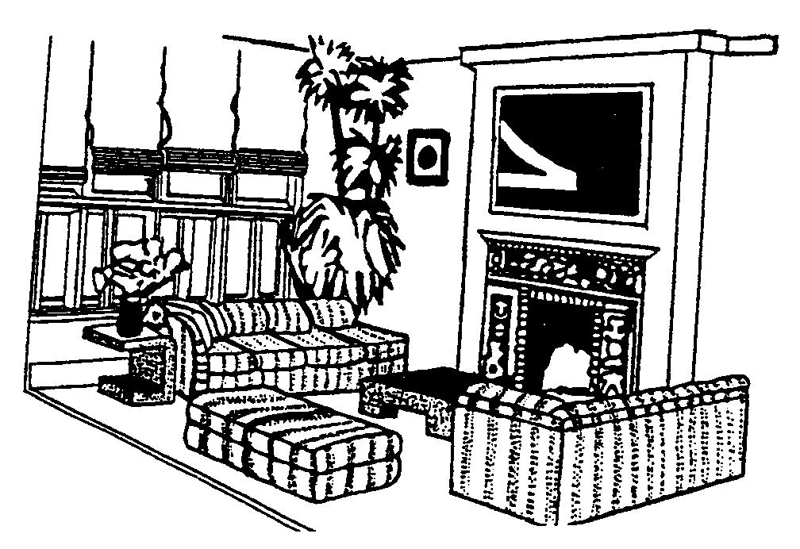

1.17.1 Select from the list THREE examples of how rhythm was obtained in the room. In your answer book write down the question number (1.17.1) and then the letters (A-F) of your choice next to it.

 | EXAMPLES OF RHYTHM
 | A | The pattern around the fireplace
 | B | The repetition of design on the couches/sofas
 | C | The side-table
 | D | The folds on the blinds
 | E | The flowers on the side table
 | F | The painting next to the plant | (3)

1.17.2 Select from the list THREE examples of how height or an illusion of height was created in the room. In your answer book, write only the question number (1.17.2) and then the letters (A-F) of your choice next to it.

 | CREATION OF HEIGHT
 | A | The blinds that hang from ceiling to floor
 | B | The table in front of the couches/sofas
 | C | The plant at the window
 | D | The flowers on the side-table
 | E | The couches/sofas
 | F | The vertical lines at the fireplace | (3)

1.17.3 Select from the list the focal point (point of emphasis) in the above room. In your answer book, write the question number (1.17.3) and then the letters (A-D) of your choice next to it.

 | FOCAL POINT
 | A | The sofas/couch
 | B | The table in front of the sofas/couch
 | C | The painting above the fireplace
 | D | The flowers on the side-table | (1)

1.18 Match the examples in Column B with the resources in Column A. Write only the question numbers (1.18.1 - 1.18.2) below each other in your answer book and then the letter (A-D) of your choice next to each number.

 | COLUMN A |  | COLUMN B |  | (2)
 | RESOURCES |  | EXAMPLES OF RESOURCES |  | (2)
 | 1.18.1 | Cognitive | A. | Enthusiasm to participate during lessons | (2)
 | 1.18.2 | Psychomotor | B. | Development of relationships | (2)
 |  |  | C. | Ability to comprehend and interpret instructions | (2)
 |  |  | D. | Ability to record and make notes | (2)

1.19 Match the financial term in Column B to the example in Column A. Write the question numbers (1.19.1 - 1.19.4) below each other in your answer book and then the letter (A-F) of your choice next to each.

 | COLUMN A |  | COLUMN B |  | (4)
 | EXAMPLES |  | FINANCIAL TERM |  | (4)
 | 1.19.1 | Sandra earns R3 000 per month. | A.  B.  C.  D.  E.  F. | Non-money income  Fringe benefits  Nett income  Gross income  Assured income  Bonus | (4)
 | 1.19.2 | After compulsory deductions, Sandra earns R2 000 per month. | A.  B.  C.  D.  E.  F. |  | (4)
 | 1.19.3 | Mr Green receives R900 per month from the person who lives in his flat at the coast. | A.  B.  C.  D.  E.  F. |  | (4)
 | 1.19.4 | Sandra regularly bakes cakes for her family. | A.  B.  C.  D.  E.  F. |  | (4)

 | TOTAL FOR SECTION A: | [26]  [50]

SECTION B

QUESTION 2

2.1 Study the following menus and answer the questions that follow:

 | MENU A | MENU B | MENU C
 | Minced Meat  Mashed Potato  Stewed Spinach  Cooked Pumpkin  Avocado Salad Mould  Jelly and Custard | Meatballs  Peas  Glazed Carrot Rings  Buttered Potatoes  Baked Apple | Fried Ham  Baked Potato  Buttered Carrots  Avocado Salad with Mayonnaise  Ice Cream and Chocolate Sauce

Identify ONE mistake in each menu that was made during the compiling of the three menus. | (3)

2.2 Redraw the following table in your answer book:

 | Cereal and Cereal Products | Fats and Oils | Meat and Meat Alternatives | Milk and Milk Products | Fruit and Vegetables

Classify the following foods under the correct headings of the Five food groups in the table.

2.2.1 Minced meat  2.2.2 Avocado pear  2.2.3 Ham  2.2.4 Mayonnaise | (4)

2.3 Rearrange the following dishes/courses in the correct order, as they will be presented in a four-course meal. Write them in the correct order below each other in your answer book.

- Coffee  - Main course  - Fish dish  - Dessert  - Consommé (soup) | (5)

2.4 Distinguish between the following menu terminology and explain where these terms will be used on the menu.

2.4.1 Hors d’oeuvres  2.4.2 Entreé | (4)

2.5 Read the following case study and answer the question that follows.

The ham in Menu C on page 9 is bought 10 days before the meal and is stored in the refrigerator. The meal is cooked and one of the family members is delayed for three hours at work. The cooked ham is kept in the warming drawer at (30ºC). The left-overs are kept for 8 days in the refrigerator to be used as sandwich fillings.

Determine the safety of the above-mentioned procedures in relation to the prevention of food poisoning. | (6)

2.6 You want to give your friend a set of saucepans. There are three types available in the shop from which you can choose.

A. Saucepans with copper bottoms and wooden handles
B. Aluminium saucepans with aluminium handles
C. Black cast-iron saucepans with iron handles

Which type of saucepan will be the best choice? Give reasons for your answer. | (3)

2.7 Choose, from the following list, the best method/s of heat transference to match the equipment listed below.

 | Conduction | Radiation | Convection

2.7.1 Toaster  2.7.2 Pressure cooker  2.7.3 Microwave-oven | (1)  (2)  (2)  [30]

QUESTION 3

Mandy decides to serve the following meal at the opening of her new shop.

Fried Fish Fillets with Tartar Sauce / White Sauce

Beef Potjie
Boiled Wheat
Mixed Salad with French salad dressing

Cream puffs and confectioner’s custard will be served with the Coffee

3.1 Name TWO characteristics of a fish fillet. | (2)

3.2 Motivate the following statement:  When fish is deep fried, it is usually covered with a batter. | (3)

3.3 Mandy decides to use hake. Classify the hake and give the fat content of this type of fish. | (2)

3.4 The following ingredients are in Mandy’s grocery cupboard. She needs to make the tartar sauce for the fish. Name THREE ingredients that she can mix with bought mayonnaise.

 | tomato  gherkins  curry powder | egg  lemon juice  bay leaf | butter  cheese  onion | (3)

3.5 Identify a dish in the above-mentioned menu where a roux is used and explain why the roux is used. | (2)

3.6 Mature Cheddar cheese can be used in the white sauce. Classify mature cheddar and give a characteristic of this type of cheese. | (2)

3.7 Cheese can be frozen. What preventative measures would you take to retain the original quality when you defrost it? | (2)

3.8 The milk that Mandy uses for the white sauce was pasteurised, homogenised and fortified.

3.8.1 Explain how pasteurisation and homogenisation affect the fat globules of the milk. | (4)

3.8.2 Explain the process of fortification and state why milk must sometimes be fortified. | (3)

3.9 Cubes of meat are used for the potjie.
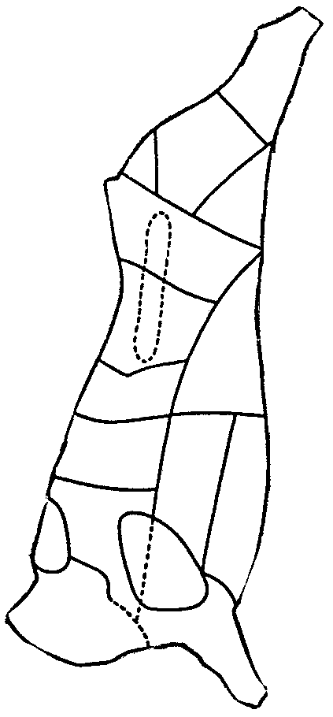
- Suggest THREE cuts from the beef  carcass that are suitable for the potjie.  Name the cuts.  3  15  17  16  12  11  13  9  10  8  6  7  5  4  2  3  1 | (3)

3.9.2 Suggest TWO reasons why you chose these cuts of meat. | (2)

3.10 Mandy makes the salad at ten o’clock in the morning to save time so that she can spend the afternoon with her new clients. Explain the wisdom of this decision. | (2)  [30]

QUESTION 4

Study the ingredients used in breadmaking and answer the questions that follow.

BREAD

375 ml lukewarm water
50 ml golden syrup
1 packet instant yeast
750 ml wholewheat flour
2 ml salt
75 ml oil

4.1 The measuring of syrup can cause problems. Suggest TWO methods that will ensure the easy measuring of syrup. | (2)

4.2 Explain why the milk must be lukewarm when added. | (2)

4.3 Why is it important to knead the bread dough? | (3)

4.4 When the bread is baking in the oven, the colour changes to light brown. What is the cause of this colour change? | (2)

4.5 How can bread be tested to make sure that it is cooked? | (2)

4.6 When a Swiss roll is baked, beaten egg white is used as the raising agent.

4.6.1 What, in the beaten egg white, serves as the raising agent? Also classify this raising agent. | (2)

4.6.2 To which stage must the egg whites be beaten to ensure the best end result and give TWO characteristics of this stage. | (3)

4.6.3 Explain when the following takes place during the beating of the egg white.  (a) Denaturation (changing of the protein molecule to a simpler form) of eggs  (b) Coagulation of the egg white | (2)  (2)

4.7 Study the ingredients and the method carefully and answer the questions that follow.

 | SPANISH CREAM
 | Ingredients | Method
 | 5 ml gelatin  25 ml cold water  250 ml milk, scalded  pinch of salt  1 egg, separated  100 ml sugar  2 ml vanilla essence | 1. Hydrate the gelatin in cold water.  2. Make custard with the milk, egg yolk, sugar, salt and vanilla essence.  3. Disperse the gelatin in the hot custard.  4. Beat the egg whites to the stiff peak stage and fold in the hot custard mixture.  5. Pour into a mould that has been rinsed with cold water.

4.7.1 During the preparation of this dish the custard curdled. Propose possible reasons for the curdling of the custard and indicate how the curdled texture of the custard can be improved. | (5)

4.7.2 After you have unmoulded the dessert, you notice that layers as well as a weak gel were formed. Why did this happen? | (5)  [30]

TOTAL FOR SECTION B: | [90]

SECTION C

QUESTION 5

Study the table and answer the questions that follow.

 | NAME | FAMILY MEMBER | PARTICULARS
 | Mr James | Father, 40 years | Engineer, works for a company.  Family photographer, records all family events.
 | Mrs James | Mother, 36 years | Housewife, just had third (unplanned) child.  Mother believes in a lot of hugging and physical contact.
 | Peter | Son, 15 years | Adolescent, friends with a 19-year-old “smoker”. Not used to doing household tasks. Always teasing Lindi. Under-achiever at school.
 | Lindi | Daughter, 7 years | Primary School pupil, loves reading – goes to library regularly. Not used to doing household tasks.
 | Claire | Baby girl | Newborn baby. Mother walks her in the park.

5.1 At what stage of the family life cycle is the James family? | (1)

5.2 Identify TWO of baby Claire’s developmental tasks. | (2)

5.3 Friendship is a very important relationship that children have to develop. Peter, in particular, will be feeling the importance of belonging to a group. List THREE advantages of being part of a group. | (3)

5.4 A division of tasks will have to be considered by the family. List TWO benefits of shared responsibilities. | (2)

5.5 Conflict occurs in all families. Which factors in the James family could cause conflict? Explain your answers. | (2)  (2)

5.6 The feeling of solidarity (unity) and commitment between family members is the main factor that helps maintain a close relationship over a long period. State TWO ways in which the James family can try to achieve solidarity. Explain this by using examples from the case study. | (4)

5.7 | Mrs James’s washing machine has broken down and cannot be repaired. A new washing machine will be the best solution, but she cannot pay cash for it. The launderette is near her house, but is very expensive to use. Washing nappies by hand will be too time-consuming. She considers all the factors and settles for a machine bought on hire purchase, where she would pay by means of monthly instalments.

5.7.1 Discuss each of the decision-making steps below that Mrs James followed in order to achieve her goal.  (i) Explain Mrs James’s problem.  (ii) Suggest alternative solutions to the problem from the case study.  (iii) Explore the consequences of all the alternatives.  (iv) What decision was made? | (1)  (2)  (3)  (1)

5.7.2 Determine TWO standards set by Mrs James relating to the washing machine problem. | (2)

5.8 | Mr James’s salary is made up of the following:  R96 000 per annum including pension fund, medical aid scheme, housing subsidy, performance bonus and a motor finance scheme.

5.8.1 Mr James’s salary is approximately R8 000 per month, yet the nett salary is only R6 500. Suggest TWO factors that could account for this difference. (Refer to the case study.) | (2)

5.8.2 Explain what fringe benefits are. | (1)

5.8.3 From the case study, list TWO fringe benefits Mr James receives. | (2)  [30]

QUESTION 6

Read the case study and answer the questions that follow.

Zandi is newly married and very proud of her new home on the smallholding just on the outskirts of Pretoria. She struggles to keep it tidy, as she has a morning job and no household help. Her teenage brother lives with her and her husband. When Zandi is at home and starting with the washing, she remembers the pile of dirty dishes, the unmade beds and the other chores still to be done. She feels despondent and incapable of managing. She shares her stressful situation with a friend. The friend insists that the drawing up of a schedule is the answer.

6.1 Predict the factors that will influence the planning/drawing up of Zandi’s schedule. | (4)

6.2 If a home manager neglects to plan or to develop skills, he/she will develop mental fatigue. Explain, in point form, how knowledge or lack thereof, can add to mental fatigue. | (4)

6.3 Nasty falls in the home are particularly common in bedrooms, kitchens, bathrooms and stairs. These accidents may be caused by various factors. List FOUR of these factors. | (4)

6.4 Study the floor plan of the townhouse and answer the questions that follow.

TOWNHOUSE

BATH
COFFEE TABLE
STAIRS
TV
IDENTICAL TOWNHOUSE
(MIRROR IMAGE)
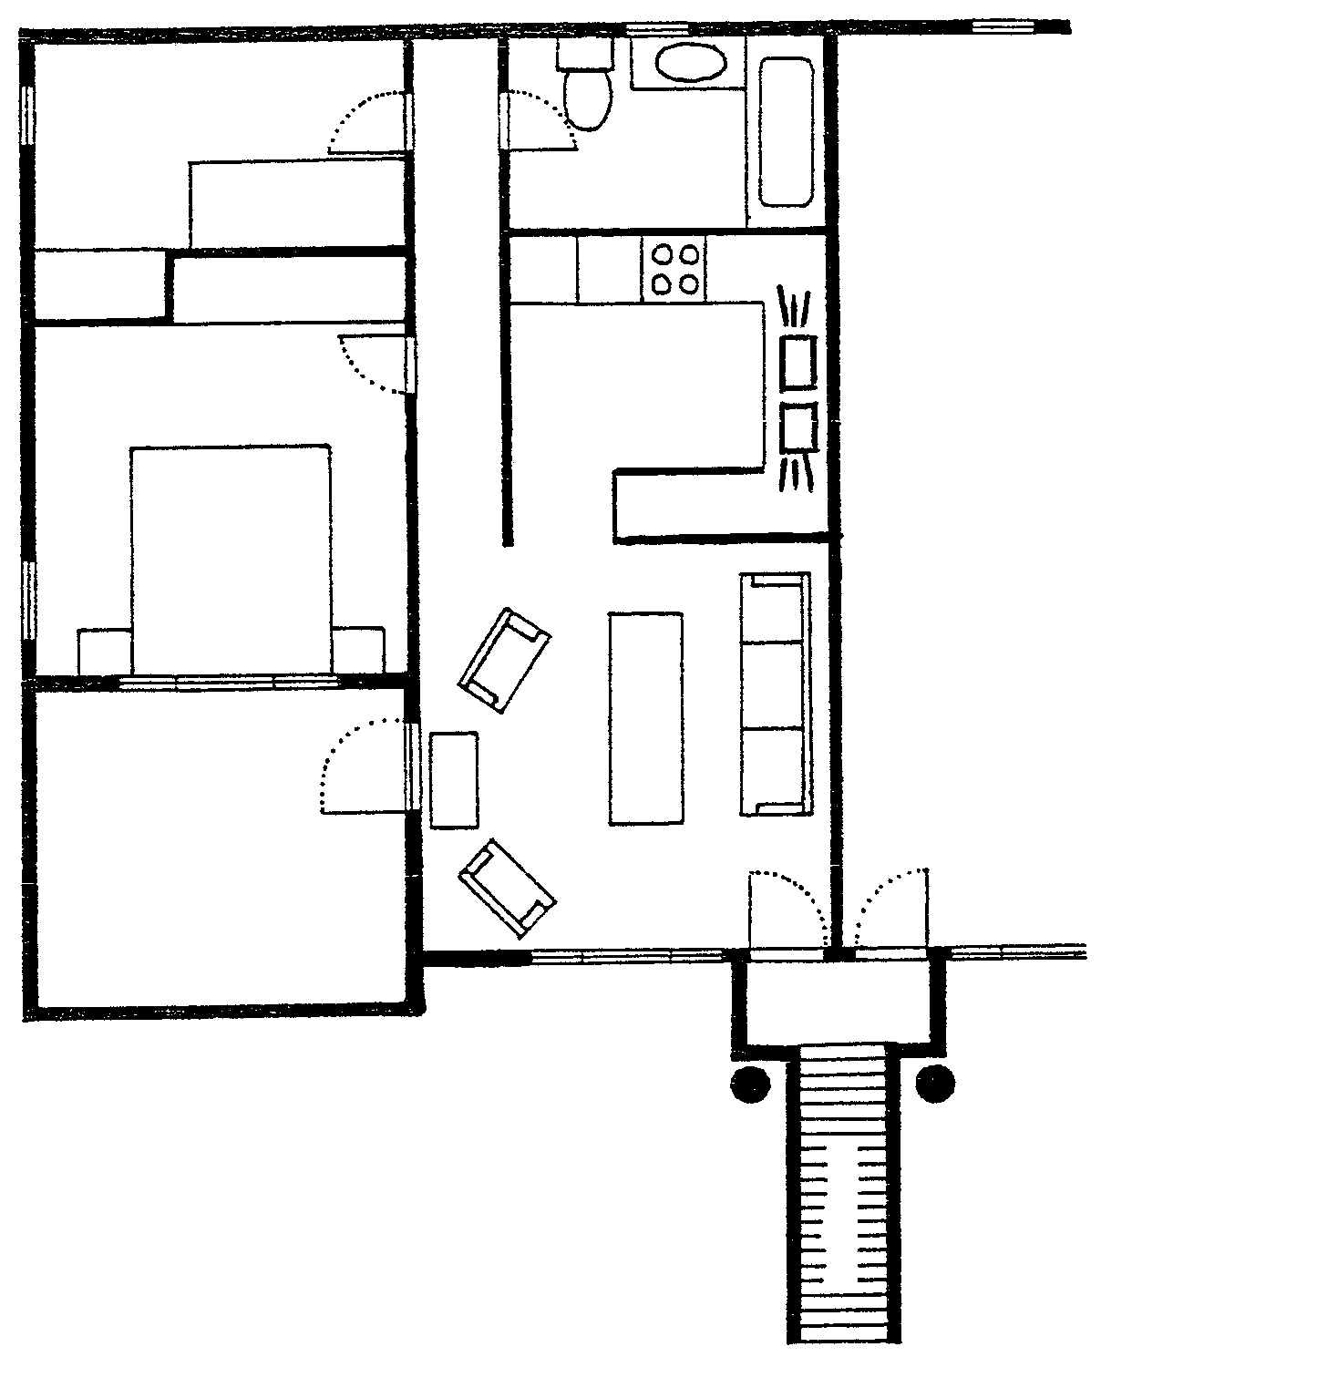
BEDROOM
1.
2.
3.
SINGLE BED
CUP-
BOARD
CUPBOARD
BEDROOM
2.
DOUBLE BED
1.
PATIO
FRIDGE
OPEN PLAN KITCHEN
LOUNGE
LANDING
PILLAR
N

S

6.4.1 Explain the mistakes in the placement and opening of doors 1, 2 and 3. | (6)

6.4.2 The furniture arrangement in the lounge is not ideal. Motivate your answer. | (3)

6.4.3 Can the small bedroom (1) be used for studying as shown on the floor plan? Motivate your answer. | (3)

6.5 Study the picture and answer the questions that follow.

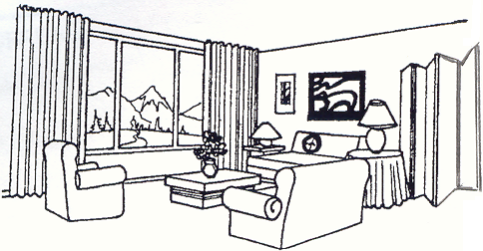

6.5.1 Give THREE examples of how the illusion of space is created in the room. | (3)

6.5.2 The north-facing room has bright sunlight during the day. Suggest a suitable monochromatic colour scheme for the room. Give a reason for your choice. | (3)

TOTAL FOR SECTION C: | [30]  [60]

TOTAL: | 200

