GAUTENG DEPARTMENT OF EDUCATION
SENIOR CERTIFICATE EXAMINATION

HOME ECONOMICS HG

TIME: 3 hours

MARKS: 300

INSTRUCTIONS:

- ALL the questions are COMPULSORY.

- Please write neatly and clearly.

- Number your answers exactly as the questions are numbered.

- Answer Question 1A (1.1 – 1.18) (multiple-choice) of Section A on the answer sheet on the inside cover of your answer book.

- Answer Question 1B (1.19 – 1.30) of Section A as well as Section B and Section C in your answer book.

- Use the suggested time guide below.

- Use FIVE minutes at the beginning of the examination to skim read the paper.

- Use FIVE minutes at the end of the examination to check your work.

 | SUGGESTED TIME GUIDE
 | QUESTION NO. |  | MARKS | TIME
 | Section A | Question 1 | 100 | 55 minutes
 | Section B | Question 2 | 40 | 23 minutes
 |  | Question 3 | 40 | 23 minutes
 |  | Question 4 | 40 | 23 minutes
 | Section C | Question 5 | 40 | 23 minutes
 |  | Question 6 | 40 | 23 minutes
 |  | TOTAL | 300 | 170 minutes

SECTION A

QUESTION 1A

Indicate the correct answer clearly by making a cross (X) over the corresponding letter on the answer sheet on the inside cover of your answer book.

EXAMPLE: Croûtons are

A. pieces of fried meat.
B. liver patties.
C. fried bread cubes.
D. fish cakes.

ANSWER: | A | B | C | D

NB. Where more than one cross appears in any answer, NO MARKS will be awarded for that question.

1.1 Which one of the dishes listed below is not suitable for a person on a low protein diet?  A. Fruit salad and ice-cream  B. Egg and cheese sandwich  C. Potato and green pepper salad  D. Cauliflower with white sauce | (2)

1.2 The bran and the germ of ______ are removed before being finely ground.  A. sorghum and semolina  B. samp and maize meal  C. flour and cornflour  D. wheat and barley | (2)

1.3 Fresh milk has a slightly salty-sweet taste because of the presence of  A. lactose and chloride salts.  B. glucose and calcium salts.  C. galactose and iron salts.  D. fructose and magnesium salts. | (2)

1.4 Fat globules in milk are kept in a state of emulsion by proteins and  A. fat globules.  B. dissolved minerals.  C. soluble sugars.  D. phospholipids. | (2)

1.5 Which two of the items listed below are low energy dairy products suitable for weight reducing diets?  1. Whipping cream  2. Cream cheese  3. Buttermilk  4. Gouda cheese (sweet milk)  5. Fresh homogenised milk  6. Skim milk  A. 1, 4  B. 2, 3  C. 3, 6  D. 4, 5 | (2)

1.6 Choose two reasons from the following list, which best illustrate the need for the production of meat analogues in Mexico and Africa.

1. Animal proteins are very expensive.  2. There is a shortage of meat.  3. Plant proteins are more nutritious.  4. Plant proteins digest easier than meat.  A. 1, 2  B. 2, 4  C. 3, 4  D. 1, 3 | (2)

1.7 Rigor mortis, the process of after-death stiffening of the carcass, is caused by  A. an electric current passing through the carcass.  B. cool-shrinkage caused by the rapid cooling of the carcass.  C. biochemical reactions under controlled conditions.  D. the formation of permanent bonds between the actin and the myosin. | (2)

1.8 The natural environment makes provision for  A. opportunities for social interaction.  B. the development of attitudes and beliefs.  C. basic needs such as food and clothing.  D. technological development such as roads and buildings. | (2)

1.9 Which of the following describes the characteristics of a homemaker who is a good manager?  1. Plans ahead, taking available time into consideration  2. Is a very artistic interior designer  3. Accepts responsibility for decisions relating to goals and resources  4. Owns the newest timesaving equipment  A. 1, 3  B. 2, 3  C. 1, 4  D. 2, 4 | (2)

1.10 Mrs Zuma is a very busy Home Economics educator and decides to buy an automatic washing machine and tumble dryer. Which type of decision did she make?  A. Economic decision  B. Central decision  C. Technical decision  D. Social decision | (2)

1.11 Identify which one of the following characteristics of his resources is applicable when Johan uses his woodwork skills to earn money.  A. Usefulness  B. Manageability  C. Interchangeability  D. Accessibility | (2)

1.12 A compulsive cleaner  A. will see that the house is always perfectly clean.  B. will see that everything looks good when visitors arrive.  C. cleans when she gets the urge.  D. ensures that the kitchen is clean and germ free. | (2)

1.13 When a student sits to write an exam, the desk must be  A. the same height as the elbow.  B. slightly lower than the elbow.  C. slightly higher than the elbow.  D. level with the armrest of the chair. | (2)

1.14 An ornamental mirror is used to great effect in  A. a white painted room.  B. a large bright room.  C. a dark corner in a room.  D. a room with a low ceiling. | (2)

1.15 An example of a family in the launching stage:  A. Rob and Kate’s oldest child is in Grade 12.  B . Pieter and Anet’s oldest child is in Grade 1.  C. Jacob and Zinzile’s youngest child got married recently.  D. Feroz and Fatima’s oldest child leaves home to study. | (2)

(Questions 1.16 – 1.18 are based on the following sketch.)

Study the sketch below of a room shared by three girls.

- 8 year old twin girls, Sam and Tammy
- 15 year old Nina
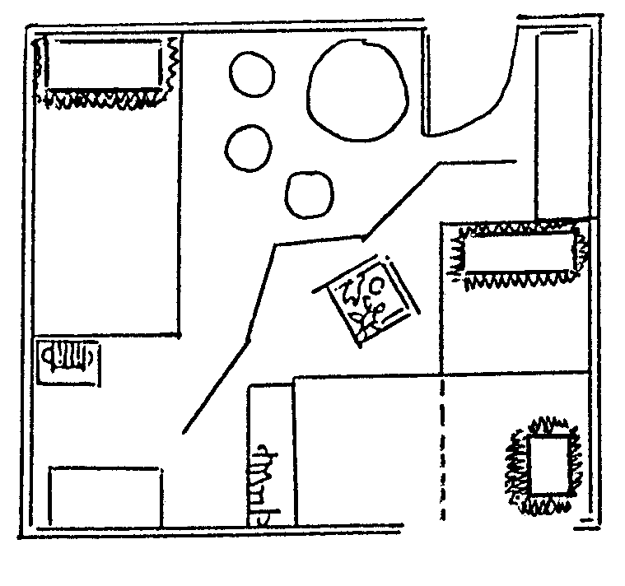
A  A. Desk and lamp  Nina  Sam  Tammy  H  D  E  F  B  G  B  C  B. Bookshelves  C. Toy box  D. Table and chairs  E. Screen (2m high)  F. Cupboard  G. Double bunk beds  H. Single bed | O

1.16 Privacy has been successfully provided for  A. Nina, by the position of her bed.  B. the twins, by the position of the toy box.  C. Tammy, by the position of her pillows.  D. the twins, by the position of the screen. | (2)

1.17 There is no traffic flow obstruction from  A. the door to the desk.  B. Nina’s bed to her desk.  C. the door to the twin’s beds.  D. the door to Nina’s bed. | (2)

1.18 How has provision for functionality been made in the room? Which combination of examples is correct?  1. Light at the study area  2. A combination of activities  3. Storage space  4. Personal care  A. 1, 2  B. 2, 3  C. 3, 4  D. 1, 3 | (2)  [36]

QUESTION 1B

1.19 Match the food example in Column B with the food system in Column A. Write the numbers (1.19.1 – 1.19.5) below each other in your answer book and then the letter (A–G) of your choice next to the correct number.

 | COLUMN A |  | COLUMN B |  | (5)
 | Food System |  | Food example |  | (5)
 | 1.19.1 | Sol | A. | Syrup | (5)
 | 1.19.2 | Water-in-oil emulsion | B. | Margarine | (5)
 | 1.19.3 | Gas-in-solid foam | C. | Meringues | (5)
 | 1.19.4 | Suspension | D. | Mayonnaise | (5)
 | 1.19.5 | Mixture | E. | Jelly with fruit cubes | (5)
 |  |  | F. | Hot white sauce | (5)
 |  |  | G. | Fruit salad | (5)

1.20 Match the egg function in Column B to the food in Column A. Write the numbers (1.20.1 – 1.20.7) below each other in your answer book and then the letter (A–I) of your choice next to the correct number.

 | COLUMN A |  | COLUMN B |  | (7)
 | Food |  | Egg Function |  | (7)
 | 1.20.1 | Baked egg custard | A. | Foam formation | (7)
 | 1.20.2 | Meat balls | B. | Garnishing | (7)
 | 1.20.3 | éclairs (Choux pastry) | C. | Emulsification | (7)
 | 1.20.4 | Fried fish | D. | Glazing | (7)
 | 1.20.5 | Meringues | E. | Filling | (7)
 | 1.20.6 | Meat pies | F. | Coating | (7)
 | 1.20.7 | Salad | G. | Binding | (7)
 |  |  | H. | Clarifying | (7)
 |  |  | I. | Thickening | (7)

1.21 (a) Match the cooking method in Column B with the food item in Column A.

(b) Match the effect of heat in Column C to the food item in Column A. In your answer book, write the given numbers (1.21.1 – 1.21.5) and then the letter (A–G) of your choice next to the correct number, then write the roman numeral (i–vii) next to the letter (A–G) of your choice. i.e. 1.21.6 – H – ix.

 | COLUMN A |  | COLUMN B |  | COLUMN C |  | (10)
 | Food Item |  | Cooking Method |  | Effect of Heat |  | (10)
 | 1.21.1  1.21.2  1.21.3  1.21.4  1.21.5 | Beef sausage  Cabbage, carrots and mushrooms  Bread rolls  Lightly seasoned hake (fish)  Beef roll | A.  B.  C.  D.  E.  F.  G. | Pot roasting  Steaming  Stir frying  Deep fat frying  Baking  Grilling  Toasting | i. | Cellulose softens, food becomes tender, but retains crispness. | (10)
 |  |  |  |  | ii. | Collagen changes to gelatine resulting in tenderising, an appetising aroma and pleasing colour. | (10)
 |  |  |  |  | iii. | Fat oozes out, food shrinks and browns rapidly. | (10)
 |  |  |  |  | iv. | Some starch gelatinises, while a small quantity dextrinises. | (10)
 |  |  |  |  | v. | Sugar dissolves and later caramelises. | (10)
 |  |  |  |  | vi. | Protein coagulates, colour changes to white, texture is firm. | (10)
 |  |  |  |  | vii. | Viscosity decreases with an increase in temperature. | (10)

1.22 Match the examples in Column A with the design principles in Column B. Write numbers (1.22.1 – 1.22.5) below each other in your answer book and then the letter (A–H) of your choice next to the number:

 | COLUMN A |  | COLUMN B
 | Example |  | Design Principle
 | 1.22.1 | Identical cushions are used on the couch and chairs in the lounge. | A.  B.  C.  D.  E.  F.  G.  H. | Formal balance  Informal balance  Harmony of texture  Harmony of colour  Emphasis  Rhythm  Proportion  Line | (5)
 | 1.22.2 | The placement of a painting above the fireplace draws attention to the fireplace in the bedroom. | A.  B.  C.  D.  E.  F.  G.  H. |  | (5)
 | 1.22.3 | The same size decorative plates hang on either side of the wall clock. | A.  B.  C.  D.  E.  F.  G.  H. |  | (5)
 | 1.22.4 | The pottery vase is displayed on the coarse carpet. | A.  B.  C.  D.  E.  F.  G.  H. |  | (5)
 | 1.22.5 | To make the ceiling appear lower, it is painted slightly darker than the walls. | A.  B.  C.  D.  E.  F.  G.  H. |  | (5)

1.23 A restaurant owner has the following poster displayed in the kitchen:

1.23.1 Personal hygiene is of importance to our customers.
1.23.2. Correct food storage is vitally important for the safety of food.
1.23.3. The eating of quality food can be influenced by the handling of food.
1.23.4. Food must be prepared, cooked and served immediately.
1.23.5. Chicken should be treated with special care during preparation and cooking.

Select from the list below TWO reasons for each of the above poster statements. In your answer book write the question number 1.23 and the letters (A – J) of your choice below each other. List numbers 1 – 5 below each other with your TWO choices next to each number i.e. 1.23 I – K, L.

 | REASONS FOR THE POSTER STATEMENTS
 | A. | Prevents the growth of micro-organisms.
 | B. | 50ºC is an unsuitable temperature at which to keep food warm.
 | C. | Oxidation may be stimulated when peeling with a blunt knife, causing food to deteriorate from within.
 | D. | Bacteria will cause decay if food was not cooked and reheated at a temperature above 60ºC.
 | E. | Transmitting of micro-organisms may cause food-related diseases.
 | F. | Ripping leafy vegetables will cause the leaves to become limp and soggy.
 | G. | Pathogenic bacteria may be found inside the body and on its surface, presenting a threat to the health of others.
 | H. | To prevent salmonella poisoning.
 | I. | To retain the texture and the Vitamin B- and C-content of vegetables.
 | J. | The presence of rats, mice and bacteria in a warm environment will cause food to deteriorate and spoil rapidly. | (10)

1.24 Select from the list FOUR conditions that will promote bacterial growth in food. In your answer book write the question number 1.24 and the FOUR letters (A–H) of your choice below each other.

 | CONDITIONS PROMOTING BACTERIAL GROWTH IN FOOD
 | A. | Reheating soup at a high temperature
 | B. | Defrost chicken on the kitchen table
 | C. | Storing food at a temperature of 12ºC
 | D. | Keeping a mutton casserole warm at 40ºC
 | E. | Leaving leftover haddock-pie overnight on the stove
 | F. | Freezing leftover food after cooling
 | G. | Defrost chicken overnight in the bottom of the fridge
 | H. | Reheat leftover chicken to 75ºC | (4)

1.25 Rearrange the phenomena, in the table below, which take place when heating milk in a saucepan. In your answer book write the question number 1.25 and the letters (A–E) in the correct order below each other.

 | THE EFFECT OF HEAT ON MILK
 | A. | A skin forms on the surface.
 | B. | Lactalbumin begins to coagulate at 65ºC.
 | C. | A ‘deposit’ forms at the bottom of the saucepan.
 | D. | Scorching results in a burnt taste.
 | E. | Lactalbumin and lactoglobulin coagulate at 80ºC.
2X5 = (10)
1.26 Choose THREE factors that will determine assured income. In your answer book write the question number 1.26 and the THREE letters (A–F) of your choice below each other.

 | FACTORS THAT DETERMINE ASSURED INCOME
 | A. | Bonuses
 | B. | Salaries
 | C. | Interest on fixed deposits
 | D. | Letting of property
 | E. | Contributions to medical aid
 | F. | Pay profit on chocolate sales occasionally into bank account | (3)

1.27 Choose THREE places where bright lights must be situated in the home. In your answer book write the question number 1.27 and the THREE letters (A–F) of your choice below each other.

 | PLACES WHERE BRIGHT LIGHTS MUST BE PLACED
 | A. | The stairs
 | B. | The dining room
 | C. | The bathroom
 | D. | The garden path
 | E. | The foyer
 | F. | The work surface in the kitchen | (3)

1.28 Redraw the following table in your answer book:

 | Cognitive | Affective | Psychomotor | Non-human

Classify the following resources, which will be used during practical cooking, under the correct headings. Write only the correct number (A – G) under the correct heading.

1.28.1 A microwave oven

1.28.2 A positive attitude towards given tasks

1.28.3 Knowledge of the different techniques to be applied

1.28.4 Endurance ability to complete the practical

1.28.5 The skill to make a roux

1.28.6 A place for the gelatine dish in the fridge

1.28.7 A recipe book | (7)  [64]

TOTAL FOR SECTION A: | [100]

SECTION B

QUESTION 2

2.1 Refer to the given recipe when answering questions 2.1.1 – 2.1.10.

 | LEMON MERINGUE PIE
 | INGREDIENTS
 | Crust | Filling | Meringue
 | 200 ml cake flour  1 ml salt  5 ml sugar  60g butter | 45 ml cornflour  125 ml sugar  175 ml boiling water  1 egg yolk, beaten  pinch of salt  20 ml cold water  7 ml butter  7 ml grated lemon rind  45 ml lemon juice | 2 egg whites  60 ml sugar  1 ml lemon juice  pinch of salt
METHOD
Crust
1. Sift cake flour and salt together.
2. Cut in butter until mixture resembles coarse breadcrumbs.
3. Press mixture together and knead to form a dough.
4. Line a pie dish (200mm diameter), prick and refrigerate for 15 minutes.
5. Bake blind at 180ºC for 10 minutes. Allow to cool.
 | Filling
1. Sift cornflour and sugar together.
2. Stir in the boiling water.
3. Cook over direct heat until very thick and translucent, stirring constantly.
4. Put over boiling water and simmer for 10 – 15 minutes more, stirring slower.
5. Add some of the paste to the egg. Stir this mixture into the hot filling.
6. Bring to boil over direct heat for 15 minutes.
7. Simmer over water. Stir occasionally.
8. Remove from heat. Add rest of ingredients.
 | Meringue-topping
1. Whisk the egg whites till foamy.
2. Add lemon juice and whisk to soft peak stage.
3. Add the sugar and salt. Whisk till sugar is well-blended and soft peaks form.
4. Pour filling into crust and decorate with topping.
5. Bake at 240ºC until golden brown.

Question 2.1.1 is applicable to the ingredients of the filling.

2.1.1 What is the function of

(a) the cornflour and

(b) the grated lemon rind in the filling? | (2)

Questions 2.1.2 to 2.1.6 are applicable to the method of the filling.

2.1.2 Name the process that occurs in step 3. | (2)

2.1.3 Mention FIVE changes that take place during the process in step 3. | (5)

2.1.4 Explain why the mixture is stirred slower in step 4. | (2)

2.1.5 Refer to step 5. Why is the beaten egg yolk not added directly to the hot starch mixture? | (2)

2.1.6 Lemon juice is added in step 7. If it is added before the cooking process, what effect will it have on the viscosity (thickness) of the filling? | (3)

Questions 2.1.7 to 2.1.10 are applicable to the meringue topping.

2.1.7 Explain why the cornflour and sugar are mixed together in step 1. | (2)

2.1.8 Name TWO ingredients typical of the meringue topping. | (2)

2.1.9 Explain why the lemon juice and sugar are added at different stages of the beating of the egg white (meringue topping). | (2)

2.1.10 Determine where the following terms occur in the preparation and storage of the Lemon Meringue Pie:

 | Coagulation, Maillard Reaction, Denaturation, Syneresis | 4x2 | (8)

2.2 What is turgor pressure (tissue tension) and explain how it contributes to the texture of vegetables? | (4)

2.3 Identify the methods of cooking used during the cooking of the following foods:

 | 2.3.1 | Potjiekos (meat and vegetables cooked in a three-legged cast-iron pot over an open fire) | (6)  [40]
 | 2.3.2 | Egg (to be used for stuffed egg) | (6)  [40]
 | 2.3.3 | French fries (chips) | (6)  [40]
 | 2.3.4 | Pancakes (not using non-stick spray e.g. Spray and Cook) | (6)  [40]
 | 2.3.5 | White bread | (6)  [40]
 | 2.3.6 | Lamb chops (over glowing coals) | (6)  [40]

QUESTION 3

3.1 Name TWO changes that take place when fruit ripens and explain how the changes happen. | (4)

3.2 Redraw the table below in your answer book.

 |  |  | 3.2.1 Salad ingredients | 3.2.2 Description of how food spoilage takes place
 | A. | Enzyme action | 1. | 1.  2.
 | B. | Non-enzymatic spoilage | 1.  2. | 1.  2.
 | C. | Withering | 1. | 1.

Study the recipe below and answer the questions that follow in the table:

Spinach Salad
Young spinach leaves, croutons, apple cubes, feta cheese, walnuts, bacon cubes, French salad dressing

3.2.1 When answering the question no ingredients may be repeated. Which ingredients in the above salad may be spoiled through:  (a) enzyme action (ONE ingredient)?  (b) non-enzymatic spoilage (TWO ingredients)?  (c) withering (One ingredient)? | (4)

3.2.2 Describe how the spoilage of each salad ingredient takes place. | (5)

3.3 Redraw the table below in your answer book and answer the questions that follow.

 | Meat and Meat alternatives | A. | Cereal and Cereal Products | B. | Fruit and Vegetables

3.3.1. Fill in the missing food groups (A and B).  3.3.2. Select a food from the list below that belongs to the five food groups. | (2)  (5)

Soya-bean burgers, bacon rashers, fruit salad, mealiemeal porridge, cheese soufflé.

3.4 Explain the given statements with regard to gelatine desserts.

3.4.1 If a relatively large amount of lemon juice is used in the dessert, more gelatine should be added. | (3)

3.4.2 If pieces of fruit are added to a gelatine mixture, the mixture should already have started to thicken. | (2)

3.4.3 Raw pineapple should not be added to gelatine dishes. | (3)

3.5 Explain how atmospheric pressure influences the boiling point of water and the cooking time of potatoes in Durban. | (3)

3.6 A pressure cooker decreases the cooking time of food. Explain how this occurs. | (3)

3.7 Explain in point form how a stable emulsion can be maintained when choux paste is made. | (6)  [40]

QUESTION 4

4.1 From the list below, select the main nutrient present in each of the following vegetables:

Sweet potatoes, carrots, corn, soya beans, spinach.

A. Carbohydrates  B. Proteins  C. Iron  D. Vitamin A | (4)

4.2 | FRIED MEATBALLS  250 g beef mince  25 ml oats  1 beaten egg  2 ml salt  1 ml pepper  Method  Mix lightly with a fork.  Shape mixture into meatballs and cook.

4.2.1 List four pre-mortal factors that will influence the eating quality of the meat. | (4)

4.2.2 Name THREE reasons why forequarter cuts are usually used for beef mince. | (3)

4.2.3 Explain what a person on a limited budget may use to extend the mince to feed more people. (To keep the nutritional value high in protein is essential.) no tradenames e.g. TOPPERS may be used. | (4)

4.2.4 The browning of the meatballs is the result of changes that take place during the cooking process. Describe TWO changes. | (4)

4.2.5 Suggest a suitable cooking method for the meatballs. | (1)

4.3 Explain the following statements related to fish:

4.3.1 Baked Salmon is usually served with a sauce. | (2)

4.3.2 Steamed Hake is used for invalid diets. | (2)

4.3.3 Grilled Kingklip develops a golden brown colour. | (2)

4.3.4 Fish to be fried is usually covered in a batter. | (2)

4.4 Explain why baked homemade bread rolls may taste sour. | (4)

4.5 Study and evaluate the menu below according to its suitability with regard to the following criteria.

A. Texture | (2)
B. Colour | (2)
C. Season | (2)
D. Nutritional value | (2)

MENU

DINNER

Tomato Soup

Grilled Fish Tartar Sauce

Tomato Stew Mashed Potatoes

Cinnamon Dumplings

Coffee
10 January 2003

[40]

TOTAL FOR SECTION B: | [120]

SECTION C

QUESTION 5

5.1 Read the case study and answer the questions that follow.

Mrs Zondo sets the following financial goals for herself:

1. My money matters are important, but they won’t rule my life.
2. I want to be financially independent in a few years.
3. My wants will be satisfied after my needs.
4. Except for a long-term home and car loan, I will try not to get into debt.
5. I will spend less than I earn and will use alternative methods available to invest for my future.
6. I will use my money and talents, to make life more pleasant for myself and others, by getting involved in community service.

5.1.1 Identify the type of goal that Mrs Zondo’s financial goals represent. Motivate your answer. | (2)

5.1.2 Determine which goal (1 to 6) in the case study will ensure Mrs Zondo will be financially sound by the time she retires. Motivate your answer. (Write only the number of the goal, i.e. Goal 2 and then your motivation) | (2)

5.1.3 Name TWO examples of alternative methods to which Mrs Zondo refers. | (2)

5.1.4 Values determine one’s attitude towards one’s fellow human beings. Determine how Mrs Zondo relates to her fellow human beings. (Goal 6) | (2)

5.1.5 Identify the need according to Maslow’s Hierarchy to which reference is made in Goal 6. Motivate your answer. | (2)

5.2 Mr Zondo and his 10-year-old daughter, Susan, have the following conversation. Study the diagram and answer the questions that follow:

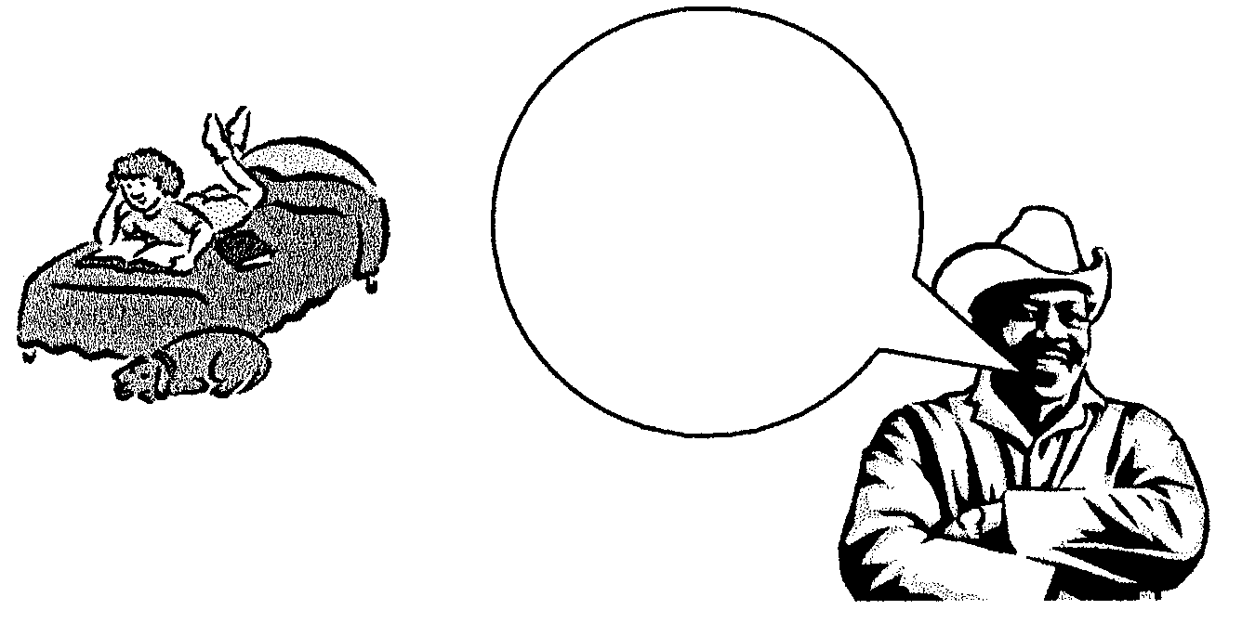
You are already 10 years old and since your brother is at the Technikon and your mother starts a new job tomorrow, you will have to accept more responsibility at home.

5.2.1 Since Susan now has more responsibility, she will be more stressed. Identify TWO emotional demands that she will experience. | (2)

5.2.2 Give a reason and explain why it will be necessary for standards relating to tasks in the Zondo home to change. | (2)

5.2.3 Do you think Susan will procrastinate when she has to cook for the whole family? Motivate your answer. | (3)

5.2.4 Shared responsibility in the home helps to strengthen family ties and cultivates better family relationships. Suggest another FOUR advantages of shared responsibilities in the family. | (4)

5.3 Study the bathroom of the Zondo family and answer the questions that follow.

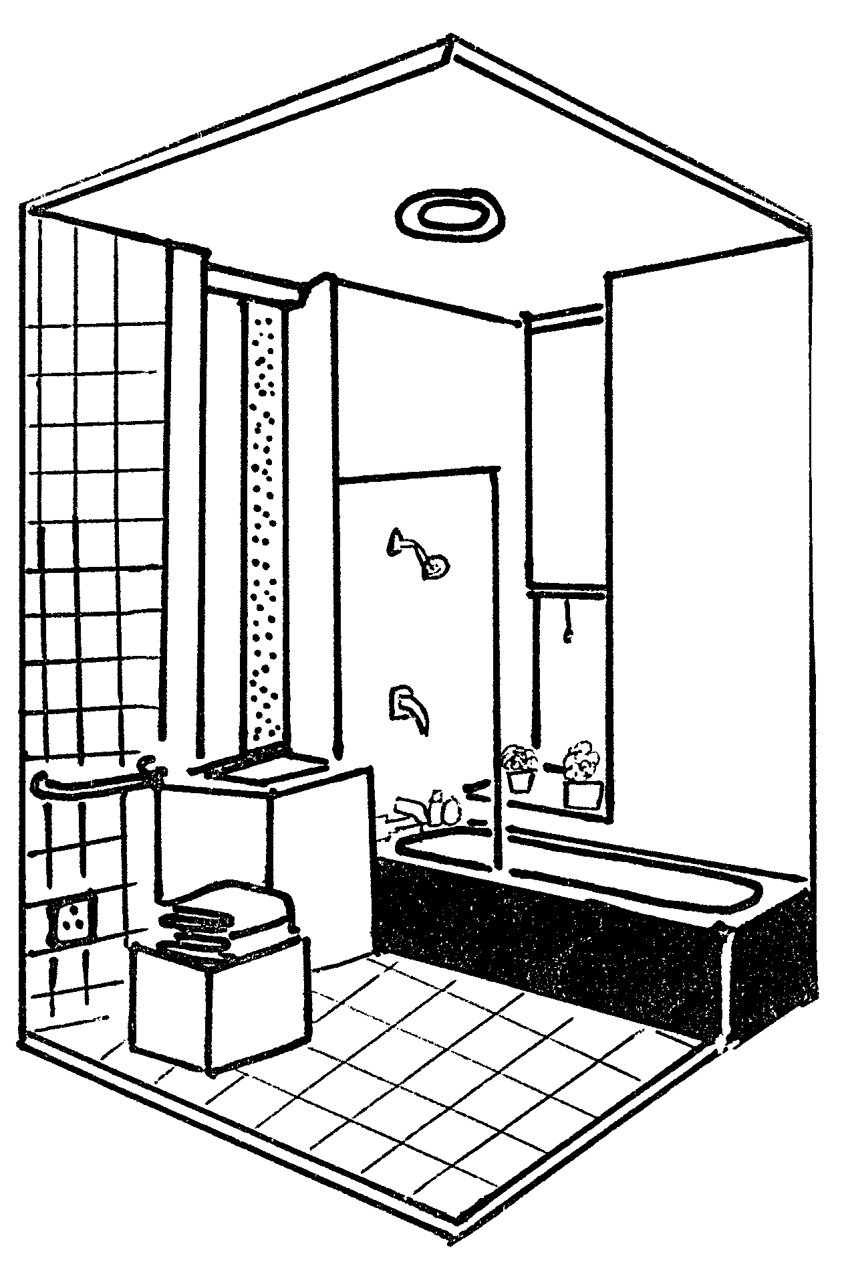

Evaluate the safety aspects in the bathroom under the following headings:

5.3.1 Bath
5.3.2 Floor in front of bath
5.3.3 Power point | (3)

5.4 Study Mr and Mrs Zondo’s bedroom and answer the questions that follow.

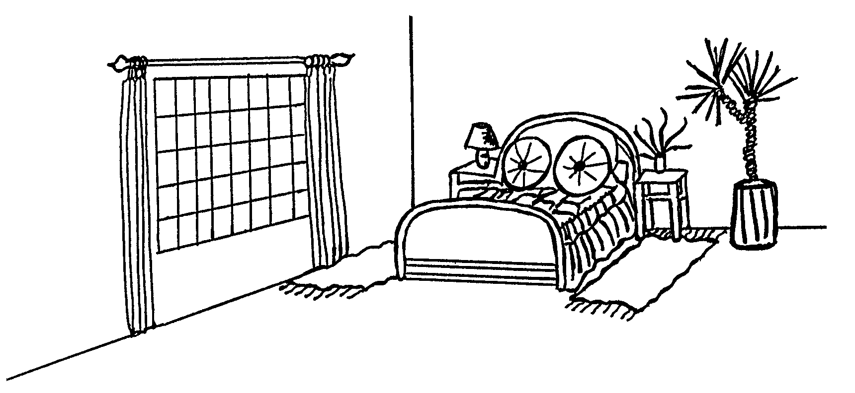

The bedroom is very big and faces south.

5.4.1 Evaluate the design principle balance in this room. | (6)

5.4.2 Suggest a complementary colour scheme for the bedroom, indicating which colour will be the main colour. | (3)

5.4.3 The room is very big. How can the room be insulated to prevent the loss of heat? | (3)

5.4.4 Redraw the table in your answer book.

 | Picture | Is the light functional? | Reasons
 | A
 | B

Study the diagrams related to lighting and answer the questions that follow.

 | DIAGRAM A |  | DIAGRAM B
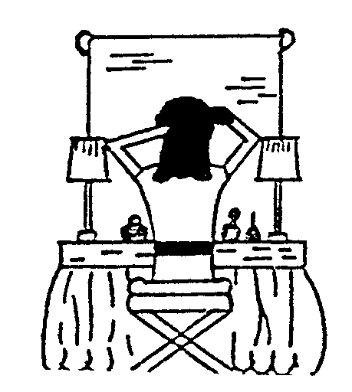
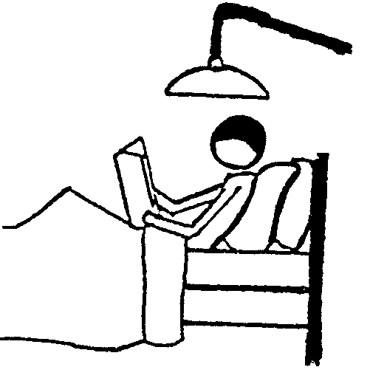

(a) Do the lights fulfil the function for which they are meant? | (2)
(b) Give ONE reason for each of your answers. | (2)  [40]

QUESTION 6

6.1 Meet the Malan family and answer the questions that follow.

 | Family Member | Name of Family Member | Personal Information of Family Member
 | Grandpa | Simon | 70 years old, Pensioner
 | Grandma | Marie | 68 years old, Pensioner
 | Mother | Karen | 44 years old, Breadwinner, works all day
 | Father | Carel | Deceased
 | Daughter | Stella | 17 years old, Grade 12, very modern
 | Son | Jason | 10 years old, Grade 4, very active

6.1.1 Stella plans to study fashion design at the Vaal Triangle Technikon after matriculating. Which stage of the family life cycle will the family enter when Stella leaves home? Motivate your answer. | (2)

6.1.2 Draw the following table in your answer book and answer the question that follows. Write only the suitable letter (A – D) in the table.

 | Factors that influence the Division of Tasks | Explanation

Choose TWO of the following factors that influence the division of tasks in the Malan family and explain.

A. Jason is too young to do too many tasks.
B. Karen is away from home hours at a time.
C. Marie is available all day. | (4)

6.1.3 If you look at the family situation, you will understand that conflict can very easily take place within a family. Explain the possible reasons for conflict between the following persons. (Refer to the personal information in the case study.)

(a) Stella and Jason | (2)
(b) Stella and Karen | (2)

6.2 Read the case study and answer the questions that follow.

Stella receives permission to redecorate her room during the April holiday. The amount of money she can spend is not limited. She gets a lot of information from interior decorating books from the library. Her friend from school offers to mix the paint for her.

Redraw the following table in your answer book and answer the question that follows.

 | THREE human resources | ONE example from case study

Choose THREE human resources from the list below and give ONE example of each from the case study.

- Money  - Time  - Library  - Helpful friend  - Knowledge | (6)

6.3 Read the following case study and answer the questions that follow:

Stella studies very hard for the upcoming exams. She draws up a timetable to work from. She plans to study next year. She plans to move into a bachelor flat. She wants to work part-time in a restaurant to earn extra money to help pay for her studies.

6.3.1 Which TWO values are important in Stella’s goal setting? | (2)

6.3.2 Regular evaluation is a very important part of the management process. Stella did not evaluate her progress regularly.  What will the consequences of this be on her future? | (2)

6.3.3 On what level of decision making will Stella make her decision relating to the year after matric? Motivate your answer. | (2)

6.4 Study the sketch of Stella’s bachelor flat for next year and answer the questions that follow.

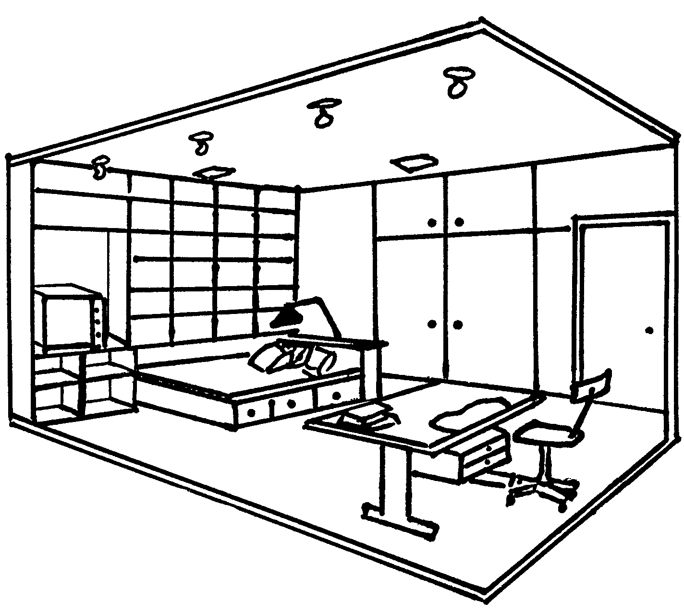

6.4.1 Explain whether Stella’s bachelor flat lends itself to entertaining friends. | (2)

6.4.2 Identify THREE places where rhythm occurs in the room. | (3)

6.4.3 Stella studies fashion design and must cut out patterns and fabric. As there is not a big enough table, she will have to cut out on the floor. She complains about constant backache.  Identify the type of muscle tension that is caused by this discomfort. | (1)

6.5 Evaluate how Stella applied the illusion of space in her room. | (6)

6.6 Study the sketch of the front door of the Malan home and answer the questions that follow.



Redraw the following table in your answer book and answer the questions.

 | Functional design | Decorative design

6.6.1 Choose from the following list the functional and decorative design present at the front door.

 | Hand railing, door bell, curved lines, lights. | (4)

6.6.2 Identify the most dominant design element on the front door. | (1)

6.6.3 Explain the effect of this design element on the front door. | (1)  [40]

TOTAL FOR SECTION C: | [80]

TOTAL: | 300

