GAUTENG DEPARTMENT OF EDUCATION
SENIOR CERTIFICATE EXAMINATION

HOME ECONOMICS HG

TIME: 3 hours

MARKS: 300

INSTRUCTIONS:

- ALL the questions are COMPULSORY.

- Please write neatly and clearly.

- Number your answers exactly as the questions are numbered.

- Answer Question 1A (1.1 to 1.14) (multiple-choice) of Section A on the answer sheet on the inside cover of your answer book.

- Answer Question 1B (1.15 to 1.30) of Section A as well as Section B and Section C in your answer book.

- Use the suggested time guide below.

- Use FIVE minutes at the beginning of the examination to skim read the paper.

- Use FIVE minutes at the end of the examination to check your work.

 | SUGGESTED TIME GUIDE
 | QUESTION NO. |  | MARKS | TIME
 | Section A | Question 1 | 100 | 55 minutes
 | Section B | Question 2 | 40 | 23 minutes
 |  | Question 3 | 40 | 23 minutes
 |  | Question 4 | 40 | 23 minutes
 | Section C | Question 5 | 40 | 23 minutes
 |  | Question 6 | 40 | 23 minutes
 |  | TOTAL | 300 | 170 minutes

SECTION A

QUESTION 1A

Indicate the correct answer clearly by making a cross (X) over the corresponding letter on the answer sheet on the inside cover of your answer book.

EXAMPLE: Croûtons are

A. pieces of fried meat.
B. liver patties.
C. fried bread cubes.
D. fish cakes.

ANSWER: | A | B | C | D

NB. Where more than one cross appears in any answer, NO MARKS will be awarded for that question.

1.1 Which one of the following meals is suitable for dieters?  A. Fried fish, chips and peas  B. Grilled liver, chips and tomato  C. Boiled egg, asparagus, cucumber and tomato  D. Fried bacon, eggs, tomato and toast | (2)

1.2 The following are part of the milk and milk product group:  A. Coffee creamer, milk, margarine  B. Yoghurt, evaporated milk, butter  C. Cheese, artificial creamer, sterilised milk  D. Full cream milk, skimmed milk powder, cheese | (2)

1.3 Measuring cups can be used to measure the following accurately:  A. 25 ml oil and 125 ml water  B. 75 ml cocoa and 250 ml coconut  C. 75 ml cocoa and 250 ml milk  D. 125 ml icing sugar and 75 ml oil | (2)

1.4 The main function of eggs during the making of choux puffs is to  A. gelatinise the starch.  B. act as a raising agent.  C. act as an emulsifier.  D. ensure a smooth surface. | (2)

1.5 Moist heat is mainly applied in the following cooking methods:  A. Pot roasting and stewing  B. Stewing and direct steaming  C. Deep frying and shallow frying  D. Ovenroasting and pot roasting | (2)

1.6 Starches with the best thickening ability include:

A. tapioca and sago.  B. cornflour and flour.  C. dextrinised flour and tapioca.  D. cornflour and dextrinised flour. | (2)

1.7 Which of the following ingredients are used during the making of creamed cottage cheese?  A. Cream and whey  B. Whey and buttermilk  C. Curd and milk  D. Cream and curd | (2)

1.8 Mayonnaise is a  A. suspension because of the presence of herbs.  B. solution because of the vinegar.  C. temporary emulsion because of the oil.  D. permanent emulsion because of the egg yolk. | (2)

1.9 The fish that are most difficult to digest are  A. cod and hake.  B. sardines and salmon.  C. sole and haddock.  D. sea trout and hake. | (2)

1.10 The nutrients necessary for the building of bones and teeth are  A. Vitamin D, Calcium and Phosphorus.  B. Calcium, Phosphorus and Vitamin E.  C. Vitamin C, Vitamin D and Calcium.  D. Vitamin A, Vitamin D and Vitamin E. | (2)

1.11 Goals should be  A. concrete and realistic.  B. abstract and aesthetic.  C. idealistic and flexible.  D. abstract and unconventional. | (2)

1.12 Examples of human resources include:  A. Modern equipment and products.  B. Postal and transport services.  C. Time and energy.  D. Money and possessions. | (2)

1.13 The economic cycle is created by the interaction between  A. consumption, expenditure and job opportunities.  B. needs, production and consumption.  C. needs, consumption and job opportunities.  D. production, consumption and expenditure. | (2)

1.14 Identify from the list below TWO examples of salary deductions.  1. Commission on sales  2. Pension fund  3. Nett monthly salary  4. Group insurance  A. 1 and 2  B. 2 and 4  C. 1 and 3  D. 3 and 4 | (2)  [28]

QUESTION 1B

1.15 Select from the list below THREE proteins present in milk. In your answer book write the question number (1.15) and the letters (A–F) of your choice below each other.

 | PROTEINS PRESENT IN MILK
 | A | Glutenin
 | B | Lactalbumin
 | C | Casein
 | D | Elastin
 | E | Ovalbumin
 | F | Lactoglobulin | (3)

1.16 Select from the list below THREE types of food that are suitable for stewing. In your answer book write the question number (1.16) and the letters (A–F) of your choice below each other.

 | TYPES OF FOOD SUITABLE FOR STEWING
 | A | Rice and pasta
 | B | Green beans and apples
 | C | Beef shin and meat stew
 | D | Boerewors and mashed potato
 | E | T-bone and dried peaches
 | F | Dried prunes and potjiekos | (3)

1.17 Select from the list below the most suitable micro-organisms for the description. In your answer book write the question numbers (1.17.1 – 1.17.5) and the letters (A–C) of your choice below each other.

 | MICRO-ORGANISMS
 | A | Bacteria
 | B | Mould
 | C | Yeast

Description:

1.17.1 Destroyed at 140ºC  1.17.2 Can live without oxygen (anaerobic)  1.17.3 Sprayed on the surface of cheese  1.17.4 Grows in dark places with little air circulation  1.17.5 Used during the making of bread | (5)

1.18 Select from the list below THREE reasons why a hot milk drink forms a skin when boiled in the microwave oven. In your answer book write the question number (1.18) and the letters (A–F) of your choice below each other.

 | REASONS WHY MILK FORMS A SKIN WHEN BOILED
 | A | Water evaporates from the surface.
 | B | Whey protein and calcium phosphate precipitate.
 | C | Gases are released when the milk is heated.
 | D | A loss of ingredients with sulphur takes place.
 | E | Lactalbumin starts to coagulate and become more soluble.
 | F | Coagulated protein forms air bubbles that form foam. | (3)

1.19 Select from the list below THREE methods that make cheese more digestible. In your answer book write the question number (1.19) and the letters (A–F) of your choice below each other.

 | METHODS TO MAKE CHEESE MORE DIGESTIBLE
 | A | Grate cheese over a piece of toast.
 | B | Use as an appetiser.
 | C | Use a moderate heat when heating.
 | D | Melt cheese under the element of the oven.
 | E | Soft and unripened cheese can be used.
 | F | Place layers between food and cover with breadcrumbs. | (3)

1.20 Hake can be used in the diet of an elderly person, as a substitute for beef fillet. Select from the list below FIVE reasons why this can be done. In your answer book write the question number (1.20) and the letters (A–J) of your choice below each other.

 | REASONS WHY HAKE CAN BE USED AS A SUBSTITUTE FOR BEEF FILLET
 | A | Hake contains more calcium, iodine and phosphorus than fillet.
 | B | Hake contains more Vitamin B complex and calcium.
 | C | Hake is much softer after rigor mortis and ripening.
 | D | Hake is cheaper than fillet and the protein content is the same.
 | E | Hake contains less connective tissue and is easier to digest.
 | F | Hake contains lots of glycogen and calcium.
 | G | Steamed hake is more digestible than grilled fillet.
 | H | Hake contains more protein of a lower biological value.
 | I | Hake contains softer connective tissue than fillet.
 | J | Hake contains more elastin than fillet. | (10)

1.21 Select from the list below THREE rules for the conventional cooking of green beans to maintain the best nutritional value. In your answer book write the question number (1.21) and the letters (A–F) of your choice below each other.

 | RULES FOR THE CONVENTIONAL COOKING OF GREEN BEANS
 | A | Use extra water later on for gravy.
 | B | Cook until done in a small amount of water.
 | C | Shred very fine to reduce cooking time.
 | D | Add bicarbonate of soda to improve green colour.
 | E | Cook for the first few minutes without a lid.
 | F | Add boiling water when the liquid has evaporated. | (3)

1.22 | Tandi does not care about recognition from her peer group or about their friendship. She is amazed when her friend Suzi hands a R100 note, that she picked up on the school grounds, to their teacher.  The unfit Tandi is unhappy with the condition of her takkies and pleads angrily with her mother to buy her professional running shoes. Tandi is adamant (set, firm) about this, because she was forced by the school coach to run the cross-country.

Select from the list below FIVE values that Tandi lacks. In your answer book write the question number (1.22) and the letters (A–J) of your choice below each other.

 | VALUES THAT TANDI LACKS
 | A | Health
 | B | Independence
 | C | Interaction
 | D | Religion
 | E | Recognition
 | F | Beauty
 | G | Security
 | H | Respect
 | I | Efficiency
 | J | Honesty | (5)

1.23 Study the sketch below and then answer Questions 1.23.1 to 1.23.3.

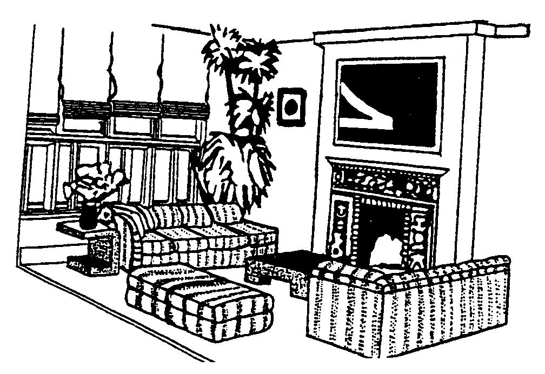

1.23.1 Select from the list below THREE examples of how rhythm was achieved in the room. In your answer book write the question number (1.23.1) and the letters (A–F) of your choice below each other.

 | EXAMPLES OF RHYTHM
 | A | The pattern around the fireplace
 | B | The repetition of design on the couches / sofas
 | C | The side table
 | D | The folds on the blinds
 | E | The flowers on the side table
 | F | The painting next to the plant | (3)

1.23.2 Select from the list below THREE examples of how height or an illusion of height was created in the above room. In your answer book write the question number (1.23.2) and the letters (A–F) of your choice below each other.

 | CREATION OF HEIGHT
 | A | The blinds that hang from ceiling to floor
 | B | The table in front of the couches / sofas
 | C | The plant at the window
 | D | The flowers on the side table
 | E | The couches / sofas
 | F | The vertical lines at the fireplace | (3)

1.23.3 Select from the list below the focal point (point of emphasis) in the above room. In your answer book write the question number (1.23.3) and the letter (A–D) of your choice below each other.

 | FOCAL POINT
 | A | The sofas / couch
 | B | The table in front of the sofas / couch
 | C | The painting above the fireplace
 | D | The flowers on the sidetable | (1)

1.24 Select from the list below FOUR guidelines for setting goals. In your answer book write the question number (1.24) and the letters (A–H) of your choice below each other.

 |  | guidelines for setting goals
 | A | Goals should be in writing.
 | B | Goals should be abstract.
 | C | Goals are the same as activities.
 | D | Goals should have target dates.
 | E | Goals should be attainable.
 | F | Goals should be compatible.
 | G | Goals should be interchangeable.
 | H | Goals should give meaning to life. | (4)

1.25 Match the dishes in Column B with the function of eggs in Column A. Write the question numbers (1.25.1 to 1.25.5) below each other in your answer book and then write the letter (A–H) of your choice next to the correct number.

 | COLUMN A |  | COLUMN B |  | (5)
 | FUNCTIONS OF EGGS |  | DISHES |  | (5)
 | 1.25.1 | Binding agent | A. | Mayonnaise | (5)
 | 1.25.2 | Emulsifier | B. | Fried fish | (5)
 | 1.25.3 | Glazing | C. | Soup | (5)
 | 1.25.4 | Protective coating | D. | Soufflé | (5)
 | 1.25.5 | Thickening of liquids | E. | Meringue | (5)
 |  |  | F. | Meatballs | (5)
 |  |  | G. | Egg custard | (5)
 |  |  | H. | Scones | (5)

1.26 Match the the type of vegetable in Column B with the classification of vegetables in Column A. Write the question numbers (1.26.1 to 1.26.5) below each other in your answer book and then write the letter (A–H) of your choice next to the correct number.

 | COLUMN A | COLUMN B
 | CLASSIFICATION | TYPE OF VEGETABLE
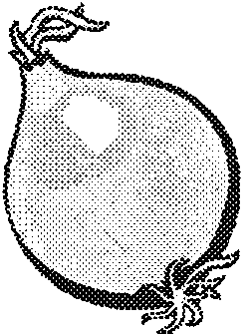  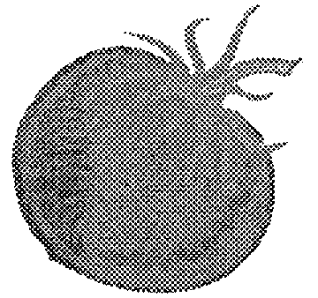  B  A | 1.26.1 Flower vegetables
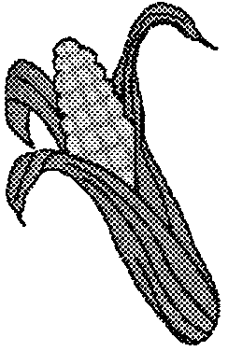  D    C  E | 1.26.2 Fruit vegetables  1.26.3 Bulb vegetables
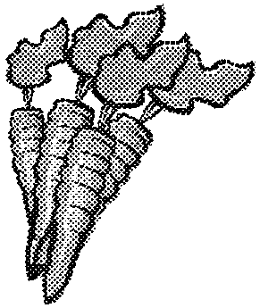  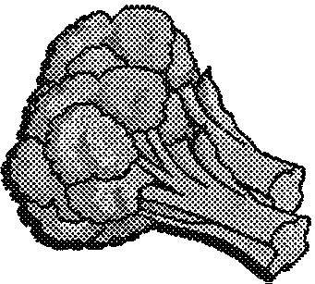  F | 1.26.4 Tuber vegetables
  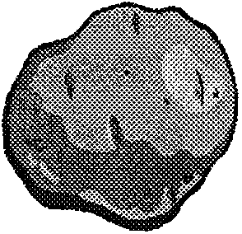  G  H | 1.26.5 Leaf vegetables |  |  |  | (5)

1.27 Match the examples in Column B with the resources in Column A. Write the question numbers (1.27.1 to 1.27.4) below each other in your answer book and then the letter (A–F) of your choice next to the correct number.

 | COLUMN A |  | COLUMN B |  | (4)
 | RESOURCES |  | EXAMPLES OF RESOURCES |  | (4)
 | 1.27.1 | Cognitive | A. | Enthusiasm to participate during lessons | (4)
 | 1.27.2 | Psychomotor | B. | Development of relationships | (4)
 | 1.27.3 | Affective | C. | Ability to comprehend and interpret instructions | (4)
 | 1.27.4 | Non-human | D. | Adequate space to study | (4)
 |  |  | E. | Ability to record and make notes | (4)
 |  |  | F. | Determining a value system | (4)

1.28 Match the examples in Column B with the work motion in Column A. Write the question numbers (1.28.1 to 1.28.3) below each other in your answer book and then the letter (A–E) of your choice next to the correct number.

 | COLUMN A |  | COLUMN B |  | (3)
 | WORK MOTIONS |  | EXAMPLES |  | (3)
 | 1.28.1 | Momentum | A. | Carrying a heavy tray as near as possible to the body. | (3)
 | 1.28.2 | Gravity | B. | Rhythmically pushing a vacuum cleaner up and down a room. | (3)
 | 1.28.3 | Leverage | C. | Standing with weight evenly spread on both feet. | (3)
 |  |  | D. | Wearing rubber gloves when doing dishes. | (3)
 |  |  | E. | Working at a desk with arms bent at a right angle with elbow joint. | (3)

1.29 Match the financial term in Column B with the example in Column A. Write the question numbers (1.29.1 to 1.29.4) below each other in your answer book and then the letter (A–F) of your choice next to the correct number.

 | COLUMN A |  | COLUMN B |  | (4)
 | EXAMPLE |  | FINANCIAL TERM |  | (4)
 | 1.29.1 | Sandra earns R3 000 per month. | A.  B.  C.  D.  E.  F. | Non-money income  Fringe benefits  Nett income  Gross income  Assured income  Bonus | (4)
 | 1.29.2 | After compulsory deductions, Sandra earns R2 000 per month. | A.  B.  C.  D.  E.  F. |  | (4)
 | 1.29.3 | Mr Green receives R900 per month from the person who lives in his flat at the sea. | A.  B.  C.  D.  E.  F. |  | (4)
 | 1.29.4 | Sandra regularly bakes cakes for her family. | A.  B.  C.  D.  E.  F. |  | (4)

1.30 Match the family stage in Column B with the family situation in Column A. Write the question numbers (1.30.1 to 1.30.5) below each other in your answer book and then write the letter (A–G) of your choice next to the correct number.

 | COLUMN A |  | COLUMN B |  | (5)  [72]
 | FAMILY SITUATION |  | FAMILY STAGE |  | (5)  [72]
 | 1.30.1  1.30.2  1.30.3  1.30.4  1.30.5 | The couple’s youngest child is getting married.  The couple’s only child is four years old.  The couple was married three years ago.  The couple’s eldest child is at university.  The couple’s first child is six months old. | A.  B.  C.  D.  E.  F.  G. | Launching  Empty nest  Establishing  Family with pre-school children  Expanding  Retired  Family with primary-school children | (5)  [72]

TOTAL FOR SECTION A: | [100]

SECTION B

QUESTION 2

2.1 Study the following menus and answer the questions that follow.

 | MENU A | MENU B | MENU C
 | Minced Meat  Mashed Potato  Stewed Spinach  Cooked Pumpkin  Avocado Salad Mould  Jelly and Custard | Meat Balls  Peas  Glazed Carrot Rings  Buttered Potatoes  Baked Apple | Fried Ham  Baked Potato  Buttered Carrots  Avocado Salad with Mayonnaise  Ice Cream and Chocolate Sauce

Identify ONE mistake in each menu that was made during the compiling of the three menus. | (3)

2.2 Redraw the following table in your answer book.

 | Cereal and Cereal Products | Fats and Oils | Meat and Meat Alternatives | Milk and Milk Products | Fruit and Vegetables

Classify the following foods under the correct headings of the Five Food Groups:

2.2.1 Minced meat  2.2.2 Avocado pear  2.2.3 Ham  2.2.4 Mayonnaise | (4)

2.3 Study the diagram of the table setting and answer the questions that follow.

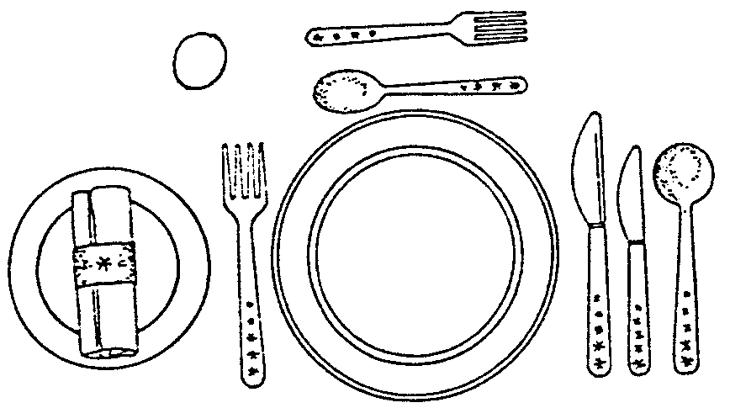

2.3.1 Is the above table setting suitable for Menu B? Motivate your answer. | (3)

2.3.2 Identify TWO mistakes that were made during the setting of the table and suggest the correct method. It is not necessary to redraw the diagram. | (4)

2.4 Rearrange the following dishes/courses in the correct order, as they will be presented in a four course meal. Write them in the correct order below each other in your answer book.

- Coffee  - Main course  - Fish dish  - Dessert  - Consommé | (5)

2.5 Distinguish between the following menu terminology and explain where they will be used on the menu.

2.5.1 Hors d’oeuvres  2.5.2 Entreé | (4)

2.6 Read the following case study and answer the question that follows.

The ham in Menu C is bought 10 days before the meal and is stored in the refrigerator. The meal is cooked and one of the family members is delayed for three hours at work. The cooked ham is kept in the warming drawer at (30ºC). The leftovers are kept for 8 days in the refrigerator to be used as sandwich fillings.

Analyse the safety of the above-mentioned procedures in relation to the prevention of food poisoning. | (9)

2.7 You want to give your friend a set of saucepans.
There are three types available in the shop from which you can choose.

A. Saucepans with copper bottoms and wooden handles.
B. Aluminium saucepans with aluminium handles.
C. Black cast iron saucepans with iron handles.

Which type of saucepan will be the best choice? Motivate your answer. | (3)

2.8 Choose from the following list the best method/s of heat transference to match the equipment listed below.

 | Conduction | Radiation | Convection

2.8.1 Toaster  2.8.2 Pressure cooker  2.8.3 Microwave oven | (1)  (2)  (2)  [40]

QUESTION 3

Mandy decides to serve the following meal at the opening of her new shop.

Fried Fish Fillets with Tartare Sauce / White Sauce

Beef Potjie
Boiled Wheat
Mixed salad with French salad dressing

Cream Puffs and Confectioners Custard will be served with the Coffee

3.1 Name TWO characteristics of a fish fillet. | (2)

3.2 Motivate the following statement:  When fish is deep fried, it is usually covered with a batter. | (3)

3.3 Mandy decides to use hake. Classify the hake and give the fat content of this type of fish. | (2)

3.4 The following ingredients are in Mandy’s grocery cupboard. She needs to make the tartare sauce for the fish. Name THREE ingredients that she can mix with bought mayonnaise.

 | tomato  gherkins  curry powder | egg  lemon juice  bay leaf | butter  cheese  onion | (3)

3.5 Identify a dish in the above-mentioned menu where a roux is used and explain why the roux is used. | (2)

3.6 Explain when synerisis may occur in the white sauce. | (2)

3.7 Mature Cheddar cheese can be used in the white sauce. Classify mature cheddar and give a characteristic of this type of cheese. | (2)

3.8 Cheese can be frozen. Which preventative measures will you take to retain the original quality when you defrost it? | (2)

3.9 The milk that Mandy uses for the white sauce was pasteurised, homogenised and fortified.

3.9.1 Explain how pasteurisation and homogenisation affect the fat globules of the milk. | (4)

3.9.2 Explain the process of fortification and state why milk must sometimes be fortified. | (4)

3.10 Cubes of meat are used for the potjie.

3.10.1 Will you recommend that the meat of the forequarter or hindquarter of the carcass be used? Motivate your answer. | (3)

3.10.2 Suggest THREE cuts from the beef carcass that are suitable for the potjie. Name the cuts.
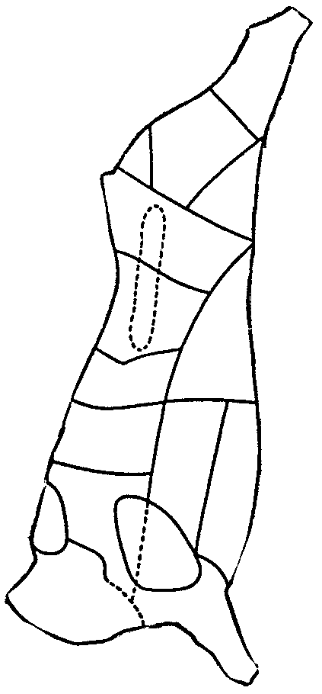
3  15  17  16  12  11  13  9  10  8  6  7  5  4  2  3  1 | (3)

3.10.3 What is the effect of the moist heat on the muscle tissue and the connective tissue of the cuts suitable for the potjie? | (4)

3.11 Mandy makes the salad at ten o’clock in the morning to save time so that she can spend the afternoon with her new clients. Explain the wisdom of this decision. | (4)  [40]

QUESTION 4

Study the ingredients used in breadmaking and answer the questions that follow.

BREAD

375 ml lukewarm water
50 ml golden syrup
1 packet instant yeast
750 ml wholewheat flour
2 ml salt
75 ml oil

4.1 What is the function of each of the following ingredients that are used in the bread:

4.1.1 Golden syrup  4.1.2 Oil | (2)  (2)

4.2 The measuring of syrup can cause problems. Suggest TWO methods that will ensure the easy measuring of syrup. | (2)

4.3 Explain why the milk must be lukewarm when added. | (2)

4.4 Why is it important to knead the bread dough? | (3)

4.5 When the bread is in the oven to bake, the colour changes to light brown. What is the cause of this colour change? | (2)

4.6 How can bread be tested to make sure that it is cooked? | (2)

4.7 When a Swiss roll is baked beaten egg white is used as the raising agent.

4.7.1 What in the beaten egg white serves as the raising agent? Also classify this raising agent. | (2)

4.7.2 To which stage must the egg whites be beaten to ensure the best end result? Give TWO characteristics of this stage. | (3)

4.7.3 What would you use to fold in the beaten egg white? Motivate your answer. | (2)

4.7.4 The eggs are stored for one month and then used at room temperature.  Explain the effect of the age and the room temperature on the volume and stability of the egg white foam. | (4)

4.7.5 Explain when the following takes place during the beating of the egg white:  (a) Denaturation of eggs  (b) Coagulation of the egg white | (2)  (2)

4.8 Study the ingredients and the method carefully and answer the questions that follow.

 | SPANISH CREAM
 | Ingredients | Method
 | 5 ml gelatin  25 ml cold water  250 ml milk, scalded  pinch of salt  1 egg, separated  100 ml sugar  2 ml vanilla essence | 1. Hydrate the gelatin in cold water.  2. Make custard with the milk, egg yolk, sugar, salt and vanilla essence.  3. Disperse the gelatin in the hot custard.  4. Beat the egg whites to the stiff peak stage and fold in the hot custard mixture.  5. Pour into a mould that has been rinsed with cold water.

4.8.1 During the preparation of this dish the custard curdled. Propose possible reasons for the curdling of the custard and indicate how the curdled texture of the custard can be improved. | (5)

4.8.2 After you have unmoulded the dessert, you notice that layers as well as a weak gel were formed. Why did this happen? | (5)  [40]

TOTAL FOR SECTION B: | [120]

SECTION C

QUESTION 5

Study the table and answer the questions that follow.

 | NAME | FAMILY MEMBER | PARTICULARS
 | Mr James | Father, 40 years | Engineer, works for a company.  Family photographer, records all family events.
 | Mrs James | Mother, 36 years | Housewife, just had third (unplanned) child  Mother believes in a lot of hugging and physical contact
 | Peter | Son, 15 years | Adolescent, Friends with a 19-year-old “smoker”, Not used to doing household tasks. Always teasing Lindi. Under-achiever at school.
 | Lindi | Daughter, 7 years | Primary School pupil, loves reading – goes to library regularly.  Not used to doing household tasks.
 | Claire | Baby girl | Newborn baby.  Mother walks her in the park.

5.1 At what stage of the family life cycle is the James family? | (1)

5.2 Identify TWO of baby Claire’s developmental tasks. | (2)

5.3 Friendship is a very important relationship that children have to develop. Peter, in particular, will be feeling the importance of belonging to a group. List THREE advantages of being part of a group. | (3)

5.4 The James family will have to adapt to a new baby in the home. Predict the changes that will have to be made by the family and discuss each change in brief. | (8)

5.5 A division of tasks will have to be considered by the family. List TWO benefits of shared responsibilities. | (2)

- Conflict occurs in all families.  5.6.1 Which factors in the James family could cause conflict?  5.6.2 Explain your answer to Question 5.6.1. | (2)  (2)

5.7 The feeling of solidarity (unity) and commitment between family members is the main factor that helps maintain a close relationship over a long period. State TWO ways in which the James family can try to achieve solidarity. Explain this by using examples from the case study. | (4)

5.8 | Mrs James’s washing machine has broken and cannot be repaired. A new washing machine will be the best solution, but she cannot pay cash for it. The launderette is near her house, but is very expensive to use. Washing nappies by hand will be too time consuming. She considers all the factors and settles for a machine bought on Hire Purchase, where she would pay by means of monthly instalments.

5.8.1 Discuss each of the decision-making steps below that Mrs James followed in order to achieve her goal.  (i) Explain Mrs James’s problem.  (ii) Suggest alternative solutions to the problem from the case study.  (iii) Explore the consequences of all the alternatives.  (iv) What decision was made? | (1)  (2)  (3)  (1)

5.8.2 Mrs James’s decision was affected by her values and standards. What type of decision did Mrs James make? | (1)

5.8.3 Determine TWO standards set by Mrs James relating to the washing machine problem. | (2)

5.9 | Mr James’s salary is made up of the following:  R96 000 per annum including pension fund, medical aid scheme, housing subsidy, performance bonus and a motor finance scheme.

5.9.1 Mr James’s salary is approximately R8 000 per month, yet the nett salary is only R6 500. Suggest TWO factors that could account for this difference. (Refer to the case study.) | (2)

5.9.2 Explain the meaning of fringe benefits. | (2)

5.9.3 From the case study, list TWO fringe benefits Mr James receives. | (2)  [40]

QUESTION 6

Read the case study and answer the questions that follow:

Zandi is newly married and very proud of her new home. She struggles to keep it tidy, as she has a morning job and no household help. Her teenage brother lives with her and her husband. When at home, Zandi starts the washing, then remembers the pile of dirty dishes, the unmade beds and the other chores still to be done. She feels despondent and incapable of managing. She shares her stressful situation with a friend. The friend insists that the drawing up of a schedule is the answer.

6.1 Predict the factors that will influence the planning/drawing up of Zandi’s schedule. | (5)

6.2 If a home manager neglects to plan or to develop skills he/she will develop mental fatigue. Explain, in point form, how knowledge or lack thereof, can add to mental fatigue. | (4)

6.3 Nasty accidents in the home are particularly common in bedrooms, kitchens, bathrooms and stairs. These accidents may be caused by various factors. List FOUR of these factors. | (4)

6.4 Study the floor plan of a townhouse and answer the questions that follow.

TOWNHOUSE

BATH
COFFEE TABLE
STAIRS
TV
IDENTICAL TOWNHOUSE
(MIRROR IMAGE)
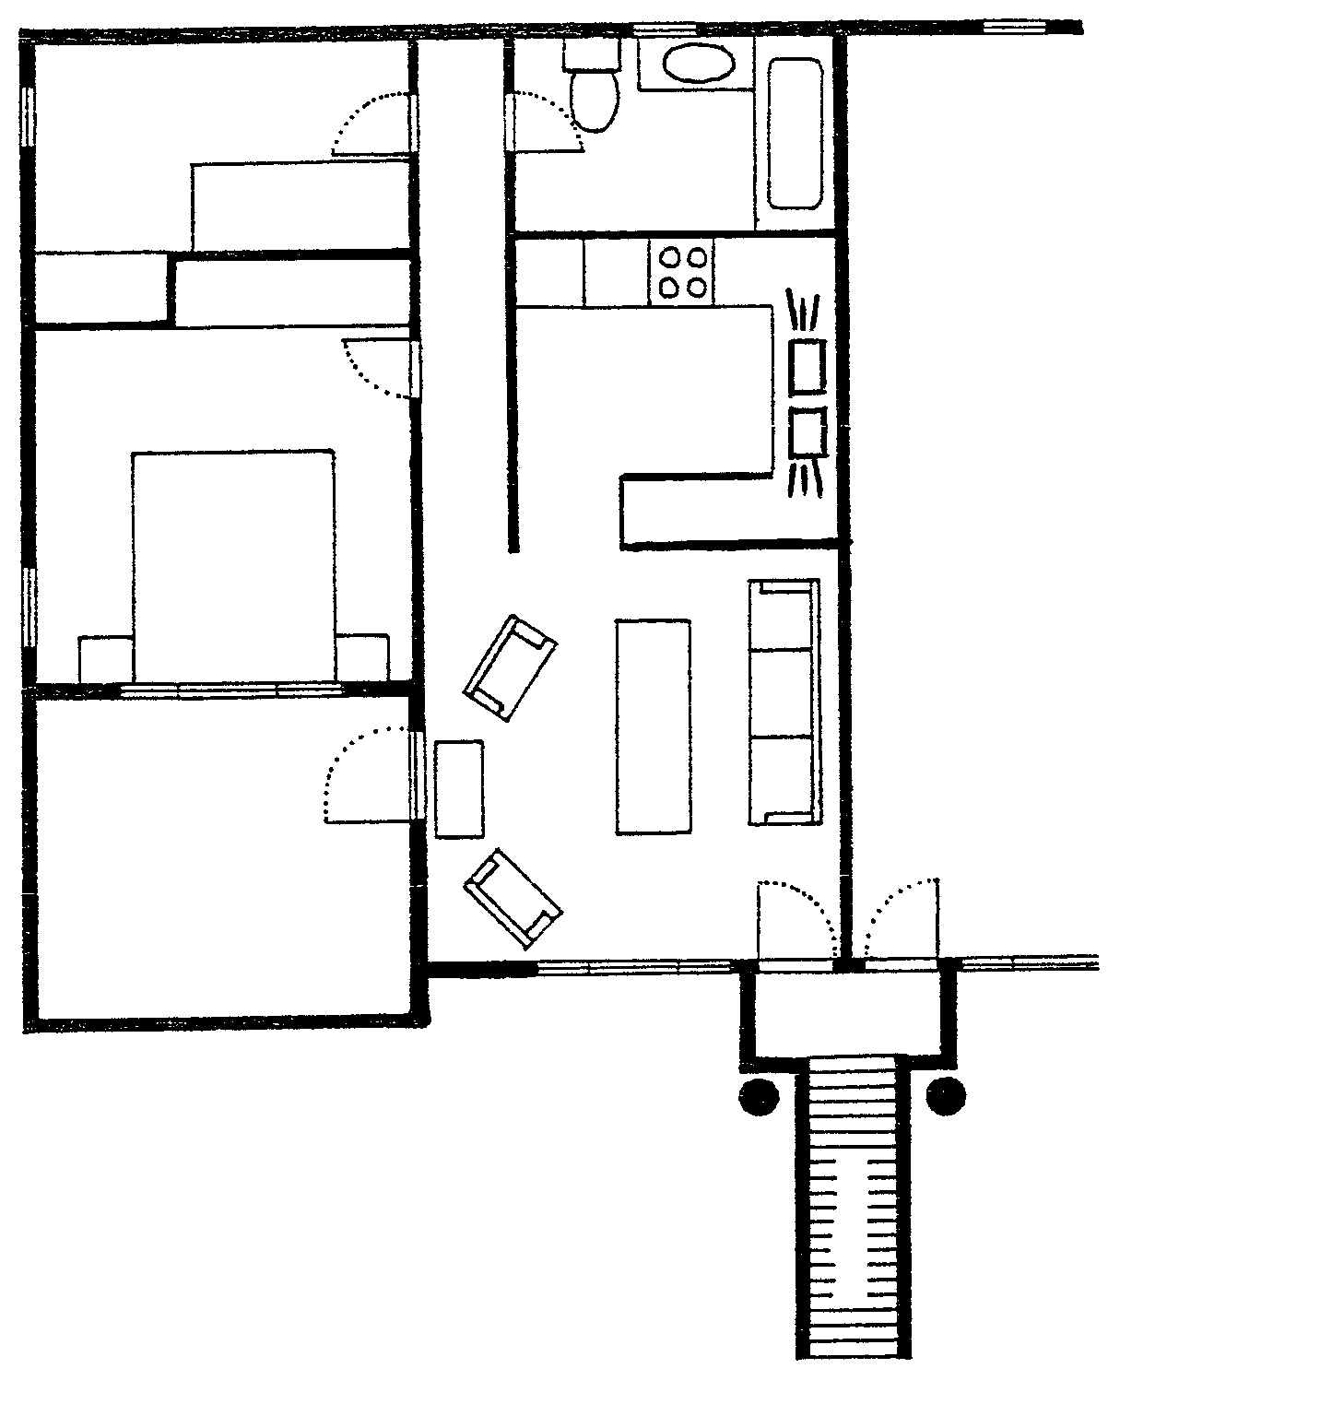
BEDROOM
1.
2.
3.
SINGLE BED
CUP-
BOARD
CUPBOARD
BEDROOM
2.
DOUBLE BED
1.
PATIO
FRIDGE
OPEN PLAN KITCHEN
LOUNGE
LANDING
PILLAR
N

S

6.4.1 Explain the mistakes in the placement and opening of doors 1, 2 and 3. | (6)

6.4.2 Identify the basic kitchen shape that the kitchen floor plan resembles? | (2)

6.4.3 The furniture arrangement in the lounge is not ideal. Explain why. | (3)

6.4.4 Can the small bedroom (1) be used for studying as shown on the floor plan? Motivate your answer. | (3)

6.4.5 There is no linen cupboard in this unit. Where would the ideal place be to build one in the townhouse? | (2)

6.5 Study the picture and answer the questions that follow.

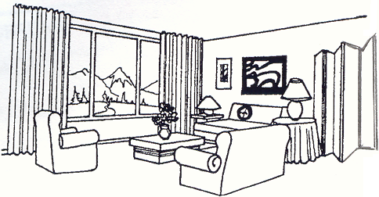

6.5.1 Identify the focal point in the room. Motivate your choice. | (2)

6.5.2 Give THREE examples of how the illusion of space is created in the room. | (3)

6.5.3 The north facing room has strong sunlight during the day. Suggest a suitable monochromatic colour scheme for the room. Give a reason for your choice. | (3)

6.5.4 Identify ONE example of how proportion has been used correctly in the room. Motivate your answer. | (2)

6.5.5 Identify one piece of furniture that has no function in the room. | (1)  [40]

TOTAL FOR SECTION C: | [80]

TOTAL: | 300

