GAUTENG DEPARTMENT OF EDUCATION

SENIOR CERTIFICATE EXAMINATION

HOME ECONOMICS SG

TIME: 3 hours

MARKS: 200
INSTRUCTIONS:

- All questions are COMPULSORY.
- Please write clearly and neatly.
- Number your answers exactly as the questions are numbered.
- Answer Questions 1.1.1 – 1.1.13 (multiple choice) of SECTION A on the answer sheet on the inside cover of your answer book (the numbering
is 1.1 – 1.13).
- Answer Questions 1.2 – 1.7 of SECTION A, SECTION B and SECTION C in your answer book.

SECTION A
ABCD

QUESTION 1

  - Indicate the correct answer clearly by making a cross (X) over the corresponding letter on the answer sheet on the inside cover of your answer book.

EXAMPLE: Croûtons are

A. pieces of fried meat. B. liver patties.
C. fried bread cubes. D. fish cakes.

ANSWER:

NB: Where more than one cross appears in any answer, NO marks will be awarded for that answer.

    - Identify the method of heat transference that takes place when a potato is baked on a braai grid.
- Radiation and conduction
- Convection and evaporation
- Radiation and convection
- Conduction and evaporation

    - The main nutrient in the food group, cereal and cereal products, has the following function in the body:
A. It is a source of energy that contributes towards the regulation of bodily functions.
- It is a reserve source of energy which increases the body’s resistance to infection.
- It is an important source of energy which promotes the absorption of vitamins.
- It provides energy and promotes peristalsis.

1.1.3 Which sealed container of milk will become sour in four days if kept at a temperature of 20°C?
- A bottle of sterilised milk
- A tin of full-cream powdered milk
- A sachet of pasteurised milk
- A tin of evaporated milk

1.1.4 Which of the following ingredients will increase the coagulation temperature of egg protein but decease the rate of coagulation?
- Fat
- Salt
- Sugar
- Acid

1.1.5 What colour pigment and nutrient is found in large quantities in spinach?
- Carotene and vitamin C
- Chlorophyll and vitamin C
- Flavones and vitamin A
- Anthocyanins and vitamin D

During a family’s early years the following priorities are emphasised:
- Standard of living, education and family relations
- Financial security, career and housing
- Financial security, housing and management
- Retirement, health and family relations

Psychomotor resources include the following:
- Comprehension and self control
- Adaptability and enthusiasm
- Muscular activities and senses
- Attitude resources and self control

1.1.8 Shades of the primary colours include the following:
- Olive green, violet, coral red
- Navy blue, wine red, mustard
- Emerald green, ruby-red, golden yellow
- Lime green, ivory, pinky beige

1.1.9 The chair in the sketch below will be suitable for a room because it will
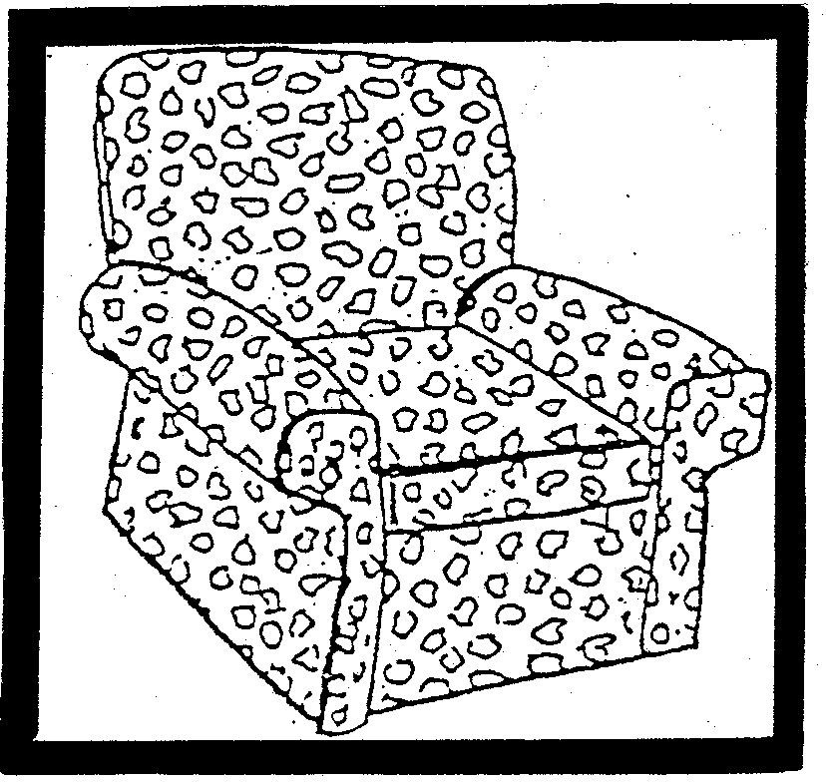

- be in harmony with cane furniture.
- be in contrast with heavy wooden furniture.
- fit well in a small, sunny room.
- be in contrast with small, flowery upholstered furniture.

    - In modern society, a sex-role stereotype means
- that certain jobs are reserved for men only or for women only.
- that homemakers should not be employed outside the home.
- that men are more involved with the education of children than women.
- that women should be able to support themselves and men should be able to manage their own households.

The following case study pertains to Questions 1.1.11 to 1.1.13.

Paul, a sporty Grade 11 boy, likes to keep his room impeccably tidy. He is an only child and enjoys many financial privileges. He is still very dependent on his parents to help solve his problems and to handle conflict situations.

Which developmental task of a teenager does Paul still have to accomplish?
- Identification with a masculine role
- Learning to make new friends
- Acceptance of his changing body
- Development of skills to handle and resolve conflict situations

Paul attaches value to
- achievement and recognition.
- tidiness and physical fitness.
- status and financial security.
- creativity and achievement.

1.1.13 A human resource available to Paul is:
- Employment opportunities
- Financial privileges
- Parental support
- Space in his bedroom
13x2=(26)

1.2 From the list below select FOUR changes that take place when fruit is cooked by means of moist heat. In your answer book write the question number (1.2) and the FOUR letters (A – H) of your choice below each other.

CHANGES THAT TAKE PLACE IN FRUIT DURING MOIST HEAT COOKING

A. Sucrose, fructose and glucose dissolve in the liquid in which the fruit was cooked

B. Organic acids decrease and the fruit become sweeter

C. Cellulose becomes softer
D. Some vitamins and minerals dissolve in the liquid

E. White fruit discolour as a result of enzyme action

F. Pectin changes into protopectin and fruit become firmer

G. Water penetrates the cells and gelatinises the starch granules
H. Lipids are oxidised in the cells | (4)

1.3 Select from the list below FOUR advantages for the selection of meat analogues. In your answer book write the question number (1.3) and the FOUR letters (A – H) of your choice below each other.

CHOICE OF MEAT ANALOGUES
A. | Freezing does not affect the structure
B. | Can be stored at room temperature
C. | Supply protein of high biological value
D. | Have a high fat content
E. | Is cheaper than meat
F. | Is rich in fibre
G. | Sometimes causes flatulence
H. | High ratio of connective tissue to amino acids | (4)

1.4 Select from the list below, the FOUR changes that occur during gelatinisation. In your answer book write only the question number (1.4) and the FOUR letters (A – H) of your choice below each other.

CHANGES THAT OCCUR DURING GELATINISATION
A. | As the heat is applied, the starch granules dehydrate and shrink.
B. | The mixture increases in viscosity.
C. | The mixture becomes opaque.
D. | Friction is created between granules and the paste becomes thicker.
E. | The mixture becomes translucent.
F. | The thickening power of starch is reduced.
G. | Water moves into the starch granules and they swell.
H. | Swelling stops as the temperature increases. | (4)

A family must acquire basic Survival Skills to function as a unit.

From the list below select FOUR Basic Survival Skills of the family. In your answer book write the question number (1.5) and the FOUR letters (A – H) of your choice below each other.

BASIC SURVIVAL SKILLS
A. | Reconciling conflicting loyalties and philosophies of life
B. | Meeting physical needs by providing food, clothing and shelter
C. | Becoming established in an occupation
D. | Supporting and maintaining the home
E. | Maintain motivation and uplift morale
F. | Develop a workable philosophy of life
G. | Guiding children towards independence as they approach adulthood
H. | Budgeting of resources, money, space and time | (4)

1.6 Select from Column B the explanation for the rule in Column A. Write the question numbers (1.6.1 – 1.6.3) below each other in your answer book and the letter of your choice (A – E) next to each question number.

COLUMN A | COLUMN B
RULE | EXPLANATION
1.6.1 Baste food regularly | A. Improves the keeping quality
1.6.2 Serve cooking liquid with food | B. Improves colour, but destroys vitamins
1.6.3 Add bicarbonate of soda to cooking green beans | C. Retains maximum nutritional value
 | D. Prevents drying out
 | E. Prevents liquid seeping out | (3)

1.7 Match the types of cheese in Column B to the dish in Column A. Write the question numbers (1.7.1 – 1.7.5) below each other in your answer book and then the letter of your choice (A – H) next to each question number.

COLUMN A  DISH | COLUMN B  TYPE OF CHEESE
1.7.1 Greek salad | A. Cream cheese
1.7.2 Macaroni and cheese | B. Feta cheese
1.7.3 Carrot cake topping | C. Brie cheese
1.7.4 Chocolate cheese cake | D. Cottage cheese
1.7.5 Minestrone soup and croûtons | E. Camembert
 | F Cheddar cheese
 | G. Parmesan
 | H. Blaaukrantz | (5)

TOTAL FOR SECTION A: | [50]

SECTION B  QUESTION 2  2.1 To celebrate the end of year examination, friends are invited to dinner. Arrange the dishes below to form a four course meal. Write out the menu according to the set rules. | (6)

roast duck, lemon soufflé, apple sauce, cauliflower au-gratin,
melba toast, green peas, hollandaise sauce, fried potatoes, poached kingklip, carrot and raisin salad, consommé soup

Explain the following cookery terms found in the preparation of the above meal.  2.2.1 Roux  2.2.2 Sauté  2.2.3 Au-gratin | (2)  (2)  (2)

2.3 Snacking between meals is recommended for certain groups of people. Name THREE groups of people who may benefit from snacking. | (3)

2.4 Which THREE factors are used to evaluate a dish? | (3)

Give ONE reason why each of the following procedures is used when cooking:  - Sear the sides of meat before potroasting.  - The shiny side of foil should not be on the outside.  - Keep water away from oil when frying.  - Meat should never be pricked when grilling.  - All food should be covered when steaming. | (5)

2.6 Classify the method of cooking for the dishes below and identify the method of heat transference. Tabulate your answer:

DISH | METHOD OF COOKING | HEAT TRANSFERENCE

2.6.1 Poached Kingklip

2.6.2 Melba toast
 |  |  | (4)

2.7 Give THREE reasons why people living alone may have problems with food preparation. | (3)
 | [30]

QUESTION 3  - Starch mixtures thickened with eggs can be problematic.  3.1.1 How can the above problem be overcome? | (4)

Why do cereals cooked in milk swell more than when cooked in water? | (2)

What is the effect of dry heat on starch? | (4)

Give a reason for the following processes when applied to milk:  - Fortification  - Sterilisation  - Homogenisation  - Purification | (4)

3.5 Classify the given components of milk as a true solution, a colloidal dispersion or dilute emulsion:

Tabulate your answer:

TRUE SOLUTION | COLLOIDAL DISPERSION | DILUTE EMULSION
(1) | (1) | (1)
(1) | (1) |  | (5)

    - Lactose
    - Casein
    - Fat globules
    - Calcium phosphate
    - Iron

3.6 3.6.1 From an organoleptic point of view, why is it advantageous to prolong rigor mortis in fish?  - Explain why white fish is a good choice for the following:  (a) Invalid diet  (b) People doing sedentary work | (1)  (1)  (1)

3.7 Compare the meat and fat of older animals with that of younger ones with regard to tenderness.

Tabulate your answer:

 |  | MEAT/FAT OF OLDER ANIMALS | MEAT/FAT OF YOUNGER ANIMALS
3.7 | TENDERNESS | (1) | (1) | (2)

3.8 Compare the effect of dry heat and moist heat on meat.

Tabulate your answer:

EFFECT OF DRY HEAT ON MEAT | EFFECT OF MOIST HEAT ON MEAT
 |  | (6)
 |  | [30]

QUESTION 4

4.1 In dried fruit, the water has evaporated and the nutrients are concentrated. Analyse the nutrient content of dried fruit under the following headings:

- Vitamin content  - Carbohydrates | (4)

4.2 4.2.1 Give FOUR factors that contribute to the development of flavours found in vegetables.  - Give TWO examples of vegetables which will develop an off-flavour if they are cooked for too long.  - Explain how off-flavours develop when vegetables are cooked. | (4)  (2)  (2)

- Supply a reason for each of the following statements:  - Gelatine should be stored in an airtight container.  - Chill ingredients and moulds beforehand when preparing gelatine dishes.  - Gelatine granules should be allowed to soften in cold water before use.  - When mixing gelatine into a milk mixture, the milk mixture must be cool.  - If pieces of fruit are added to gelatine mixtures, the mixture should have started to set. |  | (5)
4.4 4.4.1 Explain the role of lecithin in eggs when making choux paste.  4.4.2 Give THREE reasons for an incomplete or broken emulsion during the preparation of choux paste. | (3)  (3)

4.5 What effect would the following have on the fermentation process during bread making?  4.5.1 A temperature of 50°C during the proving stage  4.5.2 20 ml sugar is added at the beginning of the fermentation process  4.5.3 If the fermentation process is prolonged | (3)

4.6 Explain Maillard’s Reaction and how it will enhance the colour of bread.  TOTAL FOR SECTION B: | (4)  [30]  [90]

SECTION C  The OBE approach focuses on what is learnt and how it is learnt.  QUESTION 5  South Africa’s education system is in the process of change. Outcomes-Based Education (OBE) is the new educational approach currently being introduced into South African schools.  - According to Maslow’s hierarchy, the above statement indicates a human need.  - Identify this need according to Maslow’s hierarchy.  - Name TWO criteria needed to reach this level. | (1)  (2)

Our new education system is aimed at equipping more qualified South Africans by preparing them for the demands of life. The changes are aimed at increasing skills, promoting knowledge and a determination to succeed.

5.2 From the above case study identify the following:  - THREE long term goals  - TWO short term goals | (3)  (2)

Our new approach stresses that it is time to stop talking about under resourced schools and to look to the environment and the community to assist in the learners’ education.

5.3 Give FOUR examples of environmental resources that are available to the community that may be used to assist in the learner’s education. | (4)

Instilling values, skills, attitudes and beliefs in learners, form an important part of OBE.

5.4 5.4.1 List FOUR factors that influence the development of values.  5.4.2 Name FOUR skills that a person should develop in order to prevent mental fatigue. | (4)  (4)

5.5 From the list below select:  - TWO compulsory deductions from a monthly salary  5.5.2 TWO fringe benefits that may be offered to employees | (2)  (2)

Interest

Income tax

Investments

Medical Aid

Paid Vacation

Tips

Unemployment Insurance

Bursaries

Royalties

Recreational Facilities

Tabulate your answer as shown below:

5.5.1 COMPULSORY DEDUCTIONS | 5.5.2 FRINGE BENEFITS
1. | 1.
2. | 2.

5.6 One of the steps in financial planning is to determine your expected expenditure.

    - Classify expected expenses and supply ONE appropriate example of each expense.

Tabulate your answer as shown below

 | EXPECTED EXPENSES | ONE EXAMPLE
 |  |  |  | 2x3=(6)
 |  |  |  | [30]

QUESTION 6

6.1 Study the diagram below and answer the questions that follow:
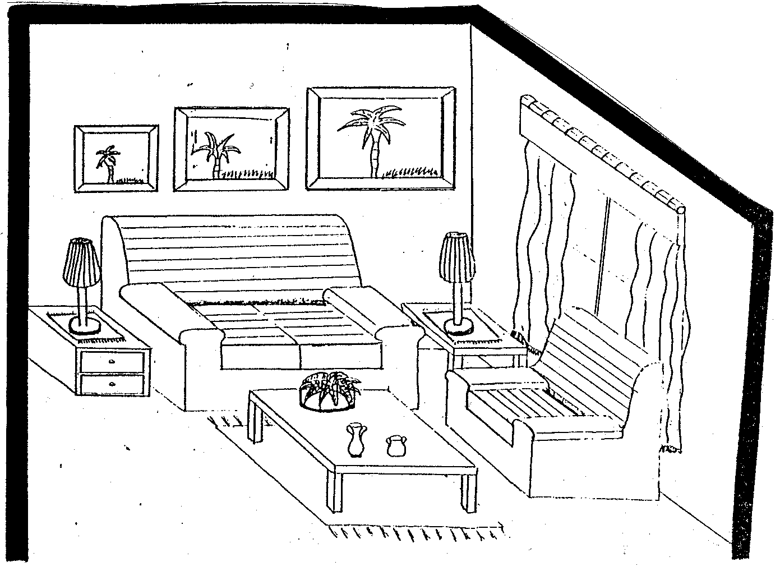

Identify THREE ways in which proportion may be found in the room.  Identify TWO ways in which rhythm has been used in the above room.  Give an example of informal balance found in the above room. | (3)  (2)  (1)

6.2 What reasonable precautionary measures should be taken to prevent accidents with fire? | (4)

6.3 Suggest TWO points that should be borne in mind when selecting a functional and comfortable bed. | (2)

6.4 How can good functional design be obtained in a home? | (4)

6.5 Consider THREE aspects to bear in mind when planning general lighting in a room. | (3)

6.6 Read the following case study and answer the questions that follow:

Mr and Mrs Sithole have three children, all of whom have left home to get married. Mr Sithole was involved in an accident and received a blood transfusion. Six months later he was diagnosed HIV positive. He died three years later.

As Mrs Sithole got older she had to learn new socialising skills. She found it lonely living by herself. She went to stay with one of her married children to help look after her grandchildren.

- In which stage of the family-life cycle is the family when we first meet them?  - (a) According to the case study, how did Mr Sithole contract Aids?  (b) Give TWO other ways in which people can be infected with Aids.  - Give THREE socialising skills Mrs Sithole must acquire in later life.  - What impact will the addition of Mrs Sithole have on the family she goes to live with?  - Identify the socialising agents with whom Mrs Sithole will come into contact.  TOTAL FOR SECTION C:  TOTAL: | (1)  (1)  (2)  (3)  (2)  (2)  [30]  [60]  200

