GAUTENG DEPARTMENT OF EDUCATION

SENIOR CERTIFICATE EXAMINATION

HOME ECONOMICS SG

TIME: 3 hours

MARKS: 200
INSTRUCTIONS:

- All the questions are COMPULSORY.
- Please write clearly and neatly.
- Number your answers exactly as the questions are numbered.
- Answer Questions 1.1.1 – 1.1.10. (multiple choice) of SECTION A on the answer sheet which is on the inside cover of your answer book. Because the numbers in the answer book differ from those in the examination paper, you are requested to make use of the numbers 1.1 to 1.10 in your answer book.
- Answer Questions 1.2 – 1.8 of SECTION A, SECTION B and SECTION C in your answer book.

SECTION A
ABCD

QUESTION 1
FOOD AND NUTRITION

  - Indicate the correct answer by drawing a cross (X) over the corresponding letter on the inside cover of your answer book.

EXAMPLE: Croûtons are

A. pieces of fried meat. B. liver patties.
C. fried bread cubes. D. fish cakes.

ANSWER:

NB: Where more than one cross appears in any answer, NO marks will be awarded for that question.

    - A finger-bowl is used to wash the fingers after serving ______ which is eaten with the fingers.
- steak and kidney pie
- beef stroganoff
- grilled prawns
- spaghetti bolognaise

1.1.2 Roasting of meat refers to cooking meat
A. on a greased flat surface or griddle.
- by simmering in a small quantity of water.
- where heat is transferred to uncovered food by means of heated air.
- by transference of heat due to conduction.

1.1.3 Salmonella is most likely to be passed on to food by food handlers who
- work with uncovered cuts and burns
- fail to wash their hands thoroughly after visiting the toilet.
- smoke while preparing food.
- cough and sneeze in the presence of food.

1.1.4 Adding sugar to a starch paste will
- decrease thickening of the cooked product.
- hydrolise the starch to dextrin.
- prevent gelatinisation in puddings.
- result in a thicker paste.

1.1.5 Milk blends should not be used to substitute milk powder for babies because they
- have a high carbohydrate content and are rich in saturated fatty acids.
- are high in cholesterol but have a low kJ value.
- have a low vitamin content and only contain 1/3 as much protein as real milk powder.
- have harmful fatty acids and a low calcium content which may harm the baby’s health.

Lecithin is the emulsifier responsible for binding the following ingredients when making mayonnaise:
- Spices and oil
- Egg yolk and oil
- Vinegar and oil
- Egg white and vinegar

The following method of ripening tomatoes produces a high ascorbic acid (vitamin C)value:
- Tomatoes ripened in greenhouses
- Tomatoes ripened outdoors
- Tomatoes ripened off the vine
- Tomatoes ripened in the shade

1.1.8 The unpleasant flavour and odour of overcooked cabbage is caused by
- hydrogen sulphide.
- magnesium sulphate.
- calcium chloride.
- sulphur dioxide.

1.1.9 Which of the following is an example of non-human resources?
- Time and energy
- Interest and belief
- Postal and transport services
- Knowledge and understanding

Question 1.1.10 relates to the diagram below. Study the diagram and answer the question that follows.
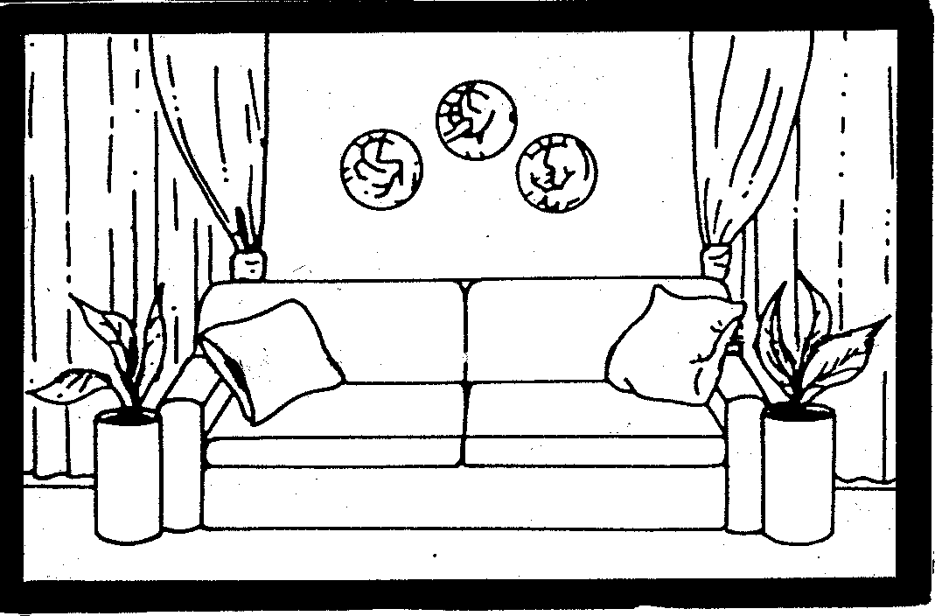

    - The design principle of proportion that is applied in the above sketch means that:
- Attention is drawn to the curtains
- Easy flowing lines are used in the room
- Pot plants and cushions are arranged in an orderly way
- The size of the objects is correct in relation to the size of the room
10x2=(20)

1.2 Select from the list below FOUR important factors to consider when planning a cleaning schedule. In your answer book write the question number (1.2) and the four letters (A – H) of your choice below each other.

FACTORS TO CONSIDER WHEN PLANNING A CLEANING SCHEDULE

A. Family situation

B. Socio-economic factors

C. Too much to do, too little time
D. Location of the house

E. The home maker’s habits

F. The activities of the occupants

G. The method of work
H. A monotonous task | (4)

1.3 Select from the list below FOUR correct statements applicable to HIV/Aids. In your answer book write the question number (1.3) and the four letters (A – H) of your choice below each other.

STATEMENTS APPLICABLE TO HIV/AIDS
A. | HIV / Aids is a disease that has a cure.
B. | You can have an HIV test free at any government clinic.
C. | Covering cuts and sores on your hands with a plaster is not necessary before handling any blood.
D. | Respect and support people with HIV/Aids.
E. | You can get Aids from living with someone who is HIV infected.
F. | Learners who are HIV infected have a right to schooling.
G. | HIV/Aids affects us all.
H. | Only the government is responsible for preventing the spread of Aids. | (4)

1.4 Identify from the list below FOUR statements that will help to strengthen family unity. In your answer book write the question number (1.4) and the four letters (A – H) of your choice below each other.

STATEMENTS TO STRENGTHEN FAMILY UNITY
A. | Family members having Christmas dinner together
B. | Family members being independent
C. | Mother buying herself an outfit for a wedding
D. | Family members going on a picnic on a Sunday afternoon
E. | Mother visits father in hospital
F. | The family watching a television programme
G. | Father says a prayer at meal time when the family is together
H. | Parents go out to dinner | (4)

1.5 Choose the correct answer from Column B to match the type of meal in Column A. Write the numbers 1.5.1 – 1.5.5 in your answer book and then the correct letter (A – H) next to each number.

COLUMN A | COLUMN B
1.5.1 Braai | A) A theme is very important.
1.5.2 Breakfast | B) A combination of breakfast and lunch, served at about 10:00.
1.5.3 Children’s party | C) Food is cooked outside in an informal atmosphere.
1.5.4 Champagne breakfast | D) No incentive to cook for themselves
1.5.5 Meals for single people | E) Should supply 25% of the daily food requirement.
 | F) Does not only save time but it is also very convenient
 | G) Dishes should be able to stand without losing their taste.
 | H) The hors d’oeuvres may be omitted from the menu and it may be served with the drinks. | (5)

1.6 Match the class in Column B to the vegetable in Column A. Write the numbers (1.6.1 – 1.6.5) below each other in your answer book and then the letter of your choice (A – H) next to each number.

COLUMN A | COLUMN B
VEGETABLE | CLASS
1.6.1 Red cabbage | A) Flowers
1.6.2 Broccoli | B) Seeds and pods
1.6.3 Tomatoes | C) Roots
1.6.4 Peas | D) Leaves
1.6.5 Turnips | E) Bulbs
 | F) Fruit
 | G) Stems
 | H) Tubers | (5)

1.7 Match the ingredients used in bread making in Column B to the function in Column A. Write the numbers (1.7.1 – 1.7.4) below each other in your answer book and then the letter of your choice (A – C) next to each number.

 | COLUMN A  FUNCTION | COLUMN B  INGREDIENTS
 | 1.7.1 Prevents the fermentation process from proceeding too fast and has a desirable firming effect on gluten | A) Salt  B) Shortening  C) Sugar
 | 1.7.2 Texture is improved and a more tender loaf is produced | A) Honey  B) Flour  C) Butter
 | 1.7.3 Promotes the formation of a fine compact crumb and a soft crust | A) Sugar  B) Eggs  C) Butter
 | 1.7.4 Increases the keeping quality of bread | A) Milk  B) Water  C) Yeast
 |  |  |  | (4)

1.8 Match the statement in Column B to the management term in Column A. Write the numbers (1.8.1 – 1.8.4) below each other in your answer book and then the letter of your choice (A – G) next to each number.

 | COLUMN A  MANAGEMENT TERM | COLUMN B  STATEMENT
 | 1.8.1 Decisions | A) Simplify difficult tasks
 | 1.8.2 Values | B) To serve as a basis for the next plan
 | 1.8.3 Goals | C) Selecting a course of action
 | 1.8.4 Non-human resources | D) Change gradually with maturity
 |  | E) Space, water and land
 |  | F) Accomplished with some effort
 |  | G) Feelings, emotions and muscular activities | (4)
TOTAL FOR SECTION A: |  |  |  | [50]  [50]

SECTION B

QUESTION 2

  - Study the menu below and answer the questions that follow.

Lunch served during an all day Aids Awareness Seminar

MENU

LUNCH

Cheese Soufflé

Fish Fillets in White Wine Sauce
Potato nests filled with Peas

Strawberries and Cream

Coffee

2000–11–23

- How many courses does the lunch consist of?  - Identify the main dish in this menu.  - Classify the dishes from the menu next to the appropriate food group and indicate the recommended daily portions for each food group.  Tabulate your answer. | (1)  (1)

FOOD GROUP | DISHES FROM MENU | RECOMMENDED DAILY PORTIONS
(a) Meat and Meat alternatives | (1) | (1)
(b) Milk and milk-products | (1) | (1)
(c) Fats and Oils | (1) | (1)
(d) Fruit and Vegetables | (1) | (1) | (8)

2.1.4 Identify the food group that is deficient in the above menu. | (1)

Explain the following terms used in the above menu.  - Soufflé  - Fillet | (2)  (2)

2.3  A chocolate mousse requiring no cooking was prepared the day before to be served at the lunch. It was discovered that the eggs were contaminated with salmonellae and could not be used.  - Identify the method of cooking fish in wine sauce.  - Give TWO reasons why this method was chosen.  - Explain the effect of moist heat on the fish muscle.  - Explain why it is advisable to use high quality frozen peas rather than fresh peas to fill the potato nests.  - Name the micro-organism that causes salmonellae infection.  - (a) If the chocolate mousse was based on a recipe where the mousse required cooking, could the contaminated eggs have been used?  - Name any TWO symptoms of illnesses caused by salmonellae infection. | (1)  (2)  (4)  (4)  (1)  (1)  (2)  [30]

QUESTION 3  - A thick white sauce is used as a basis for a cheese soufflé.  - Supply the correct cooking term for a thick cooked white sauce.  - While preparing the white sauce, the process of gelatinisation takes place.  Identify ONE food system present during this process | (1)  (1)

Give ONE reason why the following steps are recommended in the preparation of a cheese soufflé.

    - Bake at a moderate temperature (180°C).
    - Do not grease the soufflé dish.
    - Do not beat the egg whites to the dry stage.

Tabulate your answer as follows:

STEPS | ONE REASON
3.2.1 |  | (1)
3.2.2 |  | (1)
3.2.3 |  | (1)

UHT (ultra-high temperature treated) milk is used in the preparation of the white sauce.  - Describe the UHT-process.  - List FOUR advantages of homogenised milk. | (4)  (4)

3.4 Name FOUR factors that will determine the whipping quality of fresh cream. | (4)

Cooked meat is often tough and difficult to digest.  - Suggest FOUR ways to make meat more tender.  - What result can be expected if steak is brushed with garlic oil before it is grilled?  - Worldwide, stuffed turkey is traditionally served at Christmas time.  - Give THREE reasons why turkey is stuffed before it is roasted in the oven.  - From the list below, identify THREE traditional stuffings suitable for the turkey. | (4)  (3)  (3)  (3)

Orange Rice Stuffing  Parsely, Thyme and Liver Stuffing  Celery and Nut Stuffing  Mincemeat Stuffing  Bread Stuffing  Sage, Mushroom and Ricotta Stuffing | [30]

QUESTION 4

4.1 A mixed salad is prepared using the following ingredients:

Lettuce
Cubed avocados
Sliced red apples
Onion rings
Naartjie segments
Sliced banana
Cubed pineapple

Identify THREE ingredients from the above salad that turn brown after being cut.  - Give ONE reason for the change in colour.  - Name TWO precautionary measures that can be used to prevent the browning of the cut ingredients.  - Name the colour pigments found in  - avocados.  - naartjies.  - bananas. | (3)  (1)  (2)  (3)

4.2 Read the recipe below and answer the questions that follow.

CHARLOTTE (A dessert with a Gelatine base)

INGREDIENTS | METHOD
375 ml milk  5 ml cornflour  (maizena)  15 ml sugar | - Scald 250 ml milk.  - Make a paste with the rest of the ingredients.  - Cook for 3 minutes, stirring continuously.
B. 2 egg-yolks | - Beat egg yolks and add to starch mixture.  - Heat the mixture in a double boiler until it coats the back of a metal spoon.  - Cool.
C. 10 ml gelatine  25 ml water  100 ml honey | - Sprinkle gelatine over cold water and then disperse over boiling water.  - Mix the honey in. Cool.  - Mix honey mixture and egg custard well and place in the fridge until partially set.
D. 250 ml cream  egg whites  1 ml cream of tartar | - Add 1 ml cream of tartar to egg white and beat it to the stiff peak stage.  - Beat cream till stiff.  - Beat the honey / custard mixture into cream.  - Fold egg white into the cold mixture.
E. ½ packet finger biscuits | - Arrange the finger biscuits in a prepared plastic mould.  - Pour the mixture in and place in the fridge to set.

- Name FOUR ingredients typically found in a CHARLOTTE.  - Why is the double boiler used to cook the egg mixture in Step B?  - Give TWO reasons for adding cream of tartar to the egg white in step D.  - (a) How will substituting a metal mould for the plastic mould influence the setting time of the CHARLOTTE?  (b) Give a reason for your answer in (a). | (4)  (3)  (2)  (1)  (1)

4.3 Redraw and complete the table below in your answer book with regard to the following:
    - Raising agent used
    - Mixing technique used

ASPECT | SWISS ROLL | SCONES | SWEDISH TEA-RING | CHOCOLATE ECLAIRS
4.3.1 Raising agent | (1) | (1) | (1) | (1)
4.3.2 Mixing technique | (1) | (1) | (1) | (1) | (8)

Name TWO types of yeast used in bread making.  TOTAL FOR SECTION B: | (2)  [30]  [90]

SECTION C  QUESTION 5  In Maslow’s hierachy of needs, physical needs are needs that have to be met first.  - What are the other needs in the hierachy? | (4)

5.2

David and Zanele are a happily married couple who have recently

graduated from Pretoria Technikon. David specialised in art and

Zanele in catering.

Zanele bakes for a top Home Industry to supplement their
income. David is employed as a lecturer in History of Art. His
package includes a good salary, a yearly bonus, a housing
allowance, medical aid, pension fund and a car allowance.

Analyse the case study and answer the following questions:  - Classify Human Resources into THREE classes and give ONE example from the case study in each class. Do not use time in your answer.  - Identify values held by this couple from the case study.  - Identify TWO sources of income and give TWO examples for each type from the case study.  - Identify FOUR fringe benefits David receives. | (6)  (2)  (6)  (4)

5.3
Zanele has to do the baking herself and this takes up most of her
time. She is also responsible for the cooking, cleaning and
laundry in the home.

Give THREE emotional factors that may contribute to the way Zanele feels at the end of the day.  5.4 When a young couple first get married conflict is inevitable. Give David and Zanele THREE constructive ways of solving conflict.  5.5 Name any TWO types of decisions which can be made daily. | (3)  (3)  (2)  [30]

QUESTION 6

6. Read the case study below.

Mr Paul has been appointed as a farm manager in Nelspruit which is a very hot area.

He and his wife have moved into a furnished rondavel (thatched roof cottage) on the farm that was made available for them.

They have two daughters who stay with their grandmother in town during the school term. When the holidays come, they prefer to stay on the farm with their parents.

Study the inside (Diagram A) and outside (Diagram B) of the rondavel (next page) and answer the questions that follow.

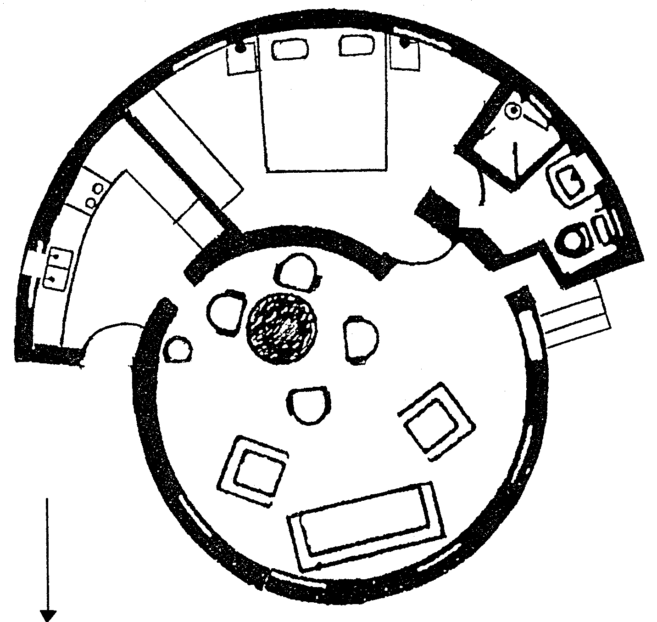  Diagram A  BATHROOM  BEDROOM  DINING ROOM  SITTING AREA  NORTH  STAIRS  F  G  H  J  I  K  L  M  C  D  E  B  A  WEST  BACK DOOR  KITCHEN  AGTERDEUR  EAST  SOUTH  Inside | KEY  A. = COUCH  B. = CHAIRS  C&D. = TABLE & CHAIR  E. = LAMP  F. = SINK  - = STOVE  - = FRIDGE  - = BUILT-IN  CUPBOARD  - = DOUBLE BED  - = SHOWER  - = WASH BASIN  - = TOILET

6.1 Identify TWO different types of balance found inside the rondavel. Motivate your answer.

TYPE OF BALANCE | MOTIVATION
 |  | (4)

6.2 Study the kitchen plan and identify the type of layout shown by the work triangle. | (1)

6.3 Explain how provision can be made for extra sleeping space / facilities for when the children are home during the holidays. | (2)

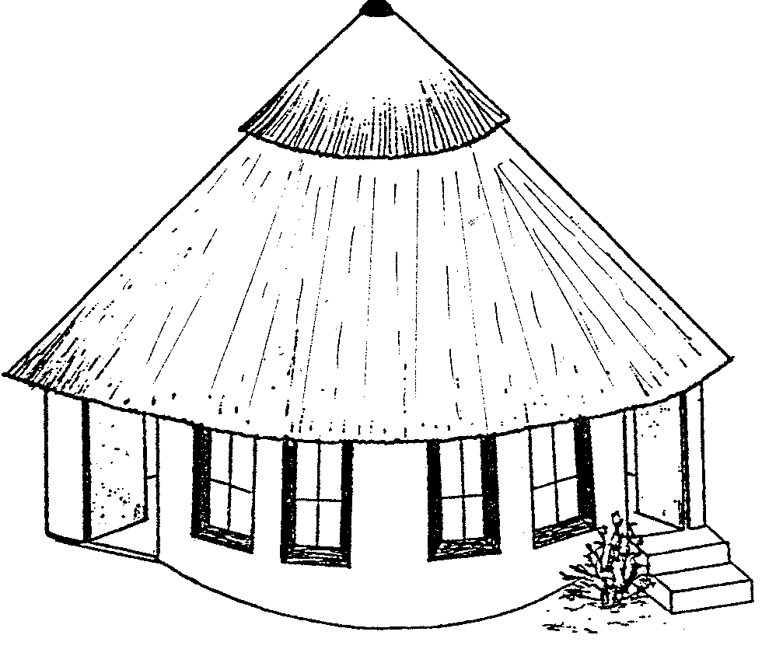
Diagram B
BACK DOOR
FRONT DOOR
EAST
WEST
SOUTH
STAIRS
THATCHED ROOF

Outside

NORTH

6.4 Study the diagram of the OUTSIDE of the rondavel.  - Give FOUR requirements that would ensure that the steps leading to the front door are safe.  - From the diagram, identify THREE factors that could contribute towards keeping the rondavel cool in the hot summer months.  6.5 Suggest a monochromatic colour scheme for the bedroom and motivate your answer. | (4)  (3)  (2)

6.6  - Make useful suggestions for storage:  - In the bathroom to store extra toiletries while the children are at home during the holidays.  - For the children’s bedding while they are at school during term time.  - For the many books and magazines pertaining to farming so that they are easily available when needed. | (3)

Name THREE ways in which family symbols can play a role in ensuring the unity of the family, especially as they are separated so often. | (3)

6.8 What FOUR factors will influence the distribution of tasks to the different family members during the holidays?  6.9 The daughters are accepted into a group of young people in the farming community. What FOUR advantages are there to being included in a group?  TOTAL FOR SECTION C:  TOTAL: | (4)  (4)  [30]  [60]  200

