GAUTENG DEPARTMENT OF EDUCATION

SENIOR CERTIFICATE EXAMINATION

HOME ECONOMICS HG

TIME: 3 hours

MARKS: 300

INSTRUCTIONS:

- ALL the questions are COMPULSORY.
- Please write neatly and clearly.
- Number your answers exactly as the questions are numbered.
- Answer Questions 1.1.1 – 1.1.18 (multiple choice) of Section A on the answer sheet on the inside cover of your answer book (the numbering is 1.1 – 1.18).
- Answer Questions 1.2 – 1.14 of Section A as well as Section B and Section C in your answer book.

SECTION A

QUESTION 1

  - Indicate the correct answer clearly by making a cross (X) over the corresponding letter on the answer sheet on the inside cover of your answer book.

EXAMPLE: Croutons are

A. pieces of dried meat. B. liver patties.
C. fried bread cubes. D. fish cakes.

ANSWER: A B C D

NB. Where more than one cross appears in any answer, NO MARKS will be awarded for that answer.

    - An entrée in a formal meal
- always contains pasta.
- is a savoury dish served just before the main course.
- is the first course on the menu.
- is a vegetable dish served with the roast.

    - Identify the method of heat transference that takes place when a potato is baked on a braai grid.
- Radiation and conduction
- Convection and evaporation
- Radiation and convection
- Conduction and evaporation

    - The main nutrient in the food group, cereal and cereal products, has the following function in the body:
- Is a source of energy, which contributes towards the regulation of bodily functions
- Is a reserve source of energy, which improves resistance to infection
- Is an important source of energy, which promotes the use of vitamins
- It provides energy and promotes peristalsis.

    - Which sealed container of milk will become sour in four days if kept at a temperature of 20º?
- A bottle of sterilised milk
- A tin of full-cream powdered milk
- A sachet of pasteurised milk
- A tin of evaporated milk

    - Which one of the following ingredients will increase the coagulation temperature of egg protein but decrease the rate of coagulation?
- Fat
- Salt
- Sugar
- Acid

    - Identify the group of fish that has a low fat content:
- Hake, kingklip
- Sole, sardines
- Trout, salmon
- Tuna, herring

    - The red-coloured liquid, known as drip, in the container of prepacked rump indicates that
- meat juices have been added to ensure a tasty, juicy steak.
- the meat is from a young animal.
- the cell contents have seeped out and the steak will be dry and unpalatable.
- not enough glycogen was present when the animal was slaughtered.

    - What colour pigment and nutrient is found in large quantities in spinach?
- Carotene and vitamin C
- Chlorophyll and vitamin C
- Flavones and vitamin A
- Anthocyanins and vitamin D

    - Select THREE general characteristics that distinguish vegetables from fruits. Vegetables
- are more acidic.
- are less acidic.
- have more sugar.
- have less sugar.
- have more vitamin C.
- have less vitamin C

- 2, 4, 6
- 2, 3, 5
- 1, 3, 6
- 2, 4, 5
    - The reason for cooking red cabbage together with a sour apple is to
- change the colour to purple.
- improve the protein content of the dish.
- retain the red colour.
- prevent the loss of vitamin A.

    - A family’s priorities in the early years of marriage emphasise:
- Living standards, education and family relations.
- Financial security, career and housing.
- Financial security, housing and management.
- Retirement, health and family relations.

    - Psychomotor resources include
- comprehension and self control.
- adaptability and enthusiasm
- muscular activities and senses.
- attitude resource and self control.

    - Shades of the primary colours include the following:
- Olive green, violet, coral red
- Navy blue, wine red, mustard
- Emerald green, ruby-red, golden yellow
- Lime green, ivory, pinky beige

    - The chair in the sketch below will be suitable for a room because it will
- be in harmony with cane furniture.
- be in contrast with heavy wooden furniture.
- fit well in a small, sunny room.
- be in contrast with small, flowery upholstered furniture.

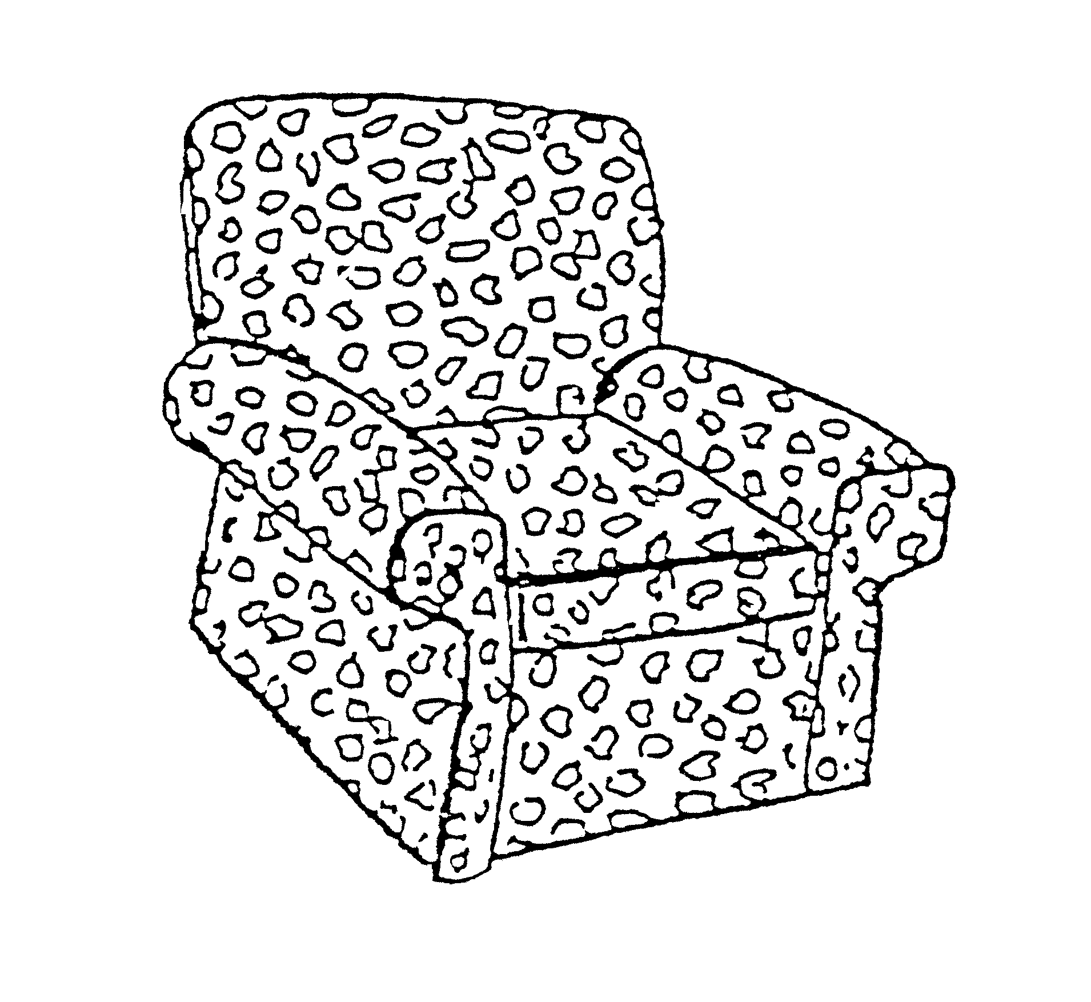

- In modern society, sex-role stereotype means  - that certain jobs are reserved for men only or for women only.  - that homemakers should not be employed outside the home.  - that men are more involved with the education of children than women.  - that women should be able to support themselves and men should be able to manage their own households.  The case study below pertains to Questions 1.1.16 to 1.1.18.  Paul, a sporty grade 11 boy likes to keep his room impeccably tidy.  He is an only child and enjoys many financial privileges. He is still very  dependent on his parents to help solve his problems and to handle conflict  situations.  - Which developmental task of a teenager does Paul still have to accomplish?  - Identification with a masculine role  - Learn to make new friends  - Acceptance of his changing body  - Develop skills to handle and resolve conflict situations  - Paul attaches value to  - achievement and recognition.  - tidiness and physical fitness.  - status and financial security.  - creativity and achievement.  - A human resource available to Paul is  - employment opportunities.  - financial privileges.  - parental support.  - space in his bedroom.  18x2 =  - From the list below, select FOUR changes that take place when fruit is cooked by means of moist heat. In your answer book write the question number (1.2) and the FOUR letters (A-H) of your choice below each other. | (36)

CHANGES THAT TAKE PLACE IN FRUIT DURING MOIST HEAT COOKING
A | Sucrose, fructose and glucose dissolve in the liquid in which the fruit was cooked.
B | Organic acids decrease and the fruit becomes sweeter.
C | Cellulose becomes softer.
D | Some vitamins and minerals dissolve in the liquid.
E | White fruit discolours as a result of enzyme action.
F | Pectin changes into protopectin and fruit becomes firmer.
G | Water penetrates the cells and gelatinises the starch granules.
H | Lipids are oxidised in the cells
(4)

  - Select from the list below FOUR advantages for the selection of meat analogues. In your answer book write the number of the question(1.3) and the FOUR letters (A-H) of your choice below each other.

CHOICE OF MEAT ANALOGUES
A | Freezing does not affect the structure
B | Can be stored at room temperature
C | Supply protein of high biological value
D | Have a high fat content
E | Is cheaper than meat
F | Is rich in fibre
G | Sometimes causes flatulence
H | High ratio of connective tissue to amino acid
(4)

1.4 Select from the list below, the FOUR changes that occur during gelatinisation. In your answer book write only the question number (1.4) and the FOUR letters (A – H) of your choice below each other.

CHANGES THAT OCCUR DURING GELATINISATION
A | As the heat is applied, the starch granules dehydrate and shrink.
B | The mixture increases in viscosity.
C | The mixture becomes opaque
D | Friction is created between granules and the paste becomes thicker.
E | The mixture becomes translucent.
F | The thickening power of starch is reduced.
G | Water moves into the starch granules and they swell
H | Swelling stops as the temperature increases
(4)

1.5 From the list below select FIVE basic survival skills of the family. In your answer book write the question number (1.5) and the five letters (A – J) of your choice below each other.

BASIC SURVIVAL SKILLS OF THE FAMILY
A | Becoming established in an occupation. Receives specialised training.
B | Supporting and maintaining of family home
C | Maintaining couple motivation and morale.
D | Budget for the use of the resources money, time and space.
E | Meeting physical needs by providing food and clothing.
F | Developing good eating habits and table manners.
G | Guiding children towards independence as they approach adulthood.
H | Maintaining a sense of purpose by developing family values.
I | Financial planning for extra expenditure due to child/ren.
J | Developing the ability to reason and think.
(5)
  - Analyse the following sketch and select FIVE factors from the list below that could contribute to an illusion of a larger more spacious bedroom. In your answer book, write the question number (1.6) and the FIVE letters (A – J) of your choice below one another.

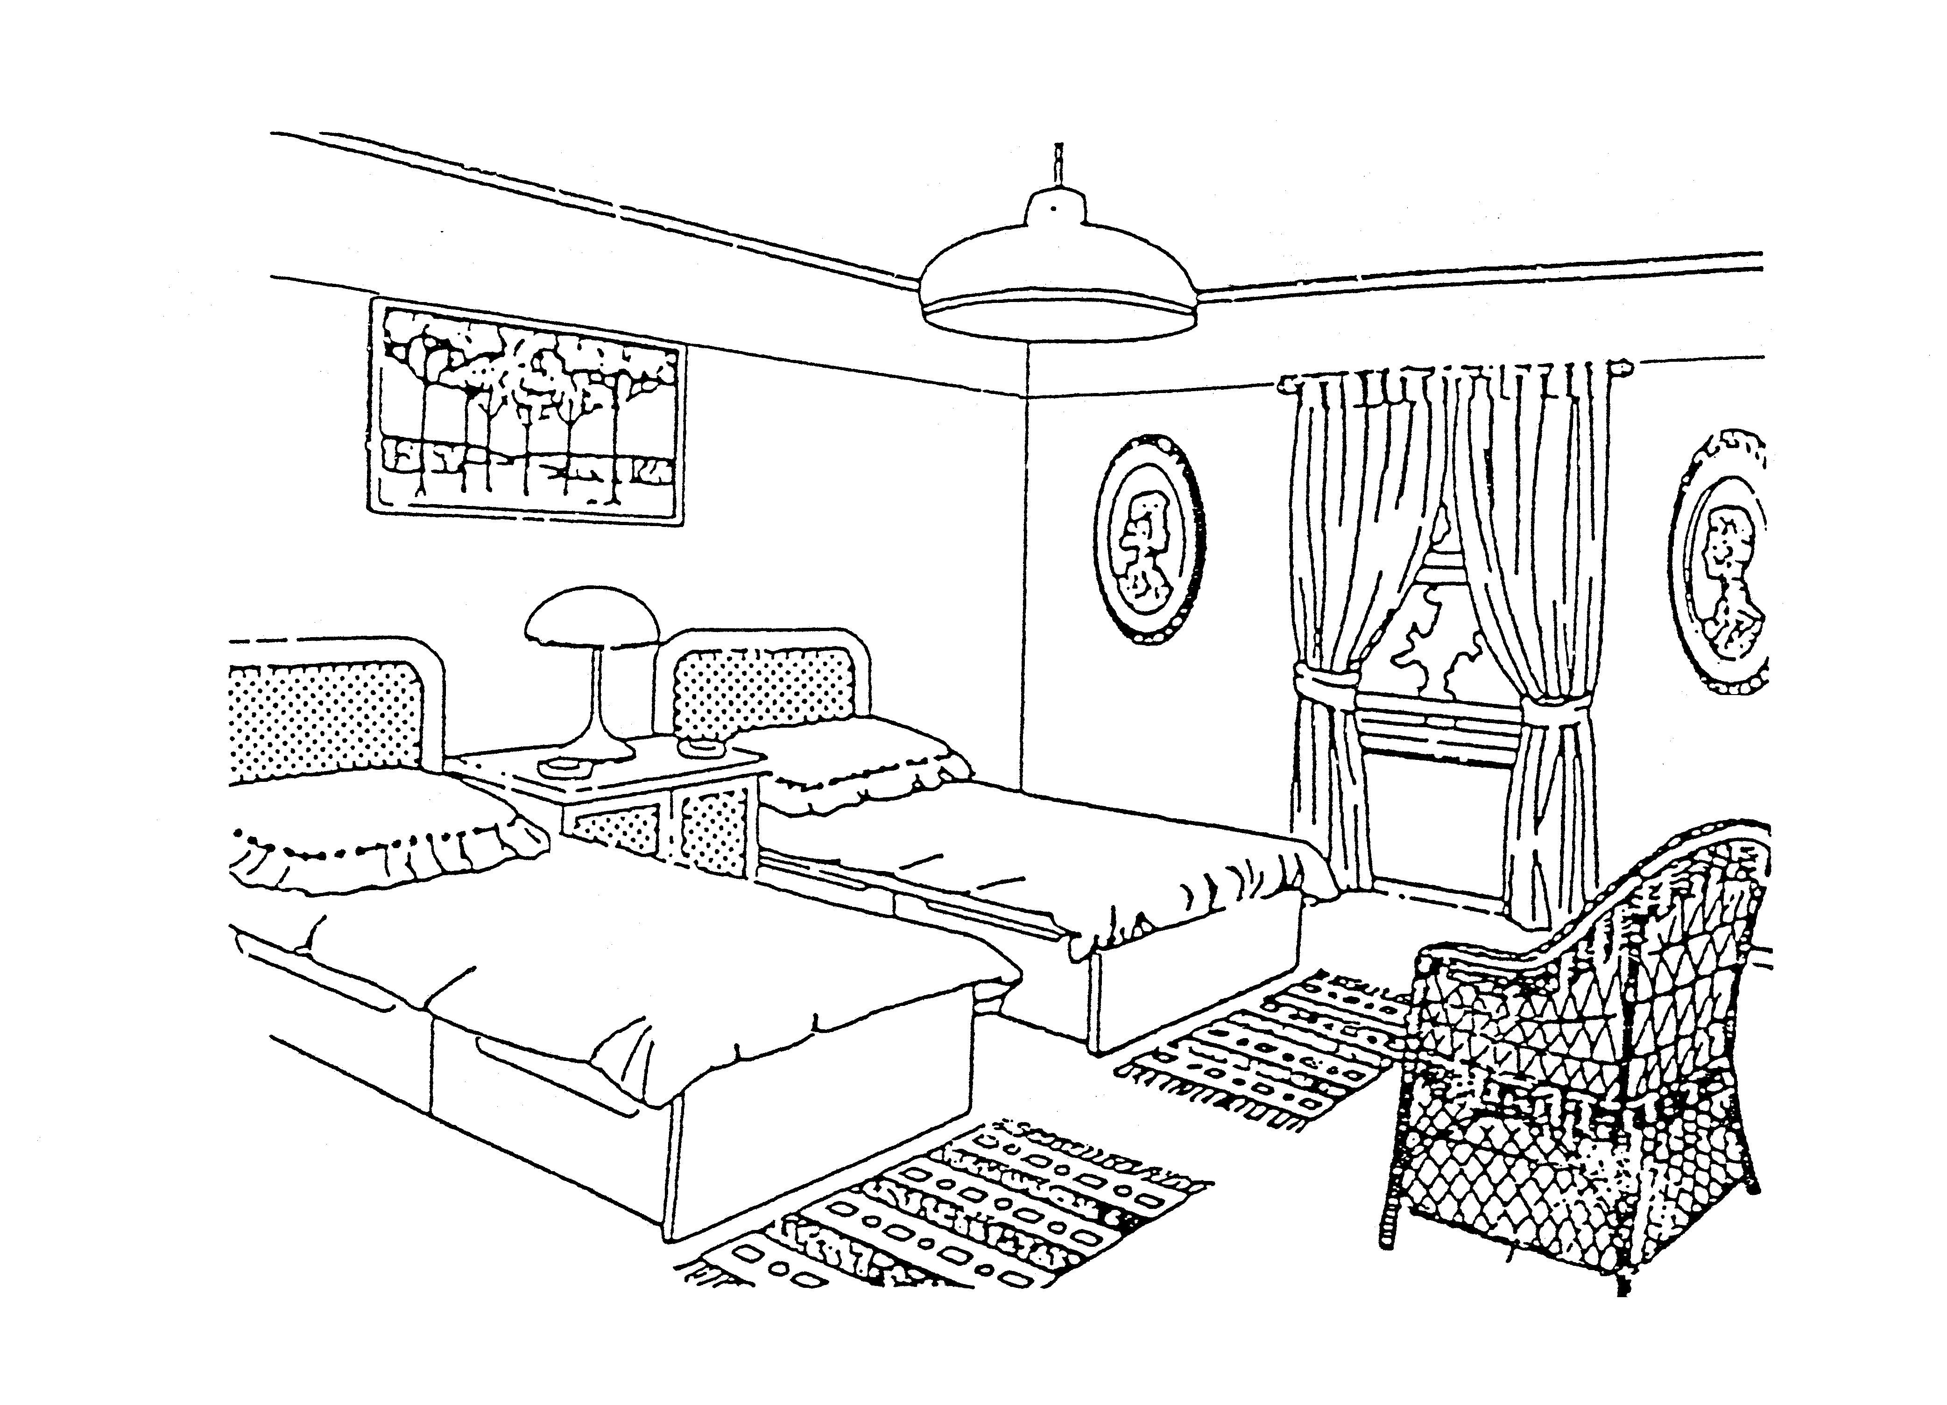

FACTORS CONTRIBUTING TO AN ILLUSION OF A LARGER, MORE SPACIOUS BEDROOM
A | Select small scale furniture
B | Paint the ceiling and part of the wall above the picture in a darker shade
C | Paint the ceiling and part of the wall above the picture in a lighter shade
D | Ensure that the ceiling and the floor of the bedroom are in a darker shade than the walls
E | A deep, rich colour on the furthest wall of the bedroom is essential
F | Place heavy furniture in the middle of the room
G | Furniture supported off the floor on sturdy legs and cane furniture should be used
H | Ornaments, accessories and furniture should be in harmony
I | Use only functional furniture in the bedroom
J | Replace the plain duvet covers with a small motif pattern
(5)

  - The sketch below includes a bunker bed. (Built-in bed) Identify from the list below THREE statements which are valid to the sketch. In your answer book write the question number (1.7) and the THREE letters (A – F) of your choice below each other.

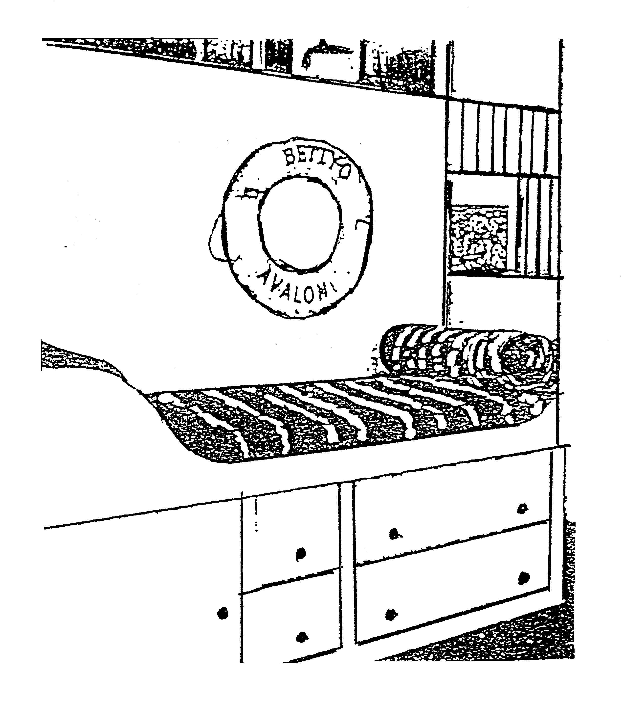

STATEMENTS VALID TO THE SKETCH
A | Ensures sufficient space
B | Is not practical to use
C | May be used for additional storage
D | Ensures easy traffic lanes
E | The room will look smaller
F | Is suitable for a study
(3)

1.8 Select from Column B the explanation for the rule in Column A. Write the numbers (1.8.1 – 1.8.3) below each other in your answer book and the letters (A – E) next to the correct number.

COLUMN A |  | COLUMN B
RULE |  | EXPLANATION
1.8.1 | Baste food regularly | A | Improves the keeping quality
1.8.2 | Serve cooking liquid with food | B | Improves colour, but destroys vitamins
1.8.3 | Add bicarbonate of soda to green beans when cooking them | C | Retains maximum nutritional value
 |  | D | Prevents drying out
 |  | E | Prevents liquid seeping out
(3)

1.9. Select the statement in Column B that best suits the factors influencing gelatinisation of cornflour in Column A. Write only the question numbers (1.9.1 – 1.9.5) below each other in your answer book and then the letters (A – H) next to the correct number.

COLUMN A |  | COLUMN B
FACTOR |  | STATEMENT
1.9.1 | Stirring | A | Hydrolyses starch to dextrin
1.9.2 | Temperature | B | Limits swelling, competes for water
1.9.3 | Acidity | C | Good thickening agent
1.9.4 | Fat | D | Lowers the temperature at which gelatinisation takes place
1.9.5 | Addition of sugar | E | Prevents lumps forming
 |  | F | Excellent thickening power
 |  | G | Gets a cooked taste
 |  | H | Screens the starch granules
(5)

  - Match the function of eggs in cookery in Column A with the food example in
Column B. Write only the question numbers (1.10.1 – 1.10.5) below each other
in your answer book and then the letters (A – I) next to the correct number.

COLUMN A |  | COLUMN B
FUNCTION OF EGGS |  | FOOD EXAMPLE
1.10.1 | Egg yolk used as a thickening agent | A | Mayonnaise
1.10.2 | Beaten egg-white used to incorporate air | B | Consommé
1.10.3 | Whole egg used to bind ingredients | C | Crumbed chops
1.10.4 | Egg yolk used as an emulsifying agent | D | Fish cakes
1.10.5 | Egg-white used to clarify soup | E | Potato salad
 |  | F | Cheese soufflé
 |  | G | Custard
 |  | H | Crystalline sweets
 |  | I | Frothy, set jelly
(5)
1.11 Choose the enzyme from Column A to match the effect it has on the food in Column B. Write the numbers (1.11.1 – 1.11.5) below each other in your answer book. Next to each answer, state if the effect is positive or negative.

COLUMN A |  | COLUMN B
ENZYME |  | EFFECT ON FOOD
1.11.1 | Bromelin | A | Changes glucose into carbon-dioxide during fermentation
1.11.2 | Zymase | B | Prevents the setting of gelatine mixture
1.11.3 | Oxidase | C | Oils in stored cereals become rancid.
1.11.4 | Papain | D | Makes tough meat tender
1.11.5 | Rennin | E | Coagulates milk to make yoghurt
 |  | F | Makes starch more soluble
 |  | G | Strengthens bread dough
 |  | H | Speeds up Maillard’s reaction
(10)

  - Match the types of cheese in Column B to the dish in Column A. Write the numbers (1.12.1 – 1.12.5) below each other in your answer book and then the letters (A – H) next to the correct number.

COLUMN A |  | COLUMN B
DISH |  | TYPE OF CHEESE
1.12.1 | Greek salad | A | Cream cheese
1.12.2 | Macaroni and cheese | B | Feta cheese
1.12.3 | Carrot cake topping | C | Brie cheese
1.12.4 | Chocolate cheese cake | D | Cottage cheese
1.12.5 | Minestrone soup and croûtons | E | Camembert
 |  | F | Cheddar cheese
 |  | G | Parmesan
 |  | H | Blaaukrantz
(5)
  - Match TWO examples in Column B with the type of decision in Column A. Write the numbers (1.13.1 – 1.13.3) below each other in your answer book and the letters (A – F) next to the correct number.

COLUMN A |  | COLUMN B
TYPE OF DECISION |  | EXAMPLE
1.13.1 | Economic | A | Deciding how to lengthen a short skirt
1.13.2 | Social | B | A decision made on the spur of the moment
1.13.3 | Technical | C | Deciding which suburb to move to
 |  | D | Walking the same route to school every day
 |  | E | Making more than one decision at a time
 |  | F | A decision to travel to work with a lift club rather than using your own car
(6)
  - Match the example in Column B with the statement in Column A. Write the numbers (1.14.1 – 1.14.5) below each other in your answer book and the letter (A – I) next to the correct number.

COLUMN A |  | COLUMN B
STATEMENT |  | EXAMPLE
1.14.1 | Optimum utilisation of space | A | Psychological space needs
1.14.2 | Furniture that can be adapted to different situations | B | Functional design
1.14.3 | Space needed by an individual to perform a task | C | Traffic lanes
1.14.4 | A non-contact person needs more space than a contact person | D | Enough legroom
1.14.5 | Activity centres should be arranged to meet the requirement of the inhabitants | E | Physical space needs
 |  | F | Functional storage space
 |  | G | Multi-purpose furniture
 |  | H | Maximum utilisation of space
 |  | I | Functional living space
(5)

TOTAL FOR SECTION A: [100]

SECTION B

QUESTION 2

  - To celebrate the end of year exams, friends are invited for dinner. Arrange the given dishes to form a four course meal. Write out the menu according to the set rules.

roast duck, lemon soufflé, apple sauce, cauliflower au-gratin, melba toast,
green peas, hollandaise sauce, fried potatoes, poached kingklip, carrot and
raisin salad, consommé soup

(6)
- Explain the following cookery terms found in the preparation of the above meal.  - Roux  - Sauté  - Au-gratin  - Snacking between meals is recommended for certain groups of people. Name THREE groups of people who may benefit from snacking.  - What THREE factors are used to evaluate a dish? | (2)  (2)  (2)  (3)  (3)

- Give ONE reason why the following procedures are used when cooking:  - Sear the sides of meat when potroasting.  - The shiny side of foil should not be on the outside.  - Keep water away from oil when frying.  - Meat should never be pricked when grilling.  - All food should be covered during steaming.  2.6 Classify the method of cooking for the dishes below and identify the method of heat transference. Tabulate your answer. | (5)

DISH |  | METHOD OF COOKING | HEAT TRANSFERENCE
2.6.1 | Poached Kingklip
2.6.2 | Fried potatoes
2.6.3 | Melba toast
(6)

2.7 Give THREE reasons why people living alone may have problems with food preparation.  2.8 Preserving certain foods increases the storage / shelf life of food. From the list below select FOUR correct preservation methods and motivate your choice. Tabulate your answer. | (3)

CORRECT PRESERVATION METHOD |  | MOTIVATION
(8)

- Blanch cauliflower buds before freezing  - Keep peaches at room temperature for a week  - Pasteurised milk  - Prepare salt pickles  - Prepare chicken and noodle salad beforehand and refrigerate  - Prepare sliced potato chips and fry two hours later  - Slice shop bread and seal well | [40]

QUESTION 3  - Starch mixtures thickened with eggs can be problematic.  How can the above problem be overcome?  - Why do cereals cooked in milk, swell more than when cooked in water?  - What is the effect of dry heat on starch?  - Give a reason for the following processes applied to milk:  - Fortification  - Sterilisation  - Homogenisation  - Purification  - Classify the given components of milk as a true solution, a colloidal dispersion or dilute emulsion:  Tabulate your answer. | (4)  (2)  (4)  (4)

TRUE SOLUTION | COLLOIDAL DISPERSION | DILUTE EMULSION
(1) | (1) | (1)
(1) | (1)

- Lactose  - Casein  - Fat globules  - Calcium phosphate  - Iron  3.6 3.6.1 From an organoleptic point of view, why is it advantageous to prolong rigor mortis in fish?  - Explain why white fish is a good choice for the following:  - Invalid diet  - People doing sedentary work  - Compare the meat and fat of older animals with that of younger ones with regards to:  - Tenderness  - Flavour  Tabulate your answer. | (1)  (1)  (1)

 |  | MEAT/FAT OF OLDER ANIMALS | MEAT/FAT OF YOUNGER ANIMALS
3.7.1 | TENDERNESS
3.7.2 | FLAVOUR
(4)

  - Compare the effect of dry heat and moist heat on meat.
Tabulate your answer.

EFFECT OF DRY HEAT ON MEAT | EFFECT OF MOIST HEAT ON MEAT
(6)

- Egg custard was cooked in a double boiler and the temperature was carefully controlled. At the end of the cooking process the top of the double boiler was not removed. Analyse the cooking method, predict the end result and motivate your answer.  QUESTION 4  - In dried fruit, the water has evaporated and the nutrients are concentrated. Analyse the nutrient content of dried fruit under the following headings:  - Vitamin content  - Carbohydrates  4.2 4.2.1 Give THREE factors that contribute to the development of flavours found in vegetables.  - Give ONE example of vegetables which will develop an off-flavour if they are cooked for too long.  - Explain how off-flavours develop while cooking vegetables.  - Supply a reason for each of the following statements:  - Gelatine should be stored in an airtight container.  - Chill ingredients and moulds beforehand when preparing gelatine dishes.  - Gelatine granules should be allowed to soften in cold water before use.  - When mixing gelatine into a milk mixture, the milk mixture must be cooled.  - If pieces of fruit are added to gelatine mixtures, the mixtures should have started to set.  - Name the dispersion medium and the dispersed phase in each of the following gelatine mixtures below.  Tabulate your answer as follows: | (8)  [40]  (4)  (3)  (1)  (2)  (5)

 |  | DISPERSED MEDIUM | DISPERSED PHASE
4.4.1 | Gelatine foam
4.4.2 | Whipped cream
(4)

4.5 4.5.1 Explain the role of lecithin in eggs when making choux paste.  4.5.2 Give THREE reasons for an incomplete or broken emulsion during the preparation of choux paste.  4.6 What effect would the following have on the fermentation process during bread making?  - A temperature of 50ºC during the proving stage  - 20 ml sugar added at the beginning of the fermentation process  - If the fermentation process is prolonged  - Explain Maillard’s Reaction and how it will enhance the colour of bread.  - Predict the end result that could be expected if raisin bread is insufficiently kneaded while mixing. Motivate each prediction with a reason.  SECTION C  QUESTION 5  - South Africa’s education system is in the process of change. Outcomes – Based Education (OBE) is the new educational approach currently being introduced into South African schools.  The OBE approach focusses on what is learnt and how it is learnt.  - According to Maslow’s hierachy the above statement indicates a human need.  - Identify this need according to Maslow’s hierachy.  - Name TWO criteria needed to reach this level.  Our new education system is aimed at equipping more qualified South Africans by preparing them for the world of work. The changes are aimed at increasing skills, promoting knowledge and a determination to succeed.  - From the above case study identify the following:  - THREE long term goals  - TWO short term goals  Our new approach stresses that it is time to stop talking about under resourced schools and to look to the environment and the community to assist in the learners’ education. | (3)  (3)  (3)  (4)  (8)  [40]  (1)  (2)  (3)  (2)

5.3 Give FOUR examples of environmental resources that are available to the community that may be used to assist in the learner’s education.  Instilling values, skills, attitudes and beliefs form an important part of OBE.  5.4 5.4.1 List FOUR factors that influence the development of values.  5.4.2 Name FOUR skills that a person should develop in order to prevent mental fatigue. | (4)  (4)  (4)

- From the list below select:  - THREE compulsory deductions from a monthly salary.  - THREE fringe benefits that may be offered to employees.  Tabulate your answer as shown below: | (3)  (3)

Interest
Income tax
Investments
Medical Aid
Paid Vacation
Tips
Unemployment Insurance
Bursaries
Royalties
Recreational facilities

5.5.1 | 5.5.2
COMPULSORY DEDUCTIONS | FRINGE BENEFITS
1. | 1.
2. | 2.
3. | 3.

- One of the steps in financial planning is to determine your expected expendi-ture.  5.6.1 Classify expected expenses and supply ONE appropriate example of each expense. Tabulate your answers as shown below: | 3x2 = (6)

EXPECTED EXPENSES | ONE EXAMPLE

Successful people know that managing time is not a mysterious gift but a skill one can learn and practice.

- Evaluate the above statement. | (8)  [40]
QUESTION 6

6.1 Study the diagram below and answer the questions that follow.

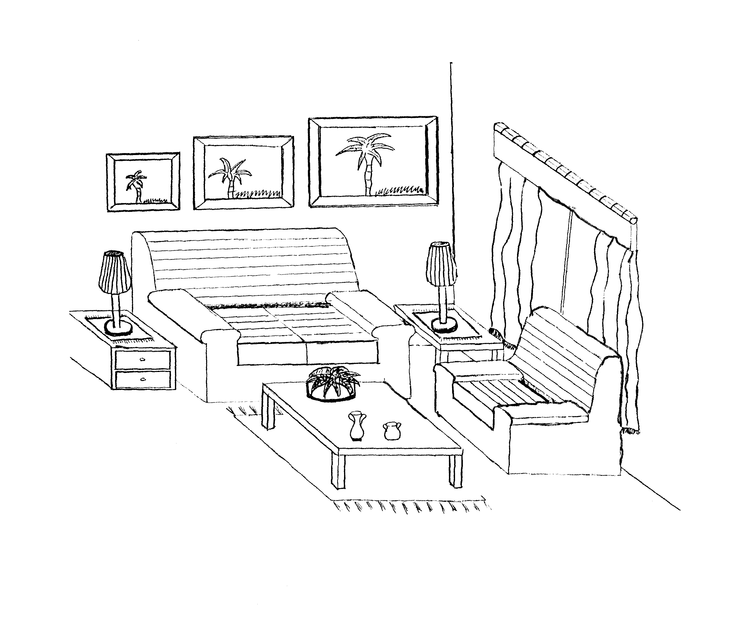

- Identify THREE ways in which proportion may be found in the above room.  - Identify TWO ways in which rhythm has been used in the above room.  - Give an example of informal balance found in the above room.  - What reasonable precautionary measures should be taken to prevent accidents with fire in the home?  - Suggest FOUR points that should be borne in mind when selecting a functional and comfortable bed.  - How can good functional design be obtained in a home? | (3)  (2)  (1)  (4)  (4)  (4)

- Consider THREE aspects to bear in mind when planning general lighting in a room. | (3)

6.6 Read the following case study and answer the questions that follow:

Mr and Mrs Sithole have three children, all of whom have left home to get married.
Mr Sithole was involved in an accident and received a blood transfusion. Six months later he was diagnosed HIV positive. He died three years later.

As Mrs. Sithole got older she had to learn new socialising skills. She found it lonely living by herself. She went to stay with one of her married children to help look after her grandchildren.

6.6.1 In which stage of the family-life cycle is the family when you first meet them?  6.6.2 (a) According to the case study, how did Mr. Sithole contract Aids?  (b) Give TWO other ways in which people can be infected with Aids.  6.6.3 Give THREE socialising skills which Mrs. Sithole had to acquire in later life.  6.6.4 What impact will the addition of Mrs. Sithole have on the family with whom she goes to live?  6.6.5 Identify the socialising agents with whom Mrs. Sithole will come into contact.  6.7 Analyse the following statements with regard to the storage of items used in the home and evaluate the effectiveness of each:  - All equipment used together should be stored together.  - Stored equipment should be easy to locate.  - Heavy equipment should be stored at or near to floor level.  - Storage space should be adjustable.  TOTAL: | (1)  (1)  (2)  (3)  (2)  (2)  (8)  [40]  300

