GAUTENG DEPARTMENT OF EDUCATION

SENIOR CERTIFICATE EXAMINATION

HOME ECONOMICS HG

TIME: 3 hours

MARKS: 300

INSTRUCTIONS:

- All the questions in this paper are COMPULSORY.
- Please write clearly and neatly.
- Number your answers exactly as the questions are numbered.
- Answer Questions 1.1.1 – 1.1.15 (multiple choice) of SECTION A on the answer sheet on the inside cover of your answer book (the numbering is 1.1 – 1.15).
- Answer Questions 1.2 – 1.14 of SECTION A as well as SECTION B and SECTION C in your answer book.

SECTION A

QUESTION 1
FOOD AND NUTRITION

  - Indicate the correct answer by drawing a cross (X) over the corresponding letter on the answer sheet on the inside cover of your answer book.

EXAMPLE: Croûtons are

A. pieces of fried meat. B. liver patties.
C. fried bread cubes. D. fish cakes.

ANSWER: A B C D

NB: Where more than one cross appears in any answer, no marks will be awarded for that answer.

    - The sensory enjoyment of a meal is determined by the
- nutritional value of food.
- colour and texture of food.
- amount of preparation.
- season and climate

    - A finger-bowl is used to wash the fingers after serving –––––––––––––– which is eaten with the fingers.

- steak and kidney pie
- beef stroganoff
- grilled prawns
- spaghetti bolognaise

    - Roasting of meat refers to cooking meat
- on a greased flat surface or griddle.
- by simmering in a small quantity of water.
- where heat is transferred to uncovered food by means of heated air.
- by transference of heat due to conduction.

    - Adding sugar to starch paste will
- decrease thickening of the cooked product.
- hydrolyse the starch to dextrin.
- prevent gelatinisation in puddings.
- result in a thicker paste.

    - Milk blends should not be used to substitute milk powder for babies because they
- have a high carbohydrate content and are rich in saturated fatty acids.
- are high in cholesterol but have a low kJ value.
- have a low vitamin content and only contain one third as much protein as real milk powder.
- contain harmful fatty acid and are low in calcium content and may harm the baby’s health.

    - Lecithin is the emulsifier responsible for binding the following ingredients when making mayonnaise:
- Spices and oil
- Egg yolk and oil
- Vinegar and oil
- Egg white and vinegar

    - The effect of freezing on fish:
- Frozen storage increases toughness of the fish muscle.
- Fish remains moist and succulent for a long period of time.
- Small ice crystals form and the volume of the muscles contract.
- Highly saturated fatty acid of oily fish freezes well.

    - Blood water, known as drip, in the trays of pre-packed meat indicates that
- the meat has been packed in liquid to make it juicy and palatable.
- sarcoplasm has oozed out and the end product will be unpalatable.
- meat juices have been added to ensure that the end product will be palatable.
- the animal has not bled sufficiently and the meat will be unpalatable.

    - The following method of ripening tomatoes produces a high ascorbic acid value:
- Tomatoes ripened in green houses
- Tomatoes ripened outdoors
- Tomatoes ripened off the vine
- Tomatoes ripened in the shade

    - The unpleasant flavour and odour of overcooked cabbage is caused by
- hydrogen sulphide.
- magnesium sulphate.
- calcium chloride.
- sulphur dioxide.

    - The macro-environment includes the
- family and close friends.
- lounge and garden of the home.
- household environment as well as the school.
- political and economic system of the country.

    - Every morning you have a cup of coffee before going to school.
The level of decision making involved is
- impulsive.
- limited.
- routine.
- extensive.

    - Which one of the following is an example of non-human resources?
- Time and energy
- Interest and belief
- Postal and transport services
- Knowledge and understanding

Questions 1.1.14 – 1.1.15 relate to the diagram below. Study the diagram and answer the questions that follow:  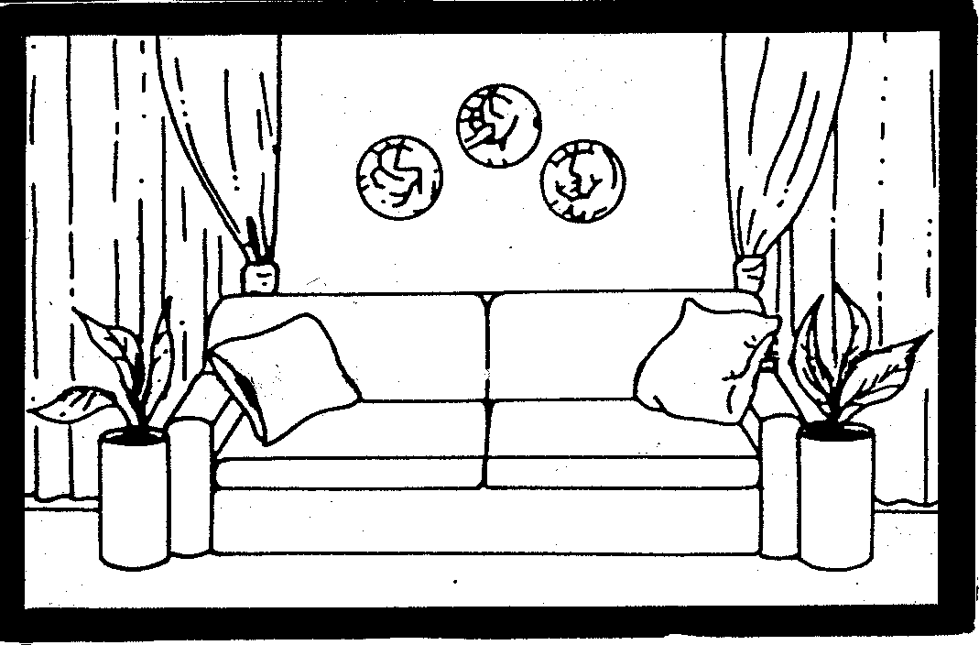  - The design principle of proportion that is applied in the above sketch means that  - attention is drawn to the curtains.  - easy flowing lines are used in the room.  - pot plants and cushions are arranged in an orderly way.  - the sizes of the objects are correct in relation to the size of the room.  - The focal point in the room is created by  - pot plants on either side of the couch.  - two cushions placed on the couch.  - the length and width of the curtains.  - the three objects on the back wall.  15x2 =  1.2  A cheese dish (fondue) is prepared from a white sauce, egg-yolk and cheese.  The end result of the dish is stringy and oily due to the high increase in temperature.  Analyse the above statement and select TWO factors from the list below that could have contributed to the end result.  In your answer book write the question number (1.2) and the TWO letters (A – F) of your choice below each other. | (30)

FACTORS CONTRIBUTING TO A CHEESE DISH BEING STRINGY AND OILY
A | Proteins over coagulate and a considerable amount of moisture is lost due to prolonged heating.
B | The mixture is not stirred continuously therefore the proteins do not coagulate evenly.
C | Cheese is grated finely causing the casein to soften.
D | The egg yolk is not beaten sufficiently before adding it to the white sauce.
E | Flour used to bind the mixture is inadequate and the end result is oily and lumpy.
F | Due to prolonged heating the emulsion breaks, becoming oily and indigestible.
(2)

  - Analyse the food systems below that occur in the ingredients used to make ice cream. Select from the list below the appropriate food system. In your answer book write the question numbers 1.3.1 – 1.3.5 below each other and the correct letter (A or B).

 | INGREDIENTS |  | FOOD SYSTEM
 | 1.3.1 | Sugar | A.  B. | Ionic Solution  True solution
 | 1.3.2 | Milk with milk solids | A.  B. | Molecular solution  Colloidal dispersion
 | 1.3.3 | Cream | A.  B. | Aerated emulsion  Foam
 | 1.3.4 | Fat | A.  B. | Globules dispersed in ice-crystals  Particles entrapped in milk serum
 | 1.3.5 | Egg white | A.  B. | Proteins in egg white envelop cells and a foam is formed  Protein film in egg white is stabilised – emulsion is formed
5x2 =  - Select from the list FOUR undesirable effects of overcooked food. In your answer book write the question number 1.4 and the FOUR letters (A – I) of your choice below each other. |  |  |  |  | (10)

 | UNDESIREABLE EFFECTS OF OVERCOOKED FOOD
 | A | French omelet will have a large volume and a tough texture.
 | B | The texture of vegetables becomes soft and mushy.
 | C | Fish shrinks minimally and has a coarse texture and is tough and dry.
 | D | Meat becomes stringy and disintegrates.
 | E | White vegetables turn a drab tan colour.
 | F | Meat analogues will shrink considerably.
 | G | Nutrients dissolve or are leached from other foods.
 | H | Milk sugar will over caramelise and result in off-flavours.
 | I | Vitamin B2 in spinach is dissolved.
 |  |  | (4)

1.5 Select from the list below FOUR important factors to consider when planning a cleaning schedule. In your answer book write the question number 1.5 and the FOUR letters (A – H) of your choice below each other.

FACTORS TO CONSIDER WHEN PLANNING A CLEANING SCHEDULE
A | Family situation
B | Socio-economic factors
C | Too much to do, too little time
D | Location of the house
E | The homemaker’s habits
F | The activities of the occupants
G | The method of work
H | A monotonous task
(4)
1.6 Select from the list below FOUR correct statements applicable to HIV/Aids. In your answer book write the question number (1.6) and the FOUR letters (A – H) of your choice below each other.

 | STATEMENTS APPLICABLE TO HIV/AIDS
 | A | HIV/Aids is a disease that has a cure.
 | B | You can have an HIV test free of charge at any government clinic.
 | C | Covering cuts and sores on your hands with a plaster is not necessary before handling any blood.
 | D | Respect and support people with HIV/Aids.
 | E | You can get Aids from living with someone who is HIV infected.
 | F | Learners who are HIV infected have a right to schooling.
 | G | HIV/Aids affect us all.
 | H | Only the Government is responsible for preventing the spread of Aids.
 |  |  | (4)
1.7 Identify from the list below FOUR statements that will help to strengthen family unity. In your answer book write the question number (1.7) and the FOUR letters (A – H) of your choice below each other.

 | STATEMENTS TO STRENGTHEN FAMILY UNITY
 | A | Family members having Christmas dinner together.
 | B | Family members being independent.
 | C | Mother buying herself an outfit for a wedding.
 | D | Family members going on a picnic on a Sunday afternoon.
 | E | Mother visits father in hospital.
 | F | The family watching a television programme.
 | G | Father says a prayer at mealtime when the family is together.
 | H | Parents go out to dinner.
 |  |  | (4)
  - MATCHING ITEMS
Copy the table below into your answer book.
- Choose the correct answer from Column B to match the type of meal in
Column A.
- Match Column C to the type of meal in Column A.

COLUMN A |  | COLUMN B | COLUMN C
1.8.1 | Braai
1.8.2 | Breakfast
1.8.3 | Children’s party
1.8.4 | Champagne breakfast
1.8.5 | Meals for single people

COLUMN A |  | COLUMN B |  | COLUMN C
1.8.1 | Braai | A | A theme is very important | i) | Colourful food, cupcakes with animal motifs
1.8.2 | Breakfast | B | A combination of breakfast and lunch, served at about 10 o’clock | ii) | Foods with a long shelf life e.g. processed food
1.8.3 | Children’s party | C | Food is cooked outside in an informal atmosphere | iii) | Cereal, fruit, eggs
1.8.4 | Champagne breakfast | D | No incentive to cook for themselves | iv) | Fresh fruit, mushroom quiche, yeast baked products and fruit juice
1.8.5 | Meals for single people | E | Should supply 25% of the daily food requirement | v) | Chicken sosaties, sweet potato in foil, mixed salad
(10)
1.9 Match the classification in Column B to the vegetable in Column A. Write the numbers (1.9.1 – 1.9.5) below each other in your answer book and then the letters
(A – H) next to the correct number.

COLUMN A |  | COLUMN B
VEGETABLE |  | CLASSIFICATION
1.9.1 | Red Cabbage | A | Flowers
1.9.2 | Broccoli | B | Seeds and pods
1.9.3 | Tomatoes | C | Roots
1.9.4 | Peas | D | Leaves
1.9.5 | Turnips | E | Bulbs
 |  | F | Fruit
 |  | G | Stems
 |  | H | Tubers
(5)

1.10 Match the description in Column A to the milk products in Column B. Write the numbers (1.10.1 – 1.10.5) below each other in your answer book and then the correct letter (A – I) next to each number.

COLUMN A  DESCRIPTION |  | COLUMN B  MILK PRODUCTS
1.10.1 | The product obtained after the fatty portion has been removed from milk | A | Condensed milk
1.10.2 | 95% of water is removed from pasteurised milk | B | Evaporated milk
1.10.3 | Pasteurised milk is heated until 50% of the water content has evaporated and sugar is added | C | Cultured buttermilk
1.10.4 | Skim milk is innoculated with 1% active lactic acid-producing bacteria. | D | Milk powder
1.10.5 | The water content of pasteurised milk is removed in a vacuum | E | Cream
 |  | F | Cultured milk
 |  | G | Yoghurt
 |  | H | Mellorine
 |  | I | Sorbet
(5)

  - Match the ingredients used in bread making in Column B to the function in
Column A. Write the numbers (1.11.1 – 1.11.4) below each other in your answer book and then the letters (A – C) from each group next to each number.

COLUMN A  FUNCTION |  | COLUMN B  INGREDIENTS
1.11.1 | Prevents the fermentation process from proceeding too fast and has a desirable firming effect on gluten | A  B  C | Salt  Shortening  Sugar
1.11.2 | Texture is improved and a more tender loaf is produced | A  B  C | Honey  Flour  Butter
1.11.3 | Promotes the formation of a fine compact crumb and a soft crust | A  B  C | Sugar  Eggs  Butter
1.11.4 | Increases the keeping quality of bread | A  B  C | Milk  Water  Yeast
(4)

1.12 Match the statement in Column B to the management term in Column A. Write the numbers (1.12.1 – 1.12.5) below each other in your answer book and then the correct letter (A – I) next to each number:

COLUMN A  MANAGEMENT TERM |  | COLUMN B  STATEMENT
1.12.1 | Decisions | A | Simplify difficult tasks
1.12.2 | Values | B | To serve as a basis for the next plan
1.12.3 | Goals | C | Selecting a course of action
1.12.4 | Conventional standards | D | Invest in people to meet demands
1.12.5 | Non-human resources | E | Change gradually with maturity
 |  | F | Originates in a cultural or social group
 |  | G | Space, water and land
 |  | H | Accomplished with some effort
 |  | I | Feelings, emotions and muscular activities
(5)

1.13 Match the financial term in Column B with the correct description in Column A. Write the numbers (1.13.1 – 1.13.5) below each other in your answer book and then the correct letter (A – H) next to each number.

COLUMN A |  | COLUMN B
DESCRIPTION |  | FINANCIAL TERMS
1.13.1 | Income that helps to make money go further | A | Assured income
1.13.2 | The amount of financial benefit a family receives over a period of time | B | Annuities
1.13.3 | Regular income which provides for daily living expenses | C | Possible income
1.13.4 | Income which the family may receive but which could be reduced by unfavourable conditions | D | Real estate
1.13.5 | Income that can be realised but cannot be relied on | E | Non-money income
 |  | F | Real income
 |  | G | Uncertain income
 |  | H | Deductions
(5)

  - A homemaker has many resources to call on to simplify her/his tasks. Associate the resources listed below with the following categories:
    - Cognitive
    - Psychomotor
    - Affective

Write only the letters (A – H) and the correct category number (1.14.1. – 1.14.3) in your answer book.

RESOURCES
A | Skill and ability to undertake various tasks
B | Awareness of new products
C | Innovative cleaning methods
D | Knowledge of cleaning methods
E | Stamina to complete a task
F | Positive attitude towards a task
G | Willpower to tackle difficult tasks
H | Efficiency with which equipment is handled.
(8)

TOTAL FOR SECTION A: [100]

SECTION B

QUESTION 2

  - Study the menu below and answer the questions that follow:

Lunch served during an all day Aids Awareness Seminar

MENU

LUNCH

Cheese Soufflé

Fish Fillets in White Wine Sauce
Potato nests filled with Peas

Strawberries and Cream

Coffee

2000/11/23

- How many courses does the lunch consist of?  - Identify the main dish in this menu.  - Classify the dishes from the menu next to the appropriate food group and indicate the recommended daily portions for each food group.  Tabulate your answer: | (1)  (1)

FOOD GROUP |  | DISHES FROM MENU | RECOMMENDED DAILY PORTIONS
A. | Meat and Meat Alternatives | (1) | (1)
B. | Milk and milk products | (1) | (1)
C. | Fats and Oils | (1) | (1)
D. | Fruit and Vegetables | (2) | (1)

- Identify the food group that is deficient in the above menu.  - Explain the following terms used in the above menu.  - Soufflé  - Fillet  2.3 2.3.1 Identify the method of cooking of the fish in the wine sauce.  - Give TWO reasons why this method was chosen.  - Explain the effect of moist heat on the fish muscle.  - Explain why it is advisable to use high quality frozen peas rather than fresh peas to fill the potato nests.  2.5  A chocolate mousse requiring no cooking was prepared the day before to be served at the lunch. It was discovered that the eggs were contaminated with salmonellae and could not be used.  - Name the micro-organism that causes salmonellae infection.  - (a) If the chocolate mousse was based on a recipe, where the mousse required cooking, could the contaminated eggs have been used?  - Motivate your answer.  - Identify TWO possible conditions leading to food poisoning other than the contaminated eggs whilst preparing the chocolate mousse. | (1)  (2)  (2)  (1)  (2)  (4)  (4)  (1)  (1)  (1)  (2)

- Evaluate the lunch menu in Question 2.1 on page 11 under the following headings:  - Occasion  - Texture  - Appearance  - Cost  QUESTION 3  - A thick white sauce is used as a basis for a cheese soufflé  - Supply the correct cooking term for a thick cooked white sauce.  - While preparing the white sauce, the process of gelatinisation takes place. Identify TWO food systems present during this process.  - Predict the result of the white sauce if 25 ml lemon juice is added to:  (a) Hot white sauce  (b) Cooled white sauce  - While preparing a cheese soufflé the following two errors were made:  - Cheese soufflé was baked at a temperature of 220º C.  - Sides and base of the soufflé dish were greased.  (A) Analyse the result of each error  (B) Name the effect of each error on the final product  (C) Give a solution to each error.  Tabulate your answer as follows: | (3)  (2)  (2)  (1)  [40]  (1)  (2)  (2)  (2)

 | A | B | C
ERROR | RESULT OF ERROR | EFFECT OF EACH ERROR | SOLUTION
3.2.1 | (2) | (1) | (1)
3.2.2 | (2) | (1) | (1)

- UHT milk is used in the preparation of the white sauce.  - Describe the UHT process.  - List FOUR advantages of homogenised milk.  - Name FOUR factors that will determine the whipping quality of fresh cream.  - Cooked meat is often tough and difficult to digest.  - Suggest FOUR ways to make meat more tender.  - What result can be expected if steak is brushed with garlic oil before it is grilled? | (4)  (4)  (4)  (4)  (3)

- Worldwide, stuffed turkey is traditionally served at Christmas time.  - Give THREE reasons why turkey is stuffed before it is roasted in the oven.  - From the list below, identify THREE traditional stuffings suitable for the turkey.  Orange Rice Stuffing  Parsley, Thyme and Liver Stuffing  Celery and Nut Stuffing  Mincemeat Stuffing  Bread Stuffing  Sage, Mushroom and Ricotta Stuffing  QUESTION 4  - A mixed salad is prepared using the following ingredients:  Lettuce  Cubed avocados  Sliced red apples  Onion rings  Naartjie segments  Sliced banana  Cubed pineapple  - Identify THREE ingredients from the above salad that turn brown after being cut.  - Give ONE reason for the change in colour.  - Name ONE precautionary measure that can be used to prevent the browning of the cut ingredients.  - Name the colour pigments found in  - avocados.  - naartjies.  - bananas. | (3)  (3)  [40]  (3)  (1)  (1)  (3)

4.2 Read the recipe below and answer the questions that follow.

CHARLOTTE (A dessert with a gelatine base)

 | INGREDIENTS | METHOD
A | 375 ml milk  5 ml cornflour  (maizena)  15 ml sugar | - Scald 250ml milk.  - Make a paste with the rest of the ingredients.  - Cook for 3 minutes stirring continuously.
B | 2 egg-yolks | - Beat egg yolks and add to starch mixture.  - Heat the mixture in a double boiler until it coats the back of a metal spoon.  - Cool.
C | 10 ml gelatine  25 ml water  100 ml honey | - Sprinkle gelatine over cold water and then disperse over boiling water.  - Mix the honey in. Cool.  - Mix honey mixture and egg custard well and place in the fridge until partially set.
D | 250 ml cream  2 egg whites  1 ml cream of tartar | - Add 1 ml cream of tartar to egg white and beat it to the stiff peak stage.  - Beat cream till stiff.  - Beat the honey/custard mixture into cream  - Fold egg white into the cold mixture.
E | ½ packet finger biscuits | - Arrange the finger biscuits in a prepared plastic mould.  - Pour the mixture in and place in the fridge to set.

- Name FOUR ingredients typically found in a Charlotte.  - What will the consistency of the mixture be at the end of Step A?  - Why is the double boiler used to cook the egg mixture in Step B?  - List TWO reasons for adding cream of tartar to the egg white in Step D.  - (a) How will substituting a metal mould for the plastic mould influence the setting time of the pudding?  (b) Give a reason for your answer in (a).  4.2.6 Where in the recipe will the following phenomena take place?  (a) Denaturation  (b) Hydration  (c) Coagulation  - Redraw and complete the table below in your answer book with regard to the following:  - Raising agent used  - Mixing technique used | (4)  (1)  (2)  (2)  (1)  (1)  (3)

ASPECT |  | SWISS ROLL | SCONES | SWEDISH TEA-RING | CHOCOLATE ECLAIRS
4.3.1 | Raising agent | (1) | (1) | (1) | (1)
4.3.2 | Mixing technique | (1) | (1) | (1) | (1)

    - Name TWO types of yeast used in bread making. (2)

4.4  Susan prepares choux paste for a function. She was in a hurry and did not follow the correct steps in the recipe.  - Analyse why the end product will not be successful if Susan uses the following method:  STEP A  She forgot to add the shortening to the water and added all the flour at once to the boiling water.  She cooked the mixture quickly at a high temperature stirring vigorously for 10 minutes.  STEP B  The choux paste is cooked for 15 minutes in a very hot oven and then removed because they are golden brown.  TOTAL FOR SECTION B:  SECTION C  QUESTION 5  - In Maslow’s hierachy of needs, physiological needs, are needs that have to be met first.  - What are the other needs in the hierachy?  5.2  David and Zanele are a happily married couple who have recently graduated from Pretoria Technicon. David specialised in art and Zanele in catering.  Zanele bakes for a top Home Industry to supplement their income. David is employed as a lecturer in History of Art. His package includes a good salary, a yearly bonus, a housing allowance, medical aid, pension fund and a car allowance.  Analyse the case study and answer the following questions:  - Classify Human Resources into THREE classes and give ONE example from the case study in each class. Do not use time in your answer.  - Identify values held by this couple from the case study.  - Identify TWO sources of each type of income and give TWO examples for each type from the case study.  - Identify FOUR additional benefits David receives. | (8)  [40]  (4)  (6)  (2)  (6)  (4)

5.3  Zanele has to do the baking herself and this takes up a lot of her time. She  is also responsible for the cooking, cleaning and laundry in the home.  - Give FOUR emotional factors that may contribute to the way Zanele feels at the end of the day.  - When a young couple first get married, conflict is inevitable. Give David and Zanele FOUR constructive ways of solving conflict.  - Name THREE types of decisions which can be made daily.  - Analyse the value of a WHOLE LIFE INSURANCE POLICY in a family’s insurance planning.  QUESTION 6  Read the case study below.  Mr Paul has been appointed as a farm manager in Nelspruit which is a very hot area.  He and his wife have moved into a furnished rondavel (thatched roof cottage) on the farm, that was made available for them.  They have two daughters who stay with their grandmother in town during the school term. When the holidays come, they prefer to stay on the farm with their parents. | (4)  (4)  (3)  (7)  [40]

Study the diagram of the inside (Diagram A) and outside (Diagram B) of the rondavel and answer the questions that follow.
EAST

WEST

A

C

D
KEY

A=Sofa
B=Chairs
C & D=Table & Chairs
E=Lamp
F=Sink
G=Stove
H=Fridge
I=Built in cupboard
J=Double bed
K=Shower

L=Basin
M=Toilet
STAIRS
FRONT DOOR
J

I
B
F

M

K

E
G
H
L
SITTING AREA
DINING ROOM
BATHROOM
BACK DOOR
KITCHEN
BEDROOM

Diagram A
Inside

SOUTH
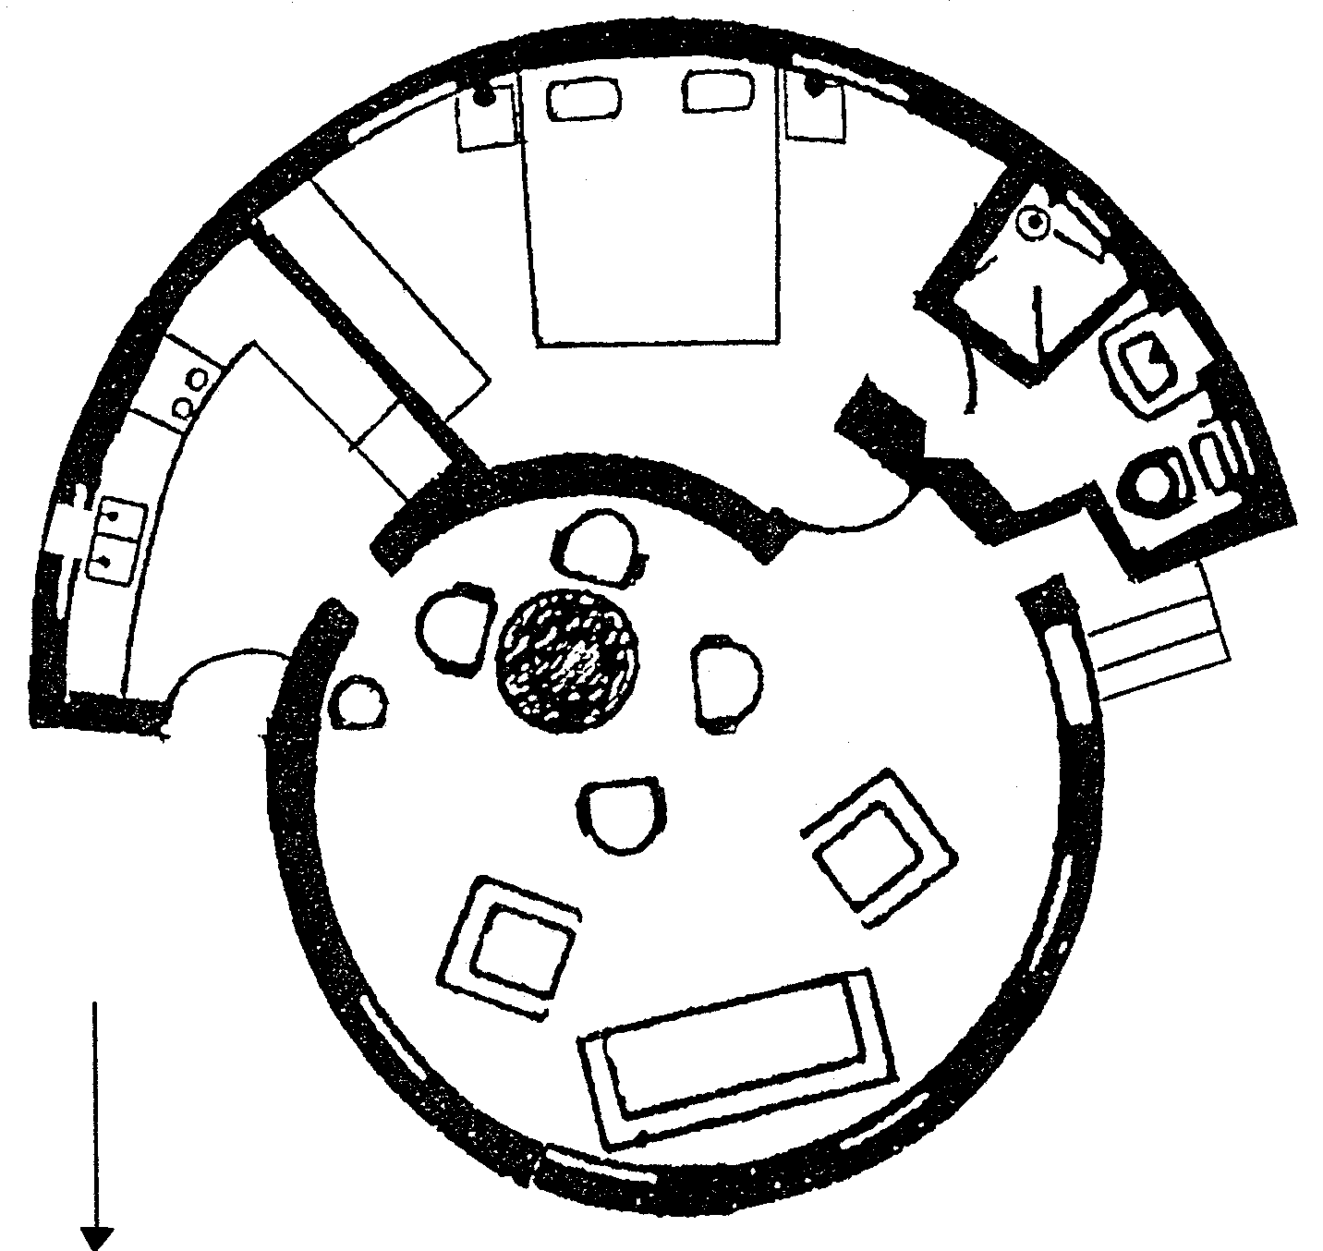
NORTH

6.1 Identify TWO different types of balance found inside the rondavel. Motivate your answer.

TYPE OF BALANCE | MOTIVATION
(4)

- Study the kitchen plan and identify the type of layout shown by the work triangle.  - Evaluate the traffic pattern in the:  - Kitchen  - Diningroom area  - Bedroom  - Suggest how the traffic pattern in the living area can be improved.  - Explain how provision can be made for extra sleeping space/facilities for when the children are home during the holidays. | (1)  (2)  (2)  (2)  (3)  (2)

Diagram B  EAST  WEST  THATCHED ROOF  BACK DOOR  FRONT DOOR  STAIRS  Outside  SOUTH  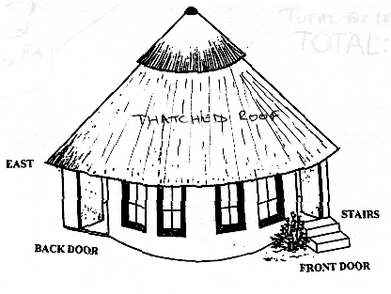  NORTH  - Study the diagram of the OUTSIDE of the rondavel.  - Give FOUR requirements that would ensure that the steps leading to the front door are safe.  - From the diagram, identify THREE factors that could contribute towards keeping the rondavel cool in the hot summer months.  - Suggest a monochromatic colour scheme for the bedroom and motivate your answer.  - 6.8.1 How could the bathroom be adapted to provide more space?  - Make useful suggestions for storage:  - In the bathroom to store extra toiletries while the children are at home during the holidays.  - For the children’s bedding while they are at school during the term.  - For the many books pertaining to farming and magazines they have so that they are easily available when needed.  - Name THREE ways in which family symbols can play a role in ensuring the unity of the family, especially as they are often separated for long periods.  - What FOUR factors will influence the distribution of tasks to the different family members during the holidays?  - The daughters are accepted into a group of young people in the farming community. What FOUR advantages are there to being included in a group?  total for section c:  TOTAL: | (4)  (3)  (2)  (1)  (3)  (3)  (4)  (4)  [40]  [80]  300

