GAUTENG DEPARTMENT OF EDUCATION

SENIOR CERTIFICATE EXAMINATION

HISTORY SG
(Second Paper: South African History)

TIME: 2½ hours

MARKS: 150
INSTRUCTIONS:

- This paper consists of TWO sections, namely Section A and Section B.

- Answer any TWO essay type questions from Section A.

- Section B is COMPULSORY. Answer ALL the questions in this section.

- All questions and subsections must be numbered correctly.

- You should spend 50 minutes on each of the three questions.

SECTION A  ESSAY QUESTIONS  Answer any TWO of the following essays. You should spend approximately 45 to 50 minutes on EACH essay.  QUESTION 1  Discuss how coalition and fusion between the National Party and the South African Party came about in 1933 and 1934. | [40]

QUESTION 2  Explain the events leading to dissatisfaction in the United Party in 1938 and how the outbreak of the Second World War (1939) contributed to a major split in the United Party. | [40]

QUESTION 3  Discuss the steps which the government took between 1951 and 1956 to have the Coloureds placed on a separate voters roll, as well as the resistance to it. | [40]

QUESTION 4  Discuss the consequences of the policy of apartheid between 1960 and 1964 under the following headings:  - Sharpeville (1960)  - The formation of Umkhonto we Sizwe and POQO  - The Rivonia trial and the government response | [40]

TOTAL FOR SECTION A: | [80]

SECTION B

SHORT AND INTERPRETATIVE QUESTIONS – 1948 TO 1976

QUESTION 5

This question is COMPULSORY. All sections must be answered. Spend approximately 50 minutes on this question.

5.1 Answer the following questions by writing down the correct letter next to the corresponding number in your answer book.

    - The leader of the opposition after the May 1948 election was

- Smuts.
- Hofmeyr.
- Strauss.
- De Villiers Graaff.

    - The person who introduced the bill to remove the Coloured vote from the common voters’ roll was

- Malan.
- Strijdom.
- Dönges.
- Verwoerd.

    - Heavy opposition to South Africa remaining in the Commonwealth in 1961 came from

- Britain.
- Canada.
- Australia.
- New Zealand.

    - The Bantu Authorities Act

- gave black homelands more powers than previously.
- put the Governor-General in charge of the homelands.
- took away black representation in parliament.
- allowed homelands to become independent.

    - The Freedom Charter was signed in

- Soweto.
- Uitenhage.
- Sharpeville.
- Kliptown.

    - The people who were tried for treason were

- some of those who had signed the Freedom Charter.
- the leaders of the defiance campaign.
- the organisers of the Sharpeville demonstration.
- those who planned the Soweto uprising.

    - A well-known leader who unexpectedly attended the All-In Africa Conference :

- Albert Luthuli
- Nelson Mandela
- Oliver Tambo
- Robert Sobukwe

    - The result of the Rivonia trial was:

- The banning of the ANC and the PAC
- The flight of Oliver Tambo to London
- Life sentences for many ANC leaders
- The declaration of a state of emergency

    - The policy of separate development was promoted by _______ in 1959.

- Verwoerd
- Vorster
- Strijdom
- Malan

- The Soweto uprising of 1976 took place on  - 21 March.  - 16 June.  - 9 August.  - 16 December. | 10x2=[20]

5.2 Find a matching item in Column B for each of the items in Column A. Write the correct letter from Column B next to the corresponding number from Column A in your answer book.

COLUMN A |  | COLUMN B
5.2.1 | Oliver Tambo | A. | First leader of the Progressive Party
5.2.2 | A.B. Xuma | B. | First leader of the PAC
5.2.3 | J.G. Strijdom | C. | Leader of the United Party
5.2.4 | B.J. Vorster | D. | First State President
5.2.5 | Jan Steytler | E. | Assassination of Verwoerd
5.2.6 | J.G.N. Strauss | F. | Prime Minister during the Soweto uprising
5.2.7 | Dimitri Tsafendas | G. | Removal of the Coloured vote
5.2.8 | C.R. Swart | H. | Rivonia Trial
5.2.9 | Braam Fischer | I. | ANC leader in the 1940s
5.2.10 | Robert Sobukwe | J. | Leader of the ANC in exile | 10x2=[20]

5.3 Are the following statements TRUE of FALSE?  - The ANC and PAC were banned after the Sharpeville shootings.  - The Freedom Charter was a result of the outcome of the Treason Trial.  - The Separate Amenities Act restricted the number of blacks who could live on white premises.  - The ANC headquarters of “Umkhonto we Sizwe” were originally at Liliesleaf Farm.  - Many young blacks left the country after 1976 to train as guerilla fighters. | [5]

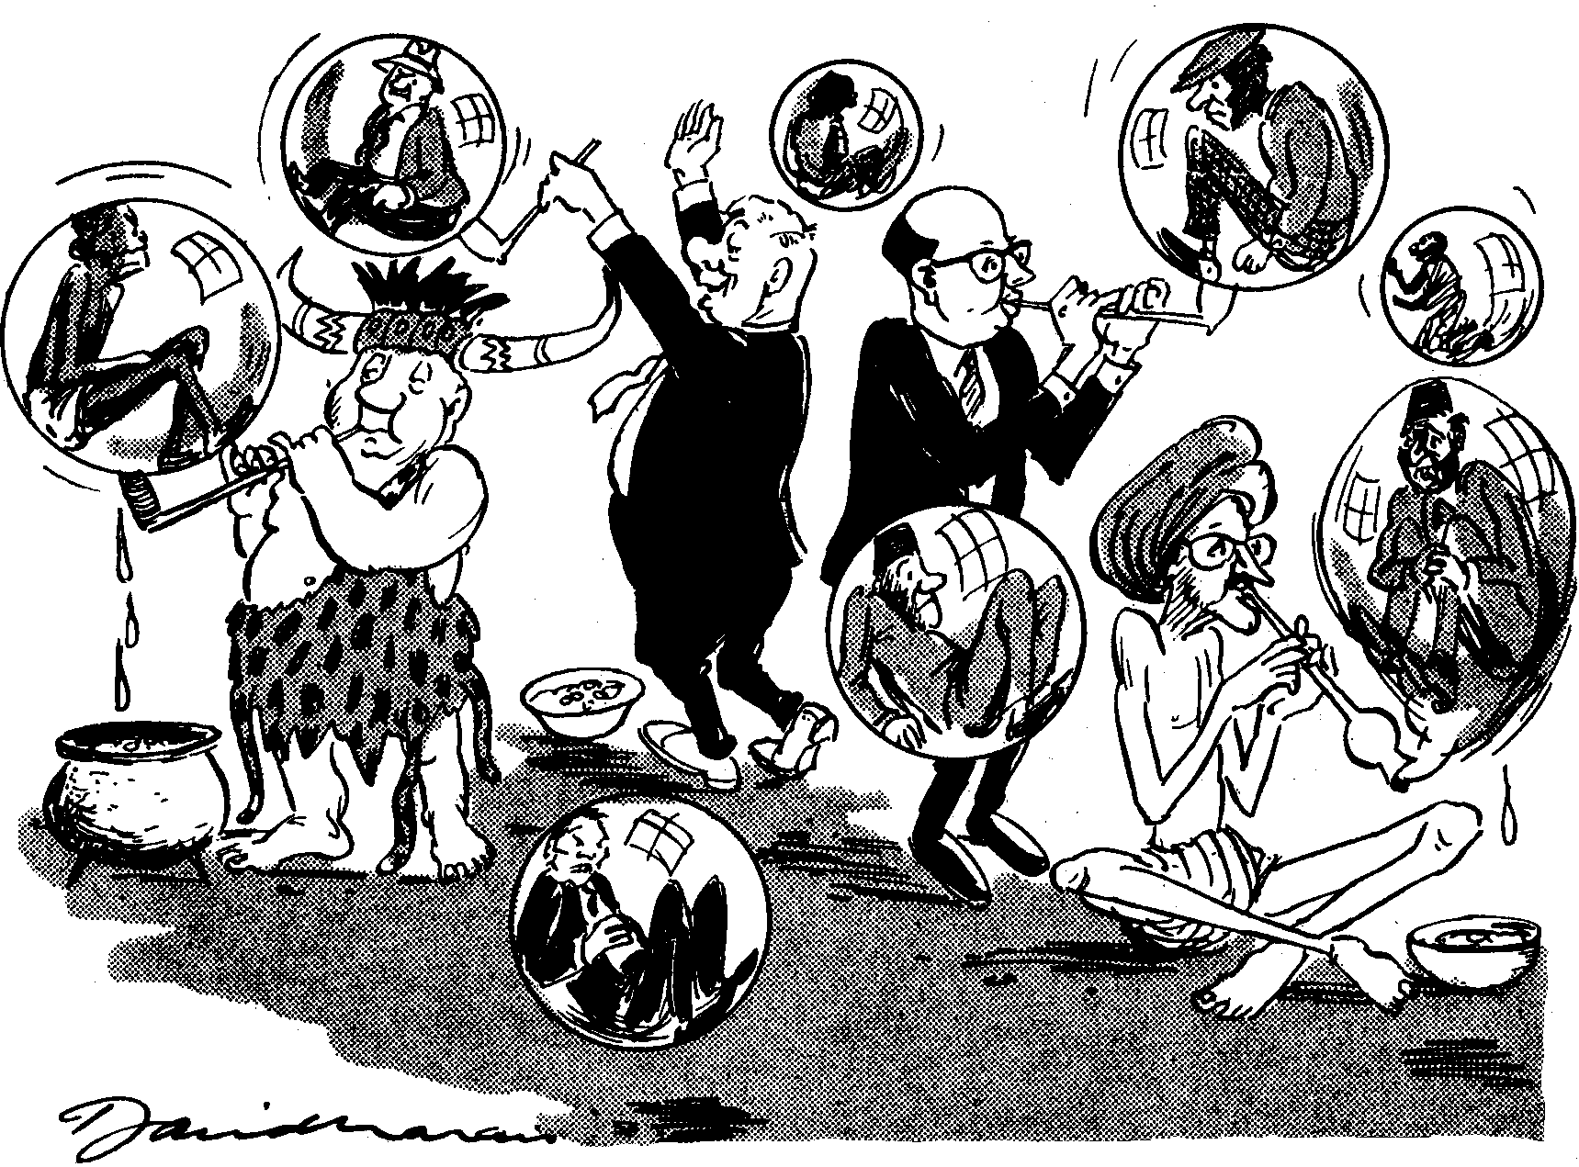
5.4 Examine the cartoon below and answer the questions that follow:

“ A sphere for everybody, and everybody in his own sphere!”

Cape Times, 15 Feb. 1962

- Explain what is being shown in the cartoon.  - What is the attitude of the cartoonist towards the subject matter? Motivate your answer. | (6)  (4)  [10]

5.5 Read the passage below and answer the questions that follow:

“By 1975, black schools in urban areas were seriously overcrowded. The schools were also poorly equipped, with few facilities, a shortage of textbooks and too few classrooms and desks to accommodate the students. At the same time, the South African economy was in a bad state. Unemployment increased and black matriculants could not find jobs.

In 1975, the government said that half of the subjects from Standard 5 had to be taught through the medium of Afrikaans. This was an unpopular decision. Black students were now forced to learn two new languages – Afrikaans and English. Afrikaans was seen as the language of the students’ oppressors.

On 16 June 1976, the day that Afrikaans was to be enforced in schools, students took to the streets and protested. In Soweto, students started marching to Orlando stadium. By the time they reached Orlando, the crowd numbered over 20,000. The police shot a tear-gas canister into the crowd without warning, killing and injuring the protestors.

The uprising spread rapidly from Soweto to townships throughout South Africa. Students clashed with the police and set fire to Bantu Affairs buildings, schools, state-owned beer halls, liquor stores, white-owned businesses and cars. In the first week of unrest, 170 students were killed. This number rose to 600 by the end of the year.

Thousands of students fled into exile in other parts of Africa, where many of them joined the liberation armies of the ANC and PAC.”

Taken from Apartheid and Resistance by Hanifa Dhansay, p. 22, (Macmillan).

- What problems faced black schools in 1976?  - What other problems faced black South Africans in the economy?  - Explain in your own words the problems which the new language regulations caused in schools.  - Why did the police shoot into the crowd?  - What was the result of the shooting?  - Explain the results of the 1976 uprising. | (3)  (2)  (2)  (3)  (2)  (3)  [15]

TOTAL FOR SECTION B: | [70]

TOTAL: | 150

