GAUTENG DEPARTMENT OF EDUCATION

SENIOR CERTIFICATE EXAMINATION

HISTORY SG
(Second Paper: South African History)

TIME: 2½ hours

MARKS: 150
INSTRUCTIONS:

- This paper consists of TWO sections, namely Section A and Section B.

- Answer any TWO essay-type questions from Section A.

- Section B is COMPULSORY. Answer ALL the questions in this section.

- All questions and subsections must be numbered accurately.

- You should spend about 50 minutes on each of the three questions.

SECTION A

ESSAY QUESTIONS

Answer any TWO of the following essays. You should spend approximately 45 to 50 minutes on EACH essay.

QUESTION 1

Discuss the success of the Pact government between 1924 and 1929 under the following headings:

- Recognition of Afrikaans  - The flag issue  - Imperial Conference (1926) and the Balfour Declaration  - The Department of Foreign Affairs | [40]

QUESTION 2  Explain how coalition and fusion resulted in Malan forming the Purified National Party. Discuss the relevant events of 1933 and 1934 in your answer. | [40]

QUESTION 3  Discuss the resistance to the policy of apartheid under the following headings:  - Programme of Action  - Defiance Campaign  - Freedom Charter  - Treason Trial  - Formation of the PAC | [40]

QUESTION 4  Discuss how Verwoerd led South Africa to become a republic and how he withdrew South Africa from the Commonwealth. Discuss the resistance towards these actions of Verwoerd. | [40]

TOTAL FOR SECTION A: | [80]

SECTION B

SHORT AND INTERPRETATIVE QUESTIONS – 1948 TO 1976

QUESTION 5

This question is COMPULSORY. All sections must be answered. Spend 50 minutes on this question.

5.1 Answer the following questions by writing down the correct letter next to the corresponding number in your answer book.

    - Malan’s political colleague in the 1948 general election victory was:

- Hertzog
- Havenga
- Pirow
- Van Rensburg

    - The Separate Representative Act of voters was finally passed under the premiership of

- Malan.
- Strijdom.
- Verwoerd.
- Vorster.

    - South Africa became a republic in

- 1960.
- 1961.
- 1964.
- 1965.

    - The Separate Amenities Act

- stopped Coloureds from using amenities in parliament.
- reserved certain amenities for specific population groups.
- allowed amenities to be shared amongst all races.
- prevented certain amenities being expanded to the homelands.

    - The Freedom Charter was signed

- in Kliptown, in 1955.
- in Cape Town, in 1961.
- in Pretoria, in 1968.
- in Soweto, in 1976.

    - The 1956 women’s march against the pass laws was conducted to

- Robben Island, in Cape Town.
- the Appeal Court, in Bloemfontein.
- the Union Buildings, in Pretoria.
- the State President’s official residence.

    - In 1964, a bomb was placed in the _______ station.

- Johannesburg
- Pretoria
- Cape Town
- Durban

    - The Sharpeville shooting incident occurred as a result of

- the government’s policy on “civilized labour”.
- an anti-pass demonstration.
- South Africa leaving the Commonwealth.
- the anti-republican movement.

    - Independence under apartheid was NOT obtained by the following homeland:

- Lesotho
- Venda
- Ciskei
- Kwazulu

- A major result of the Soweto uprising was:  - Many blacks left the country to train as guerrilla soldiers  - The government of Vorster negotiated with the ANC  - The Defiance Campaign was started  - The ANC exiles returned to the country | 10x2=[20]

5.2 Find a matching item in Column B for each of the items in Column A. Write the correct letter from Column B next to the corresponding number from Column A in your answer book.

COLUMN A |  | COLUMN B
5.2.1 | Robert Sobukwe | A. | ANC leader in the 1950s
5.2.2 | Helen Suzman | B. | United Party leader
5.2.3 | De Villiers Graaff | C. | Progressive Party
5.2.4 | Hendrik Verwoerd | D. | Defeated Smuts in 1948
5.2.5 | Steve Biko | E. | Head of POQO
5.2.6 | Nelson Mandela | F. | Black Consciousness
5.2.7 | Hector Petersen | G. | Rivonia Trial
5.2.8 | Potlako Leballo | H. | Soweto uprising
5.2.9 | James Moroka | I. | Leader of the PAC
5.2.10 | Daniël Malan | J. | Prime Minister of a Republic | 10x2=[20]

5.3 Are the following statements TRUE or FALSE?  - The Coloured vote in Parliament was removed by B.J. Vorster after the 1976 Soweto uprising.  - Harold Macmillan, British Prime Minister, made the “Winds of Change” speech in South Africa.  - The Immorality Act prevented white women from marrying black men.  - Sharpeville township outside Vereeniging was the scene of an anti-pass demonstration in March 1960.  - The first state president of the Republic of South Africa was Nelson Mandela. | [5]

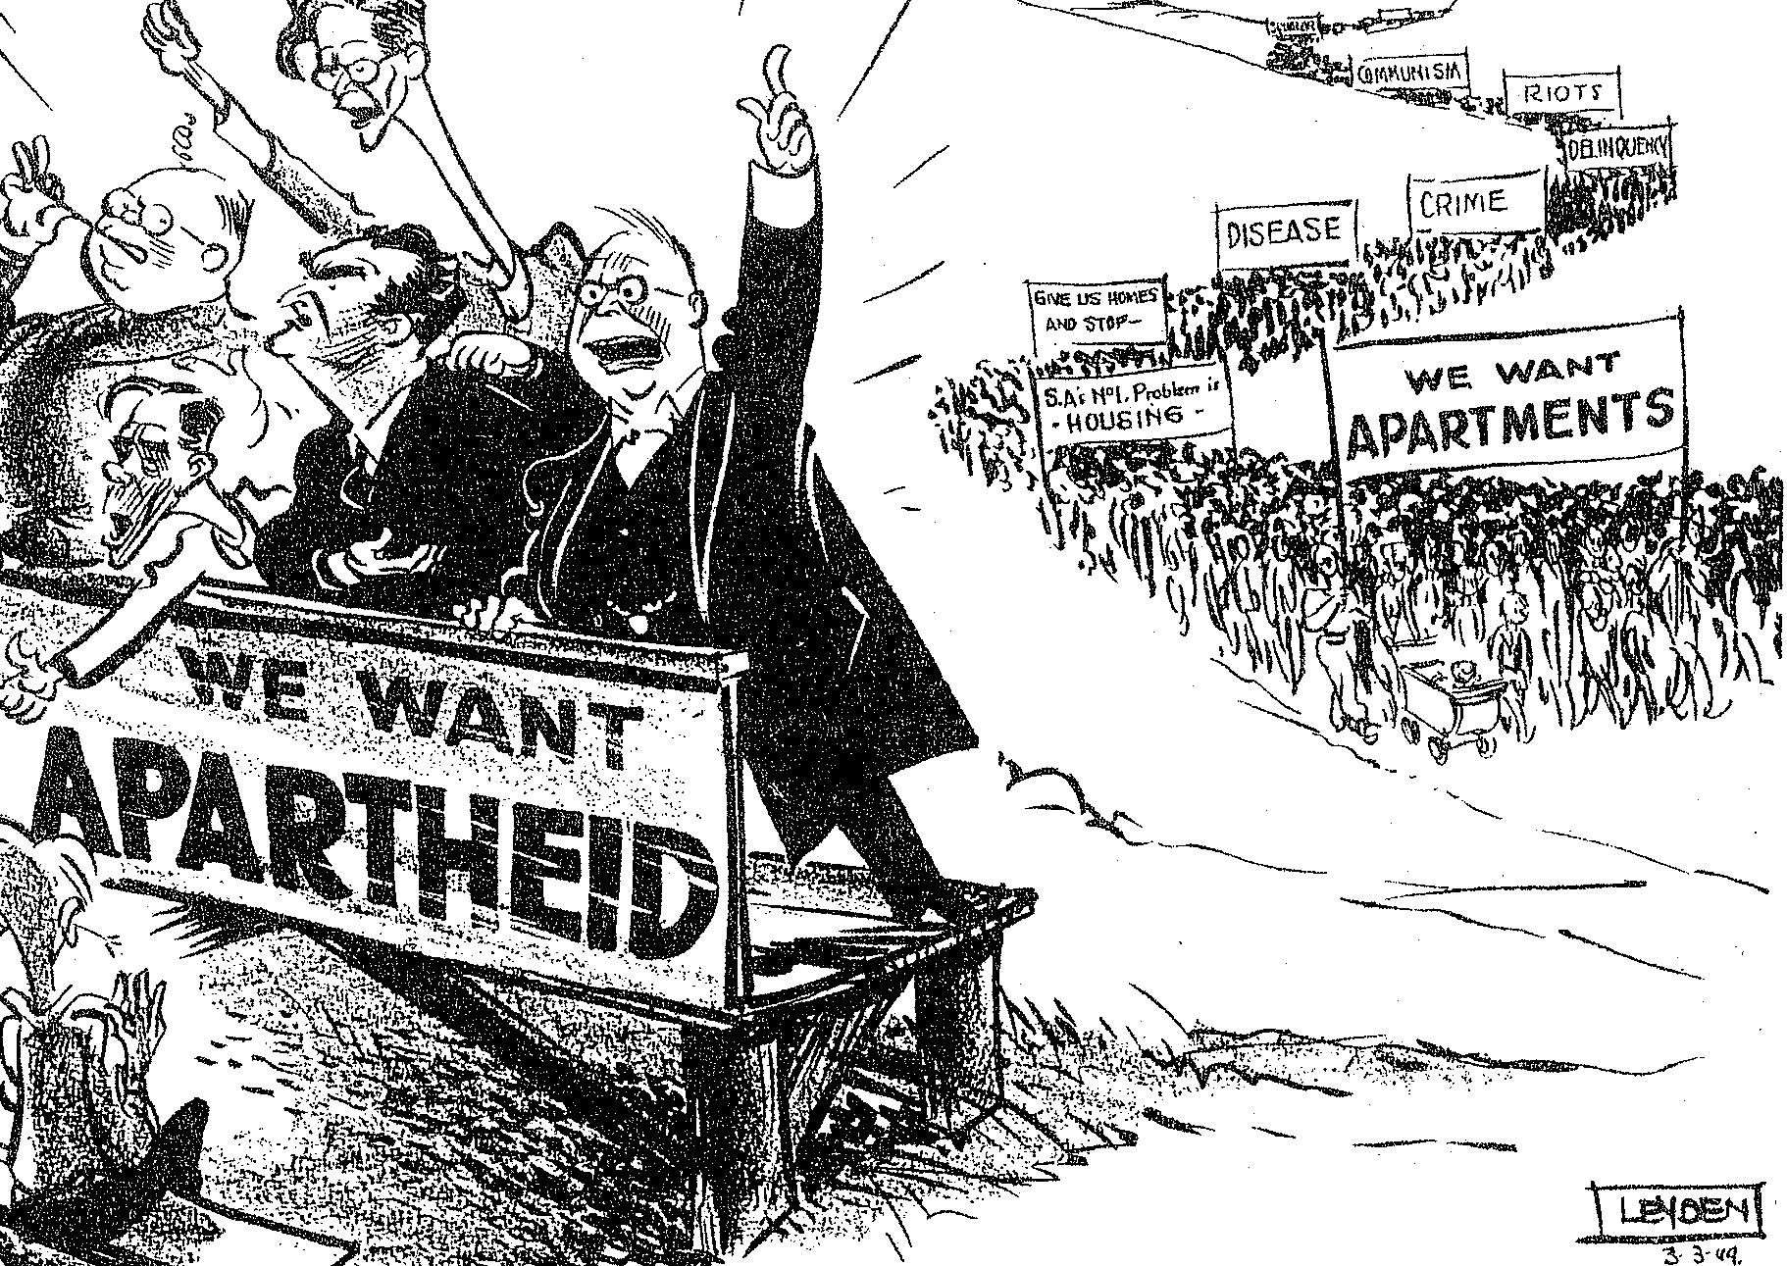
5.4 Examine the cartoon below and answer the questions that follow:

“There’s none so blind ...” Daily News, March 1949

- Which political party is represented by the men on the left?  - Name TWO important individuals who were members of this party in March 1949.  - Why were they so eager to implement apartheid?  - What does the demonstration behind them represent?  - Explain the difference in the numbers of people on the left and right sides of the cartoon.  - What is the meaning of the caption: “There’s none so blind....” with reference to the cartoon? | (1)  (2)  (2)  (2)  (2)  (2)  [11]

5.5 Read the passage below and answer the questions that follow:

“Have you heard of Lilian Ngoyi? During the 1950s, she appeared in news papers all over South Africa and in other parts of the world. She was also the president of the ANC Women’s League and the Federation of South African Women.

The anti-pass campaign of these two organisations brought together women of all races from all over the country. The pass laws were some of the most hated apartheid laws. These laws only allowed those Africans with passes to enter cities. Police could stop Africans in the streets of a city at any time and demand to see their pass books. If they did not have one, they were immediately jailed.

The National Party government extended the pass laws to women in 1952. But the parts of the act relating to women were only enforced from 1955. This meant that all African women were forced to register and carry passes. The passes meant that African women had to live and work in certain areas. The law forbade

them to bring their children to urban areas where they worked. So mothers and children were separated from each other for long periods of time.

Fedsaw and the ANCWL organised a march for 9 August 1956. On that day 20,000 women from all over South Africa marched to the government offices at the Union Buildings in Pretoria. When they arrived in Pretoria, the women found that the march had been banned. So they walked in small groups of twos and threes to the Union Buildings. A delegation of women, led by Lilian Ngoyi, went to deliver the anti-pass petitions to the Prime Minister, Mr J.G. Strijdom.

But Strijdom refused to see the women. So they left a huge pile of thousands of petitions outside his door. All the while, the women sang, “Strijdom, Wathinta abafazi, wathint’imbokodo”. Roughly translated, this means, “Strijdom, when you strike a woman, you strike a rock.”

The government arrested many of the Fedsaw leaders, but it was only years later, at the end of the 1960s that the government managed to force African women to carry passes.

Ever since 1956, women all over South Africa have held mass meetings on
9 August to remember the women’s march to Pretoria. Today, 9 August is a public holiday, known as National Women’s Day.”

Taken from Apartheid and Resistance by Hanifa Dhansay, p. 14, (Macmillan)

- Which organisations did Lilian Ngoyi head?  - Explain what was meant by the pass laws.  - Why did women become involved with the struggle against passes?  - What action did Lilian Ngoyi and other women undertake to protest against the pass laws? Describe this action.  - Why did the government refuse to meet with the women?  - What is meant by : “When you strike a woman, you strike a rock”?  - How is this 1956 event still remembered? | (2)  (2)  (2)  (3)  (2)  (2)  (1)  [14]

TOTAL FOR SECTION B: | [70]

TOTAL: | 150

