GAUTENG DEPARTMENT OF EDUCATION
SENIOR CERTIFICATE EXAMINATION

HISTORY SG
(First Paper: General History)

TIME: 2½ hours

MARKS: 150

INSTRUCTIONS:

- This paper consists of TWO sections:

- Section A consists of four essay questions. Candidates may answer ANY TWO essays. Do not use headings or memorandum style in your essay.

- Section B consists of COMPULSORY short questions. Candidates must answer ALL the short questions.

- The ADDENDUM (pages 16 to 19) contains information and illustrations which pertain to Section B. You are advised to detach the Addendum and place each page alongside the relevant question(s) for easy reference.

- Write as clearly and neatly as possible.

- Number ALL answers clearly and accurately.

SECTION A

ESSAY-TYPE QUESTIONS

Answer any TWO questions from this section. Use approximately 40 minutes to answer each question. Please remember to use the sources.

QUESTION 1

THE RISE OF THE SUPER POWERS: THE USSR

In order for the Soviet Union to catch up with the capitalist countries, Stalin argued that two major changes had to be made:

- Eliminate small farms by collectivising agriculture.
- Build up production in heavy industry (e.g. steel, chemicals).

- Discuss how the Soviet Union carried out the agricultural policy of collectivisation under Stalin.  - List the positive and negative influences these changes had on the people of the Soviet Union. | (30)  (10)  [40]

Answer the questions with the help of the following sources:

A Centrally Planned Economy under Gosplan

“The Soviet Union was the first country to implement Socialism. It tried to do this by a centrally planned or command economy. The government controls nearly all major economic decisions and resources.”

“The way out lies in systematically increasing the yield of individual small- and middle-peasant farms. We cannot and should not lend any support to the individual large kulak farms.”

Stalin, 1929

“Tell me you wretched people, what hope is there for you if you remain on individual pieces of land? … Don’t you see that there is nothing ahead of you but ruin and starvation?”

Party official

 | Development of Soviet agriculture 1928 – 1940
 |  | 1928 | 1940
 | Grain  Potatoes  Collective farms  Households | 92 200 000 hectares  5 700 000 hectares  400 000 | 110 500 000 hectares  7 700 000 hectares  18 750 000
 |  | 1916 | 1941
 | Cows  Sheep and goats | 29 000 000  96 000 000 | 28 000 000  92 000 000
“Stalin, ignoring the great cost in human life and misery, claimed that collectivisation was a success; for, after the great famines caused at the time … no more famines came to haunt the Russian people. The collective farms, despite their inefficiencies, did grow more food than the tiny, privately owned holdings had done.”

E. Roberts, Stalin, Man of Steel, 1986

“Nothing strikes the visitor to the Soviet Union more forcibly than the lack of fear. No fear of not having enough money at the birth of a child. No fear of doctor’s fees, school fees, or university fees. No fear of underwork, no fear of overwork. No fear of wage reduction in a land where none is unemployed.”

Dr Hewlett Johnson, Dean of Canterbury Cathedral, visiting the USSR in 1939

“Whoever heard of such a thing – to give up our land and our cows and our tools and our buildings to work all the time and divide everything with others? Nowadays members of the same family get in each other’s way and quarrel and fight, and here we strangers are to act as one family.”

Peasant farmer

“The countryside became the theatre of undeclared civil war. The peasants tenaciously clung to their property, attacked and killed party commissars, slaughtered cattle, burned barns and stables and buried or destroyed whole harvests of grain. The (secret) police replied with mass executions and mass deportations. Mammoth concentration camps were set up in the enormous desolate plains of Siberia and in the icy wastes of the Far North.”

German historian, 1966

“How are things with you?” I asked one man. He looked around anxiously to see that no soldiers were about. “We have nothing, absolutely nothing. They have taken everything away.”

The Manchester Guardian, 25th March 1933

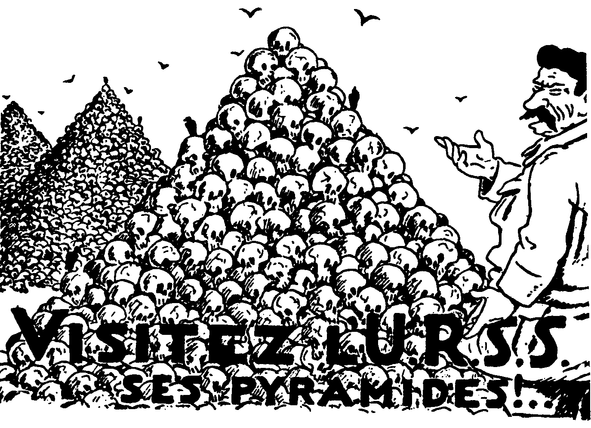

Poster made by Russian Exiles in France in the late 1930s:
“Visit the USSR’s Pyramids”

QUESTION 2

THE RISE OF THE SUPER POWERS: THE UNITED STATES OF AMERICA

- Discuss the so-called Seven Fat Years or Roaring Twenties in the American economy between 1922 and 1929.  - List the basic weaknesses in this period with the help of the following source material. | (30)  (10)  [40]

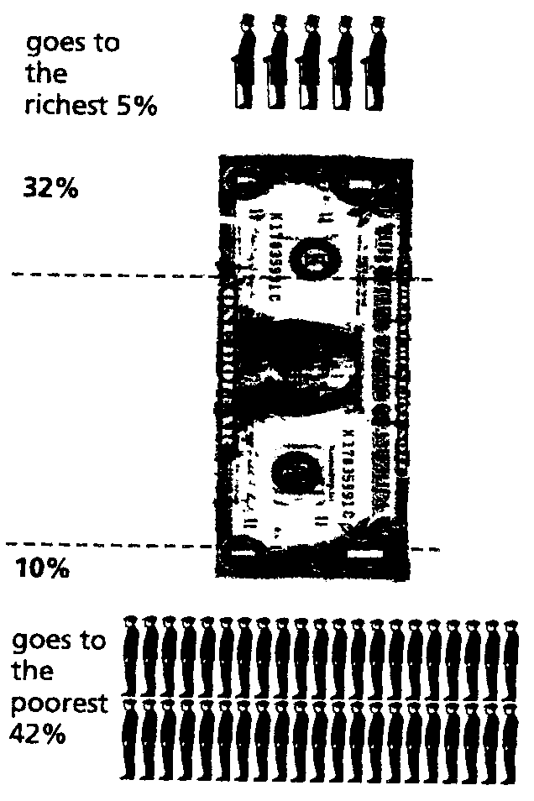
The distribution of income in 1925

“America’s black population was particularly badly hit. They had always done the least skilled jobs in the rural areas. As they lost their jobs on the farms, three-quarters of a million of them joined the ranks of the unemployed.”

Ben Walsh, historian, 1996

“The boom years of the early 1920s was a great time for speculators. During this time, dividends increased by 65% (remember wages increased only by 8%). This was a time of great success for speculators … In the 1920s … many people bought shares – sometimes even people who had never owned shares before.”

“What’s more, throughout this period, unemployment remained a problem. The growth in industry in the 1920s did not create many new jobs. Industries were growing by electrifying or mechanising production.”

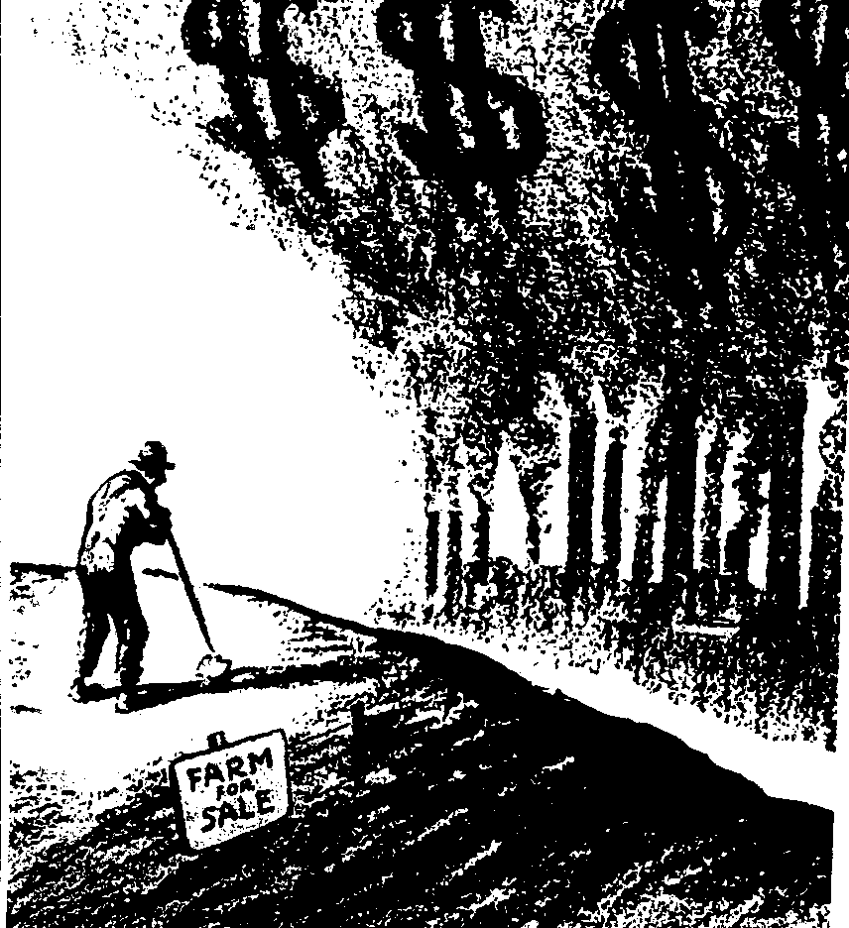

A cartoon showing problems faced by American farmers in the 1920s

“Among semi-skilled workers only three in every hundred owned a car … The poor whites did not benefit much from the new chain stores. Nearly all of them were in middle-class districts.”

QUESTION 3

- Describe how the Soviet Union gained control over Eastern Europe and managed to maintain it from 1945 to 1955. Refer to the following in your essay:  - Yalta Conference  - Potsdam Conference  - Establishment of the Cominform  - The First Berlin Crisis  - Establishment of the German Democratic Republic (GDR)  - Second Berlin Crisis  - Establishment of the Warsaw Pact  - Use the sources below to list FIVE aims of Stalin after the conclusion of the Second World War. | (35)  (5)  [40]

Stalin, proposing a toast at a dinner at the Yalta Conference, 1945:

“I want to drink to our alliance, that it should not lose its … intimacy, its free expression of views … I know of no such close alliance of three Great Powers as this … May it be strong and stable, may we be as frank as possible.”

Milovan Djilas writing about Yalta:

“In the hallway (at Yalta) we stopped before a map of the world on which the Soviet Union was coloured in red. Stalin waved his hand over the Soviet Union and exclaimed, ‘They will never accept the idea that so great a space should be red, never, never!’”

Churchill writing to Roosevelt shortly after the Yalta Conference:

“The Soviet Union has become a danger to the free world. A new front must be created against her onward sweep. This front should be as far east as possible. A settlement must be reached on all major issues between West and East in Europe before the armies of democracy melt.”

Stalin speaking about the take-over of Eastern Europe:

“This war is not as in the past; whoever occupies a territory, also imposes on it his own social system. Everyone imposes his own system as far as his army has power to do so. It cannot be otherwise.”

Winston Churchill speaking in the USA, March 1946:

“A shadow has fallen upon the scenes so lately lighted by the Allied victory. From Stettin on the Baltic to Trieste on the Adriatic, an iron curtain has descended. Behind that line lie all the states of central and eastern Europe. The Communist parties have been raised to power far beyond their numbers and are seeking everywhere to obtain totalitarian control. This is certainly not the liberated Europe we fought to build. Nor is it one which allows permanent peace.”

Stalin’s reply to Churchill’s speech:

“The following circumstances should not be forgotten. The Germans made their invasion of the USSR through Finland, Poland and Romania. The Germans were able to make their invasion through these countries because, at the time, governments hostile to the Soviet Union existed in these countries. What can there be surprising about the fact that the Soviet Union, anxious for its future safety, is trying to see to it that governments loyal in their attitude to the Soviet Union should exist in these countries?”
From: Ben Walsh – Modern World History

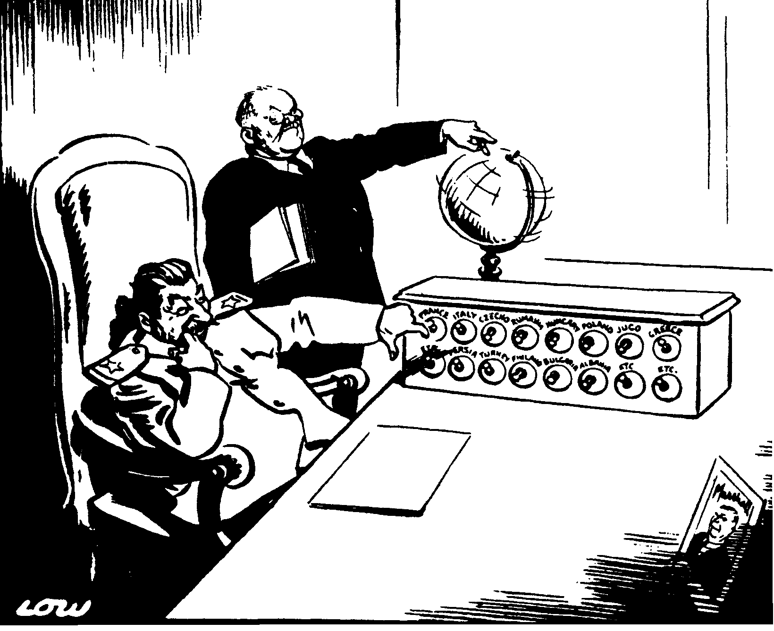

Who’s next to be liberated from freedom?

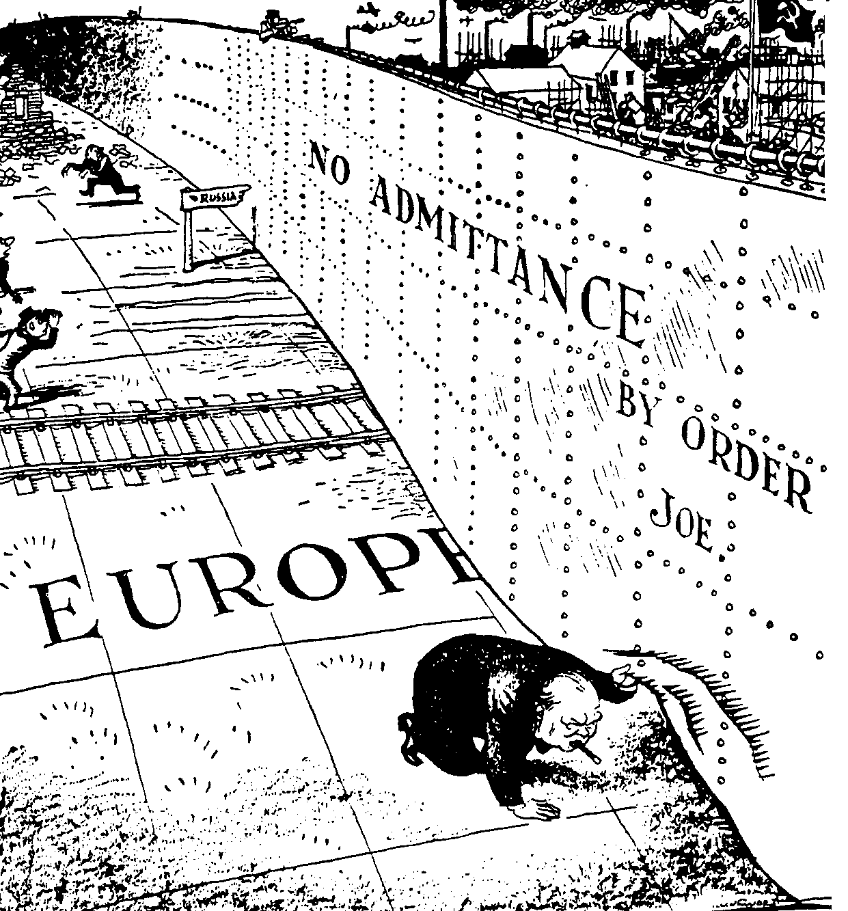

Peep under the iron curtain

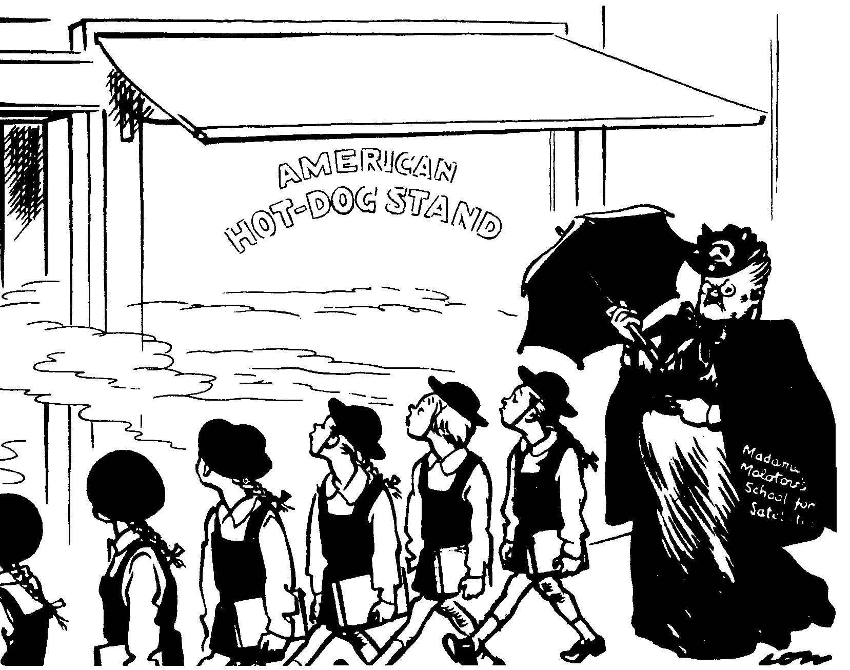

Madam Molotov’
School for
Satellites

Noses Left!

QUESTION 4

- Explain the role of the Peoples’ Republic of China in Africa after 1945.  - Use the sources below to list FIVE aims of the Super Powers and more specifically China, in Africa. | [40]

THE INVOLVEMENT OF WORLD POWERS IN AFRICA

A Gavshon, Crisis in Africa – Battleground of East and West:

“The objectives of East and West were essentially selfish and contributed little to the urgent need for stability in the region. The consequence of escalating tension was a full-scale arms race in a continent crying out for socio-economic and not military development.”

A Gavshon, Crisis in Africa – Battleground of East and West:

“They had to recognise that hungry Africans could no more eat bullets, than they could cure their rampant disease with doses of anti-communist or anti-capitalist medicine.”

A Gavshon, Crisis in Africa – Battleground of East and West:

“East and West were using aid to advance or preserve their own interests and to score national or ideological gains.”

To the Point:

“They arrive in Dar-es-Salaam harbour by the hundreds, in Chinese ships, all dressed in identical baggy uniforms with peaked caps and wearing Mao badges, looking for all the world like so many automatons of an assembly line.”

A Gavshon, Crisis in Africa – Battleground of East and West:

“Life in the bush entailed hardship and tremendous stamina. The Chinese lived at levels no higher than those of the Africans, in tents or huts or in the open. Preparing their own meals, cultivating vegetables when they were static, requiring their co-workers to do nothing they themselves would shirk. They transmitted their know-how and experience freely, without arrogance, training loco-drivers, welders and surveyors as they went along.”

A Gavshon, Crisis in Africa – Battleground of East and West:

“In an age of energy shortages and nuclear development; whether for civil or military use, and of technological advances, Africa’s oil, uranium, cobalt, phosphates and other scarce minerals possessed great importance.”
Boyce, A.N.: The Modern World and South Africa

TOTAL FOR SECTION A: | [80]

SECTION B

COMPULSORY

Information and illustrations pertaining to Section B are to be found in the Addendum on page 16 to 19. Please detach the Addendum for easy reference.

QUESTION 5

NON-ESSAY TYPE QUESTIONS

- Select the correct answer for each of the following. Write down only the correct letter against the corresponding number in your answer book, e.g. 5.1.1 A.  5.1.1 Fascist governments were opposed to _____ forms of government.  - autocratic  - despotic  - totalitarian  - liberal | (2)

- During Mussolini’s campaign in Abyssinia, the League of Nations  - remained neutral.  - used force of arms.  - applied sanctions.  - negotiated with Mussolini. | (2)

- Manchuria was a province of  - China.  - Russia.  - Japan.  - Finland. | (2)

- In 1924, the _____ was drawn up under the leadership of Britain and France as a basis for disarmament and the settlement of border disputes.  - Geneva Protocol  - Locarno Pact  - Kellogg-Briand Agreement  - Anti-Comintern Pact | (2)

- Britain and France declared war when Germany invaded  - Sudetenland.  - Austria.  - the Saar.  - Poland. | (2)

Select the item which does NOT fit in each of the following statements. Write down only the letter next to the corresponding number in your answer book.

- Results of the invasion of Abyssinia:  - The Stresa Front collapsed.  - Mussolini withdrew Italy from the League of Nations.  - The League of Nations showed that it was a strong organisation capable of protecting its member states.  - Mussolini and Hitler started working more closely. | (2)

- Members of the Berlin-Rome-Tokyo Axis:  - Russia  - Japan  - Italy  - Germany | (2)

- Education of the German Youth:  - Teachers had to support the Hitler regime.  - Private schools were subsidised.  - Anti-Semitism was propagated.  - German girls were not encouraged to go into higher education. | (2)

- The territory which was reoccupied by Germany in March 1936:  - Austria  - Saarland  - Alsace-Lorraine  - Rhineland | (2)

- Nazi leaders between 1933 and 1939:  - Stresemann  - Himmler  - Rosenberg  - Goebbels | (2)  [20]

5.2 Use Documents 1, 2, 3 and 4 to assist you in answering the following questions. Write down only the letter next to the corresponding number in your answer book.  - The war often referred to as Hitler’s war:  - The Seven Weeks’ War  - The Second World War  - The Third World War  - The First World War | (2)

- The emperor of Abyssinia who asked for protection from the League of Nations:  - Victor Emmanuel III  - Kwame Nkrumah  - Rudolph Hess  - Haille Selassie | (2)

- Hitler asserted that the German nation had been stabbed in the back by the  - Treaty of Locarno.  - Kapp-Putch.  - Treaty of Versailles.  - Dawes Plan. | (2)

- A referendum can be described as a/an  - special vote by the people of a nation.  - autocratic government.  - rule by the minority.  - special meeting of parliament. | (2)

- The Lytton Commission is associated with  - the Manchurian incident.  - the invasion of Abyssinia.  - a trade agreement.  - the Nine Power Treaty. | (2)  [10]

5.3. Find a matching item in Column B for each of the items in Column A. Write down only the question numbers in your answer book and next to each the letter from Column B that matches it. Use Documents 1, 2, 3 and 4 to assist you in finding some of the answers.
There are questions to which the answers are not in the documents.

COLUMN A | COLUMN B
5.3.1 Manchukuo | A. Powerful industrial group in Japan
5.3.2 Nuremberg Laws | B. Symbol of the Nazi party
5.3.3 Mussolini | C. Germany and Italy
5.3.4 Hitler | D. Austrian Chancellor
5.3.5 Kurt Schuschnigg | E. Führer
5.3.6 Rome-Berlin Axis | F. Japanese puppet state
5.3.7 Neville Chamberlain | G. Persecution of Jews
5.3.8 General Tojo | H. Il Duce
5.3.9 Swastika | I. Believed in policy of ‘appeasement’
5.3.10 Zaibatzu | J. Prime Minister of Japan in 1941

2 x 10 = | [20]

5.4 Use Documents 1 and 2, the Map and Cartoon 1 to answer the following questions:

- Which organisation could boys join at the age of ten?  5.4.2 At what age did boys join Hitler’s youth? | (1)  (1)

5.4.3 Which organisation could young men join after they left the army?  - Why did Hitler decide to rearm in 1935 specifically?  - What was the reaction of the Super Powers such as Britain and France to Hitler’s rearming?  - Which Continent appears on this map?  - Which TWO countries on the cartoon are represented by B and C?  - Country A could have been left out of the cartoon. Do you agree? Motivate your answer.  - Give the name of person C. | (1)  (1)  (1)  (1)  (2)  (1)  (1)  [10]
5.5 Use Document 3, 4 and Cartoon 2 to answer the following questions:  - Who supported Italy during the Abyssinian Campaign?  - Which agreement had its foundations laid during Mussolini’s visit to Hitler?  - What role did Germany play during the Abyssinian issue?  - Italy concluded the Stresa agreement with France and Britain in April 1935. With which Stresa member did she later clash?  - What was the treaty between Italy, Germany and Japan called?  - Name the countries which are represented by figures A to D in Cartoon 2.  - In which country was the Rome-Berlin Axis signed?  TOTAL FOR SECTION B:  TOTAL: | (1)  (1)  (1)  (1)  (1)  (4)  (1)  [10]  [70]  [150]

ADDENDUM

Please detach the Addendum (pages 16 to 19) and place alongside the relevant questions in Section B for easy reference.

DOCUMENT 1: ‘The fight for the mind of youth starts in the cradle’

The fight for the mind of youth starts in the cradle. The baby’s earliest fairy tales must be in accordance with Nazi ideas. The Führer is ‘the man sent from Heaven’, who triumphed over some evil people called the Allies and who started a long fight to kill the bad ogre – the Bolshevik – who is for ever trying to eat up honest little German children.  At the age of ten, each little boy gets a brown shirt … Henceforth he belongs to the ‘Young Folk’. The little girls will join the ‘Union of German Maidens’ … Little boy and girl alike are pledged to sacrifice everything for the Führer and are taught that he is everything and themselves nothing. After four years of this, the boy of fourteen joins the Hitler Youth, the outward symbol of his promotion being the change to brown shirts and the presentation of a red swastika arm-band as worn by adult members of the Brownshirt organisation. Henceforth he is a Storm Trooper in miniature … |  | When grown up, the boy goes to camp for six months, compulsory labour service, … in the fields. This is followed by two years’ service in the army as a conscript, but, by the time the army gets hold of him, he is saturated with Nazi ideology … After leaving the army, our young man may become a member of the Brown or Blackshirts, first on the active list and later with the reserves …  It would be foolish to underestimate the enthusiasm of young Germany for their Führer. All other interests are disappea-ring, and it would be misleading to think that the religious bodies … are holding their own with the children. Again and again in Germany, even in Catholic Bavaria and the Black Forest, I found cases of children whose Roman Catholic parents tried to keep them in the few struggling church societies that still exist for children. In every case the children wanted to join the Hitler Jugend.

DOCUMENT 2

Hitler was determined to rearm his country. A conference in February 1932 with the aim of disarming was a failure. The most troublesome matter was Germany’s demand for equal treatment, which would mean a threat to France’s safety. Germany eventually withdrew from the conference and later when Hitler became the German chancellor he also withdrew from the League of Nations. This was to allow him greater freedom to ignore the stipulations of the Treaty of Versailles. In 1935 Hitler decided to reinstate military service but declare that it was only for the purpose of defence aiming to keeping peace.

DOCUMENT 3: Benito meets Adolf. Mrs Mussolini remembers.

Three years elapsed before Mussolini and Hitler met again. Their second encounter occurred in Germany. By now Hitler fully understood the true meaning of Mussolini and Fascism. When, after the Abyssinian campaign, the League of Nations imposed sanctions on Italy, Hitler alone offered economic and political aid and was the first to recognise the Empire. The Führer had made a profitable investment … For the Duce remembered this support when Hitler made overtures for an alliance. It was a determining factor, plus the vision of what such an alliance could achieve against Bolshevism – already graphically seen in the Italian-German intervention in the Spanish War.  The wind seemed set fair for Benito’s visit to |  | Germany. He left Rome on 23 September 1937, expecting a cordial welcome; he returned overwhelmed. In those five days, Hitler was his constant companion, attending to his slightest needs. He ensured that Benito had the hard pillow he liked to sleep on … Nothing was overlooked – right down to the flowers in the Duce’s room and the train stops to allow adequate rest … The visit reached a climax in Berlin with one vast demonstration after another … Hitler, realising that his show of strength had impressed the Duce and anxious to strike while the iron was hot, immediately laid the foundations of an agreement which was to become the Pact of ‘Steel’.

DOCUMENT 4

By 1936, three of the world’s most powerful military countries found themselves outside the illustrious world body, the League of Nations. And it was unavoidable that these three countries would co-operate. As we know, Germany and Japan had already concluded a treaty earlier. At first Germany and Italy were divided on the Austrian question, because the unification of Germany with Austria would only mean a stronger Germany on the north border of Italy. But as a result of the Abyssinian question Mussolini changed his mind so that in 1937 he visited Germany and concluded the so-called Rome-Berlin Axis treaty.

MAP

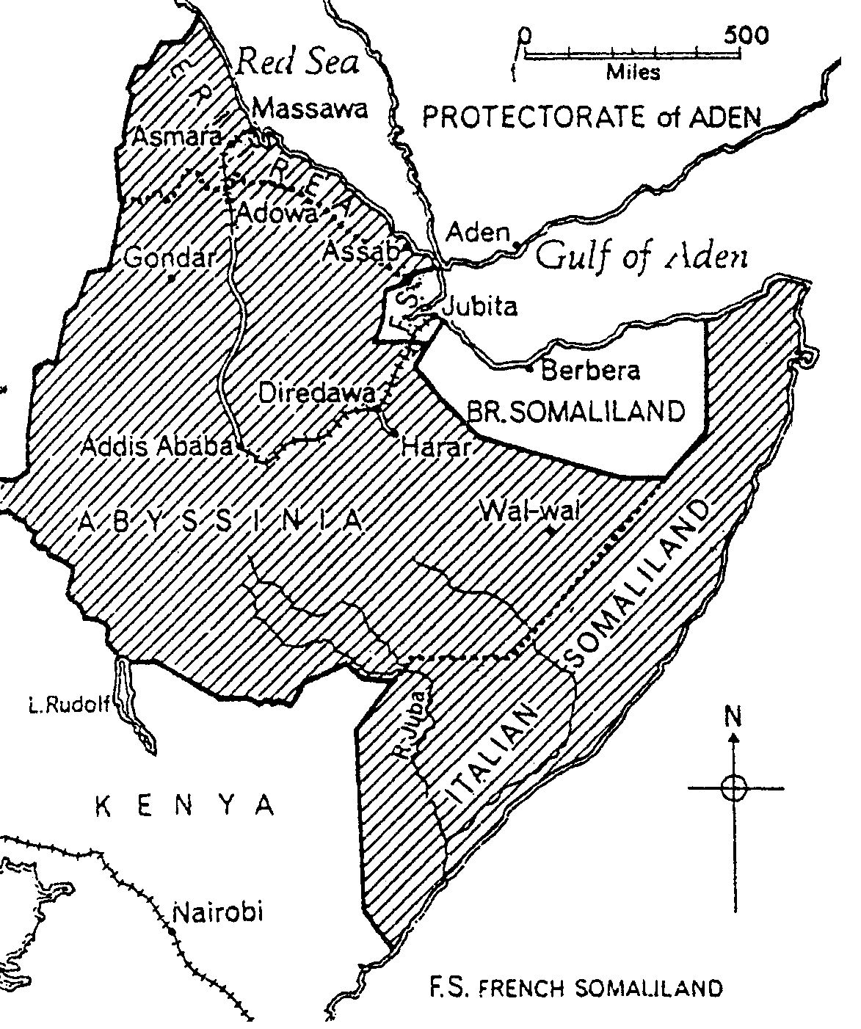
SUDAN

CARTOON 1
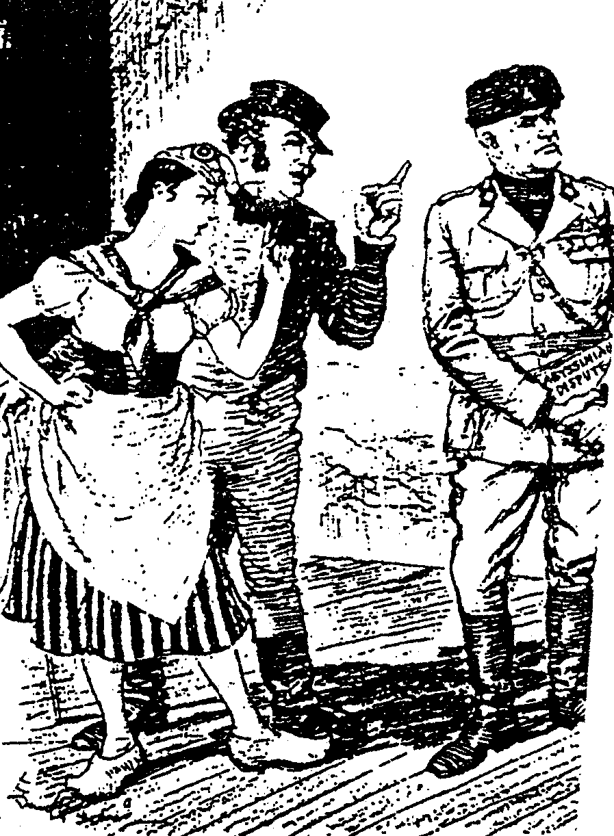

A
B
C

THE WARNING

Roestorff, Schnetler: “Mastering General History”

CARTOON 2
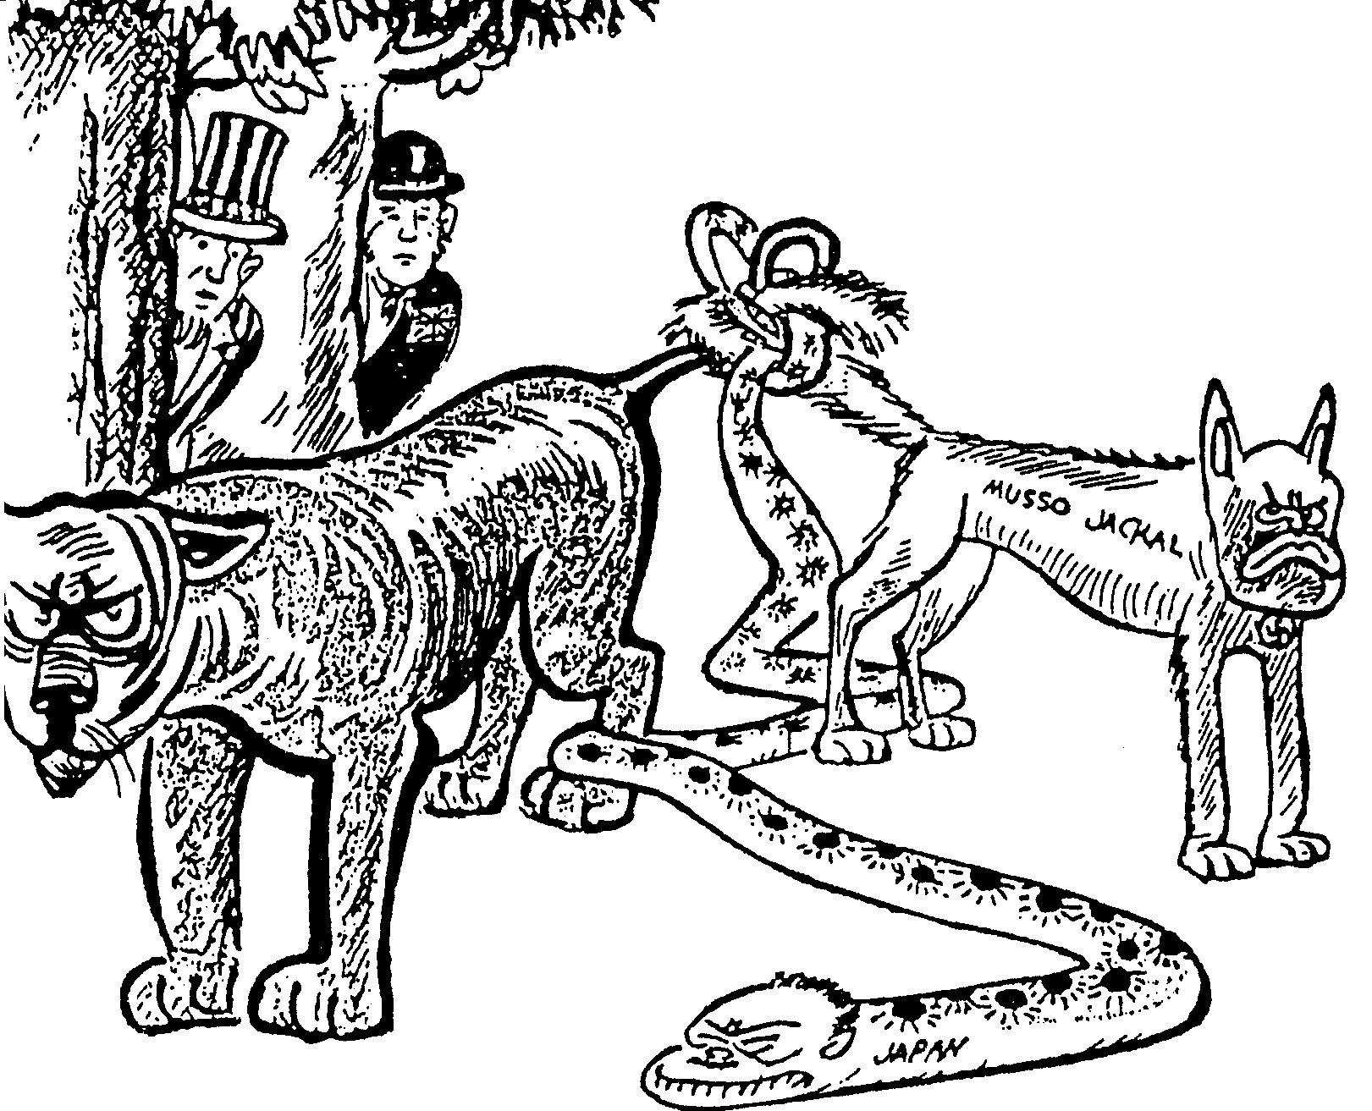
A
B
C

D

E

Malan, Appelgryn, Theron: “New History to the Point, Std 10”

