GAUTENG DEPARTMENT OF EDUCATION
SENIOR CERTIFICATE EXAMINATION

HISTORY SG
(First Paper: General History)

TIME: 2½ hours

MARKS: 150

INSTRUCTIONS:

- This paper consists of TWO sections:

- Section A consists of four essay questions. Candidates may answer ANY TWO essays. Do not use headings or memorandum style in your essay.

- Section B consists of COMPULSORY short questions. Candidates must answer ALL the short questions.

- The ADDENDUM (pages 16 to 19) contains information and illustrations which pertain to Section B. You are advised to detach the Addendum and place each page alongside the relevant question(s) for easy reference.

- Please write clearly and neatly.

- Number ALL answers clearly and accurately.

SECTION A

ESSAY-TYPE QUESTIONS

Answer any TWO questions from this section. Use approximately 40 minutes to answer each question. Please remember to consult the source material.

QUESTION 1

THE RISE OF THE SUPER POWERS : THE USSR

“In terms of increasing production, the Soviet approach was very successful. By 1939, the Soviet Union was the second leading country in the world as far as heavy industrial production was concerned.”

1.1 Explain how Stalin went about achieving the above successes in the Soviet Union between 1928 and 1939. | (30)

Read the following sources

- What were the sacrifices that workers in the Soviet Union were expected to make in order to achieve the goals set out by Gosplan for the industries? | (10)  [40]

“Thousands of people were resettled in new towns and given training … At first working and living conditions in the industrial towns were at least as bad as they had been before the revolution, but gradually things improved. More and more facilities such as shops, clubs and hospitals were provided.”

Baker, historian, 1990

“In 1935, Alexei Stakhanov cut over a hundred tons of coal in six hours. It was a publicity stunt arranged with the help of other workers. The government made him into a ‘Hero of Socialist Labour’ and the propaganda machine encouraged all Soviet workers to become Stakhanovites.”

“Work in the Soviet Union is a duty. He who does not work, shall not eat.”

Soviet Constitution

“By the late 1930s, many Soviet workers had improved their conditions by acquiring well-paid skilled jobs and earning bonuses for meeting targets. Unemployment was almost non-existent. In 1940, the USSR had more doctors per head of population than Britain. Education became free and compulsory for all and Stalin invested huge sums in training schemes based in colleges and in the work place.”

“But on the other hand life was very harsh under Stalin. Factory discipline was strict and punishments were hard. Lateness or absences were punished by sacking, and that often meant losing your flat or house as well. To escape the hard work and hard discipline workers tried to move to other jobs, so the secret police introduced internal passports, which prevented free movement of workers inside the USSR.”

“On the great engineering projects such as dams and canals many of the workers were prisoners who had been sentenced to hard labour for being political opponents, or suspected opponents of Stalin, for being kulaks or Jews.”

Ben Walsh, Modern World History, 1998

“What were the results of the Five Year Plan after four years?”

- We did not have an iron and steel industry. Now we have one.
- We did not have a machine tool industry. Now we have one.
- We did not have a modern chemical industry. Now we have one.
- We did not have a big industry for producing agricultural machinery.
Now we have one.

Stalin speaking about the first Five Year Plan in 1932.

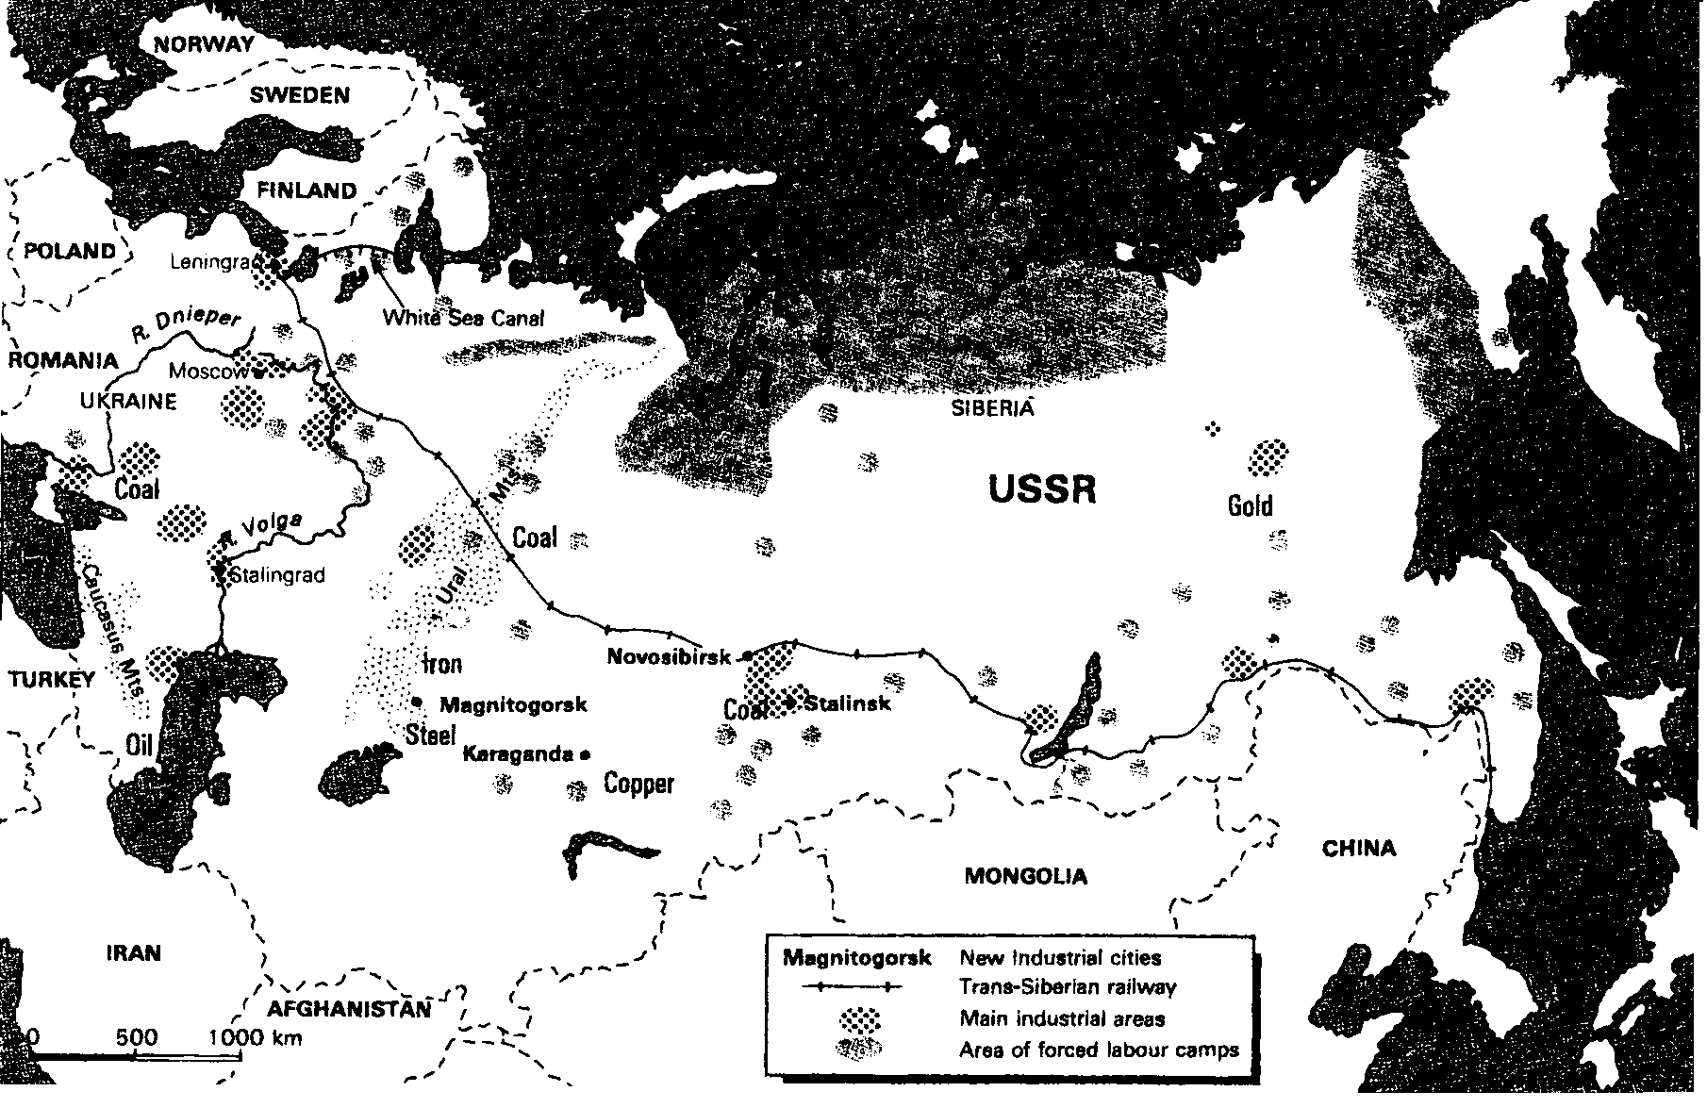

Industry in the USSR
under Stalin

QUESTION 2

THE RISE OF THE SUPER POWERS: THE UNITED STATES OF AMERICA

The American economy went through three distinct phases between 1922 and 1939, namely rapid growth, depression and recovery.  Explain the reasons for these three phases by referring to the events below, with the help of the source material provided.  - The post-war economic situation, 1918 to 1920  - The stock market crash, 1929 and the plight of the ordinary worker  - The presidential election of 1932 and the policy behind the New Deal up to and including the Hundred Days. | [40]

“As war-torn countries turned their factories over to the production of war goods such as guns, American factories experienced a high demand for ordinary goods and armaments. Industry thrived. Similarly, farmers produced more crops than the normal market needed so that the surplus could be shipped to Europe.”

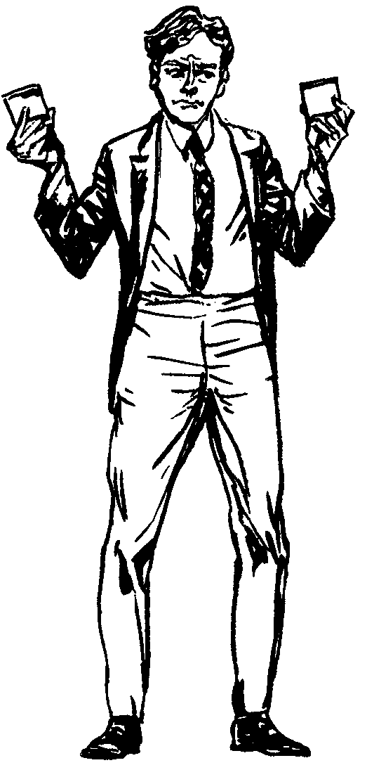
e.g. local item
= 20c
overseas import item
= 15c + tax of 10c
totals 25c (therefore
more expensive)

When such a practice is adopted, we speak
of ‘protectionist’ policies and a ‘tariff wall’.

“There is not an unemployed man in the country who hasn’t contributed to the wealth of every millionaire in America. The working class didn’t bring this on, it was the big boys … We’ve got more wheat, more corn, more food, more cotton, more money in the banks, more everything in the world than any nation that ever lived ever had, yet we are starving to death. We are the first nation in the history of the world to go to the poorhouse in an automobile.”

Will Rogers, an American writer, 1931

“People in the agricultural areas were the hardest hit by the Depression, because the 1920s had not been kind to them anyway. Huge farmers were unable to pay their mortgages … To make matters worse for farmers, over-farming and drought in the central southern states turned millions of acres into a dust bowl and had driven farmers off their land.”

Ben Walsh, historian, 1996

A cartoon by John McCutcheon, 1932. The man on the bench has lost all his savings because of a bank failure.

“But why didn’t you save some money for the future, when times were good?”
“I did”

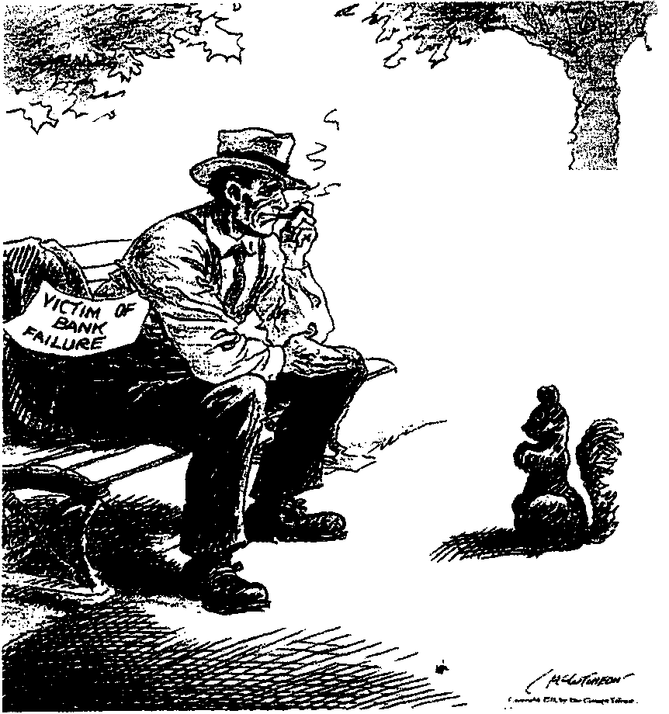

Unemployed workers queuing for a cheap meal.

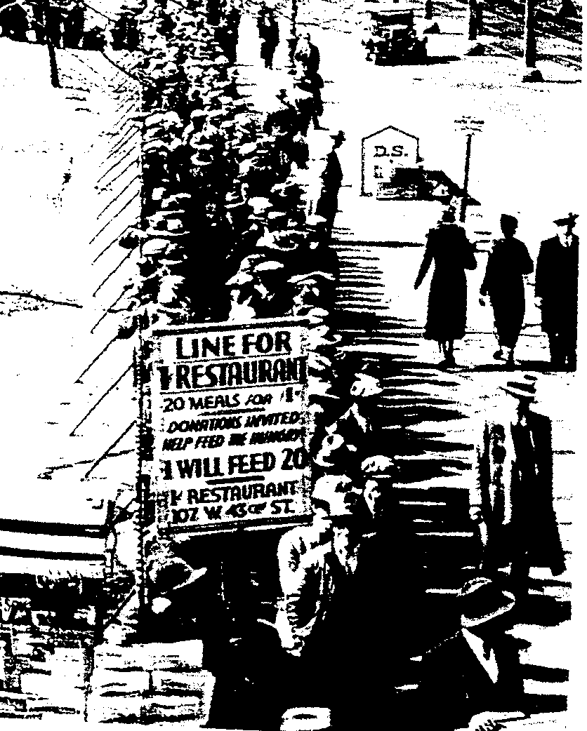

“The country needs … the country demands bold, persistent experimentation … It is common sense to take a method and try: if it fails, admit it frankly and try another. But above all, try something: The millions who are in want will not stand by silently for long …”

The Public Papers and Addresses of Franklin D. Roosevelt, 1938

“Millions of our citizens cherish the hope that their old standards of living have not gone forever. Those millions shall not wait in vain. I pledge you, I pledge myself, to a New Deal for the American people … I am waging a war against Destruction, Delay, Deceit and Despair …”

Roosevelt’s pre-election speech, 1932

“In the first hundred days of his presidency, Roosevelt worked round the clock with his advisors to produce a range of sweeping measures.”

Ben Walsh, historian, 1996

“The bank rescue of 1932 was probably the turning point of the Depression. When people were able to survive the shock of having all the banks closed, and then see the banks opening again, with their money protected, there began to be confidence. Good times were coming. It marked the revival of hope.”

Raymond Moley, one of Roosevelt’s advisors during the “Hundred Days” Congress Session

QUESTION 3

- Use the sources to compile a list of how Khruschev wanted to change life in the Eastern European satellite states.  - Give an account of the Hungarian revolt against Soviet rule.  - Use the sources to list FIVE (5) reasons why the Hungarian people revolted against Russia. | (5)  (30)  (5)  [40]

Revolts against Russian supremacy in Eastern Europe

Nikita Khrushchev, 1955:

“We must produce more grain. The more grain there is, the more meat, lard and fruit there will be. Marxist theory helped us win power and consolidate it. Having done this we must help the people eat well, dress well and live well. If after forty years of Communism, a person cannot have a glass of milk or a pair of shoes, he will not believe Communism is a good thing, whatever you tell him.”

Khruschev, 1956:

“Stalin used extreme methods and mass repressions at a time when the revolution was already victorious … Stalin showed in a whole series of cases his intolerance, his brutality and his abuse of power … He often chose the path of repression and physical annihilation, not only against actual enemies, but also against individuals who had not committed any crimes against the Party and the Soviet government.”

Làszlò Beke, a Hungarian student, 1956:

“Wearing western clothes, interest in jazz, was considered dangerous. To cite a small example: my colleague John showed up at lectures one day in a new suit, a striped shirt and necktie from the United States. His shoes were smooth suede and would have cost one month’s wages in Hungary. After classes John was summoned by the party officer. He received a tongue-lashing and was expelled.”

A Hungarian student describes the mood in 1953:

“Living standards were declining and yet the papers and radio kept saying that we had never had it so good. Why? Why these lies? Everybody knew the state was spending the money on armaments. Why could they not admit that we were worse off because of the war effort and the need to build new factories … I finally arrived at the realisation that the system was wrong and stupid.”

David Irving in Uprising:

“If a farmer in the collective farm cannot fulfil his quota each Wednesday he knows that the Communists will give him three days, then send round a ten-man ‘transfer brigade’ of gypsies as bailiffs. They are paid a hundred florins a day to break into the peasants’ homes and strip them of whatever they can find of value. Communism has brought these earthy country folk none of the rewards promised by Marx and Lenin.”

A telex message sent by the Hungarian rebels fighting the Communists, 1957:

“We have almost no weapons, no heavy guns of any kind. People are running up to the tanks, throwing in hand grenades and closing the drivers’ windows. The Hungarian people are not afraid of death. It is only a pity that we cannot last longer. Now the firing is starting again. The tanks are coming nearer and nearer. You can’t let people attack tanks with their bare hands. What is the United Nations doing?”

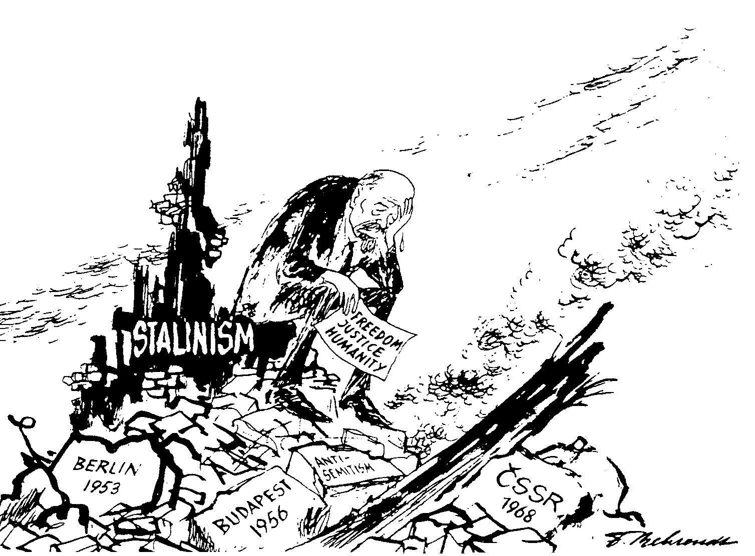

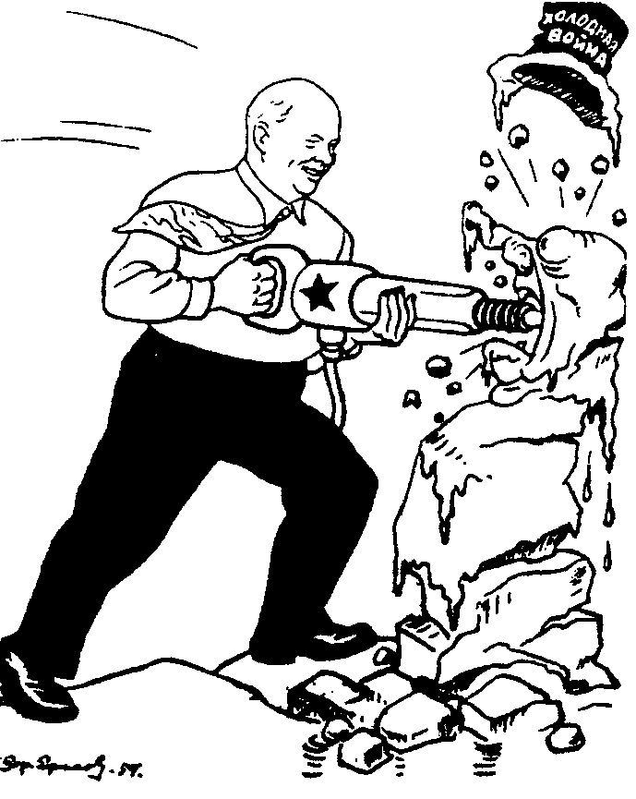
A Soviet cartoon of 1960. Khruschev is destroying ‘the Cold War’

QUESTION 4

- What were the main aims of the Super Powers in Africa?  - Explain the involvement of the United States of America in Africa after 1945.  - Write an essay on the influence of the USSR in Africa after 1945. | [40]

The involvement of world powers in Africa

A Gavshon, Crisis in Africa – Battleground of East and West:

“The objectives of East and West were essentially selfish and contributed little to the urgent need for stability in the region. The consequence of escalating tension was a full-scale arms race in a continent crying out for social-economic and not military development.”

A Gavshon, Crisis in Africa – Battleground of East and West:

“They had to recognise that hungry Africans could no more eat bullets, than they could cure their rampant disease with doses of anti-communist or anti-capitalist medicine.”

A Gavshon, Crisis in Africa – Battleground of East and West:

“East and West were using aid to advance or preserve their own interests and to score national or ideological gains.”

Boyce, A N: The Modern World and South Africa:

“During the presidency of Brezhnev, Russia made every effort to gain access to the raw materials of Africa and to expand trade.”

A Gavshon, Crisis in Africa – Battleground of East and West:

“In an age of energy shortages and nuclear development; whether for civil or military use, and of technological advances, Africa’s oil, uranium, cobalt, phosphates and other scarce minerals possessed great importance.”

A Gavshon, Crisis in Africa – Battleground of East and West:

“Kissinger saw the countries and regions of the Third World in Africa only against the background of the problem of maintaining an American-Soviet balance of power.”

A Gavshon, Crisis in Africa – Battleground of East and West:

“Strategically it was essential for the United states navy to retain access to those straits and ‘choke-points’ linking major oceanic routes.”

Boyce, A N: The Modern World and South Africa

TOTAL FOR SECTION A: | [80]

SECTION B

COMPULSORY

Information and illustrations pertaining to Section B are to be found in the Addendum on pages 16 to 19. Please detach these pages for easy reference.

QUESTION 5

NON-ESSAY TYPE QUESTIONS

- Select the correct answer for each of the following. Write down only the correct letter next to the corresponding number in your answer book, e.g. 5.1.1 E.  5.1.1 Which one of the following countries was not a Totalitarian state?  - Japan  - Great Britain  - Italy  - Germany | (2)

- The spirit of Fascism was strictly  - Communist.  - Socialist.  - Nationalist.  - Capitalist. | (2)

- After its occupation by Japan in 1931, Manchuria became a Japanese  - crown colony.  - self-governing state.  - protectorate.  - republic. | (2)

- In 1922, Mussolini’s followers took part in a mass-march to  - Florence.  - Milan.  - Rome.  - Aventine. | (2)

- Which one of the following countries did not take part in the Munich Conference of 1938?  - France  - Italy  - Germany  - Russia | (2)

Select the item which does not fit in each of the following statements. Write only the letter next to the corresponding number in your answer book.  - Characteristics of a Totalitarian state:  - Private ownership is prohibited.  - Only one political party has the right to exist.  - Freedom of the press is prohibited.  - Secret police and special military units are used to purge the party of dissenters. | (2)

- Factors which gave rise to the collapse of the Weimar Republic:  - The government was blamed for the ‘Diktat of Versailles’.  - The constitution was too autocratic.  - Political instability.  - Germany suffered a devastating blow to its economy as USA loans dried up. | (2)

- Which country did not form part of the Italian Empire in East Africa prior to 1936?  - Abyssinia  - Libya  - Tunisia  - Somalia | (2)

- In 1934, Japan issued the Amau Declaration, which amounted to  - a kind of Monroe Doctrine for Asia.  - a declaration by Japan that she was the only country that could maintain order in the Far East.  - an idea by Japan to surround herself with several satellite states.  - a declaration that only the Axis powers were allowed to possess colonies in the Far East. | (2)

- The results of the Anschluss:  - The democracies of Britain and France welcomed the manner in which the union was achieved.  - Hitler gained people, territory and resources for the German Reich.  - Britain and France did nothing to stop the unification.  - Hitler’s next intended victim, Czechoslovakia, was surrounded on three sides by German territory.  10 x 2 = | (2)  [20]

5.2 Use Documents 1, 2, 3 and 4 to assist you in answering the following questions. Write down only the letter next to the corresponding number in your answer book.  - When Hitler withdrew Germany from the League of Nations, he also withdrew the country from the European Disarmament Conference in  - Geneva.  - Munich.  - Berchtesgaden.  - Berlin. | (2)

- The Austrian Chancellor in 1938 was  - Dr Dolfuss.  - Dr Schuschnigg.  - Von Ribbentropf.  - Dr Seyss-Inquart. | (2)

- Laws introduced in September 1935 to formalise discrimination against the Jews in Germany:  - Jewish laws  - Crystal Night laws  - Nuremberg laws  - Aryan laws | (2)

- The countries which formed the Anti-Comintern Pact in 1936 were  - Germany and Italy.  - Britain and France.  - Germany and Japan.  - USA and Japan. | (2)

- The country created as a new country at the end of World War One from parts of the old Austro-Hungarian Empire:  - Czechoslovakia  - Sudetenland  - Bohemia  - Poland  5 x 2 = | (2)  [10]

5.3 Match the item in Column B with the item in Column A. Write down only the question numbers in your answer book and next to each the letter from Column B that matches it. Use Documents 1, 2, 3 and 4 to assist you in finding the answers.

There are questions to which the answers are not in the documents.

COLUMN A |  | COLUMN B
5.3.1 | SA troops | A. | Chinese nationalist who wanted closer ties with Manchuria
5.3.2 | German President (1932) | B. | A member of the Little Entente
5.3.3 | Haile Selassie | C. | Attacks on the Jews and Communists
5.3.4 | Chiang-Kai-Shek | D. | President of Czechoslovakia
5.4.5 | Naval Treaty | E. | Brown Shirts formed by Hitler
5.3.6 | Czechoslovakia | F. | Von Hindenburg
5.3.7 | Mein Kampf | G. | The emperor of Abyssinia
5.3.8 | Ruhr Area | H. | Concluded between Mussolini and the Pope
5.3.9 | Benes | I. | Occupied by France in 1923
5.3.10 | Lateran Treaty | J. | British approval of Germany’s rearmament programme

10 x 2 = | [20]

5.4 Use Documents 1, 2, 3, the Map and Cartoon 1 to answer the following questions:  - Which THREE countries are represented in the cartoon?  5.4.2 What treaty was concluded between these THREE countries? | (3)  (1)

5.4.3 Of which political party was Hitler the leader?  - What promise did Hitler make to the German people in paragraph 3 of Document 1?  - Which agreement existed between Germany and Austria?  - Name the concentration camp to which the prisoners were taken. | (1)  (1)  (1)  (1)

- How many seats did the N.S.D.A.P. (Nazi Party) win in the Reichstag election on 5 March 1933?  - What title did the Nazis give to Berlin? | (1)  (1)  [10]

5.5 Use Documents 2, 3 and 4 as well as Cartoon 2 to answer the following questions:  - Who are the TWO main figures in Cartoon 2?  - Which countries do they represent?  - Which treaty is involved here?  - Supply a heading for Cartoon 2.  - Who arrested the writer on 10 November 1938? (Document 3)  - What did the SS men do to the prisoners as they jumped from the truck?  - Who was the President of Czechoslovakia in 1939?  TOTAL FOR SECTION B:  TOTAL: | (2)  (2)  (1)  (1)  (1)  (2)  (1)  [10]  [70]  150

ADDENDUM

Please detach the Addendum (pages 16 to 19) and place alongside the relevant questions in Section B for easy reference.

DOCUMENT 1: Hitler’s broadcast to the German People, 1 February 1933

More than fourteen years have passed since the unhappy day when, dazzled by promises from home and abroad, the German people forgot its most precious possessions, our past, the Empire, its honour and freedom and thus lost everything. Since those days of betrayal the Almighty has withdrawn His blessing from our people. Discord and hatred came among us. With the deepest sorrow millions of the best German men and women from all walks of life saw the unity of the nation founder and disappear in a confusion of politically egotistical opinions, economic interests and opposing attitudes.

So the national government will regard it as its highest and first task to restore the united spirit and will of our people … It will take under its firm protection Christianity, as the basis of our collective morality, and the family as the nurturer of our people and state. It will transcend position and class to bring our people again to an awareness of its national and political unity and the duties arising from this.

In fourteen years the November parties have ruined German farming. In fourteen years they have created an army of millions of unemployed. The national government will carry out the following plan with iron resolution and the toughest persistence. Within four years the German farmer must be free from impoverishment. Within four years unemployment must be overcome permanently.

In foreign policy the national government will see its highest mission in the preservation of natural rights and thus in regaining the freedom of our people … By its resolution to end the chaotic conditions in Germany, it will help to introduce to the community of nations a state of equal worth and thus of course with equal rights. In doing this it is inspired by the greatness of the duty to support this free nation in maintaining and strengthening, as an equal, that peace which the world needs as never before. Now, German people, give us those four years and then judge us and give your verdict!

Following the order of the General marshal (Hindenburg) let us make a start. May Almighty God look graciously on our work, direct out purpose, bless our understanding and enrich us with the trust of our People. For we do not intend to fight for ourselves, but for Germany!

Max Domarus, Hitler, Reden und Proklamationen, 1932 – 1945, vol 1
(translated by M J Simpson)

DOCUMENT 2: Anschluss

Dr Schuschnigg was invited to Berchtesgaden to discuss with Hitler Austrian-German relations, but on his arrival, an ultimatum was delivered to him; all anti-Nazi activities in Austria had to be stopped and one of Hitler’s supporters, Dr Seyss-Inquart, had to be appointed to the post of Interior Minister. In this way Hitler could, through one of his sidekicks control public safety in Austria. On his arrival back in Austria, Dr Schuschnigg tried one more time to ensure his country’s independence: he had to decide if his country should join Germany or not. This referendum was never held.

DOCUMENT 3: ‘Crystal Night’

The tenth of November, 1938, was Crystal Night, the occasion on which the Nazis orchestrated an attack on Jews throughout Germany, arresting 20 000 and burning and looting Jewish property and synagogues.

Document Three is an account by a Jewish man who was arrested and sent to a concentration camp on Crystal Night.

Read the document and answer the questions in the question paper:

On November 10, 1938 … a man from the Gestapo … who, incidentally, was very courteous, told me that he had orders to arrest me … He could give me no reason, but thought I would be back home late in the evening … In the courtyard of the police headquarters stood hundreds of people, all Jews. Soon we were put in lorries and driven away. No one knew where to. After a lengthy journey throughout the northern suburbs of Berlin we arrived at the Sachsenhausen concentration camp. As we were made to jump from the trucks in the dark, we were met by S.S men with blows to the head, kicks, and jabs with their rifle-butts. |  | We stood the whole night on the huge parade ground. No one was allowed to break rank. More truckloads arrived every few minutes. In the early hours of the morning we were led into a barrack block and ordered to strip. Money and valuables were taken away though we got receipts for them. Stripped bare, we went into the next room, where our heads were shorn. In a third room we were issued with light underwear as well as with a blue and white striped canvas uniform …  While we were standing there, the S.S. men amused themselves by punching or kicking us at will …

DOCUMENT 4: The end of Czechoslovakia

In March 1939, he rejected the Munich agreement as “a worthless piece of paper”. German troops were gathered at the border and on 14 March the president of Czechoslovakia, Dr Emil Hacha was ordered to Berlin where he handed his country over to Germany. The next day German troops crossed the border and that was the end of Czechoslovakia’s independence. “It was the end of the twenty year old republic, which was destroyed, like Austria, through internal struggles incited by a powerful and a conscienceless neighbour.”

MAP: Hitler’s Germany

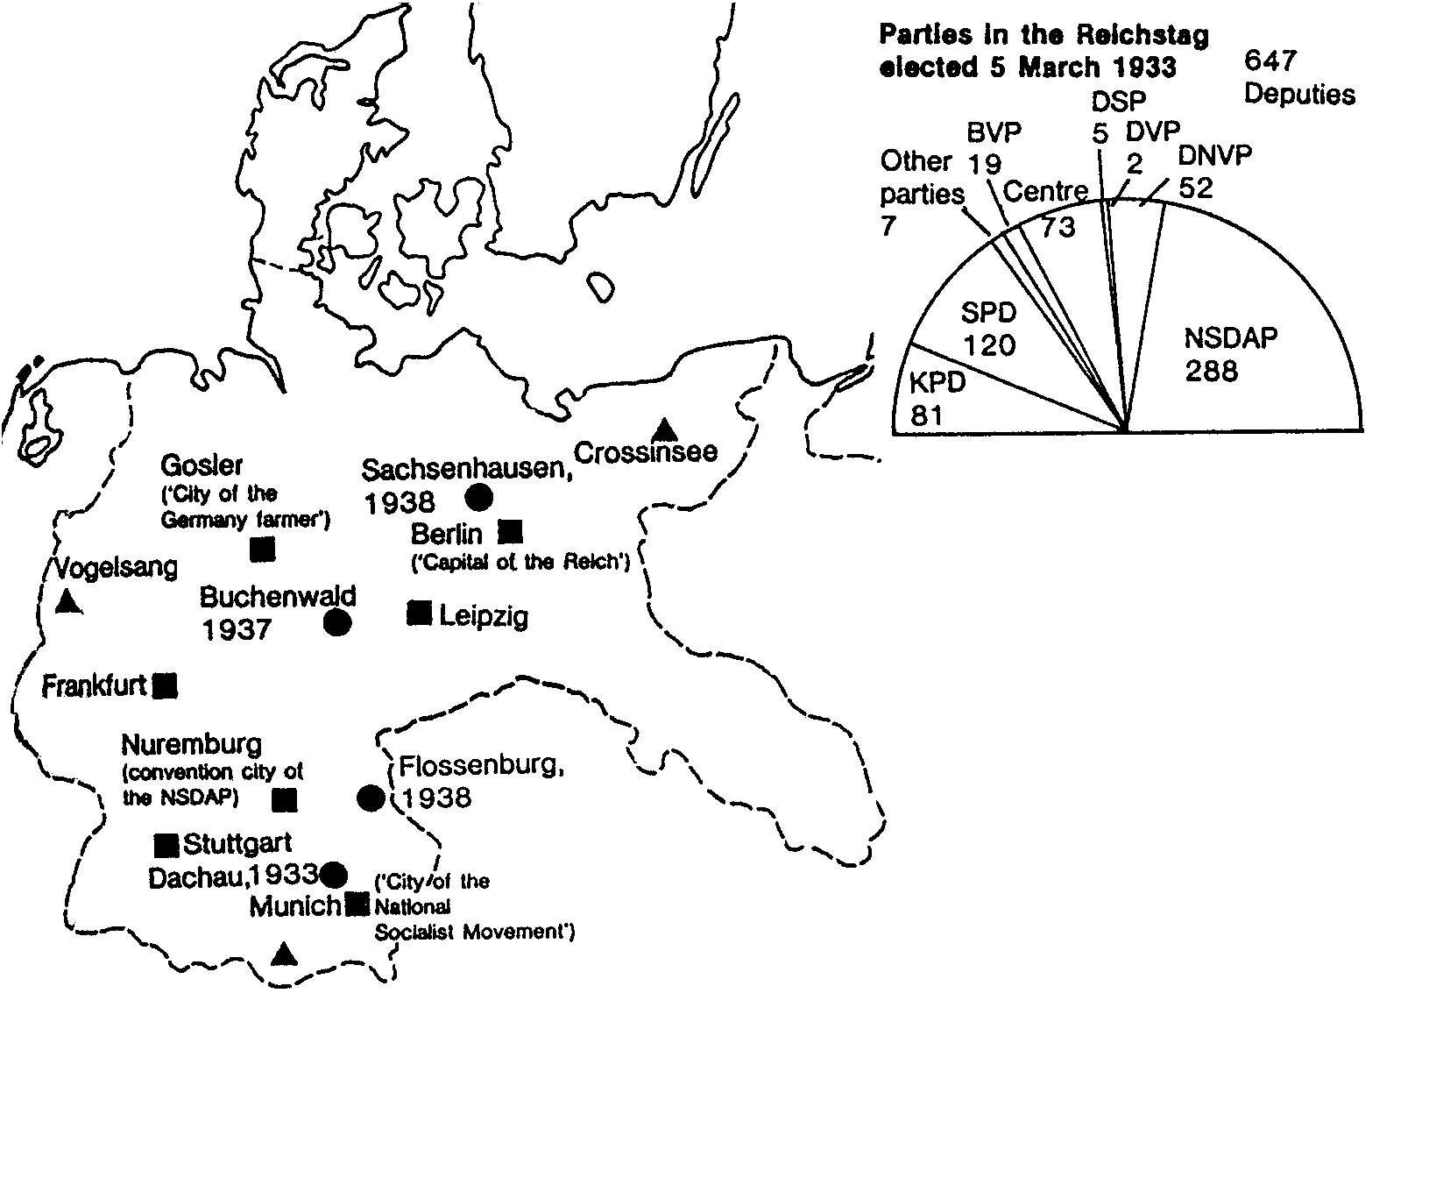

KPD: German Communist Party
SPD: German Social Democratic Party
BVP: Bavarian People’s Party
Centre: Catholic Centre Party
DSP: Germany State Party
DVP: National Liberals
NDVP: Conservatives and Free Conservatives
NSDAP: Nazi, or National Socialist German Workers’ Party
Coalition Government of the National Alliance from 30 January 1933
- Chancellor: Hitler
Vice-Chancellor: von Papen
Foreign Affairs: von Neurath
- Interior: Frick
Economic Affairs: Hugenberg
Finance: Schwerin von Korsigk
Defence: von Blomberg
Justice: Gurtner
Malls and Transport: von Eltz Rubenach
Labour: Seidt (Stalheim)
- Minister Without Portfolio: Goring
- Public Enlightenment and Propaganda: Goebbels (13 March)

■ Important centres for the National Socialist state

▲ Political training schools

● Concentration camps, with year of first mention

- Ministries given to Nazis

CARTOON 1: The justice and injustice of Abyssinia

THE LEAGUE? PAH! THE LEAGUE IS CONTEMPTIBLE! THE LEAGUE CAN DO NOTHING!
BUT AREN’T YOU THE LEAGUE?
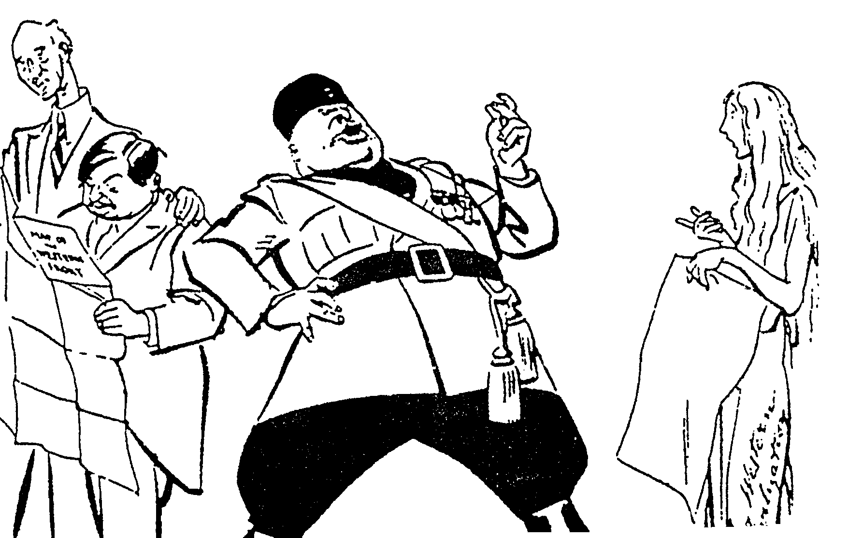

Terreblanche, Illsley: “Help-U-History Gr 12”
CARTOON 2

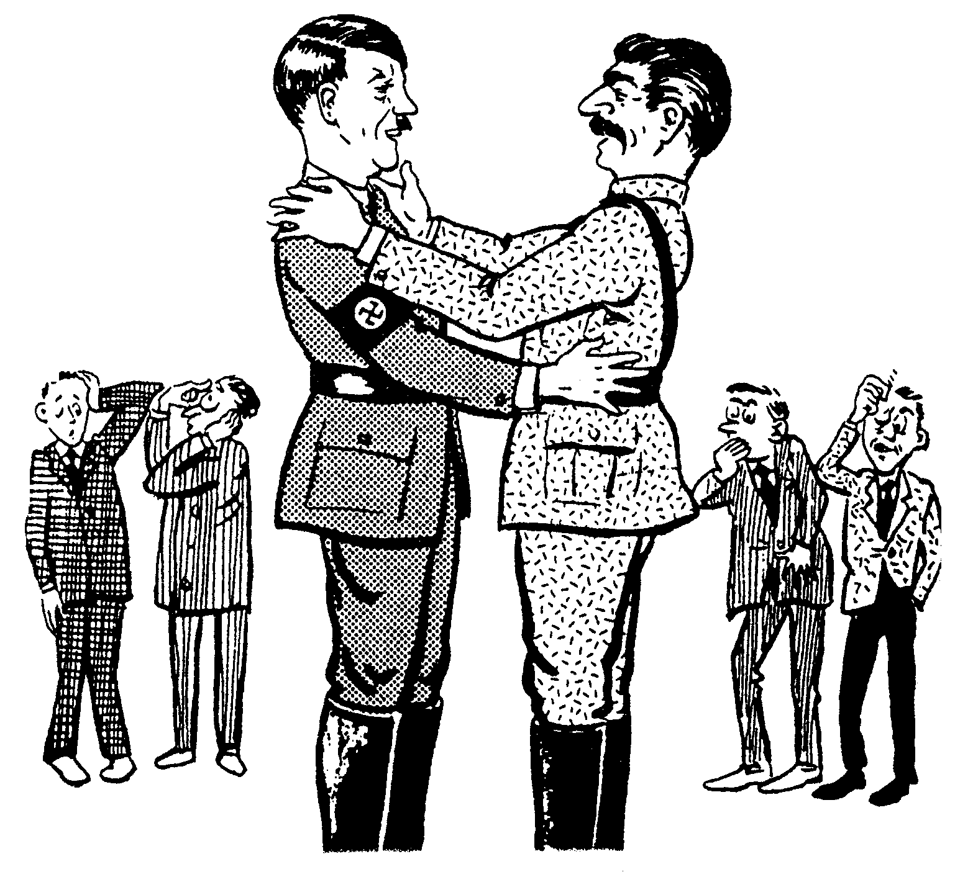

A
B

Roestorff, Schnetler: “Mastering General History”

