GAUTENG DEPARTMENT OF EDUCATION
SENIOR CERTIFICATE EXAMINATION

HISTORY HG
(Second Paper: South African History)

TIME: 2½ hours

MARKS: 200

INSTRUCTIONS:

- This paper consists of THREE sections:

- Section A: Essays 1924 – 1948.
- Section B: Essays 1948 – 1976.
- Section C: Short questions

- Answer ONE essay from Section A: Essays 1924 – 1948

- Answer ONE essay from Section B: Essays 1948 – 1976

- Section C is COMPULSORY. Answer ALL the questions in this section.

- All questions and subsections must be numbered clearly and accurately.

- You should spend approximately 50 minutes on each of the three questions.

- The Addendum (pages 7 – 9) contains information and illustrations pertaining to Section C. You are advised to detach the Addendum and place each page alongside the relevant question(s) for easy reference.

SECTION A
ESSAYS ON SOUTH AFRICAN HISTORY FROM 1924 TO 1948

Answer ONE of the following essays. Spend approximately 50 minutes on this essay.

QUESTION 1

1.1 “The Great Depression of 1929 forced two political rivals to join forces in 1933 to overcome problems within the Union.”  Critically explain how and why these rivals moved closer together during the period 1929 to 1934. | (45)

1.2 “Instead of solving the problem, this alliance created new political difficulties.” Do you agree with this statement? Refer to the years 1939 to 1948 (during and after World War Two) in your answer. | (15)  [60]

OR

QUESTION 2

“After the 1938 election two events had a great influence on the political scene, namely the centenary celebrations for the Great Trek in 1938 and the outbreak of the Second World War in September 1939.”
(Exploring History: S.P. Jordaan, A. Jordaan, H.A. Mocke)

Do you agree with the above statement? Analyse to what extent these events changed the political scene in South African history. | [60]

TOTAL FOR SECTION A: | [60]

SECTION B
ESSAYS ON SOUTH AFRICAN HISTORY FROM 1948 TO 1976

Answer ONE of the following essays. Spend approximately 50 minutes on this essay.

QUESTION 3

“In 1951 the NP began a long battle to remove the Coloured voters from the common voting roll.”
(From: Martin Roberts – A History of South Africa)

Explain why there was such a long battle and how the situation was eventually resolved. | [60]

OR

QUESTION 4

The Pass Laws had long been a particular source of frustration and humiliation for millions of Africans – and it seemed to both the ANC and the PAC that action in defiance of them might provide the long-sought trigger for popular resistance.
(Reader’s Digest Illustrated History of South Africa: p. 401)

Discuss the statement by referring to the period 1959 – 1964 (from the formation of the PAC to the end of the Rivonia trial) as well as the government’s reaction to the resistance during this period. | [60]

TOTAL FOR SECTION B: | [60]

SECTION C
SHORT AND INTERPRETATIVE QUESTIONS: 1948 TO 1976

QUESTION 5

This question is COMPULSORY. All questions must be answered. Spend approximately 50 minutes on this question.

5.1 Answer the following questions by writing down the correct letter next to the corresponding number in your answer book.

5.1.1 The Black Consciousness Movement

A. relied on white support.
B. was established by AZAPO as an alternative to NUSAS.
C. started as a policy after the Soweto uprising.
D. became important as a policy of black self-reliance.

5.1.2 In 1948, Dr Malan was allied with the _______ Party.

A. Labour
B. United
C. Afrikaner
D. South African

5.1.3 In 1951, the government tried to remove the Coloured vote by means of the

- Separate Representation of Voters Act.
- High Court of Parliament Act.
- Appellate Division Quorum Act.
- Senate Act.

5.1.4 Why did Dr. D.F. Malan not institute a republic in South Africa?

- He was not greatly interested in the republican ideal.
- He did not believe it would be accepted internationally.
- The Commonwealth was opposed to it.
- He believed more English support was needed for it.

5.1.5 The government policy towards the Indians under Dr Malan was

- consultation with the aim of repatriation.
- an attempt to give them a separate group area in Natal.
- a limited representation in the House of Assembly.
- a permanent representation in the Senate.

5.1.6 FRANC was

- a government-sponsored initiative to sort out the franchise.
- a firm agreement on better economic relations with France.
- a body that was hostile to the removal of the coloured vote.
- an ANC-led organisation to free blacks from the pass system.

5.1.7 The Rivonia trial was the result of

- months of government effort to prevent anti-pass campaigns.
- the location of the headquarters of Umkhonto we Sizwe.
- a breakthrough in government efforts to curb POQO.
- the last effort to prevent further treason trials occurring.

5.1.8 The Promotion of Bantu Self-Government Act

- declared the homelands independent.
- provided for ethnic groups to rule their own areas.
- allowed economic assistance to come to the homelands.
- gave the State President the power to rule homelands.

5.1.9 The Soweto uprising was a result of

- the aftermath of the Sharpeville shootings.  - the death of Steve Biko in detention.  - an attempt to assassinate the Prime Minister.  - dissatisfaction with the language ruling in schools. | 9x2=[18]

5.2 Study Sources A to C and answer the questions that follow.

5.2.1 What is the name commonly given to the complete document, of which Source A is a shortened version? | (1)
5.2.2 Where and when was this document signed? | (2)
5.2.3 With reference to evidence from Document A, explain why this document would have been unpopular with the National Party government. | (5)
5.2.4 Explain the link between Source A and Source B. | (3)
5.2.5 Explain the progress and outcome of the trial in Source B. | (4)
5.2.6 What caused the event portrayed in Source C? | (4)
5.2.7 What happened in this event and what was the result of it? | (6)
5.2.8 What link can be found between Sources B and C? | (3)  [28]

5.3 Study Sources D to F and answer the questions that follow.

5.3.1 What circumstances led to Nelson Mandela making the speech of which a part is reproduced in Source D? | (6)
5.3.2 Explain the meaning of what Mandela is saying in the speech. | (5)
5.3.3 What attitude does the author of Source E have towards the same events that are referred to in Source D? | (4)
5.3.4 Explain in about 80 words how Source E reflects a completely different tone towards that shown in Source D. | (7)
5.3.5 Explain the meaning of the cartoon (Source F). | (4)
5.3.6 What is the attitude of the cartoonist towards the subject matter? | (4)
5.3.7 How does the cartoon link to Sources D and E? | (4)  [34]

TOTAL: | 200

SOURCE A

“The People shall govern!
All national groups shall have equal rights!
The people shall share in the country’s wealth!
The land shall be shared amongst those who work it!
All shall be equal before the law!
All shall enjoy human rights!
There shall be work and security!
The doors of learning and culture shall be opened!
There shall be houses, security and comfort!
There shall be peace and friendship!
These freedoms we shall fight for, side by side, throughout our lives, until we have won our liberty.”

SOUCE B
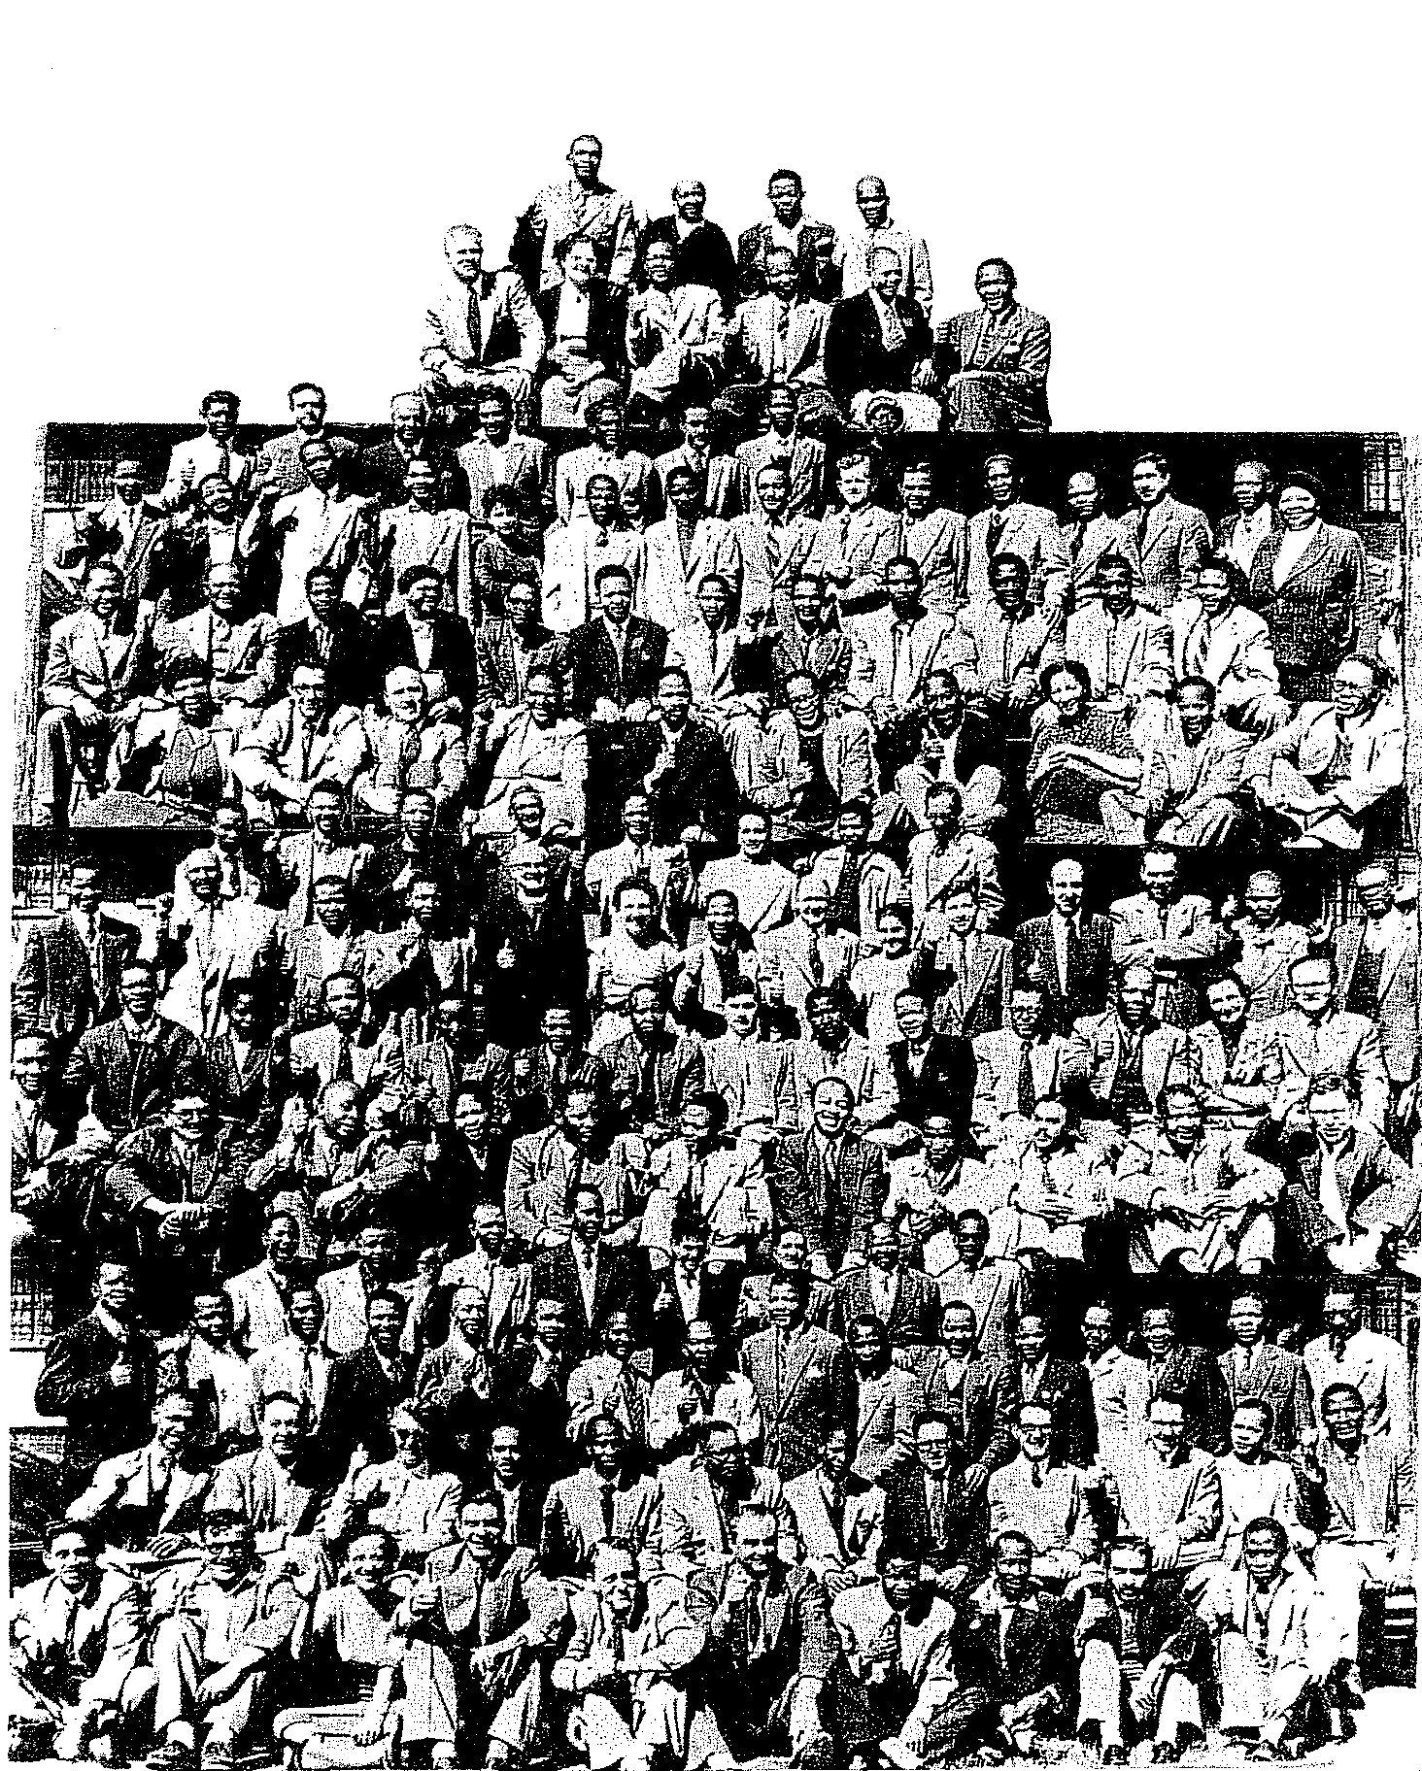

TREASON TRIAL

THE

ACCUSED

DECEMBER
1956

SOURCE C

Helen Joseph remembers:

“As Lilian (Ngoyi) raised her right arm in the Congress salute, 20 000 women went up and stayed there for those endless minutes. We knew that all over South Africa, women in the cities and towns were gathered together in protest. We were not just twenty thousand, but many thousand more… At the end of that half-hour, Lilian began to sing, softly at first, ‘Nkosi, Sikelel’ iAfrika’ (God bless Africa!) The voices rose, joining Lilian, ever louder and stronger. Then I heard a new song, composed specially for the protest, “Wathint’ abafazi, wathint’ imbokodo, uza kufa” (You have struck the women, you have struck a rock, you shall be destroyed.) It was meant for Strijdom.”

[Taken from Western Cape Exam Paper 1999: An extract adapted from Helen Joseph: Side by Side]

SOURCE D

“During my lifetime, I have dedicated my life to this struggle of the African people. I have fought against white domination and I have fought against black domination. I have cherished the ideal of a democratic and free society in which all persons live together in harmony and with equal opportunities. It is an ideal which I hope to live for and to achieve. But, if needs be, it is an ideal for which I am prepared to die.”

[Taken from: Nelson Mandela, Long Walk to Freedom, p. 438]

SOURCE E

“With only a very few exceptions, the overseas press completely condemned the South African government for the trials. The communist press world-wide had nothing but typical dialectical lies and socialistic venom for the legal system of South Africa. Surprisingly, within South Africa itself, even most of the liberal and leftist press sided with the verdict. The well-known Rand Daily Mail, famed for its leftist stance reported, ‘The sentences pronounced by Mr Justice de Wet in Pretoria yesterday at the conclusion of the Rivonia trial were both wise and just.’
Thus, the most famous trial in the history of South Africa came to an end. However, the CPSA had not. Even before the trial had ended, they were back again in secret meetings, trying desperately to reorganise with their leader, Advocate Fischer. His days, too, were numbered.”

[Taken from: Henry R. Pike, A History of Communism in South Africa, p. 398]

SOURCE F

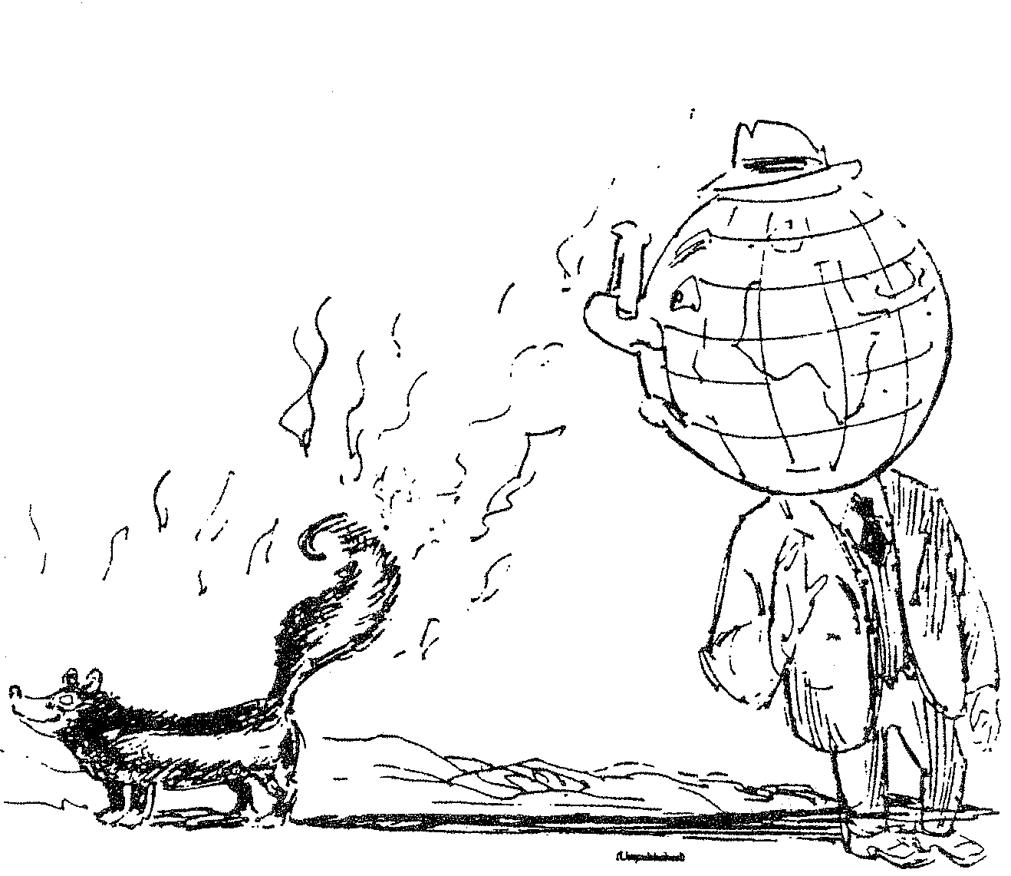

From: Abe Berry: “Act by Act”

