GAUTENG DEPARTMENT OF EDUCATION
SENIOR CERTIFICATE EXAMINATION

HISTORY HG
(Second Paper: South African History)

TIME: 2½ hours

MARKS: 200

INSTRUCTIONS:

- This paper consists of THREE sections:

- Section A: Essays 1924 – 1948.
- Section B: Essays 1948 – 1976.
- Section C: Short questions

- Answer ONE essay from Section A: Essays 1924 – 1948

- Answer ONE essay from Section B: Essays 1948 – 1976

- Section C is COMPULSORY. Answer ALL the questions in this section.

- All questions and subsections must be numbered clearly and accurately.

- You should spend approximately 50 minutes on each of the THREE questions.

- The Addendum (pages 8 to 11) contains information and illustrations pertaining to Section C. You are advised to detach the Addendum and place each page alongside the relevant question(s) for easy reference.

SECTION A
ESSAYS ON SOUTH AFRICAN HISTORY FROM 1924 TO 1948

Answer ONE of the following essays. Spend approximately 50 minutes on the essay.

QUESTION 1

To what extent was the Pact government successful in its first term of office between the years 1924 and 1929? Discuss. | [60]

OR

QUESTION 2

“Malan was determined to win for them (Afrikaners) the ‘promised land’ that he said Britain had stolen.”
(From: Understanding History: Bryn O’ Callaghan)

Analyse Malan’s role in politics from 1933 (the coalition election) to 1940 (his appointment as leader of the Reunited National Party) in his struggle to gain power to achieve the above. | [60]

TOTAL FOR SECTION A: | [60]

SECTION B
ESSAYS ON SOUTH AFRICAN HISTORY FROM 1948 TO 1976

Answer ONE of the following essays. Spend approximately 50 minutes on the essay.

QUESTION 3

“The coming to power of Malan’s apartheid government stimulated the ANC to shift to the more militant stand advocated by members of the Youth League and the CPSA (Communist Party of S.A.).”
(From: Foundations of the New South Africa: J. Pampallis; p. 191)

Analyse the above statement by referring to the period from the change of government in 1948 up to and including the formation of the P.A.C. in 1959. | [60]

OR

QUESTION 4

Use the cartoon as a guide to evaluate and discuss the decisions taken by the South African government under Verwoerd concerning the relationship between Britain and South Africa between 1958 and 31 May 1961. Also discuss the reaction to the South African government’s decisions. | [60]

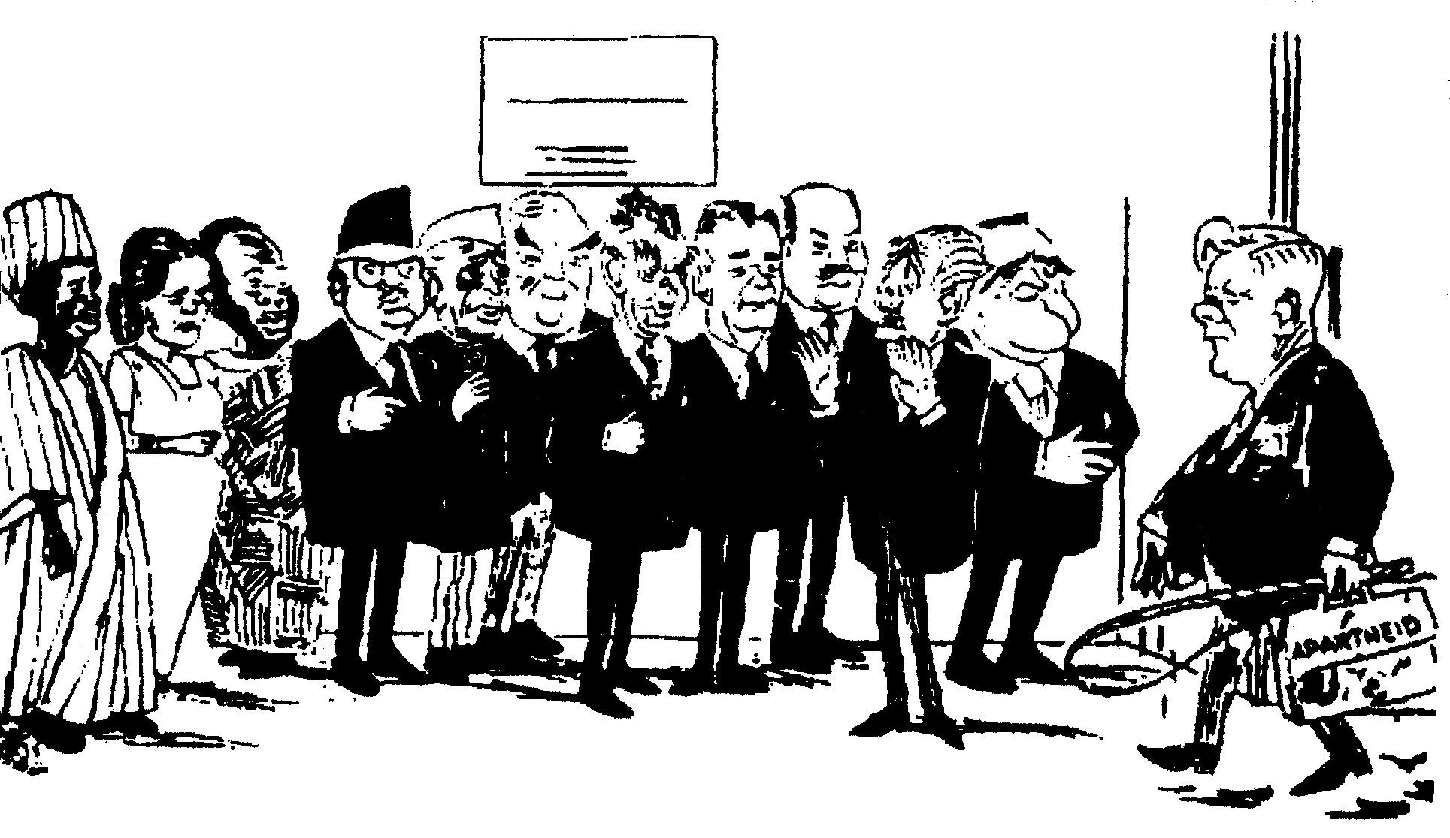
TODAY’S
AGENDA
SOUTH AFRICA
“Ssh, now, be nice to him – he says he’s misunderstood…”
COMMONWEALTH
CLUB

[The 13 March 1961 Commonwealth Conference in London]

TOTAL FOR SECTION B: | [60]

SECTION C
SHORT AND INTERPRETATIVE QUESTIONS: 1948 TO 1976

This question is COMPULSORY. All questions must be answered. Spend approximately 50 minutes on this question.

QUESTION 5

5.1 Answer the following questions by writing down the correct letter next to the corresponding number in your answer book.

5.1.1 One of the main reasons why the apartheid policy was introduced was

- to improve race relations in South Africa.
- to protect the whites in South Africa.
- as a direct result of World War Two.
- to get in line with the rest of the world.

5.1.2 The High Court of Parliament consisted of:

- Members of the Supreme and Appeal Courts
- Members of the Senate and the House of Assembly
- Members of the Supreme Court and the Senate
- The Appeal Court and the House of Assembly

5.1.3 Which one of the following is not one of the measures passed by Strijdom to break ties with Britain?

- Simonstown became South Africa’s naval base.
- The creation of one flag and one anthem for South Africa
- The right of appeal to the British Privy Council was abolished.
- The crown was replaced by the castle on military insignia.

5.1.4 The Group Areas Act

- removed people from the homelands.
- reserved certain areas of South Africa for specific population groups.
- arranged for the transportation of black people to homelands.
- provided for separate facilities for different population groups.

5.1.5 The 1956 march to the Union Buildings

- consisted of women who protested against the pass laws.
- was a mass demonstration opposing the removal of the Coloured vote.
- brought the defiance campaign to a fitting climax.
- was part of an international campaign, sponsored by the United Nations.

    - The meeting at Kliptown in 1955 finalised the adoption of the

- South African Bill of Rights.
- new South African Constitution.
- Freedom Charter.
- defiance campaign.

5.1.7 Which one of the following persons placed a bomb at the Johannesburg station in 1964?

- Robert Sobukwe of the Pan-Africanist Congress
- Joe Slovo of the South African Communist Party
- John Harris of the African Resistance Movement
- Walter Sisulu of the African National Congress

5.1.8 Border industries

- were established inside the homelands to help with revenue.  - were established in white South Africa to assist the homelands.  - did not involve the South African government in any way.  - were a major factor in making the homelands self-sufficient. | 8x2=[16]

5.2 Study Sources A to C and answer the questions that follow.

5.2.1 Who is the Prime Minister represented in the cartoon (Source A)? At this time he was Minister of Native Affairs. | (1)
5.2.2 To which apartheid regulations is he referring in this cartoon? | (2)
5.2.3 What is the irony depicted in the cartoon – that is, what makes the attitude of the Minister ridiculous? | (4)
5.2.4 Explain the attitude of the cartoonist towards the subject matter. | (4)
5.2.5 Which major event is discussed in Sources B and C? | (1)
5.2.6 How did the circumstances reflected in the cartoon impact on events described in Sources B and C? | (4)

5.2.7 Sources B and C have contradictory views of the same event. Analyse briefly, with evidence, how and why these extracts view this event differently. | (8)
5.2.8 Explain how the attitudes of the authors of Sources B and C differ. Which political parties might they have supported? | (4)  [28]

5.3 Study Sources D to F and answer the questions that follow.

5.3.1 Identify territories 1 to 4 on the map (Source D). | (4)
5.3.2 What is the major difference in status between territories 1 and 2, and territories 3 and 4? Explain this difference in approximately 80 words. | (4)
5.3.3 Explain why most of the world did not regard territories 1 and 2 as being fully independent. Study the map to help you answer this question. | (4)
5.3.4 Explain what is being portrayed in the cartoon (Source E). | (5)
5.3.5 Explain the attitude of the cartoonist towards the material he is portraying. | (4)
5.3.6 How does this interpretation of the cartoonist link with the attitude of most of the world towards these territories? Explain your answer. | (4)
5.3.7 Analyse the argument outlined by Dr Verwoerd in Source F. | (3)
5.3.8 How does this argument differ from the interpretation of the cartoonist shown in Source E? | (4)
5.3.9 What is your interpretation of the argument outlined by Dr Verwoerd? Explain your answer. | (4)  [36]

TOTAL FOR SECTION C: | [80]

TOTAL: | 200

ADDENDUM

Please detach this Addendum and place it next to the relevant questions for easy reference.

SOURCE A
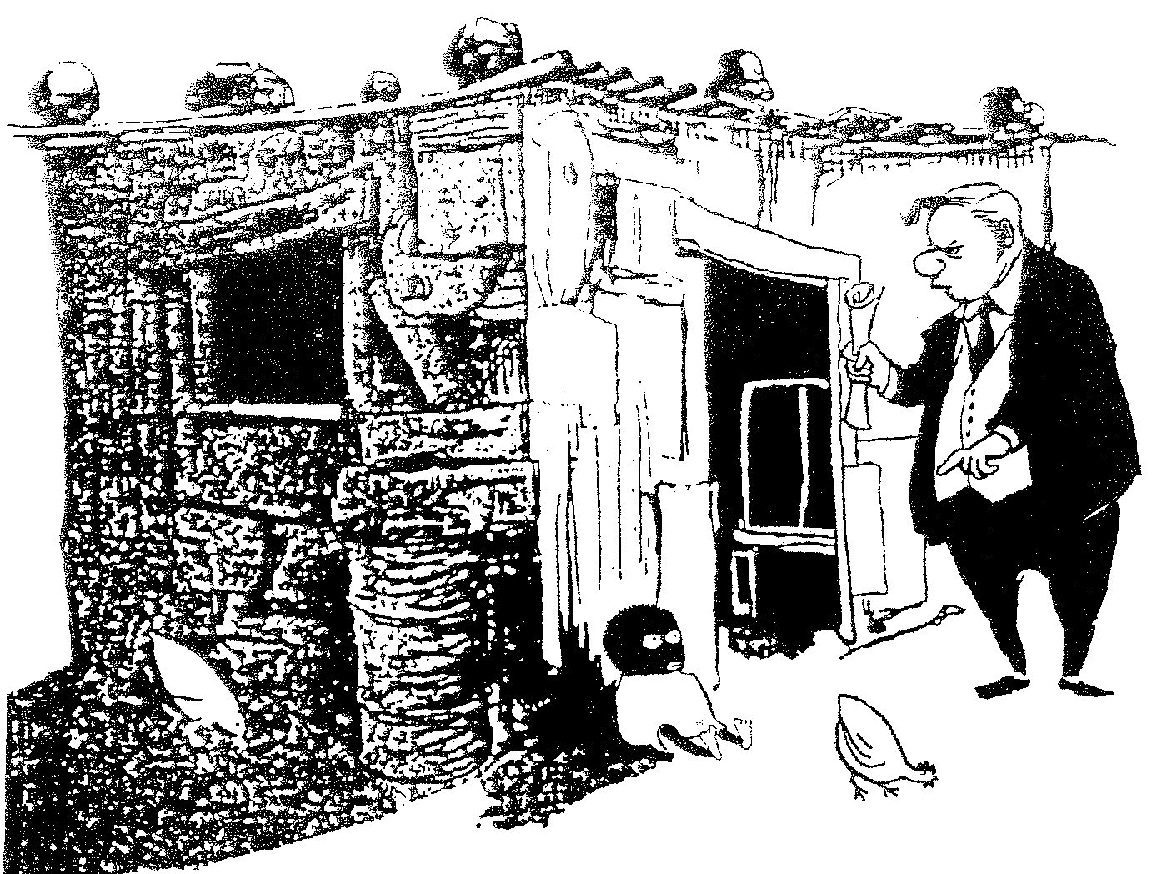
[Cape Times, 1957]

“You haven’t had 15 years’ continuous residence
or ten years’ continuous employment. You are not
qualified to live anywhere at all!”

SOURCE B

“On 16 June 1976, about 10,000 school children in Soweto marched in protest against the regulation that they had to take some of their subjects through the medium of Afrikaans. They gave the “black power” salute and carried placards bearing slogans such as the following, ‘Down with Afrikaans’, ‘Viva Azania’ and ‘If we do Afrikaans, Vorster must do Zulu’. In the vicinity of the Orlando West High School, they were confronted by the police. When the police used teargas in an effort to disperse the crowd, the children started to throw stones at the police. The police opened fire and at least one pupil, the 13-year old Hector Petersen, was killed. After that, chaos reigned. The mob of youths of whom about half were older than twenty, went berserk and attacked everything they associated with the white government. Vehicles and buildings were stoned and set on fire. Two white officials, one of whom had worked tirelessly for the welfare of blacks, were cornered and beaten to death. Even some of the police dogs were caught, killed and set alight. For a week, gangs of youths moved through the streets of Soweto, plundering, setting fires and robbing. The police were compelled to fire on the vandals and within only a few days the death toll stood at 140.”

(C.F.J. Muller – 500 Years p.546)

SOURCE C

“Thousands of students from other Soweto schools were already converging on Vilakazi Street outside Phefeni Junior. Phefeni Junior pupils and those from nearby Orlando West High streamed out, some jumping over fences to meet them.

A policeman stood with a gun cradled in his arms with a van full of police dogs next to him. More policemen arrived in vans and trucks. They were armed and also accompanied by dogs.

The massive crowd, standing deep down the road, blocked the road entirely. They sang, waving placards. Five white police officers in blue uniforms stood side by side in the middle of the road about fifteen paces away. Behind them, more and more uniformed police, most of them black and riot squad men alighted from police trucks, armed with rifles and accompanied by howling dogs… several women some with babies strapped to their backs, watched in groups from the roadside.

‘Are you really going to kill our children?’, a woman in a group asked a police sergeant as he strode past.

‘No, there’ll be no shooting’, the officer said calmly. ‘The children are not fighting anybody, they are only demonstrating’.

He was still talking when the white officer on the extreme right quickly stepped to the side, stooped down and picked up what seemed to be a stone. Then he hurled the object into the huge crowd. Instantly, the kids in front of the column scattered to the sides. They picked up stones, then hurriedly surged back into the street. ‘Amandla! Amandla!’, they screamed, hesitantly advancing towards the police.

Bang, a shot rang out, then another and yet another. In rapid succession.

The throng broke up with pupils fleeing in all directions. Some collapsed in their tracks as they fled, some ran on. Some remained petrified in the middle of the road. A police dog charged at a group in the street and the group stoned it dead. A kid and a man lay dead, with many others wounded. The peaceful protest march had turned sour.”

(From: ‘Black South Africa, a People on the Boil (1976–1986)’ by Harry Mashabela. Quoted in ‘Hands-on History’ by Emilia Potenza and Diane Favis p. 71)

SOURCE D

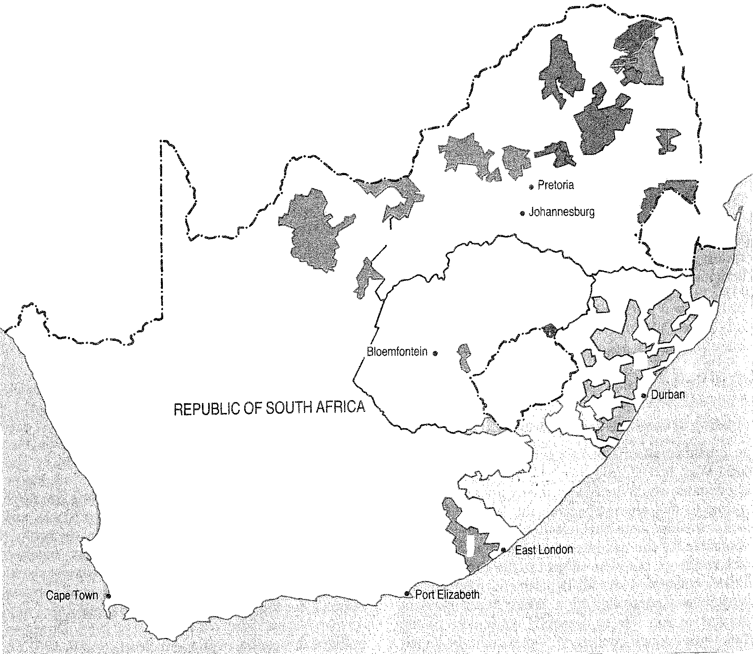
3
4
2
1

SOURCE E
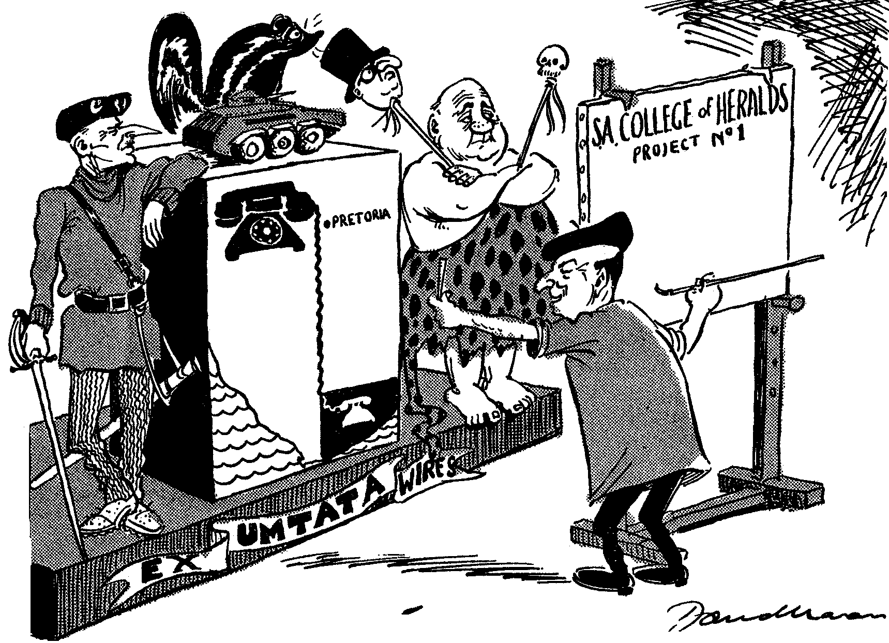
[Cape Times, 7 Feb. 1962]
“We start off with the arms of the sovereign independent state of the Transkei.
A little more rampant, please.”

SOURCE F

“We want each of our population groups to control and govern themselves, as is the case with other nations. I perceive the development of a Commonwealth of South Africa in which the white states and the black states can co-operate together as separate and independent states. In such an association, no state will lord it over any other.”
(Dr Verwoerd, speaking in London in March 1961)

COMMONWEALTH
CLUB

