GAUTENG DEPARTMENT OF EDUCATION
SENIOR CERTIFICATE EXAMINATION

HISTORY HG
(First Paper: General History)

TIME: 2½ hours

MARKS: 200

INSTRUCTIONS:

- This paper consists of TWO sections:

- Section A consists of FOUR essay questions. TWO essays must be answered. Candidates are to answer either Question 1 or 2. Candidates are then to answer either Question 3 or 4. Do not use headings or memorandum style in your essay.

- Section B consists of COMPULSORY short questions. Candidates must answer ALL the short questions.

- The Addendum (pages 15 – 18) contains information and illustrations which pertain to Section B. You are advised to detach the Addendum and place each page alongside the relevant question(s) for easy reference.

- Write as clearly and neatly as possible.

- Number all answers clearly and accurately.

SECTION A
ESSAY-TYPE QUESTIONS

Answer TWO questions from this section. Answer either Question 1 or Question 2 AND either Question 3 or Question 4. Use approximately 45 to 50 minutes per question.

QUESTION 1
THE RISE OF THE SUPER POWERS: THE USSR

Great changes took place in the Soviet Union during the years of Stalin’s rule. The Soviet Union changed from a backward, mainly agricultural country to one of the world’s greatest industrial powers. Yet at the same time, the population faced great hardships to achieve this goal of industrialisation. Some historians consider the sacrifices made by the Soviet people as the only way in which the country could have been industrialised. But other historians argue that there could have been alternative paths towards industrialisation and progress.

1.1 Discuss the changes that were made in the agricultural sector in the Soviet Union between 1928 and 1938. | (40)

1.2 Study the following sources and through a thorough analysis thereof, say whether you agree that the hardships faced by the Soviet population were necessary or not. | (20)  [60]

“In order to turn a peasant society into an industrialised country, countless material and human sacrifices were necessary. The people had to accept this, but it would not be achieved by enthusiasm alone… If a few million people had to perish in the process, history would forgive comrade Stalin… The great aim demanded great energy that could be drawn from a backward people only by great harshness.”

[Anatoli Rybakov, Children of the Arabat, 1988]

“Stalin ignoring the great cost in human life and misery, claimed that collectivisation was a success; for, after the great famines caused at the time… no more famines came to haunt the Russian people. The collective farms, despite their inefficiencies, did grow more food than the tiny, privately owned holdings had done. Collectivisation also meant the introduction of machines into the countryside. New methods of farming were taught by agricultural experts. The countryside was transformed.”

[E. Roberts, Stalin, Man of Steel, 1986]

“Nothing strikes the visitor to the Soviet Union more forcibly than the lack of fear. No fear of not having enough money at the birth of a child. No fear of doctor’s fees, school fees, or university fees. No fear of underwork, no fear of overwork. No fear of wage reduction in a land where none is unemployed.”

[Dr. Hewlett Johnson, Dean of Canterbury Cathedral,
Visiting the USSR in 1939]

“Whoever heard of such a thing – to give up our land and our cows and our tools and our buildings to work all the time and divide everything with others? Nowadays members of the same family get in each other’s way and quarrel and fight, and here we strangers are to act as one family”.

[Peasant farmer]

“The countryside became the theatre of undeclared civil war. The peasants tenaciously clung to their property, attacked and killed party commissars, slaughtered cattle, burned barns and stables and buried or destroyed whole harvests of grain. The (secret) police replied with mass executions and mass deportations. Mammoth concentration camps were set up in the enormous desolate plains of Siberia and in the icy wastes of the Far North.”

[German historian, 1966]

“It has been alleged, probably with some truth, that the famine was not unwelcome to Stalin; it was an effective way to break peasant resistance.”

[J Westwood]

“The industrial development, however did not change the nature of the regime. The average Soviet citizen gained nothing substantial either in material comfort, or for personal freedom.”

[Bereday, writer on Soviet education]

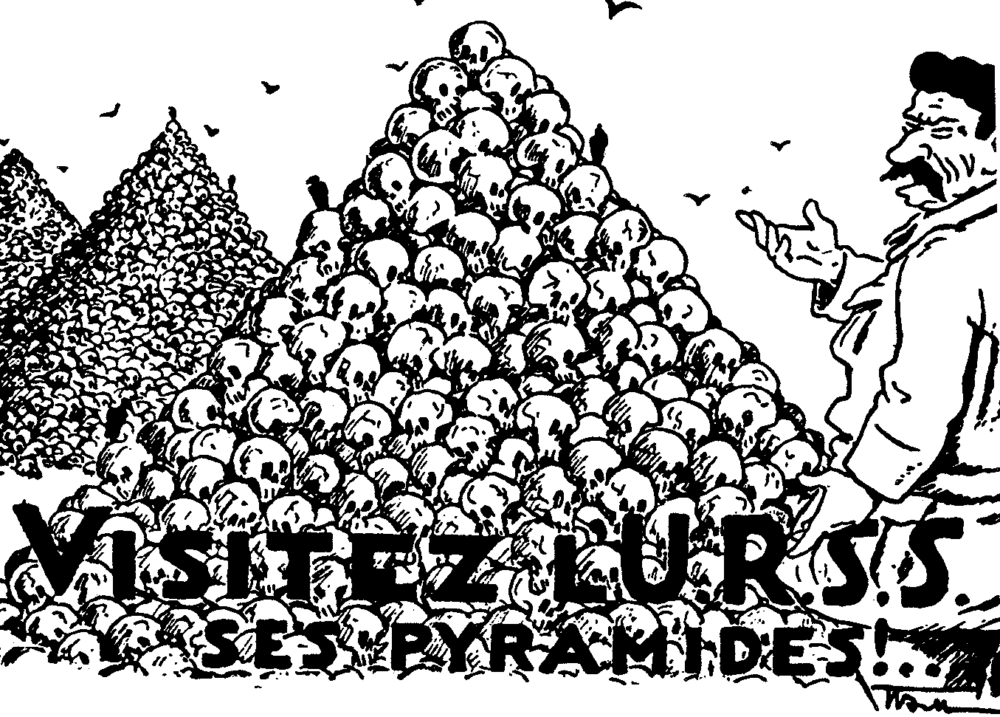

Poster made by Russian exiles in France in the late 1930s:
“Visit the USSR’s Pyramids”

OR

QUESTION 2
THE RISE OF THE SUPER POWERS: THE UNITED STATES OF AMERICA

In the 1920s America was the richest and most powerful country in the world. Its industry was booming.

2.1 Explain why and how this happened. | (40)

2.2 Was the economic boom as widespread as it is sometimes made out to be? Motivate your answer with the help of the following source material. | (20)  [60]

“America’s black population was particularly badly hit. They had always done the least skilled jobs in the rural areas. As they lost their jobs on the farms three quarters of a million of them joined the ranks of the unemployed.”

[Ben Walsh, historian, 1996]

“The boom years of the early 1920s was a great time for speculators. During this time, dividends increased by 65% (remember wages increased only by 8%). This was a time of great success for speculators… In the 1920s… many people bought shares – sometimes even people who had never owned shares before.”

A comparison of the growth of profits and the growth of average earnings.

The distribution of income in 1925

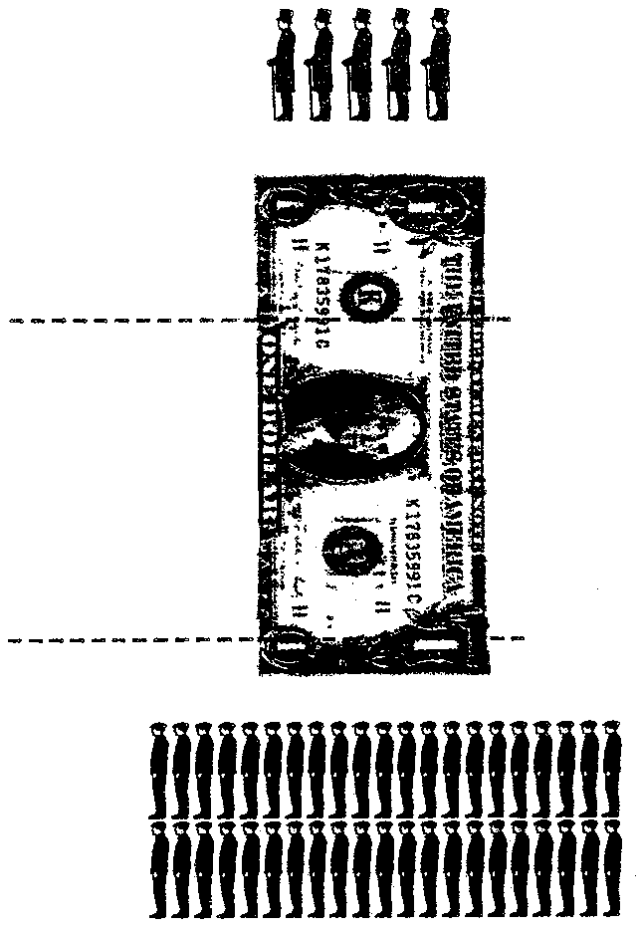
goes to
the
richest
5%
32%
goes to
the
poorest
42%
10%

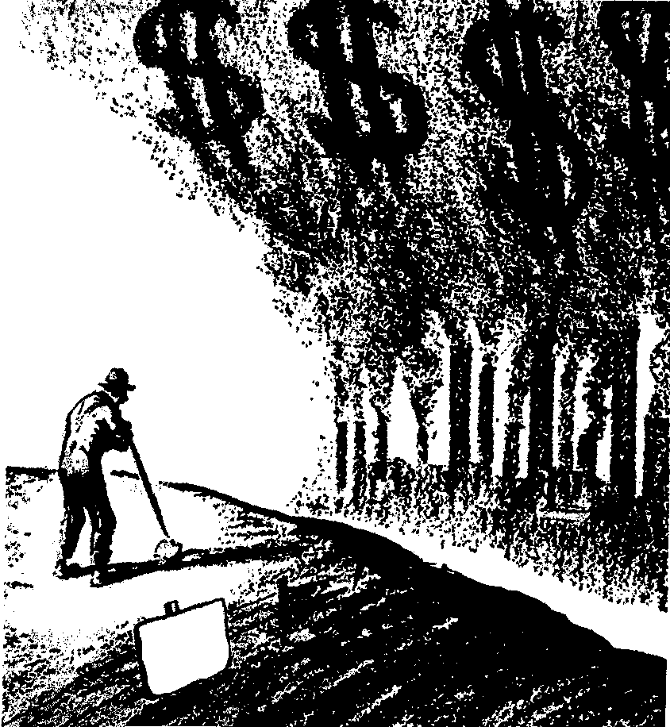

A cartoon showing problems faced by American farmers in the 1920s.

“What’s more, throughout this period unemployment remained a problem. The growth in industry in the 1920s did not create many new jobs. Industries were growing due to electrification and mechanisation of production.”

“Among semi-skilled workers only three in every hundred owned a car… The poor whites did not benefit much from the new chain stores. Nearly all of them were in middle-class districts.”

AND

QUESTION 3
COLD WAR IN EUROPE

- “The successes of the Red Army in the latter part of the Second World War gave Stalin the idea to use force and extend Soviet power and the influence of Communism.”  In an essay, explain the attempts of the Soviet Union to establish her control and influence in Eastern Europe from the Potsdam Conference in 1945 until the forming of the Warsaw Pact 1955. | (40)

3.2 Use the following information, and your essay to analyse the extent of peace and freedom which existed in Eastern Europe after the conclusion of the Second World War. | (20)  [60]

Stalin, proposing a toast at a dinner at the Yalta Conference, 1945:
“I want to drink to our alliance, that it should not lose its… intimacy, its free expression of views… I know of no such close alliance of three Great Powers as this… May it be strong and stable, may we be as frank as possible.”

Milovan Djilas writing about Yalta:
“In the hall way (at Yalta) we stopped before a map of the world on which the Soviet Union was coloured in red. Stalin waved his hand over the Soviet Union and exclaimed, ‘They will never accept the idea that so great a space should be red, never, never!”

Churchill writing to Roosevelt shortly after the Yalta Conference:
“The Soviet Union has become a danger to the free world. A new front must be created against her onward sweep. This front should be as far east as possible. A settlement must be reached on all major issues between West and East in Europe before the armies of democracy melt.”

Stalin speaking about the takeover of eastern Europe:
“This war is not as in the past; whoever occupies a territory, also imposes on it his own social system. Everyone imposes his own system as far as his army has power to do so. It cannot be otherwise.”

Winston Churchill speaking in the USA, March 1946:
“A shadow has fallen upon the scenes so lately lighted by the Allied victory. From Stettin on the Baltic to Trieste on the Adriatic, an iron curtain has descended. Behind that line lie all the states of central and eastern Europe. The Communist parties have been raised to power far beyond their numbers and are seeking everywhere to obtain totalitarian control. This is certainly not the liberated Europe we fought to build. Nor is it one which allows permanent peace.”

Stalin’s reply to Churchill’s speech:
“The following circumstances should not be forgotten. The Germans made their invasion of the USSR through Finland, Poland and Romania. The Germans were able to make their invasion through these countries because, at the time, governments hostile to the Soviet Union existed in these countries. What can there be surprising about the fact that the Soviet Union, anxious for its future safety, is trying to see to it that governments loyal in their attitude to the Soviet Union should exist in these countries?”

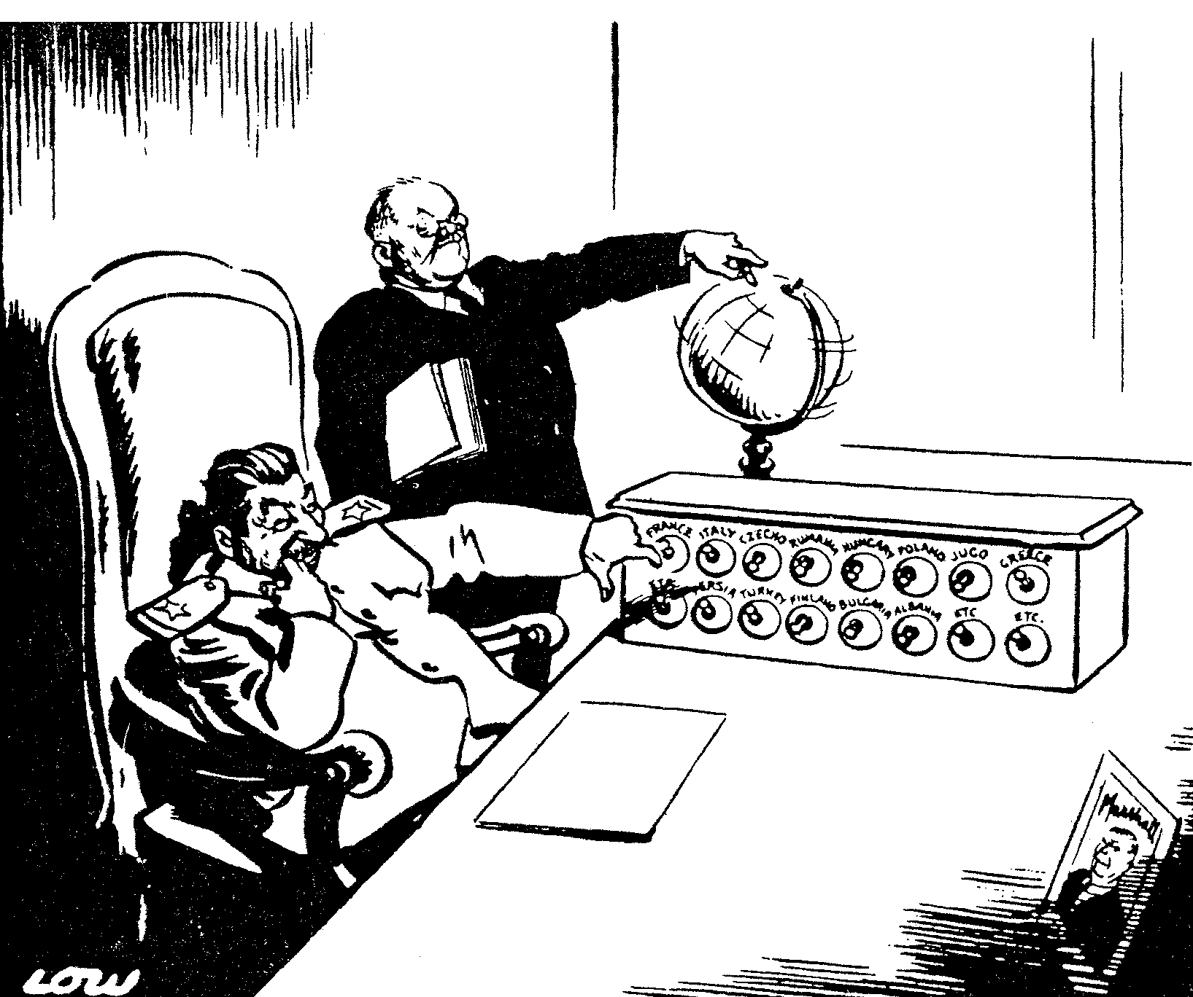

Who’s next to be liberated from freedom?

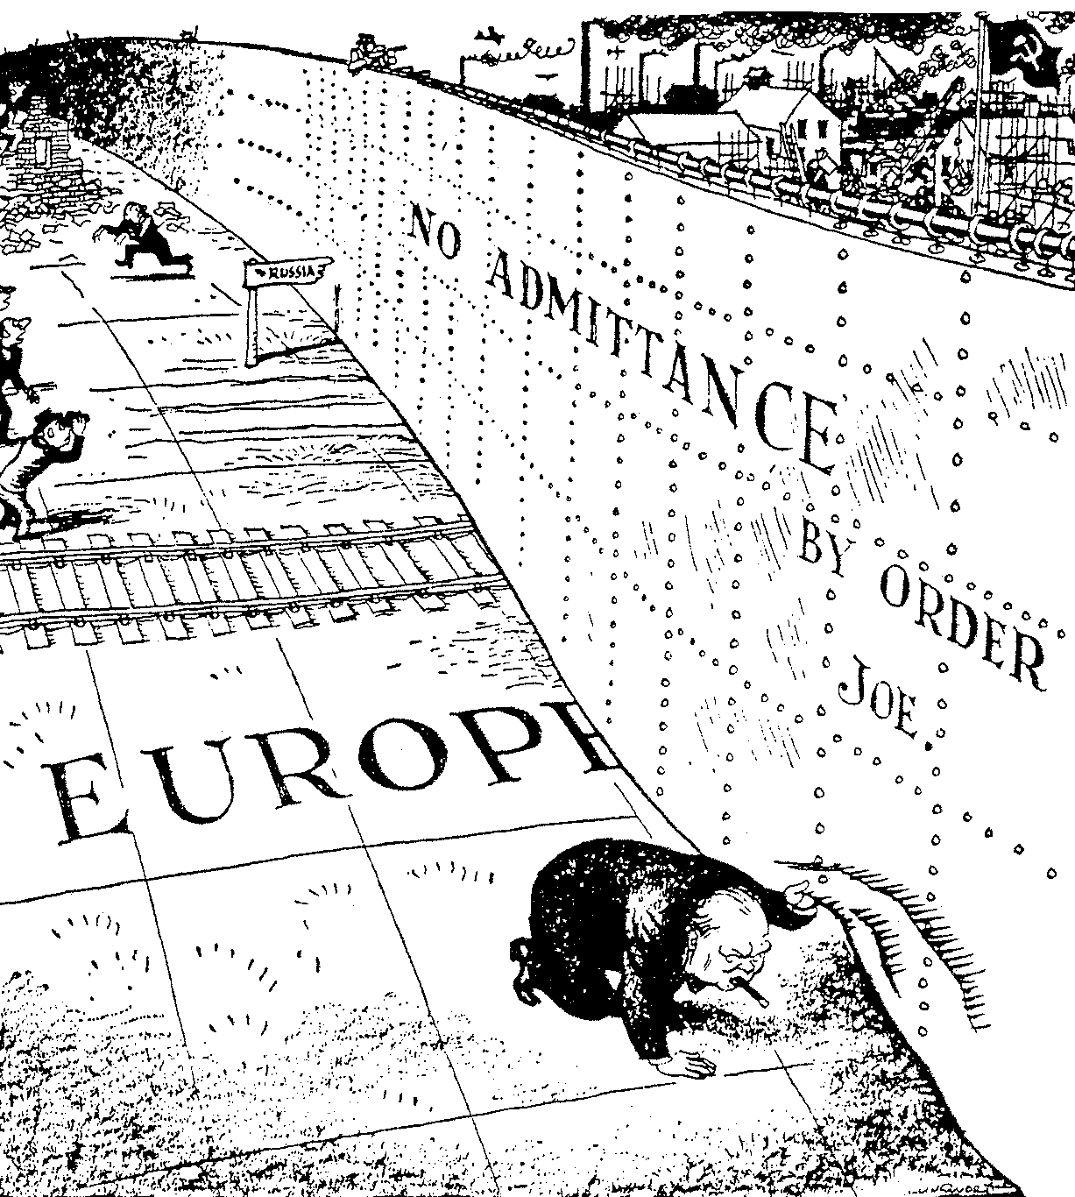

Peep under the iron curtain

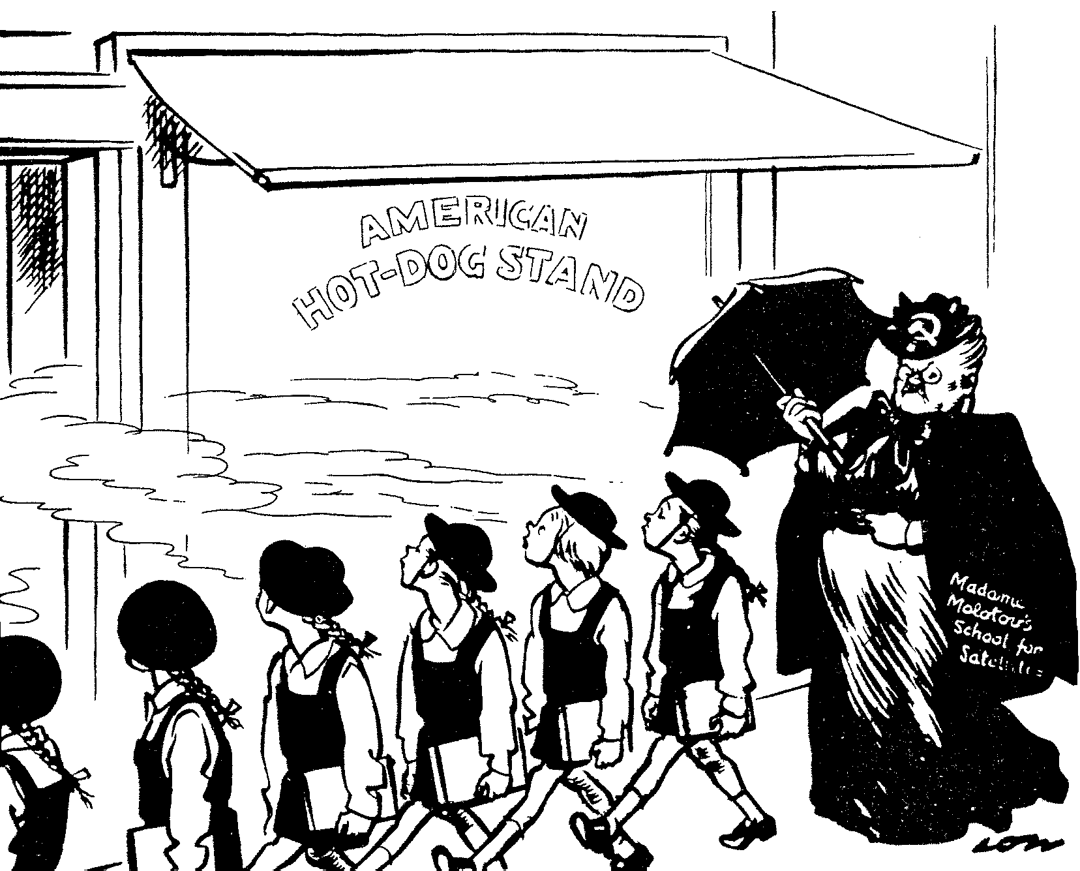

Madame
Molotov’s
School for
Satellites

Noses Left!

OR

QUESTION 4
AFRICA AFTER THE SECOND WORLD WAR

- “After the withdrawal of the old colonial powers from Africa, a vacuum was left which the Chinese and the Americans were eager to fill.  Write an essay about the involvement of the People’s Republic of China and the United States of America in Africa after 1945. | (40)

4.2 Use the following information, and your essay to analyse the difference in approach between the Chinese and American involvement in Africa. How did the attitude of the African States assist in the success or failure of these countries to befriend Africa? | (20)  [60]

The involvement of world powers in Africa.

A. Gavshon, “Crisis in Africa – Battleground of East and West”:
“The objectives of East and West were essentially selfish and contributed little to the urgent need for stability in the region. The consequence of escalating tension was a full-scale arms race in a continent crying out for socio-economic and not military development.”

A. Gavshon, “Crisis in Africa – Battleground of East and West”:
“They had to recognise that hungry Africans could no more eat bullets, than they could cure their rampant disease with doses of anti-communist or anti-capitalist medicine.”

A. Gavshon, “Crisis in Africa – Battleground of East and West”:
“East and West were using aid to advance or preserve their own interests and to score national or ideological gains.”

To the Point:
“They arrived in Dar-es-Salaam harbour by the hundreds, in Chinese ships, all dressed in identical baggy uniforms with peaked caps and wearing Mao badges, looking for all the world like so many automatons of an assembly line.”

A. Gavshon, “Crisis in Africa – Battleground of East and West”:
“Life in the bush entailed hardship and tremendous stamina. The Chinese lived at levels no higher that those of the Africans, in tents or huts or in the open. Preparing their own meals, cultivating vegetables when they were static, requiring their co-workers to do nothing they themselves would shirk. They transmitted their know-how and experience freely, without arrogance, training loco-drivers, welders and surveyors as they went along.”

A. Gavshon, “Crisis in Africa – Battleground of East and West”:
“In an age of energy shortages and nuclear development; whether for civil or military use, and of technological advances, Africa’s oil, uranium, cobalt, phosphates and other scarce minerals possessed great importance.”

A. Gavshon, “Crisis in Africa – Battleground of East and West”:
“Kissinger saw the countries and regions of the Third World in Africa only against the background of the problem of maintaining an American-Soviet balance of power.”

A. Gavshon, “Crisis in Africa – Battleground of East and West”:
“Strategically it was essential for the United States navy to retain access to those straits and ‘choke-points’ linking major oceanic routes.”

[Boyce, A.N.: The Modern World and South Africa]

SECTION B
COMPULSORY

QUESTION 5
NON-ESSAY TYPE QUESTIONS

Information and illustrations pertaining to Section B are to be found in the Addendum on pages 15 – 18. Please detach the Addendum for easy reference.

5.1 Select the correct answer for each of the following. Write down only the correct letter next to the corresponding number in your answer book, e.g. 5.1.11 A.

5.1.1 During the Fascist regime in Italy, the actual power lay with

- the National Council.  - Viktor Emmanuel III.  - Syndicates.  - II Duce. | (2)

5.1.2 In 1928 Mussolini

- came to power.  - had a prominent socialist leader killed.  - abolished universal suffrage.  - formed a coalition government. | (2)

5.1.3 Japan used the following as a pretext for invading Manchuria in 1931:

- The Mukden railway incident  - Russia’s extension of the railway line to Port Arthur  - The Marco Polo incident  - The sinking of a Japanese ship by China | (2)

5.1.4 The immediate response of Britain, France and Italy to the 1935 rearmament announcement by Hitler was the

- Locarno agreement.  - Stresa Front.  - Axis Pact.  - imposition of sanctions under the League of Nations. | (2)

5.1.5 The countries who negotiated the Munich agreement in 1938 were:

- Germany, USSR, Britain, France  - Germany, Czechoslovakia, Britain, Italy  - Britain, France, Poland, Hungary  - Britain, France, Italy, Germany | (2)

Select the item which does not fit in each of the following statements. Write down the number of each question in your answer book and next to it, the letter of the item which does not fit.

5.1.6 The decision to invade Abyssinia was motivated by:

- The need to distract attention from domestic problems in Italy  - The desire to create a 20th Century ‘Roman’ empire  - The need to test the strength of European influence in Abyssinia  - The weakness of this independent African State | (2)

5.1.7 Factors which seemed to favour Japanese expansionism in Asia by late 1941:

- The USA had given up efforts to oppose Japan  - Hitler had invaded the USSR  - Japan had become a military dictatorship  - Certain European countries with colonies in Asia had been invaded by Germany | (2)

5.1.8 Education in Nazi Germany:

- Teachers must support the Hitler regime  - Private schools are subsidised  - Anti-Semitism was propagated  - German girls were not encouraged to go into higher education | (2)

5.1.9 Results of the militarisation of the Rhineland:

- Hitler had defied the Treaty of Versailles  - France built the Maginot Line  - Britain and France’s lack of response  - Hitler’s popularity with his generals decreased | (2)

5.1.10 Hitler wanted to gain the Sudetenland region, because

- it contained a number of Germans.  - it contained important raw materials.  - Czechoslovakia was willing to surrender the area by early 1938.  - the defences in this region were the key to all of Czechoslovakia. | (2)  10x2=[20]

5.2 Write a sentence to clarify each of the following words:

- Disarmament  - Diktat of Versailles  - Open door policy  - Allies  - Dictator | 5x2=[10]

5.3 Find a matching item in COLUMN B for each of the items in COLUMN A. Write down only the letter next to the corresponding number in your answer book.

COLUMN A | COLUMN B
- Attack on Pearl Harbour  - Hitler used them as guards  - Anti-Semitism  - Pact of Steel  - Treaty of Versailles, 1919 | - Germany and Japan  - It ended World War One  - The SS  - 7 December 1941  - Campaign against the Jews  - Germany and Italy  - Red Terror | 2x5=[10]

5.4 Use document 1, the map and cartoon 1 to answer the following questions:

5.4.1 At what age did boys join the Hitler youth? |  |  | (1)
5.4.2 Which organisation could young men join after they had left the army? |  |  | (1)
5.4.3 What do you understand by the word ‘conscription’? | (2)
5.4.4 What does the map and the cartoon have in common? | (2)
5.4.5 To which continent does Abyssinia belong? | (1)
5.4.6 What agreement existed between the THREE persons in the cartoon? |  |  |  | (1)
5.4.7 Which THREE countries are represented by the THREE people in the cartoon? | (3)
5.4.8 On which part of the continent is this state situated? | (1)
5.4.9 Why did persons A and B have an admonishing attitude against person C? |  | (2)  [14]

5.5 Use documents 2 and 3 to answer the following questions:

5.5.1 Why did Hitler resign from the League of Nations? Give TWO reasons. | (2)
5.5.2 Why did Hitler specifically decide to rearm in 1935? | (2)
5.5.3 Why was military service really introduced? | (2)
5.5.4 How did Britain and France react to this announcement? | (2)
5.5.5 What was the feeling of the German people about rearmament? | (2)
5.5.6 Who offered economic and political aid to Italy when the League of Nations imposed sanctions due to the Abyssinia campaign? | (1)
5.5.7 When did Mussolini visit Germany? | (1)
5.5.8 Who was Mussolini’s constant companion during his five days in Germany? | (1)
5.5.9 Which agreement had its foundations laid during this visit? | (1)  [14]

5.6 Use document 4 and cartoon 2 to answer the following questions:

5.6.1 ‘By 1934 Germany and Italy were very far removed from each other; but by 1936 these two countries concluded an agreement.’ What brought about these changes? | (2)
5.6.2 Why was the treaty between Germany and Italy called the Rome- Berlin Axis treaty? | (2)
5.6.3 Who is the third power referred to in document 4? | (1)
5.6.4 What was the treaty between these THREE countries called? | (1)
5.6.5 Give a heading for the cartoon. | (1)
5.6.6 Who are figures A and B in cartoon 2? | (2)
5.6.7 Which figure under the trees was previously an ally of figure C? |  | (1)
5.6.8 What agreement originated between figures A and C during 1936? | (1)
5.6.9 In 1936 figures A and B also concluded an agreement. Which agreement was this? | (1)  [12]

TOTAL FOR SECTION B: | [80]

TOTAL: | 200

ADDENDUM: You are advised to detach the Addendum and place each page alongside the relevant questions for easy reference

DOCUMENT 1: ‘The fight for the mind of youth starts in the cradle’.

The fight for the mind of youth starts in the cradle. The baby’s earliest fairy tales must be in accordance with Nazi ideas. The Führer is ‘the man sent from Heaven’, who triumphed over some evil people called the Allies and who started a long fight to kill the bad ogre – the Bolshevik – who is for ever trying to eat up honest little German children.

At the age of ten, each little boy gets a brown shirt… Henceforth he belongs to the ‘Young Folk’. The little girl will join the ‘Union of German Maidens’… Little boy and girl alike are pledged to sacrifice everything for the Führer and are taught that he is everything and themselves nothing. After four years of this, the boy of fourteen joins the Hitler Youth, the outward symbol of his promotion being the change to brown trousers and the presentation of a red swastika arm-band as worn by adult members of the Brownshirt organization. Henceforth he is a Storm Trooper in miniature…

When grown up, the boy goes to camp for six months, compulsory labour service, … in the fields. This is followed by two years’ service in the army as a conscript, but, by the time the army gets hold of him, he is saturated with Nazi ideology … After leaving the army, our young man may become a member of the Brown or Black-shirts, first on the active list and later with the reserves…

It would be foolish to underestimate the enthusiasm of young Germany for their Führer. All other interests are disappearing, and it would be misleading to think that the religious bodies … are holding their own with the children. Again and again in Germany, I found cases of children whose Roman Catholic parents tried to keep them in the few struggling Church societies that still exist for children. In every case the children wanted to join the Hitler Jugend.

DOCUMENT 2: Rearmament of Germany, March 1935

Hitler was determined to rearm his country. A conference in February 1932 with the aim of disarming was a failure.

The most troublesome matter was Germany’s demand for equal treatment, which would mean a threat to France’s safety.

Germany eventually withdrew from the conference and later when Hitler became the German chancellor he also withdrew from the League of Nations. This was to allow him greater freedom to ignore the stipulations of the Treaty of Versailles.

In 1935 Hitler decided to reinstate military service but declared that it was only for the purpose of defence aiming at keeping peace.

DOCUMENT 3: Mrs Mussolini remembers her husband’s visit to Hitler

Three years elapsed before Mussolini and Hitler met again. Their second encounter occurred in Germany. By now Hitler fully understood the true meaning of Mussolini and Fascism. When, after the Abyssinian campaign, the League of Nations imposed sanctions on Italy, Hitler alone offered economic and political aid and was the first to recognise the Empire. The Führer had made a profitable investment… For the Duce remembered this support when Hitler made overtures for an alliance. It was a determining factor, plus the vision of what such an alliance could achieve against Bolshevism – already graphically seen in the Italian-German intervention in the Spanish War.

The wind seemed set fair for Benito’s visit to Germany. He left Rome on 23 September 1937, expecting a cordial welcome; he returned overwhelmed. In those five days, Hitler was his constant companion, attending to his slightest needs. He ensured that Benito had the hard pillows he liked to sleep on… Nothing was overlooked – right down to the flowers in the Duce’s room and the train stops to allow adequate rest… The visit reached a climax in Berlin ‘with one vast demonstration after another … Hitler, realising that his show of strength had impressed the Duce and anxious to strike while the iron was hot, immediately laid the foundations of an agreement which was to become the Pact of Steel’.

DOCUMENT 4

By 1936 three of the world’s most powerful military countries found themselves outside the illustrious world body, the League of Nations. And it was unavoidable that these three countries would co-operate. As we know, Germany and Japan had already concluded a treaty earlier. At first Germany and Italy was divided on the Austrian question, because the unification of Germany with Austria would only mean a stronger Germany on the north border of Italy. But as a result of the Abyssinian question Mussolini changed his mind so that in 1937 he visited Germany and concluded the so-called Rome-Berlin Axis treaty.

MAP AND CARTOON 1

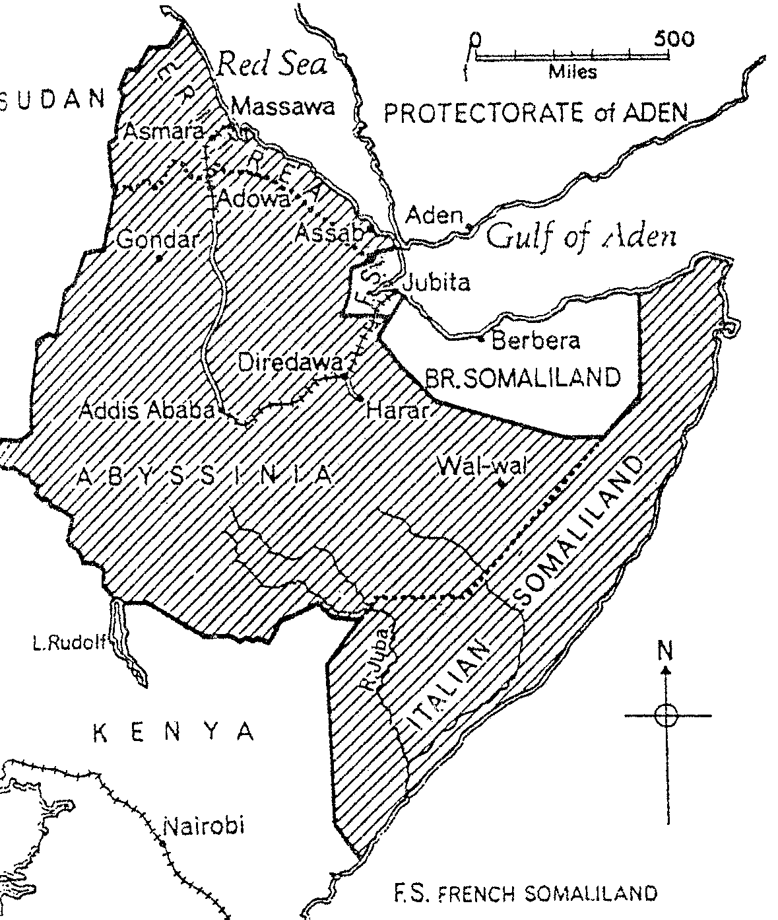

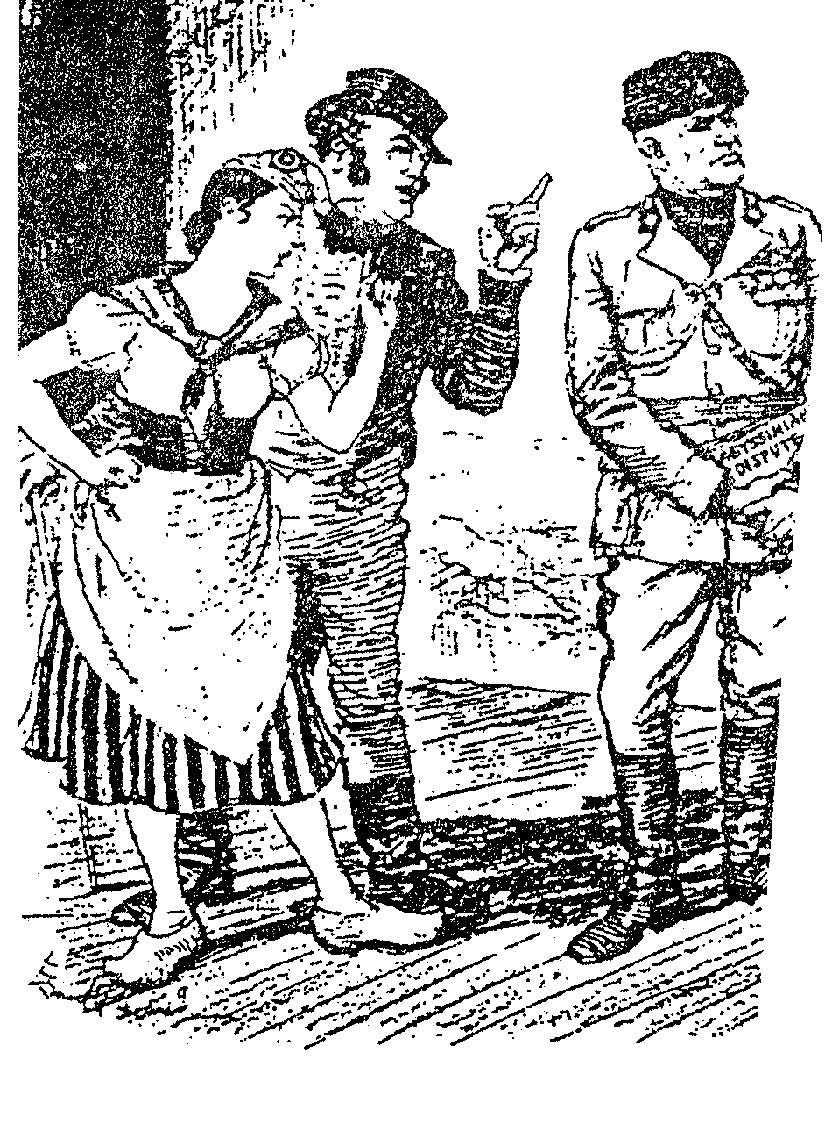

THE AWFUL WARNING
A
B
C

Roestorff, Schnetter: “Mastering General History”

CARTOON 2

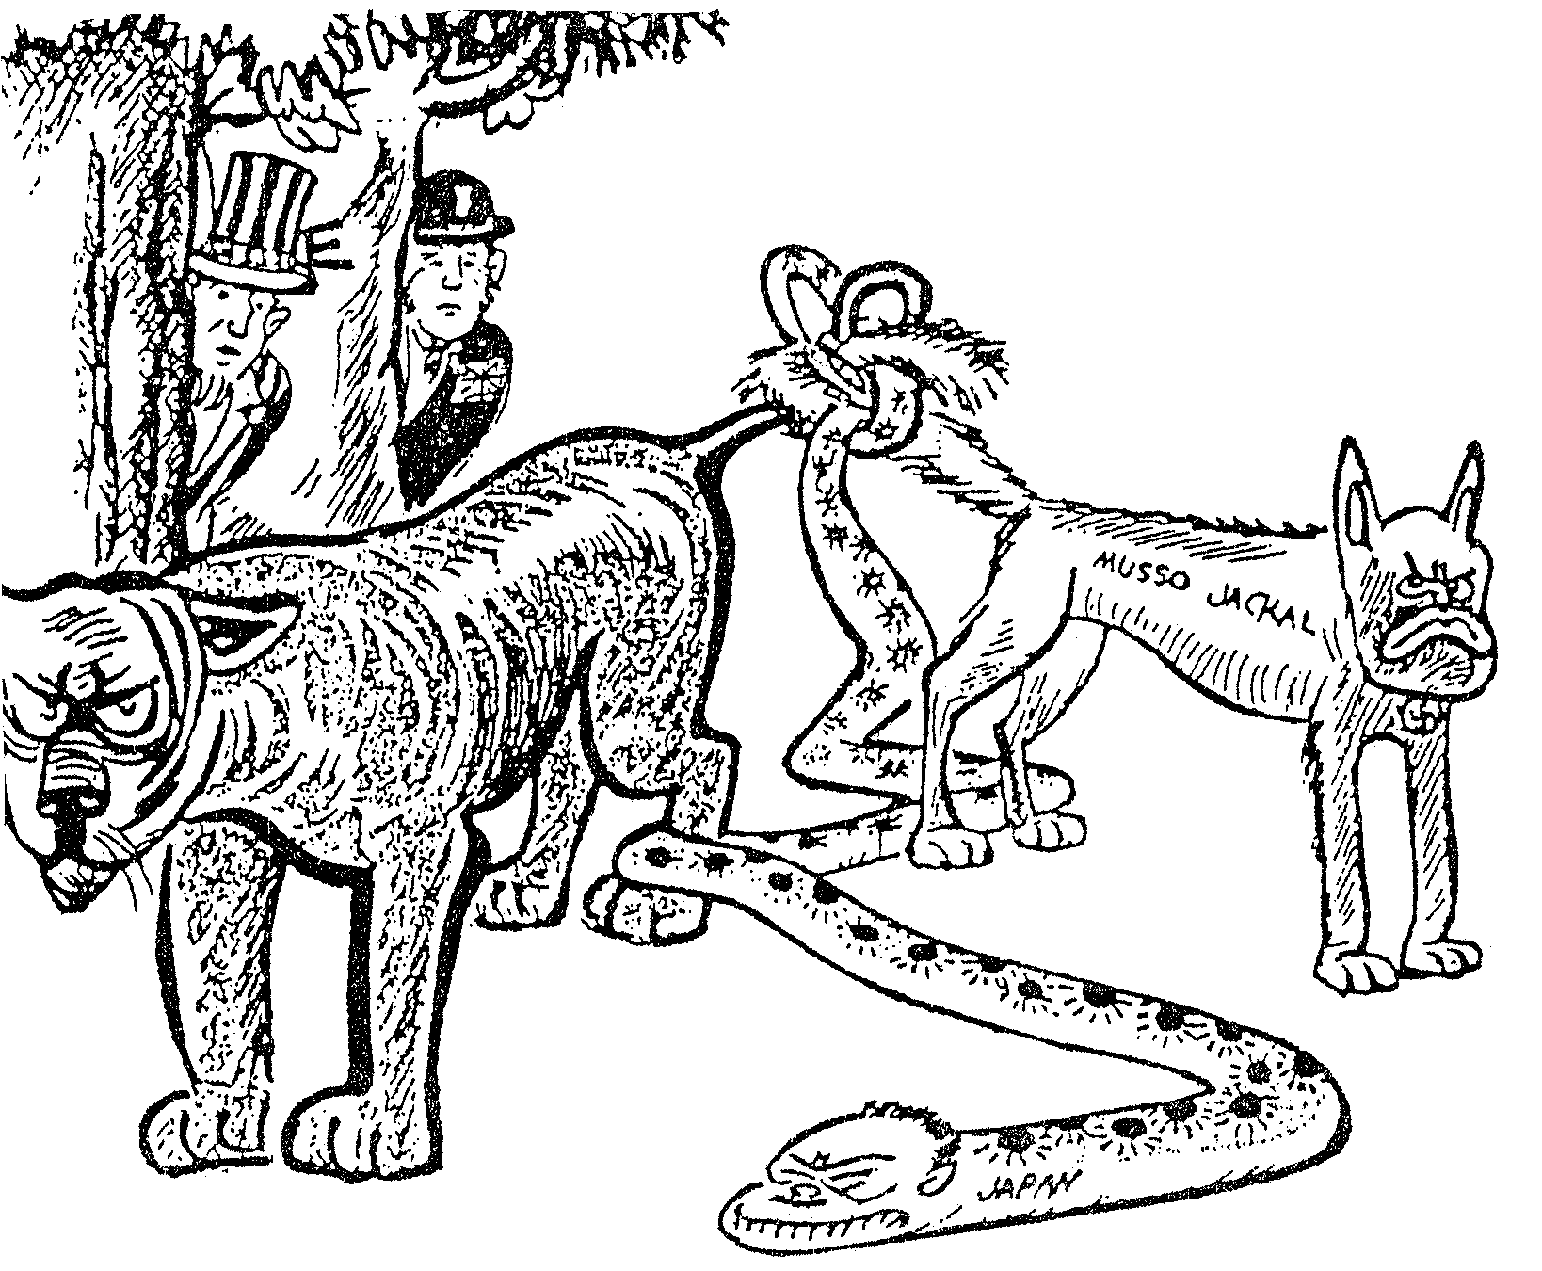

D

A

B

C

Malan, Appelgryn, Theron: “New History to the Point”

