GAUTENG DEPARTMENT OF EDUCATION
SENIOR CERTIFICATE EXAMINATION

HISTORY HG
(First Paper: General History)

TIME: 2½ hours

MARKS: 200

INSTRUCTIONS:

- This paper consists of TWO sections:

- Section A consists of FOUR essay questions. TWO essays must be answered. Candidates are to answer either Question 1 or 2. Candidates are then to answer either Question 3 or 4. Do not use headings or memorandum style in your essays.

- Section B consists of COMPULSORY short questions. Candidates must answer ALL the short questions.

- The Addendum (pages 16 – 19) contains information and illustrations which pertain to Section B. You are advised to detach the Addendum and place each page alongside the relevant question(s) for easy reference.

- Write as cleary and neatly as possible.

- Number all answers clearly and accurately.

SECTION A
ESSAY-TYPE QUESTIONS

Answer TWO questions from this section. Answer either Question 1 or Question 2 and either Question 3 or Question 4. Use approximately 45 to 50 minutes per question.

QUESTION 1
THE RISE OF THE SUPER POWERS: THE USSR

1.1 Discuss the industrialisation programme under Stalin between 1929 and 1938. | (40)

1.2 “The Five Year Plans brought glory to Stalin and misery to his people.” Give a critical analysis of this statement with the help of the following sources: | (20)  [60]

“What were the results of the Five Year Plan after four years?”

- We did not have an iron and steel industry. Now we have one.
- We did not have a machine tool industry. Now we have one.
- We did not have a modern chemicals industry. Now we have one.
- We did not have a big industry for producing agricultural machinery. Now we have one.”

[Stalin speaking about the first Five year Plan in 1932]

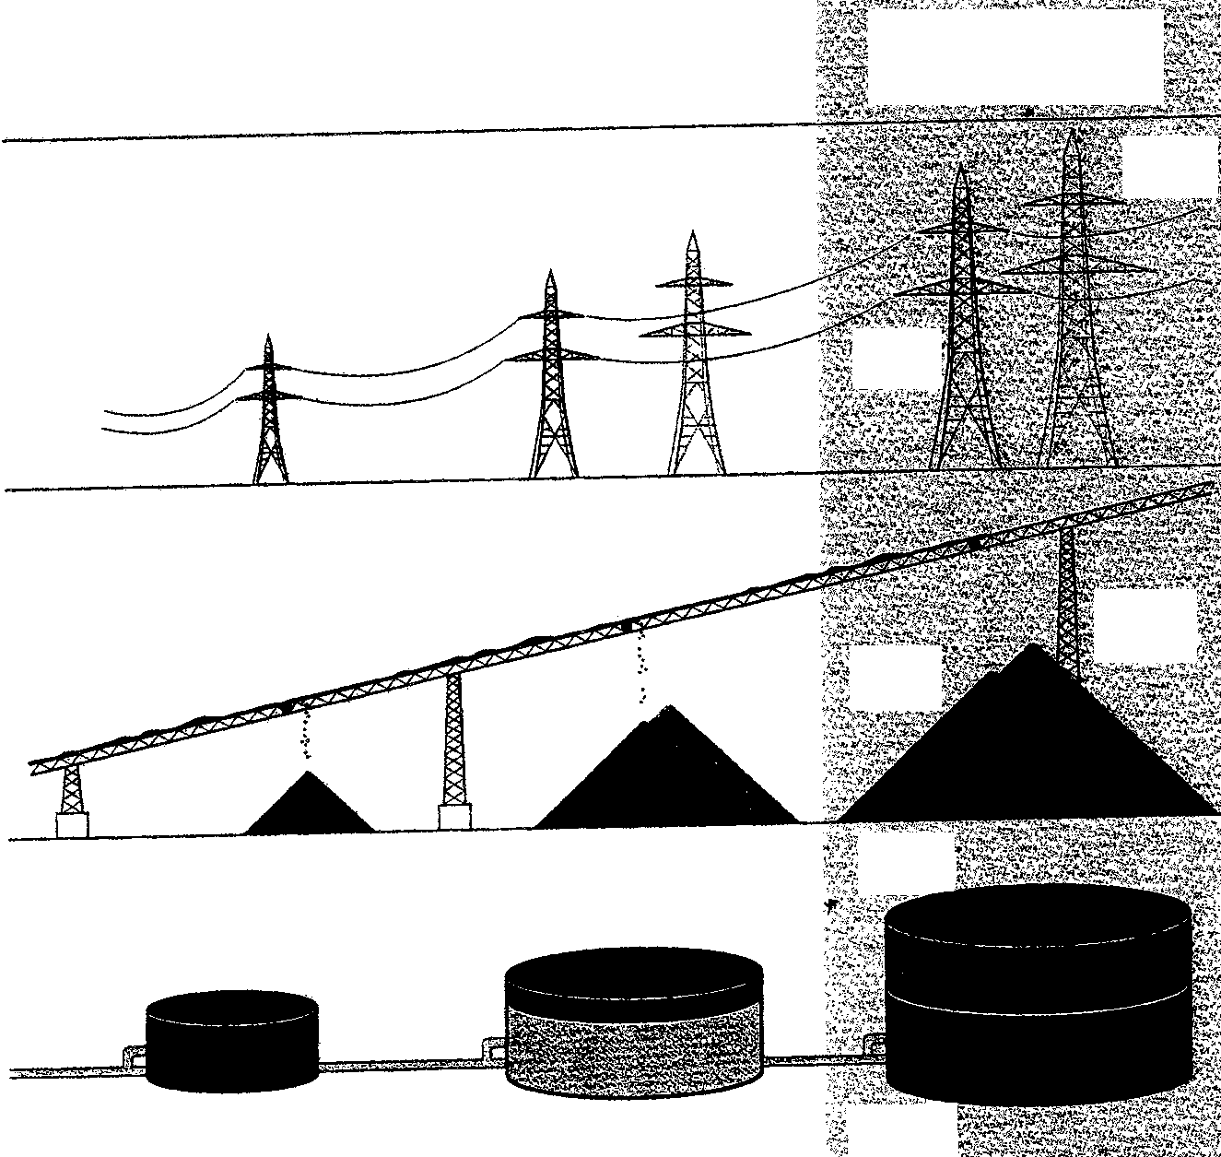

Production in 1927–28
First Five-Year Plan.
Target and actual
production in 1933
Second Five-Year Plan.
Target and actual
production in 1937
ELECTRICITY
(thousand million
kilowatt hours)

Target
17.0

Actual
13.4

Target
38.0

Actual
36.2
COAL
(million tonnes)

Target
64.3

Actual
128.0

Target
152.52
OIL
(million tonnes)

Actual
21.4

Target
46.8

Target
19.0

Actual
28.5

Actual
35.4

The achievements of the Five year Plans

“There is evidence that he (Stalin) exaggerated Russia’s industrial deficiency in 1929. The tsars had developed a considerable industrial capacity… in a sense the spade work had already been done and it is not altogether surprising that Stalin should have achieved such rapid results”.

[Historian, S.J. Lee, The European Dictatorships, 1918–1945, 1987]

“These men lifted their villainous hands against comrade Stalin. By lifting their hands against comrade Stalin, they lifted them against all of us, against the working class,… against the teachings of Marx, Engels, Lenin… Stalin is our hope, Stalin is the beacon which guides all progressive mankind. Stalin is our banner. Stalin is our will. Stalin is our victory.”

[From a speech made by Communist leader Nikita Kruschev in 1937, at the height of the Purges.]

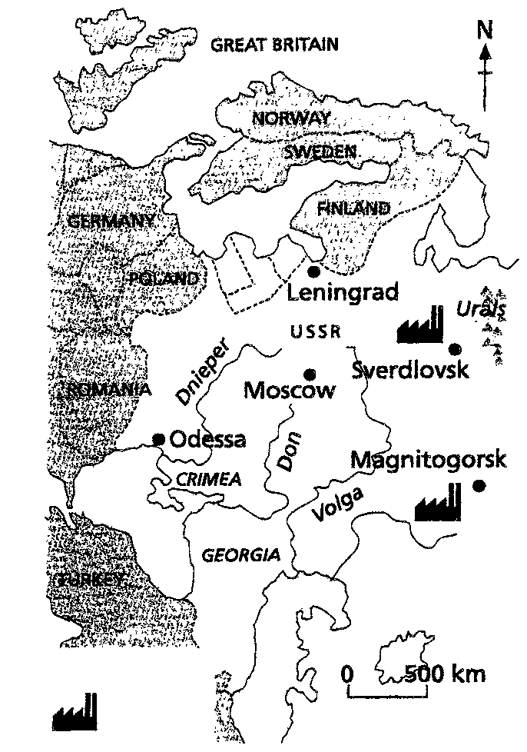
Scale
Key
New
Industry

“By the late 1930s many Soviet workers had improved their conditions by acquiring well-paid skilled jobs and earning bonuses for meeting targets. Unemployment was almost non-existent. In 1940 the USSR had more doctors per head of populations than Britain. Education became free and compulsory for all and Stalin invested huge sums in training schemes based in colleges and in the workplace.
But on the other hand life was very harsh under Stalin. Factory discipline was strict and punishments were hard. Lateness or absences were punished by sacking, and that often meant losing your flat or house as well. To escape the hard work and hard discipline workers tried to move to other jobs, so the secret police introduced internal passports, which prevented free movement of workers inside the USSR.
On the great engineering projects such as dams and canals, many of the workers were prisoners who had been sentenced to hard labour for being political opponents, or suspected opponents of Stalin, for being kulaks or Jews.
[Ben Walsh, Modern World History, 1998]

“The Soviet people sincerely believed in Stalin and this belief was built up quite deliberately by Communist leaders and by Stalin himself. It developed into what is known as the Cult of Personality. The history of the Soviet Union was rewritten so that Lenin and Stalin were the only real heroes of the Revolution.”
[Ben Walsh, Modern World History, 1998]

OR

QUESTION 2
THE RISE OF THE SUPER POWERS: THE USA

Although Charles Dickens referred to the times of the French Revolution when he wrote, “it was the best of times, it was the worst of times”, his statement aptly describes the American economy and society of 1922 to 1932.
The rapid growth of the American economy between 1922 and 1929 was followed by the worst years as depression hit America from 1929 to 1932.

2.1 Discuss the reasons for both the “best of times” and “worst of times”. | (40)

2.2 Do you think that F. D. Roosevelt’s New Deal dealt with the problems facing America in the 1930s? To answer this question, critically analyse the following source material relating to the effectiveness of the New Deal. | (20)  [60]

“The New Deal was nothing more or less than an effort to take away from the thrifty what the thrifty and their ancestors have accumulated, or may accumulate, and give it to others who have not earned it and never will earn it, and thus indirectly destroyed the incentive for all future accumulation. Such a purpose is in defiance of all the ideas upon which our civilisation has been founded.”

[A Republican opponent of the New Deal speaking in 1935]

I hope THIS will
Make’er work
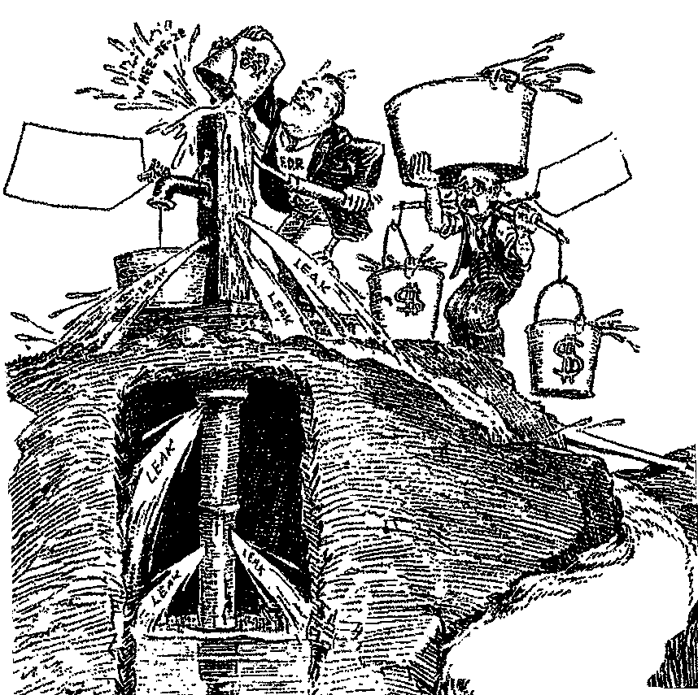

7 THOUSAND

MILLIONS
MORE

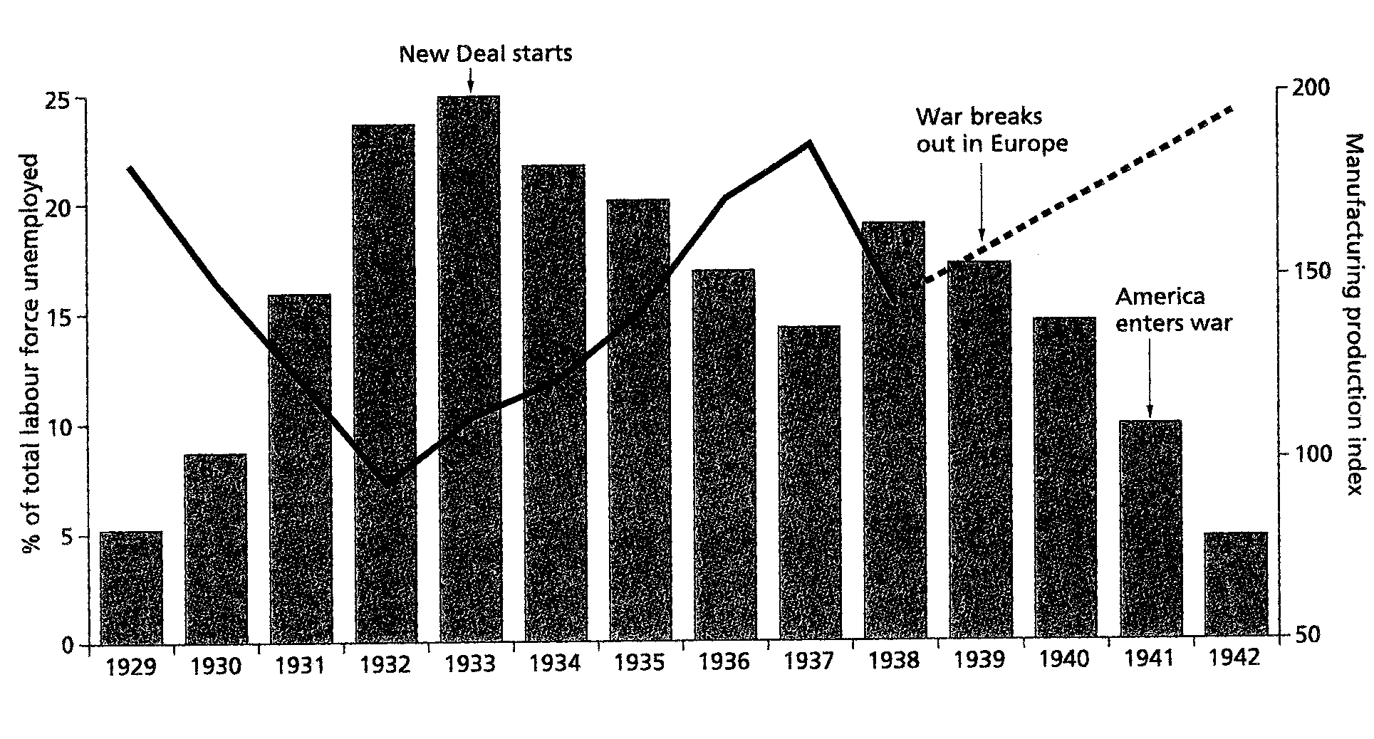
Graph showing the performance of the US economy during the 1930s, and unemployment during the 1930s

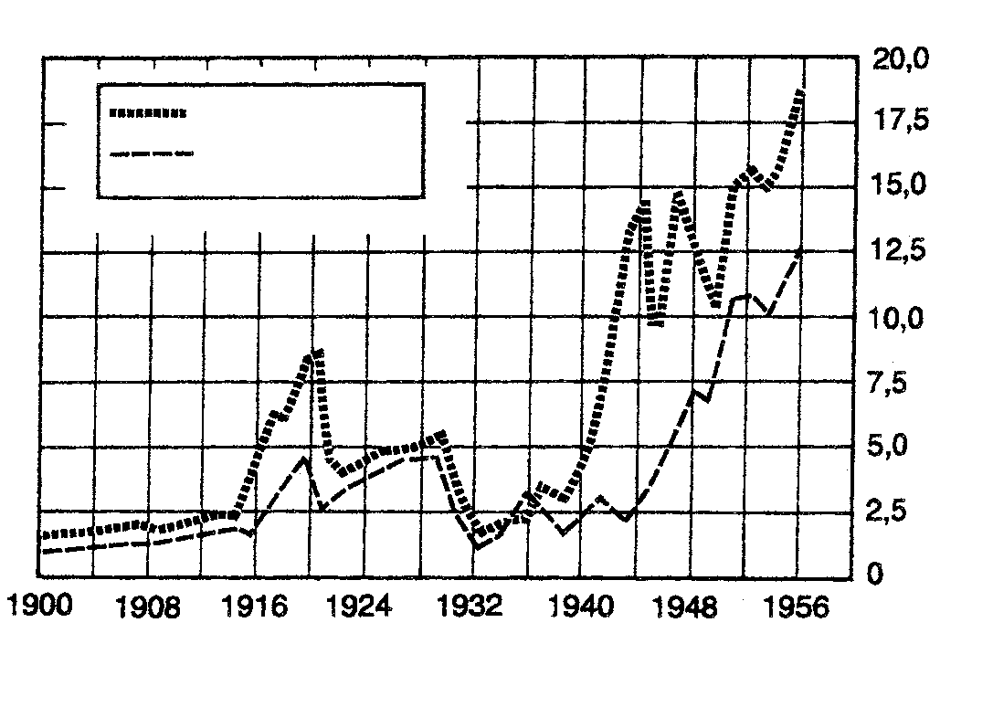

Billions of dollars
Foreign trade, 1900–1956

Domestic exports
Imports for
consumption

“When the New Deal was over, capitalism remained intact. The rich still controlled the nation’s wealth, as well as its laws, courts, police, newspapers, churches, colleges. Enough help had been given to enough people to make Roosevelt a hero to millions, but the same system that had brought depression and crisis – the system of waste, of inequality, of concern over human need – remained.”

[Zinn, historian]

“Roosevelt handed out as much money as he could get away with. When his measures failed to bring immediate results, he spent more. …he was facilitating the economic recovery when in fact his actions prevented swift readjustment. If the government simply let the economy alone, recovery would have been rapid.”

[Noble, Historian]

“The New Deal achieved a just society by recognising groups which had been largely not represented – staple farmers, industrial workers, particular ethnic groups, and the new intellectual-administrative class.”

[Leuchtenburg, historian]

AND

QUESTION 3
COLD WAR IN EUROPE

3.1 Write an essay on the revolts in Hungary and Czechoslovakia against the Soviet domination. | (40)

3.2 Use the following sources and your essay to assess the unity, solidarity, sovereignty and co-operation among the East European states. | (20)  [60]

Nikita Krushchev, 1955:
“We must produce more grain. The more grain there is, the more meat, lard and fruit there will be. Marxist theory helped us win power and consolidate it. Having done this we must help the people eat well, dress well and live well. If after forty years of Communism, a person cannot have a glass of milk or a pair of shoes, he will not believe Communism is a good thing, whatever you tell him.”

Khrushchev, 1956:
“Stalin used extreme methods and mass repressions at a time when the revolution was already victorious … Stalin showed in a whole series of cases his intolerance, his brutality and his abuse of power … He often chose the path of repression and physical annihilation, not only against actual enemies, but also against individuals who had not committed any crimes against the Party and the Soviet government.”

Làszlò Beke, a Hungarian student, 1956:
“Wearing western clothes, interest in jazz, was considered dangerous. To cite a small example: my colleague John showed up at lectures one day in a new suit, a striped shirt and necktie from the United States. His shoes were smooth suede and would have cost one month’s wages in Hungary. After classes John was summoned by the party officer. He received a tongue-lashing and was expelled.”

An Hungarian student describes the mood in 1953:
“Living standards were declining and yet the papers and radio kept saying that we had never had it so good. Why? Why these lies? Everybody knew the state was spending the money on armaments. Why could they not admit that we were worse off because of the war effort and the need to build new factories … I finally arrived at the realisation that the system was wrong and stupid.”

David Irving in “Uprising”:
“If a farmer in the collective farm cannot fulfil his quota each Wednesday he knows that the Communists will give him three days, then send round a ten-man ‘transfer brigade’ of gypsies as bailiffs. They are paid a hundred florins a day to break into the peasants’ homes and strip them of whatever they can find of value. Communism has brought these earthy country folk none of the rewards promised by Marx and Lenin.”

A telex message sent by the Hungarian rebels fighting the Communists, 1957:
“We have almost no weapons, no heavy guns of any kind. People are running up to the tanks, throwing in hand grenades and closing the drivers’ windows. The Hungarian people are not afraid of death. It is only a pity that we cannot last longer. Now the firing is starting again. The tanks are coming nearer and nearer. You can’t let people attack tanks with their bare hands. What is the United Nations doing?”

Lubos Dubrovsky, a Czech writer, May 1968:
“All the different kinds of state in which the Communist Party has taken power have gone through rigged trials… There must be a fault other that just the wrong people were chosen. There must be a fault in the theory itself.”

A Prague radio report, 21 August 1968:
“Yesterday troops from Russia, Poland, East Germany, Hungary and Bulgaria crossed the frontier of Czechoslovakia… The Czechoslovak Communist Party Central Committee regard this act as contrary to the basic principles of good relations between socialist states.”

The Brezhnev Doctrine:
“When internal and external forces hostile to socialism attempt to turn the development of any socialist country in the direction of the capitalist system, when a threat arises to the causes of socialism in that country, a threat to the socialist commonwealth as a whole – it becomes not only a problem of the people of that country but also a general problem, the concern of all socialist countries.”

A Soviet news agency report, 21 August 1968:
“The party and government leaders of the Czechoslovak Socialist Republic have asked the Soviet Union and other allies to give the Czechoslovak people urgent assistance, including assistance with armed forces. This request was brought about … by the threat from counter revolutionary forces … working with foreign forces hostile to socialism.”

[From Ben Walsh: Modern World History.]

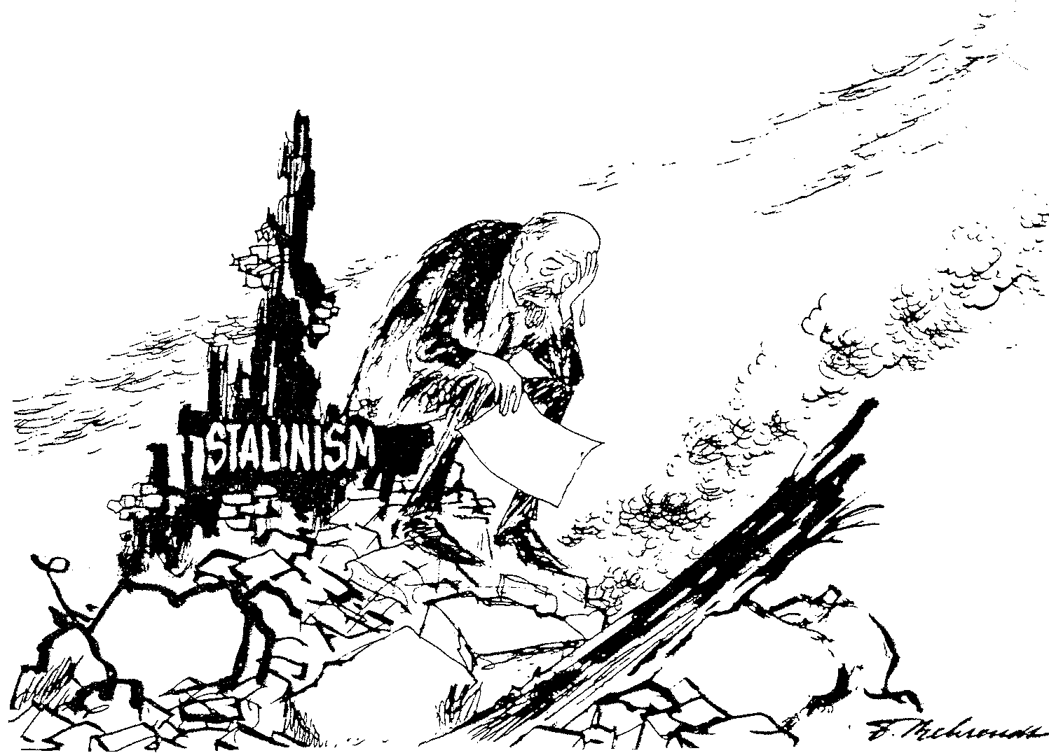

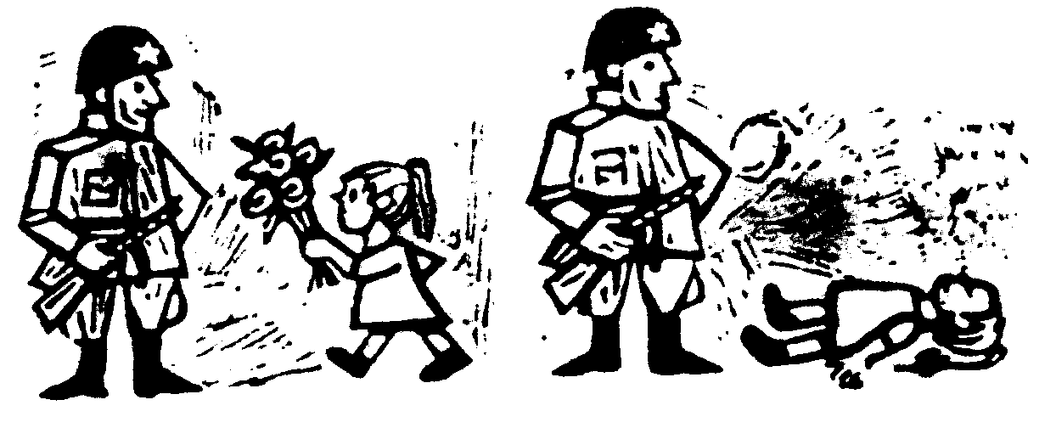
1968
1945
A Street poster
in Prague

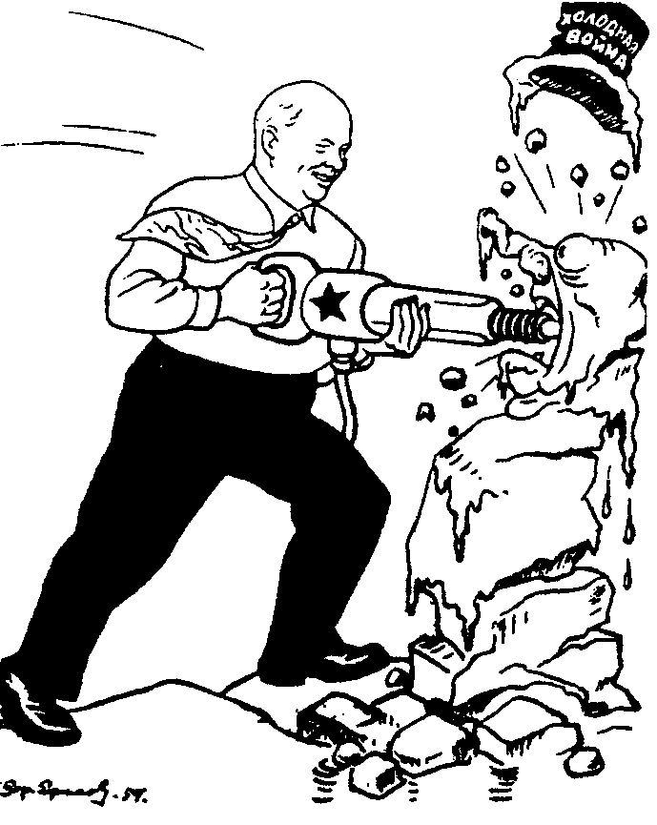
A Soviet cartoon of 1960. Khrushchev is destroying ‘the Cold War’.

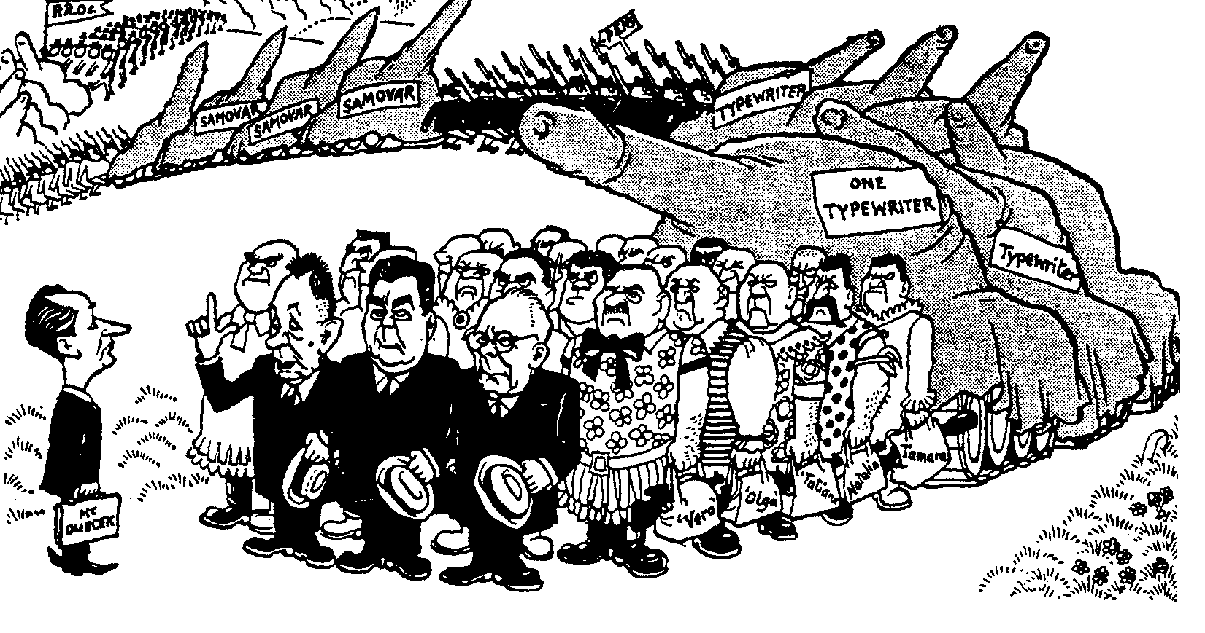
“Of course, Mr. Dubeck, we’ve had to bring a few lady stenographers, one or two secretaries and some tea boys...”

OR

QUESTION 4
AFRICA AFTER THE SECOND WORLD WAR

- “After the withdrawal of the old colonial powers in Africa, a vacuum was left which the Russians and Americans were eager to fill.”  In an essay, explain the involvement of the United States of America and the Soviet Union in Africa after 1945. | (40)

4.2 Use the information given above to analyse the main aims of the USA and Russia in Africa. To what extent were their attempts assisted or thwarted by the attitudes of the African states? | (20)  [60]

A Gavshon, “Crisis in Africa – Battleground of East and West”:
“The objectives of East and West were essentially selfish and contributed little to the urgent need for stability in the region. The consequence of escalating tension was a full-scale arms race in a continent crying out for socio-economic and not military development.”

A Gavshon, “Crisis in Africa – Battleground of East and West”:
“They had to recognise that hungry Africans could no more eat bullets, than they could cure their rampant disease with doses of anti-communist or anti- capitalist medicine.”

A Gavshon, “Crisis in Africa – Battleground of East and West”:
“East and West were using aid to advance or preserve their own interests and to score national or ideological gains.”

Boyce, A N: The Modern World and South Africa:
“During the presidency of Brezhnev, Russia made every effort to gain access to the raw materials of Africa and to expand trade.”
A Gavshon, “Crisis in Africa – Battleground of East and West”:
“In an age of energy shortages and nuclear development; whether for civil or military use, and of technological advances, Africa’s oil, uranium, cobalt, phosphates and other scarce minerals possessed great importance.”

A Gavshon, “Crisis in Africa – Battleground of East and West”:
“Kissinger saw the countries and regions of the Third World in Africa only against the background of the problem of maintaining an American-Soviet balance of power.”

A Gavshon, “Crisis in Africa – Battleground of East and West”:
“Strategically it was essential for the United States navy to retain access to those straits and ‘choke-points’ linking major oceanic routes.”

[Boyce, A N: The Modern World and South Africa]

SECTION B
COMPULSORY

QUESTION 5
NON-ESSAY TYPE QUESTIONS

Information and illustrations pertaining to Section B are to be found in the Addendum on pages 16 – 19. Please detach these pages for easy reference.

5.1 Select the correct answer for each of the following. Write down only the correct letter next to the corresponding number in your answer book, e.g. 5.1.11 A .

5.1.1 Which of the following leaders was not a Fascist?

- Mussolini  - Roosevelt  - Hitler  - Franco | (2)

5.1.2 The Dawes Plan relates to

- political measures.  - a military operation.  - economic measures.  - an election strategy. | (2)

5.1.3 “Manchuria” was the name for the

- capitalists and industrialists who were bent on influencing the Japanese Government to follow a moderate foreign policy.  - militarists who favoured a policy of aggression and violence.  - Chinese province, in which Japan had substantial economic interests.  - army officers for the Japanese government. | (2)

5.1.4 The conservatives and property owners in Italy supported Mussolini because they

- were against the Pope.  - wanted to practice free trade.  - were afraid of having their possessions confiscated.  - believed in Fascism. | (2)

5.1.5 The new Nazi Germany (1932) was known as the

- National German Reich.  - Herrenvolk.  - Second German Reich.  - Third German Reich. | (2)

Select the item which does not fit in each of the following statements. Write only the number of each question in your answer book and next to it the letter of the item which does not fit.

5.1.6 Characteristics of a Totalitarian state:

- Private ownership is prohibited  - Only one political party has the right to exist  - Freedom of the press is prohibited  - Secret police and special military units are used to purge the party of dessenters | (2)

5.1.7 Characteristics of Nazi-Germany:

- The state was ruled by the party and the party by the Führer  - Ernst Röhm remained Hitler’s sternest supporter up to his death  - The Gestapo and the SS troops enabled Hitler to get rid of all his political enemies  - Strasser planned the organisation of the party to the finest detail | (2)

5.1.8 Factors which prohibited Germany and Italy becoming immediate allies after Hitler’s takeover in 1932:

- The first visit by Hitler to Italy was not a great success due to each dictator wanting to be superior to the other  - Mussolini’s fear of a strong rival in Europe  - Hitler was too communistic  - The Austrian Nazi Party attempted to seize power in Vienna in 1934 after murdering Chancellor Dolfuss | (2)

5.1.9 In 1934 Japan issued the Amau Declaration, which amounted to

- a kind of Monroe Declaration for Asia.  - a declaration by Japan that she was the only country that could maintain order in the Far East.  - an idea by Japan to surround herself with several satellite states.  - only the Axis powers being allowed to possess colonies in the Far East. | (2)

5.1.10 Hitler’s aims as ruler of Germany:

- To maintain Germany’s borders like they were in the time of Bismarck  - The destruction of the Peace Treaty of Versailles  - Rearmament of Germany (1935)  - To unite all Germans in a united Germany | (2)  10x2=[20]

5.2 Write a sentence in which the connection between the following sets of items is indicated:

- Hoare and Laval  - Schuschnigg and Seyss-Inquart  - Bohemia and Moravia  - Molotov and Von Ribbentrop  - General Tojo and Pearl Harbour | (2)  (2)  (2)  (2)  (2)  5x2=[10]

5.3 Find a matching item in Column B for each of the items in Column A. Write down only the letter next to the corresponding number in your answer book.

COLUMN A | COLUMN B
- Braunau  - Twenty year armistice  - Herman Göring  - Mussolini  - Japan (1940) | - Avanti  - Nazi propaganda  - Giant of the East  - Establishment of Gestapo  - Period between 1919 and 1939  - Period of fighting  - Hitler’s town of birth | 5x2=[10]

5.4 Use document 1 and the map to answer the following questions:

- Of which party was Hitler the leader?  - What TWO promises did Hitler make in paragraph 3 of document 1 to the German people?  - Name the Field Marshall being referred to in paragraph 5?  - Who was the Nazi vice-Chancellor and Minister of public enlightenment and propaganda in the coalition government formed on 30 January 1933? (See map).  - Name the TWO political training schools established by the Nazi’s. | (1)  (2)  (1)  (1)  (1)  (2)

- What names did the Nazi’s give to the following TWO German cities: Berlin and Munich?  5.4.7 Name the TWO concentration camps established by the Nazi’s in Germany in 1938 after they came to power. | (2)  (2)  [12]

5.5 Use document 2 and cartoon 1 to answer the following questions:

- Supply a heading for document 2.  - When did this meeting take place?  - What agreement existed between Germany and Austria at that time?  - How did Dr Schuschnigg react to German propaganda advocating fusion with Germany?  - What historical event preceded cartoon 1?  - What THREE countries are represented in the cartoon?  - What treaty was concluded between these THREE countries? | (2)  (1)  (2)  (2)  (1)  (3)  (1)
- To which defects of the League was Mussolini referring when he said: ‘The League is contemptible! The League can do nothing.’ (Give TWO examples.)  - Explain Mussolini’s attitude to the League as indicated by his statements and facial expression. | (4)  (2)  [18]

5.6 Use documents 3 and 4 as well as cartoon 2 to answer the following questions:

- What did the SS men do to the prisoners as they jumped from the trucks?  - Where did the prisoners spend the night?  - What type of uniform were the prisoners issued with?  - What was the ‘Crystal Night’?  - After Munich, Chamberlain declared that ‘peace with honour had been obtained’. Is this statement a true reflection? Motivate your answer.  - From which countries were the TWO main figures in cartoon 2?  - Why do the people in the background look so sceptical at what they see?  - Which treaty is involved here? | (1)  (1)  (1)  (1)  (2)  (2)  (1)  (1)  [10]

TOTAL FOR SECTION B: | [80]

TOTAL: | 200

ADDENDUM

Please detach the Addendum (pages 16 – 19) and place alongside the relevant questions in Section B for easy reference.

DOCUMENTS

DOCUMENT 1: Hitler’s broadcast to the German People, 1 February 1933

- More than fourteen years have passed since the unhappy day when dazzled by promises from home and abroad, the German people forgot its most precious possessions, our past, the Empire, its honour and freedom and thus lost everything. Since those days of betrayal the Almighty has withdrawn His blessing from our people. Discord and hatred came among us. With the deepest sorrow millions of the best German men and women from all walks of life saw the unity of the nation flounder and disappear in a confusion of politically egotistical opinions, economic interests and opposing attitudes.

2. So the national government will regard it as its highest and first task to restore the united spirit and will of our people … It will take under its firm protection Christianity, as the basis of our collective morality, and the family as the nurturer of our people and state. It will transcend position and class to bring our people again to an awareness of its national and political unity and the duties arising from this.

3. In fourteen years the November parties have ruined German farming. In fourteen years they have created an army of millions of unemployed. The national government will carry out the following plan with iron resolution and the toughest persistence. Within four years the German farmer must be free from impoverishment. Within four years unemployment must be overcome permanently.

4. In foreign policy the national government will see its highest mission in the preservation of natural rights and thus in regaining the freedom of our people … By its resolution to end the chaotic conditions in Germany, it will help to introduce into the community of nations a state of equal worth and thus of course with equal rights. In doing this it is inspired by the greatness of the duty to support this free nation in maintaining and strengthening, as an equal, that peace which the world needs as never before. Now, German people, give us those four years and then judge us and give your verdict!

- Following the order of the General Marshal (Hindenburg) let us make a start. May Almighty God look graciously on our work, direct our purpose, bless our understanding and enrich us with the trust of our People. For we do not intend to fight for ourselves, but for Germany!

[Max Domarus, Hitler, Reden und Proklamationen, 1932 – 1945, vol 1. (translated by M J Simpson)

MAP

HITLER’S GERMANY

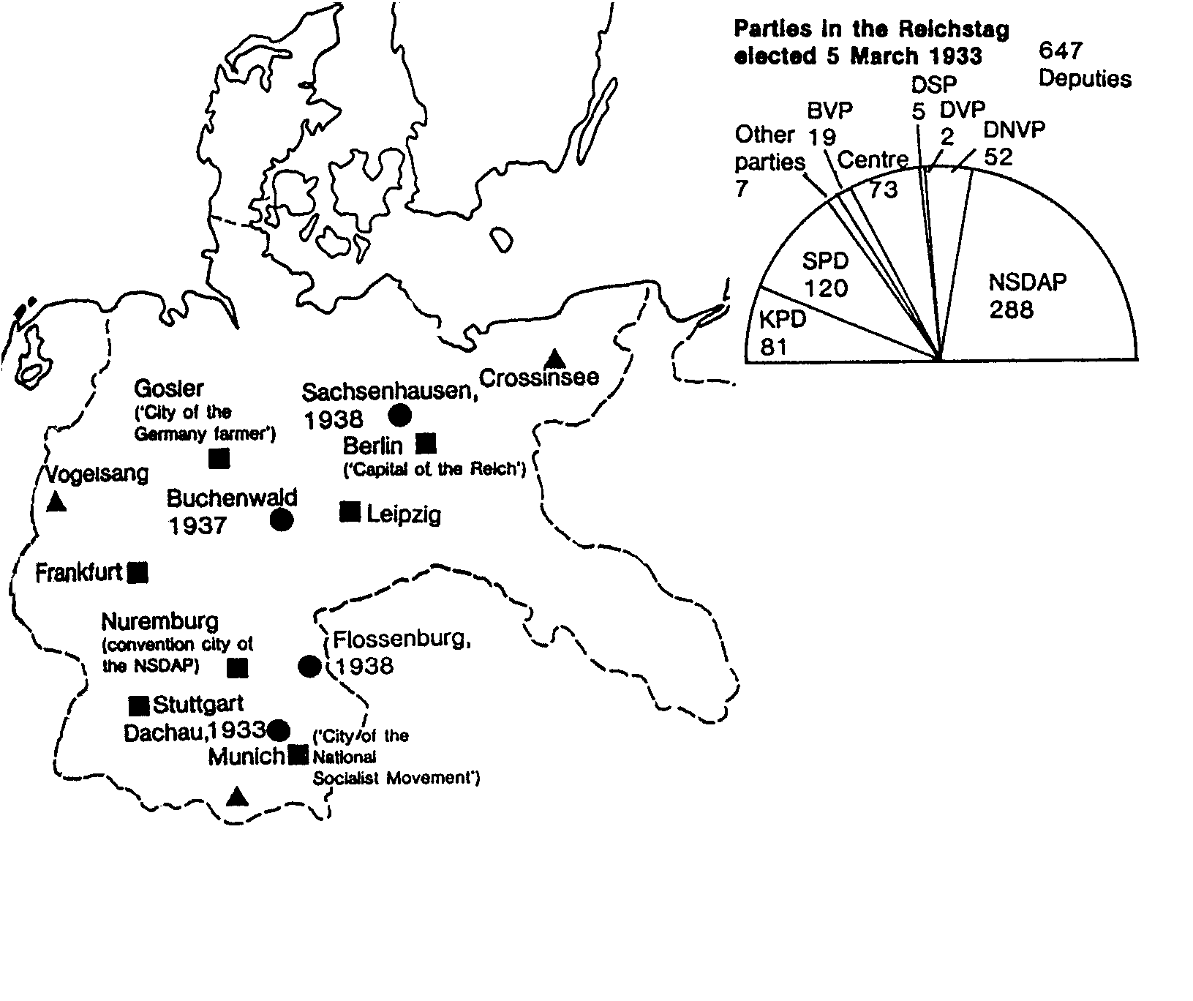
KPD: German Communist Party
SPD: German Social Democratic Party
BVD: Bavarian People’s Party
Centre: Catholic Centre Party
DSP: Germany State Party
DVP: National Liberals
DNVP: Conservatives and Free Conservatives
NSDAP: Nazi, or National Socialist German Workers’ Party
COALITION GOVERNMENT OF
THE ‘NATIONAL ALLIANCE’ FROM
30 JANUARY 1933
▫ Chancellor: Hitler
Vice-Chancellor: van Papen
Foreign Affairs: von Neurath
▫ Interior: Frick
Economic Affairs: Hugenberg
Finance: Schwerin van Korsigk
Defence: von Blomberg
Justice: Gurtner
Malls and Transport: von Eltz Rubenach
Labour: Seidt (Stalheim)
▫ Minister Without Portfolio: Goring
▫ Public Enlightenment and Propaganda:
Goebbels (13 March)
■ Important centres for the
National Socialist state
▲Political training schools
●Concentration camps, with
year of first mention
▫ Ministries given to Nazis

DOCUMENT 2:

Dr. Schuschnigg was invited to Berchtesgaden to discuss with Hitler Austrian-German relations, but on his arrival, an ultimatum is delivered to him, all anti-Nazi activities in Austria had to be stopped and that one of Hitler’s supporters, Dr Seyss-Inquart, be appointed to the post of Interior Minister. In this way Hitler could through one of his sidekicks control public safety in Austria. On his arrival back in Austria Dr. Schuschnigg tried one more time to ensure his country’s independence: he had to decide if his country should join Germany or not. This referendum was never held.

DOCUMENT 3: ‘Crystal Night’

Document 3 is an account by a Jewish man who was arrested and sent to a concentration camp on Crystal Night.

The tenth of November, 1938, was Crystal Night, the occasion on which the Nazi’s orchestrated an attack on Jews throughout Germany, arresting 20 000 and burning and looting Jewish property and synagogues.
On November 10, 1938 a man from the Gestapo … who, incidentally, was very courteous, told me that he had orders to arrest me …. He could give me no reason, but thought I would be back home late in the evening …. In the courtyard of the police headquarters stood hundreds of people, all Jews. Soon we were put in lorries and driven away. No one knew where to. After a lengthy journey through the northern suburbs of Berlin we arrived at the Sachsenhausen concentration camp. As we were made to jump from the trucks in the dark, we were met by S.S. men with blows to the head, kicks, and jabs with their rifle-butts. We stood the whole night on the huge parade ground. No one was allowed to break rank. More truck loads arrived every few minutes. In the early hours of the morning we were led into a barrack block and ordered to strip. Money and valuables were taken away though we got receipts for them. Stripped bare, we went into the next room, where our heads were shorn. In a third room we were issued with light underwear as well as with a blue and white striped canvas uniform….

While we were standing there the S.S. men amused themselves by punching or kicking us at will….

DOCUMENT 4: The end of Czechoslovakia

In March 1939 he rejected the Munich agreement as “a worthless piece of paper”. German troops were gathered at the border and on 14 March the president of Czechoslovakia, Dr. Emil Hacha was ordered to Berlin where he handed his country over to Germany. The next day German troops crossed the border and that was the end of Czechoslovakia’s independence. “It was the end of the twenty year old republic, which was destroyed, like Austria, through internal struggles incited by a powerful and a conscienceless neighbour.

CARTOON 1
THE JUSTICE AND INJUSTICE OF ABYSSINIA

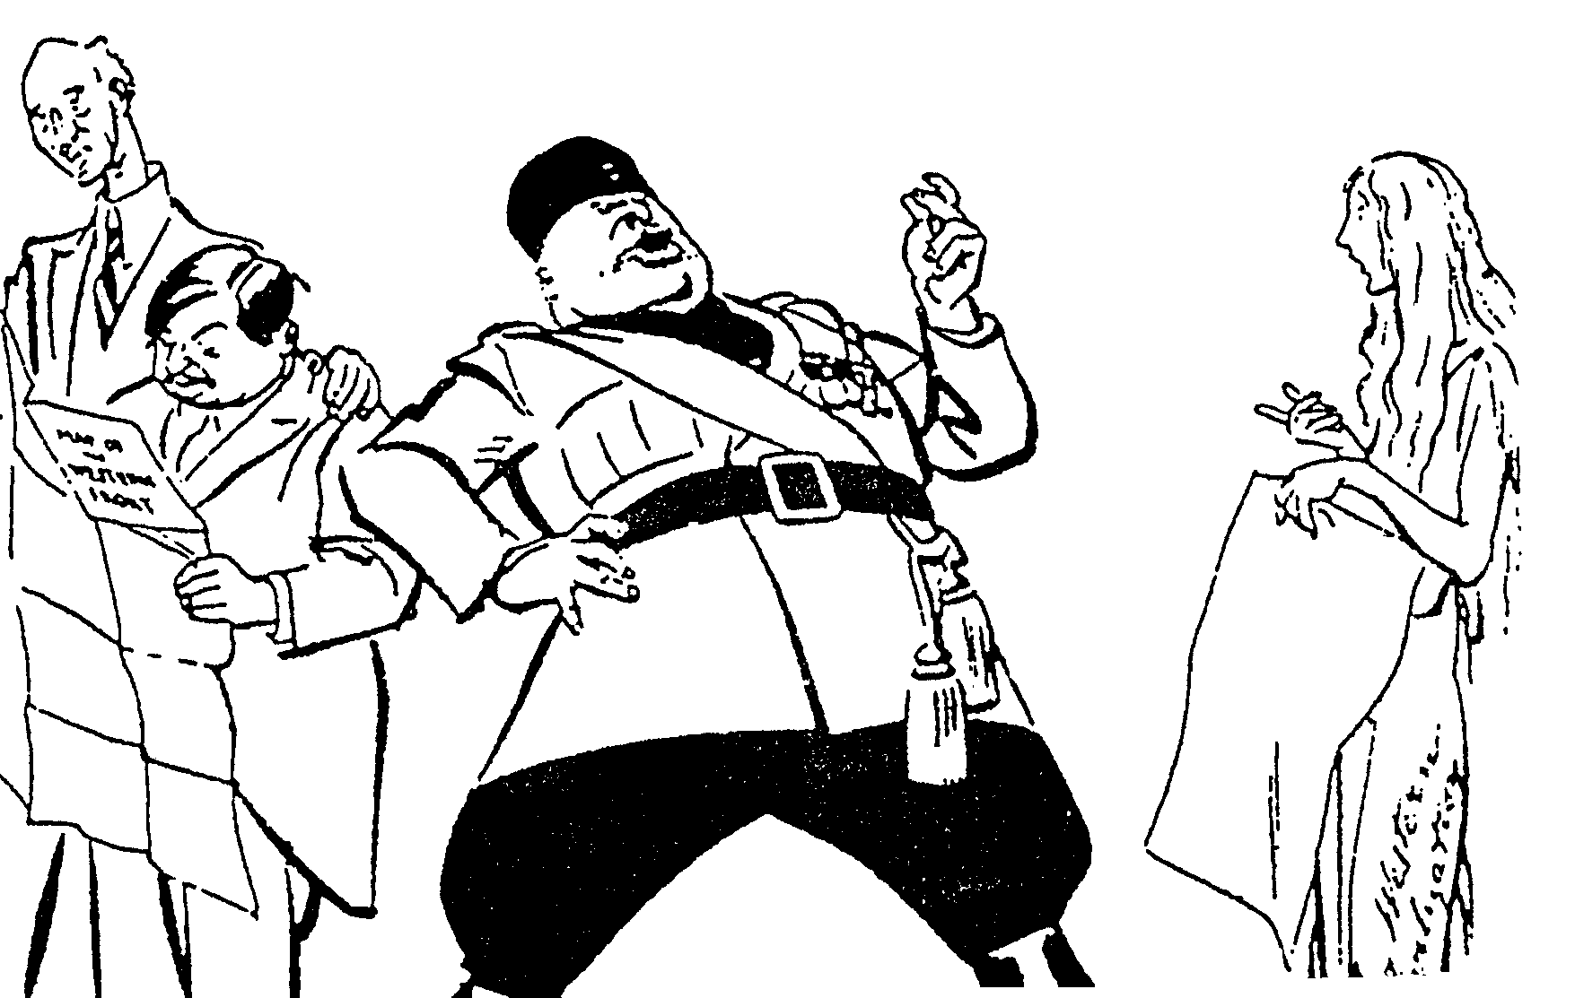

THE LEAGUE? PAH! THE LEAGUE IS CONTEMPTIBLE
THE LEAGUE CAN DO NOTHING!
BUT AREN’T
YOU THE
LEAGUE?

Terreblanche, Illsley: “Help-U-History Gr 12”

CARTOON 2

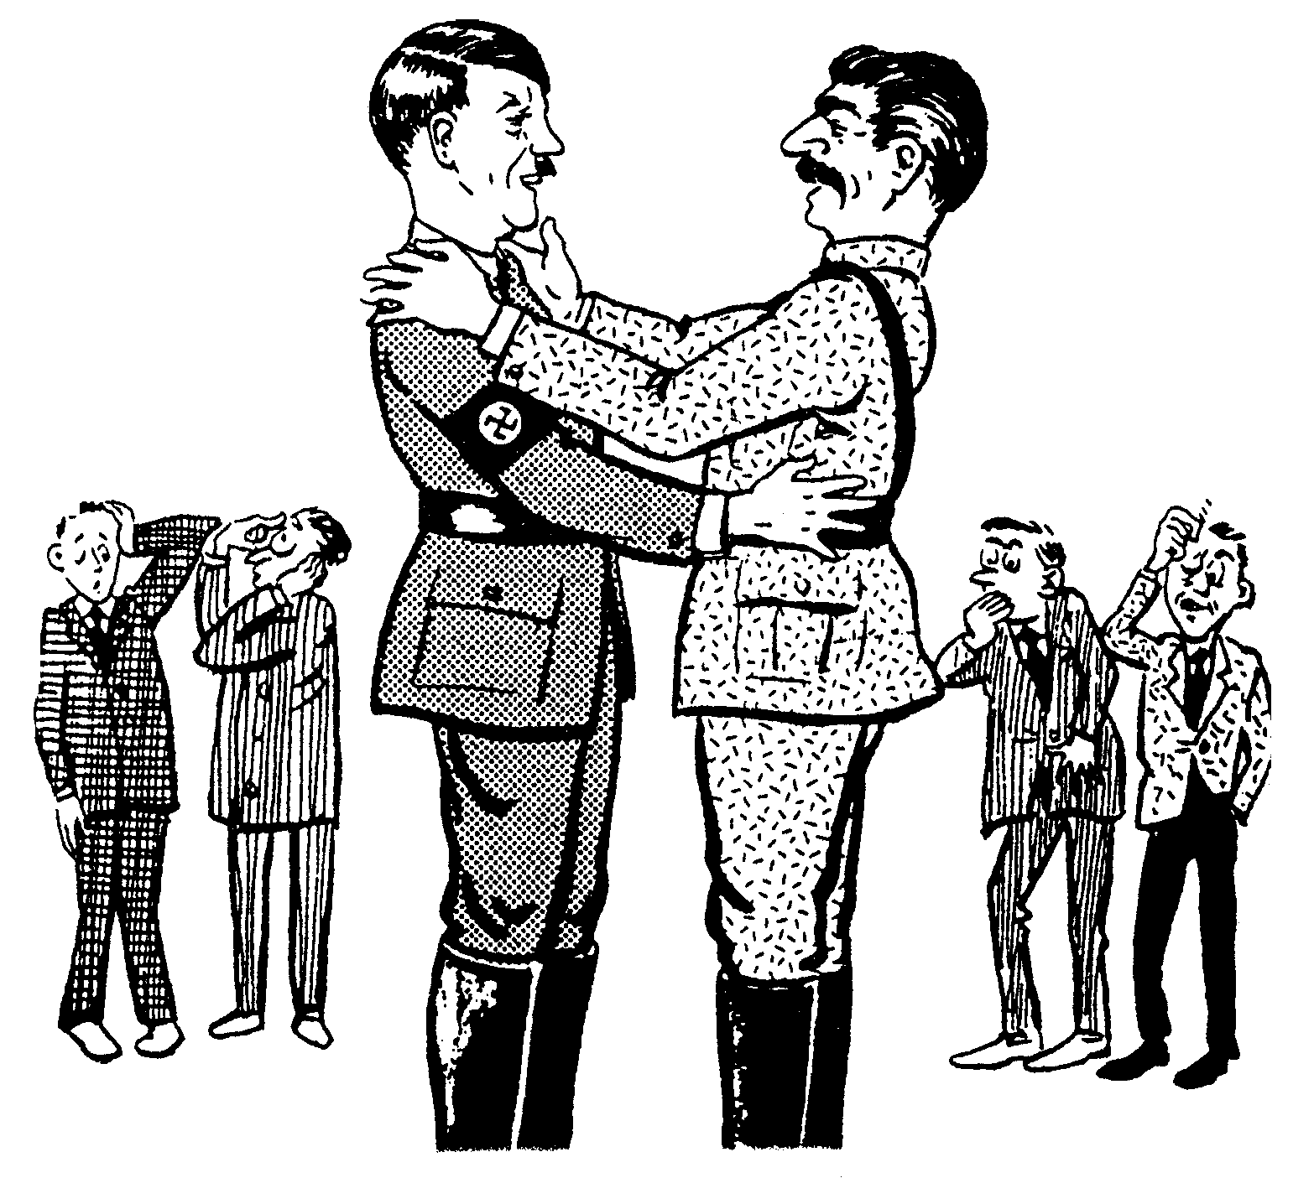
A
B

Roestorff, Schnetter: “Masterning General History”

