GAUTENG DEPARTMENT OF EDUCATION

SENIOR CERTIFICATE EXAMINATION

HISTORY SG
(Second Paper: South African History)

TIME: 2 hours

MARKS: 150
INSTRUCTIONS:

- Answer ANY TWO essay type questions from Section A.

- Section B is COMPULSORY. Answer ALL the questions in this section.

- The Addendum (pages 6 to 8) contains illustrations and information which pertain to Section B. You are advised to detach the Addendum and place it alongside the relevant question for easy reference.

- All questions and sub-sections must be numbered accurately.

- Spend 40 minutes on each question.

SECTION A  ESSAY TYPE QUESTIONS  Answer ANY TWO questions. Spend 40 minutes on this section.  QUESTION 1  Describe how the formation of the coalition government in 1933 led to fusion of the South African Party and the National Party in 1934 and the split that occurred as a result of it. | [40]

QUESTION 2  Describe Smuts’s term of office between 1939 – 1947 and specifically his involvement in  - the Second World War.  - Racial Policy.  - the UNO. | [40]

QUESTION 3  Explain the struggle of blacks against the apartheid policy of the National Party government between the period 1949 to 1961. | [40]

QUESTION 4  Describe how the National Party tried to implement the policy of separate development from 1959 to 1971 and also state whether they were successful or not.  TOTAL FOR SECTION A: | [40]  [80]

SECTION B

SHORT AND INTERPRETATIVE QUESTIONS
COMPULSORY

Information and illustrations pertaining to Section B are to be found in the Addendum on pages 6 to 8. Please detach these pages for easy reference.
Spend 40 minutes on this section.

QUESTION 5

5.1 Examine the cartoon (Source A) in the Addendum on page 6 and answer the questions that follow.

Describe and explain clearly what is portrayed in the cartoon (Source A).  - What comment on apartheid is being made in this cartoon – and what laws are being referred to especially? Explain this in some detail.  - What is the cartoonist’s view towards his subject-matter? Explain this and justify your answer. | (6)  (4)  (4)

Refer to the Addendum

5.2 Examine the four photographs shown in Sources B, C, D and E on the Addendum on page 7. Identify the people portrayed in each source and then explain clearly what role they played in promoting apartheid, or in the anti-apartheid struggle. | 4x3=(12)

5.3
- Name and explain THREE steps taken by Strijdom that helped to bring about a republic in South Africa.  - Explain the steps taken by Verwoerd that finally led to South Africa leaving the British Commonwealth in 1961.  - Name and explain TWO steps taken by Malan to remove the Coloured vote from the Common Voter’s roll in South Africa. | 3x2=(6)  3x2=(6)  2x3=(6)

Refer to the Addendum

5.4 Read the passage (Source F) on page 8 and answer the questions that follow:

- Name TWO ways in which Source F justifies the implementation of apartheid.  - Name and explain briefly TWO major laws which brought about the system of apartheid.  - Imagine you are a black nationalist leader in the 1950’s. Write an argument criticising the policy of apartheid and state why you believe the justifications given in Source F are invalid. | 2x2=(4)  2x2=(4)  2x2=(4)

5.5 Answer the following questions by simply writing down the correct letter next to the corresponding number in your answer book:

    - The act that removed black and coloured people from places like Sophiatown and District 6 was
- the Homelands Citizenship Act.
- the Resettlement of Natives Act.
- the Urban Areas Amendment Act.
- the Trust and Land Act.

    - Higher education in South Africa was changed by
- the Bantu Authorities Act.
- the Bantu Education Act.
- the Extension of University Education Act.
- the Native Resettlement Act.

    - The last governor-general of South Africa was
- Swart.
- Verwoerd.
- Jansen.
- Dönges.

    - The president of the ANC who won the Nobel peace prize, was
- Tutu.
- Luthuli.
- Xuma.
- Moroka.

A republic in South Africa was agreed upon after
- a proclamation by the State President.
- a referendum amongst the whites.
- a general vote in both houses of parliament.
- a general election held in 1960.

An incident that did not bring South African whites together before the gaining of a republic:
- Macmillan’s “Winds of Change” speech
- Pratt’s attempt on Verwoerd’s life
- The Sharpeville and Langa incidents

The outcome of the Rivonia trial

- A black homeland which never became independent was  - Kwazulu.  - Transkei.  - Venda.  - Bophuthatswana.  TOTAL FOR SECTION B:  TOTAL: | 7x2=(14)  [70]  150

ADDENDUM
ticket office/ kaartjie kantoor

Please detach this Addendum (pages 6 – 7) and place alongside the relevant questions in Section B for easy reference.
Maak asseblief hierdie bladsye (6 – 7) los en plaas dit naas die betrokke vrae in Afdeling B vir maklike verwysing.

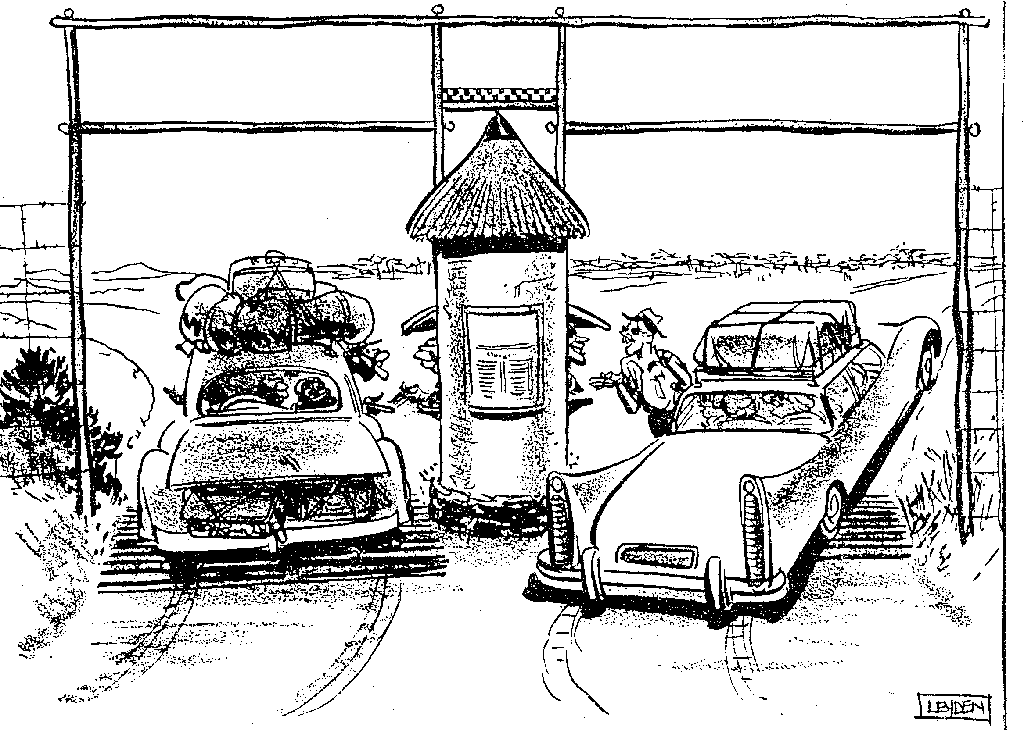
NON-EUROPEAN ENTRANCE/NIE-BLANKE INGANG
Keep left to the Black Rhinos and Black Umfolosi River /Hou links na die swart-renosters en swart Umfolozi-rivier
EUROPEAN ENTRANCE/BLANKE INGANG
Keep right to the White Rhinos
and White Umfolosi River/Hou regs na die witrenosters en wit Umfolozi-rivier
game reserve / wildreservaat
By Order
By Order

Source A / Bron A

Map : Game Reserve / Kaart : Wildreservaat

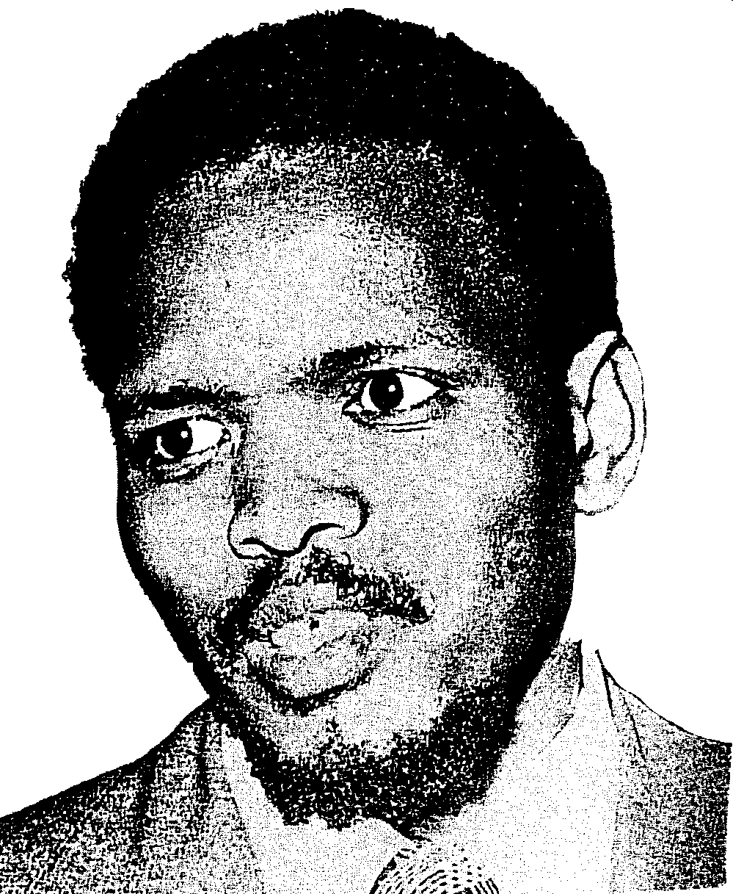
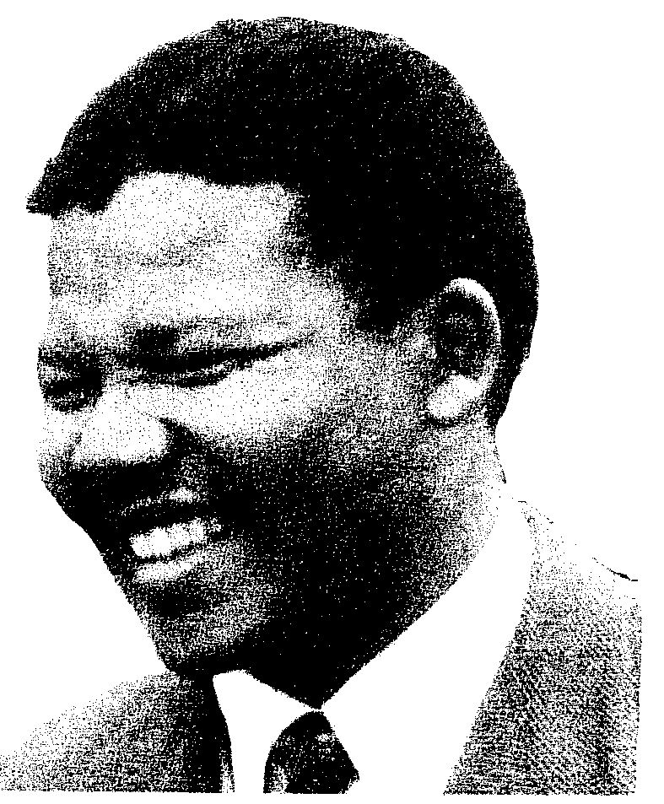
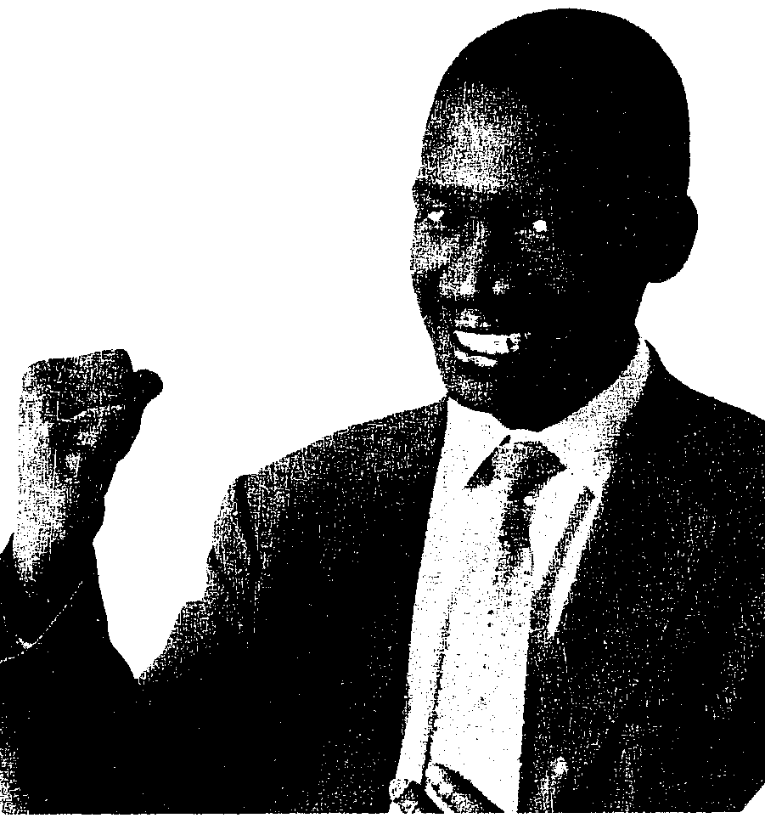

Source D / Bron D
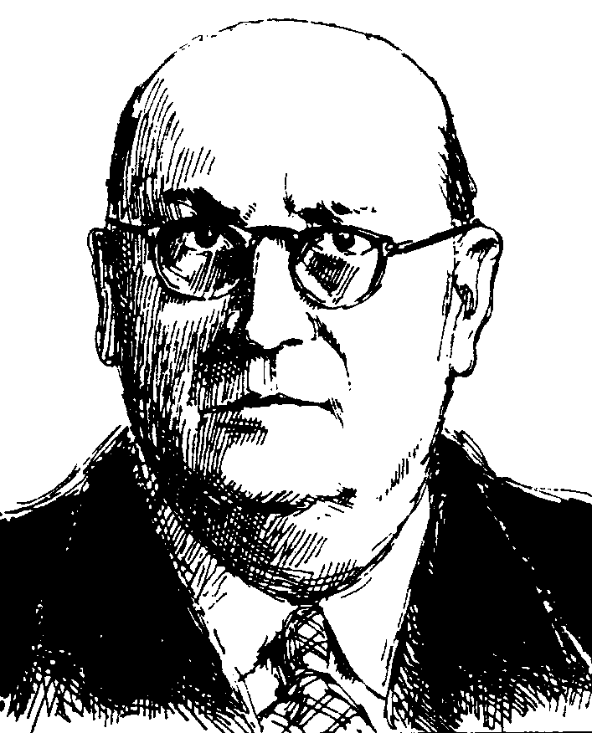

Source B/ Bron B

Source C/ Bron C

Source E / Bron E

Source F/ Bron F

5.4

“The word ‘apartheid’ was first used in discussions about politics and race in the 1930s by Afrikaner thinkers who led the Afrikaner nationalist revival of those years. Their main message was that the races in South Africa needed to be separated more, not less. For them, the history of South Africa proved that different races could not live together in peace. One race was bound to bully the others and close contact between the races always caused fear and hatred. The only way forward for South Africa was for the different races to live apart and develop their lives separately.”

“Die woord ‘apartheid’ is aanvanklik gebruik in besprekings oor politiek en ras in die 1930’s deur Afrikanerdenkers wat die Afrikaner Nasionalistiese herlewing van daardie jare gelei het. Hulle doelstelling was om die rasse in Suid-Afrika nog verder te skei. Hulle wou bewys dat volgens Suid-Afrika se geskiedenis, die verskillende rasse nie saam in harmonie kon leef nie. Een ras was geneig om die ander te boelie en te intimideer en interaksie tussen die rasse het angs en haat meegebring. Die doelbewuste skeiding en aparte ontwikkeling was die enigste weg vorentoe vir Suid-Afrika.”

