GAUTENG DEPARTMENT OF EDUCATION

SENIOR CERTIFICATE EXAMINATION

HISTORY SG
(Second Paper: South African History)

TIME: 2 hours

MARKS: 150
INSTRUCTIONS:

- Answer ANY TWO essay type questions from Section A.
- Section B is COMPULSORY. Answer ALL the questions in this section.
- The Addendum (pages 6 to 8) contains illustrations and information which pertain to Section B. You are advised to detach the Addendum and place it alongside the relevant question for easy reference.
- All questions and sub-sections must be numbered accurately.
- Spend 40 minutes on each question.

SECTION A  ESSAY TYPE QUESTIONS  Answer ANY TWO questions. Spend 40 minutes on this section.  QUESTION 1  Describe how Hertzog managed to achieve South Africa’s sovereign independence between 1926 – 1934 by referring to the following:  - 1926 Imperial Conference  - Department of External Affairs  - Statute of Westminster, 1931  - Status and Seals Act, 1934 | [40]

QUESTION 2  Discuss the United Party’s segregation policy and resistance to it from 1936 – 1946 under the following headings:  - Native Land and Trust Act 1936, Native Representation Act  - Reaction of the ANC, Coloureds and Indians | [40]

QUESTION 3  Discuss how the National Party tried to impose apartheid from 1949 to 1956 by means of introducing laws that kept black and white apart. | [40]

QUESTION 4  Describe the roles played by Verwoerd and Mandela to enforce or to resist apartheid, up to approximately 1966.  TOTAL FOR SECTION A: | [40]  [80]

SECTION B

SHORT AND INTERPRETATIVE QUESTIONS
COMPULSORY

Information and illustrations pertaining to Section B are to be found in the Addendum on pages 6 to 8. Please detach these pages for easy reference.
Spend 40 minutes on this section.

QUESTION 5

Examine the cartoons given in Sources A and B in the Addendum on page 6+7 and answer the questions that follow

- Describe what is happening in each of the cartoons (Sources A and B).  - Describe the attitude of the cartoonist towards the subject-matter in each of the cartoons. Justify your answer.  - How would these cartoons have been viewed by many white South Africans during the 1970s? Justify your answer. | 2x3=(6)  2x2=(4)  (4)

Study the Homelands map (Source C) on page 7 and answer the questions that follow

- Name the homelands listed as numbers 1, 5, 6 and 7 and name the tribe that was designated to live in these homelands according to the National Party government.  - Identify a major weakness of the homelands which could be one factor why they were not recognised as truly independent states. | 4x2=(8)  (2)

Read the passage (Source D) on page 8 and answer the questions that follow

What happened in Soweto in 1976?  - Describe some of the incidents that occurred in Soweto during this time.  - What caused the events as described in Source D, to happen?  - Name and explain some of the results of this. | (2)  (4)  (4)  (4)

5.4 5.4.1 Name and explain THREE steps taken by Malan that helped to bring about a republic in South Africa.  - Explain THREE steps taken by Verwoerd that finally led to a republic being achieved in South Africa.  - Name and explain THREE steps taken by Strijdom to remove the Coloured vote from the common voters’ roll in South Africa. | 3x2=(6)  (6)  3x2=(6)

5.5 Answer the following questions by simply writing down the correct letter next to the corresponding number in your Answer Book.

    - A major document drawn up at Kliptown in 1955 was known as the
- “Winds of Change” speech.
- Freedom Charter.
- M.K. Manifesto.
- Tricameral Petition.

    - An organization not opposed to the removal of the Coloured vote was
- FRANC.
- the Black Sash.
- the New Order.
- the Torch Commando.

    - A leader in the march of the women on the Union Buildings in 1956 was
- Winnie Mandela.
- Helen Suzman.
- Sheena Duncan.
- Lillian Ngoyi.

    - At Sharpeville in 1960,
- protestors opened fire on the police.
- a meeting to protest against the Rivonia Trial laws was held.
- many people demonstrating were shot in the back.
- there were protests against the use of Afrikaans in education.

The organization most associated with Steve Biko is  - the Black Consciousness Movement.  - the PAC.  - Umkhonto we Sizwe.  - POQO. | (2)

South Africa became a republic on
- 30 May 1960.
- 31 May 1960.
- 31 May 1961.
- 30 May 1961.

- The first homeland to be granted “independence” by the South African government, was  - Bophuthatswana.  - Venda  - Ciskei  - Transkei.  TOTAL FOR SECTION B:  TOTAL: | 7x2=(14)  [70]  150

ADDENDUM

Please detach these pages and place alongside the relevant questions in Section B for easy reference.
Maak asseblief hierdie bladsye los en plaas dit naas die betrokke vrae in Afdeling B vir maklike verwysing.

Source A – Map / Bron A – Kaart

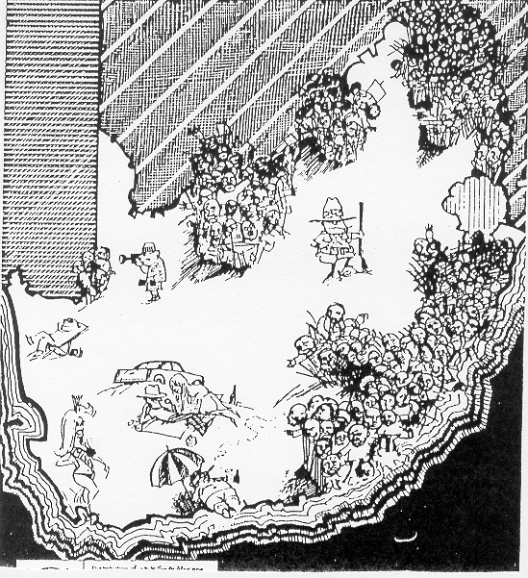

Source B – Cake / Bron B – Koek
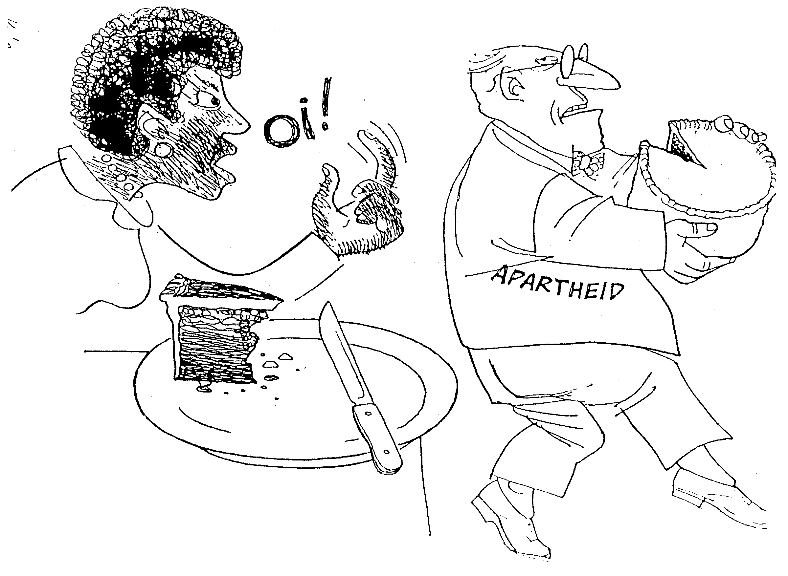

5.2 Source C / Bron C
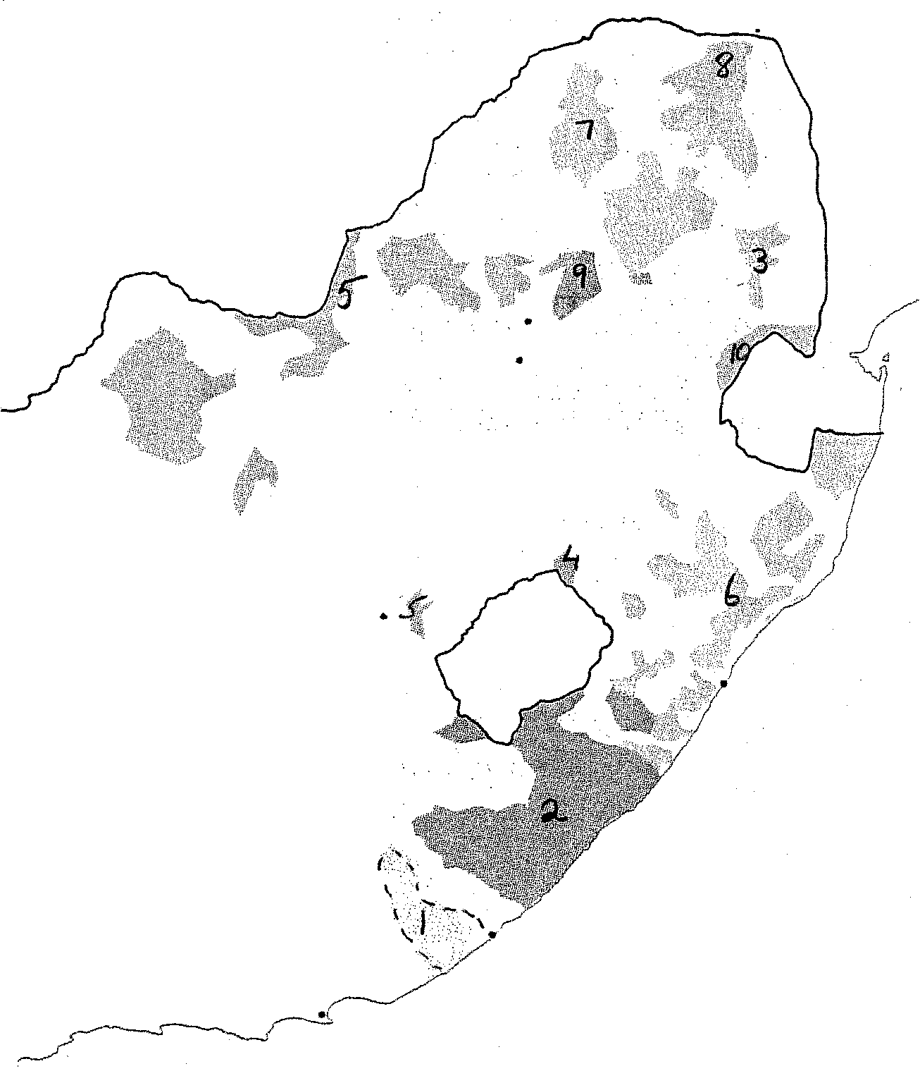
Port Elizabeth
East London
Oos-Londen
Durban
Bloemfontein
Johannesburg
Pretoria

* (Martin Roberts: South Africa 1948-1994: LONGMAN)

Source D / Bron D

‘The police, addressing us first in Afrikaans and then in broken Zulu, tried to order us to disperse. But we had grievances which could no longer wait. We surged forward, aiming to sweep them out of our path if they would not give way. By now, our frienzied numbers had swelled and swelled. We shouted “Amandla” (Power), “Inkululeko ngoku” (Freedom in our lifetime) and “One Azania, one nation” as we marched on, our clenched fists held high.’ /

‘Die polisie het ons eers in Afrikaans en daarna in gebroke Zoeloe toegespreek en ons versoek om uitmekaar te gaan. Maar ons het griewe gehad wat nie langer uitgestel kon word nie. Ons het vorentoe gedring en ons doel was om hulle uit die weg te loop indien hulle nie wou padgee nie. Teen hierdie tyd het ons getalle geweldig vermeerder. Ons krete was “Amandla” (Krag vir die massas), “inkululeko ngoku” (Vryheid in ons leeftyd) en “Een Afrika, Een Nasie” terwyl ons met gebalde vuiste vorentoe gemarsjeer het.’

(From M.V.Mzame: Children of Soweto, 1982)

