GAUTENG DEPARTMENT OF EDUCATION
SENIOR CERTIFICATE EXAMINATION

HISTORY SG
(First Paper: General History)

TIME: 2½ hours

MARKS: 150

INSTRUCTIONS:

- This paper consists of two sections:

▲ Section A consists of four essay type questions. Candidates may answer ANY TWO essays. Do not use headings or point form in your essays.

▲ Section B consists of COMPULSORY short questions. Candidates must answer ALL the short questions.

- The Addendum (pages 9 – 13) contains information and illustrations which pertain to Section B. You are advised to detach the Addendum and place each page alongside the relevant question(s) for easy reference.

- Write as clearly and neatly as possible.

- Answers must be clearly and accurately numbered.

SECTION A  ESSAY TYPE QUESTIONS  Answer any TWO questions from this section.  QUESTION 1  THE RISE OF THE SUPER POWERS: USSR  Outline how Lenin, by means of the October Revolution in 1917, succeeded in carrying out a coup d’ etat in Russia, and then discuss the civil war in Russia and war communism. | [40]

QUESTION 2  THE RISE OF THE SUPER POWERS: THE UNITED STATES OF AMERICA  Explain the measures introduced under the New Deal to solve the unemployment problem, to assist the farmers and to combat poverty in the USA. | [40]

QUESTION 3  INTERNATIONAL RELATIONS AND EVENTS, 1945 TO 1970: THE COLD WAR IN EUROPE  - Explain what you understand by the term Cold War.  - Discuss the USA policy of containment and the reaction of the USSR thereto with reference to:  - The First Berlin crisis  - The establishment of NATO and the Warsaw Pact | [40]

QUESTION 4  INTERNATIONAL RELATIONS AND EVENTS, 1945 TO 1970: AFRICA SINCE THE SECOND WORLD WAR  - Discuss the strengths and weaknesses of the Organisation for African Unity, using the following headings:  - Decolonisation  - Steps against Southern Africa  - Non-Alignment  - Lack of unity  - Internal unrest  - Liberation organisations  4.2 What are the aims and principles of the OAU? Discuss.  TOTAL FOR SECTION A: | [40]  [80]

SECTION B  COMPULSORY  Information and illustrations pertaining to Section B are to be found in the Addendum on pages 9 – 13. Please detach these pages for easy reference.  QUESTION 5  NON-ESSAY TYPE QUESTIONS  - Select the correct answer for each of the following. Write down only the correct letter against the corresponding number in your answer book, e.g. 1A, 2B, 3C.  5.1.1 In 1933 ________ became Chancellor of Germany.  A. Bruning  B. Von Schleicher  C. Hitler  D. Von Papen | (2)

5.1.2 The leader of Italy in 1929 was  - Matteoti.  - Mussolini.  - Gioletti.  - Victor Emmanuel II. | (2)

5.1.3 In 1929 Japan was in possession of _____ on the Asian continent.  - the Philippines  - Manchuria  - Thailand  - Korea | (2)

- The “Zaibatsu” was the name for the _____ in Japan before World War II.  - wealthy industrialists  - monarchists  - military commanders  - liberal parliamentarians | (2)

- On 1 September 1939 the Nazi Air Force bombarded the Polish capital  - Prague.  - Vienna.  - Warsaw.  - Bucharest. | (2)

Select the item which does not fit in each of the following statements. Write down only the letter against the corresponding number in your answer book.  - The economic symptoms of the Great Depression (1929 – 1932) on Germany:  - Reduction in trade and production made it impossible for Germany to support herself.  - There was a drop in prices and wages.  - There was no loss of jobs.  - Foreign loans were not available. | (2)

- Steps taken by Hitler to change the terms of the Treaty of Versailles:  - Request to occupy the Polish Corridor  - Annexation of Bohemia and Moravia  - Re-armament  - Militarisation of the Rhineland | (2)

- Italian colonies in 1939:  - Somalia  - Libya  - Abyssinia  - Tunisia | (2)

- Dictatorships in Europe by 1939:  - France  - Italy  - USSR  - Germany | (2)

- Territories and places attacked and conquered by Japan by the end of 1941:  - Pearl Harbour  - Manchuria  - Pakistan  - China | (2)

5.2 Use Documents 1, 2, 3 and 4 to assist you in answering the following questions. Write down only the letter against the corresponding number in your answer book.

- Country in Europe of which the independence had to be honoured by Germany according to the Treaty of Versailles:  - England  - France  - Austria  - Czechoslovakia | (2)

- Country from which Germany was not allowed to occupy any territory in this country according to the Treaty of Versailles:  - Poland  - Austria  - Rhineland  - Saar | (2)

- Territory which Germany had to give to France:  - Rhineland  - Austria  - Czechoslovakia  - Alsace-Lorraine | (2)

- The territory which was militarised by Germany in 1936:  A. Alsace-Lorraine  B. Rhineland  C. Saarland  D. Austria | (2)

- The president of the Reichstag in 1936  - Von Ribbentropf  - Goebbels  - Göring  - Hess | (2)

5.3 Find a matching item in Column B for each of the items in Column A. Write down only the question numbers in your Answer Book and next to each the letter from Column B that matches it. Use Documents 1, 2, 3 and 4 to assist you in finding some of the answers.

There are questions to which the answers are not in the documents.

COLUMN A | COLUMN B
5.3.1 Anti-Comintern Pact | - The Nazi manner of acknowledging the Fϋhrer
5.3.2 National-Socialist Party | - Invaded by the Japanese army
5.3.3 Munich agreement | - The ruling party in Italy in 1935
5.3.4 Goebbels | D. The day when Nazi Germany commemorated their soldiers who died in World War I
5.3.5 Mussolini | E. Was previously known as the National Socialist German Workers’ Party
5.3.6 Treaty of Saint-Germaine | F. II Duce
5.3.7 Manchuria | - Germany and Japan
5.3.8 “Heil” | - Sudetenland given to Germany
5.3.9 Fascist Party | - The treaty signed with Austria after World War I.
5.3.10 Heroes’ Day | J. The Nazi minister of propaganda
10x2=(20)

5.4 Use Documents 1, 2 and 3, the Map and Cartoon 1 to answer the following questions:

5.4.1 In which territory is the goose walking? | (1)

5.4.2 Which country is depicted by the goose? | (1)

5.4.3 What is depicted by the goose? | (1)

5.4.4 Why is the goose carrying so many weapons? | (1)

5.4.5 Name any TWO European countries located on the western borders of the territory in which the goose is walking. | (2)

5.4.6 What action did Hitler take to determine if the German population supported his action in this territory? | (1)

5.4.7 Which flag is hanging outside the building behind the goose? | (1)

5.4.8 Did the representatives of the Reichstag approve of this action by Hitler? Explain your answer. | (2)  (10)

5.5 Use Documents 1, 2 and 4, as well as Cartoon 2 (Good Hunting) to answer the following questions.

5.5.1 Who are the TWO persons depicted in the cartoon? | (2)

5.5.2 Which country is depicted by the deer being carried by the one man? | (1)

5.5.3 What message does the cartoonist want to convey concerning the future of the deer? | (1)

5.5.4 There is a sign stating “Strictly Preserved”. Was the hunter allowed to shoot the deer? Look at Clause 80 of the Treaty of Versailles and state a reason for your answer. | (2)

5.5.5 Why does the man say to the hunter: “I never heard a shot”? | (2)

5.5.6 Why did the hunter need the country depicted by the deer? Look at paragraphs 2 and 4 of Document 4. | (2)  (10)

TOTAL FOR SECTION B:  TOTAL: | [70]  [150]

ADDENDUM

Please detach the Addendum (pages 9 – 13) and place alongside the relevant questions in Section B for easy reference.

DOCUMENTS

Document 1: Treaty of Versailles

This document contains some extracts from the treaty of Versailles. The numbers down on the left-hand side of the document refer to the clauses of the treaty,

42 Germany is forbidden to maintain or construct any fortifications either on the left bank of the
Rhine or on the right bank to the west of a line drawn fifty kilometres to the east of the Rhine.

43 In the area defined above, the maintenance and assembly of armed forces and military
manoeuvres of any kind ….. are in the same way forbidden …..

45 As compensation for the destruction of the coal mines in the north of France and as part
payment towards the total reparation due from Germany for the damage resulting from the war,
Germany cedes to France ….. the coal mines situated in the Saar Basin …..

51 The High Contracting Parties recognising the moral obligation to redress the wrong done by
Germany in 1871 both to the rights of France and to the wishes of the population of Alsace and
Lorraine, which were separated from their country ….. The territories which were ceded to
Germany ….. are restored to French sovereignty

80 Germany acknowledges and will respect strictly the independence of Austria

87 Germany recognises the complete independence of Poland, and renounces in her favour all
rights and title over the territory …..

160 The German Army ….. must not exceed one hundred thousand men, including officers and
establishments of depots. The Army shall be devoted exclusively to the maintenance of order
within the territory and to the control of frontiers …..

(Taken from: Condon, C: The Making of the Modern World)

Document 2: The 25-Point Programme of the National Socialist German Workers’ Party.
25 February 1920.
This document contains some extracts taken from the original 25 – Point Programme of the Nationlist Socialst German Workers’ Party. The numbers down the left-hand side of the document refer to the clauses of this programme.

The program of the German Workers’ Party is limited as to period. The leaders have no intention, once the aims announced in it have been achieved, of setting up fresh ones, merely in order to increase the discontent of the masses artificially and to ensure the continued existence of the party.

1 We demand the union of all Germans to form a Greater Germany on the basis of the right of
self-determination of nations.

2 We demand equality of rights for the German people in its dealings with other nations, and
abolition of the Peace Treaty of Versailles and Saint-Germaine.

3 We demand land and territory (colonies) for the nourishment of our people and for settling our
surplus population.

(Taken from: Snyder, L.L.: Fifty Major Documents of the Twentieth Century)

Document 3: The March Into The Rhineland, 1936

An extract from an article in “The Times,” 9 March 1936.

Herr Hitler read the memorandum towards the end of a speech which lasted an hour and a half. The Führer asked the Reichstag to testify to two holy, innermost articles of faith; first, to uphold the honour of Germany at all cost; secondly, to work now all the more for European understanding, and particularly understanding with western nations and western neighbours. The uniformed Deputies rose as one man to testify with cries of “Heil”. He then announced that the Reichstag was to be dissolved in order to give the German people an opportunity of giving their approval to the work done by himself and his colleagues during the last three years. General Göring, as President of the Reichstag, read the message of dissolution ….. The elections will take place on Sunday,
29 March, and Dr Goebbels, the Propaganda Minister, has been appointed to direct them.

While the Führer was speaking troops were marching, and had been since early morning, into the demilitarised zone. According to a statement issued here the troops moved are nineteen battalions of infantry, thirteen detachment of artillery, two flights of pursuit aircraft, and two anti-aircraft detachments – some 25 000 to 30 000 men in all. The local population was naturally jubilant. For economic, if for no other, reasons the absence of the military establishments in the Rhineland has been a sore point with them, particularly since the introduction of conscription.

In Berlin the news appeared to be taken very calmly, even in National-Socialist Party circles. In moderate and responsible quarters there was anxious astonishment at the decision to occupy the Rhineland ….. Nevertheless, flags were hung out by the population at Dr Goebbels’ request in celebration of the final re-establishment of German freedom and sovereignty and therewith of German honour. The flags, Dr Goebbels ordered, should also remain out today, the German Armistice Day, to empress inner unity with the War dead, whose “sacrifice is no longer in vain”. The flags which on Heroes’ Day are usually flown half-mast were today flown full-mast. There were large crowds outside the Chancery during the day and in the evening the SA staged a torchlight procession along Wilhelmstrasse,Herr Hitler taking the salute.

(From: Wroughton, J and Cook, D: Documents on World History 2; 1919 to the present day)

Document 4: The Hossbach Document, 5 November 1937

At a secret meeting held on 5 November 1937, Hitler outlined to his military leaders the practical steps in undertaking aggression against other countries. The minutes of the meeting, as recorded by Hitler’s adjutant, Colonel Hossbach, reveal how Hitler planned to wage war two years before the outbreak of hostilities.

The Führer then stated: The aim of German policy is the security and the preservation of the Volk (nation) and its propagation. This is consequently a problem of space ….. The question for Germany is where the greatest possible conquest can be made at lowest cost.

German politics must reckon with its two hateful enemies, England and France, to whom a strong German colossus in the centre of Europe would be intolerable. Both these states would oppose and further reinforcement of Germany, both in Europe and overseas, and in this opposition they would have the support of all parties …..

For the improvement of our military political position it must be our first aim, in every case of entanglement by was, to conquer Czechoslovakia and Austria simultaneously, in order to remove any threat from the flanks in case of a possible advance west-ward …..

(Taken from: Snyder, L.L.: Fifty Major Documents of the Twentieth Century)

Cartoon 1 / Spotprent 1
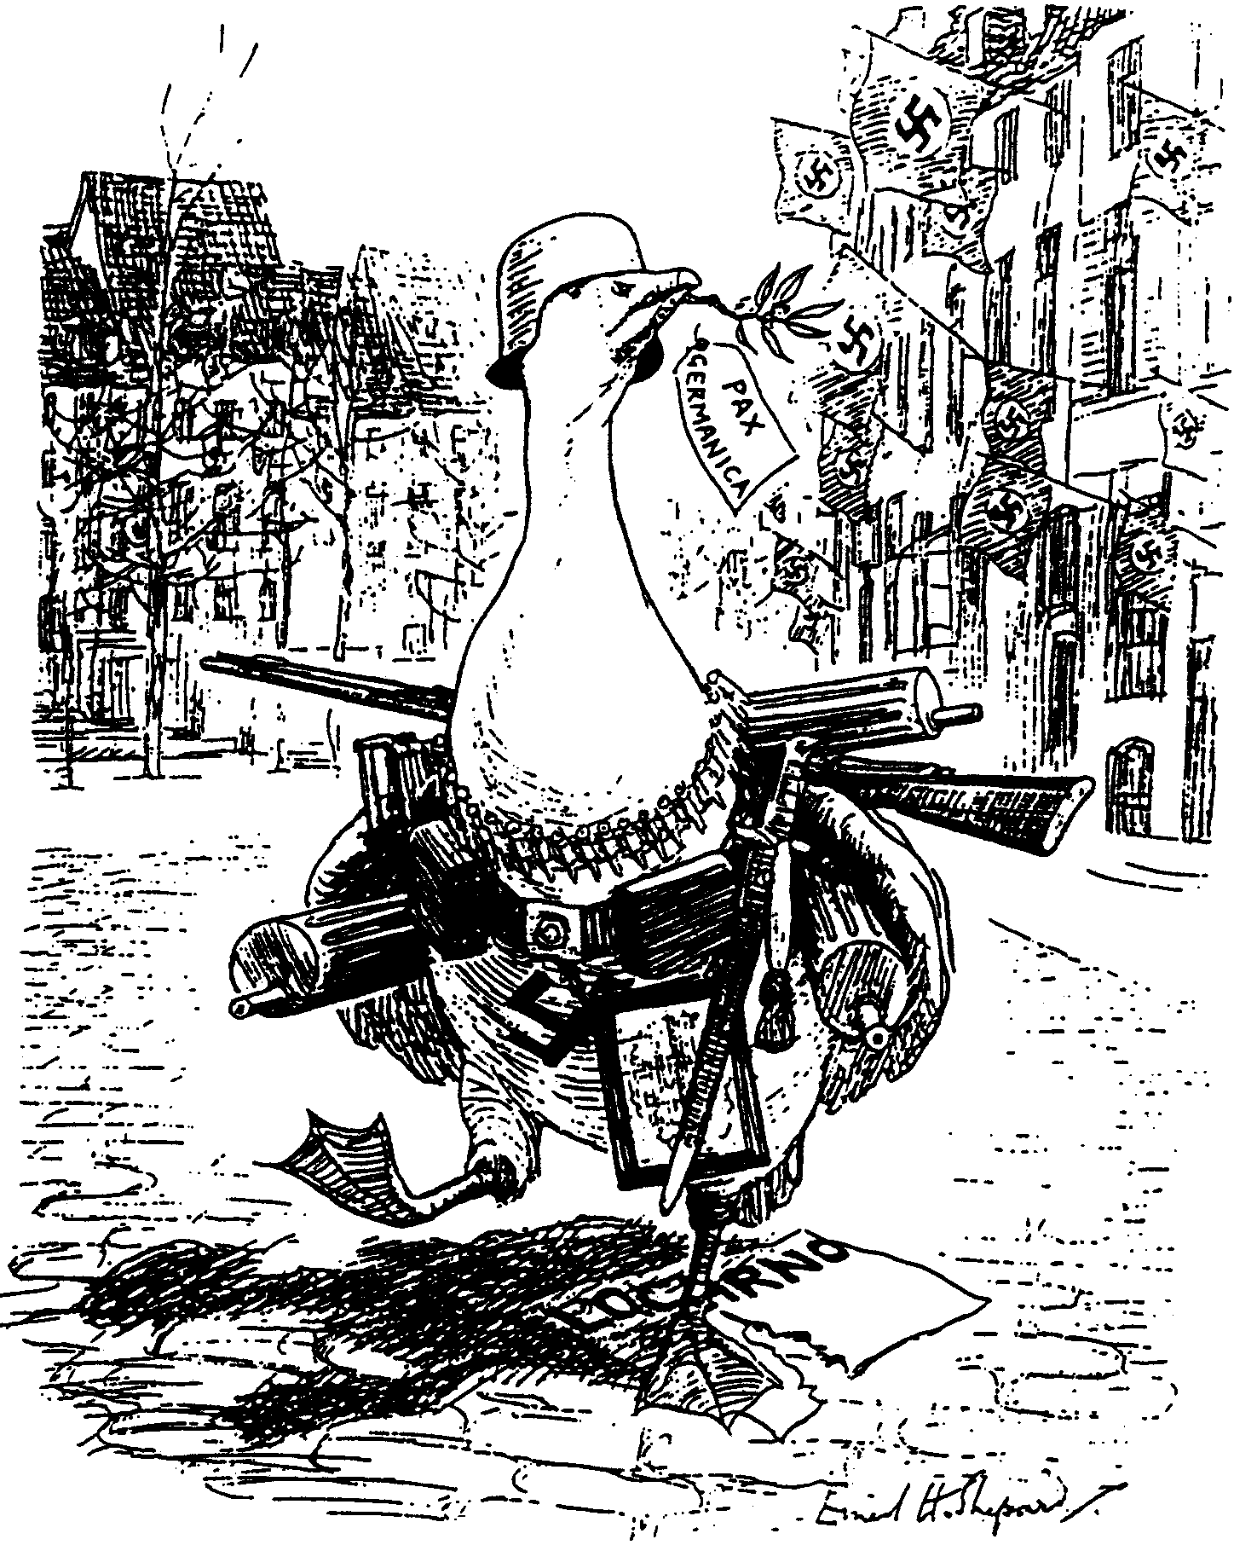

The Goose-Step / Die Ganspas

‘Goosey Goosey Gander, Whither dost thou wander?’
‘Only through the Rhineland, Pray excuse my blunder!’
(A Punch cartoon, March 1936)
‘Gansie, Gansie, waarheen wandel jy?’
‘Sommer deur die Rynland, verskoon tog my flater!’
(’n Punch-spotprent, Maart 1936)

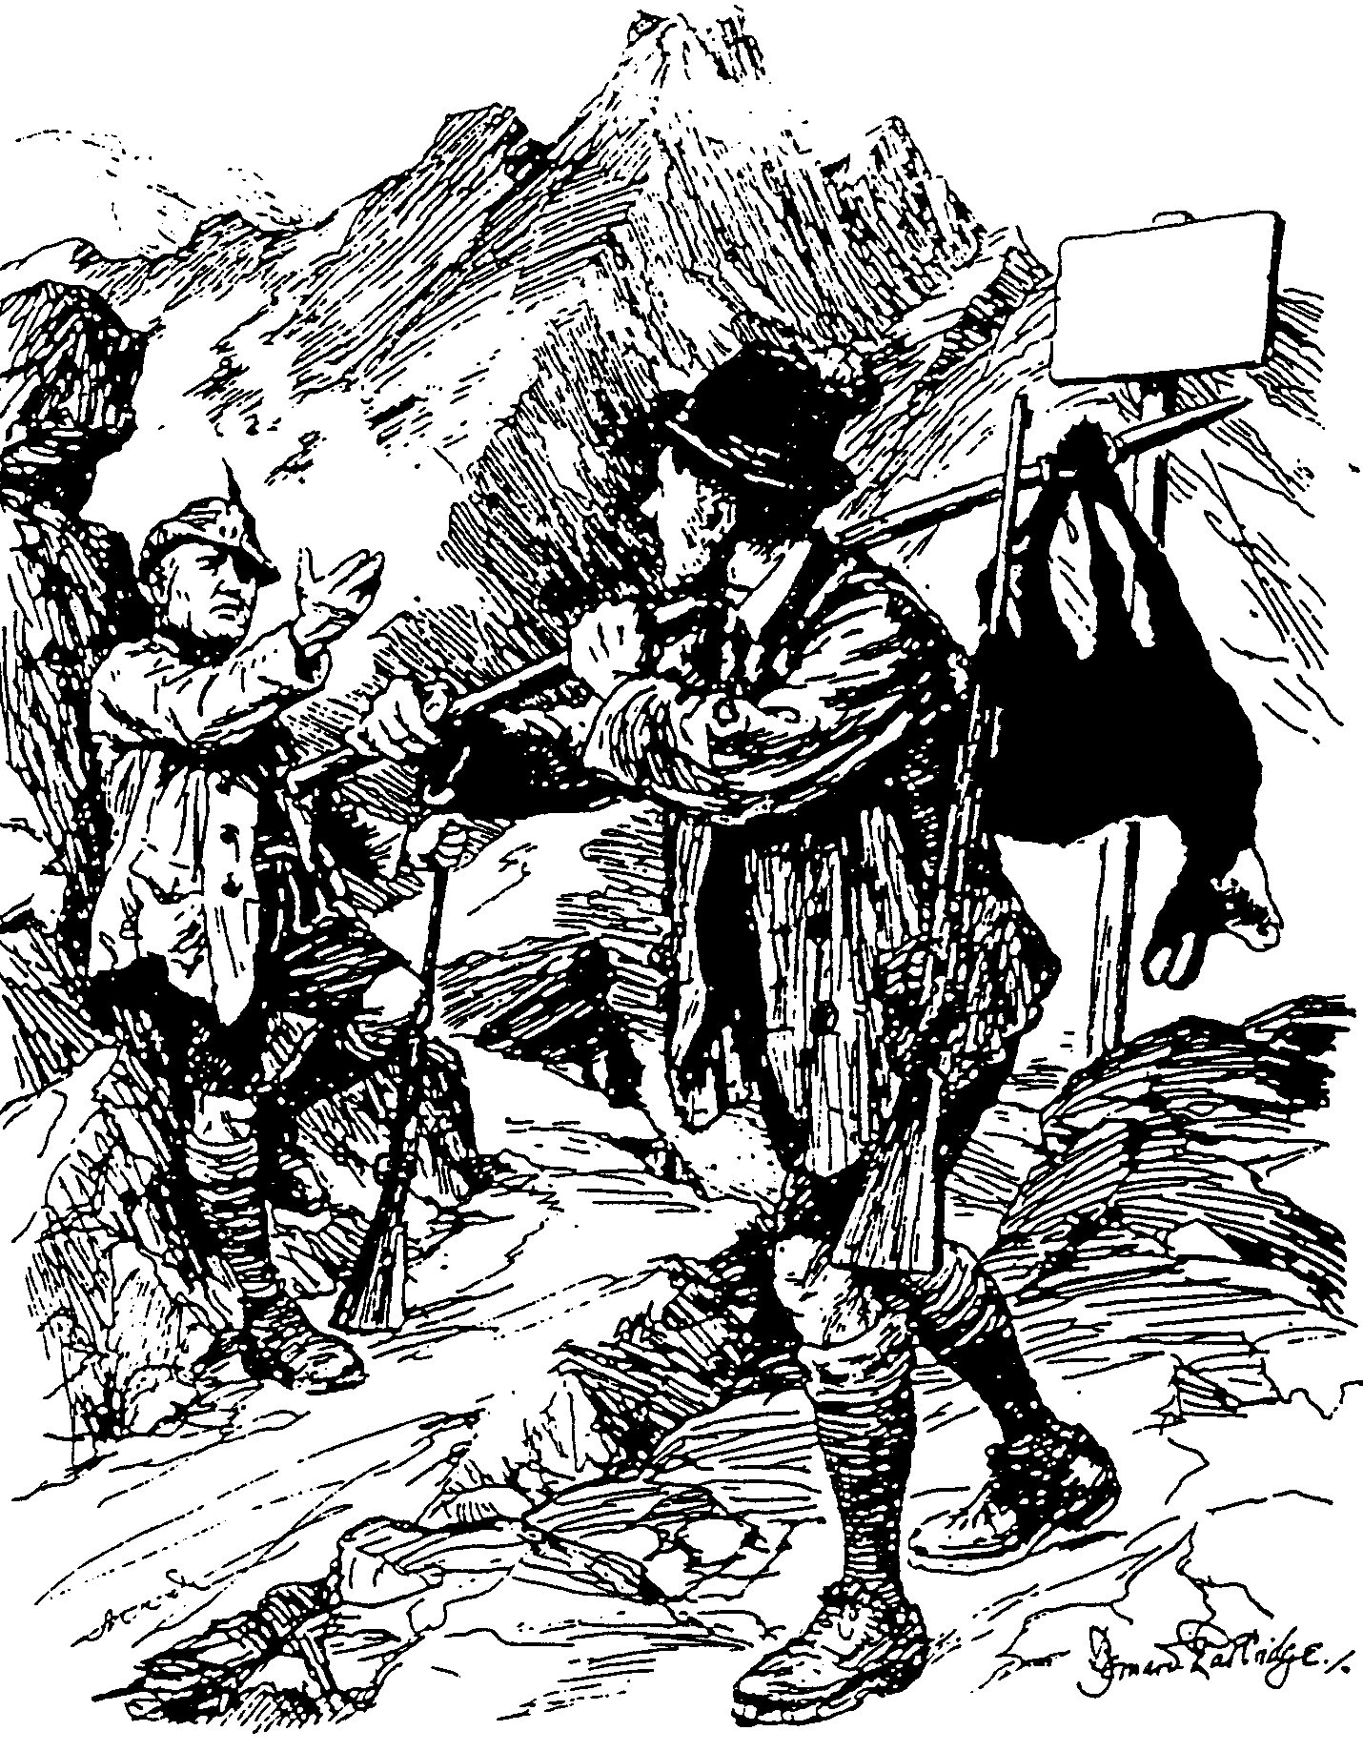

STRICTLY
PRESERVED
STRENG
VERBODE

Cartoon 2 / Spotprent 2

Good Hunting / Goeie Jagtog

Mussolini: “All right, Adolf – I never heard a shot.”
Mussolini: “Reg, Adolf – ek het geen skoot gehoor nie.”

Map / Kaart
