GAUTENG DEPARTMENT OF EDUCATION
SENIOR CERTIFICATE EXAMINATION

HISTORY SG
(First Paper: General History)

TIME: 2 hours

MARKS: 150

INSTRUCTIONS:

- This paper consists of TWO sections.
◆ Section A consists of four essay questions. TWO essays must be answered. Candidates may answer ANY TWO essays. Do not use headings or point form in your essays.
◆ Section B consists of COMPULSORY short questions. Candidates must answer ALL the short questions.
- The Addendum (pages 8 – 12) contains information and illustrations which pertain to Section C. You are advised to detach the Addendum and place each page alongside the relevant question(s) for easy reference.
- Write as clearly and neatly as possible.
- Number all your answers clearly and accurately.

SECTION A  ESSAY-TYPE QUESTIONS  Answer any TWO questions from this section.  QUESTION 1  THE RISE OF THE SUPER POWERS: USSR  Discuss Lenin’s New Economic Policy and its effects on Russia. | [40]

QUESTION 2  THE RISE OF THE SUPER POWERS: THE UNITED STATES OF AMERICA  Discuss the following reasons for the Great Depression in the United States of America:  - Economic isolationism  - American business economy  - A rich man’s economy  - Decline of world trade (including agriculture)  - The role of the stock market | [40]

QUESTION 3  INTERNATIONAL RELATIONS AND EVENTS, 1945 TO 1970: THE COLD WAR IN EUROPE  Speaking in 1949, President Truman stated that the “Berlin Blockade was a move to test our (USA) ability and will to resist.” In Soviet circles the crisis was seen as “planned in Washington, behind a smokescreen of anti-Soviet propaganda”.  Discuss:  (a) The decisions of the Potsdam agreement regarding Germany and Berlin (b) The Berlin crisis and airlift | [40]

QUESTION 4  INTERNATIONAL RELATIONS AND EVENTS, 1945 TO 1970: AFRICA SINCE THE SECOND WORLD WAR  - Provide an overview of the most significant common economic and social problems of the African states after 1945.  - To what extent do the successes of the OAU reflect the solution to these problems? Discuss critically.  4.3 Discuss shortly the role the OAU should play in the fight against AIDS in Africa.  TOTAL FOR SECTION A: | [40]  [80]

SECTION B  COMPULSORY  Information and illustrations pertaining to Section B are to be found in the Addendum (pages 8 – 12). Please detach these pages for easy reference.  QUESTION 5  NON-ESSAY TYPE QUESTIONS  - Select the correct answer for each of the following. Write down the correct letter next to the corresponding number in your answer book e.g. 1A, 2B, 3C.  - In 1929, at about the start of the Great Depression, the well known German Chancellor ______ died, leaving a leadership gap in Germany.  - Bruning  - Von Papen  - Stresemann  - Ebert | (2)

5.1.2 Mussolini referred to himself as ________, which means leader.  - II Duce  - Avanti  - II Popolo d’Italia  - Risorgimento | (2)

5.1.3 In 1932 Japan occupied the Chinese province of  - Korea.  - Formosa.  - the Philippines.  - Manchuria. | (2)

- The strong group of industrialists in Japan known as the “Zaibatsu” supported the ________ in the 1930’s  - Socialists  - Militarists  - Democrats  - Monarchists | (2)

- In March 1938 Hitler met the Austrian chancellor, ______, at Berchtesgaden.  - Seyss-Inquart  - Dollfuss  - Schuschnigg  - Benes | (2)

Which item DOES NOT FIT? Write down only the correct letter next to the corresponding number in your answer book.  - Aspects of totalitarianism in Nazi Germany:  - The Nazi Party was in total control of the country.  - The state controlled all education.  - Industries were totally independent and could produce whatever they wanted to.  - Only the Nazi Party could have seats in the Reichstag. | (2)

- The agreement reached at Munich in September 1938 between Germany, Britain, France and Italy:  - Bohemia and Moravia were given to Germany.  - Germany was allowed to annex Sudetenland.  - The independence of the rest of Czechoslovakia was safeguarded.  D. Permanent peace would be maintained in Europe. | (2)

- Reasons why the relations between Germany and Italy were so strong in 1936:  - They both supported General Franco in the Spanish Civil War.  - They both left the League of Nations.  - Both wanted to expand their territories by force.  - Germany supported the Italian attempt to obtain Austria. | (2)

- Effects of the Great Depression on Japan:  - The declining foreign demand for silk left thousands of Japanese peasants in financial hardship.  - The Emperor dissolved parliament to solve the problem.  - Mines and heavy industries came to a standstill, thus increasing unemployment.  - The social and economic distress of the people led to political unrest. | (2)

- Leaders of the Three Powerful countries present at the Potsdam Conference:  - Stalin  - Truman  - Roosevelt  - Attlee  Refer to the Addendum. | (2)

5.2 Use Documents 1, 2, 3 and 4 as well as the Map to assist you in answering the following questions. Write down only the correct letter next to the corresponding number in your answer book.

- The territory in which Germany was not allowed to have any armed forces according to the Treaty of Versailles:  - Austria  - Saarland  - Rhineland  - Poland | (2)

- The restricted size of the German Army according to the Treaty of Versailles:  - 100 000  - 1 000 000  - 10 000  - 500 000 | (2)

- The Nazi minister of propaganda was  - Hossbach.  - Göring.  - Hess.  - Goebbels. | (2)

- Countries in Europe regarded by Hitler as the most hateful enemies of Germany:  - Russia and Poland  - Britain and France  - Spain and Italy  - Austria and Hungary | (2)

- The title used to refer to Hitler:  - Emperor  - Tsar  - Führer  - Kaiser | (2)

Refer to the Addendum.

5.3 Find a matching item in Column B for each of the items in Column A. Write down only the question numbers from Column A in your answer book and next to each the letter from Column B that fits. Make use of Documents 1, 2, 3 and 4 to assist you. All answers will however not be found in the documents.

COLUMN A | COLUMN B
5.3.1 Pact of Steel | A. USA declared war on Japan
5.3.2 Hirohito | B. Invaded by Japanese troops
5.3.3 Chamberlain | C. Nazi-Minister of the Air Force
5.3.4 Atlantic Charter | D. Japanese prime minister
5.3.5 Göring | E. Territory conquered by Italy
5.3.6 General Tojo | F. British prime minister
5.3.7 Pearl Harbour | G. Final agreement after World War II
5.3.8 Manchuria | H. Emperor of Japan
5.3.9 Potsdam | I. Proposed peace after World War II
5.3.10 Abyssinia | J. Germany and Italy in a military alliance
10x2=(20)

Refer to the Addendum.

5.4 Use the Map, Cartoon 1 and Documents 1, 2 and 3 to answer the following questions:

5.4.1 Which event is depicted by Cartoon 1? | (1)

5.4.2 Why was this action regarded as important by Germany? | (1)

5.4.3 Which treaty was violated by the action depicted in the cartoon? | (1)

5.4.4 Which political party demanded that the territory depicted in the cartoon must be accessible to the German armed troops? | (1)

5.4.5 The Locarno Treaty was signed to secure the borders between Germany and two of her western neighbours. Which TWO countries were they? | (2)

5.4.6 What was the name of the German parliament? | (1)

5.4.7 How was the incident depicted by the cartoon, celebrated in Berlin? | (1)

- Why was this incident regarded as the “re-establishment of German freedom and sovereignty”? | (2)

Refer to the Addendum.

5.5 Use Cartoon 2 and Documents 1, 3 and 4 to answer the following questions:

5.5.1 Which TWO countries are represented by the persons depicted in the cartoon? | (2)

5.5.2 This cartoon depicts the occupation of a country. Which country was this? | (1)

5.5.3 What was the German word used for this occupation? | (1)

5.5.4 Why did Hitler regard the occupation of this country as important for Germany? | (2)

5.5.5 Which treaty prevented Germany from occupying this country? Quote the clause. | (2)

5.5.6 This was part of Hitler’s master plan. Which document proves this point? State the clause to motivate your answer. | (2)  (10)

TOTAL FOR SECTION B:  TOTAL: | [70]  [150]

ADDENDUM

Please detach the Addendum (pages 8 – 14) and place alongside the relevant questions in Section B for easy reference.

DOCUMENTS

Document 1: Treaty of Versailles

This document contains some extracts from the Treaty of Versailles. The numbers on the left-hand side of the document refer to the clauses of the treaty.

42 Germany is forbidden to maintain or construct any fortification either on the left bank of the
Rhine or on the right bank to the west of a line drawn fifty kilometres to the east of the Rhine.

43 In the area defined above the maintenance and assembly of armed forces and military
manoeuvres of any kind ….. are in the same way forbidden …..

45 As compensation for the destruction of the coal mines in the north of France and as part
payment towards the total reparation due from Germany for the damage resulting from the war,
Germany cedes to France ….. the coal mines situated in the Saar Basin …..

51 The High Contracting Parties recognising the moral obligation to redress the wrong done by
Germany in 1871 both to the rights of France and to the wishes of the population of Alsace and
Lorraine, which were separated from their country ….. The territories which were ceded to
Germany ….. are restored to French sovereignty

80 Germany acknowledges and will respect strictly the independence of Austria… ..

87 Germany recognises the complete independence of Poland, and renounces in her favour all
rights and title over the territory …..

160 The German Army ….. must not exceed one hundred thousand men, including officers and
establishments of depots. The Army shall be devoted exclusively to the maintenance of order
within the territory and to the control of frontiers …..

(Taken from: Condon, C: The Making of the Modern World)

Document 2: The 25-Point Programme of the National Socialist German Workers’ Party.
25 February 1920. This document contains some extracts from the original 25 – Point Program of the National Socialist German Workers’ Party. The numbers on the left-hand side of the document refer to the clauses of this programme.

The programme of the German Workers’ Party is limited as to period. The leaders have no intention, once the aims announced in it have been achieved, of setting up fresh ones, merely in order to increase the discontent of the masses artificially and to ensure the continued existence of the party.

1 We demand the union of all Germans to form a Greater Germany on the basis of the right of self-
determination of nations.

2 We demand equality of rights for the German people in its dealings with other nations, and
abolition of the Peace Treaty of Versailles and Saint-Germaine.

3 We demand land and territory (colonies) for the nourishment of our people and for settling our
surplus population.
(Taken from: Snyder, L.L.: Fifty Major Documents of the Twentieth Century)

Document 3: The March Into The Rhineland, 1936

An extract from an article in “The Times,” 9 March 1936.

Herr Hitler read the memorandum towards the end of a speech which lasted an hour and a half. The Führer asked the Reichstag to testify to two holy, innermost articles of faith; first, to uphold the honour of Germany at all cost; secondly, to work now all the more for European understanding, and particularly understanding with Western nations and Western neighbours. The uniformed Deputies rose as one man to testify with cries of “Heil”. He then announced that the Reichstag was to be dissolved in order to give the German people an opportunity of giving their approval to the work done by himself and his colleagues during the last three years. General Göring, as President of the Reichstag, read the message of dissolution ….. The elections will take place on Sunday,
29 March, and Dr Goebbels, the Propaganda Minister, has been appointed to direct them.

While the Führer was speaking troops were marching, and had been since early morning, into the demilitarised zone. According to a statement issued here the troops moved are nineteen battalions of infantry, thirteen detachments of artillery, two flights of pursuit aircraft, and two anti-aircraft detachments – some 25 000 to 30 000 men in all. The local population was naturally jubilant. For economic, if for no other, reasons the absence of the military establishments in the Rhineland has been a sore point with them, particularly since the introduction of conscription.

In Berlin the news appeared to be taken very calmly, even in National-Socialist Party circles. In moderate and responsible quarters there was anxious astonishment at the decision to occupy the Rhineland ….. Nevertheless, flags were hung out by the population at Dr Goebbels’ request in celebration of the final re-establishment of German freedom and sovereignty and therewith of German honour. The flags, Dr Goebbels ordered, should also remain out today, the German Armistice Day, to express inner unity with the war dead, whose “sacrifice is no longer in vain”. The flags which on Heroes Day are usually flown half-mast were today flown full-mast. There were large crowds outside the Chancellery during the day and in the evening the SA staged a torchlight procession along Wilhelmstrasse,Herr Hitler taking the salute.

(From: Wroughton, J and Cook, D: Documents on World History 2; 1919 to the present day)

Document 4: The Hossbach Document, 5 November 1937

At a secret meeting held on 5 November 1937, Hitler outlined to his military leaders the practical steps in undertaking aggression against other countries. The minutes of the meeting, as recorded by Hitler’s adjutant, Colonel Hossbach, reveal how Hitler planned to wage war two years before the outbreak of hostilities.

The Führer then stated: The aim of German policy is the security and the preservation of the Volk (nation) and its propagation. This is consequently a problem of space ….. The question for Germany is where the greatest possible conquest can be made at lowest cost.

German politics must reckon with its two hateful enemies, England and France, to whom a strong German colossus in the centre of Europe would be intolerable. Both these states would oppose a further reinforcement of Germany, both in Europe and overseas, and in this opposition they would have the support of all parties …..

For the improvement of our military political position it must be our first aim, in every case of entanglement, to conquer Czechoslovakia and Austria simultaneously, in order to remove any threat from the flanks in case of a possible advance west-ward …..

(Taken from: Snyder, L.L.: Fifty Major Documents of the Twentieth Century)

Cartoon 1 / Spotprent 1
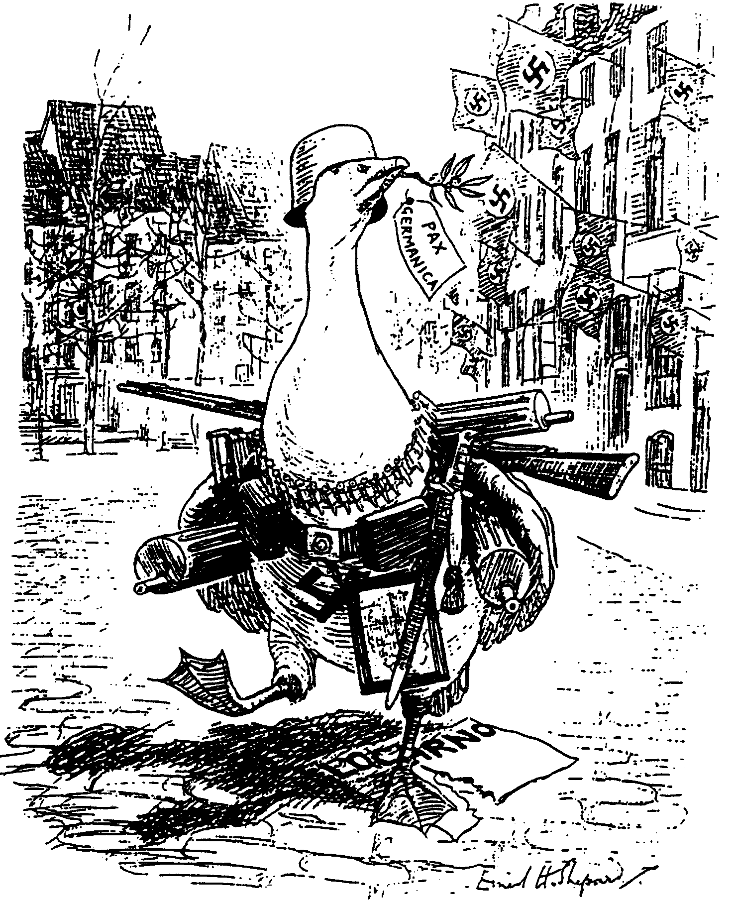

The Goose-Step / Die Ganspas

‘Goosey Goosey Gander, Whither dost thou wander?’
‘Only through the Rhineland, Pray excuse my blunder!’
(A Punch cartoon, March 1936)
‘Gansie, Gansie, waarheen wandel jy?’
‘Sommer deur die Rynland, verskoon tog my flater!’
(’n Punch-spotprent, Maart 1936)

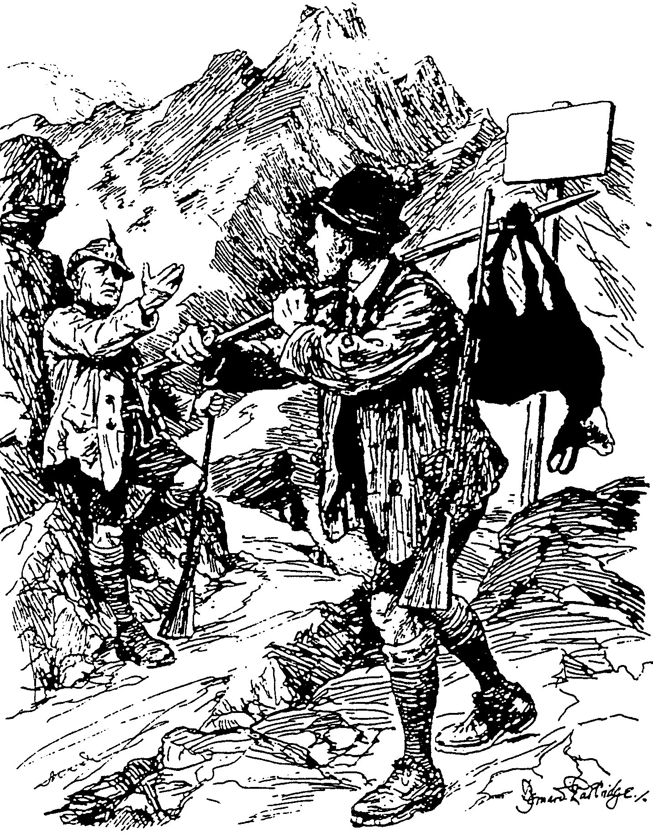

STRICTLY
PRESERVED
STRENG VERBODE

Cartoon 2 / Spotprent 2

Good Hunting / Goeie Jagtog

Mussolini: “All right, Adolf – I never heard a shot.”
Mussolini: “Reg, Adolf – ek het geen skoot gehoor nie.”

Map / Kaart
