GAUTENG DEPARTMENT OF EDUCATION
SENIOR CERTIFICATE EXAMINATION

HISTORY HG
(Second Paper: South African History)

TIME : 2½ hours

MARKS : 200

INSTRUCTIONS:

- Answer only ONE essay from the two in Section A: Essays 1924 – 1948.

- Answer only ONE essay from the two in Section B: Essays 1948 – 1976.

- Section C is COMPULSORY. Answer ALL the questions in this section.

- The Addendum (pages 7 to 9) contains illustrations and information which pertain to Section C. You are advised to detach the Addendum and place each page alongside the relevant questions for easy reference.

- All questions and sub-sections must be numbered accurately.

SECTION A

ESSAYS ON SA HISTORY (1924 – 1948)

Answer ONE of the following two essays.

QUESTION 1  “The period 1924 to 1934 was characterised by coalition, fusion and splits.”  Discuss the above statement. | [60]

OR

QUESTION 2  Describe how Jan Smuts became prime minister of South Africa in 1939 and discuss and assess his term of office during the period 1939 to 1947. | [60]

TOTAL FOR SECTION A: | [60]

SECTION B

ESSAYS ON SA HISTORY (1948 – 1976)

Answer ONE of the following two essays.

QUESTION 3

“With urbanisation came not only inflation, social problems and insecurity, but also organised black resistance against the government’s apartheid policy.”

Trace the attempts made by relevant organisations against the government’s apartheid policy. Refer to the period 1949 to 1961 in your answer. | [60]

OR

QUESTION 4

Separate development was a policy used by the National Party to keep blacks and whites apart.

Analyse the steps the party took during the years 1959 to 1971 to implement this policy and state, from the evidence, whether or not they were successful. | [60]

TOTAL FOR SECTION B: | [60]

SECTION C

SHORT AND INTERPRETATIVE QUESTIONS (1948 – 1976)

This section is COMPULSORY. Answer ALL the questions in this section.

Illustrations and information pertaining to Section C are to be found in the Addendum (pages 7 to 9). Please detach these pages for easy reference.

5.1 Examine the photograph (Source A) and the cartoon (Source B) on page 7 and answer the questions that follow.

- The crowd in the photograph (Source A) are celebrating a major event for white South Africans that occurred on 31 May 1961. Which event are they celebrating and why?  - The cartoon also refers to the event mentioned above. Explain what is happening in the cartoon.  - Why was the “Lady’s” support for this event needed?  5.1.4 What is the attitude of the cartoonist towards the subject-matter? Justify your answer. | (2)  (3)  (2)  (3)

5.1.5 This event happened at the time that Dr Verwoerd was prime minister. Name TWO steps taken by EACH of the previous prime ministers to help bring about this event and explain, in ONE sentence each, the significance of each step. 4 x 2 = | (8)

5.2 Identify the figures portrayed in the pictures in the Addendum on page 8 (Sources C to H). Write ONE sentence on each figure to explain his role in promoting the policy of apartheid or resisting it. (Note: You must be specific in your answers.) 6 x 2 = | (12)

5.3 Study Sources I – K on page 9 and answer the questions that follow.

- Explain, in your own words, what the author is saying in Source I.  5.3.2 What is the attitude of the author towards what he is writing about, as can be concluded from the extract? Is he positive or negative in tone? Justify your answer. | (3)  (3)

5.3.3 Explain the circumstances which led to Mandela making the speech in Source J.  - What was Mandela’s reaction, as shown in his speech, to the policies outlined in Source I?  - What were the results of the speech Mandela made (Source J)?  5.3.6 The cartoon, Source K, is a comment on what happened after Mandela’s speech. What is being portrayed in the cartoon? | (4)  (4)  (3)  (3)

5.3.7 What is the attitude of the cartoonist to the subject matter? Justify your answer. | (2)

5.4 Explain the content and significance of the following pieces of legislation:  - The Separate Representation of Voters Act  - The Senate Act 2 x 3 = | (6)

5.5 Which item suits the introductory phrase? Write the relevant letter next to the corresponding question number in your answer book.

    - The Group Areas Act
- provided for different facilities for the separate race groups.
- was the act that provoked the Sharpeville incident.
- enforced the pass system by returning defaulters to the homelands.
- made provision for separate living areas for the different races.

    - This law made provision for the number of black workers that were allowed on white properties in towns:
- The Urban Areas Amendment Act
- The Group Areas Act
- The Homelands Citizenship Act
- The Resettlement of Natives Act

    - The person who introduced legislation which attempted to place the Coloureds on to a separate voter’s roll was
- Hertzog.
- Strijdom.
- Dönges.
- Verwoerd.

    - The Appellate Division Quorum Act
- required 11 judges to be present when constitutional matters were heard in the Appeal Court.
- prevented the Appeal Court from interfering with amendments to legislation.
- replaced the High Court of Parliament Act as a means of enforcing government policy.
- was the final step taken by Malan to have the Coloured vote on a seperate voters roll..

    - During the period that the Coloureds were being removed from the voters’ roll, the United Party was led by
- Smuts.
- Havenga.
- Strauss.
- De Villiers Graaff.

    - An event that helped to bind white South Africans more closely together before the referendum on a republic, was
- the assassination of Verwoerd by Tsafendas.
- the removal of British control from Simonstown.
- the “Winds of Change” speech delivered by Macmillan.
- South Africa’s leaving the British Commonwealth.

    - This party was in favour of all races voting in the referendum on becoming a republic:
- National Party
- Afrikaner Party
- United Party
- Progressive Party

    - The leader of the ANC at the time of the republic referendum was:
- Luthuli
- Sisulu
- Moroka
- Xuma

5.5.9 Black Consciousness was NOT:
- promoted as a philosophy to enhance black dignity.
- aimed at reducing black dependence on white liberals in their resistance to apartheid.
- founded and led by Steve Biko.
- a movement founded to protest against the Rivonia Trial.

5.5.10 The South African Students Organisation
- was founded as a government-sponsored initiative to separate blacks from whites.
- was provoked by the police and this led to the 1976 Soweto uprising.
- was initiated because some black students felt uncomfortable in NUSAS.
- played an important role in the Treason Trial.

- The minister of Bantu Education during the 1976 Soweto uprising was  - Andries Treurnicht.  - M.C. Botha.  - Piet Koornhof.  - F.W. de Klerk.  11 x 2 = | (22)  [80]

TOTAL FOR SECTION C:  TOTAL: | [80]  [200]

ADDENDUM

Please detach this Addendum (pages 7 – 9) and place alongside the relevant questions in Section C for easy reference.
Maak asseblief hierdie Addendum los (bladsye 7 – 9) en plaas dit teenoor die betrokke vrae in Afdeling C vir maklike verwysing.

Source A / Bron A

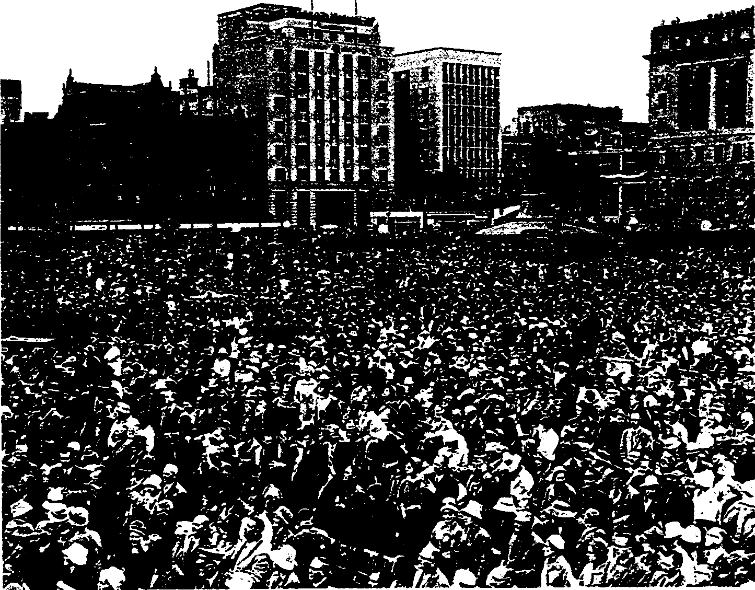

Source B / Bron B

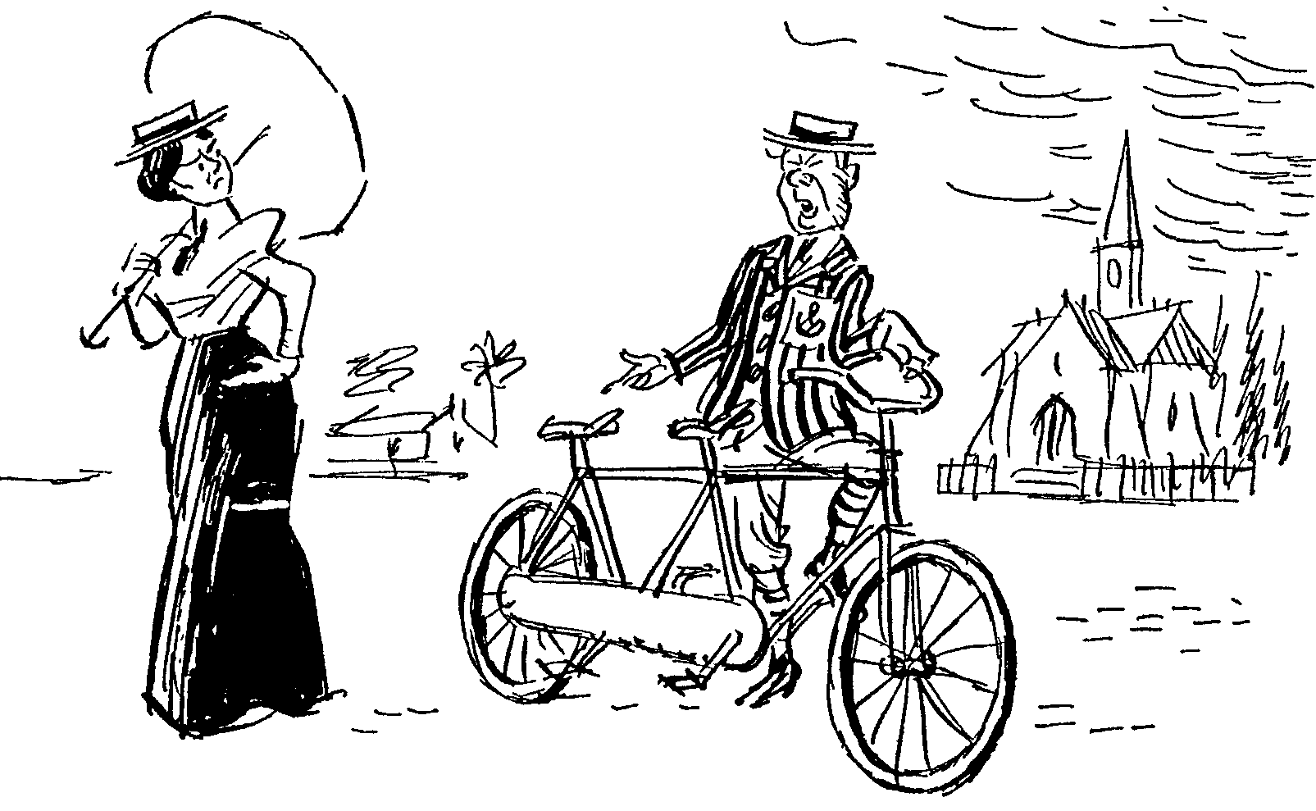

23 June 1960 / 23 Junie 1960
… on a bicycle made for two!
… op ’n fiets bedoel vir twee!

Source C / Bron C Source D / Bron D

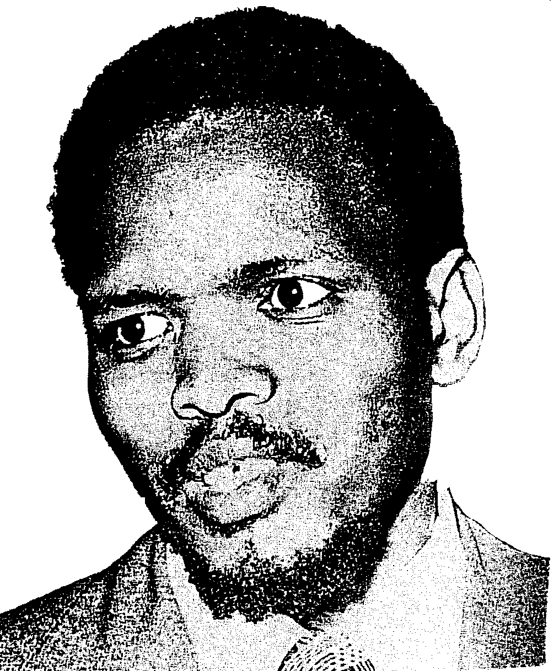
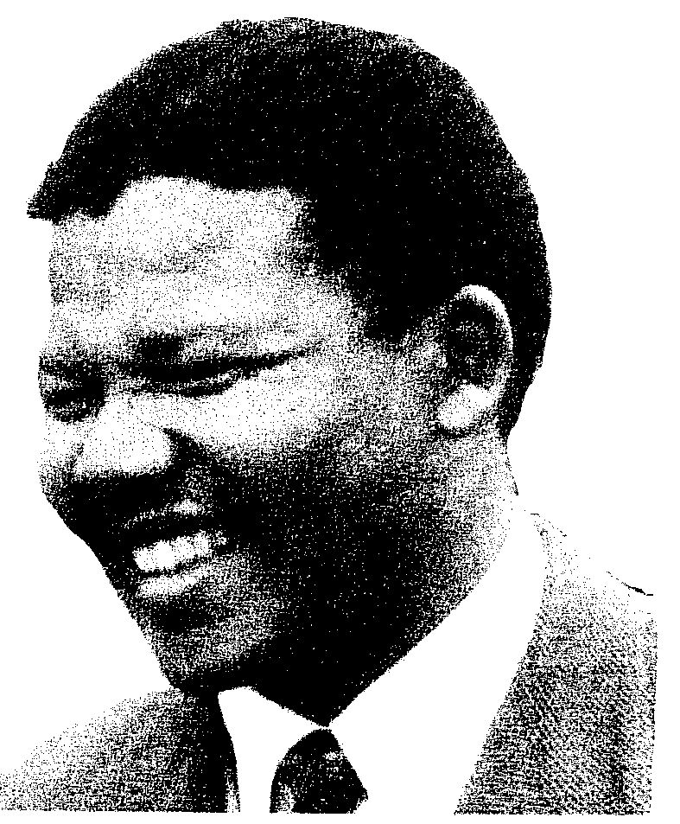
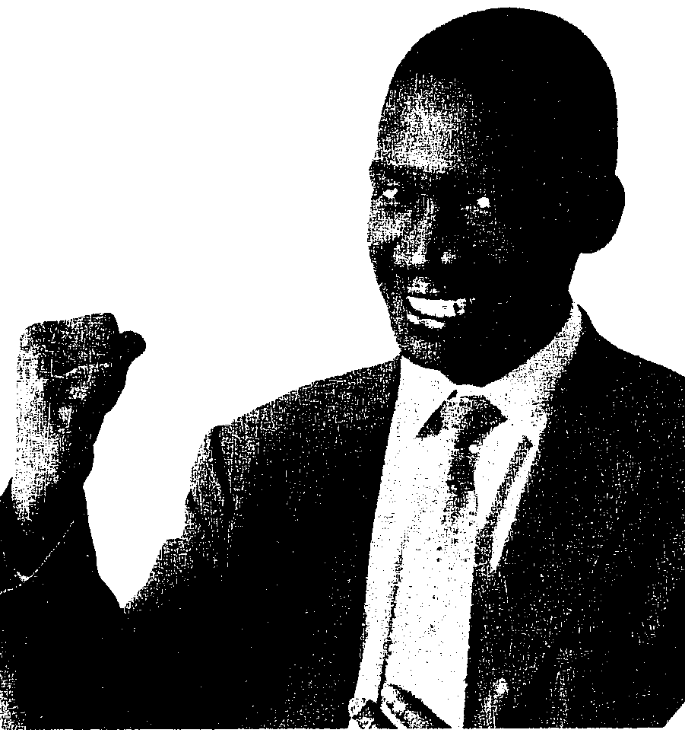

Source F/ Bron F

Source E / Bron E
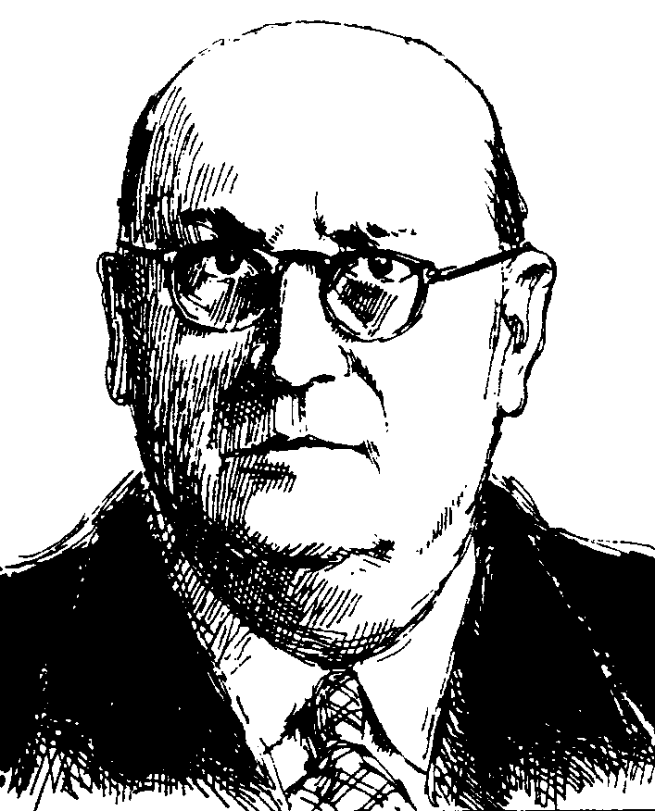

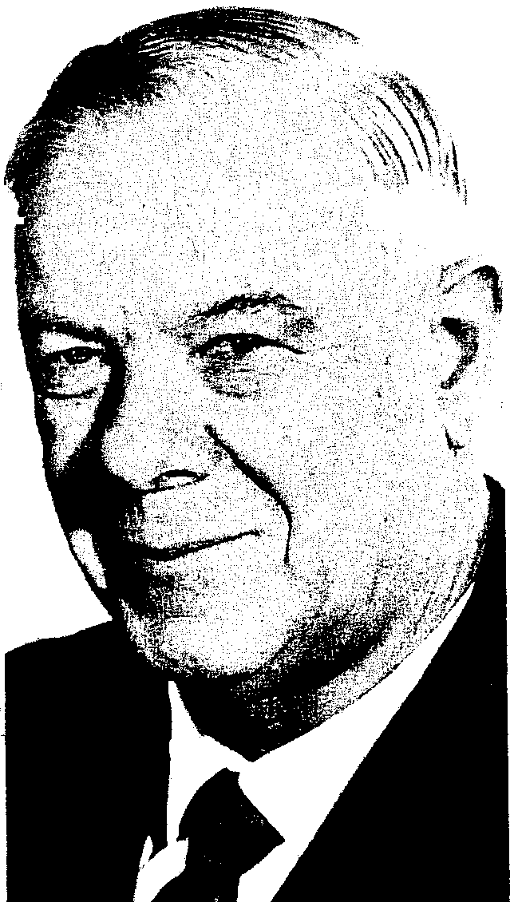
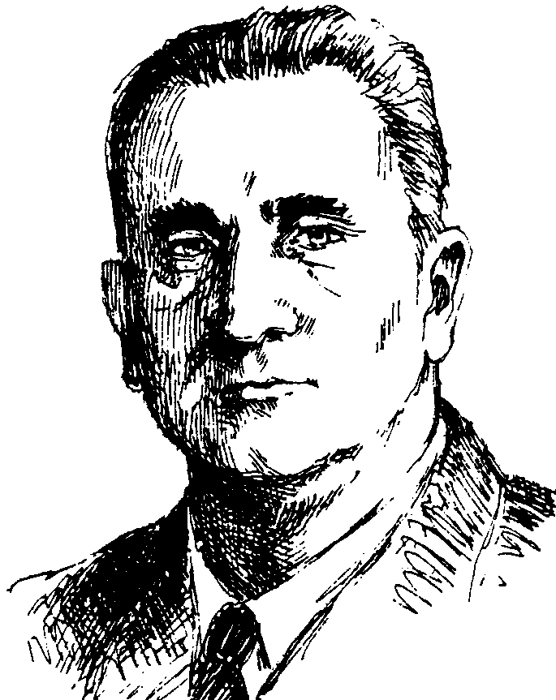

Source H / Bron H

Source G / Bron G

Source I / Bron I

Extract from: A History of South Africa by Robert Lacour-Gayet (1977)
Uittreksel uit: A History of South Africa deur Robert Lacour-Gayet (1977) [Vrye vertaling]

“Under Verwoerd, the rather defensive attitude to race relations, as reflected in Malan and Strijdom’s policy of apartheid, was replaced with a more positive, dynamic approach – the government began to talk in terms of separate development of the races. The new approach catered for the national aspirations of the black groups, while at the same time safeguarding the future of the whites.” (Page 305)
“Verwoerd het die defensiewe houding teenoor die beleid van afsonderlike ontwikkeling soos deur Malan en Strijdom weerspieël, in ’n meer positiewe, dinamiese houding verander. Die regering het begin verwys na die afsonderlike ontwikkeling vir alle rasse. Die nuwe benadering het die nasionale aspirasies van alle swart volke erken en terselfdertyd die toekoms van die blankes beskerm.” (Bladsy 305)

Source J / Bron J

Extract from speech given by Nelson Mandela at the Rivonia Trial, 1964
Uittreksel uit die toespraak van Nelson Mandela tydens die Rivonia-verhoor, 1964 [Vrye vertaling]

“During my lifetime, I have dedicated my life to this struggle of the African people. I have fought against white domination and I have fought against black domination. I have cherished the idea of a democratic and free society in which all persons live together in harmony and with equal opportunities. It is an ideal which I hope to live for and to achieve. But, if need be, it is an ideal for which I am prepared to die.”
“Ek het my lewe gewy aan die stryd van die Afrika-volke. Ek het teen sowel blanke as swart oorheersing geveg. Ek is ten gunste van ’n demokratiese vrye gemeenskap waarin alle mense in harmonie saam leef en gelyke geleenthede het. Dit is die ideaal waarvoor ek leef en hoop om te verwesenlik, maar dit is ook ’n ideaal waarvoor ek bereid is om te sterf.”

Source K / Bron K
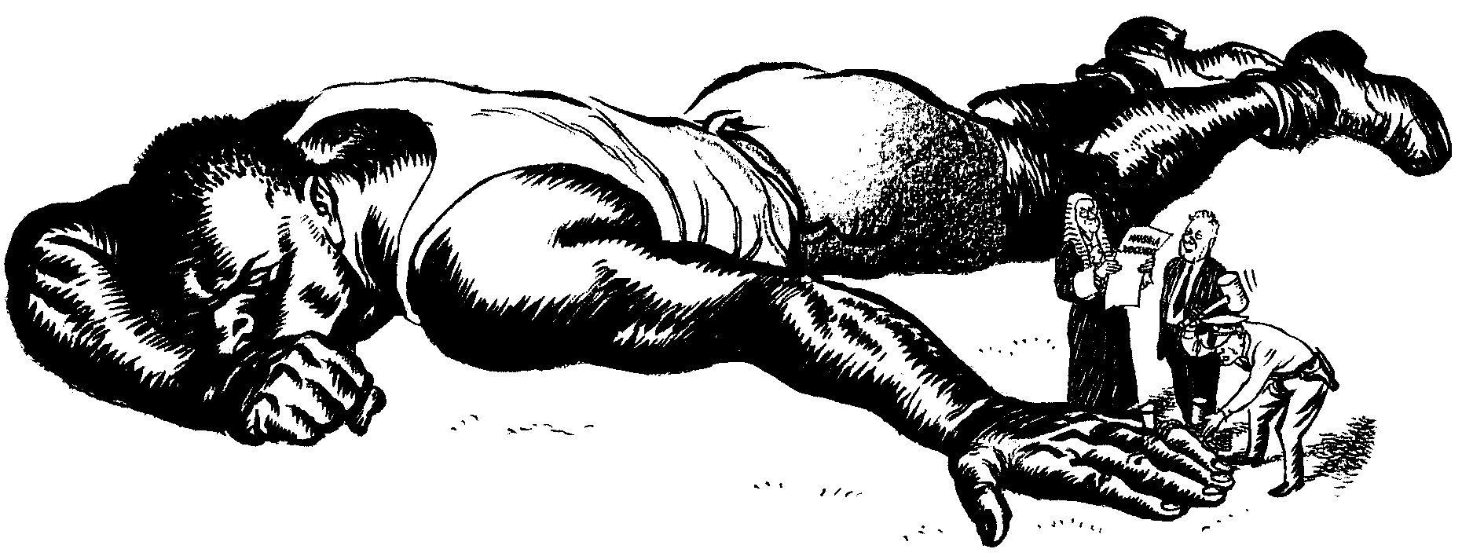
The wording on the document in the hands of the judge says ‘Mandela Judgement’

Die bewoording op die dokument in die regter se hande sê ‘Mandela Uitspraak’

Cartoon drawn by the British cartoonist Illingworth, 1964
Spotprent deur die Britse spotprenttekenaar Illingworth, 1964

Source K / Bron K
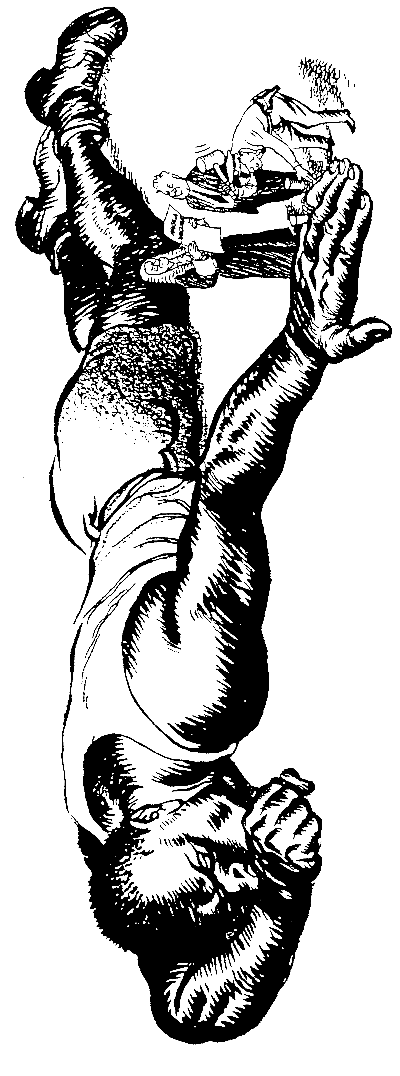

Cartoon drawn by the British cartoonist Illingworth, 1964
Spotprent deur die Britse spotprenttekenaar Illingworth, 1964

The wording on the document in the hands of the judge says ‘Mandela Judgement’
Die bewoording op die dokument in die regter se hande sê ‘Mandela Uitspraak’

