GAUTENG DEPARTMENT OF EDUCATION
SENIOR CERTIFICATE EXAMINATION

HISTORY HG
(Second Paper: South African History)

TIME : 2½ hours

MARKS : 200

INSTRUCTIONS:

- Answer only ONE essay from the two in Section A : Essays 1924-1948.

- Answer only ONE essay from the two in Section B : Essays 1948-1976.

- Section C is COMPULSORY. Answer ALL the questions in this section.

- The Addendum (pages 7 to 9) contains illustrations and information which pertain to Section C. You are advised to detach the Addendum and place each page alongside the relevant question(s) for easy reference.

- All questions and subsections must be numbered accurately.

SECTION A

ESSAYS ON SA HISTORY (1924–1948)

Answer ONE of the following two essays.

QUESTION 1  “One of Hertzog’s major aims was to gain sovereign independence for South Africa.” Discuss this statement with reference to the period 1924–1934. | [60]

OR

QUESTION 2  “The United Party supported the policy of political and territorial segregation between blacks and whites.” Do you agree with this statement? Analyse the policy of the United Party during the period 1936 to 1946 and discuss the resistance to this policy by Blacks, Coloureds and Indians. | [60]

TOTAL FOR SECTION A: | [60]

SECTION B

ESSAYS ON SA HISTORY (1948–1976)

Answer ONE question from this section.

QUESTION 3  “Theoretically, the objective of the policy of apartheid can be fully realised by dividing the country into two states, with the whites in one and all the natives in the other…” (Malan on the vision of apartheid).  Explain how the National Party tried to implement this policy through legislation during the years 1948 to 1956. | [60]

OR

QUESTION 4  Provide a critical analysis of the roles played by Verwoerd and Mandela during the period 1958 to 1966 whereby each man tried to achieve his goal. | [60]

TOTAL FOR SECTION B: | [60]

SECTION C

SHORT AND INTERPRETATIVE QUESTIONS: (SOUTH AFRICA 1948–1976)

This section is COMPULSORY. Answer ALL the questions.

QUESTION 5

Illustrations and information pertaining to Section C are to be found in the Addendum (pages 7 to 9). Please detach these pages for easy reference.

5.1 Examine the cartoons and map (Sources A –C on pages 7 and 8) and answer the questions that follow.

- Which prime minister is portrayed in both cartoons?  - Which black homeland leader is portrayed in Source A?  - Identify the homeland (by number, on the map) from which this leader came.  - What is being taken away from the blacks by this Act?  - What are the black leaders getting in return?  - Name TWO other pieces of legislation passed by the National Party government that affected the constitutional position of this homeland.  - Explain clearly the meaning of Source A.  - Identify on the map, Territories 5 and 6, and explain how independent each of them became under the system of separate development.  - Taking all the sources into account, write a brief assessment of why foreign countries would not regard the homelands as being truly independent. | (1)  (1)  (1)  (1)  (2)  (2)  (2)  (4)  (4)

5.2 Examine Sources D, E and F in the Addendum on pages 8 and 9 and answer the questions that follow.

- What is the name of the person in Source D?  - Name ONE of the organisations with which he was involved.  - What view did he hold regarding black people and what they should strive for?  - What happened to this man?  - What view did this man’s organisation have on the events mentioned in Source E?  - Who was Treurnicht?  - What did the language ruling refer to?  - Why was the language ruling “too bitter”?  - Why did the SA Institute of Race Relations express concern?  - What is the meaning of the last sentence of the comprehension?  - Explain the connection between Source E and Source F. How did the one lead to the other?  - What incident is portrayed in Source F?  5.2.13 Name THREE results of what is described in Sources D, E and F. | (1)  (1)  (2)  (1)  (1)  (1)  (2)  (2)  (2)  (2)  (3)  (1)  (3)

5.3 5.3.1 Explain, in a paragraph of about 80 words, how and why Verwoerd withdrew South Africa from the Commonwealth in 1961.  - What would an Afrikaner nationalist have thought of Verwoerd’s action? Justify your answer.  5.3.2 What did many English-speaking South Africans feel about Verwoerd’s action? Justify your answer. | (6)  (3)  (3)

5.4 Write the question numbers 5.4.1 to 5.4.11 underneath each other in your answer book. Answer the questions that follow by simply writing the correct letter alongside the corresponding question number.

5.4.1 The policy of apartheid
- has been applied in South Africa for many centuries.
- was first put forward by Nationalist politicians in the 1940s.
- was supported by the United Party under Jan Smuts.
- was not able to withstand the criticism of Harold MacMillan.

    - The Separate Representation of Voters Act
- was aimed at removing the Coloureds from the common voters’ roll.
- withdrew black representatives from the House of Assembly.
- allowed for the separate representation of Indian voters in a special council.
- was passed unanimously by parliament under the leadership of Malan.

    - The Group Areas Act
- restricted the land that blacks could purchase to within the homelands.
- provided a special card for blacks over the age of 16 to indicate where they could live.
- enforced a policy of separate residential areas for different races.
- could only come into effect after South Africa had become a republic.

    - The right of appeal to the British Privy Council was abolished by
- Verwoerd.
- Malan.
- Strijdom.
- Vorster.

    - The last governor-general of the Union of South Africa
- was the first state president of the Republic of South Africa.
- was appointed by Britain at the time of the “Winds of Change” speech.
- indicated that no more could be done to hand the protectorates over to South Africa.
- was an Afrikaner nationalist, E.G. Jansen.

    - Why did the Defiance Campaign meet with limited success?
- There was a split amongst black nationalists into ANC and PAC camps.
- The Treason Trial robbed the ANC of much of its leadership.
- It was not possible for many people to accept jail terms over long periods as they needed to support their families.
- The banning of resistance movements made organisation difficult.

    - A republic refers to
- a state without any recognised head.
- a state not under any foreign influence.
- a state not linked to the British Commonwealth.
- the policy promoted by Smuts in the 1948 election.

    - Verwoerd and Louw attended the Commonwealth Prime Ministers’ conference in 1961
- to ask that South Africa be allowed to leave the Commonwealth.
- to request that South Africa keep its racial policies.
- to ask to remain within the commonwealth as a republic.
- to confirm that economic and sporting links would remain.

    - Black Consciousness
- aimed at restoring dignity to black people so that they would not be as reliant on whites as they had been previously.
- was propagated by Robert Sobukwe as a more Africanist approach to solving racial problems.
- was instrumental, together with the ANC Youth League, in leading the defiance campaign against unjust laws.
- was unable to succeed as its leaders were banned immediately the organisation was formed.

    - The 1976 Soweto uprising was caused by
- the dissatisfaction experienced over many years of apartheid rule.
- the insistence of the government that Afrikaans be used as medium of instruction in schools.
- frustration at the fact that many legitimate political leaders had been banned for over 10 years.
- a combination of all the factors listed above.

- The result of the 1976 uprising was:  - Vorster resigned as prime minister and was replaced by P.W. Botha.  - Steve Biko was detained in Soweto after the uprising and executed.  - Many young men left the country to train overseas as guerrillas.  - A combination of all the above.  11 x 2 = | (22)

5.5 Explain the content and significance of the following pieces of legislation:  - The High Court of Parliament Act  - The Appellate Division Quorum Act | (3)  (3)  [80]

TOTAL FOR SECTION C:  TOTAL: | [80]  [200]

ADDENDUM

Please detach the Addendum (pages 7 – 9) and place alongside the relevant questions in Section C for easy reference.
Skeur asseblief hierdie Addendum (bladsye 7 – 9) los en plaas dit teenoor die relevante vrae vir Afdeling C vir maklike verwysing.

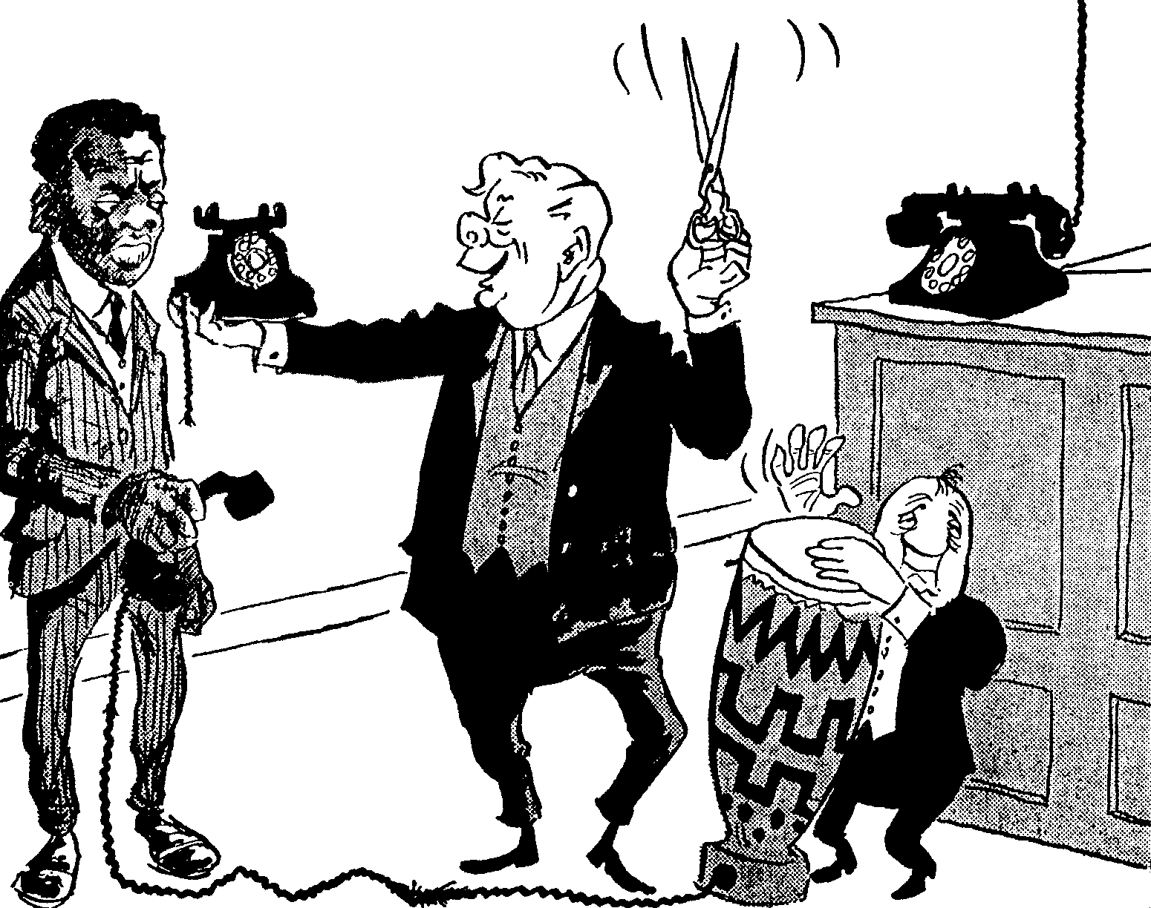
22 January 1959

22 Januarie 1959
“Instead of your useless representatives in Parliament, I’m giving you a telephone exactly
like mine. Listen in any time you like.”
“In plaas van jou nuttelose verteenwoordigers in die Parlement, gee ek vir jou ’n telefoon presies soos myne. Voel vry om enige tyd in te luister.”
David Marais: The Cape Times

Source A / Bron A

Direct Line – Private
Direkte Lyn – Privaat

Source B / Bron B
Bridge on the River Kei!
Brug oor Die Kei-rivier!
The Argus, 18 June 1959

The Argus, 18 Junie 1959
TRANSKEI
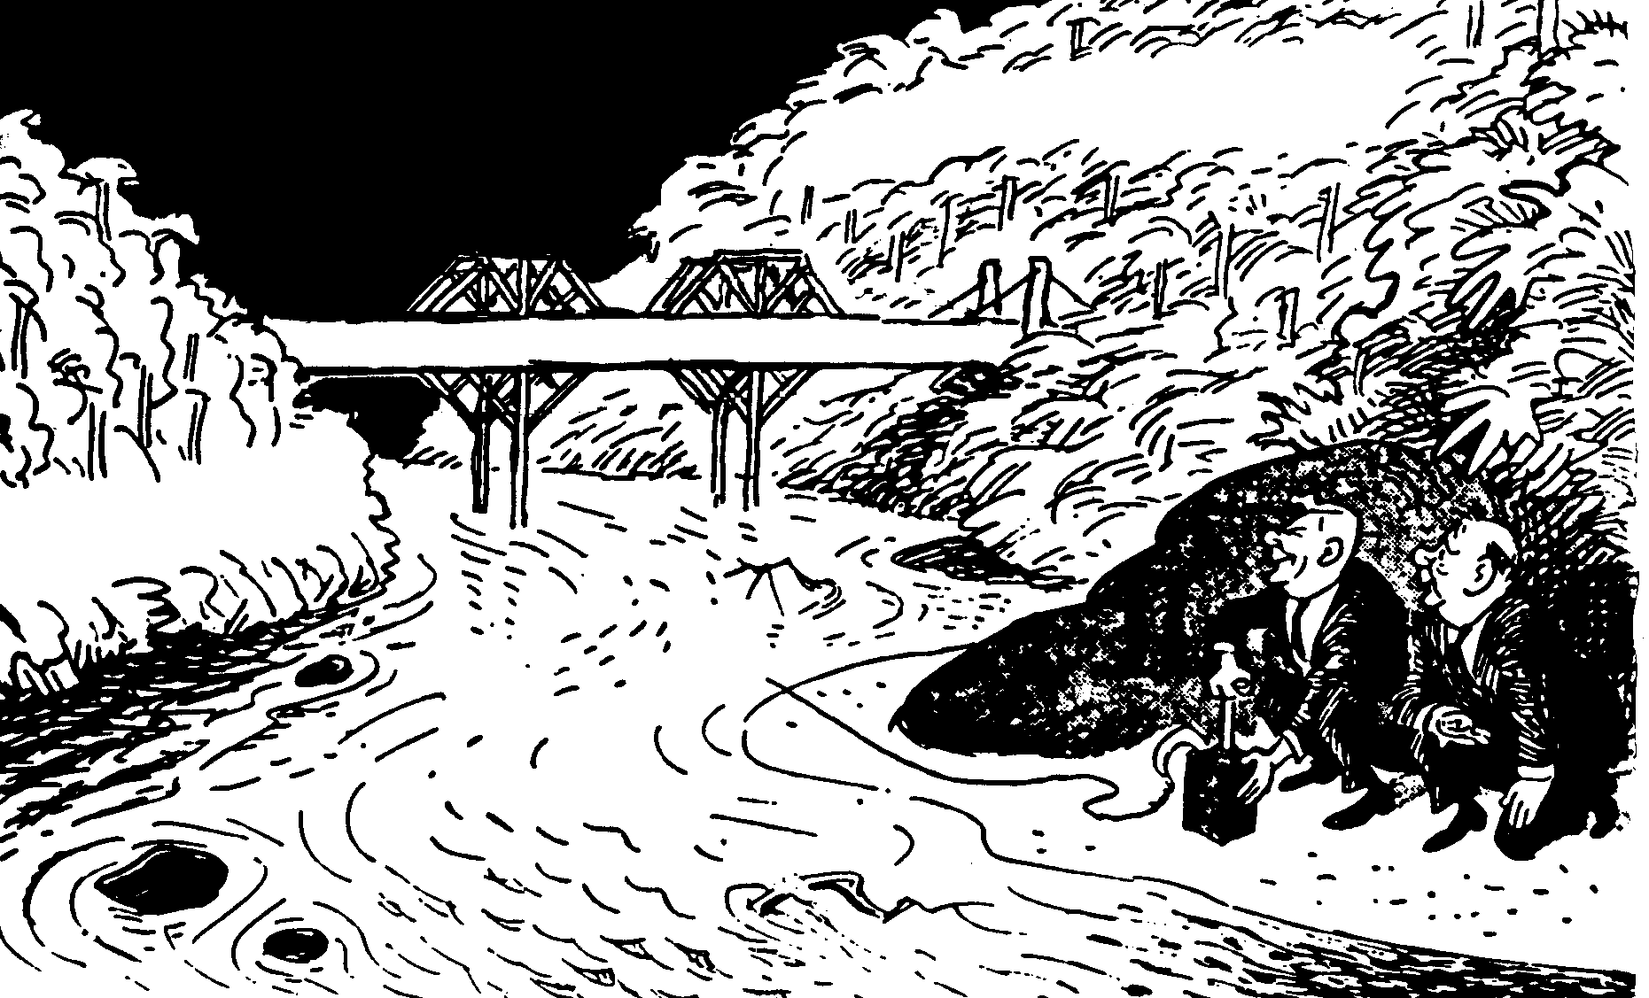

NATIVES’ REPRESENTATIVES / NATURELLE-VERTEENWOORDIGERS

Durban
Bloemfontein
Pretoria
Johannesburg
6

4

5
3

9

10
8

7
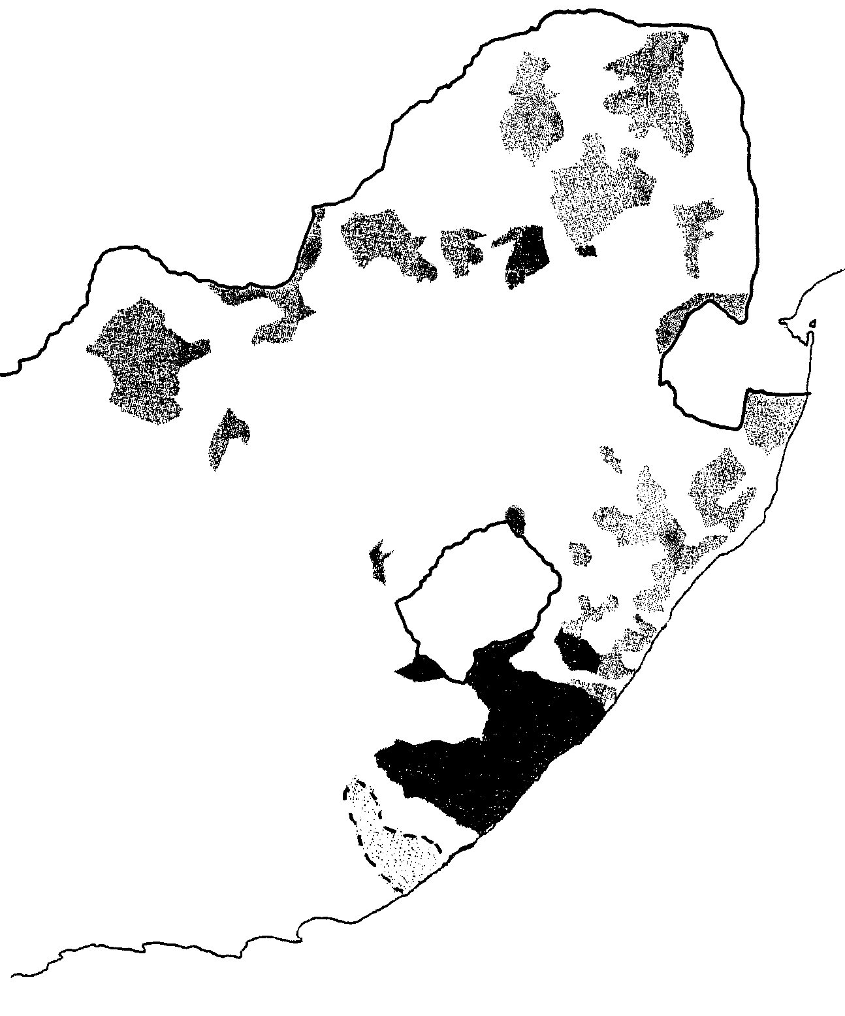

Source C / Bron C
5
2

1
- East London / Oos-Londen

Source D / Bron D
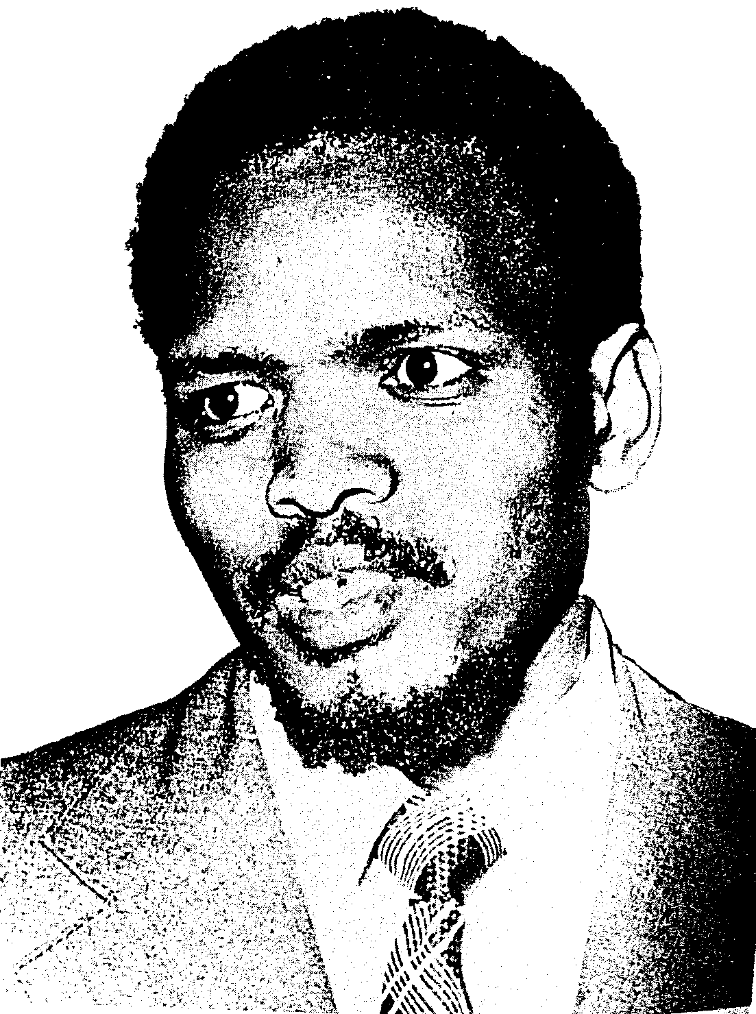

Source E / Bron E

“The final straw came with Treurnicht’s insistence that black students should receive lessons in Afrikaans. It was simply too bitter. Afrikaans, as their placards of protest were to announce, was the ‘oppressor’s language’. On 17 May, the pupils of Orlando West Junior Secondary School in Soweto walked out, saying they would not return until the Afrikaans-medium rule was withdrawn. On 21 May, the South African Institute of Race Relations cabled Treurnicht expressing concern. Treurnicht accused the Institute of overreacting. This was neither the first nor the last warning to be made and dismissed.”

(From R.W. Johnson: How Long will South Africa Survive?, pages 191-192).

“Die laaste strooi was Treurnicht se aandrang dat swart studente in Afrikaans hul onderrig moes ontvang. Dit was te erg. Hulle het geprotesteer dat Afrikaans die onderdrukker se taal was. Op 17 Mei het die leerlinge van Orlando-Wes Junior Sekondêre Skool uitgestap. Hulle het geweier om terug te keer solank Afrikaans as onderrigmedium gebruik word. Op 21 Mei het die Suid-Afrikaanse Instituut vir Rasseverhoudinge ’n telegram aan Treurnicht gestuur waarin hulle hul bekommernis oor die situasie uitgespreek het. Treurnicht het gesê die Instituut oorreageer. Dit was nie die eerste of laaste waarskuwing wat geïgnoreer is nie.”

(Vrye vertaling uit: How Long will South Africa Survive? deur R.W. Johnson,
bl. 191–192.)

Source F / Bron F
