GAUTENG DEPARTMENT OF EDUCATION
SENIOR CERTIFICATE EXAMINATION

HISTORY HG
(First Paper: General History)

TIME : 2½ hours

MARKS : 200

INSTRUCTIONS:

- This paper consists of TWO sections:

► Section A consists of four essay questions. TWO essays must be answered. Candidates are to answer either essay Question 1 OR 2. Candidates are then to answer either essay Question 3 OR 4. Do not use headings or point form in your essay.

► Section B consists of COMPULSORY short questions. Candidates must answer ALL the short questions.

- The Addendum (pages 8 – 12) contains information and illustrations which pertain to Section B. You are advised to detach the Addendum and place each page alongside the relevant question(s) for easy reference.

- Write as clearly and neatly as possible.

- Number all answers clearly and accurately.

SECTION A

ESSAY-TYPE QUESTIONS

Answer TWO questions from this section. Answer either Question 1 OR Question 2 AND either Question 3 OR Question 4.

QUESTION 1  THE RISE OF THE SUPER POWERS : USSR  “On his return to Russia from Switzerland, Lenin started implementing the Bolshevik policies in Russia.”  In the light of this statement, explain how Lenin assumed power in 1917 and discuss the major problems facing the Bolsheviks and the solutions to the problems up to 1921. | [60]

OR

QUESTION 2  THE RISE OF THE SUPER POWERS : THE UNITED STATES OF AMERICA  President Franklin D. Roosevelt of the United States of America had no clear idea of how to solve America’s economic problems. However, he was bold and adaptive and willing to try anything which might revive the economy.  Analyse this statement with reference to the period 1932 to 1936. | [60]

QUESTION 3

INTERNATIONAL RELATIONS AND EVENTS, 1945 TO 1970 : THE COLD WAR IN EUROPE

Speaking in 1987, Mikhail Gorbachev, the Soviet leader, stated:

“The time is ripe for abandoning views on foreign policy which are influenced by an imperial standpoint. Neither the Soviet Union, nor the USA is able to force its will on others. It is possible to suppress, compel, bribe, break or blast, but only for a certain period. From the point of view of long term big time politics, no-one will be able to subordinate the other. That is why only one thing – relations of equality – remains. All of us must realise this ….. This also obliges us to respect one another and everybody….”

(From: Pape, Friedman and others: Making History. Grade 12, p. 172)

Do you think, given the background and events after World War II, that the Soviet Union and the USA would have been able to act as Gorbachev suggests? Motivate your answer by giving a thorough discussion of the viewpoints and acts of the USSR and USA in Western and Eastern Europe between 1945 and 1955. | [60]

OR

QUESTION 4  INTERNATIONAL RELATIONS AND EVENTS, 1945 TO 1970 : AFRICA SINCE THE SECOND WORLD WAR  - Discuss the strengths and weaknesses of the Organisation of African Unity and provide an exposition of the aims and principles of the OAU.  4.2 What should the role of the OAU be as far as the fight against AIDS in Africa is concerned? Discuss briefly. | [60]

TOTAL FOR SECTION A: | [120]

SECTION B  COMPULSORY  NON-ESSAY TYPE QUESTIONS  QUESTION 5  Information and illustrations pertaining to Section B are to be found in the Addendum (pages 8 – 12). Please detach these pages for easy reference.  - Select the correct answer for each of the following sentences. Write down only the correct letter against the corresponding number in your answer book, eg. 1A; 2B; 3C.  5.1.1 When Hitler became chancellor in 1933, ________ was the vice- chancellor of Germany.  - Bruning  - Von Schleicher  - Von Papen  - Von Hindenburg  - The Italian government which ruled in 1929:  - The Facta government who ruled under a state of emergency.  - The Gioletti government who ruled with the aid of the Fascist Party.  - The Military dictatorship of Benito Mussolini.  - A constitutional monarchy under the Pope  5.1.3 Which three territories did Japan have by 1929 in the Pacific Ocean:  - Shantung; Korea; Formosa  - Shantung; Taiwan; South Sakhalin  - Formosa; South Sakhalin; the Phillippines  - South Sakhalin; Formosa; Korea | (2)  (2)  (2)

5.1.4 The “Zaibatsu” was the name for the  - wealthy industrialists interested in obtaining new areas to enlarge their markets.  - liberal parliamentarians who believed in a democratic state.  - people close to the Emperor who believed in the traditional Japanese culture of the divine right of the Throne.  - military clique who wanted to reign the country.  5.1.5 The German invasion of Poland on September 1, 1939 was the direct result of:  - Unsuccessful discussions between Mussolini, Chamberlain and Hitler at the so-called “second Munich”  - Poland’s continued refusal to give in to Hitler’s demands concerning Danzig and the Polish Corridor.  - British-French Ultimatum to Germany  D. Unsuccessful attempts to sign a neutrality agreement between Germany and Russia | (2)  (2)

Select the item which DOES NOT FIT in each of the following statements. Write down the number of each question in your Answer Book and next to it the letter of the item which DOES NOT FIT.

5.1.6 The economic symptoms of the Great Depression (1929 – 1932) in Germany:  - Dwindling trade and production made it impossible for Germany to support herself.  - There was a drop in prices and wages.  - The lower prices made production cheaper which made it possible for factory owners to maintain a large work force leading to a low unemployment rate.  - Foreign loans were no longer available.  - Reasons why the British prime minister Neville Chamberlain followed a policy of appeasement towards the aggressive German foreign policy:  - The general public opinion in Britain was against war and against a strong demanding policy towards Germany.  - The British ambassador in Berlin convinced Chamberlain that the German territorial demands were a disguise to protect the weaknesses of her army.  - The First World War and the Great Depression dumped the British economy in an acute crisis, which needed time to recover.  - A very small portion of the annual budget was spent on the British armed forces, thus making her ill-equipped for war. | (2)  (2)

- Actions taken against Mussolini’s invasion of Abyssinia:  - The League of nations declared economic sanctions against Italy.  - Britain and France suggested the Hoare-Laval Plan.  - Italy was kicked out of the League of Nations.  - Britain closed the Suez Canal for Italian troops.  - Japan’s intentions with the Amau Declaration of 1934:  - Only the Axis Powers were allowed to possess colonies in the East.  - The East was declared to be Japan’s sphere of influence.  - No foreign intervention in the East would be tolerated.  - It was the Japanese equivalent of the Monroe Doctrine.  - Meetings between Stalin, Roosevelt and Churchill, took place in  - Moscow.  - Teheran.  - Potsdam.  - Yalta. | (2)  (2)  (2)  [20]

5.2 Write a sentence, using the set of words in each of the following questions, to explain the relation between the items.  - Pearl Harbour ; General Tojo: Japanese delegation to Washington  - Molotov: Non-aggression Pact (Moscow Pact); Britain  - Chamberlain; Czechoslovakia; Daladier  - Atlantic Charter; Roosevelt; British-American military co-operation  5.2.5 Vatican City; Mussolini; Pope | (2)  (2)  (2)  (2)  (2)
[10]

5.3 Find a matching item in Column B for each of the items in Column A. Write down only the letter next to the corresponding number in your answer book.

COLUMN A | COLUMN B | 5x2=[10]
- Anti-Comintern Pact  - Munich agreement  - Mussolini  - Manchuria  - Austria | - Bohemia and Moravia given to Germany.  - Invaded by the Kwantung army of Japan.  - Anschluss  - Germany and Italy  - Militarised in 1936 in objection to the Treaty of Versailles.  - II Duce  - Germany and Japan  - Sudetenland given to Germany. | 5x2=[10]

Refer to the Addendum.  - Use Document 1 (Treaty of Versailles) and the Map (German Territorial Losses, 1919) to answer the following questions:  5.4.1 Name the area numbered 1 on the map to which clauses 42 and 43 refer.  - What was the final decision on the status of this area after 1919?  - Why did the peace makers at Versailles decide on this status for the area?  5.4.4 Which European countries are located on the western borders of this area? | (1)  (1)  (2)  (4)
[8]

Refer to the Addendum.  5.5 Use Documents 1, 2 and 3, the Map and Cartoon 1 (The Goose Step) to answer the following questions:  - In which area of Germany is the “goose” walking?  - Why is the “goose” carrying weapons?  5.5.3 Which event is depicted by the cartoon? | (1)  (1)  (1)

- What is the significance of the “goose” standing on a piece of paper with the words “Locarno” written on it?  - Which other treaty was also violated by this action? Motivate your answer.  - Did Hitler obtain permission from the Reichstag for this action? Motivate your answer.  5.5.7 What did Hitler do to test the opinion of the German people after this action? | (3)  (2)  (3)  (1)  [12]

Refer to the Addendum.  5.6 Use Documents 1, 2 and 4, as well as Cartoon 2 (Good Hunting) to answer the following questions:  - Clause 2 of Document 2 refers to “abolition of the Peace Treaty of Versailles and Saint-Germaine”. With which country was the Treaty of Saint-Germaine concluded?  - What treatment did the Treaty of Versailles (Clause 80) expect of Germany towards the country with whom the Treaty of  Saint-Germaine was signed?  - What were Hitler’s plans for the country with whom the Treaty of Saint-Germaine was signed?  - Who are the TWO persons depicted in the cartoon?  - What is meant by the caption ”Good Hunting”?  - What is the significance of the notice board stating “Strictly preserved”?  - Why does the one man say to the other: “I never heard a shot”? | (1)  (2)  (1)  (2)  (1)  (1)  (2)  [10]

Refer to the Addendum.  5.7 Use Document 3 to answer the following questions.  This document highlights a number of very strange aspects of Germany as a totalitarian state. Keep this in mind when answering the questions.  - What was the Reichstag?  - Why is it strange to learn that Hitler addressed the Reichstag?  - What type of legislation was passed by the Reichstag in Nazi Germany? Motivate your answer.  - What is peculiar and indicated by “uniformed deputies rose as one man to testify with cries of ‘Heil’”?  5.7.5 Why would the flags normally be flown half-mast on Heroes Day in Nazi Germany? | (1)  (2)  (2)  (4)  (1)  [10]

TOTAL FOR SECTION B:  TOTAL: | [80]  [200]

ADDENDUM

Please detach the Addendum (pages 8 – 12) and place alongside the relevant questions in Section B for easy reference.

DOCUMENTS

Document 1: Treaty of Versailles

This document contains some extracts from the Treaty of Versailles. The number down the left-hand side of the document refer to the clauses of the Teaty.

42 Germany is forbidden to maintain or construct any fortification either on the left bank of the
Rhine or on the right bank to the west of a line drawn fifty kilometres to the east of the Rhine.

43 In the area defined above, the maintenance and assembly of armed forces and military
manoeuvres of any kind ….. are in the same way forbidden …..

45 As compensation for the destruction of the coal mines in the north of France and as part
payment towards the total reparation due from Germany for the damage resulting from the war,
Germany cedes to France ….. the coal mines situated in the Saar Basin …..

51 The High Contracting Parties recognising the moral obligation to redress the wrong done by
Germany in 1871 both to the rights of France and to the wishes of the population of Alsace and
Lorraine, which were separated from their country ….. The territories which were ceded to
Germany ….. are restored to French sovereignty

80 Germany acknowledges and will respect strictly the independence of Austria… ..

87 Germany recognises the complete independence of Poland, and renounces in her favour all
rights and title over the territory …..

160 The German Army ….. must not exceed one hundred thousand men, including officers and
establishments of depots. The Army shall be devoted exclusively to the maintenance of order
within the territory and to the control of frontiers …..

(Taken from: Condon, C: The Making of the Mondern World)

Document 2: The 25-Point Program of the National Socialist German Workers’ Party.
25 February 1920. This document contains some extracts from the original 25-Point Program of the National Socialist German Workers’ Party. The number down the left-hand side of the document refer to the clauses of this program.

The program of the German Workers’ Party is limited as to period. The leaders have no intention, once the aims announced in it have been achieved, of setting up fresh ones, merely in order to increase the discontent of the masses artificially and to ensure the continued existence of the party.

1 We demand the union of all Germans to form a Great Germany on the basis of the right of self-
determination of nations.

2 We demand equality of rights for the German people in its dealings with other nations, and
abolition of the Peace Treaty of Versailles and Saint-Germaine.

3 We demand land and territory (colonies) for the nourishment of our people and for settling our
surplus population.

(Taken from: Snyder, L.L.: Fifty Major Documents of the Twentieth Century)

Document 3: The March Into The Rhineland, 1936

An extract from an article in “The Times,” 9 March 1936.

Herr Hitler read the memorandum towards the end of a speech which lasted an hour and a half. The Führer asked the Reichstag to testify to two holy, innermost articles of faith; first, to uphold the honour of Germany at all cost; secondly, to work now all the more for European understanding, and particularly understanding with western nations and western neighbours. The uniformed Deputies rose as one man to testify with cries of “Heil”. He then announced that the Reichstag was to be dissolved in order to give the German people an opportunity of giving their approval to the work done by himself and his colleagues during the last three years. General Göring, as President of the Reichstag, read the message of dissolution ….. The elections will take place on Sunday,
29 March, and Dr Goebbels, the Propaganda Minister, has been appointed to direct them.

While the Führer was speaking troops were marching, and had been since early morning, into the demilitarised zone. According to a statement issued here the troops moved are nineteen battalions of infantry, thirteen detachments of artillery, two flights of pursuit aircraft, and two anti-aircraft detachments – some 25 000 to 30 000 men in all. The local population was naturally jubilant. For economic, if for no other reasons, the absence of the military establishments in the Rhineland has been a sore point with them, particularly since the introduction of conscription.

In Berlin the news appeared to be taken very calmly, even in National-Socialist Party circles. In moderate and responsible quarters there was anxious astonishment at the decision to occupy the Rhineland ….. Nevertheless, flags were hung out by the population at Dr Goebbels’ request in celebration of the final re-establishment of German freedom and sovereignty and therewith of German honour. The flags, Dr Goebbels ordered, should also remain out today, the German Armistice Day, to express inner unity with the War dead, whose “sacrifice is no longer in vain”. The flags which on Heros’ Day are usually flown half-mast were today flown full-mast. Large crowds outside the Chancellery during the day and in the evening the SA staged a torchlight procession along Wilhelmstrasse,Herr Hitler taking the salute.

(From: Wroughton, J and Cook, D: Documents on World History 2; 1919 to the present day)

Document 4: The Hossbach Document, 5 November 1937

At a secret meeting held on 5 November 1937, Hitler outlined to his military leaders the practical steps in undertaking aggression against other countries. The minutes of the meeting, as recorded by Hitler’s adjutant, Colonel Hossbach, reveal how Hitler planned to wage war two years before the outbreak of hostilities.

The Führer then stated: The aim of German policy is the security and the preservation of the Volk (nation) and its propagation. This is consequently a problem of space ….. The question for Germany is where the greatest possible conquest can be made at lowest cost.

German politics must reckon with its two hateful enemies, England and France, to whom a strong German colossus in the centre of Europe would be intolerable. Both these states would oppose a further reinforcement of Germany, both in Europe and overseas, and in this opposition they would have the support of all parties …..

For the improvement of our military political position it must be our first aim, in every case of entanglement, to conquer Czechoslovakia and Austria simultaneously, in order to remove any threat from the flanks in case of a possible advance west-ward …..

(Taken from: Snyder, L.L.: Fifty Major Documents of the Twentieth Century)

Map / Kaart
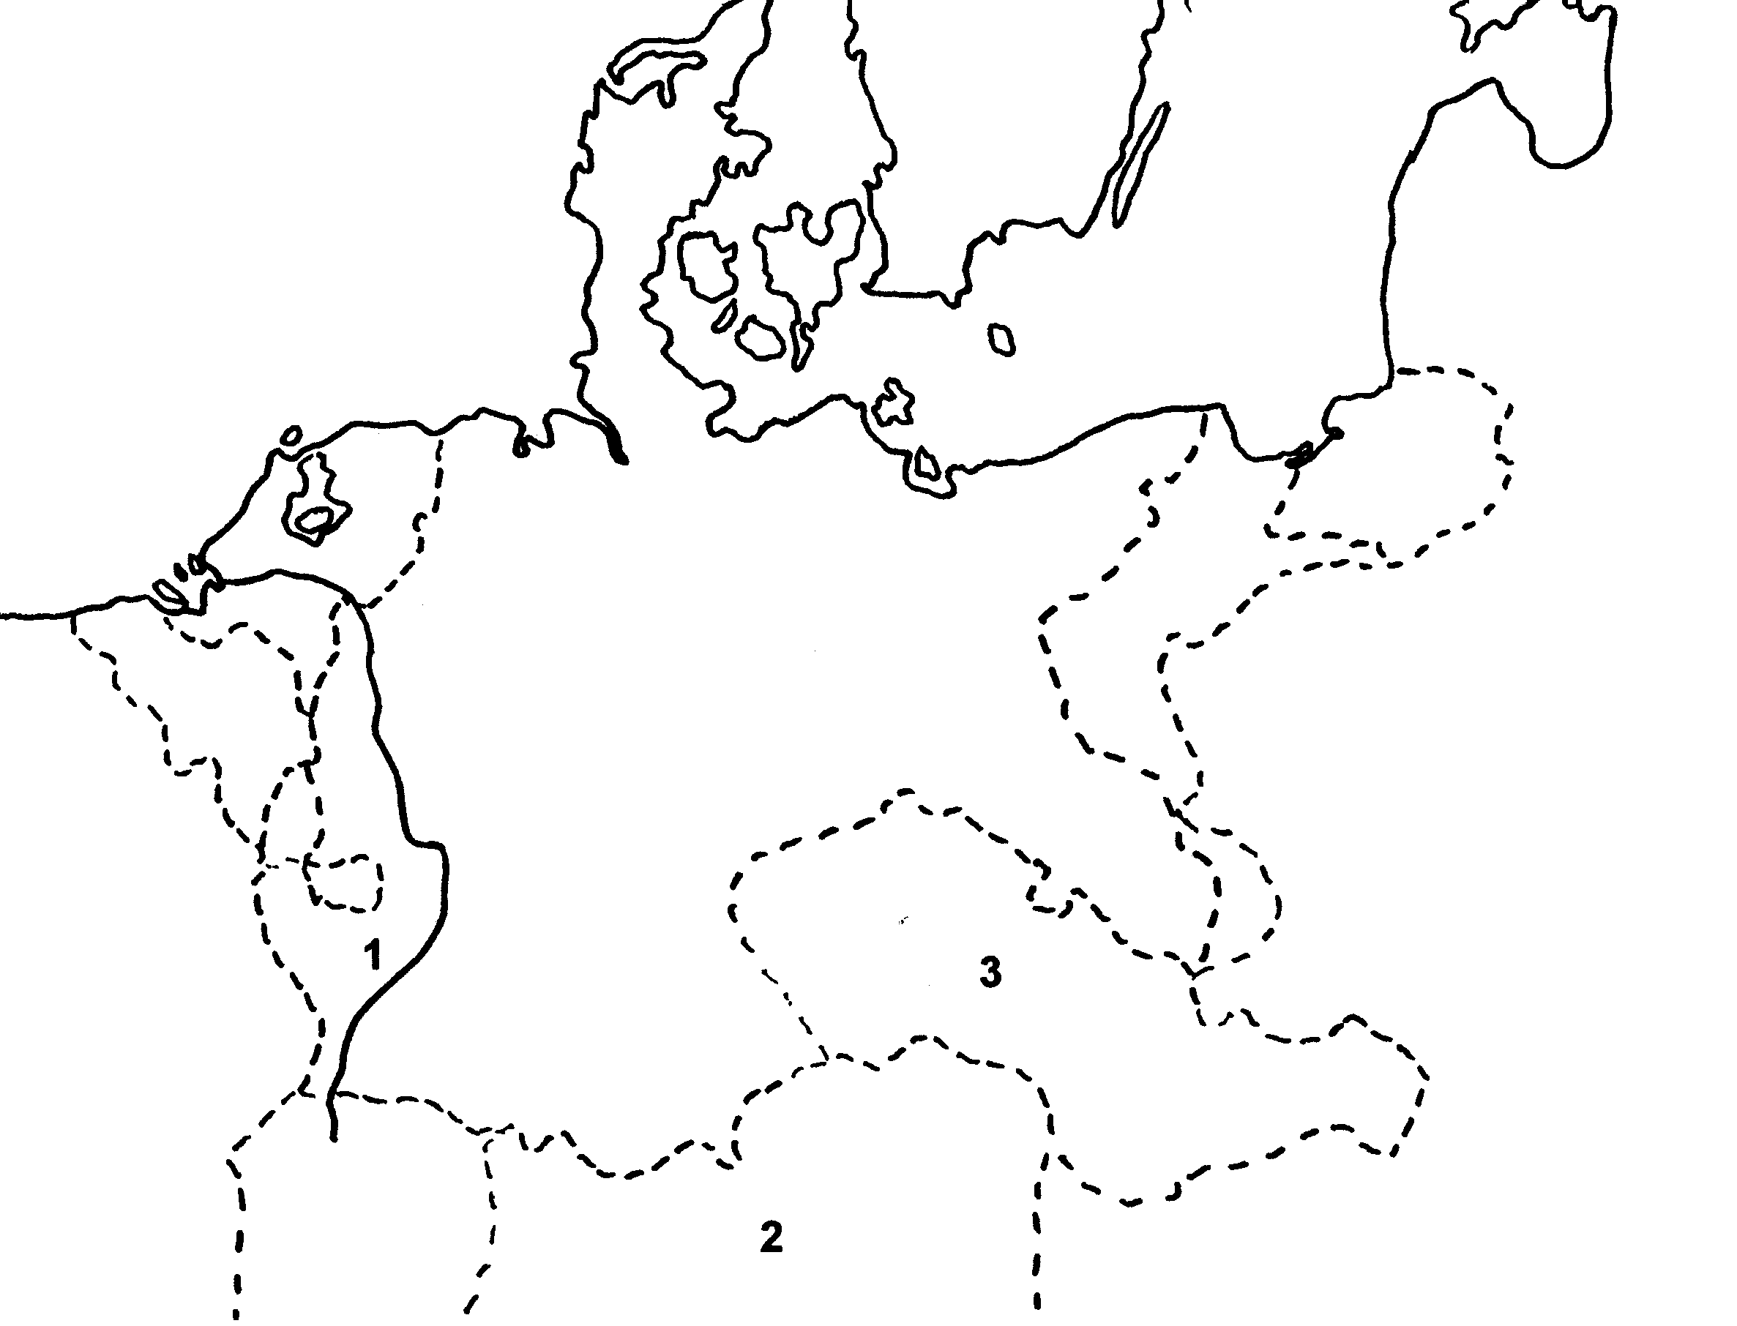

Cartoon 1 / Spotprent 1
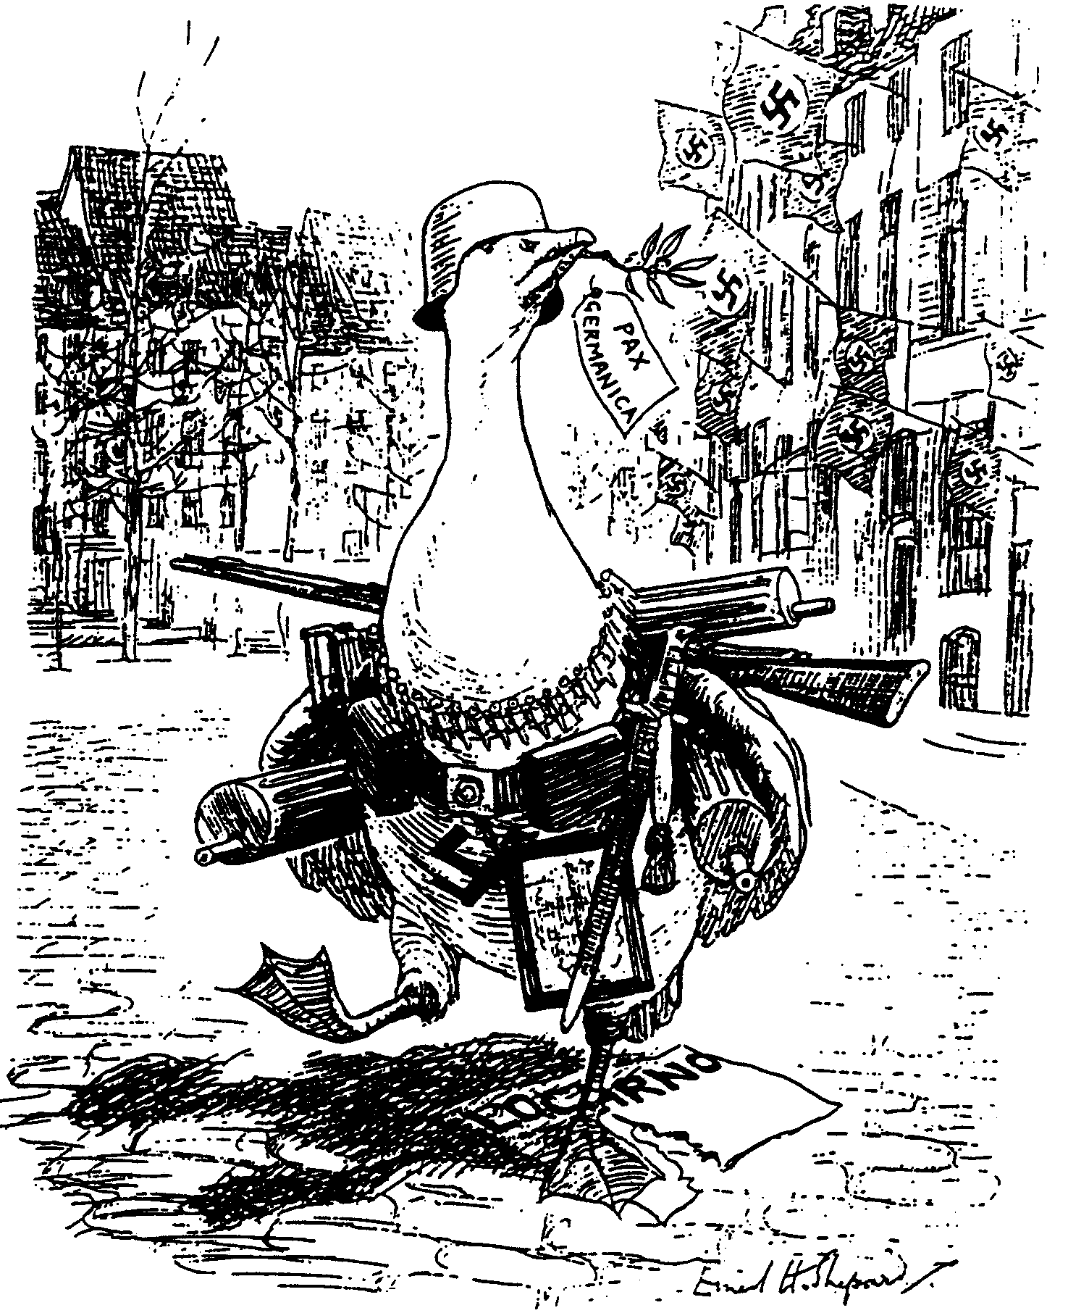

The Goose-Step / The Ganspas

‘Goosey Goosey Gander, Whither dost thou wander?’
‘Only through the Rhineland, Pray excuse my blunder!’
(A Punch cartoon, March 1936)
‘Gansie, Gansie, waarheen wandel jy?’
‘Sommer deur die Rynland, verskoon tog my flater!’
’n Punch-spotprent, Maart 1936

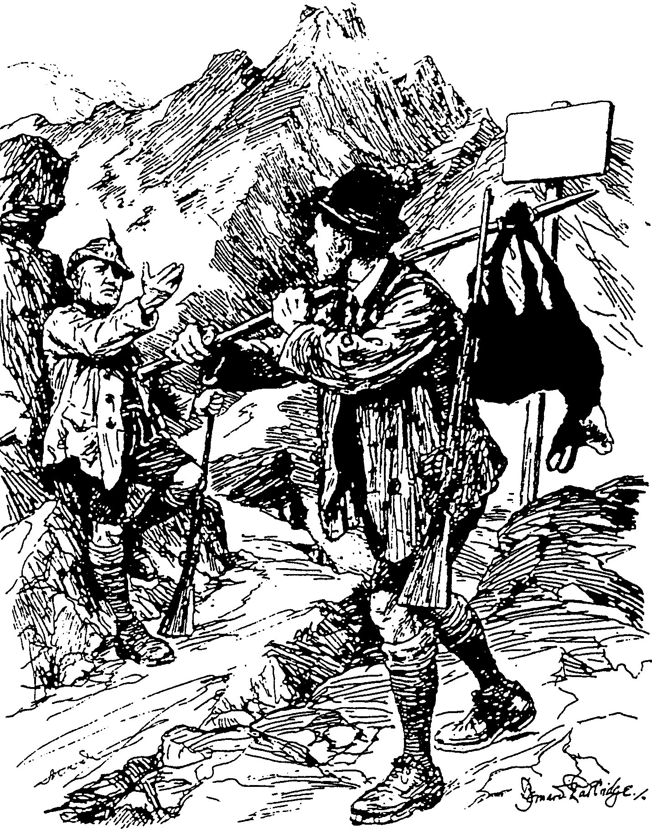

STRICTLY
RESERVED
STRENG
VERBODE

Cartoon 2 / Spotprent 2

Good Hunting / Goeie Jagtog

Mussolini: “All right, Adolf – I never heard a shot.”
Mussolini: “Reg, Adolf – ek het geen skoot gehoor nie.”

