GAUTENG DEPARTMENT OF EDUCATION
SENIOR CERTIFICATE EXAMINATION

CLASSICAL GREEK SG

TIME: 3 hours

MARKS: 300

Answer ALL questions.

SECTION A

PRESCRIBED READING

QUESTION 1

Translate the following passages into English and answer the questions which follow.

1.1 Medea tells Jason that, because she helped him, she has nowhere to go, now that she has to leave his country.
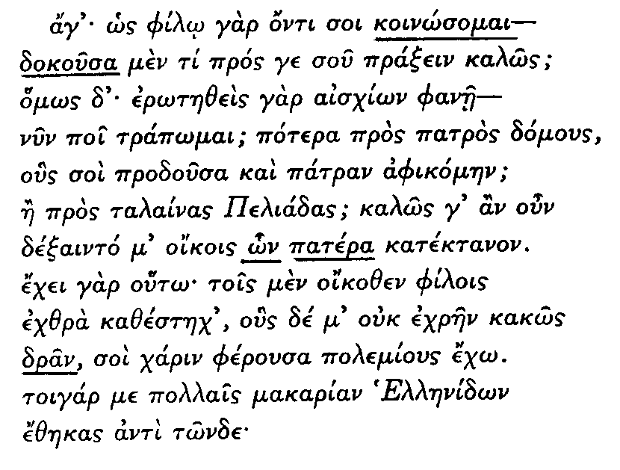

Euripides: Medea 499 – 510 | [30]

1.1.1 Write down the tense and mood of each of the following:

(6)

1.1.2 Parse the relative pronoun:

 | (3)

    - With reference to the word :


- Give the case of the word  - Give the nominative singular  - Give the dative plural | (3)  [12]

1.2 Xerxes asks Artabanos his opinion of the expedition’s chances. Artabanos expresses his doubts since two elements are hostile to it.

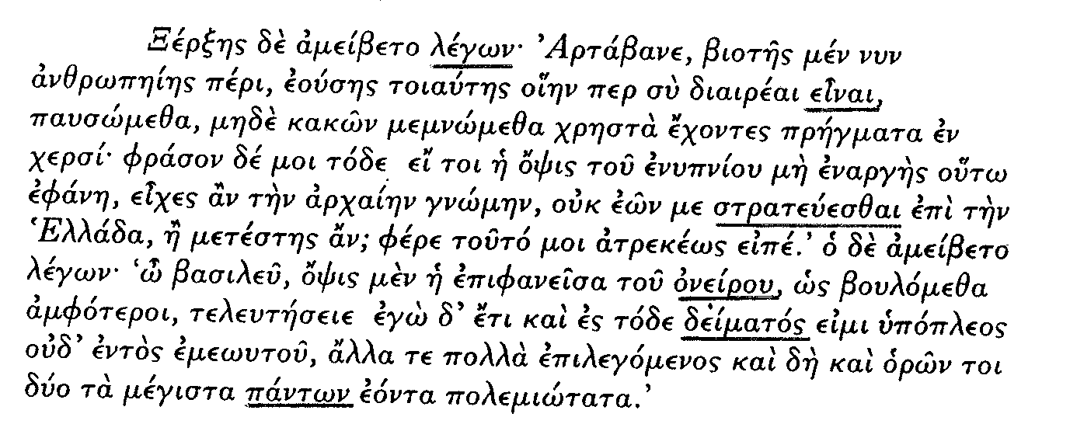

Herodotus Bk. 7. 47 – 48. | [30]

1.2.1 Write down the tense, mood and voice of the following verb forms:

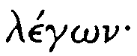


1.2.2 Write down the case and number of each of the following:
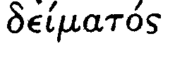


(6)
[12]

1.3 Xerxes does not believe the Greeks will fight against him. He waits four days, expecting them to flee. When they do not, he attacks, without success.

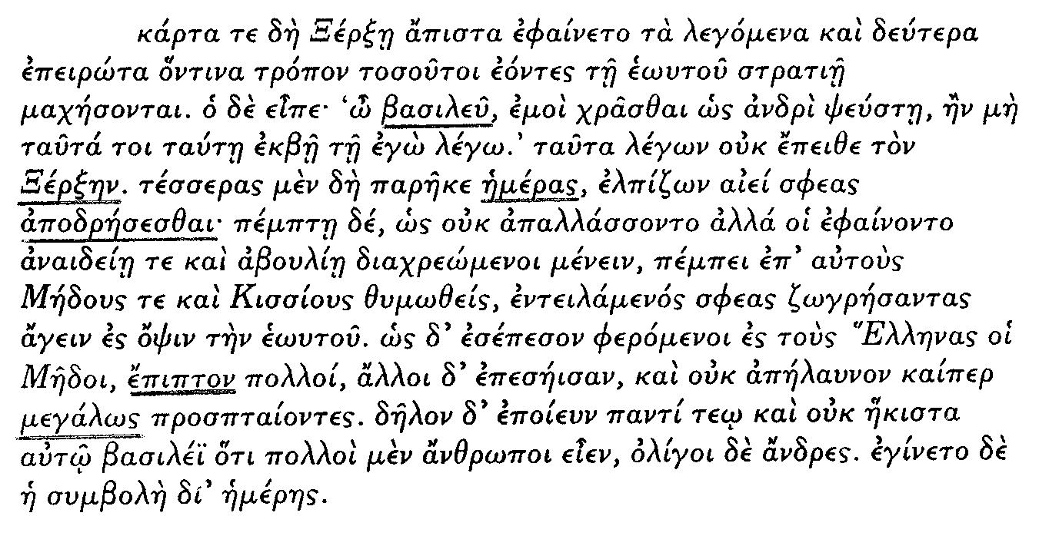

Herodotus Bk. 7. 209 – 210 | [30]

1.3.1 State and account for the case of:
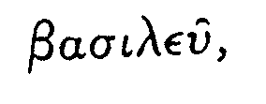
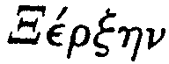

(6)

1.3.2 Parse the following verb:

(3)

- State and account for the mood of:  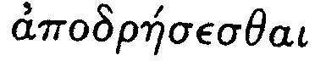 | (2)

- What part of speech is:   | (1)  [12]

1.4 Medea tells Jason what he must do to prepare himself for sowing the dragon’s teeth.

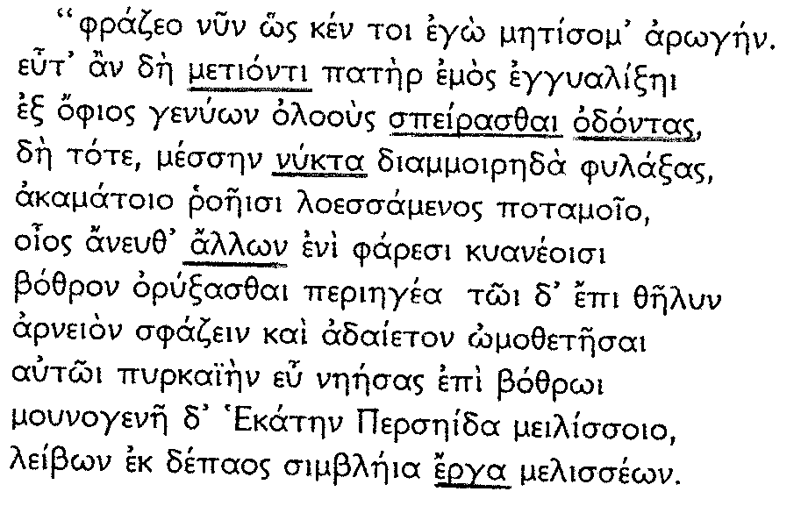

Apollonius Rhodius: Argonautica Bk III 1026 – 1036 | [30]

1.4.1 State the case and number of each of the following:


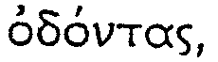
(6)

1.4.2 Parse the following verb form:

(4)

1.4.3 Give the singular of the following, in the same case:


(2)
[12]

QUESTION 2

Choose THREE of the following extracts and write comments, as directed, on the passages you choose.

(NB: Translation is not required.)

2.1
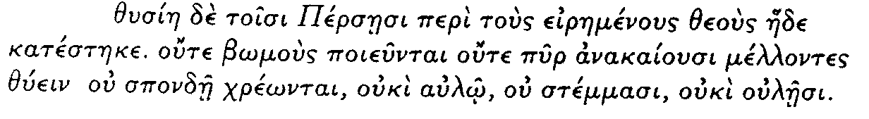

Herodotus Bk. 1. 132

According to Herodotus, the ceremonies which were important to the Greeks, had no place in the sacrifices of the Persians. How did the Persians go about offering sacrifices to the gods?
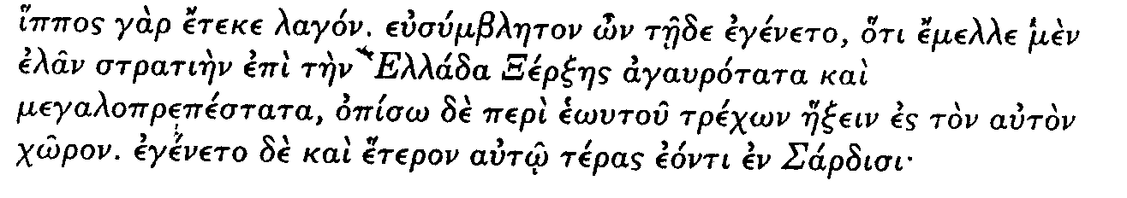
2.2

Herodotus Bk. 7. 57 – 58

What was this strange thing that had occurred in Sardis, even before the mare gave birth to a hare?

2.3
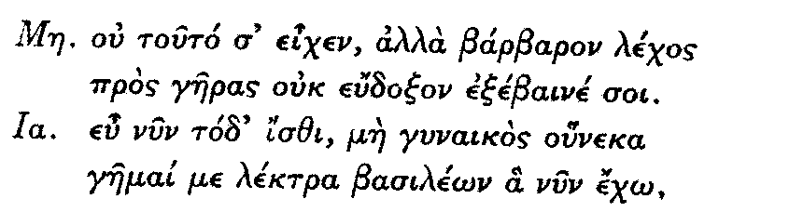

Euripides: Medea 591 – 594

Jason says that he is not making this second marriage for the sake of any woman. What, according to him, is his reason for marrying the princess?

2.4
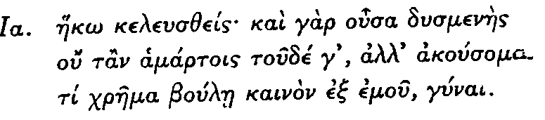

Euripides: Medea 866 – 868

When Jason wants to know why Medea sent for him, what reason does she give?

2.5
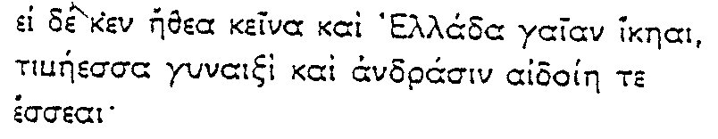

Apollonius Rhodius: Argonautica Bk III. 1122 – 1124

Why, according to Jason, will women and men in Hellas honour and worship Medea as a goddess? 3x6= | [18]

TOTAL FOR SECTION A: | [186]

SECTION B

UNSEEN TRANSLATION

QUESTION 3

Translate the following passage into English.

A Persian woman asks King Darius to release her brother rather than any other relative. Darius is amazed and wants to know the reason for this request.

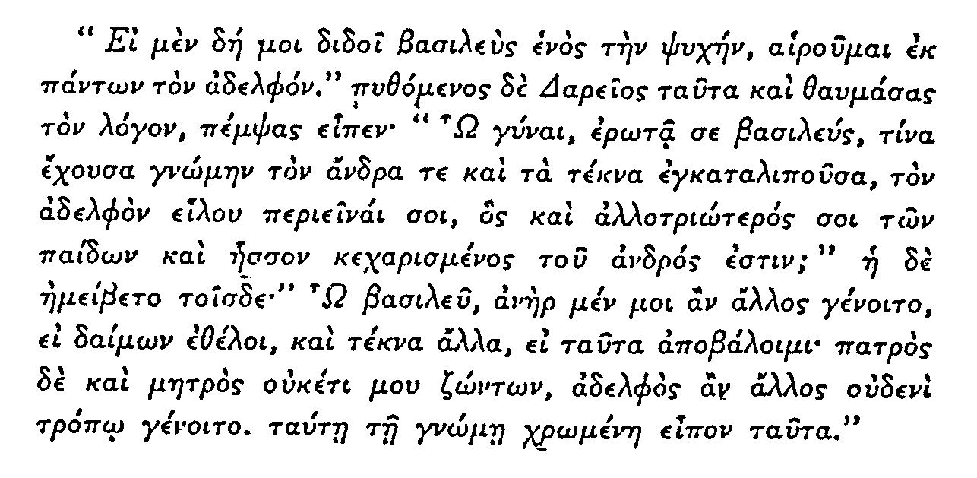

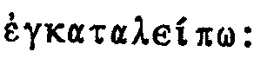
I abandon

remotely related

Herodotus Bk 3. 119

TOTAL FOR SECTION B: | [54]

SECTION C

BACKGROUND STUDY

QUESTION 4

Choose TWO of the following topics. Write an essay of approximately 400 words (covering about 1½ pages of your examination answer book on each of the topics you have chosen).

Please note: Essays must be written in English and not in Modern Greek.

4.1 Describe the events which led to Jason’s quest for the golden fleece.

  - Which events caused the Trojan War? Write notes on the involvement in the war of:

Agamemnon, Achilles and Hector

4.3 If you were the defender in a case against Jason for his treatment of Medea, as described in the drama by Euripides, which arguments would you use?

4.4 Theatre was an all important part of Greek society. Write notes on any TWO of the following aspects of ancient Greek theatre:

- The origin of tragedy  - Costume  - The actors  - Acting 2x30= | [60]

TOTAL FOR SECTION C: | [60]

TOTAL: | 300

