GAUTENG DEPARTMENT OF EDUCATION

SENIOR CERTIFICATE EXAMINATION

FUNCTIONAL PHYSICAL SCIENCE SG
(Second Paper: Chemistry)

TIME: 2 hours

MARKS: 150
REQUIREMENTS:

- An approved (non-programmable, scientific) pocket calculator. Candidates should supply their own calculators.

INSTRUCTIONS:

- Write your examination number in the spaces provided for this purpose on the front of your answer book.

- Answer ALL questions.

- Answer Question 1 on the answer sheet on the inside cover of your answer book. Make a cross (X) over the letter A, B, C or D, to indicate the letter you have chosen.

- Answer all the other questions in the answer book. If you need to redo an answer, redo it on a new page. Number all answers clearly.

- Start each question on a new page.

- A data sheet is provided at the end of this question paper. It contains formulae and constants. The information provided may be useful in answering the questions.

- Rough work may be done on the blank pages at the back of your answer book.

QUESTION 1
A B C D
MULTIPLE-CHOICE QUESTIONS

Study each item and the suggested answers which are indicated by the letters A, B, C and D. Make a cross (X) over the corresponding letter on the answer sheet after you have decided which is the correct one. If more than one cross appears in any answer, NO MARKS will be awarded.

EXAMPLE:

Pure ice melts at?

- -4 °C
- 0 °C
- 0 K
- 4 °C

ANSWER:

- Rutherford found that when gold foil was bombarded with alpha particles most of the alpha particles passed through the foil, but a small number were reflected. He proposed that  - electrons move in orbits around atoms.  - electrons are very large particles compared with protons.  - the nucleus of the atom is made up of protons and neutrons.  - the atom consists of a small, dense positive nucleus surrounded by electrons. | (3)

- An atom has an atomic number of 3 and a relative atomic mass of 7. How many electrons will be found in the neutral atom?  - 3  - 4  - 7  - 10 | (3)

  - The volume and mass of the atom are determined, respectively, by:

 |  | VOLUME OF THE ATOM | MASS OF THE ATOM
 | A | electrons | protons
 | B | protons | neutrons
 | C | electron cloud | nucleus
 | D | nucleus | electron cloud
 |  |  |  |  | (3)

  - The bonding between two atoms is ionic when

- electron pairs are shared between atoms.  - electrostatic forces bind electrons together.  - the electron clouds of atoms overlap.  - electron transfer has taken place. | (3)

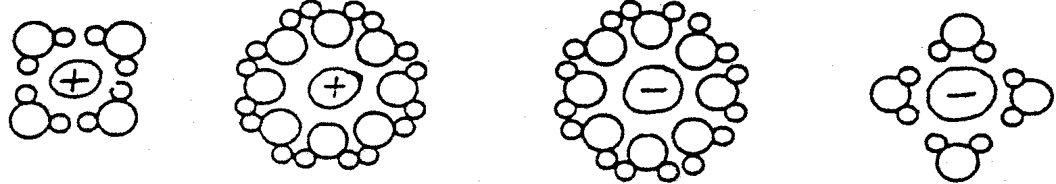  - Certain substances dissolve in water to form ions. Which of the following sketches is the best representation of ions in water?  I  II  III  IV  - I and IV only  - II and III only  - II and IV only  - I, III and IV only | (3)

- Energy is needed to break bonds, while energy is usually released when bonds are formed. The heating of calcium carbonate (CaCO₃) is an example of a reaction where bonds  - play no part.  - are broken.  - are formed.  - remain unchanged. | (3)

Cr₂O₇²⁻(aq) + OH⁻(aq) 2CrO₄²⁻(aq) + H⁺(aq)  orange yellow  Colour changes may be brought about in this reaction by adding either an acid or alkali. This shows that  - ionic reactions proceed rapidly.  - potassium dichromate is soluble.  - water can ionise to H⁺(aq) and OH⁻(aq).  - the reaction can take place in both directions. | (3)

- The concentration of the products in any chemical reaction which is in equilibrium, may be increased by  - adding a catalyst.  - increasing the concentration of the reagents.  - decreasing the pressure.  - increasing the temperature. | (3)

- Which chemical species is reduced in the reaction below?  2Aℓ(s) + 6H⁺(aq) 2Aℓ³⁺(aq) + 3H₂(g)  - Aℓ  - H⁺  - Aℓ³⁺  - H₂ | (3)

- Consider the equation of the following reaction:  2FeCℓ₃+ H₂S → 2FeCℓ₂ + S + 2HCℓ  The oxidation number of the oxidising agent changes from  - –2 to 0  - +3 to +2  - +3 to 0  - –2 to +2 | (3)

- An electrochemical cell transfers  - chemical potential energy to electrical energy.  - electrical energy to chemical potential energy.  - electrical energy to kinetic energy.  - kinetic energy to electrical energy. | (3)

- What is the purpose of the salt bridge which connects the copper half-cell with the zinc half-cell in the Daniell cell?  The salt bridge  - provides a passage for the flow of electrons.  - supplies anions to the zinc half-cell and cations to the copper half-cell.  - provides a mechanism by which electrons can be transferred between neighbouring ions.  - allows ions to migrate between the two half-cells. | (3)

1.13 The elements in group I on the periodic table easily  - donate electrons.  - donate protons.  - accept protons.  - accept electrons. | (3)

1.14 The formula for ethanol is:  - CH₃CH₂Cℓ  - CH₃CHO  - CH₃CH₂OH  - CH₃COOH | (3)
- Which one of the following has a sour taste?  - CH₃COOH  - C₂H₂  - C₂H₆  - CH₃I | (3)

15x3=[45]

QUESTION 2
ATOMIC STRUCTURE

An excited calcium atom with 41 nucleons has the following electron configuration:

1s² 2s² 2p⁶ 3s² 3p⁶ 4s¹ 5s¹

- What is meant by the excited state of this atom?  x  y  - Is the excited state a stable or an unstable state? Explain your answer.  - Write down the electron configuration of  - this atom in the ground state.  - a double positively charged ion of this atom.  - Write down a symbol of an isotope of this calcium atom in the form Ca, where x and y are appropriate numbers.  - Is energy required or released, when the Ca ion is formed? | (2)  (4)  (2)  (2)  (2)  (2)  [14]

QUESTION 3  CHEMICAL BONDING  Consider the following two elements:  Lithium (Li)  Oxygen (O)  - Give the Aufbau diagrams for an atom of both elements.  - Give the ions which will be formed by atoms of each of the elements.  - Give the formula of the product which will be formed if ions of these two elements react with each other.  - What is the nett difference in electronegativity between these two elements?  - Does this compound have a covalent or ionic nature? | (4)  (4)  (2)  (2)  (2)  [14]

QUESTION 4
INTERMOLECULAR FORCES

In the table below, information for hypothetical substances A, B, C and D is given.

SUBSTANCE | MELTING | BOILING | ELECTRICAL CONDUCTIVITY
 | POINT (°C) | POINT (°C) | SOLID | LIQUID
A | 1700 | 2500 | poor | poor
B | 800 | 1470 | poor | good
C | -23 | 77 | poor | poor
D | -115 | -85 | poor | poor

- Which substance is most likely composed of ions?  - In which substance are the  - strongest intermolecular forces present?  - weakest intermolecular forces present? | (2)  (2)  (2)

- At room temperature (25 °C) which substance(s) will be a  - liquid?  - gas? | (2)  (2)  [10]

QUESTION 5

ENERGY AND CHEMICAL BONDING

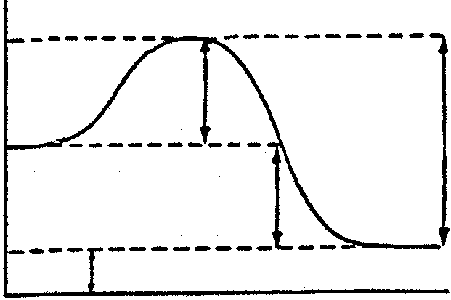
Hydrogen iodide breaks up to form hydrogen and iodine. The reaction may be represented as follows:
A
D
C
B
E
2HI(g) → H₂(g) + I₂(g)
REACTION CO-ORDINATE

The energy changes which occur during this reaction may be represented as follows:

- Is this reaction exothermic or endothermic?  - Explain your answer to Question 5.1.  - Which interval on the graph (refer to A, B, C or D) represents  - the heat of the reaction?  - the activation energy of the forward reaction?  - Explain the concept activation energy. | (1)  (2)  (2)  (2)  (2)  [9]

QUESTION 6
4NH₃(g) + 5O₂(g) 4NO(g) + 6H₂O(g); ∆H<O

CHEMICAL EQUILIBRIUM

The equilibrium represented in the equation below, exists in a closed system.

How will the equilibrium concentration of NH₃(g) change, if  - the temperature is decreased?  - the pressure is decreased?  - water is removed from the system? | (2)  (2)  (2)

- During the forward reaction a nett amount of energy is released. Explain the origin of this excess energy.  - Name ONE factor that will increase the production of NO(g). | (4)  (2)  [12]

QUESTION 7

REDOX REACTIONS

- Explain, by referring to electron transfer, what the term oxidation means.  - Explain, by referring to oxidation numbers, what the term oxidation means. | (2)  (2)

- Consider the equations of the following reactions:  7.3.1 NaOH + HCℓ → NaCℓ + H₂O  7.3.2 KBr + Cℓ₂ → KCℓ + Br₂  7.3.3 H₂SO₄ + Cu → CuSO₄ + SO₂ + H₂O  Choose TWO of the above reactions which are redox in nature. Write down the question number and indicate which substance is oxidised. | (6)  [10]

QUESTION 8
ELECTROCHEMISTRY

8.1 Draw a sketch of a Zn/Cu electrochemical cell which contains an instrument in the external circuit to indicate the current flow. Label the various parts. | (6)

8.2 Write down equations to represent the half-reaction which would take place in the  - zinc half-cell.  - copper half-cell. | (2)  (2)

8.3 8.3.1 Which one of the electrodes would acquire a negative charge?  8.3.2 Which electrode is the anode? | (1)  (1)  [12]

QUESTION 9  PROPERTIES OF ELEMENTS  Chlorine gas (Cℓ₂) is bubbled through a solution of potassium bromide (KBr) in water.  - What colour change do you observe in the solution?  - What substance which forms is responsible for this change?  - For this reaction, provide the  - oxidation half-reaction;  - reduction half-reaction; and the  - total reaction.  9.4 What would happen if bromine (Br₂) is added to a solution of potassium chloride? | (2)  (2)  (2)  (2)  (2)  (3)  [13]

QUESTION 10

ORGANIC CHEMISTRY

Hydrocarbons can be used, among other things, for fuel.  - Of what elements are hydrocarbons composed?  - What products are formed when hydrocarbons burn in excess oxygen?  - 10.3.1 What hydrocarbon is used in gas welding?  10.3.2 Why is this gas used? | (4)  (4)  (2)  (3)  [11]

TOTAL: | 150

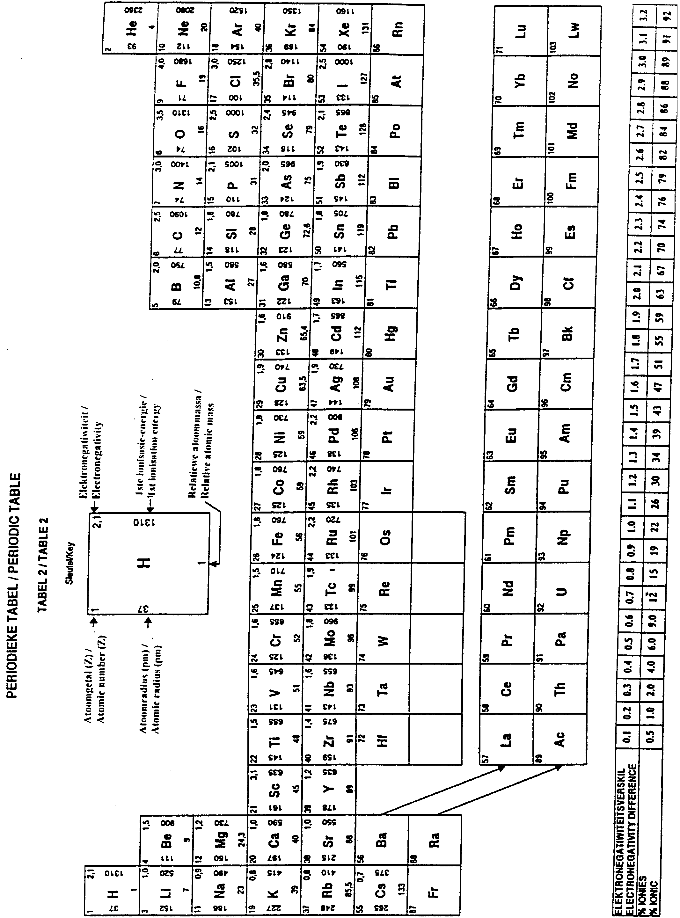

STANDARD reduction potentials OF A NUMBER OF HALF-REACTIONS
STANDAARDreduksiepotensiale VAN VERSKEIE HALFREAKSIES

Increasing  reducing  ability  Toenemende  reduseer-  vermoë  Increasing  oxidising  ability  Toenemende  oksideer-  vermoë | Half-reaction / Halfreaksie
 | Oxidising agent / Oksideermiddel | Reducing agent / Reduseermiddel | E° (volts) /  E° (volt)
 | Li⁺ + eˉ  K⁺ + eˉ  Ba²⁺ + 2eˉ  Ca²⁺ + 2eˉ  Na⁺ + eˉ  Mg²⁺ + 2eˉ  Aℓ³⁺ + 3eˉ  Mn²⁺ + 2eˉ  2H₂O + 2eˉ  Zn²⁺ + 2eˉ  Cr²⁺ + 2eˉ  Cr³⁺ + 3eˉ  Fe²⁺ + 2eˉ  Cr³⁺ + eˉ  Cd²⁺ + 2eˉ  Co²⁺ + 2eˉ  Ni²⁺ + 2eˉ  Sn²⁺ + 2eˉ  Pb²⁺ + 2eˉ  Fe³⁺ + 3eˉ  2H⁺ + 2eˉ  S + 2H⁺ + 2eˉ  Sn⁴⁺+ 2eˉ  SO₄²⁻ + 4H⁺ + 2eˉ  Cu²⁺ + 2eˉ  2H₂O + O₂ + 4eˉ  SO₂ + 4H⁺ + 4eˉ  I₂ + 2e⁻  O₂(g) + 2H⁺ + 2eˉ  Fe³⁺ + eˉ  NO₃ˉ + 2H⁺ + eˉ  Hg²⁺ + 2eˉ  Ag⁺ + eˉ  NO₃ˉ + 4H⁺ + 3eˉ  Br₂(ℓ) + 2eˉ  O₂(g) + 4H⁺ + 4eˉ  MnO₂ + 4H⁺ + 2eˉ  Cr₂O₇²ˉ + 14H⁺ + 6eˉ  Cℓ₂(g) + 2eˉ  MnO₄ˉ + 8H⁺ + 5eˉ  Co³⁺ + 2eˉ  F₂(ℓ) + 2eˉ |  Li   K   Ba   Ca   Na   Mg   Aℓ   Mn   H₂(g) + OHˉ   Zn   Cr   Cr   Fe   Cr²⁺   Cd   Co   Ni   Sn   Pb   Fe   H₂(g)   H₂S(g)   Sn²⁺   SO₂(g) + 2H₂O   Cu   4OHˉ   S + 2H₂O   2lˉ   H₂O₂   Fe²⁺   NO₂(g) + H₂O   Hg(ℓ)   Ag   NO(g) + 2H₂O   2Br⁻   2H₂O   Mn²⁺ + 2H₂O   2Cr³⁺ + 7H₂O   2Cℓˉ   Mn²⁺ + 4H₂O   Co²⁺   2Fˉ | -3,04  -2,92  -2,90  -2,87  -2,71  -2,37  -1,66  -1,18  -0,83  -0,76  -0,74  -0,74  -0,44  -0,41  -0,40  -0,28  -0,25  -0,14  -0,13  -0,04  0,00  +0,14  +0,15  +0,17  +0,34  +0,40  +0,45  +0,54  +0,68  +0,77  +0,78  +0,78  +0,80  +0,96  +1,06  +1,23  +1,28  +1,33  +1,36  +1,52  +1,82  +2,87

E° = E° – E° E° = E° – E°
CELL CATHODE ANODE SEL KATODE ANODE

