GAUTENG DEPARTMENT OF EDUCATION

SENIOR CERTIFICATE EXAMINATION

FUNCTIONAL PHYSICAL SCIENCE SG
(Second Paper: Chemistry)

TIME: 2 hours

MARKS: 150
REQUIREMENTS:

- An approved (non-programmable, scientific) pocket calculator. Candidates should supply their own calculators.

INSTRUCTIONS:

- Write your examination number in the spaces provided for this purpose on the front of your answer book.

- Answer ALL questions.

- Answer Question 1 on the answer sheet which is on the inside cover of your answer book. Make a cross (X) over the letter A, B, C or D on the answer sheet to indicate the letter you have chosen.

- Answer all the other questions in the answer book. If you need to redo the answer redo it on a blank page. Number these answers clearly.

- Start each question on a new page.

- An Information Sheet is provided at the end of this question paper. It contains formulae and constants. The information provided may be useful in answering the questions.

- Rough work may be done on the blank pages at the back of your answer book.

QUESTION 1
A B C D
MULTIPLE-CHOICE QUESTIONS

Study each item and the suggested answers which are indicated by the letters A, B, C and D. Make a cross (X) over the corresponding letter on the answer sheet after you have decided which is the correct one. If more than one cross appears in any answer, NO MARKS will be awarded.

EXAMPLE:

Pure ice melts at:

- -4 °C
- 0 °C
- 0 K
- 4 °C

ANSWER:

- The mass of the atom is  - concentrated in the nucleus.  - distributed outside the nucleus.  - uniformly spread throughout the atom.  - made up by the protons. | (3)

- The number of protons in this nucleus is:  ₈  ¹⁷O  - 1  - 8  - 9  - 17 | (3)

- An isotope with a mass number of 23 contains 12 neutral particles in its nucleus. Its chemical symbol is:  - Na  - Mg  - V  - Ne | (3)

- The maximum number of electrons that is found in a single p-orbital, is  - 1  - 2  - 6  - 8 | (3)

  - Study the following table:

MOLECULE | MOLECULAR MASS | BOILING POINT  (°C)
Cℓ₂ | 71 | -35
Br₂ | 160 | 59
I₂ | 254 | 184

Why does the boiling point of these substances increase down the table?  - The bonds within the molecules become more covalent.  - The number of hydrogen bonds between the molecule increases.  - The size of the molecule increases with molecular mass.  - Van der Waals forces are proportional to molecular mass. | (3)

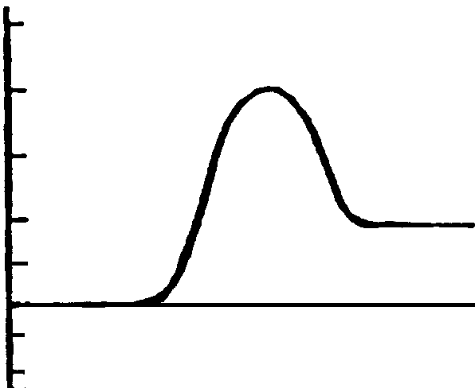
50
40
30
20
0
-20
A + B
C + D
(kJ / mol)
Ep
R

The above graph represents the potential energy diagram for the reaction

A + B → C + D

This reaction is  - rapid.  - slow.  - exothermic.  - endothermic. | (3)

- Which one of the following describes a chemical reaction at equilibrium under all circumstances?  - The reaction takes place in a closed container.  - The reaction mixture contains equal concentrations of the reactants and products.  - The rate of the forward reaction is equal to the rate of the reverse reaction.  - The reaction is exothermic. | (3)

- When the system H₂O (ℓ) H₂O (g) has reached equilibrium in a closed container, the  - concentration of the gas molecules increases.  - vapour pressure and temperature remain constant.  - temperature decreases.  - pressure increases. | (3)

- In the reaction  Mg + Cℓ₂ → MgCℓ₂  - chlorine is oxidised.  - magnesium is oxidised.  - chlorine is a reducing agent.  - magnesium is an oxidising agent. | (3)

- The oxidation number of nitrogen is – 3 in  - NO₂  - NO  - NH₄Cℓ  D. NaNO₃ | (3)

Questions 1.11 and 1.12 refer to the following electrochemical cell.
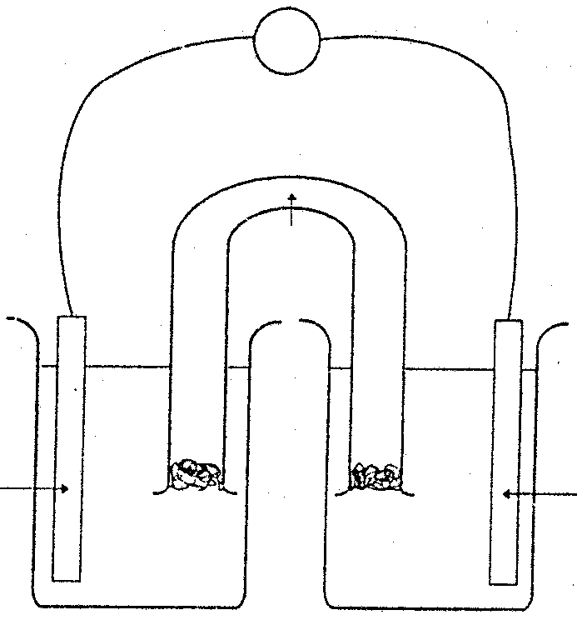
Zn(s)
Cu(s)
P
R
V
Q

- The half-reaction taking place at the anode, is  - Cu(s) → Cu²⁺(aq) + 2e–  - Cu²⁺(aq) + 2e– → Cu(s)  - Zn(s) → Zn²⁺(aq) + 2e–  - Zn²⁺(aq) + 2e– → Zn(s) | (3)

1.12 Possible electrolytes which can be used in P, Q and R are

 | P  Zinc half-cell | Q  Salt bridge | R  Copper half-cell | (3)
A. | ZnS | KNO₃ | KCℓ | (3)
B. | ZnSO₄ | KCℓ | KNO₃ | (3)
C. | Cu(NO₃)₂ | KCℓ | Zn(NO₃)₂ | (3)
D. | Zn(NO₃)₂ | KNO₃ | Cu (NO₃)₂ | (3)

1.13 The halogens are known as  - weak oxidising agents.  - weak reducing agents.  - strong reducing agents.  - strong oxidising agents. | (3)

1.14 All organic compounds contain  - carbon.  - sulphur.  - oxygen.  D. halogens. | (3)

- Which one of the following substances is a haloalkane?  - CH₃COOH  - C₂H₂  - C₂H₆  - CH₃I | (3)

15x3=[45]

QUESTION 2
ATOMIC STRUCTURE

Make use of the electron configurations of the atoms of imaginary elements M, Q, X, Y and Z to answer Questions 2.1 to 2.6.

M: 1s² 2s² 2p⁶ 3s²
Q: 1s² 2s² 2p⁶ 3s¹
X: 1s² 2s² 2p⁶
Y: 1s² 2s² 2p⁵
Z: 1s² 2s¹ 2p¹

- Which ONE of the elements is a noble gas?  - In which period and in which group would element Z be classified in the Periodic Table of Elements?  - With which ONE of the elements would element M combine to form an ionic substance?  - What is the atomic number of element Y?  - Which ONE of these electron configurations does not represent an atom in its lowest energy state?  - What is the formula of the molecule or compound that forms when M combines with Y? | (2)  (4)  (2)  (2)  (2)  (2)  [14]

QUESTION 3  CHEMICAL BONDING  - An Aufbau diagram of a carbon atom in an excited state, is given.  - How many electrons are there in the ground state of carbon?  - What is meant by an excited state?  - How many unpaired electrons are in this excited carbon atom?  - What is the valency of this carbon atom?  - Give the Lewis diagram for this excited carbon atom. | (2)  (1)  (1)  (1)  (1)
   |  | ↑ | ↑ | ↑
  ↑
  ↑↓

The Lewis diagram for hydrogen is H●.  - Give the Lewis diagram for the compound that forms when one carbon atom bonds with hydrogen.  - Give the molecular formula for the compound which formed as indicated in Question 3.2.1. | (2)  (2)

What types of bonds are there between the atoms in a  - molecule of nitrogen (N₂)?  - molecule of hydrogen chloride (HCℓ)? | (2)  (2)  [14]

QUESTION 4
INTERMOLECULAR FORCES

Use the following table to answer the following questions:

Molecule | CH₄ | C₂H₆ | C₃H₈ | C₄H₁₀ | C₅H₁₂
Boiling point of substance (°C) | -182 | -88 | -42 | 0 | 36

- Which substance’s molecules would form a liquid at room temperature?  - Which substance has the strongest intermolecular forces?  - What type of intermolecular force do we find between the molecules referred to in Question 4.2?  - Explain why C₅H₁₂ has a higher melting and boiling point than CH₄. | (2)  (2)  (2)  (4)  [10]

QUESTION 5

ENERGY AND CHEMICAL BONDING

The reaction for the industrial production of ammonia can be represented by the following equation:  N₂(g)+ 3H₂(g) 2NH₃(g); ∆H < O  - Is the forward reaction of the above reversible reaction exothermic or endothermic?  - How will the potential energy of the reactants (nitrogen and hydrogen) compare with the potential energy of the product (ammonia)? Use only the terms “higher”, “lower” or “same as” to answer this question.  - Give a reason for your answer to Question 5.1.2. | (1)  (2)  (2)

- When sugar dissolves in water, the temperature of the solution decreases. Is this process endothermic or exothermic?  - What is meant by the activation energy of a chemical reaction? | (2)  (2)  [9]

QUESTION 6
CO₂(g) + H₂(g) CO(g) + H₂O(g); ∆H<O

CHEMICAL EQUILIBRIUM

The following reaction is in equilibrium in a closed system.

- Name TWO factors which can be changed in order to disturb the above system in equilibrium to cause a change in one of the reaction rates.  - Name THREE methods to reduce the concentration of CO₂.  - Explain why a change in pressure does not influence the equilibrium.  - If the system is heated, will the endothermic or exothermic reaction be promoted? | (2)  (6)  (2)  (2)  [12]

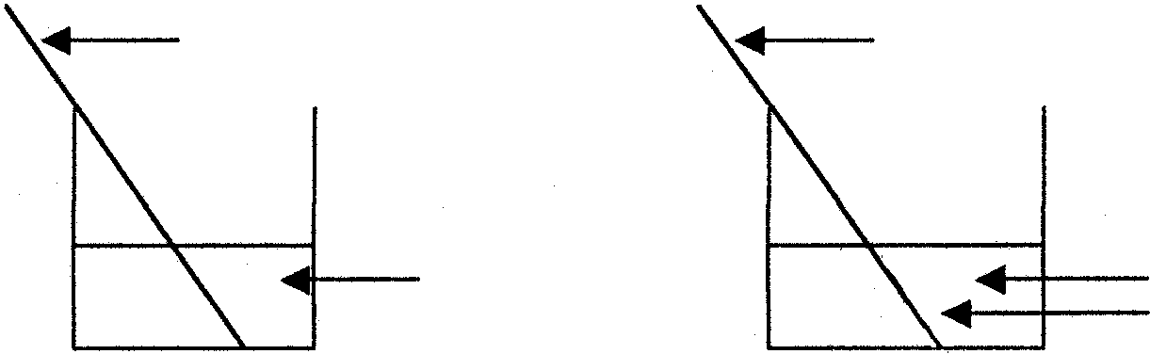
QUESTION 7
zinc wire
zinc wire
colourless solution deposit on zinc wire
blue solution
CuCℓ₂(aq)
Initially
Later

REDOX REACTIONS

A clean length of zinc wire is placed in a blue solution of copper chloride (CuCℓ₂).
After a few hours the colour of the solution disappears.

- Name the ion which is responsible for the blue colour.  - Write down the half-reaction which represents the formation of colourless ions.  - A deposit forms on the zinc wire. Give the name of the deposit.  - Write down the half-reaction which represents the formation of the deposit.  - Write down the redox reaction for the process described. | (2)  (3)  (2)  (3)  (2)  [12]

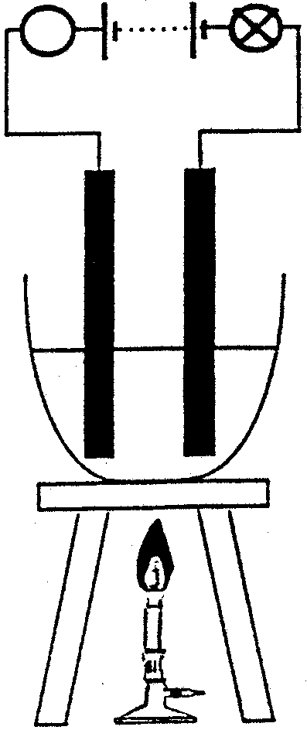
QUESTION 8
A
X
Y

ELECTROCHEMISTRY

Sodium chloride (NaCℓ) is melted in a fume cupboard and electrolysed as shown in the sketch.

8.1 What is electrode X called? | (2)

8.2 Identify on the data sheet and give an equation for the half-reaction which occurs at  - electrode X.  - electrode Y. | (3)  (3)

- Give an equation for the overall reaction which occurs in the crucible.  - Identify the oxidising agent. | (2)  (2)  [12]

QUESTION 9  PROPERTIES OF ELEMENTS  In investigating the oxidising properties of chlorine (Cℓ₂), a learner places a small piece of lithium (Li) in a deflagrating spoon. He heats the lithium until it melts and lowers it into a gas jar containing chlorine.  - Describe what happens to the electron structure of  - lithium.  - chlorine. | (4)

For this reaction write down the  - oxidation half-reaction.  - reduction half-reaction.  - Identify the  - oxidising agent.  - reducing agent. | (4)  (4)  [12]

QUESTION 10

ORGANIC CHEMISTRY

Write down the structural formula for each of the following:  - Ethane  - CH₃COOH  - C₃H₆  - Methanol | (2)  (2)  (2)  (2)

To which functional group do the following hydrocarbons belong?  - Hydrocarbons with only single bonds between carbon atoms.  - Hydrocarbons with a double bond between two adjacent carbon atoms. | (1)  (1)  [10]

TOTAL: | 150

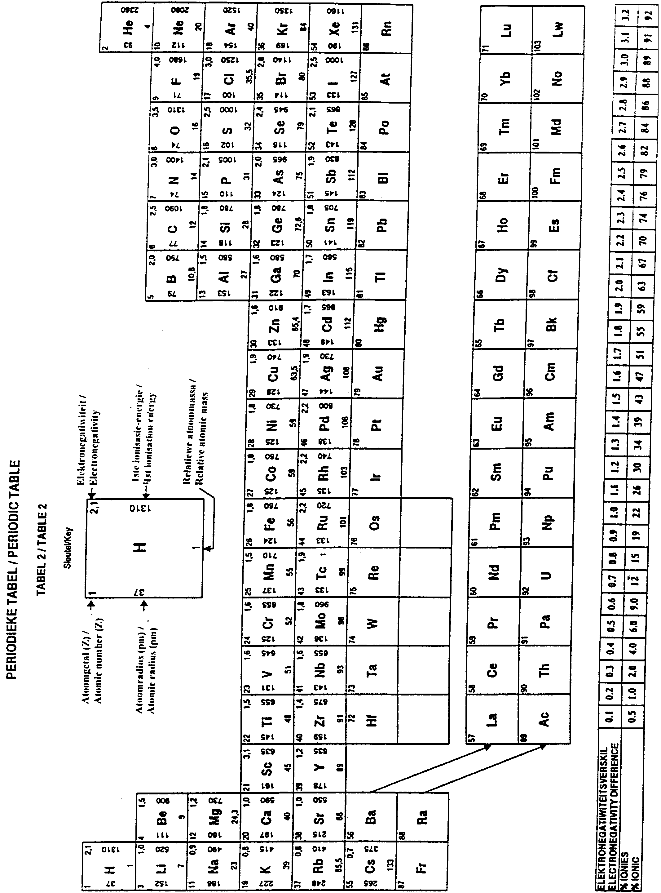

STANDARD reduction potentials OF A NUMBER OF HALF-REACTIONS
STANDAARDreduksiepotensiale VAN VERSKEIE HALFREAKSIES

Increasing  reducing  ability  Toenemende  reduseer-  vermoë  Increasing  oxidising  ability  Toenemende  oksideer-  vermoë | Half-reaction / Halfreaksie
 | Oxidising agent / Oksideermiddel | Reducing agent / Reduseermiddel | E° (volts) /  E° (volt)
 | Li⁺ + eˉ  K⁺ + eˉ  Ba²⁺ + 2eˉ  Ca²⁺ + 2eˉ  Na⁺ + eˉ  Mg²⁺ + 2eˉ  Aℓ³⁺ + 3eˉ  Mn²⁺ + 2eˉ  2H₂O + 2eˉ  Zn²⁺ + 2eˉ  Cr²⁺ + 2eˉ  Cr³⁺ + 3eˉ  Fe²⁺ + 2eˉ  Cr³⁺ + eˉ  Cd²⁺ + 2eˉ  Co²⁺ + 2eˉ  Ni²⁺ + 2eˉ  Sn²⁺ + 2eˉ  Pb²⁺ + 2eˉ  Fe³⁺ + 3eˉ  2H⁺ + 2eˉ  S + 2H⁺ + 2eˉ  Sn⁴⁺+ 2eˉ  SO₄²⁻ + 4H⁺ + 2eˉ  Cu²⁺ + 2eˉ  2H₂O + O₂ + 4eˉ  SO₂ + 4H⁺ + 4eˉ  I₂ + 2e⁻  O₂(g) + 2H⁺ + 2eˉ  Fe³⁺ + eˉ  NO₃ˉ + 2H⁺ + eˉ  Hg²⁺ + 2eˉ  Ag⁺ + eˉ  NO₃ˉ + 4H⁺ + 3eˉ  Br₂(ℓ) + 2eˉ  O₂(g) + 4H⁺ + 4eˉ  MnO₂ + 4H⁺ + 2eˉ  Cr₂O₇²ˉ + 14H⁺ + 6eˉ  Cℓ₂(g) + 2eˉ  MnO₄ˉ + 8H⁺ + 5eˉ  Co³⁺ + 2eˉ  F₂(ℓ) + 2eˉ | Li  K  Ba  Ca  Na  Mg  Aℓ  Mn  H₂(g) + OHˉ  Zn  Cr  Cr  Fe  Cr²⁺  Cd  Co  Ni  Sn  Pb  Fe  H₂(g)  H₂S(g)  Sn²⁺  SO₂(g) + 2H₂O  Cu  4OHˉ  S + 2H₂O  2lˉ  H₂O₂  Fe²⁺  NO₂(g) + H₂O  Hg(ℓ)  Ag  NO(g) + 2H₂O  2Br⁻  2H₂O  Mn²⁺ + 2H₂O  2Cr³⁺ + 7H₂O  2Cℓˉ  Mn²⁺ + 4H₂O  Co²⁺  2Fˉ | -3,04  -2,92  -2,90  -2,87  -2,71  -2,37  -1,66  -1,18  -0,83  -0,76  -0,74  -0,74  -0,44  -0,41  -0,40  -0,28  -0,25  -0,14  -0,13  -0,04  0,00  +0,14  +0,15  +0,17  +0,34  +0,40  +0,45  +0,54  +0,68  +0,77  +0,78  +0,78  +0,80  +0,96  +1,06  +1,23  +1,28  +1,33  +1,36  +1,52  +1,82  +2,87

E° = E° – E° E° = E° – E°
CELL CATHODE ANODE SEL KATODE ANODE

