GAUTENG DEPARTMENT OF EDUCATION
SENIOR CERTIFICATE EXAMINATION

FUNCTIONAL PHYSICAL SCIENCE SG
(First Paper: Physics)

TIME: 2 hours

MARKS: 150

REQUIREMENTS:

- An approved (non-programmable, scientific) calculator. Candidates should supply their own calculators.

INSTRUCTIONS:

- Write your examination number in the spaces on the front of your answer book provided for this purpose.

- Answer ALL questions.

- Answer Question 1 on the answer sheet on the inside cover of your answer book. Make a cross (X) over the letter A, B, C or D, to indicate which letter you have chosen.

- Answer all other questions in your answer book. If you need to redo an answer, redo it on a new page. Number all answers clearly.

- Start each question on a new page.

- A data sheet is provided at the end of this question paper. It contains formulae and constants. The information provided may be useful in answering the questions.

- Rough work may be done on the blank pages at the back of your answer book.

QUESTION 1
MULTIPLE-CHOICE QUESTIONS

Each question has been provided with four possible answers (A, B, C and D). Choose the letter which, in your opinion, represents the correct answer and indicate it by drawing a cross (X) over the corresponding letter on the answer sheet on the inside cover of your answer book. If more than one cross appears in an answer, NO MARKS will be allocated.

EXAMPLE:

At what temperature does pure ice melt?

- -4 ºC
- 0 ºC
- 0 K
- 4 ºC

ANSWER:

A | B | C | D

1.1 Peter places a current-bearing conductor P perpendicular in a magnetic field as shown in the sketch below.
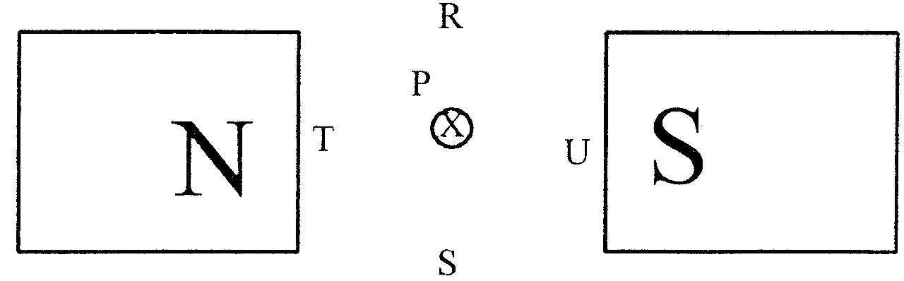

The electron current enters perpendicular into the paper.

In which direction will conductor P experience a force?

- U  - T  - S  - R | (3)

1.2 When switch S in the circuit below is closed, the magnet will
Cardboard cylinder

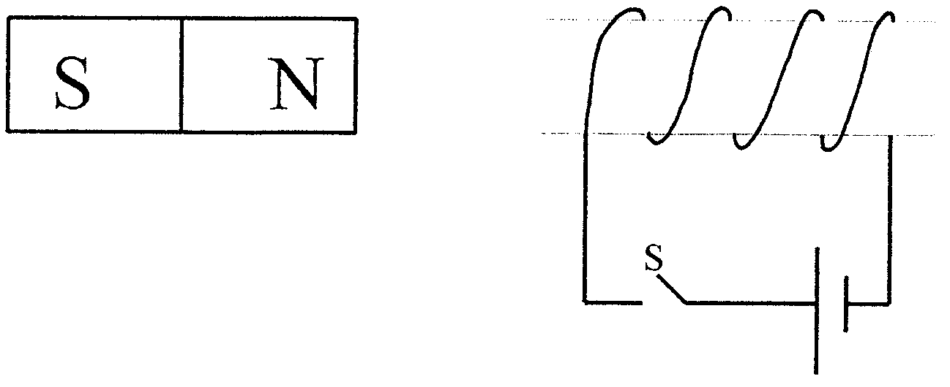

- be attracted by the coil.  - move perpendicularly downwards.  - be repelled to the left.  - remain stationary. | (3)

  - A teacher places a soft-iron core in a current-bearing solenoid.
What influence does the soft-iron core have on the solenoid’s magnetic field?

The magnetic field

- changes direction.  - changes into a permanent magnetic field.  - increases in intensity.  - decreases in intensity. | (3)

1.4 In the following diagram, L₁ and L₂ are two bulbs and B is a battery of negligible internal resistance.

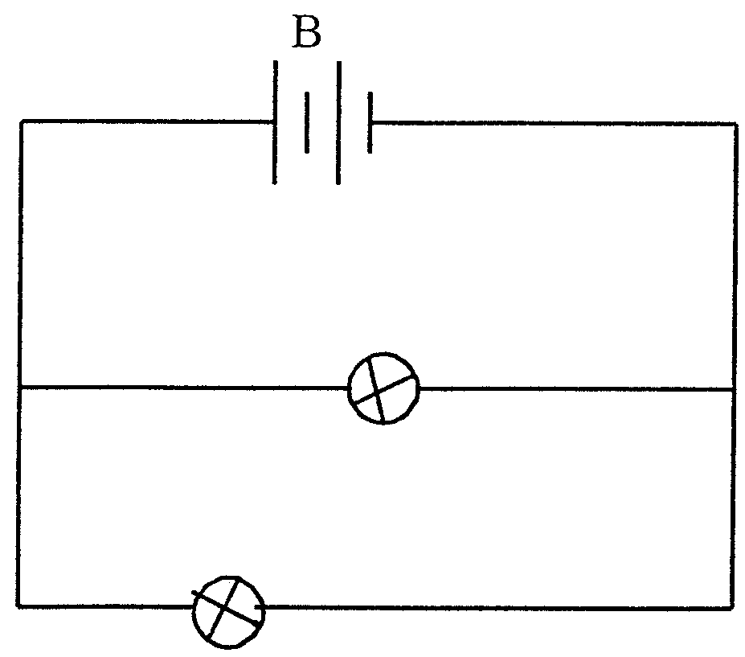
L₁
L₂

If Susan disconnects bulb L₂ from the circuit, then bulb L₁ will

- not glow at all.  - glow more dimly than before.  - glow more brightly than before.  - glow as brightly as before. | (3)

1.5 Which statement is applicable to a step-down transformer?

In a step-down transformer, the

- number of turns on the primary coil is more than the number of turns on the secondary coil.  - number of turns on the secondary coil is more than the number of turns on the primary coil.  - current in the secondary coil is less than the current in the primary coil.  - current in the secondary coil is the same as the current in the primary coil. | (3)

1.6 In an alternating current

- the magnitude and the direction of the current remain constant.  - the magnitude of the current remains constant, but the direction changes periodically.  - the magnitude and the direction of the current change periodically.  - the direction of the current remains constant, but its magnitude changes periodically. | (3)

1.7 Anne causes waves in a ripple tank. A water wave moves from deep to shallow water. The water wave’s

- wavelength decreases.  - speed remains constant.  - frequency decreases.  - speed increases. | (3)

1.8 A vibrator, with a frequency of 20 Hz, generates waves with a wavelength of 0,1 m in a string. Which ONE of the following expressions gives the speed of the waves in m/s?

- $$\frac{\text{20}}{0,1}$$  - $$\frac{2}{\text{10}}$$  - (20) (0,1)  - (2) (10) | (3)

1.9 Which quality of light determines the colour of the light? The light’s

- speed.  - wavelength.  - amplitude.  - frequency. | (3)

1.10 Divan shines blue light onto a certain metal. The metal emits photo-electrons. By what means can Divan increase the number of photo-electrons that the metal emits in a specific time?

Use

- red light instead of blue light.  - blue light with a higher intensity.  - light with a higher frequency.  - light with a lower frequency. | (3)

1.11 Which statement is applicable to electro-magnetic waves?

In a vacuum, all electromagnetic waves have the same

- frequency.  - speed.  - wavelength.  - energy. | (3)

1.12 Two polaroid plates are placed against each other in front of a lamp so that no light passes through them. This proves that light

- can travel in straight lines.  - has particle properties.  - has wave properties.  - is a transversal wave. | (3)

1.13 A wave having one plane of vibration only, is said to be

- polarised.  - diffracted.  - reflected.  - refracted. | (3)

1.14 What is the sequence, in increasing frequency, of the following colours?

- Red, yellow, green, blue  - Blue, yellow, green, red  - Green, red, yellow, blue  - Yellow, red, blue, green | (3)

1.15 When the line spectrum of a certain element is observed through a diffraction grating, the ________ line is seen furthest from the central bright line.

- violet  - red  - blue  - green | (3)  15x3=[45]

ANSWER THE FOLLOWING QUESTIONS IN THE ANSWER BOOK. SHOW ALL THE NECESSARY CALCULATIONS AS WELL AS THE FORMULAE USED IN ANSWERING THE QUESTIONS.

QUESTION 2
MAGNETIC EFFECT OF AN ELECTRIC CURRENT

Francin connects a battery to a coil as shown in the sketch below.

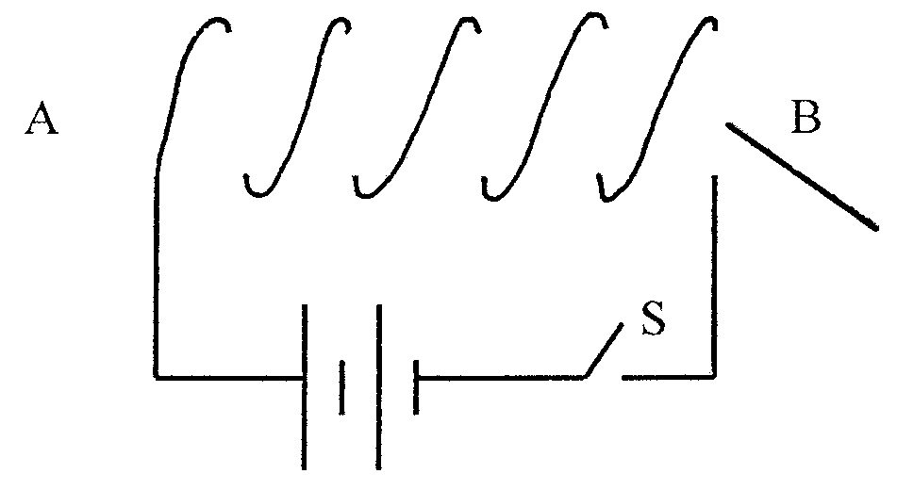
Cardboard cylinder

- On which side of the coil will a north pole develop if Francin closes  switch S? (At A or B?) | (2)

2.2 Name THREE ways how she can increase the strength of the magnet. | (6)

2.3 Give TWO applications of this principle in everyday life. | (2)  [10]

QUESTION 3
MAGNETIC INDUCTION

Chris places two coils next to each other as shown in the sketch below.

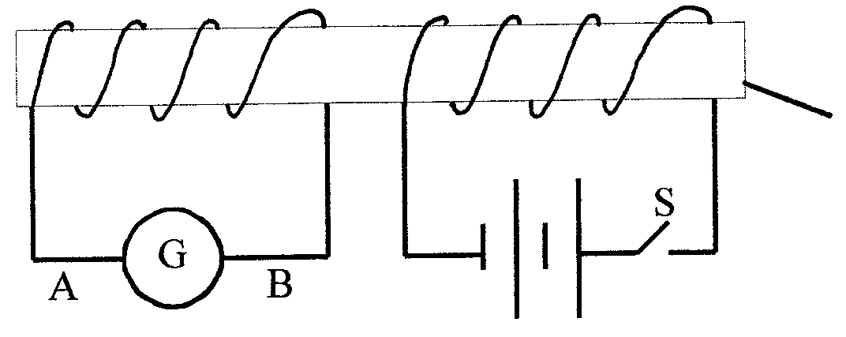
Cardboard cylinder

- What will Chris observe on the galvanometer at the instant he closes  switch S? | (2)

3.2 What will he observe when the switch remains closed? | (2)

3.3 3.3.1 What principle is illustrated by the above observations?  3.3.2 Describe the principle. | (2)  (2)

3.4 What will the direction of the current through the galvanometer be the moment the switch is opened again? (From A to B or from B to A?) | (2)

3.5 How will the reading on the galvanometer be influenced if a soft-iron core is placed in the coil? | (2)

3.6 Which apparatus functions according to the principle which is demonstrated in the sketch? | (2)  [14]

QUESTION 4
TRANSFORMERS

Sarel wants to play with his electric toy car. The car needs a voltage of 6 V. He wants to use it in a home with a voltage supply of 220 V. The transformer that he uses has 600 turns on its secondary coil.

4.1 Does a transformer require direct or alternating current to function? | (2)

4.2 Explain your answer to Question 4.1. | (3)

4.3 Which type of transformer will he use? | (2)

4.4 Calculate the number of turns on the primary coil of the transformer you identified in Question 4.3. | (4)  [11]

QUESTION 5
ELECTRONICS

The diagram below shows a diode which is connected to an alternating current source.

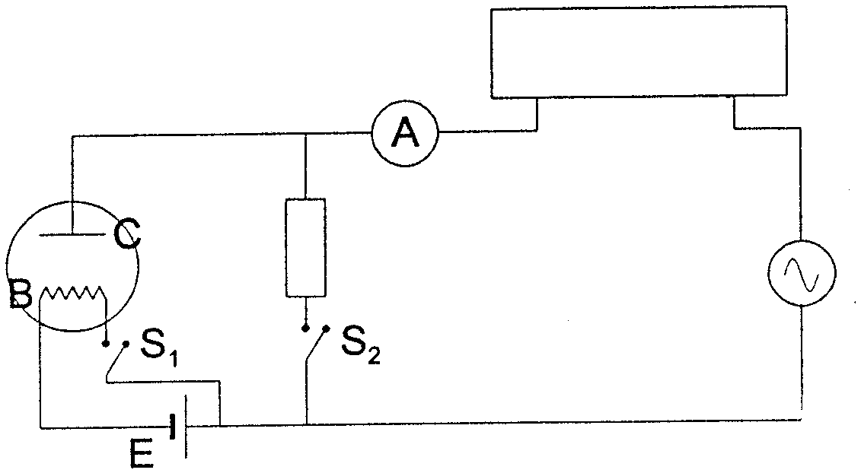
OSCILLOSCOPE

5.1 What is the function of cell E? | (2)

5.2 Switch S₁ is closed.

- Which particles are emitted at filament B?  - What is the name of this phenomenon? | (1)  (2)

5.3 What must the polarity of plate C be to prevent any current from passing through the diode? | (2)

5.4 Switch S₁ is opened and switch S₂ is closed.

- What type of current flows through ammeter A?  - Draw the image you will observe on the screen of the oscilloscope. | (1)  (2)

5.5 Switch S₁ is closed and switch S₂ is opened.

- What type of current will now flow through ammeter A?  - Draw the image you will observe on the screen of the oscilloscope. | (1)  (2)

5.6 What is the function of the diode in this circuit? | (2)  [15]

QUESTION 6
OHM’s LAW

A science teacher constructed the following circuit to carry out a number of experiments.

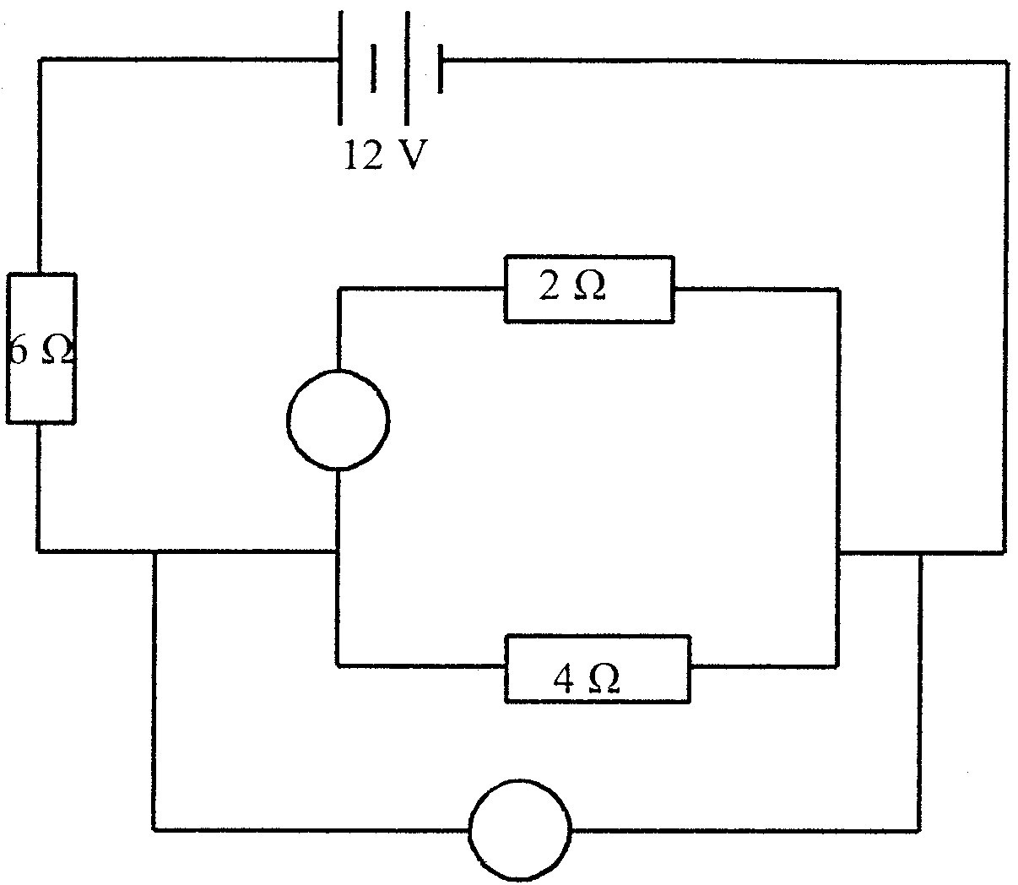
A₁
V₁

6.1 Calculate the total resistance in the circuit. | (5)

6.2 Calculate the current strength through the 6 Ω resistor. | (4)

6.3 What is the reading on voltmeter V₁? | (4)

6.4 What is the reading on ammeter A₁? | (4)  [17]

QUESTION 7
ELECTRONS IN THE ATOM

7.1 Name TWO ways to release electrons from matter. | (4)

7.2 The diagrams below show two different photocells which are connected to identical circuits.

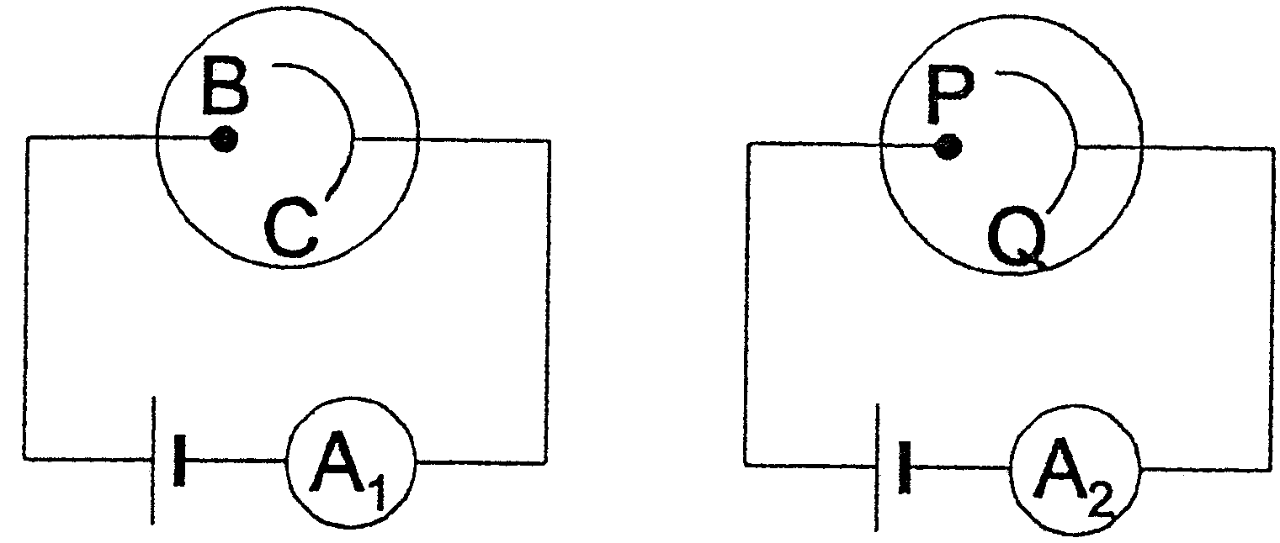

- Which letters represent the cathodes in the two photocells?  - Both cathodes are irradiated with blue light with the same frequency and intensity. A reading is noted on micro-ammeter A₁, but not on micro-ammeter A₂. Explain why this is possible.  - The cathode with micro-ammeter A₂ is now irradiated with red light with the same intensity. Will a reading be observed on ammeter A₂? Explain your answer. | (2)  (3)  (4)  [13]

QUESTION 8
WAVES

The sketch below shows a wave movement of particles in a medium at a specific time. The time it takes for the wave to move from N to P is 0,5 s.
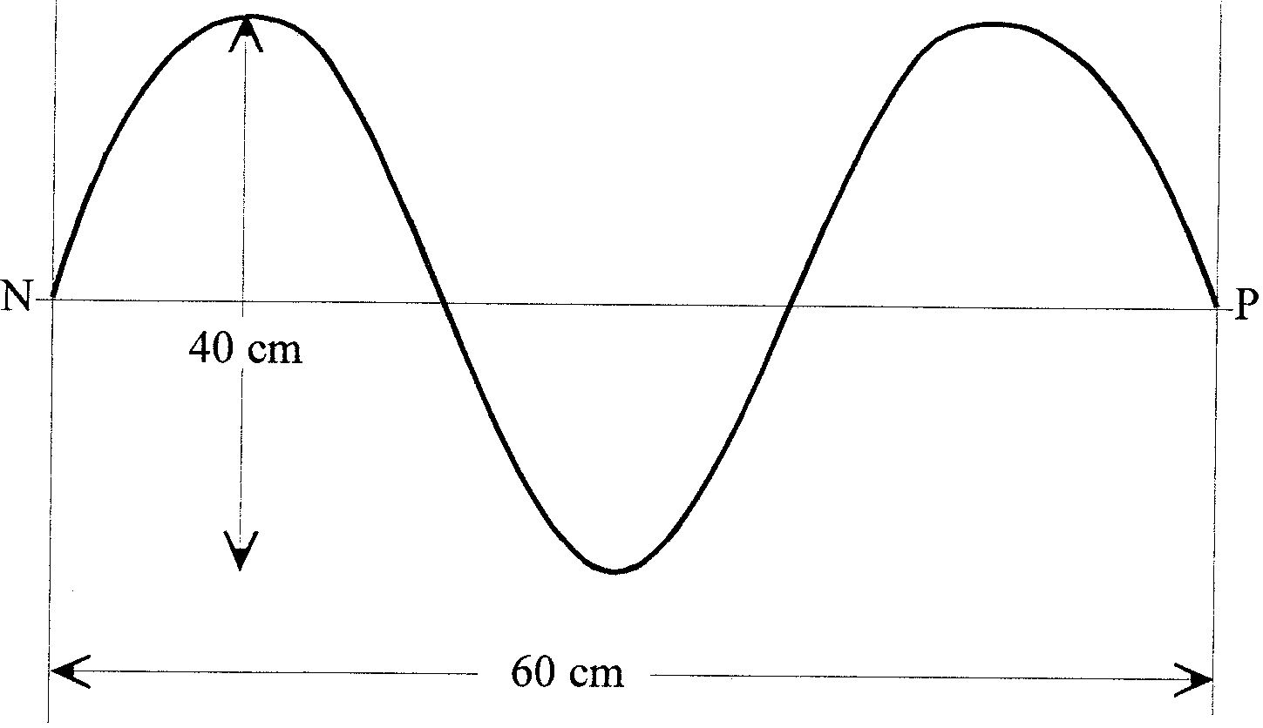

8.1 What is the amplitude of the wave? | (2)

8.2 Calculate the wavelength of the wave. | (2)

8.3 Calculate the frequency of the wave. | (3)

8.4 What is the period of the wave? | (2)

8.5 Calculate the speed of the wave. | (4)  [13]

QUESTION 9
LIGHT, COLOUR AND SPECTRA

9.1 Ria looks through a spectroscope at light which is emitted by a hydrogen discharge tube.

- What type of spectrum will she observe?  - Explain briefly how this spectrum occurs. | (2)  (4)

9.2 A light beam moves from glass through air.

How does the

- frequency change?  - wavelength change?  - speed of the light change? | (2)  (2)  (2)  [12]

TOTAL: | 150

PHYSICS INFORMATION SHEET/
FISIKA-INLIGTINGSBLAD

EQUATIONS / VERGELYKINGS

WAVES / GOLWE | ELECTRICITY / ELEKTRISITEIT
v = f λ  f = $\frac{1}{T}$ | R = r₁ + r₂ + r₃  $\frac{1}{R}$ = $\frac{1}{r_{1}}$ + $\frac{1}{r_{2}}$ + $\frac{1}{r_{3}}$  V_{p}I_{p} = V_{s}I_{s}  $\frac{V_{s}}{V_{p}}$ = $\frac{N_{s}}{N_{p}}$

PHYSICS CONSTANTS /
FISIKA KONSTANTES

Miscellaneous constants (Approximate values)
Diverse konstantes (Benaderde waardes)

NAME/NAAM | SYMBOL/SIMBOOL | VALUE/WAARDE
Speed of light  Spoed van lig | c | 3,0 x 10⁸ m.s⁻¹
Charge on electron  Lading op elektron | e⁻ | –1,6 x 10⁻¹⁹ C

