GAUTENG DEPARTMENT OF EDUCATION
SENIOR CERTIFICATE EXAMINATION

FUNCTIONAL PHYSICAL SCIENCE SG
(First Paper: Physics)

TIME: 2 hours

MARKS: 150

REQUIREMENTS:

- An approved (non-programmable, scientific) calculator. Candidates should supply their own calculators.

INSTRUCTIONS:

- Write your examination number in the spaces provided for this purpose on the front of your answer book.

- Answer ALL questions.

- Answer Question 1 on the answer sheet on the inside cover of your answer book. Make a cross (X) over the letter A, B, C or D, to indicate the letter you have chosen.

- Answer all other questions in the answer book. If you need to redo an answer, redo it on a new page. Number all answers clearly.

- Start each question on a new page.

- A data sheet is provided at the end of this question paper. It contains formulae and constants. The information provided may be useful in answering the questions.

- Rough work may be done on the blank pages at the back of your answer book.

QUESTION 1
MULTIPLE-CHOICE QUESTIONS

Each question has four possible answers (A, B, C and D). Choose the letter which in your opinion, represents the correct answer and make a cross (X) over the corresponding letter on the answer sheet on the inside cover of your answer book. If more than one cross appears in an answer, NO MARKS will be awarded.

EXAMPLE:

At what temperature does pure ice melt?

- -4 ºC
- 0 ºC
- 0 K
- 4 ºC

ANSWER:

A | B | C | D

1.1 The diagram shows a wire conducting a current between the poles of a magnet. The direction of conventional current is shown in the sketch.

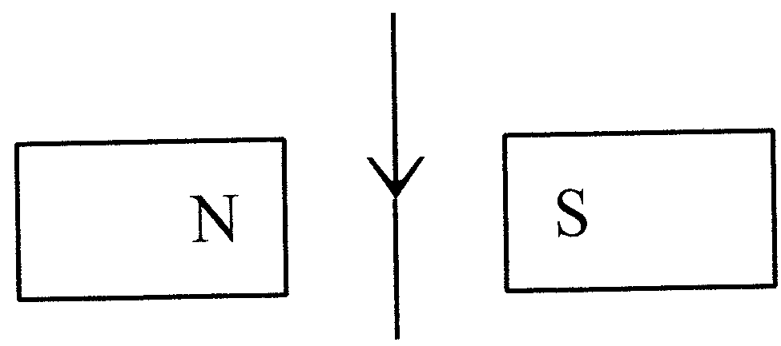

In which direction does the wire tend to move?

- Into the paper  - Out of the paper  - Towards the south pole of the magnet  - Towards the north pole of the magnet | (3)

1.2 Peter wants to induce a potential difference in the coil below which causes a conventional current to flow from X to Y through the galvanometer.

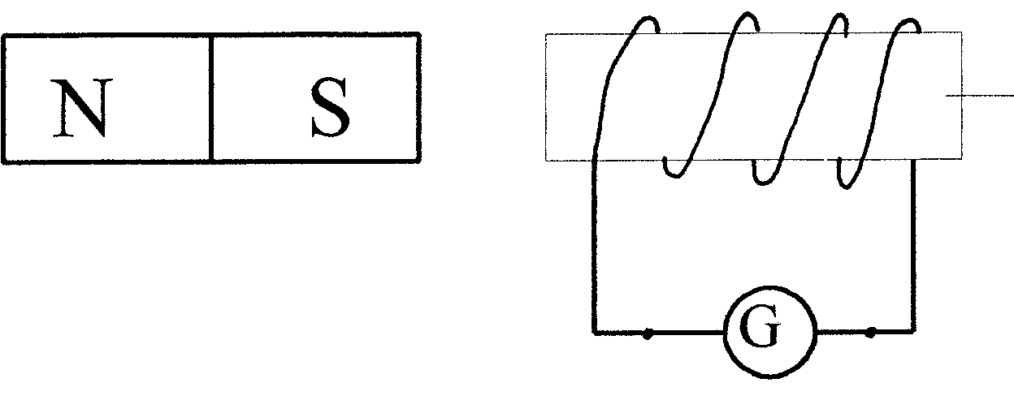
Cardboard cylinder

X

Y

He must

- move the magnet rapidly to the right.  - move the magnet rapidly to the left.  - turn the magnet through half a revolution.  - hold the north pole of the magnet near the coil. | (3)

1.3 Ian wants to build an electromagnet. He will use ________ for the core of the electromagnet.

- copper  - silver  - steel  - iron | (3)

1.4 The cells and the conducting wires in the following circuit diagram have a negligible internal resistance.
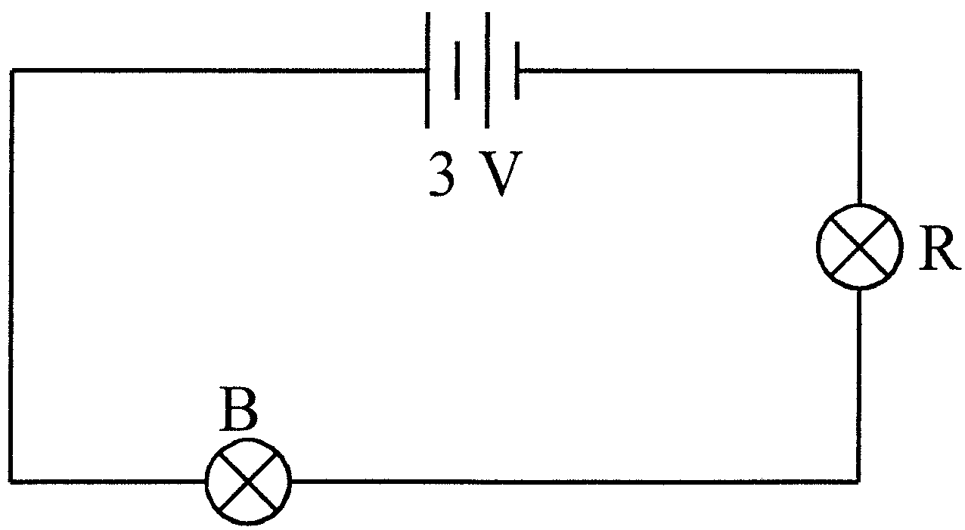

Which one of the following changes will increase the brightness of bulb B?

Connect

- an additional resistor in parallel with bulb R.  - another 3 V battery in parallel with the existing one.  - an additional resistor in series with bulb R.  - an additional resistor in series with bulb B. | (3)

1.5 What is the function of a transformer?

- To generate direct current  - To generate alternating current  - To increase or decrease alternating voltage  - To change alternating current into direct current | (3)

1.6 In the following circuit the internal resistance of the battery is negligible.

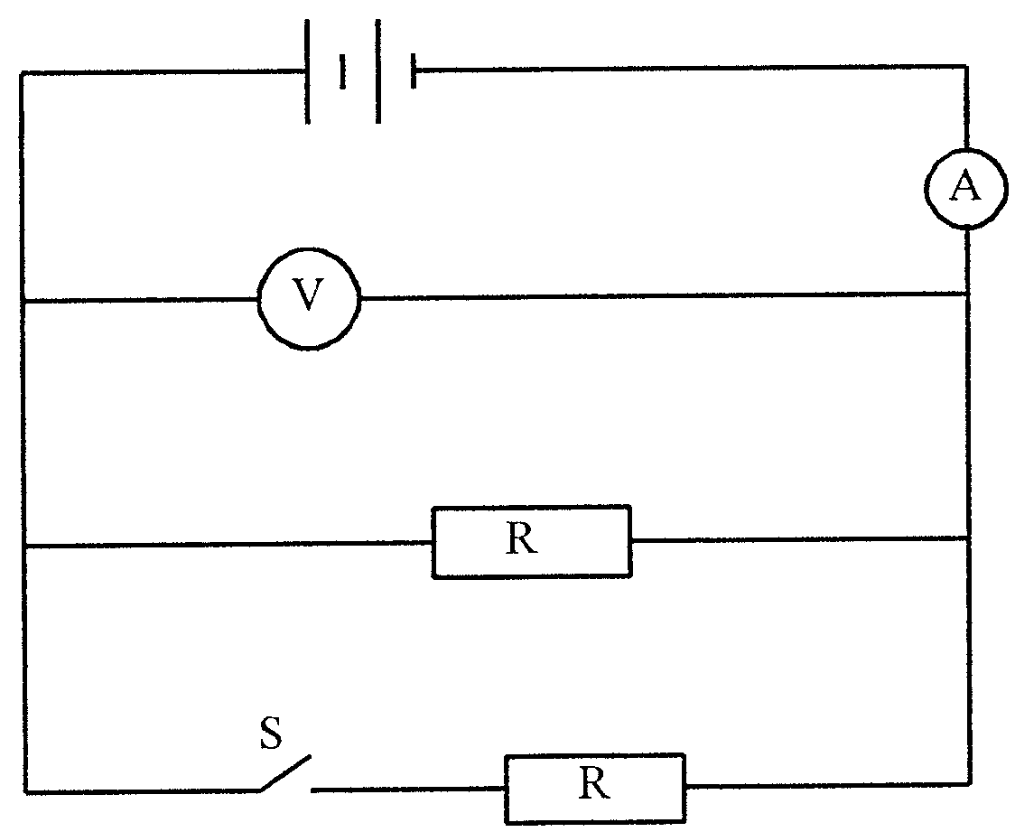

How would the ammeter and voltmeter readings change when switch S is closed?

 | AMMETER | VOLTMETER
A. | Increases | Remains constant
B. | Increases | Increases
C. | Decreases | Remains constant
D. | Decreases | Decreases | (3)

1.7 Which of the following phenomena can occur with longitudinal waves?

- Interference only  - Interference and diffraction only  - Interference, refraction and polarisation  - Interference, refraction and diffraction | (3)

1.8 The following diagram presents a wave motion:
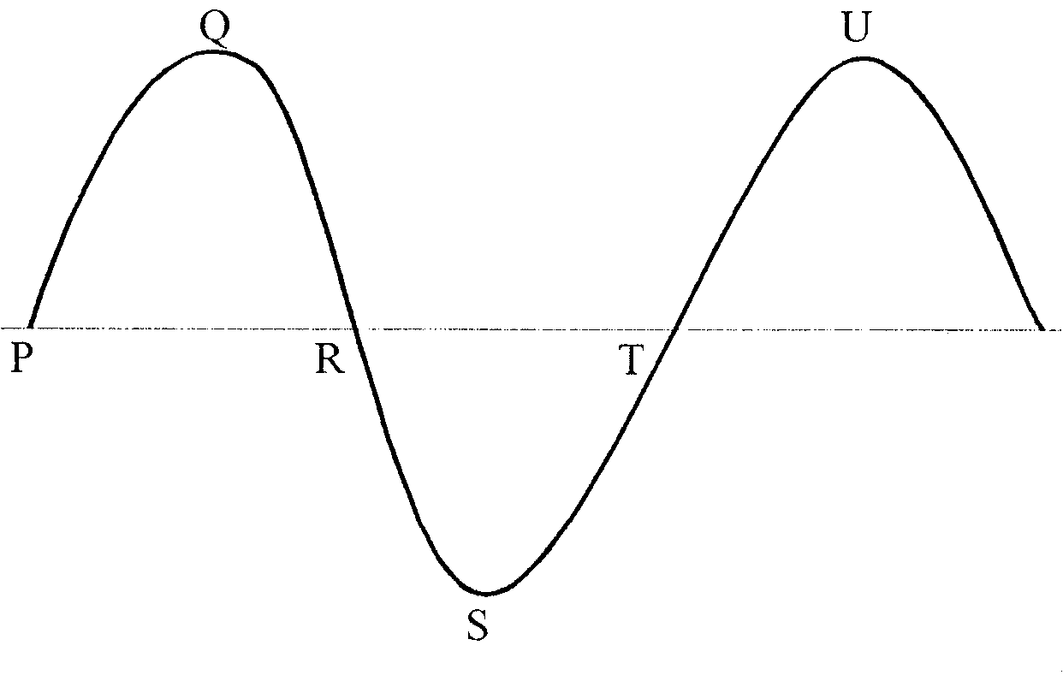

Which TWO points are in phase?

- P and T  - Q and S  - P and R  - S and U | (3)

1.9 What happens when a wave moves from one medium to another medium? The

- frequency and wavelength stay the same.  - wavelength stays the same, but its speed changes.  - frequency stays the same, but its speed changes.  - speed stays the same, but its frequency changes. | (3)

1.10 The experimental set-up shown in the accompanying sketch is used to observe interference fringes on the screen.

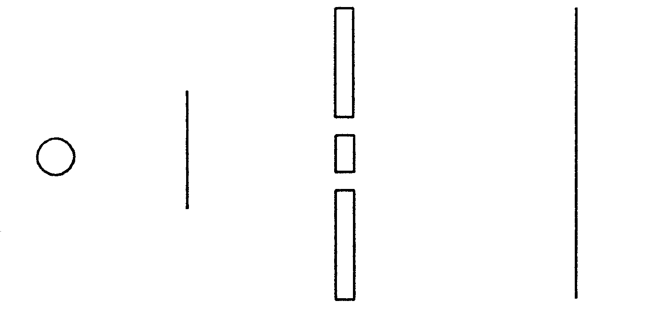
Light source
Green filter

Double slit
Screen

How can the distance between the observed interference fringes be increased?

- Replace the green filter with a blue filter.  - Move the screen further from the slits.  - Increase the width of each slit.  - Increase the distance between the slits. | (3)

1.11 Two photons of electromagnetic radiation, travelling in a vacuum, have different energies. This implies that they inevitably differ in their

- velocity.  - intensity.  - charge.  - frequency. | (3)

1.12 Which statement is applicable to the photo-electric effect?

The photo-electric effect

- can only occur with visible light.  - is evidence of the wave nature of light.  - is evidence of the particle nature of light.  - can only occur with the metal zinc. | (3)

1.13 A teacher irradiates a certain metal with a variety of rays. Only one of the rays causes the metal to emit photo-electrons. Which one of the following radiations is most likely to cause the metal to emit photo-electrons?

- Infrared  - Blue light  - Red light  - Radio waves | (3)

1.14 Dirk shines a red beam of light through a glass prism as shown in the sketch below.

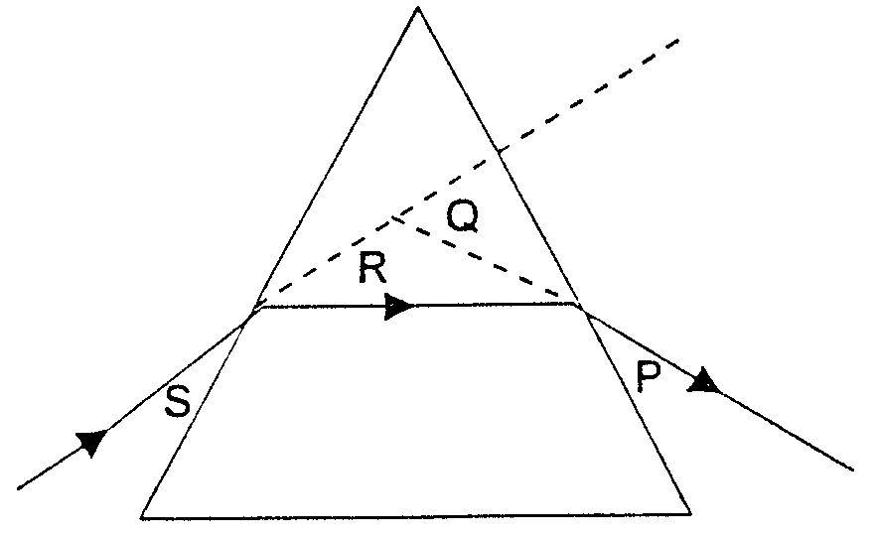

The angle of deviation is

- P.  - Q.  - R.  - S. | (3)

1.15 The speed of a water wave is 4 m/s. The wavelength is 0,5 m. What is the period of this wave?

- 2 s  - 0,5 s  - 0,25 s  - 0,125 s | (3)  15x3=[45]

Answer the following questions in your answer book. Show all the necessary equations as well as the calculations you have used in the answering of the questions.

QUESTION 2
MAGNETIC EFFECT OF AN ELECTRIC CURRENT

Steven places a current-bearing conductor P perpendicular in a magnetic field as shown in the sketch.
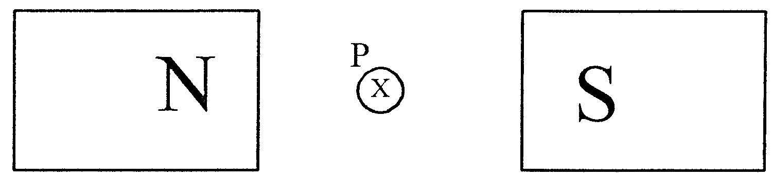

The electron current is perpendicular into the paper.

2.1 In which direction will conductor P experience a force? | (2)

2.2 Name TWO changes which will increase the force on P. | (4)

2.3 Name TWO everyday applications of the above-mentioned principle. | (4)  [10]

QUESTION 3
MAGNETIC INDUCTION

The following sketch is a simple presentation of an alternating current dinamo.

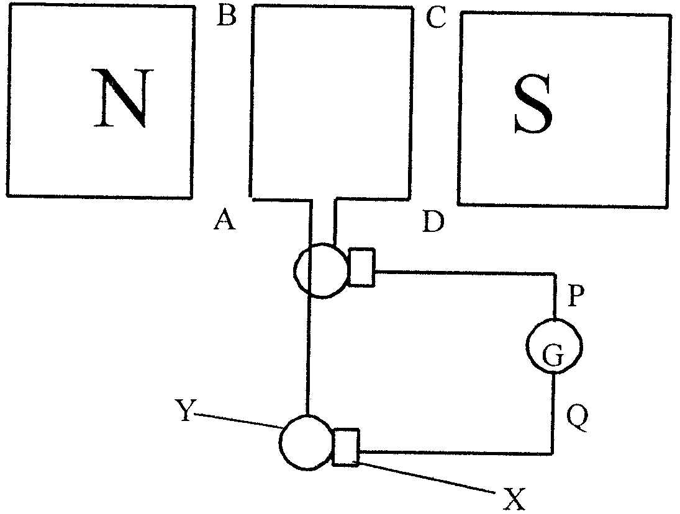

3.1 Name the following parts:

- X  - Y | (1)  (1)

3.2 What will the direction of the conventional current be through the galvanometer at the moment when conductor AB moves into the page? (From Q to P or from P to Q) | (2)

3.3 How would you change the apparatus into a direct current dynamo? | (2)

3.4 Name TWO methods to increase the reading on the galvanometer. | (4)  [10]

QUESTION 4
TRANSFORMERS

Willem wants to build a transformer which can change a voltage of 220 V to a voltage of 12 V.
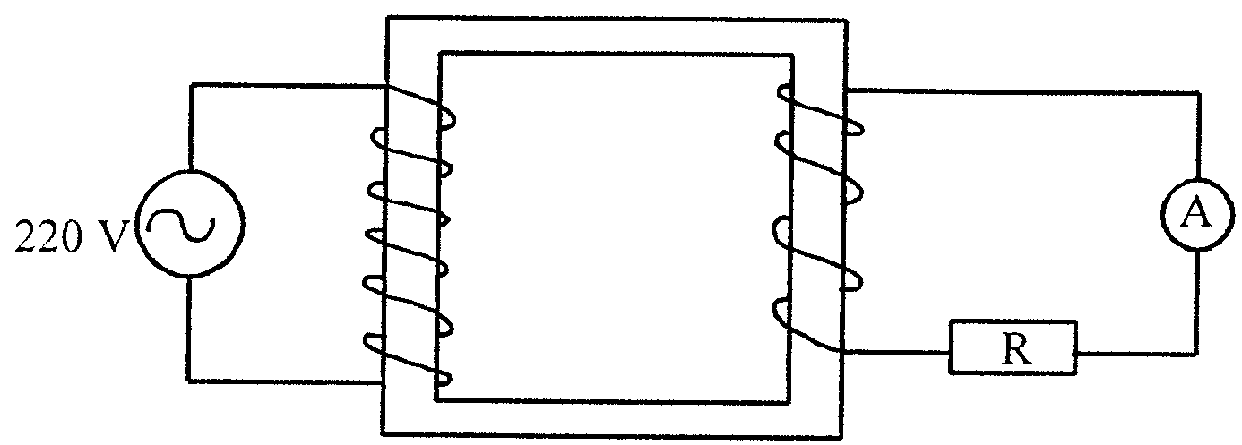

4.1 The current in the primary coil is 0,1 A. Calculate the reading on the ammeter in the secondary coil. | (4)

4.2 What type of transformer is this? | (2)

4.3 Calculate the resistance of R in the secondary coil. | (4)

4.4 Calculate the number of turns in the secondary coil if there are 360 turns in the primary coil. | (4)  [14]

QUESTION 5
ELECTRONICS

5.1 Explain the difference between alternating current and direct current. | (4)

5.2 Itumeleng connects a certain electrical component in an electric circuit. The component causes the image, which is observed on the oscilloscope, to change as follows:
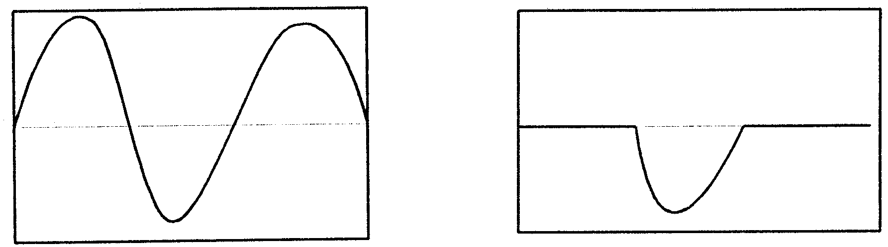
Image before the component is connected
Image after the component is connected

- Which component is connected in the circuit?  - What is the function of this component? | (2)  (2)

5.3 Draw a labelled sketch of a transistor circuit symbol. | (4)  [12]

QUESTION 6
OHM’s LAW

A heating element with a resistance of 10 Ω is used to heat water as shown in the sketch below.

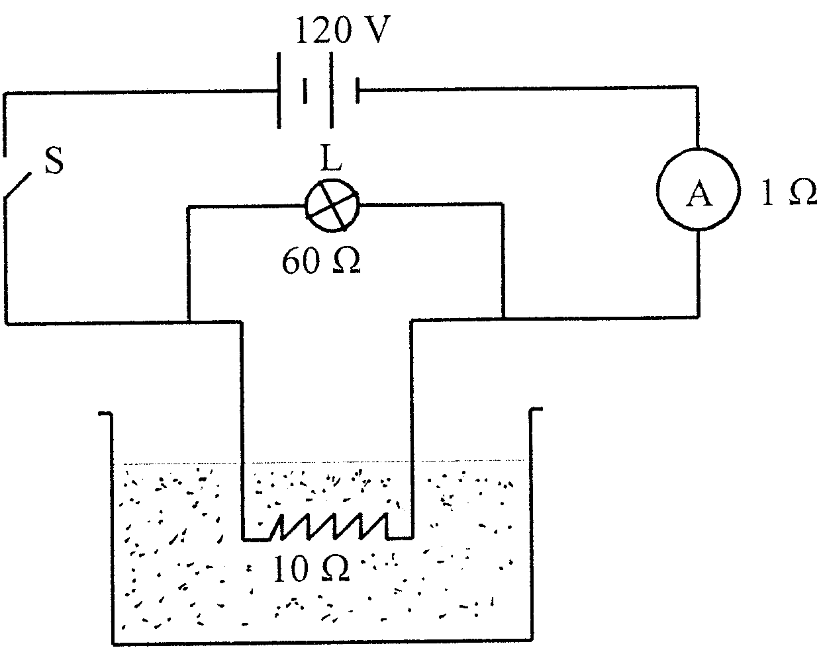

L is a bulb which shows when the circuit is completed. The water starts boiling 3 minutes after switch S is closed. The ammeter has a resistance of 1 Ω.

6.1 Calculate the total resistance in the circuit. | (5)

6.2 Calculate the reading on the ammeter when switch S is closed. | (4)

6.3 What is the current through bulb L when switch S is closed? | (5)

6.4 If bulb L is removed from its socket (leaving a gap in the circuit at that point), will it take a shorter time or a longer time or the same time to boil the same volume of water? | (2)

6.5 Explain your answer to Question 6.4. | (4)  [20]

QUESTION 7
ELECTRONS IN THE ATOM

The sketch below shows a photo-electric cell which is connected to a power source with variable emf. Note the polarity of the power source. When the photocell is irradiated with green light and the emf is low, a current will flow in the circuit. This emf is increased until the reading on the micro-ammeter decreases to zero.

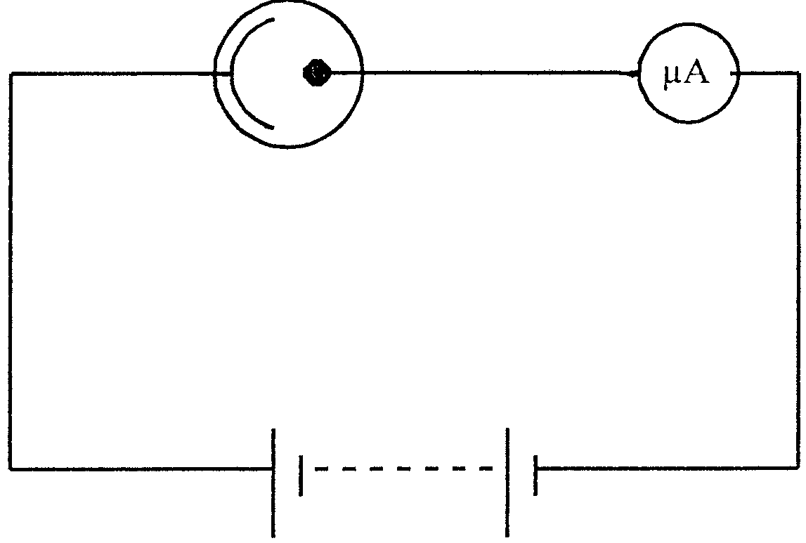
Variable emf

7.1 Explain why the reading on the ammeter decreases to zero. | (3)

7.2 What information does the magnitude of the potential difference give about the electrons which are emitted? | (2)

7.3 Will a brighter green light cause a current to flow in the circuit? Explain your answer. | (4)

7.4 Will an ultraviolet light cause a current to flow in the circuit? Explain your answer. | (4)  [13]

QUESTION 8
WAVES

8.1 Karin causes waves in a ripple tank. The waves have a speed of 0,8 m/s and a wavelength of 20 mm.

- Calculate the frequency of these waves.  - What is the period of these waves?  8.1.3 When the wave moves to shallow water, it changes velocity to 0,5 m/s. | (4)  (2)

- What is the frequency of this wave?  - Calculate the wavelength of this wave. | (2)  (4)

8.2 Sound and light are both transmitted by means of waves.

- Which ONE is a transverse wave?  - Which ONE can be polarised?  - Which ONE is an electromagnetic wave? | (2)  (2)  (2)  [18]

QUESTION 9
LIGHT, COLOUR AND SPECTRA

Sashin shines white light onto one side of a glass prism.
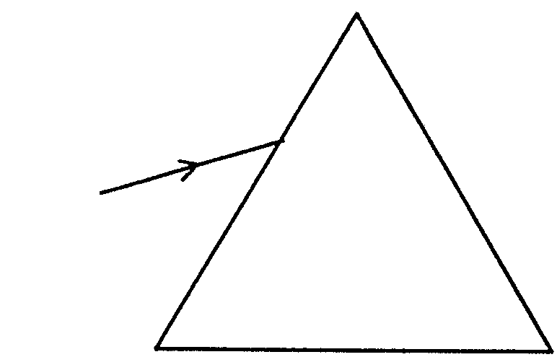
White light

9.1 What is the phenomenon called that he will observe? | (2)

9.2 What type of spectrum does he observe? | (2)

9.3 Which colour experiences the most refraction? | (2)

9.4 Which colour from this spectrum has the highest frequency? | (2)  [8]

TOTAL: | 150

PHYSICS INFORMATION SHEET/
FISIKA-INLIGTINGSBLAD

EQUATIONS / VERGELYKINGS

WAVES / GOLWE | ELECTRICITY / ELEKTRISITEIT
v = f λ  f = $\frac{1}{T}$ | R = r₁ + r₂ + r₃  $\frac{1}{R}$ = $\frac{1}{r_{1}}$ + $\frac{1}{r_{2}}$ + $\frac{1}{r_{3}}$  V_{p}I_{p} = V_{s}I_{s}  $\frac{V_{s}}{V_{p}}$ = $\frac{N_{s}}{N_{p}}$

PHYSICS CONSTANTS /
FISIKA KONSTANTES

Miscellaneous constants (Approximate values)
Diverse konstantes (Benaderde waardes)

NAME/NAAM | SYMBOL/SIMBOOL | VALUE/WAARDE
Speed of light  Spoed van lig | c | 3,0 x 10⁸ m.s⁻¹
Charge on electron  Lading op elektron | e⁻ | –1,6 x 10⁻¹⁹ C

