GAUTENG DEPARTMENT OF EDUCATION

SENIOR CERTIFICATE EXAMINATION

FUNCTIONAL PHYSICAL SCIENCE SG
(Second Paper: Chemistry)

TIME: 2 hours

MARKS: 150
REQUIREMENTS:

- An approved (non-programmable, scientific) calculator. Candidates should supply their own calculators.

INSTRUCTIONS:

- Answer ALL the questions.

- Answer Question 1 on the answer sheet which is on the inside cover of your answer book. Make a cross (X) over the letter A, B, C or D on the answer sheet, to indicate the letter you have chosen.

- Answer all the other questions in your answer book. If you need to redo the answer, redo it on a blank page. Number these answers clearly.

- A data sheet is provided at the end of this question paper. It contains formulae and constants. The information provided may be useful in answering the questions.

- Rough work may be done on the blank pages at the back of your answer book.

QUESTION 1
A B C D
MULTIPLE CHOICE QUESTIONS

Study each item and the suggested answers which are indicated by the letters A, B, C and D. Make a cross (X) over the corresponding letter on the answer sheet after you have decided which is the correct one. If more than one cross appears in any answer, no marks will be awarded.

EXAMPLE:

Pure ice melts at?

- -4°C
- 0°C
- 0 K
- 4°C

ANSWER:

Questions 1.1 to 1.3 refer to the following Aufbau diagram which represents the energy levels of electrons in the ground state:

↓ ↑ |  |  | ↓ ↑ |  | ↑ |  | ↑
3s |  |  | 3p_{x} |  | 3p_{y} |  | 3p_{y}

- In which Group will this element be found?  - II  - IV  - V  - VI | (3)

- The normal ionic charge of this element is:  - 2+  - 2-  - 4+  - 4- | (3)

- This element is:  - C  - O  - S  - Cℓ | (3)

- Between the molecules of which one of the following elements do the strongest intermolecular forces exist?  - F₂  - Cℓ₂  - Br₂  - I₂ | (3)

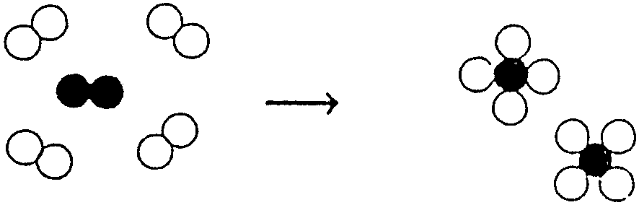  - The energy needed to break the following bonds, is as follows:  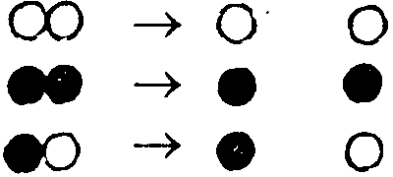  4 units  6 units  3 units  The energy transferred in the following process is  - 2 units released.  - 7 units absorbed.  - 7 units released.  - more than 7 units used. | (3)

- In which one of the following reactions will the forward reaction be favoured if the pressure is increased (by decreasing the volume of the container)?  - 2NO(g)  N₂(g) + O₂(g)  - 2H₂(g) + O₂(g)  2H₂O(g)  - 2SO₃(g)  2SO₂(g) + O₂ (g)  - 2NH₃(g)  N₂(g) + 3H₂(g) | (3)

- The oxidation state of nitrogen (N) in the compound NO₃– is:  - –1  - +3  - –6  - +5 | (3)

- In the following reaction, the reducing agent is:  Zn(s) + Cu²⁺(aq) → Zn²⁺(aq) + Cu(s)  - Zn(s)  - Cu²⁺(aq)  - Zn²⁺(aq)  - Cu(s) | (3)

- Which of the following is a characteristic reaction of an alkali metal (M)?  - M + e– → M–  - 4M + O₂ → 2M₂O  - M + H₂O → M⁺ + OH–  - M + 2H₂O → M(OH)₂ + H₂ | (3)

- There is an enormous number of different organic compounds because  - carbon occurs in many forms on earth.  - organic chemistry is a very old science.  - organic compounds are of tremendous industrial value.  - carbon atoms form chains and rings with one another. | (3)

- Alkanes are all organic compounds which  - are very reactive substances.  - contain only carbon and hydrogen.  - have the general formula C_{n}H_{2n}.  - are gases at room temperature. | (3)

- Which one of the following is a saturated hydrocarbon?  - C₂H₄  - CH₄  - C₂H₂  - CH₃OH | (3)

1.13 Ethyne can be represented by the following structural formula:

 | A.  H H  H C C H  H H  C.  H C ≡ C H | B.  H C = C H  H H  D.  H H  C = C  OH H
 |  |  | (3)

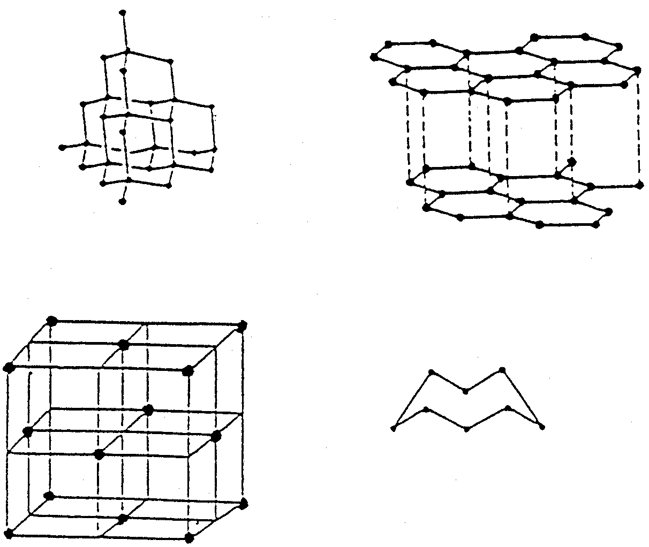  1.14 Which diagram is the best representation of graphite?  A.  B.  D.  C. | (3)

1.15 The functional group we find in carboxylic acids is

 | A.  C OH  C.  C = C  H | B.  C = O  OH  D.  C C C  OH O
(3)
15x3=[45]

QUESTION 2  ATOMIC STRUCTURE AND CHEMICAL BONDING  In an atom, electrons are encountered in energy levels around the nucleus.  - In which energy level is an electron with the lowest energy found?  - What would happen to an electron if it receives enough energy? | (2)  (2)

What is necessary to remove electrons from an atom?  - 2.4.1 How does the energy of an electron change when it moves from a higher to a lower energy level?  2.4.2 In what form is this released energy observed?  - What type of particle is formed when an atom  - loses an electron?  - gains an electron? | (2)  (2)  (2)  (2)  (2)  [14]

QUESTION 3  NH₃; C; MgCℓ₂; CH₄; F₂; Fe.  - Draw a Lewis diagram of an NH₃ molecule.  - Draw a Couper structure for the CH₄ molecule.  - From the following list of substances, select the one which is referred to in each of the statements. For each statement select ONE substance only.  - A substance consisting of polar molecules with polar covalent bonds.  - A substance consisting of non-polar molecules with polar covalent bonds.  - Mainly hydrogen bonding occurs in the solid or liquid phase of this substance.  - In the solid phase the particles of this substance are held together by covalent bonding.  - This substance dissolves to form positive and negative ions. | (3)  (3)  (2)  (2)  (2)  (2)  (2)  [16]

QUESTION 4
INTERMOLECULAR FORCES

In the table below, the melting points and boiling points of a few molecular solids are given.

COMPOUND | MELTING POINT(°C) | BOILING POINT(°C)
A.  B.  C.  D. | 0  -184  27  -270 | 100  -162  316  -269

- In which compound are  - the strongest intermolecular forces present?  - the weakest intermolecular forces present?  - hydrogen bonds present? | (2)  (2)  (2)

- At room temperature (25°C), which compound(s) will be a  4.2.1 liquid?  4.2.2 solid? | (2)  (2)  [10]

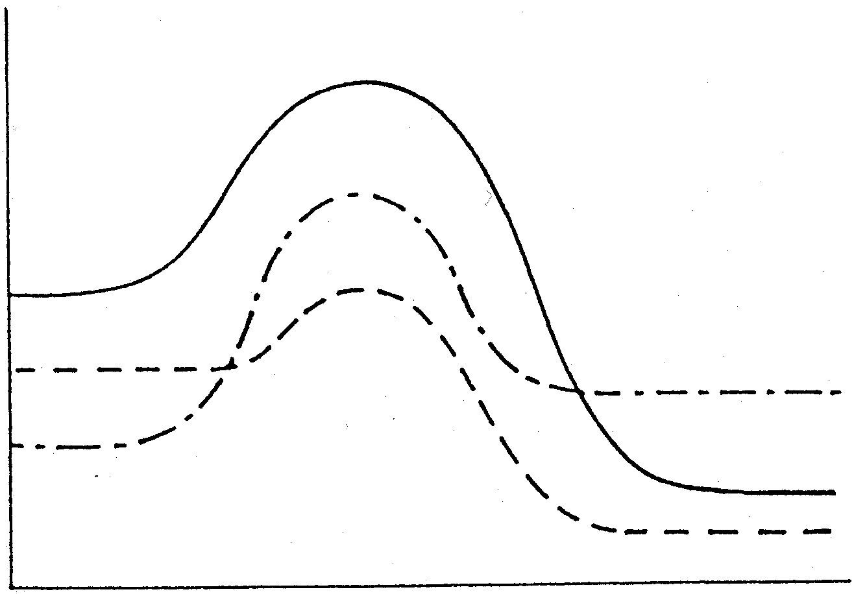
QUESTION 5
A
B
C
E_{p}
ENERGY AND CHEMICAL REACTIONS

Answer questions 5.1 to 5.5 by using the symbols A, B and C on the following diagram:

REACTION CO-ORDINATE

Which diagram shows an endothermic process?  Which reaction has the smallest activation energy? | (2)  (2)

- In which reaction is ∆H the greatest?  - In which reaction is ∆H negative?  - When sugar is dissolved in water, heat is absorbed. Which diagram might illustrate this process? | (2)  (2)  (2)  [10]

QUESTION 6
H₂O(ℓ) + energy  H₂O (g)

CHEMICAL EQUILIBRIUM

  - Equal volumes of H₂O are placed into two identical beakers, X and Y, and each beaker is sealed with a glass plate. The two beakers are then kept for a considerable time at 15°C and 80°C respectively. A dynamic equilibrium originates in both X and Y. The equation for the equilibrium reaction is as follows:

- What is a dynamic equilibrium?  6.1.2 How does the volume of liquid in X compare with the volume of liquid in Y? | (2)  (2)

6.1.3 The glass plate on beaker X is removed. What effect will this have on the equilibrium in the beaker? | (2)

Consider the equation for the following equilibrium reaction:  2NO ₂ (g)  N₂O₄(g) + energy  - Which reaction is favoured most if the temperature is decreased?  - Which reaction is favoured if pressure is decreased (by increasing the volume of the container)? | (2)  (2)

A saturated solution of table salt in water is prepared and the following solubility equilibrium originates:  NaCℓ(s)  Na⁺(aq) + Cℓ – (aq)  A quantity of Cℓ – is then added to the equilibrium system. What effect does this have on the amount of each of the following in the reaction flask?  - NaCℓ(s)  - Na⁺(aq) | (2)  (2)  [14]

QUESTION 7  Zn + HCℓ → ZnCℓ₂ + H₂  OXIDATION AND REDUCTION  - When does oxidation take place in a chemical reaction?  - Consider the following reaction:  - Which substance is oxidized?  - Which substance is reduced?  - State the name of HCℓ.  - What is this type of reaction called?  - Balance the equation. | (2)  (2)  (2)  (1)  (2)  (2)  [11]

QUESTION 8  ELECTROCHEMISTRY  - An electrochemical cell converts chemical energy into electrical energy.  - Draw a neat, labelled diagram of a Zn/Cu electrochemical cell that contains an instrument to indicate potential difference. The electrolytes used, are: potassium nitrate, zinc nitrate and copper nitrate. Label all the parts and solutions fully. | (7)

Is the anode, or cathode, positive?  Explain the term electrolyte. | (2)  (2)

Oxygen and hydrogen can be prepared in the laboratory by electrolysis of acidified water.  - Write down a chemical equation for the half-reaction that takes place at the anode.  - Write down a chemical equation for the reaction that takes place at the cathode. | (3)  (3)  [17]

QUESTION 9  PROPERTIES OF ELEMENTS  Chlorine gas is bubbled through a solution of potassium bromide in water.  - What would you observe about the colour of the solution?  - Which substance which is formed would be responsible for this change?  - For this reaction write down:  - The oxidation half-reaction  - The reduction half-reaction  9.3.3 The overall reaction | (2)  (2)  (3)  (3)  (3)  [13]

TOTAL: | 150

